3GPP TR 38.863 V19.4.0 (2026-06)
Technical Report

3rd Generation Partnership Project;
Technical Specification Group Radio Access Network;
Solutions for NR to support non-terrestrial networks (NTN):
Non-terrestrial networks (NTN) related RF and co-existence aspects
(Release 19)
 | 
The present document has been developed within the 3rd Generation Partnership Project (3GPP TM) and may be further elaborated for the purposes of 3GPP.
The present document has not been subject to any approval process by the 3GPP Organizational Partners and shall not be implemented.
This Specification is provided for future development work within 3GPP only. The Organizational Partners accept no liability for any use of this Specification.
Specifications and Reports for implementation of the 3GPP TM system should be obtained via the 3GPP Organizational Partners' Publications Offices.

3GPP
Postal address

3GPP support office address
650 Route des Lucioles - Sophia Antipolis
Valbonne - FRANCE
Tel.: +33 4 92 94 42 00 Fax: +33 4 93 65 47 16
Internet
http://www.3gpp.org

Copyright Notification
No part may be reproduced except as authorized by written permission.
The copyright and the foregoing restriction extend to reproduction in all media.

© 2026, 3GPP Organizational Partners (ARIB, ATIS, CCSA, ETSI, TSDSI, TTA, TTC).
All rights reserved.

UMTS™ is a Trade Mark of ETSI registered for the benefit of its members
3GPP™ is a Trade Mark of ETSI registered for the benefit of its Members and of the 3GPP Organizational Partners
LTE™ is a Trade Mark of ETSI registered for the benefit of its Members and of the 3GPP Organizational Partners
GSM® and the GSM logo are registered and owned by the GSM Association

Contents
Foreword 10
1 Scope 11
2 Reference 11
3 Definition of terms, symbols and abbreviations 13
3.1 Terms 13
3.2 Symbols 13
3.3 Abbreviations 14
4 General aspects 15
4.1 Work item objectives 15
5 Regulatory aspects 15
5.1 ITU-R 15
5.2 Regulatory aspects for NTN satellites 16
5.2.1 NTN Satellite band: UL 1980–2010 MHz / DL 2170–2200 MHz 16
5.2.2 NTN Satellite band: UL 1626.5–1660.5 MHz / DL 1525–1559 MHz 18
5.2.3 NTN Satellite band: UL 27.5-30.0 GHz / DL 17.3-20.2 GHz 21
5.2.3.1 ITU-R 21
5.2.3.2 FCC 24
5.2.3.3 CEPT 25
5.2.4 NTN Satellite band: UL 2000–2020 MHz / DL 2180–2200 MHz 25
5.2.5 NTN Satellite band: UL 1668-1675 MHz / DL 1518-1525 MHz) 28
5.2.5.1 ITU-R 29
5.2.5.2 FCC 31
5.2.5.3 CEPT/ECC 33
5.2.5.3.1 CEPT 33
5.2.5.3.2 ECC Report 263 33
5.2.5.4 ETSI 34
5.2.5.4.1 ETSI EN 301 681 34
5.2.5.4.1.1 In-band and Out-of-band Emission Requirements 34
5.2.5.4.1.2 Additional measures to protect Radioastronomy (RA) stations 40
5.2.6 NTN Satellite band: UL13.75-14.5 GHz / DL 10.7-12.75 GHz 41
5.2.6.1 ITU-R 41
5.2.6.2 FCC 43
5.2.6.3 CEPT 45
5.3 Regulatory aspects for HAPS 47
6 Co-existence study 47
6.1 Co-existence simulation scenario 47
6.2 Co-existence simulation assumption 49
6.2.1 Network layout model 49
6.2.1.1 Co-existence between NTN satellite and TN 49
6.2.1.2 Co-existence between HAPS and TN 52
6.2.1.3 Co-existence between HAPS and HAPS 53
6.2.2 System parameters 53
6.2.2.1 Satellite parameters 53
6.2.2.2 NTN UE parameters 55
6.2.2.3 HAPS parameters 56
6.2.2.4 TN parameters 57
6.2.3 Antenna and beamforming pattern modelling 59
6.2.3.1 Satellite and UE Antenna and beam forming pattern modelling 59
6.2.3.2 TN BS and UE antenna and beam forming pattern modelling 63
6.2.3.3 HAPS antenna model 64
6.2.4 ACIR model 65
6.2.5 Propagation model 65
6.2.5.1 Propagation model between NTN SAN and UE 65
6.2.5.2 Propagation model between TN BS and UE 66
6.2.5.3 Propagation model between NTN SAN and TN BS 66
6.2.5.4 Propagation model for HAPS 66
6.2.6 Transmission power control model 66
6.2.6.1 TN UL TPC 66
6.2.6.2 NTN UL TPC 66
6.2.6.3 NTN DL TPC 66
6.2.6.4 HAPS UL TPC 66
6.2.6.5 HAPS DL TPC 66
6.2.7 Received power model 66
6.2.8 Performance metric 67
6.2.9 Throughput ~ SNR mapping 67
6.3 Co-existence simulation methodology 67
6.3.1 Simulation procedure 67
6.3.2 Methods and principle to process co-existence simulation results 68
6.4 Co-existence simulation results 69
6.4.1 Scenario 1: 2GHz TN DL interfering NTN DL 69
6.4.2 Scenario 2: 2GHz TN UL interfering NTN UL 72
6.4.3 Scenario 3: 2GHz NTN DL interfering TN DL 76
6.4.3.1 LEO Class 76
6.4.4 Scenario 4: 2GHz NTN UL interfering TN UL 83
6.4.5 Scenario 5: 2GHz NTN UL interfering TN DL 87
6.4.6 Scenario 6: 2GHz TN DL interfering NTN UL 90
6.4.7 Scenario 7: 2GHz HAPS DL interfering TN DL 92
6.4.8 Scenario 8: 2GHz TN UL interfering HAPS UL 93
6.5 Summary of co-existence study 94
6.5.1 Coexistence at 2GHz 94
6a Co-existence study for 17/27GHz 96
6a.1 Co-existence simulation scenario for 17/27GHz 96
6a.2 Co-existence simulation assumption for 17/27GHz 98
6a.2.1 Network layout model 98
6a.2.1.1 Co-existence between NTN satellite and TN 98
6a.2.2 System parameters 101
6a.2.2.1 Satellite parameters 101
6a.2.2.2 NTN UE parameters 102
6a.2.2.3 Void 103
6a.2.2.4 TN parameters 103
6a.2.3 Antenna and beam forming pattern modelling 104
6a.2.3.1 Satellite parameters 104
6a.2.3.2 TN BS and UE antenna and beam forming pattern modelling 105
6a.2.4 ACIR model 107
6a.2.5 Propagation model 107
6a.2.6 Transmission power control model 107
6a.2.6.1 UL TPC 107
6a.2.6.2 DL TPC 108
6a.2.7 Received power model 108
6a.2.8 Performance metric 108
6a.2.9 Throughput ~ SNR mapping 108
6a.3 Co-existence simulation methodology for 17/27GHz 108
6a.3.1 Simulation procedure 108
6a.3.2 Methods and principle to process co-existence simulation results 108
6a.4 Co-existence simulation results for 17/27GHz 109
6a.4.1 Scenario 1a: 27GHz NTN UL interfering TN UL 109
6a.4.2 Scenario 2a: 27GHz TN UL interfering NTN UL 114
6a.4.3 Scenario 3a: 27GHz NTN UL interfering TN DL 119
6a.4.4 Scenario 4a: 27GHz TN DL interfering NTN UL 121
6a.4.5 Scenario 5a: 17GHz TN DL interfering NTN DL 126
6a.4.6 Scenario 6a: 17GHz NTN DL interfering TN DL 132
6a.4.7 Scenario 7a: 17GHz NTN DL interfering TN UL 134
6a.4.8 Scenario 8a: 17GHz TN UL interfering NTN DL 136
6a.5 Summary of co-existence study 139
6a.5.1 Coexistence at 17/27GHz 139
6b Co-existence study for NTN HPUE in FR1 140
6b.1 Co-existence simulation scenario for NTN HPUE in FR1 140
6b.2 Co-existence simulation assumption for NTN HPUE in FR1 142
6b.2.1 Network layout model 142
6b.2.1.1 Co-existence between NTN satellite and TN 142
6b.2.2 System parameters 143
6b.2.2.1 Satellite parameters 143
6b.2.2.2 NTN UE parameters 145
6b.2.2.3 TN parameters 146
6b.2.3 Antenna and beam forming pattern modelling 147
6b.2.3.1 NTN SAN and NTN UE 147
6b.2.3.2 TN BS and TN UE 151
6b.2.4 ACIR model 152
6b.2.4.1 NR-NTN 152
6b.2.4.2 IoT-NTN 152
6b.2.5 Propagation model 152
6b.2.5.1 Propagation model between NTN SAN and UE 152
6b.2.5.2 Propagation model between TN BS and UE 152
6b.2.5.3 Propagation model between NTN SAN and TB BS 152
6b.2.6 Transmission power control model 152
6b.2.6.1 TN uplink transmission power control 152
6b.2.6.2 NTN uplink transmission power control 153
6b.2.6.3 Downlink transmission power control 153
6b.2.7 Received power model 153
6b.2.8 Performance metric 154
6b.2.9 Throughput ~ SNR mapping 154
6b.3 Co-existence simulation methodology for NTN HPUE in FR1 154
6b.3.1 Simulation procedure 154
6b.3.2 Methods and principle to process co-existence simulation results 154
6b.4 Co-existence simulation results for NTN HPUE in FR1 154
6b.4.1 NR-NTN Power Class 2: Scenario 4b 154
6b.4.2 NR-NTN Power Class 1.5: Scenario 4b 155
6b.4.3 NR-NTN Power Class 1: Scenario 4b 155
6b.4.4 IoT-NTN Power Class 2: Scenario 4b 156
6b.4.5 IoT-NTN Power Class 1: Scenario 4b 157
6b.5 Summary of co-existence study for NTN HPUE in FR1 157
6c Co-existence study for 11/14GHz 158
6c.1 Co-existence simulation scenario for 11/14GHz 158
6c.2 Co-existence simulation assumption for 11/14GHz 159
6c.2.1 Network layout model 159
6c.2.1.1 Co-existence between NTN satellite and TN 159
6c.2.2 System parameters 162
6c.2.2.1 Satellite parameters 162
6c.2.2.2 NTN UE parameters 163
6c.2.2.3 TN parameters 165
6c.2.3 Antenna and beam forming pattern modelling 165
6c.2.3.1 Satellite parameters 165
6c.2.3.2 TN BS antenna and beam forming pattern modelling 166
6c.2.3.3 TN UE antenna model 169
6c.2.4 ACIR model 169
6c.2.5 Propagation model 169
6c.2.6 Transmission power control model 169
6c.2.6.1 UL TPC 169
6c.2.6.2 DL TPC 170
6c.2.7 Received power model 170
6c.2.8 Performance metric 170
6c.2.9 Throughput ~ SNR mapping 170
6c.3 Co-existence simulation methodology for 11/14GHz 170
6c.3.1 Simulation procedure 170
6c.3.2 Methods and principle to process co-existence simulation results 170
6c.4 Co-existence simulation results for 11/14GHz 171
6c.4.1 Scenario 1x: 14GHz NTN UL interfering TN UL 171
6c.4.2 Scenario 4x: 14GHz TN DL interfering NTN UL 172
6c.4.3 Scenario 5x: 11GHz TN DL interfering NTN DL 172
6c.4.4 Scenario 6c: 11GHz NTN DL interfering TN DL 173
6c.5 Summary of co-existence study 174
6c.5.1 Coexistence at 11/14GHz 174
7 RF requirements 176
7.1 SAN Reference points for RF requirements 176
7.1.1 General 176
7.1.2 SAN type 1-C 176
7.1.3 SAN type 1-H 176
7.1.4 SAN type 1-O 177
7.2 Common issues for satellite access node and NTN UE 177
7.2.1 General 177
7.2.2 Operating bands 177
7.2.3 Channel bandwidth, SCS and spectral utilization 178
7.2.3.1 Asymmetric channel bandwidth 178
7.2.4 Channel raster and sync raster 179
7.2.4.1 Channel raster 179
7.2.4.2 Sync raster 180
7.3 Satellite Access Node requirements 180
7.3.1 General 180
7.3.1.1 SAN class 180
7.3.2 Transmission characteristics 181
7.3.2.1 General 181
7.3.2.2 Conducted transmitter requirements 181
7.3.2.2.1 SAN output power 181
7.3.2.2.2 Output power dynamics 182
7.3.2.2.3 Transmitted signal quality 182
7.3.2.2.4 Unwanted emissions 183
7.3.2.2.5 Transmitter spurious emission 184
7.3.2.3 Radiated transmitter requirements 185
7.3.2.3.1 Reserved 185
7.3.2.3.2 Reserved 185
7.3.2.3.3 Reserved 185
7.3.2.3.4 Reserved 185
7.3.2.3.5 Reserved 185
7.3.2.3.6 Reserved 185
7.3.2.3.7 Reserved 185
7.3.3 Receiver characteristics 186
7.3.3.1 General 186
7.3.3.2 Conducted receiver characteristics 186
7.3.3.2.1 Reference sensitivity level 186
7.3.3.2.2 Dynamic range 187
7.3.3.2.3 In-band selectivity and blocking 187
7.3.3.2.4 Out-of-band blocking 189
7.3.3.2.5 Receiver spurious emissions 190
7.3.3.2.6 Receiver intermodulation 190
7.3.3.2.7 In-channel selectivity 190
7.3.3.3 Radiated receiver characteristics 190
7.3.3.3.1 OTA sensitivity 190
7.3.3.3.2 OTA reference sensitivity level 190
7.3.3.3.3 OTA dynamic range 190
7.3.3.3.4 OTA in-band selectivity and blocking 191
7.3.3.3.5 OTA out-of-band blocking 191
7.3.3.3.6 OTA receiver spurious emissions 191
7.3.3.3.7 OTA receiver intermodulation 192
7.3.3.3.8 OTA in-channel selectivity 192
7.3.4 Others 192
7.3.4.1 SAN RF requirements for 3MHz channel bandwidth 192
7.3.4.1.1 Conducted Tx/Rx requirements 192
7.3.4.1.2 Radiated Tx/Rx requirements 193
7.4 NTN UE requirements 195
7.4.1 General 195
7.4.1.1 TX-RX frequency separation 195
7.4.2 UE Transmission characteristics for satellite access 195
7.4.2.1 General 195
7.4.2.2 Conducted transmitter characteristics 196
7.4.2.2.1 Maximum output power 196
7.4.2.2.2 MPR/AMPR 196
7.4.2.2.3 Output power dynamics 207
7.4.2.2.4 Frequency error 207
7.4.2.2.5 Transmit modulation quality 207
7.4.2.2.6 Spectrum emission mask 207
7.4.2.2.7 ACLR 207
7.4.2.2.8 Spurious emissions 208
7.4.2.2.9 Transmit intermodulation 209
7.4.2.2.10 UE to UE coexistence issues between NTN and TN 209
7.4.2.3 Radiated transmitter characteristics for Ka band VSAT 211
7.4.2.3.1 VSAT maximum output power 211
7.4.3 UE Receiver characteristics for satellite access 212
7.4.3.1 General 212
7.4.3.2 Conducted receiver characteristics 212
7.4.3.2.1 General and diversity characteristics 212
7.4.3.2.2 Reference sensitivity 212
7.4.3.2.3 Maximum input level 215
7.4.3.2.4 Adjacent channel selectivity 216
7.4.3.2.5 Blocking characteristics 216
7.4.3.2.6 Spurious response 216
7.4.3.2.7 Intermodulation characteristics 216
7.4.3.2.8 Rx Spurious emissions 216
7.4.3.2.9 Void 217
7.4.3.3 Radiated receiver characteristics for Ka band VSAT 217
7.4.3.3.1 Polarization characteristics 217
7.4.3.3.2 OTA reference sensitivity level 217
7.4.4 UE antenna characteristics for satellite access 218
7.4.4.1 Handheld UE antenna characteristics for satellite access 218
8 Conclusion 218
Annex A: Calibration results of NTN components 219
A.1 Calibration assumptions at 2GHz 219
A.1a Calibration assumptions at 11/14GHz 219
A.2 Calibration results at 2GHz 220
Annex B: Calibration results of TN components 225
B.1 Calibration assumptions at 2GHz 225
B.1a Calibration assumptions at 11/14GHz 226
B.2 Calibration results at 2GHz 226
Annex C: Summary of NR-NTN co-existence study 229
C1: Summary of n252 UE-to-UE co-existence study/simulations 229
C.1.1 UE-to-UE separation distance and UE-to-UE protection limit (R4-2416459) 229
C.1.2: AMPR study for n252 230
C.1.2.1 Power back-off simulation from company A (R4-2503176) 230
C.1.2.1.1 Assumption for power-back off simulation 230
C.1.2.1.2 Power back-off simulations for -40dBm/MHz 230
C.1.2.1.3 Power back-off simulations for -30dBm/MHz 233
C.1.2.2 Power back-off simulation from company B (R4-2504544) 235
C.1.2.3 Power back-off simulation from company C (R4-2506521) 237
C.1.2.3.1 Simulation parameters 237
C.1.2.3.2 NS_07N mask 237
C.1.2.3.3 Simulation result 237
C.1.2.3.4 A-MPR proposal 239
C.1.2.4 Measurement results from company D 239
C.1.2.4.1 Measurement parameters 239
C.1.2.4.2 Measurement result 240
Annex D: Summary of simulation results for the IoT derivation 241
Annex E: Examples of Delay and Doppler shift variation as a function of time for different satellite orbit types 242
E.1 LEO 600 km case 242
E.2 LEO 1200 km case 243
E.3 GSO orbit case 243
E.4 Examples of Doppler and Delay for different elevation angles and for different satellite orbit types 244
Annex F: Power back-off simulation results for the S-band 246
F.1 PC3 power class 246
F.1.1 General aspects 246
F.1.1.1 NS_24N 246
F.1.1.1.1 Company A 246
F.1.1.1.1.1 Simulation assumptions 246
F.2.1.1.1.2 Simulation results 246
F.1.1.1.2 Company B 248
F.1.1.1.2.1 Simulation assumptions 248
F.1.1.1.2.2 Simulation results 248
F.1.1.1.3 Company C 248
F.1.1.1.3.1 Simulation assumptions 248
F.1.1.1.3.2 Simulation results 249
F.2 PC2 power class 249
F.2.1 General aspects 249
F.2.1.1 NS_24N 249
F.2.1.1.1 Company A (MediaTek/R4-2509854) 249
F.2.1.1.1.1 Simulation assumptions F.2.1.1.1.2 Simulation results 249
F.2.1.1.2 Company B (Qualcomm/R4-2511400) 249
F.2.1.1.2.1 Simulation assumptions 249
F.2.1.1.2.2 Simulation results 250
F.2.1.1.3 Company C (R4-2510521/OPPO) 251
F.2.1.1.3.1 Simulation assumptions 251
F.2.1.1.3.2 Simulation results 251
F.2.1.1.4 Company D (R4-2511269/Nokia) 254
F.2.1.1.4.1 Simulation assumptions 254
F.2.1.1.4.2 Simulation results 255
F.2.1.1.5 Company E (R4-2509537/Apple) 257
F.2.1.1.5.1 Simulation assumptions 257
F.2.1.1.5.2 Simulation results 258
F.3 PC1.5 power class 262
F.3.1 General aspects 262
F.4 PC1 power class 262
F.4.1 General aspects 262
F.4.1.1 NS_24N 262
F.4.1.1.1 Company A (R4-2511269/Nokia) 262
F.4.1.1.1.1 Simulation assumptions 262
F.4.1.1.1.2 Simulation results 262
F.4.1.1.2 Company B (R4-2510521/OPPO) 265
F.4.1.1.2.1 Simulation assumptions 265
F.4.1.1.2.2 Simulation results 266
Annex G: Power back-off simulation results for the L-band 267
G.1 PC3 power class 267
G.1.1 General aspects 267
G.1.1.1 NS_02N 268
G.1.1.1.1 Company A (OPPO/R4-2510521) 268
G.1.1.1.1.1 Simulation assumptions 268
G.1.1.1.1.2 Simulation results 268
G.1.1.2 NS_09N 268
G.1.1.2.1 Company A 268
G.1.1.2.1.1 Simulation assumptions 268
G.1.1.2.1.2 Simulation results 268
G.1.1.3 NS_10N 270
G.1.1.3.1 Company A 270
G.1.1.3.1.1 Simulation assumptions 270
G.1.1.3.1.2 Simulation results 270
G.1.1.4 NS_14N 275
G.1.1.4.1 Company A 275
G.1.1.4.1.1 Simulation assumptions 275
G.1.1.4.1.2 Simulation results 276
G.2 PC2 power class 279
G.2.1 General aspects 279
G.2.1.1 NS_02N 279
G.2.1.1.1 Company A (Qualcomm/R4-2511400) 279
G.2.1.1.1.1 Simulation assumptions 279
G.2.1.1.1.2 Simulation results 279
G.2.1.1.2 Company B (OPPO/R4-2510521) 279
G.2.1.1.2.1 Simulation assumptions 279
G.2.1.1.2.2 Simulation results 280
G.2.1.1.3 Company C (LGE/R4-2510776) 283
G.2.1.1.3.1 Simulation assumptions 283
G.2.1.1.3.2 Simulation results 283
G.2.1.1.4 Company D (Apple/R4-2509536) 285
G.2.1.1.4.1 Simulation assumptions 285
G.2.1.1.4.2 Simulation results 285
G.3 PC1.5 power class 286
G.3.1: General aspects 286
G.3.1.1 NS_02N 286
G.3.1.1.1 Company B (OPPO/ R4-2510521) 286
G.3.1.1.1.1 Simulation assumptions 286
G.3.1.1.1.2 Simulation results 286
G.4 PC1 power class 288
G.4.1 General aspects 288
G.4.1.1 NS_02N 288
G.4.1.1.1 Company A (Qualcomm/R4-2511400) 288
G.4.1.1.1.1 Simulation assumptions 288
G.4.1.1.1.2 Simulation results 288
Annex H: Summary of NTN HPUE simulation results 289
Annex I (informative): Change history 290

Foreword
This Technical Report has been produced by the 3rd Generation Partnership Project (3GPP).
The contents of the present document are subject to continuing work within the TSG and may change following formal TSG approval. Should the TSG modify the contents of the present document, it will be re-released by the TSG with an identifying change of release date and an increase in version number as follows:
Version x.y.z
where:
x the first digit:
1 presented to TSG for information;
2 presented to TSG for approval;
3 or greater indicates TSG approved document under change control.
y the second digit is incremented for all changes of substance, i.e. technical enhancements, corrections, updates, etc.
z the third digit is incremented when editorial only changes have been incorporated in the document.
In the present document, modal verbs have the following meanings:
shall indicates a mandatory requirement to do something
shall not indicates an interdiction (prohibition) to do something
The constructions "shall" and "shall not" are confined to the context of normative provisions, and do not appear in Technical Reports.
The constructions "must" and "must not" are not used as substitutes for "shall" and "shall not". Their use is avoided insofar as possible, and they are not used in a normative context except in a direct citation from an external, referenced, non-3GPP document, or so as to maintain continuity of style when extending or modifying the provisions of such a referenced document.
should indicates a recommendation to do something
should not indicates a recommendation not to do something
may indicates permission to do something
need not indicates permission not to do something
The construction "may not" is ambiguous and is not used in normative elements. The unambiguous constructions "might not" or "shall not" are used instead, depending upon the meaning intended.
can indicates that something is possible
cannot indicates that something is impossible
The constructions "can" and "cannot" are not substitutes for "may" and "need not".
will indicates that something is certain or expected to happen as a result of action taken by an agency the behaviour of which is outside the scope of the present document
will not indicates that something is certain or expected not to happen as a result of action taken by an agency the behaviour of which is outside the scope of the present document
might indicates a likelihood that something will happen as a result of action taken by some agency the behaviour of which is outside the scope of the present document
might not indicates a likelihood that something will not happen as a result of action taken by some agency the behaviour of which is outside the scope of the present document
In addition:
is (or any other verb in the indicative mood) indicates a statement of fact
is not (or any other negative verb in the indicative mood) indicates a statement of fact
The constructions "is" and "is not" do not indicate requirements.

1 Scope
The present document covers the RF and co-existence aspects of the work item “Solutions for NR to support non-terrestrial networks (NTN)” [2]
The objectives for the study are the following:
- Study and specify adjacent channel co-existence scenarios of Non-terrestrial networks (NTN).
- Study and specify needed generic RF core requirements for the network and the UE such that adjacent channel co-existence scenarios are met.
NOTE: Satellite operation is used as complementarily to Terrestrial Network operation, and in separate location when satellite operates in an adjacent channel/band of terrestrial network. For instance, NTN satellite UE is assumed to connect and transmit to the satellite when it is outside a Terrestrial Network operating in an adjacent channel/band. The satellite beam might still overlap the terrestrial network.

2 Reference
The following documents contain provisions which, through reference in this text, constitute provisions of the present document.
- References are either specific (identified by date of publication, edition number, version number, etc.) or non-specific.
- For a specific reference, subsequent revisions do not apply.
- For a non-specific reference, the latest version applies. In the case of a reference to a 3GPP document (including a GSM document), a non-specific reference implicitly refers to the latest version of that document in the same Release as the present document.
[1] 3GPP TR 21.905: "Vocabulary for 3GPP Specifications".
[2] 3GPP RP-213691: "Revised WID: Solutions for NR to support non-terrestrial networks (NTN)".
[3] ITU-R Radio Regulations, 2020 Edition
[4] ECC Decision 06(09): "Designation of the bands 1980-2010 MHz and 2170-2200 MHz for use by systems in the Mobile-Satellite Service including those supplemented by a Complementary Ground Component (CGC)", Approved 01 December 2006, Amended 05 September 2007,
[5] 3GPP TR 38.811: "Study on New Radio (NR) to support non-terrestrial networks".
[6] 3GPP TR 38.821: "Solutions for NR to support Non-Terrestrial Networks (NTN)".
[7] 3GPP RP-152284: "Revised Work Item: Narrowband IoT ".
[8] 3GPP TR 36.942: "Evolved Universal Terrestrial Radio Access (E-UTRA); Radio Frequency (RF) system scenarios".
[9] 3GPP TR 45.820: "Cellular system support for ultra-low complexity and low throughput Internet of Things (CIoT)".
[10] 3GPP TR 38.901: "Study on channel model for frequencies from 0.5 to 100 GHz".
[11] Report ITU-R M.2292: "Characteristics of terrestrial IMT-Advanced systems for frequency sharing/interference analyses".
[12] 3GPP RP-200559: "LS on Parameters of terrestrial component of IMT for sharing and compatibility studies in preparation for WRC-23 (below 5 GHz) ".
[13] ITU-R Annex 4.4 to Document 5D/716-E.
[14] 3GPP TR 38.921: "Study on International Mobile Telecommunications (IMT) parameters for 6.425 - 7.025 GHz, 7.025 - 7.125 GHz and 10.0 - 10.5 GHz".
[15] 3GPP TR 36.802: "Evolved Universal Terrestrial Radio Access (E-UTRA); NB-IOT; Technical Report for BS and UE radio transmission and reception".
[16] 3GPP TS 38.104: "NR; Base Station (BS) radio transmission and reception".
[17] 3GPP TS 38.101-1: "NR; User Equipment (UE) radio transmission and reception; Part 1: Range 1 Standalone".
[18] 3GPP R4-2111460: "On the Rx Parameters and Rx Testing Setup for NTN gNB".
[19] 3GPP R4-2108099: "WF on [312] NTN_Solutions_Part1".
[20] FCC Online Table of Frequency Allocations, 47 C.F.R § 2.106, February 1, 2021.
[21] FCC Order 03-15, Report and Order and Notice of Proposed Rule Making, January 29, 2003.
[22] FCC Order 20-48, Order and Authorization, April 19, 2020.
[23] FCC Code of Federal Regulations.
[24] SoftBank, Loon LLC, Nokia, Ericsson, “Proposed deployment and system characteristics of HIBS in the working document towards a preliminary draft new Report ITU-R M.[HIBS-CHARACTERISTICS],” ITU WP-5D contribution, Sep. 28, 2020.
[25] 3GPP TS 38.181: "NR; Satellite Node conformance testing".
[26] 3GPP TS 38.108: "NR; Satellite Node radio transmission and reception".
[27] 3GPP R4-213618: "Moderator’s summary of discussion [94e-41-R17-NRNTN-RAN4Spec] ".
[28] ERC Recommendation 74-01: "Unwanted emissions in the spurious domain".
[29] Recommendation ITU-R SM.1541-6: "Unwanted emissions in the out-of-band domain".
[30] Recommendation ITU-R SM.329: "Unwanted emissions in the spurious domain".
[31] 3GPP TR 38.817-02: "General aspects for Base Station (BS) Radio Frequency (RF) for NR".
[32] 3GPP TR 38.817-01: " General aspects for User Equipment (UE) Radio Frequency (RF) for NR".
[33] FCC 16-89, REPORT AND ORDER AND FURTHER NOTICE OF PROPOSED RULEMAKING
[34] FCC 20-159, REPORT AND ORDER
[35] FCC 20-166, SECOND REPORT AND ORDER IN IB DOCKET NO. 17-95 AND REPORT AND ORDER IN IB DOCKET NO. 18-315 AND FURTHER NOTICE OF PROPOSED RULEMAKING
[36] ECC Decision(05)01, The use of the band 27.5-29.5 GHz by the Fixed Service and uncoordinated Earth stations of the Fixed-Satellite Service (Earth-to-space)
[37] ECC Decision(13)01, The harmonised use, free circulation and exemption from individual licensing of Earth Stations On Mobile Platforms (ESOMPs) within the frequency bands 17.3-20.2 GHz and 27.5-30.0 GHz

3 Definition of terms, symbols and abbreviations

3.1 Terms
For the purposes of the present document, the terms and definitions given in TR 21.905 [1] and the following apply. A term defined in the present document takes precedence over the definition of the same term, if any, in TR 21.905 [1].
Feeder link: Wireless link between NTN-Gateway and satellite
Geostationary Earth Orbit: Circular orbit at 35,786 km above the Earth's equator and following the direction of the Earth's rotation. An object in such an orbit has an orbital period equal to the Earth's rotational period and thus appears motionless, at a fixed position in the sky, to ground observers.
Geosynchronous Orbit: Earth-centered orbit at approximately 35786 kilometres above Earth's surface and synchronised with Earth's rotation. A geostationary orbit is a non-inclined geosynchronous orbit, i.e. in the Earth’s equator plane.
Low Earth Orbit: Orbit around the Earth with an altitude between 300 km, and 1500 km.
Minimum Elevation angle: Minimum angle under which the satellite or HAPS can be seen by a UE.
Non-Geostationary Satellites: Satellites (LEO and MEO) orbiting around the Earth with a period that varies approximately between 1.5 hour and 10 hours. It is necessary to have a constellation of several Non-Geostationary satellites associated with handover mechanisms to ensure a service continuity.
Non-terrestrial networks: Networks, or segments of networks, using an airborne or space-borne vehicle to embark a transmission equipment relay node or base station.
NTN-Gateway: An earth station or gateway is located at the surface of Earth, and providing sufficient RF power and RF sensitivity for accessing to the satellite (resp. HAPS).
Satellite: A space-borne vehicle embarking a bent pipe payload or a regenerative payload telecommunication transmitter, placed into Low-Earth Orbit (LEO), Medium-Earth Orbit (MEO), or Geostationary Earth Orbit (GEO).
Service link: Radio link between satellite and UE
Transparent payload: Payload that changes the frequency carrier of the UL/DL RF signal, filters and amplifies it before transmitting it on the DL/UL, respectively.
UE transmission bandwidth configuration: Set of resource blocks located within the UE channel bandwidth which may be used for transmitting or receiving by the UE.
User Throughput: data rate provided to a terminal

3.2 Symbols
For the purposes of the present document, the following symbols apply:
ΔF_{Raster} Band dependent channel raster granularity
ΔF_{Global} Granularity of the global frequency raster
ΔF_{Raster} Band dependent channel raster granularity
BW_{Channel} Channel bandwidth
BW_{interferer} Bandwidth of the interferer
F_{DL_low} The lowest frequency of the downlink operating band
F_{DL_high} The highest frequency of the downlink operating band
F_{UL_low} The lowest frequency of the uplink operating band
F_{UL_high} The highest frequency of the uplink operating band
F_{Interferer} Frequency of the interferer
F_{Interferer} (offset) Frequency offset of the interferer (between the center frequency of the interferer and the carrier frequency of the carrier measured)
F_{Ioffset} Frequency offset of the interferer (between the center frequency of the interferer and the closest edge of the carrier measured)
F_{OOB} The boundary between the NR out of band emission and spurious emission domains
F_{REF} RF reference frequency
F_{REF-Offs} Offset used for calculating F_{REF}
F_{uw} (offset) The frequency separation of the center frequency of the carrier closest to the interferer and the center frequency of the interferer
N_{RB} Transmission bandwidth configuration, expressed in units of resource blocks N_{REF} NR Absolute Radio Frequency Channel Number (NR-ARFCN)
N_{REF} NR Absolute Radio Frequency Channel Number (NR-ARFCN)
N_{REF-Offs} Offset used for calculating N_{REF}
P_{Interferer} Modulated mean power of the interferer
P_{uw} Power of an unwanted DL signal

3.3 Abbreviations
For the purposes of the present document, the abbreviations given in 3GPP TR 21.905 [1] and the following apply. An abbreviation defined in the present document takes precedence over the definition of the same abbreviation, if any, in 3GPP TR 21.905 [1].
ACLR Adjacent Channel Leakage Ratio
ACS Adjacent Channel Selectivity
A-MPR Additional Maximum Power Reduction
BS Base Station
BW Bandwidth
BWP Bandwidth Part
CG Carrier Group
CP-OFDM Cyclic Prefix-OFDM
CW Continuous Wave
DFT-s-OFDM Discrete Fourier Transform-spread-OFDM
DM-RS Demodulation Reference Signal
DTX Discontinuous Transmission
EIRP Equivalent Isotropically Radiated Power
EVM Error Vector Magnitude
FR Frequency Range
FRC Fixed Reference Channel
FRF Frequency Reuse Factor
FSS Fixed Satellite Services
FWA Fixed Wireless Access
GEO Geostationary Earth Orbiting
gNB next Generation Node B
GW Gateway
GSCN Global Synchronization Channel Number
HAPS High Altitude Platform Station
HIPS HAPS as IMT Base Stations
IBB In-band Blocking
IDFT Inverse Discrete Fourier Transformation
ISL Inter-Satellite Links
ITU-R Radiocommunication Sector of the International Telecommunication Union
LEO Low Earth Orbiting
Mbps Mega bit per second
MBW Measurement bandwidth defined for the protected band
MCG Master Cell Group
MEO Medium Earth Orbiting
MOP Maximum Output Power
MPR Allowed maximum power reduction
MS Mobile Services
MSD Maximum Sensitivity Degradation
MSS Mobile Satellite Services
NGEO Non-Geostationary Earth Orbiting
NR New Radio
NR-ARFCN NR Absolute Radio Frequency Channel Number
NS Network Signalling
NTN Non-Terrestrial Network
OCNG OFDMA Channel Noise Generator
OOB Out-of-band
P-MPR Power Management Maximum Power Reduction
PRB Physical Resource Block
PSCCH Physical Sidelink Control CHannel
PSSCH Physical Sidelink Shared CHannel
QAM Quadrature Amplitude Modulation
RAN Radio Access Network
RE Resource Element
REFSENS Reference Sensitivity
RF Radio Frequency
RMS Root Mean Square (value)
RSRP Reference Signal Receiving Power
Rx Receiver
SAN Satellite Access Node
SC Single Carrier
SCG Secondary Cell Group
SCS Subcarrier spacing
SEM Spectrum Emission Mask
SNR Signal-to-Noise Ratio
SRS Sounding Reference Symbol
SS Synchronization Symbol
TAE Time Alignment Error
TAG Timing Advance Group
Tx Transmitter
TxD Tx Diversity
UE User Equipment
ULFPTx Uplink Full Power Transmission

4 General aspects

4.1 Work item objectives
The Work item objectives are captured in [2].

5 Regulatory aspects

5.1 ITU-R
The following services are among those defined in the ITU-R Radio Regulations [3]:
- Fixed (1.20): A radiocommunication service between specified fixed points.
- Fixed satellite (1.21) : A radiocommunication service between earth stations at given positions, when one or more satellites are used; the given position may be a specified fixed point or any fixed point within specified areas; in some cases this service includes satellite-to-satellite links, which may also be operated in the inter-satellite service; the fixed-satellite service may also include feeder links for other space radiocommunication services.
- Mobile (1.24): radiocommunication service between mobile and land stations, or between mobile stations (CV).
- Mobile satellite (1.25): A radiocommunication service:
- between mobile earth stations and one or more space stations, or between space stations used by this service; or
- between mobile earth stations by means of one or more space stations.
This service may also include feeder links necessary for its operation.
Based on the ITU-R Radio Regulations [3], the following frequency ranges are allocated to MSS and have been identified as first candidate bands for NTN satellite operations:
- S-band: UL: 1980–2010 MHz / DL: 2170–2200 MHz.
- L-band: UL: 1626.5-1660.5 MHz / DL: 1525-1559 MHz.
For providing mobile services through HAPS, current ITU-R Radio Regulations [3] allow the use of frequency ranges 1885–1980 MHz, 2010-2025 MHz and 2110–2170 MHz by HAPS. Additional spectrum may be allocated for HAPS in 2023 (see clause 5.3).

The following additional frequency ranges allocated to MSS based on the ITU-R Radio Regulations [3] have been identified as additional bands for NTN satellite operations:
- Extended L-band: UL: 1668-1675 MHz / DL: 1518-1525 MHz.

5.2 Regulatory aspects for NTN satellites

5.2.1 NTN Satellite band: UL 1980–2010 MHz / DL 2170–2200 MHz
The ITU-R Radio Regulations [3] specify the following service allocation for those frequency ranges, shown in Table 5.2.1-1:
Table 5.2.1-1: Allocation of 1980–2010 MHz and 2170–2200 MHz in the ITU-R Radio Regulations
Allocation to services
Region 1 | Region 2 | Region 3
2 170-2 200 FIXED
MOBILE
MOBILE-SATELLITE (space-to-Earth) 5.351A
5.388 5.389A 5.389F
1 980-2 010 FIXED
MOBILE
MOBILE-SATELLITE (Earth-to-space) 5.351A
5.388 5.389A 5.389B 5.389F
5.351A: For the use of the bands 1 518-1 544 MHz, 1 545-1 559 MHz, 1 610-1 645.5 MHz, 1 646.5-1 660.5 MHz,1 668- 1 675 MHz, 1 980-2 010 MHz, 2 170-2 200 MHz, 2 483.5-2 520 MHz and 2 670-2 690 MHz by the mobile satellite service, see Resolutions 212 (Rev.WRC-07)* and 225 (Rev.WRC-07)**.
* This Resolution was revised by WRC-15 and WRC-19.
** This Resolution was revised by WRC-12.

5.388: The frequency bands 1 885-2 025 MHz and 2 110-2 200 MHz are intended for use, on a worldwide basis, by administrations wishing to implement International Mobile Telecommunications (IMT). Such use does not preclude the use of these frequency bands by other services to which they are allocated. The frequency bands should be made available for IMT in accordance with Resolution 212 (Rev.WRC-15)* (see also Resolution 223 (Rev.WRC-15)*). (WRC-15)
* This Resolution was revised by WRC-19.
5.389A: The use of the bands 1 980-2 010 MHz and 2 170-2 200 MHz by the mobile-satellite service is subject to coordination under No. 9.11A and to the provisions of Resolution 716 (Rev.WRC-2000)**.
** This Resolution was revised by WRC-12.
5.389B: The use of the frequency band 1 980-1 990 MHz by the mobile-satellite service shall not cause harmful interference to or constrain the development of the fixed and mobile services in Argentina, Brazil, Canada, Chile, Ecuador,the United States, Honduras, Jamaica, Mexico, Paraguay, Peru, Suriname, Trinidad and Tobago, Uruguay and Venezuela. (WRC-19)
5.389F: In Algeria, Cape Verde, Egypt, Iran (Islamic Republic of), Mali, Syrian Arab Republic and Tunisia, the use of the frequency bands 1 980-2 010 MHz and 2 170-2 200 MHz by the mobile-satellite service shall neither cause harmful interference to the fixed and mobile services, nor hamper the development of those services prior to 1 January 2005, nor shall the former service request protection from the latter services. (WRC-19)

Following Figure 5.2.1-1 gives an overview of the NR TN bands adjacent to the NTN n256 band.
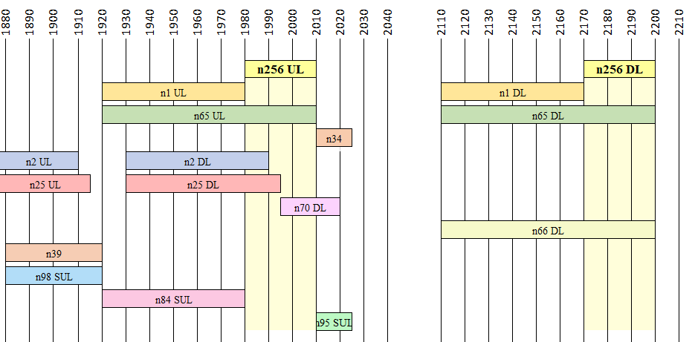
Figure 5.2.1-1: Adjacent TN bands to NTN band n256
As shown in Figure 5.2.1-1, the NTN satellite band is adjacent to NR bands n1 (FDD) and n34 (TDD). The bands need to be protected and co-existence analysis is required to determine the Adjacent Channel Interference Ratio (ACIR) and in-band power levels.
Also, the NTN band n256 will fully be overlapped by TN NR bands n65 and partly overlapped by TN NR bands n2, n25, n70 and n66, limiting band n256 deployment accordingly to countries where n2, n25 and/or n70 are not deployed or regional regulation applies.
Per ECC Decision 06(09) [4], n256 and Complementary Ground Component (CGC) could operate simultaneously in the upper 30 MHz portion of n65 in CEPT countries.

5.2.2 NTN Satellite band: UL 1626.5–1660.5 MHz / DL 1525–1559 MHz
The ITU-R Radio Regulations [3] specify the following service allocation for frequency ranges 1525 – 1559 MHz and 1626.5 – 1660.5 MHz as shown in Table 5.2.2-1.
Table 5.2.2-1: Allocation of 1525 –1559 MHz and 1626.5 – 1660.5 MHz in the ITU-R Radio Regulations
Allocation to services
Region 1 | Region 2 | Region 3
1 525-1 530  SPACE OPERATION  (space-to-Earth)  FIXED  MOBILE-SATELLITE  (space-to-Earth) 5.208B 5.351A  Earth exploration-satellite  Mobile except aeronautical mobile 5.349  5.341 5.342 5.350 5.351  5.352A 5.354 | 1 525-1 530  SPACE OPERATION  (space-to-Earth)  MOBILE-SATELLITE  (space-to-Earth) 5.208B 5.351A  Earth exploration-satellite  Fixed  Mobile 5.343  5.341 5.351 5.354 | 1 525-1 530  SPACE OPERATION  (space-to-Earth)  FIXED  MOBILE-SATELLITE  (space-to-Earth) 5.208B 5.351A Earth exploration-satellite  Mobile 5.349  5.341 5.351 5.352A 5.354
1 530-1 535  SPACE OPERATION  (space-to-Earth)  MOBILE-SATELLITE  (space-to-Earth) 5.208B 5.351A  5.353A  Earth exploration-satellite  Fixed  Mobile except aeronautical mobile  5.341 5.342 5.351 5.354 | 1 530-1 535  SPACE OPERATION (space-to-Earth)  MOBILE-SATELLITE (space-to-Earth) 5.208B 5.351A 5.353A  Earth exploration-satellite  Fixed  Mobile 5.343  5.341 5.351 5.354
1 535-1 559 MOBILE-SATELLITE (space-to-Earth) 5.208B 5.351A
5.341 5.351 5.353A 5.354 5.355 5.356 5.357 5.357A 5.359 5.362A
1 626.5-1 660 MOBILE-SATELLITE (Earth-to-space) 5.351A
5.341 5.351 5.353A 5.354 5.355 5.357A 5.359 5.362A 5.374 5.375 5.376
1 660-1 660.5 MOBILE-SATELLITE (Earth-to-space) 5.351A
RADIO ASTRONOMY
5.149 5.341 5.354 5.362A 5.376A
The details of the notes 5.208B, 5.341, 5.342, 5.350, 5.351, 5.351A, 5.352A, 5.353A, 5.354, 5.355, 5.356, 5.357, 5.357A, 5.359, 5.362A, 5.374, 5.375 and 5.376A related to MOBILE-SATELLITE service can be found in [3].

FCC’s specifies the following service allocation for frequency ranges 1525 – 1559 MHz and 1626.5 – 1660.5 MHz in USA[20] as shown in Table 5.2.2-2.
Table 5.2.2-2: Allocation of 1525 –1559 MHz and 1626.5 – 1660.5 MHz in the US
Allocation to services
Federal Table | Non-Federal Table | FCC Rule Part(2)
1525-1535  MOBILE-SATELLITE (space-to-Earth) US315 US380  5.341 5.351 |  | Satellite Communications (25)  Maritime (80)
1535-1559  MOBILE-SATELLITE (space-to-Earth) US308 US309 US315 US380  5.341 5.351 5.356 |  | Satellite Communications (25)  Maritime (80)  Aviation (87)
1626.5-1660  MOBILE-SATELLITE (Earth-to-space) US308 US309 US315 US380  5.341 5.351 5.375 |  | Satellite Communications (25)  Maritime (80)  Aviation (87)
1660-1660.5  MOBILE-SATELLITE (Earth-to-space) US308 US309 US380  RADIO ASTRONOMY  5.341 5.351 US342 |  | Satellite Communications (25)  Aviation (87)
The details of the notes 5.341, 5.351, 5.356, 5.375, US308, US309, US315 and US342 related to MOBILE-SATELLITE service can be found in [20].

US380 In the bands 1525-1544 MHz, 1545-1559 MHz, 1610-1645.5 MHz, 1646.5-1660.5 MHz, and 2483.5-2500 MHz, a non-Federal licensee in the mobile-satellite service (MSS) may also operate an ancillary terrestrial component in conjunction with its MSS network, subject to the Commission’s rules for ancillary terrestrial components and subject to all applicable conditions and provisions of its MSS authorization.

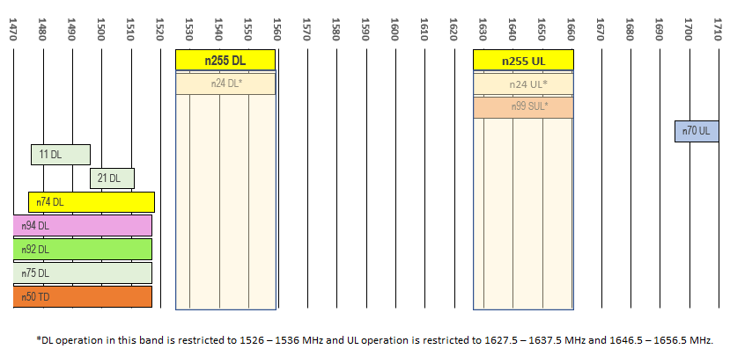
NOTE: DL operation in band n24 is restricted to 1526-1536MHz and UL operation is restricted to 1627.5-1637.5MHz and 1646.5-1656.5MHz
Figure 5.2.2-1: Adjacent TN bands to NTN band n255
As shown in Figure 5.2.2-1, the NTN satellite band is not adjacent to any TN NR or LTE bands. The edge-to-edge separation for nearest TN band, n74 DL, is 7 MHz.
Also, the NTN band n255 fully overlaps with TN NR bands n24 and SUL NR band n99. Per note US380 in Table 5.2.2-2 simultaneous operation of n24/n99 and n255 is allowed in USA. Commission’s authorization and technical rules for TN can be found in FCC Orders 03-15 [21] and 20-48 [22] respectively. Commission’s technical rules for its MSS authorization can be found in FCC 47 C.F.R Part 25.
Technical rules for NTN SAN and UEs operating in 1 to 3 GHz from FCC’s 47 C.F.R. § 25.202 [23] are summarized below:
47 C.F.R. § 25.202:
(d) Frequency tolerance, Earth stations. The carrier frequency of each earth station transmitter authorized in these services shall be maintained within 0.001 percent of the reference frequency.
(e) Frequency tolerance, space stations. The carrier frequency of each space station transmitter authorized in these services shall be maintained within 0.002 percent of the reference frequency.
47 C.F.R. § 25.202 (f):
Emission limitations. Except for SDARS terrestrial repeaters and as provided for in paragraph (i), the mean power of emissions shall be attenuated below the mean output power of the transmitter in accordance with the schedule set forth in paragraphs (f)(1) through (f)(4) of this section. The out-of-band emissions of SDARS terrestrial repeaters shall be attenuated in accordance with the schedule set forth in paragraph (h) of this section.
(1) In any 4 kHz band, the center frequency of which is removed from the assigned frequency by more than 50 percent up to and including 100 percent of the authorized bandwidth: 25 dB;
(2) In any 4 kHz band, the center frequency of which is removed from the assigned frequency by more than 100 percent up to and including 250 percent of the authorized bandwidth: 35 dB;
(3) In any 4 kHz band, the center frequency of which is removed from the assigned frequency by more than 250 percent of the authorized bandwidth: An amount equal to 43 dB plus 10 times the logarithm (to the base 10) of the transmitter power in watts;
(4) In any event, when an emission outside of the authorized bandwidth causes harmful interference, the Commission may, at its discretion, require greater attenuation than specified in paragraphs (f) (1), (2) and (3) of this section.
47 C.F.R. § 25.216:
(a) The e.i.r.p. density of emissions from mobile earth stations placed in service on or before July 21, 2002 with assigned uplink frequencies between 1610 MHz and 1660.5 MHz shall not exceed −70 dBW/MHz, averaged over any 2 millisecond active transmission interval, in the band 1559-1587.42 MHz. The e.i.r.p. of discrete emissions of less than 700 Hz bandwidth generated by such stations shall not exceed −80 dBW, averaged over any 2 millisecond active transmission interval, in that band.
(b) The e.i.r.p. density of emissions from mobile earth stations placed in service on or before July 21, 2002 with assigned uplink frequencies between 1610 MHz and 1626.5 MHz shall not exceed −64 dBW/MHz, averaged over any 2 millisecond active transmission interval, in the band 1587.42-1605 MHz. The e.i.r.p. of discrete emissions of less than 700 Hz bandwidth generated by such stations shall not exceed −74 dBW, averaged over any 2 millisecond active transmission interval, in the 1587.42-1605 MHz band.
(c) The e.i.r.p. density of emissions from mobile earth stations placed in service after July 21, 2002 with assigned uplink frequencies between 1610 MHz and 1660.5 MHz shall not exceed −70 dBW/MHz, averaged over any 2 millisecond active transmission interval, in the band 1559-1605 MHz. The e.i.r.p. of discrete emissions of less than 700 Hz bandwidth from such stations shall not exceed −80 dBW, averaged over any 2 millisecond active transmission interval, in the 1559-1605 MHz band.
(d) As of January 1, 2005, the e.i.r.p. density of emissions from mobile earth stations placed in service on or before July 21, 2002 with assigned uplink frequencies between 1610 MHz and 1660.5 MHz (except Standard A and B Inmarsat terminals used as Global Maritime Distress and Safety System ship earth stations) shall not exceed −70dBW/MHz, averaged over any 2 millisecond active transmission interval, in the 1559-1605 MHz band. The e.i.r.p. of discrete emissions of less than 700 Hz bandwidth from such stations shall not exceed −80 dBW, averaged over any 2 millisecond active transmission interval, in the 1559-1605 MHz band. Standard A Inmarsat terminals used as Global Maritime Distress and Safety System ship earth stations that do not meet the e.i.r.p. density limits specified in this paragraph may continue operation until December 31, 2007. Inmarsat-B terminals manufactured more than six months after Federal Register publication of the rule changes adopted in FCC 03-283 must meet these limits. Inmarsat B terminals manufactured before then are temporarily grandfathered under the condition that no interference is caused by these terminals to aeronautical satellite radio-navigation systems. The full-compliance deadline for grandfathered Inmarsat-B terminals is December 31, 2012.
(e) The e.i.r.p density of emissions from mobile earth stations with assigned uplink frequencies between 1990 MHz and 2025 MHz shall not exceed −70 dBW/MHz, averaged over any 2 millisecond active transmission interval, in frequencies between 1559 MHz and 1610 MHz. The e.i.r.p. of discrete emissions of less than 700 Hz bandwidth from such stations between 1559 MHz and 1605 MHz shall not exceed −80 dBW, averaged over any 2 millisecond active transmission interval. The e.i.r.p. of discrete emissions of less than 700 Hz bandwidth from such stations between 1605 MHz and 1610 MHz manufactured more than six months after Federal Register publication of the rule changes adopted in FCC 03-283 shall not exceed −80 dBW, averaged over any 2 millisecond active transmission interval.
(f) Mobile earth stations placed in service after July 21, 2002 with assigned uplink frequencies in the 1610-1660.5 MHz band shall suppress the power density of emissions in the 1605-1610 MHz band to an extent determined by linear interpolation from −70 dBW/MHz at 1605 MHz to −10 dBW/MHz at 1610 MHz.
(g) Mobile earth stations manufactured more than six months after Federal Register publication of the rule changes adopted in FCC 03-283 with assigned uplink frequencies in the 1610-1626.5 MHz band shall suppress the power density of emissions in the 1605-1610 MHz band-segment to an extent determined by linear interpolation from −70 dBW/MHz at 1605 MHz to −10 dBW/MHz at 1610 MHz averaged over any 2 millisecond active transmission interval. The e.i.r.p of discrete emissions of less than 700 Hz bandwidth from such stations shall not exceed a level determined by linear interpolation from −80 dBW at 1605 MHz to −20 dBW at 1610 MHz, averaged over any 2 millisecond active transmission interval.
(h) Mobile earth stations manufactured more than six months after Federal Register publication of the rule changes adopted in FCC 03-283 with assigned uplink frequencies in the 1626.5-1660.5 MHz band shall suppress the power density of emissions in the 1605-1610 MHz band-segment to an extent determined by linear interpolation from −70 dBW/MHz at 1605 MHz to −46 dBW/MHz at 1610 MHz, averaged over any 2 millisecond active transmission interval. The e.i.r.p of discrete emissions of less than 700 Hz bandwidth from such stations shall not exceed a level determined by linear interpolation from −80 dBW at 1605 MHz to −56 dBW at 1610 MHz, averaged over any 2 millisecond active transmission interval.
(i) The e.i.r.p density of carrier-off state emissions from mobile earth stations manufactured more than six months after Federal Register publication of the rule changes adopted in FCC 03-283 with assigned uplink frequencies between 1 and 3 GHz shall not exceed −80 dBW/MHz in the 1559-1610 MHz band averaged over any two millisecond interval.
(j) A Root-Mean-Square detector shall be used for all power density measurements.
For L-band NTN satellite operation in the US, additional spectrum emission requirements in 47 C.F.R § 25.216 (h) need to be specified for L-band NTN satellite UE. This can be captured as part of additional spurious emission requirements which allows inclusion of frequency ranges that are less than F_{OOB} (MHz) from the edge of the channel bandwidth.

5.2.3 NTN Satellite band: UL 27.5-30.0 GHz / DL 17.3-20.2 GHz

5.2.3.1 ITU-R
The ITU-R Radio Regulations [3] specify the following service allocation for those frequency ranges, shown in Table 5.2.3.1-1:
Table 5.2.3.1-1: Allocation of 17.3-20.2 GHz and 27.5-30.0 GHz in the ITU-R Radio Regulations
Allocation to services
Region 1 | Region 2 | Region 3
17.3-17.7  FIXED-SATELLITE  (Earth-to-space) 5.516  (space-to-Earth) 5.516A 5.516B  Radiolocation  5.514 | 17.3-17.7  FIXED-SATELLITE  (Earth-to-space) 5.516  BROADCASTING-SATELLITE  Radiolocation  5.514 5.515 | 17.3-17.7  FIXED-SATELLITE  (Earth-to-space) 5.516  Radiolocation  5.514
17.7-18.1  FIXED  FIXED-SATELLITE  (space-to-Earth) 5.484A 5.517A  (Earth-to-space) 5.516  MOBILE | 17.7-17.8  FIXED  FIXED-SATELLITE  (space-to-Earth) 5.517 5.517A  (Earth-to-space) 5.516  BROADCASTING-SATELLITE  Mobile  5.515 | 17.7-18.1  FIXED  FIXED-SATELLITE  (space-to-Earth) 5.484A 5.517A  (Earth-to-space) 5.516  MOBILE
17.8-18.1
FIXED
FIXED-SATELLITE
(space-to-Earth) 5.484A 5.517A
(Earth-to-space) 5.516
MOBILE
5.519
18.1-18.4 FIXED
FIXED-SATELLITE (space-to-Earth) 5.484A 5.516B 5.517A
(Earth-to-space) 5.520
MOBILE
5.519 5.521
18.4-18.6 FIXED
FIXED-SATELLITE (space-to-Earth) 5.484A 5.516B 5.517A
MOBILE
18.6-18.8  EARTH EXPLORATION-SATELLITE (passive)  FIXED  FIXED-SATELLITE  (space-to-Earth) 5.517A 5.522B  MOBILE except aeronautical  mobile  Space research (passive)  5.522A 5.522C | 18.6-18.8  EARTH EXPLORATION-  SATELLITE (passive)  FIXED  FIXED-SATELLITE  (space-to-Earth) 5.516B 5.517A 5.522B  MOBILE except aeronautical mobile  SPACE RESEARCH (passive)  5.522A | 18.6-18.8  EARTH EXPLORATION-SATELLITE (passive)  FIXED  FIXED-SATELLITE  (space-to-Earth) 5.517A 5.522B  MOBILE except aeronautical  mobile  Space research (passive)  5.522A
18.8-19.3 FIXED
FIXED-SATELLITE (space-to-Earth) 5.516B 5.517A 5.523A
MOBILE
19.3-19.7 FIXED
FIXED-SATELLITE (space-to-Earth) (Earth-to-space) 5.517A 5.523B
5.523C 5.523D 5.523E
MOBILE
19.7-20.1  FIXED-SATELLITE  (space-to-Earth) 5.484A 5.484B 5.516B 5.527A  Mobile-satellite (space-to-Earth) | 19.7-20.1  FIXED-SATELLITE  (space-to-Earth) 5.484A 5.484B 5.516B 5.527A  MOBILE-SATELLITE  (space-to-Earth) | 19.7-20.1  FIXED-SATELLITE  (space-to-Earth) 5.484A 5.484B 5.516B 5.527A  Mobile-satellite (space-to-Earth)
5.524 | 5.524 5.525 5.526 5.527 5.528 5.529 | 5.524
20.1-20.2 FIXED-SATELLITE (space-to-Earth) 5.484A 5.484B 5.516B 5.527A
MOBILE-SATELLITE (space-to-Earth)
5.524 5.525 5.526 5.527 5.528
27.5-28.5 FIXED 5.537A
FIXED-SATELLITE (Earth-to-space) 5.484A 5.516B 5.517A 5.539
MOBILE
5.538 5.540
28.5-29.1 FIXED
FIXED-SATELLITE (Earth-to-space) 5.484A 5.516B 5.517A 5.523A 5.539
MOBILE
Earth exploration-satellite (Earth-to-space) 5.541
5.540
29.1-29.5 FIXED
FIXED-SATELLITE (Earth-to-space) 5.516B 5.517A 5.523C 5.523E 5.535A 5.539 5.541A
MOBILE
Earth exploration-satellite (Earth-to-space) 5.541
5.540
29.5-29.9  FIXED-SATELLITE  (Earth-to-space) 5.484A 5.484B 5.516B 5.527A 5.539  Earth exploration-satellite  (Earth-to-space) 5.541  Mobile-satellite (Earth-to-space)  5.540 5.542 | 29.5-29.9  FIXED-SATELLITE  (Earth-to-space) 5.484A 5.484B 5.516B 5.527A 5.539  MOBILE-SATELLITE  (Earth-to-space)  Earth exploration-satellite  (Earth-to-space) 5.541  5.525 5.526 5.527 5.529 5.540 | 29.5-29.9  FIXED-SATELLITE  (Earth-to-space) 5.484A 5.484B 5.516B 5.527A 5.539  Earth exploration-satellite  (Earth-to-space) 5.541  Mobile-satellite (Earth-to-space)  5.540 5.542
29.9-30.0 FIXED-SATELLITE (Earth-to-space) 5.484A 5.484B 5.516B 5.527A 5.539
MOBILE-SATELLITE (Earth-to-space)
Earth exploration-satellite (Earth-to-space) 5.541 5.543
5.526 5.527 5.538 5.540 5.542

In addition:
- WRC-15 authorized ESIM operations in 19.7-20.2 GHz (space-to-Earth) and 29.5-30.0 GHz (Earth-to-space) under certain conditions, and for GSO systems only.
- WRC-19 authorized ESIM operations in 17.7-19.7 GHz (space-to-Earth) and 27.5-29.5 GHz (Earth-to-space) under certain conditions, and for GSO systems only (Resolution 173).Editor’s note: This TR would be updated with WRC-23 outcomes (Agenda Item 1.16 on NGSO ESIM Ka band).

5.2.3.2 FCC
In 2016, FCC issued Report and Order FCC 16-89 [33] allocating the 27.50-28.35 GHz frequency range for terrestrial licensed mobile operations (IMT 5G). This frequency range corresponds to the 3GPP band n261.
In 2020, FCC issued Report and Order FCC 20-159 [34] which streamlines part 25 rules that govern the licensing of satellite space and earth stations in a satellite system through a unified license. The unified licensing framework specified frequency bands which includes:
- Space-to-Earth:
- For GSO: 18.3-18.8 GHz and 19.7-20.2 GHz
- For NGSO: 17.8-18.6 GHz, 18.8-19.4 GHz and 19.6-20.2 GHz
- Earth-to-space:
- For GSO: 28.35-29.1 GHz and 29.25-30.0 GHz.
- For NGSO: 28.35-29.1 GHz and 29.5-30.0 GHz.
In 2020 as well, FCC issued the Report and Order FCC-20-66 [35] which facilitates the deployment of, and reduce the regulatory burdens on, Earth Stations in Motion (ESIMs). It allows ESIMs to communicate in additional frequency bands with GSO satellites operating in FSS bands and adopts rules for ESIMs to communicate with NGSO satellites in specific FSS bands. Those FSS bands include:
- Space-to-Earth:
- For GSO: 17.8-19.4 GHz, 19.6-20.2 GHz.
- For NGSO: 17.8-18.6 GHz, 18.8-19.4 GHz, 19.6-20.2 GHz
- Earth-to-space:
- For GSO: 28.35-29.1 GHz and 29.25-30.0 GHz.
- For NGSO: 28.4-29.1 GHz and 29.5-30.0 GHz.

5.2.3.3 CEPT
The ECC Decision (05)01 [36] addresses the use of band 27.5-29.5GHz, regulated for Fixed Service and Fixed Satellite Service:
- The bands 27.5-27.8285 GHz, 28.4445-28.8365 GHz and 29.4525-29.5 GHz are designated for the use of uncoordinated FSS earth stations.
- The band 28.8365-28.9485 GHz is designated for the use of uncoordinated FSS earth stations, considering, until 1 January 2020, the legacy FS systems licensed in this band in some countries before 18 March 2005.
- The bands 27.8285-28.4445 GHz and 28.9485-29.4525 GHz are designated for the use of FS systems.
Also, this ECC Decision(05)01 states that the CEPT administrations shall not authorize the deployment of uncoordinated FSS earth stations in the bands designed for the use of FS systems.

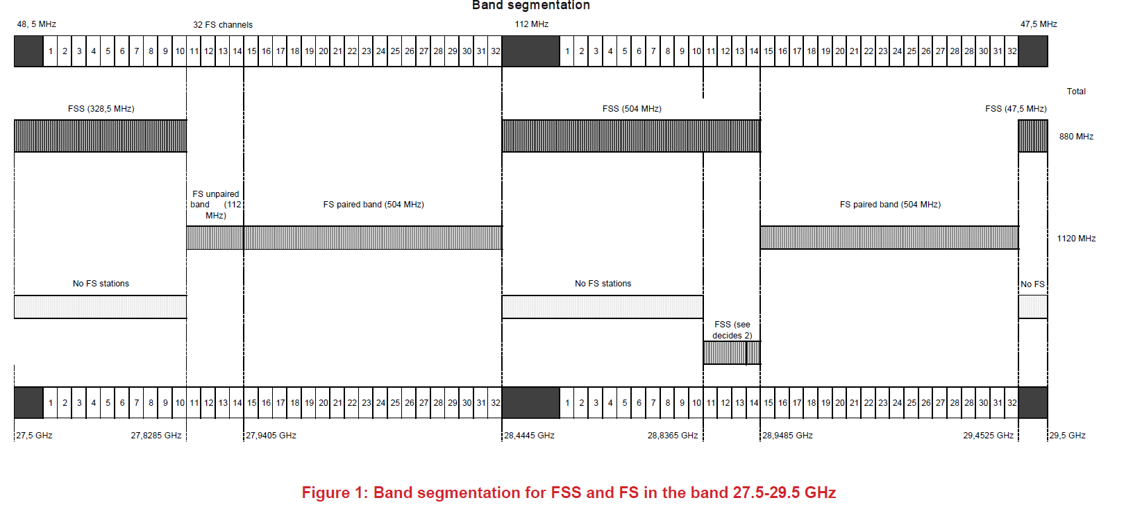
Figure 5.2.3.3-1: ECC Decision(05)01 - 27.5-29.5 band segmentation

The ECC Decision(13)01 [37] specifies the harmonized use, free circulation, and exemption from individual licensing of Earth stations on mobile platforms (ESOMPs) within the ranges 17.3-20.2 GHz and 27.5-30.0 GHz, in the portion identified for their use within the territory of operation, and under the conditions specified in Annexes 1,2 and 3 of this ECC Decision. ESOMPs are terminals with small directional antennas for the provision of broadband communication services. The terminals may be mounted on aircraft, ships or land vehicles or may be transportable devices used in motion or at temporary halts. This ECC Decision also specifies the conditions for those ESOMP devices to operate.

5.2.4 NTN Satellite band: UL 2000–2020 MHz / DL 2180–2200 MHz
Table 5.2.4-1 shows the service allocation for the frequency range in the ITU-R Radio Regulations [3] and Table 5.2.4-2 shows the FCC frequency allocation table for the frequency range [20]. From Table 5.2.4-1 and Table 5.2.4-2, there is some deviation in how MSS S-band is allocated in region 2 versus in all other regions. Per ITU, the Region 2 MSS S-Band had been allocated to UL 1980-2025 MHZ and DL 2160-2200 MHz. In the case of North America region (US, Canada, Mexico) the MSS band is allocated to UL 2000 MHz -2020 MHz and DL 2180 MHz -2200 MHz which is not exactly aligned to n256 definition, i.e., UL 1980 MHz – 2010 MHz, DL 2170 MHz – 2200 MHz. The 3GPP NTN S-band n252 (UL 2000 MHz -2020 MHz and DL 2180 MHz -2200) is defined for consistency across North America and Region 2 as a whole.

Table 5.2.4-1: Allocation of 2000-2020 MHz and 2180–2200 MHz in the ITU-R Radio Regulations
Allocation to services
Region 1 | Region 2 | Region 3
1 980-2 010 | FIXED  MOBILE  MOBILE-SATELLITE (Earth-to-space) 5.351A  5.388 5.389A 5.389B 5.389
2 010-2 025  FIXED  MOBILE 5.388A 5.388B  5.388 | 2 010-2 025  FIXED  MOBILE-SATELLITE  (Earth-to-space)  5.388 5.389C 5.389E | 2 010-2 025  FIXED  MOBILE 5.388A 5.388B  5.388
2 170-2 200 | FIXED  MOBILE  MOBILE-SATELLITE (space-to-Earth) 5.351A  5.388 5.389A 5.389F
5.388: The frequency bands 1 885-2 025 MHz and 2 110-2 200 MHz are intended for use, on a worldwide basis, by administrations wishing to implement International Mobile Telecommunications (IMT). Such use does not preclude the use of these frequency bands by other services to which they are allocated. The frequency bands should be made available for IMT in accordance with Resolution 212 (Rev.WRC-15)* (see also Resolution 223 (Rev.WRC-15)*).
5.389A: The use of the bands 1 980-2 010 MHz and 2 170-2 200 MHz by the mobile-satellite service is subject to coordination under No. 9.11A and to the provisions of Resolution 716 (Rev.WRC-2000)**
5.389B: The use of the frequency band 1 980-1 990 MHz by the mobile-satellite service shall not cause harmful interference to or constrain the development of the fixed and mobile services in Argentina, Brazil, Canada, Chile, Ecuador, the United States, Honduras, Jamaica, Mexico, Paraguay, Peru, Suriname, Trinidad and Tobago, Uruguay and Venezuela.
5.389F: In Algeria, Cape Verde, Egypt, Iran (Islamic Republic of), Mali, Syrian Arab Republic and Tunisia, the use of the frequency bands 1 980-2 010 MHz and 2 170-2 200 MHz by the mobile-satellite service shall neither cause harmful interference to the fixed and mobile services, nor hamper the development of those services prior to 1 January 2005, nor shall the former service request protection from the latter services.

Table 5.2.4-2: FCC frequency allocation for 2000-2020 MHz and 2180–2200 MHz
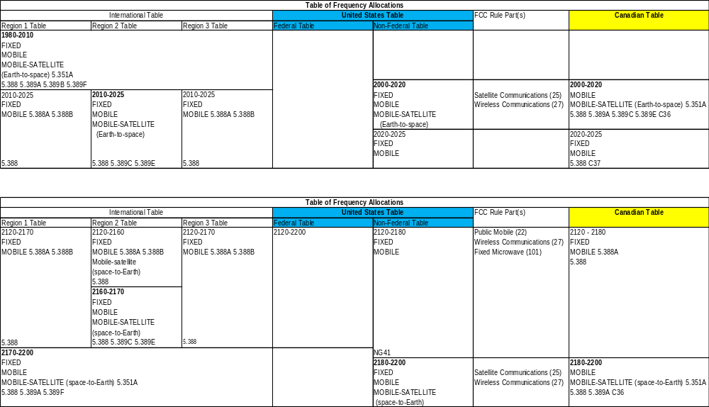

The following are the applicable FCC regulatory requirements:
47 CFR § 25.202
According to paragraph (a)(4)(ii), the following frequencies are available for use by the 2 GHz Mobile-Satellite Service:
1. 2000-2020 MHz: User-to-Satellite Link;
2. 2180-2200 MHz: Satellite-to-User Link.
According to paragraph (f) on emission limitations, except for SDARS terrestrial repeaters and as provided for in paragraph (i), the mean power of emissions shall be attenuated below the mean output power of the transmitter in accordance with the schedule set forth in paragraphs (f)(1) through (f)(4) of this section:
(1) In any 4 kHz band, the center frequency of which is removed from the assigned frequency by more than 50 percent up to and including 100 percent of the authorized bandwidth: 25 dB;
(2) In any 4 kHz band, the center frequency of which is removed from the assigned frequency by more than 100 percent up to and including 250 percent of the authorized bandwidth: 35 dB;
(3) In any 4 kHz band, the center frequency of which is removed from the assigned frequency by more than 250 percent of the authorized bandwidth: An amount equal to 43 dB plus 10 times the logarithm (to the base 10) of the transmitter power in watts;
(4) In any event, when an emission outside of the authorized bandwidth causes harmful interference, the Commission may, at its discretion, require greater attenuation than specified in paragraphs (f) (1), (2) and (3) of this section.
47 CFR § 25.216
According to paragraph (e) on limits on emissions from mobile earth stations for protection of aeronautical radionavigation-satellite service, the e.i.r.p density of emissions from mobile earth stations with assigned uplink frequencies between 1990 MHz and 2025 MHz shall not exceed −70 dBW/MHz, averaged over any 2 millisecond active transmission interval, in frequencies between 1559 MHz and 1610 MHz. The e.i.r.p. of discrete emissions of less than 700 Hz bandwidth from such stations between 1559 MHz and 1605 MHz shall not exceed −80 dBW, averaged over any 2 millisecond active transmission interval. The e.i.r.p. of discrete emissions of less than 700 Hz bandwidth from such stations between 1605 MHz and 1610 MHz manufactured more than six months after Federal Register publication of the rule changes adopted in FCC 03-283 shall not exceed −80 dBW, averaged over any 2 millisecond active transmission interval.
It should be noted that for the TN Band 23, which is studied and documented in [xx], the FCC regulation part 25.252 on ATC (Ancillary Terrestrial Component) for satellite service was referred to derive the RF requirements. However, since n252 is defined as an NTN band, ATC related requirements are not applicable for this band.
The following figure 5.2.4-1 shows an overview of the NR TN bands adjacent to the NTN n252 band.
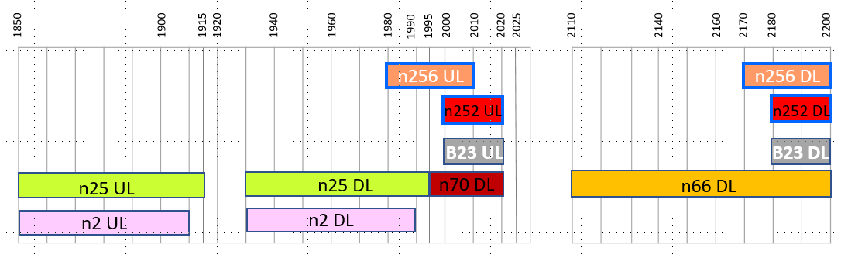Figure 5.2.4-1: Adjacent TN bands to NTN band n252 in North America
As shown in figure 5.2.4-1, the n252 is adjacent to NR bands n25 DL and n2 DL, is overlap with n70 DL and n66 DL. Section 7.4.2.2.10.2 describes the RAN4 agreement on UE-to-UE coexistence requirement to protect the n25 DL, n2 DL, and n66 DL. The same section also describes the agreement for n70 DL.

5.2.5 NTN Satellite band: UL 1668-1675 MHz / DL 1518-1525 MHz)
The purpose of this section is to collect information from existing regulatory documents concerning regulatory rules applicable to this NTN Extended L-band.
NOTE1: As per agreement in RAN4#108, the following assumption is captured:
For the time being, re-use TN-NTN coexistence assumptions from TR 38.863, which would yield a total separation distance of 5250 m from TN BS site and NTN UE, at least for low-gain land-based NTN UE, compatible with smartphone and IoT use cases.
NOTE2: At RAN#108-bis Xiamen, an LS Reply was received from ETSI SES SCN (R4-2317932), with the following content:
“ETSI TC SES would like to thank 3GPP RAN4 for its LS on the 3GPP NTN requirements and the potential impact on the specification work in ETSI TC SES.
ETSI TC SES want to clarify that the requirements in the ETSI harmonised standards for earth stations are defined based on and referenced in CEPT regulatory framework or in accordance with ITU recommendations. Current TC-SES ETSI harmonised standards have not yet considered 3GPP NTN access technology and updates may be needed.
Therefore, it is proposed to create a new work item (NWI) in ETSI in order to accommodate NTN requirements in harmonised standards. There are already ongoing discussions between ETSI TC SES and ETSI TC MSG groups to find a way forward to capture the 3GPP NTN specifications in ETSI standards.
ETSI TC SES would remain at the disposal of 3GPP RAN4 for any additional information.”
NOTE3: ETSI requirements from EN 301 681 and ECC requirements from ECC Report 263 are captured for information, but have not presently been included in the specification.
As per the agreements in RAN4#109, the introduction of additional blocking requirements from ETSI EN 301 681 and recommendations from ECC Report 263 has been put on hold. Any ETSI- or ECC-specific requirements will be addressed after further feedback from ETSI is received.

5.2.5.1 ITU-R
The ITU-R Radio Regulations [3] specify the following service allocation for the frequency ranges 1518 – 1525 MHz and 1668 – 1675 MHz, shown in Table 5.2.5.1-1:
Table 5.2.5.1-1: Allocation of 1518-1525 MHz and 1668-1675 MHz in the ITU-R Radio Regulations
Allocation to services
Region 1 | Region 2 |  | Region 3
1 518-1 525  FIXED  MOBILE except aeronautical  mobile  MOBILE-SATELLITE  (space-to-Earth) 5.348 5.348A  5.348B 5.351A |  | 1 518-1 525  FIXED  MOBILE 5.343  MOBILE-SATELLITE  (space-to-Earth) 5.348 5.348A  5.348B 5.351A |  | 1 518-1 525  FIXED  MOBILE  MOBILE-SATELLITE  (space-to-Earth) 5.348 5.348A  5.348B 5.351A
5.341 5.342 |  | 5.341 5.344 |  | 5.341
1 668-1 668.4 MOBILE-SATELLITE (Earth-to-space) 5.351A 5.379B 5.379C
RADIO ASTRONOMY
SPACE RESEARCH (passive)
Fixed
Mobile except aeronautical mobile
5.149 5.341 5.379 5.379A
1 668.4-1 670 METEOROLOGICAL AIDS
FIXED
MOBILE except aeronautical mobile
MOBILE-SATELLITE (Earth-to-space) 5.351A 5.379B 5.379C
RADIO ASTRONOMY
5.149 5.341 5.379D 5.379E
1 670-1 675 METEOROLOGICAL AIDS
FIXED
METEOROLOGICAL-SATELLITE (space-to-Earth)
MOBILE
MOBILE-SATELLITE (Earth-to-space) 5.351A 5.379B
5.341 5.379D 5.379E 5.380A
5.149 In making assignments to stations of other services to which the bands:
13 360-13 410 kHz,  25 550-25 670 kHz,  37.5-38.25 MHz,  73-74.6 MHz in Regions 1 and 3,  150.05-153 MHz in Region 1,  322-328.6 MHz,  406.1-410 MHz,  608-614 MHz in Regions 1 and 3,  1 330-1 400 MHz,  1 610.6-1 613.8 MHz,  1 660-1 670 MHz,  1 718.8-1 722.2 MHz,  2 655-2 690 MHz,  3 260-3 267 MHz,  3 332-3 339 MHz,  3 345.8-3 352.5 MHz,  4 825-4 835 MHz, | 4 950-4 990 MHz,  4 990-5 000 MHz,  6 650-6 675.2 MHz,  10.6-10.68 GHz,  14.47-14.5 GHz,  22.01-22.21 GHz,  22.21-22.5 GHz,  22.81-22.86 GHz,  23.07-23.12 GHz,  31.2-31.3 GHz,  31.5-31.8 GHz in Regions 1 and 3,  36.43-36.5 GHz,  42.5-43.5 GHz,  48.94-49.04 GHz,  76-86 GHz,  92-94 GHz,  94.1-100 GHz, | 102-109.5 GHz,  111.8-114.25 GHz,  128.33-128.59 GHz,  129.23-129.49 GHz,  130-134 GHz,  136-148.5 GHz,  151.5-158.5 GHz,  168.59-168.93 GHz,  171.11-171.45 GHz,  172.31-172.65 GHz,  173.52-173.85 GHz,  195.75-196.15 GHz,  209-226 GHz,  241-250 GHz,  252-275 GHz
are allocated, administrations are urged to take all practicable steps to protect the radio astronomy service from harmful interference. Emissions from spaceborne or airborne stations can be particularly serious sources of interference to the radio astronomy service (see Nos. 4.5 and 4.6 and Article 29). (WRC-07)

5.341 In the bands 1 400-1 727 MHz, 101-120 GHz and 197-220 GHz, passive research is being conducted by some countries in a programme for the search for intentional emissions of extraterrestrial origin.
5.342 Additional allocation: in Armenia, Azerbaijan, Belarus, the Russian Federation, Uzbekistan, Kyrgyzstan and Ukraine, the frequency band 1 429-1 535 MHz is also allocated to the aeronautical mobile service on a primary basis, exclusively for the purposes of aeronautical telemetry within the national territory. As of 1 April 2007, the use of the frequency band 1 452-1 492 MHz is subject to agreement between the administrations concerned. (WRC-15)

5.348 The use of the band 1 518-1 525 MHz by the mobile-satellite service is subject to coordination under No. 9.11A. In the band 1 518-1 525 MHz stations in the mobile-satellite service shall not claim protection from the stations in the fixed service. No. 5.43A does not apply. (WRC-03)
5.348A In the band 1 518-1 525 MHz, the coordination threshold in terms of the power flux-density levels at the surface of the Earth in application of No. 9.11A for space stations in the mobile-satellite (space-to-Earth) service, with respect to the land mobile service use for specialized mobile radios or used in conjunction with public switched telecommunication networks (PSTN) operating within the territory of Japan, shall be –150 dB(W/m²) in any 4 kHz band for all angles of arrival, instead of those given in Table 5-2 of Appendix 5. In the band 1 518-1 525 MHz stations in the mobile-satellite service shall not claim protection from stations in the mobile service in the territory of Japan. No. 5.43A does not apply. (WRC-03)
5.348B In the band 1 518-1 525 MHz, stations in the mobile-satellite service shall not claim protection from aeronautical mobile telemetry stations in the mobile service in the territory of the United States (see Nos. 5.343 and 5.344) and in the countries listed in No. 5.342. No. 5.43A does not apply. (WRC-03)

5.351A For the use of the frequency bands 1 518-1 544 MHz, 1 545-1 559 MHz, 1 610-1 645.5 MHz, 1 646.5-1 660.5 MHz, 1 668-1 675 MHz, 1 980-2 010 MHz, 2 170-2 200 MHz, 2 483.5-2 520 MHz and 2 670-2 690 MHz by the mobile-satellite service, see Resolutions 212 (Rev.WRC-23) and 225 (Rev.WRC-23). (WRC-23)

5.379 Additional allocation: in Bangladesh, India, Indonesia, Nigeria and Pakistan, the band 1 660.5-1 668.4 MHz is also allocated to the meteorological aids service on a secondary basis.
5.379A Administrations are urged to give all practicable protection in the band 1 660.5-1 668.4 MHz for future research in radio astronomy, particularly by eliminating air-to-ground transmissions in the meteorological aids service in the band 1 664.4-1 668.4 MHz as soon as practicable.
5.379B The use of the frequency band 1 668-1 675 MHz by the mobile-satellite service is subject to coordination under No. 9.11A. (WRC-23)
5.379C In order to protect the radio astronomy service in the band 1 668-1 670 MHz, the aggregate power flux-density values produced by mobile earth stations in a network of the mobile-satellite service operating in this band shall not exceed –181 dB(W/m²) in 10 MHz and −194 dB(W/m²) in any 20 kHz at any radio astronomy station recorded in the Master International Frequency Register, for more than 2% of integration periods of 2 000 s. (WRC-03)
5.379D For sharing of the frequency band 1 668.4-1 675 MHz between the mobile-satellite service and the fixed and mobile services, Resolution 744 (Rev.WRC-23) shall apply. (WRC-23)
5.379E In the band 1 668.4-1 675 MHz, stations in the mobile-satellite service shall not cause harmful interference to stations in the meteorological aids service in China, Iran (Islamic Republic of), Japan and Uzbekistan. In the band 1 668.4-1 675 MHz, administrations are urged not to implement new systems in the meteorological aids service and are encouraged to migrate existing meteorological aids service operations to other bands as soon as practicable. (WRC-03)
5.380A In the band 1 670-1 675 MHz, stations in the mobile-satellite service shall not cause harmful interference to, nor constrain the development of, existing earth stations in the meteorological-satellite service notified before 1 January 2004. Any new assignment to these earth stations in this band shall also be protected from harmful interference from stations in the mobile-satellite service. (WRC-07)

5.2.5.2 FCC
The FCC Rules [23] specify the following service allocations and technical rules for the frequency ranges 1518 – 1525 MHz and 1668 – 1675 MHz.
Table of Frequency Allocations 1626.5-2110 MHz (UHF) |  |  |  |  | Page 35
International Table |  |  | United States Table |  | FCC Rule Part(s)
Region 1 Table | Region 2 Table | Region 3 Table | Federal Table | Non-Federal Table | FCC Rule Part(s)
1668-1668.4  MOBILE-SATELLITE (Earth-to-space) 5.351A 5.379B 5.379C  RADIO ASTRONOMY  SPACE RESEARCH (passive)  Fixed  Mobile except aeronautical mobile  5.149 5.341 5.379 5.379A |  |  | 1660.5-1668.4  RADIO ASTRONOMY US74  SPACE RESEARCH (passive)
1668.4-1670  METEOROLOGICAL AIDS  FIXED  MOBILE except aeronautical mobile  MOBILE-SATELLITE (Earth-to-space) 5.351A 5.379B 5.379C  RADIO ASTRONOMY  5.149 5.341 5.379D 5.379E |  |  | 5.341 US246
1670-1675  METEOROLOGICAL AIDS  FIXED  METEOROLOGICAL-SATELLITE (space-to-Earth)  MOBILE  MOBILE-SATELLITE (Earth-to-space) 5.351A 5.379B  5.341 5.379D 5.379E 5.380A |  |  | 1668.4-1670  METEOROLOGICAL AIDS (radiosonde)  RADIO ASTRONOMY US74  5.341 US99 US342

47 CFR 2.106(b)(341)
5.341 In the bands 1400-1727 MHz, 101-120 GHz and 197-220 GHz, passive research is being conducted by some countries in a programme for the search for intentional emissions of extraterrestrial origin.
47 CFR 2.106(b) (348)
5.348 The use of the band 1518-1525 MHz by the mobile-satellite service is subject to coordination under No. 9.11A. In the band 1518-1525 MHz stations in the mobile-satellite service shall not claim protection from the stations in the fixed service. No. 5.43A does not apply.
(i) 5.348A In the band 1518-1525 MHz, the coordination threshold in terms of the power flux-density levels at the surface of the Earth in application of No. 9.11A for space stations in the mobile-satellite (space-to-Earth) service, with respect to the land mobile service use for specialized mobile radios or used in conjunction with public switched telecommunication networks (PSTN) operating within the territory of Japan, shall be −150 dB(W/m2) in any 4 kHz band for all angles of arrival, instead of those given in Table 5-2 of Appendix 5. In the band 1518-1525 MHz stations in the mobile-satellite service shall not claim protection from stations in the mobile service in the territory of Japan. No. 5.43A does not apply.
(ii) 5.348B In the band 1518-1525 MHz, stations in the mobile-satellite service shall not claim protection from aeronautical mobile telemetry stations in the mobile service in the territory of the United States (see paragraphs (b)(343) and (344) of this section) and in the countries listed in paragraph (b)(342) of this section. No. 5.43A does not apply.
47 CFR 2.106(b)(351)
(i) 5.351A For the use of the bands 1518-1544 MHz, 1545-1559 MHz, 1610-1645.5 MHz, 1646.5-1660.5 MHz, 1668-1675 MHz, 1980-2010 MHz, 2170-2200 MHz, 2483.5-2520 MHz and 2670-2690 MHz by the mobile-satellite service, see Resolutions 212 (Rev.WRC-19) and 225 (Rev.WRC-12).
47 CFR 2.106(b)(379)
5.379 Additional allocation: in Bangladesh, India, Indonesia, Nigeria and Pakistan, the band 1660.5-1668.4 MHz is also allocated to the meteorological aids service on a secondary basis.
(i) 5.379A Administrations are urged to give all practicable protection in the band 1660.5-1668.4 MHz for future research in radio astronomy, particularly by eliminating air-to-ground transmissions in the meteorological aids service in the band 1664.4-1668.4 MHz as soon as practicable.
(ii) 5.379B The use of the band 1668-1675 MHz by the mobile-satellite service is subject to coordination under No. 9.11A. In the band 1668-1668.4 MHz, Resolution 904 (WRC-07) shall apply.
(iii) 5.379C In order to protect the radio astronomy service in the band 1668-1670 MHz, the aggregate power flux-density values produced by mobile earth stations in a network of the mobile-satellite service operating in this band shall not exceed −181 dB(W/m2) in 10 MHz and −194 dB(W/m2) in any 20 kHz at any radio astronomy station recorded in the Master International Frequency Register, for more than 2% of integration periods of 2000 s.
(iv) 5.379D For sharing of the band 1668.4-1675 MHz between the mobile-satellite service and the fixed and mobile services, Resolution 744 (Rev.WRC-07) shall apply.
(v) 5.379E In the band 1668.4-1675 MHz, stations in the mobile-satellite service shall not cause harmful interference to stations in the meteorological aids service in China, Iran (Islamic Republic of), Japan and Uzbekistan. In the band 1668.4-1675 MHz, administrations are urged not to implement new systems in the meteorological aids service and are encouraged to migrate existing meteorological aids service operations to other bands as soon as practicable.
47 CFR 2.106(b)(380)
5.380A In the band 1670-1675 MHz, stations in the mobile-satellite service shall not cause harmful interference to, nor constrain the development of, existing earth stations in the meteorological-satellite service notified before 1 January 2004. Any new assignment to these earth stations in this band shall also be protected from harmful interference from stations in the mobile-satellite service.
US211: In the bands 1670-1690, 5000-5250 MHz and 10.7-11.7, 15.1365-15.35, 15.4-15.7, 22.5-22.55, 24-24.05, 31.0-31.3, 31.8-32.0, 40.5-42.5, 116-122.25, 123-130, 158.5-164, 167-168, 191.8-200, and 252-265 GHz, applicants for airborne or space station assignments are urged to take all practicable steps to protect radio astronomy observations in the adjacent bands from harmful interference; however, US74 applies.
US362: The band 1670-1675 MHz is allocated to the meteorological-satellite service (space-to-Earth) on a primary basis for Federal use. Earth station use of this allocation is limited to Wallops Island, VA (37° 56' 44'' N, 75° 27' 37'' W), Fairbanks, AK (64° 58' 22'' N, 147° 30' 04'' W), and Greenbelt, MD (39° 00' 02'' N, 76° 50' 29'' W). Applicants for non-Federal stations within 100 kilometers of the Wallops Island or Fairbanks coordinates and within 65 kilometers of the Greenbelt coordinates shall notify NOAA in accordance with the procedures specified in 47 CFR 1.924.

5.2.5.3 CEPT/ECC

5.2.5.3.1 CEPT
This section is reserved.

5.2.5.3.2 ECC Report 263
NOTE: The coexistence assumptions used in ECC Report 263 are different compared to the assumptions used by 3GPP in the TN-NTN coexistence analysis captured in TR 38.863.
The following section contains some excerpts from ECC Report 263.
The report has established the technical characteristics of the IMT and the MSS system and determined the relevant scenarios. It has also determined the appropriate propagation models for these scenarios according to the environment where the equipment is used and further the protection criteria has been established.
The report has, from these characteristics and parameters, developed an MCL analysis with the resulting required separation distances for the 3 different frequency separations (1 MHz, 3 MHz and 6 MHz frequency separations).
The frequency separation allocation is not addressed by this report.
Further the report makes use of the MCL to establish interference arising in the first MES channel above the 3 different frequency separations investigated for an area with IMT coverage.
The results of the simulations show that there will be some interference irrespective of the selected frequency separation.
MES terminals currently on the market which have characteristics similar to those selected for this study, may experience interference problems because of the susceptibility of the MES receiver to the wanted signals from the IMT systems. As there are currently no available technical characteristics which outline at what frequency this effect starts to occur, blocking may also be experienced from IMT transmitters more than 6 MHz away into the IMT band below 1518 MHz.
Based on the findings of this report, the following mitigation techniques could further improve the compatibility between IMT and MSS around 1518 MHz:
- The interference due to IMT OOB emissions can be reduced by improved filtering on the IMT base station.
- The interference due to blocking can be reduced by improving the MES resilience to LTE blocking signals in the adjacent band.
- Either adding location based frequency allocation to MSS to avoid the use the lower couple of MHz and/or, implementing interference avoidance which would in addition allow for a better frequency utilisation of the lower part of the 1518-1559 MHz frequency band for MSS. The feasibility and impact of these techniques have not been assessed.
The following values have been used to examine the impact of enhanced MES receiver performance.
Table 7.1.2.2-1: Assumed blocking level for enhanced MES receivers
Frequency separation  between channel edges | Interference level  (at output of receiving antenna)
1 MHz | –55 to –45 dBm
3 MHz | –35 to –30 dBm
6 MHz | –30 to –25 dBm

Based on the final results of its compatibility studies, it is concluded that:
- the minimum in-band blocking characteristic for land mobile earth stations receivers from a 5 MHz broadband signal interferer (LTE) operating below 1518 MHz shall be −30dBm above 1520 MHz (Note: when the MES operates above 1520 MHz),
- the base station unwanted emission limits EIRP for a broadband signal interferer (LTE) operating below 1518 MHz shall be −30dBm/MHz above 1520 MHz. This figure is 10 dB more stringent than ECC Decision (13)03 due to a different service in the adjacent band.
It is noted that the IMT block ends at 1517 MHz.

5.2.5.4 ETSI

5.2.5.4.1 ETSI EN 301 681

5.2.5.4.1.1 In-band and Out-of-band Emission Requirements
The following section includes excerpts from ETSI EN 301 681.
ETSI EN 301 681 is applicable to Mobile Earth Stations (SES) with both transmit and receive capabilities for operation in Satellite Personal Communications Networks (S-PCN) in any combination of all or any part of the Mobile Satellite Service (MSS) frequency bands sub-band 1 and sub-band 2 defined in table 5.2.5.4.1.1-1.
Table 5.2.5.4.1.1-1: Mobile Satellite Service (MSS) frequency band
Sub-band | Transmission path | MSS frequency band
1 | MESs transmit 1 | 1 626,5 MHz to 1 660,5 MHz
 | MESs receive 1 | 1 525 MHz to 1 559 MHz
2 | MESs transmit 2 | 1 668,0 MHz to 1 675,0 MHz
 | MESs receive 2 | 1 518,0 MHz to 1 525,0 MHz

Unwanted emissions from Mobile Earth Stations (LMESs) outside the band 1 626,5 MHz to 1 660,5 MHz and outside the band 1 668 MHz to 1 675 MHz shall be below the following limits.
Unless otherwise stated the specification in this clause shall apply to all types of MESs notwithstanding their transmitting capabilities within the frequency bands as defined in table 5.2.5.4.1.1-1:
- For MES that are capable of transmitting within only the sub-band 1 frequency band as defined in table 5.2.5.4.1.1-1, the maximum EIRP spectral density of the unwanted emissions from the MES outside the band 1 626,5 MHz to 1 660,5 MHz shall not exceed the limits in either table 5.2.5.4.1.1-2 or table 5.2.5.4.1.1-3. The applicant shall declare which alternative shall be used.
- For MES that are capable of transmitting within only sub-band 2 frequency band or within both the sub-band 1 and sub-band 2 frequency bands, the maximum EIRP spectral density of the unwanted emissions from the MES outside the bands 1 626,5 MHz to 1 660,5 MHz and 1 668,0 MHz to 1 675,0 MHz shall not exceed the limits in table 5.2.5.4.1.1-3.
Table 5.2.5.4.1.1-2: Unwanted emissions outside the band 1 626,5 MHz to 1 660,5 MHz for MES only capable of transmitting within sub-band 1 frequency band as defined in table 5.2.5.4.1.1-1
Frequency (MHz) | Carrier - on state
 | EIRP  (dBW) | Measurement  bandwidth | Measurement method  (see note 6)
30 to 1 000 | -66 | 100 kHz | Peak Hold
1 000 to 1 559 | -61 | 1 MHz | Average
1 559 to 1 605,0 | -70 | 1 MHz  (see note 3) | Average (see note 2)
1 605,0 to 1 612,5 | -70 to -58,5  (see note 4) | 1 MHz  (see note 3) | Average
1 612,5 to 1 616,5 | -55 to -50  (see note 4) | 1 MHz | Average
1 616,5 to 1 621,5 | -50 to -46  (see note 4) | 1 MHz | Average
1 621,5 to 1 624,5 | -60 | 30 kHz | Average
1 624,5 to 1 625,0 | -60 to -57,5  (see notes 4, 5, 7) | 30 kHz | Average
1 625,0 to 1 625,125 | -57,5 to -57,2  (see notes 4, 5, 7) | 30 kHz | Average
1 625,125 to 1 625,8 | -57,2 to -50  (see notes 4, 5, 7) | 30 kHz | Average
1 625,8 to 1 626,0 | -50 to -47  (see notes 4, 5, 7) | 30 kHz | Average
1 626,0 to 1 626,2 | -47 to -40  (see notes 4, 5, 7) | 30 kHz | Average
1 626,2 to 1 626,5 | -40  (see notes 5, 7) | 30 kHz | Average
1 626,5 to 1 660,5 | NOT APPLICABLE | NOT APPLICABLE | NOT APPLICABLE
1 660,5 to 1 662,5 | The levels in table 4a shall apply from 1 660,5 MHz to 1 662,5 MHz
1 662,5 to 1 665,5 | -60 | 30 kHz | Average
1 665,5 to 1 670,5 | -60 | 100 kHz | Average
1 670,5 to 1 680,5 | -60 | 300 kHz | Average
1 680,5 to 1 690,5 | -60 | 1 MHz | Average
1 690,5 to 2 250 | -60 | 3 MHz | Average
2 250 to 12 750  (see note 1) | -60 | 3 MHz | Peak Hold
NOTE 1: In the band 3 253,0 MHz to 3 321,0 MHz the maximum EIRP in one, and only one, 3 MHz measurement bandwidth shall not exceed -38 dBW. Elsewhere in this band the power limit in table 3 shall be applied.
In each of the bands 4 879,5 MHz to 4 981,5 MHz, 6 506,0 MHz to 6 642,0 MHz and 8 132,5 MHz to 8 302,5 MHz the maximum EIRP in one, and only one, 3 MHz measurement bandwidth shall not exceed -48 dBW. Elsewhere in this band the power limit in table 3 shall be applied.
NOTE 2: The average measurement method defined in clause 5.2.2.3 shall apply except that an averaging period of 20 ms shall be used in the sub-band 1 573,42 MHz to 1 580,42 MHz.
NOTE 3: Measurement bandwidths less than 1 MHz are allowable provided the power in the narrower bandwidth is integrated over 1 MHz.
NOTE 4: Linearly interpolated in dBW vs. Frequency.
NOTE 5: The power limits specified in the band 1 624,5 MHz to 1 626,5 MHz require further study. This study is important to determine whether less stringent limits may enhance spectrum efficiency and utilization immediately above 1 626,5 MHz.
NOTE 6: Peak Hold and Average measurements shall be performed as specified in clauses 5.2.2.2 and 5.2.2.3.
NOTE 7: For systems employing CDMA, the EIRP limits shall be decreased by 10 log (N) dB, where N is the maximum number of MESs in the receive beam of the satellite to which these MESs are communicating and which are expected to transmit simultaneously in the same frequency band within
that same beam. This number shall be declared by the manufacturer (N = 1 in a TDMA system).

Table 5.2.5.4.1.1-3: Unwanted emissions outside the bands 1 626,5 MHz to 1 660,5 MHz and 1 668,0 MHz to 1 675,0 MHz for MES capable of transmitting within all or any part of sub-band 1 and sub-band 2 frequency bands as defined in table 5.2.5.4.1.1-1
Frequency (MHz) | Carrier - on state
 | EIRP (dBW) | Measurement bandwidth | Measurement method (see note 8)
30 to 1 000 | -66 | 100 kHz | Peak Hold
1 000 to 1 559 | -61 | 1 MHz | Average
1 559 to 1 605,0 | -70 | 1 MHz  (see note 5) | Average (see note 2)
1 605,0 to 1 612,5 | -70 to -58,5  (see note 6) | 1 MHz  (see note 5) | Average
1 612,5 to 1 616,5 | -55 to -50  (see note 6) | 1 MHz | Average
1 616,5 to 1 621,5 | -50 to -46  (see note 6) | 1 MHz | Average
1 621,5 to 1 624,5 | -60 | 30 kHz | Average
1 624,5 to 1 625,0 | -60 to -57,5  (see notes 6, 7, 9) | 30 kHz | Average
1 625,0 to 1 625,125 | -57,5 to -57,2  (see notes 6, 7, 9) | 30 kHz | Average
1 625,125 to 1 625,8 | -57,2 to -50  (see notes 6, 7, 9) | 30 kHz | Average
1 625,8 to 1 626,0 | -50 to -47  (see notes 6, 7, 9) | 30 kHz | Average
1 626,0 to 1 626,2 | -47 to -40  (see notes 6, 7, 9) | 30 kHz | Average
1 626,2 to 1 626,5 | -40  (see notes 7, 9) | 30 kHz | Average
1 626,5 to 1 660,5 | NOT APPLICABLE | NOT APPLICABLE | NOT APPLICABLE
1 660,5 to 1 662,5 | note 1 | note 1 | note 1
1 662,5 to 1 666,0 | -55 | 30 kHz | Average
1 666,0 to 1 668,0 | note 2 | note 2 | note 2
1 668,0 to 1 675,0 | NOT APPLICABLE | NOT APPLICABLE | NOT APPLICABLE
1 675,0 to 1 677,0 | note 2 | note 2 | note 2
1 677,0 to 1 680,0 | -60 | 30 kHz | Average
1 680,0 to 1 685,0 | -60 | 100 kHz | Average
1 685,0 to 1 695,0 | -60 | 300 kHz | Average
1 695,0 to 1 705,0 | -60 | 1 MHz | Average
1 705,0 to 2 250 | -60 | 3 MHz | Average
2 250 to 12 750  (see note 3) | -60 | 3 MHz | Peak Hold
NOTE 1: For an MES transmitting in sub-band 1 (as defined in table 1) the limits defined in table 4a shall apply for the band 1 660,5 MHz to 1 662,5 MHz. For an MES transmitting in sub-band 2 (as defined in table 1) a limit of -55 dBW in 30 kHz shall apply for the band 1 660,5 MHz to 1 662,5 MHz.
NOTE 2: For an MES transmitting in sub-band 2 (as defined in table 1) the limits defined in table 4a shall apply for the bands 1 666,0 MHz to 1 668,0 MHz and 1 675,0 MHz to 1 677,0 MHz. For an MES transmitting in sub-band 1 (as defined in table 1) a limit of -55 dBW in 30 kHz shall apply for the bands
1 666,0 MHz to 1 668,0 MHz and 1 675,0 MHz to 1 677,0 MHz.
NOTE 3: In the bands 3 253,0 MHz to 3 321,0 MHz and 3 336,0 MHz to 3 350,0 MHz the maximum EIRP in one, and only one, 3 MHz measurement bandwidth shall not exceed -38 dBW. Elsewhere in this band the power limit in table 3a shall be applied.
In the bands 4 879,5 MHz to 4 981,5 MHz and 5 004,0 MHz to 5 025,0 MHz the maximum EIRP in one, and only one, 3 MHz measurement bandwidth shall not exceed -48 dBW. Elsewhere in this band the power limit in table 3a shall be applied.
In the bands 6 506,0 MHz to 6 642,0 MHz and 6 672,0 MHz to 6 700,0 MHz the maximum EIRP in one, and only one, 3 MHz measurement bandwidth shall not exceed -48 dBW. Elsewhere in this band the power limit in table 3a shall be applied.
In the bands 8 132,5 MHz to 8 302,5 MHz and 8 340,0 MHz to 8 375,0 MHz the maximum EIRP in one, and only one, 3 MHz measurement bandwidth shall not exceed -48 dBW. Elsewhere in this band the power limit in table 3a shall be applied.
NOTE 4: The average measurement method defined in clause 5.2.2.3 shall apply except that an averaging period of 20 ms shall be used in the sub-band 1 573,42 MHz to 1 580,42 MHz.
NOTE 5: Measurement bandwidths less than 1 MHz are allowable provided the power in the narrower bandwidth is integrated over 1 MHz.
NOTE 6: Linearly interpolated in dBW vs. Frequency.
NOTE 7: The power limits specified in the band 1 624,5 MHz to 1 626,5 MHz require further study. This study is important to determine whether less stringent limits may enhance spectrum efficiency and utilization immediately above 1 626,5 MHz.
NOTE 8: Peak Hold and Average measurements shall be performed as specified in clauses 5.2.2.2 and 5.2.2.3.
NOTE 9: For systems employing CDMA, the EIRP limits shall be decreased by 10 log (N) dB, where N is the maximum number of MESs in the receive beam of the satellite to which these MESs are communicating and which are expected to transmit simultaneously in the same frequency band within that same beam. This number shall be declared by the manufacturer (N = 1 in a TDMA system).

Table 5.2.5.4.1.1-4: Maximum unwanted emissions in the bands 1 626,5 MHz to 1 660,5 MHz and 1 660,5 MHz to 1 662,5 MHz caused by S-PCN MESs transmitting in the band 1 626,5 MHz to 1 660,5 MHz; and maximum unwanted emissions in the bands 1 666,0 MHz to 1 668,0 MHz, 1 668,0 MHz to 1 675,0 MHz and 1 675,0 MHz to 1 677,0 MHz caused by S-PCN MESs transmitting in the band 1 668,0 MHz to 1 675,0 MHz
Frequency | Carrier-on state
offset (kHz)  (see note 1) | EIRP (dBW)  (see note 2) | Measurement bandwidth  (kHz) | Measurement method
0 to 25 | 0 to -15 | 3 | Average
25 to 125 | -15 to -50 | 3 | Average
125 to 425 | -50 | 3 | Average
425 to 1 500 | -50 to -65 | 3 | Average
1 500 to 36 000 | -55 | 30 | Average
NOTE 1: Frequency offset is determined from the edge of the nominated bandwidth. NOTE 2: Linearly interpolated in dBW vs. Frequency offset.

Table 5.2.5.4.1.1-5: Maximum unwanted emissions in the bands 1 626,5 MHz to 1 660,5 MHz caused by S-PCN MESs transmitting in the band 1 626,5 MHz to 1 660,5 MHz; and maximum unwanted emissions in the bands 1 668,0 MHz to 1 675,0 MHz caused by S-PCN MESs transmitting in the band 1 668,0 MHz to 1 675,0 MHz
Frequency offset  (kHz) | Carrier-on state
(see notes 1 and 3) | EIRP  (dBW)  (see note 2) | Measurement bandwidth  (kHz) | Measurement method
0 to 25 | 0 to -15 | 3 | Average
25 to 55 | -15 to -25  (see note 4) | 3 | Average
55 to AB | -25  (see note 4) | 3 | Average
AB to (AB + 0,35 x B3dB) | -25 to -40  (see note 4) | 3 | Average
(AB + 0,35 x B3dB) to CD | -40 | 3 | Average
CD to (CD + 0,25 x B3dB) | -40 to -50 | 3 | Average
(CD + 0,25 x B3dB) to EF | -50 | 3 | Average
EF to 1 500 | -50 to -65 | 3 | Average
1 500 to 36 000 | -55 | 30 | Average
NOTE 1: Frequency offset is determined from the edge of the nominated bandwidth.
NOTE 2: Linearly interpolated in dBW vs. Frequency offset.
NOTE 3: The parameters AB, CD, EF are defined below.
NOTE 4: The limit of -25 dBW in this table is determined on the assumption that the adjacent channel interference results from a single interferer. This limit shall apply to MESs that are designed for operation in a network where the occurrence of two (or more) interferers, all transmitting with the maximum permitted level of unwanted emissions, does not exceed 0,1 % of the time; otherwise a limit of -30 dBW shall apply.

The parameters AB, CD and EF are defined as a proportion of the 3 dB Bandwidth as follows:
AB = (55) or (100 % of the B3dB), whichever is the greater; • CD = (95) or (200 % of the B3dB), whichever is the greater;
EF = (125) or (300 % of the B3dB), whichever is the greater.

5.2.5.4.1.2 Additional measures to protect Radioastronomy (RA) stations
ETSI EN 301 681 harmonized standard specifies requirements for the protection of radioastronomy bands. In section 4.2.6 of the document, the protection of radioastronomy services is mandated by disabling devices in the vicinity of radioastronomy stations recorded in the ITU master international frequency register.
To protect the radio astronomy service in the 1 660 MHz to 1 660,5 MHz band and the 1 668,0 MHz to 1 670,0 MHz band from emissions produced by MESs the transmissions in these frequency bands shall be capable of being disabled in the vicinity of RA stations recorded in the ITU Master International Frequency Register.
Requirements are also set out for the activation of this disable function:
“An MES which is in the carrier-on state shall not continue transmissions for a period of time longer than 1s after receipt of a transmission disable command.”
Spectrum emission requirements are further specified when a transmission disable command is issued, in the form of carrier-off state emissions:
Table 5.2.5.4.1.2-1 EN 301 681 Carrier-off state requirements
Frequency  (MHz) | EIRP  (dBW) | Measurement  bandwidth | Measurement  method
30 to 1 000 | -87 | 100 kHz | peak hold
1 000 to 1 525 | -87 | 100 kHz | peak hold
1 525 to 1 559 | -97  (see note 3) | 100 kHz | average
1 559 to 1 610 | -70 | 1 MHz  (see note 1) | average (see note 2)
1 610 to 12 750 | -87 | 100 kHz | peak hold
NOTE 1: Measurement bandwidths less than 1 MHz are allowable provided the power in the narrower bandwidth is integrated over 1 MHz.
NOTE 2: The average measurement method defined in clause 5.2.2.3 shall apply except that a measurement time of 20 ms shall be used in the sub-band 1 573,42 MHz to
1 580,42 MHz.
NOTE 3: If MES antenna gain is higher than 8 dBi, the unwanted emission limit in the band 1 525 MHz to 1 559 MHz shall be considered to be -90 dBW in 100 kHz.

The emissions limit for 1610-12750MHz captures the carrier-off requirements for protection of radioastronomy bands within 1660-1660.5MHz and 1668-1670MHz, mandating a limit of -87dBW/100kHz, measured in any time period as a peak hold measurement.

5.2.6 NTN Satellite band: UL13.75-14.5 GHz / DL 10.7-12.75 GHz

5.2.6.1 ITU-R
The ITU-R Radio Regulations [3] specify the following service allocation for those frequency ranges, shown in Table 5.2.6.1-1 (10.7-12.75 GHz) and Table : 5.2.6.1-2 (13.75-14.5 GHz).
Table 5.2.6-1: Allocation of 10.7 – 12.75 GHz in the ITU-R Radio Regulations
Allocation to services
Region 1 |  | Region 2 |  | Region 3
10.7-10.95  FIXED  FIXED-SATELLITE  (space-to-Earth) 5.441  (Earth-to-space) 5.484  MOBILE except aeronautical  mobile |  | 10.7-10.95  FIXED  FIXED-SATELLITE (space-to-Earth) 5.441  MOBILE except aeronautical mobile
10.95-11.2  FIXED  FIXED-SATELLITE  (space-to-Earth) 5.484A  5.484B  (Earth-to-space) 5.484  MOBILE except aeronautical  mobile |  | 10.95-11.2  FIXED  FIXED-SATELLITE (space-to-Earth) 5.484A 5.484B  MOBILE except aeronautical mobile
11.2-11.45  FIXED  FIXED-SATELLITE  (space-to-Earth) 5.441  (Earth-to-space) 5.484  MOBILE except aeronautical  mobile |  | 11.2-11.45  FIXED  FIXED-SATELLITE (space-to-Earth) 5.441  MOBILE except aeronautical mobile
11.45-11.7  FIXED  FIXED-SATELLITE  (space-to-Earth) 5.484A 5.484B  (Earth-to-space) 5.484  MOBILE except aeronautical  mobile |  | 11.45-11.7  FIXED  FIXED-SATELLITE (space-to-Earth) 5.484A 5.484B  MOBILE except aeronautical mobile
11.7-12.5  FIXED  MOBILE except aeronautical mobile  BROADCASTING  BROADCASTING-SATELLITE  5.492 | 11.7-12.1  FIXED 5.486  FIXED-SATELLITE  (space-to-Earth) 5.484A 5.484B 5.488  Mobile except aeronautical mobile  5.485 |  | 11.7-12.2  FIXED  MOBILE except aeronautical mobile  BROADCASTING  BROADCASTING-SATELLITE  5.492
12.1-12.2
FIXED-SATELLITE
(space-to-Earth) 5.484A 5.484B 5.488
 | 5.485 5.489 |  | 5.487 5.487A
 | 12.2-12.7  FIXED  MOBILE except aeronautical  mobile  BROADCASTING  BROADCASTING-SATELLITE  5.492 |  | 12.2-12.5  FIXED  FIXED-SATELLITE  (space-to-Earth) 5.484A 5.484B  MOBILE except aeronautical  mobile  BROADCASTING
5.487 5.487A |  |  | 5.487
12.5-12.75  FIXED-SATELLITE  (space-to-Earth) 5.484A 5.484B  (Earth-to-space)  5.494 5.495 5.496 | 5.487A 5.488 5.490 |  | 12.5-12.75  FIXED  FIXED-SATELLITE  (space-to-Earth) 5.484A 5.484B  MOBILE except aeronautical  mobile  BROADCASTING-  SATELLITE 5.493
12.7-12.75
FIXED
FIXED-SATELLITE
(Earth-to-space)
MOBILE except aeronautical
mobile

Table 5.2.6-2: Allocation of 13.75 – 14.5 GHz in the ITU-R Radio Regulations
Allocation to services
Region 1 | Region 2 |  | Region 3
13.75-14 FIXED-SATELLITE (Earth-to-space) 5.484A
RADIOLOCATION
Earth exploration-satellite
Standard frequency and time signal-satellite (Earth-to-space)
Space research
5.499 5.500 5.501 5.502 5.503
14-14.25 FIXED-SATELLITE (Earth-to-space) 5.457A 5.457B 5.484A 5.484B 5.506 5.506B
RADIONAVIGATION 5.504
Mobile-satellite (Earth-to-space) 5.504B 5.504C 5.506A
Space research
5.504A 5.505
14.25-14.3 FIXED-SATELLITE (Earth-to-space) 5.457A 5.457B 5.484A 5.484B 5.506 5.506B
RADIONAVIGATION 5.504
Mobile-satellite (Earth-to-space) 5.504B 5.506A 5.508A
Space research
5.504A 5.505 5.508
14.3-14.4  FIXED  FIXED-SATELLITE  (Earth-to-space) 5.457A  5.457B 5.484A 5.484B 5.506 5.506B  MOBILE except aeronautical  mobile  Mobile-satellite (Earth-to-space) 5.504B 5.506A 5.509A  Radionavigation-satellite  5.504A |  | 14.3-14.4  FIXED-SATELLITE  (Earth-to-space) 5.457A  5.484A 5.484B 5.506 5.506B  Mobile-satellite (Earth-to-space) 5.506A  Radionavigation-satellite  5.504A |  | 14.3-14.4  FIXED  FIXED-SATELLITE  (Earth-to-space) 5.457A  5.484A 5.484B 5.506 5.506B  MOBILE except aeronautical  mobile  Mobile-satellite (Earth-to-space) 5.504B 5.506A 5.509A  Radionavigation-satellite  5.504A
14.4-14.47 FIXED
FIXED-SATELLITE (Earth-to-space) 5.457A 5.457B 5.484A 5.484B 5.506 5.506B
MOBILE except aeronautical mobile
Mobile-satellite (Earth-to-space) 5.504B 5.506A 5.509A
Space research (space-to-Earth)
5.504A
14.47-14.5 FIXED
FIXED-SATELLITE (Earth-to-space) 5.457A 5.457B 5.484A
5.506 5.506B
MOBILE except aeronautical mobile
Mobile-satellite (Earth-to-space) 5.504B 5.506A 5.509A
Radio astronomy
5.149 5.504A

5.2.6.2 FCC
The FCC specifies the following service allocation for the 10.7-12.75 GHz and 13.75-14.5 GHz frequency ranges, as shown in Table 5.2.6.2-1 (10.7-12.75 GHz) and Table 5.2.6.2-2 (13.75-14.5 GHz).
Table 5.2.6.2-1 FCC allocation of 10.7 – 12.75 GHz
United States Table |  | FCC Rule Part(s)
Federal Table | Non-Federal Table | FCC Rule Part(s)
10.7-11.7  US131 US211 | 10.7-11.7  FIXED  FIXED-SATELLITE (space-to-Earth)  5.441 US131 US211 NG52 | Satellite Communications (25)  Fixed Microwave (101)
11.7-12.2 | 11.7-12.2  FIXED-SATELLITE (space-to-  Earth) 5.485 5.488 NG143  NG527A | Satellite Communications (25)
12.2-12.75 | 12.2-12.7  FIXED  BROADCASTING-SATELLITE  5.487A 5.488 5.490 | Satellite Communications (25)  Fixed Microwave (101)
12.2-12.75 | 12.7-12.75  FIXED NG118  FIXED-SATELLITE (Earth-to-space)  MOBILE | TV Broadcast Auxiliary (74F)  Cable TV Relay (78)  Fixed Microwave (101)

Table 5.2.6.2-2 FCC allocation of 13.75 – 14.5 GHz

United States Table |  | FCC Rule Part(s)
Federal Table | Non-Federal Table | FCC Rule Part(s)
13.75-14  RADIOLOCATION G59  Standard frequency and time  signal-satellite (Earth-to-space)  Space research US337  US356 US357 | 13.75-14  FIXED-SATELLITE  (Earth-to-space) US337  Standard frequency and time  signal-satellite (Earth-to-space)  Space research  Radiolocation  US356 US357 | Satellite Communications (25)  Private Land Mobile (90)
14-14.2  Space research US133 | 14-14.2  FIXED-SATELLITE (Earth-to-space)  NG527A  Mobile-satellite (Earth-to-space)  Space research  US133 | Satellite Communications (25)
14.2-14.4 | 14.2-14.47  FIXED-SATELLITE (Earth-to-space)  NG527A  Mobile-satellite (Earth-to-space) | Satellite Communications (25)
14.4-14.47  Fixed  Mobile |  | Satellite Communications (25)
14.47-14.5  Fixed  Mobile  US113 US133 US342 | 14.47-14.5  FIXED-SATELLITE (Earth-to-space)  NG527A  Mobile-satellite (Earth-to-space)  US113 US133 US342 | Satellite Communications (25)

Also, the 13.75-14 GHz frequency range is submitted to additional restrictions on minimum antenna diameter, minimum and maximum EIRP.
(356) US356 In the band 13.75-14 GHz, an earth station in the fixed-satellite service shall have a minimum antenna diameter of 4.5 m and the e.i.r.p. of any emission should be at least 68 dBW and should not exceed 85 dBW. In addition the e.i.r.p., averaged over one second, radiated by a station in the radiolocation service shall not exceed 59 dBW. Receiving space stations in the fixed-satellite service shall not claim protection from radiolocation transmitting stations operating in accordance with the United States Table of Frequency Allocations in this section. ITU Radio Regulation No. 5.43A does not apply.

ESIM operations are allowed in the following frequency ranges (CFR 47 25.202):
- 10.7-11.7 GHz (s-to-E) for both GSO and NGSO.
- 11.7-12.2 GHz (s-to-E) for both GSO and NGSO.
- 14.0-14.5 GHz (E-to-s) for both GSO and NGSO.
But under the condition of footnote NG527A, which stipulates that ESIM operation in 10.7-11.7 GHz frequency range may be authorized under the conditions that those earth stations don’t claim protection from fixed service.
(527) NG527A Earth Stations in Motion (ESIMs), as regulated under part 25 of this chapter, are an application of the fixed-satellite service (FSS) and the following provisions shall apply:
(i) In the bands 10.7-11.7 GHz, 19.3-19.4 GHz, and 19.6-19.7 GHz, ESIMs may be authorized for the reception of FSS emissions from geostationary and non-geostationary satellites, subject to the conditions that these earth stations may not claim protection from transmissions of non-Federal stations in the fixed service and that non-geostationary-satellite systems not cause unacceptable interference to, or claim protection from, geostationary-satellite networks.
(ii) In the bands 11.7-12.2 GHz (space-to-Earth), 14.0-14.5 GHz (Earth-to-space), 18.3-18.8 GHz (space-to-Earth), 19.7-20.2 GHz (space-to-Earth), 28.35-28.6 GHz (Earth-to-space), and 29.25-30.0 GHz (Earth-to-space), ESIMs may be authorized to communicate with geostationary satellites on a primary basis.
(iii) In the bands 11.7-12.2 GHz (space-to-Earth), 14.0-14.5 GHz (Earth-to-space), 18.3-18.6 GHz (space-to-Earth), 19.7-20.2 GHz (space-to-Earth), 28.4-28.6 GHz (Earth-to-space), and 29.5-30.0 GHz (Earth-to-space), ESIMs may be authorized to communicate with non-geostationary satellites, subject to the condition that non-geostationary-satellite systems may not cause unacceptable interference to, or claim protection from, geostationary-satellite networks.

5.2.6.3 CEPT
In the considered frequency ranges, the ECC Decisions captured in Table 5.2.6.3-1 are relevant for in the scope of the NTN specification work.
Table 5.2.6.3-1 Relevant ECC Decisions
ECC Decision | Frequency Range | Title
ECC Decision(18)04 | 10.7 - 12.75 GHz (S-to-E)  14.0 – 14.5 GHz (E-to-S) | The harmonised use, exemption from individual licensing and free circulation and use of land based Earth Stations In-Motion (ESIM) operating with GSO FSS satellite systems in the frequency bands 10.7-12.75 GHz and 14.0- 14.5 GHz
ECC Decision(18)05 | 10.7 - 12.75 GHz (S-to-E)  14.0 – 14.5 GHz (E-to-S) | The harmonised use, exemption from individual licensing and free circulation and use of Earth Stations In-Motion (ESIM) operating with NGSO FSS satellite systems in the frequency bands 10.7-12.75 GHz and 14.0-14.5 GHz
ECC Decision(19)04 | 10.7 - 12.75 GHz (S-to-E)  12.75 – 13.25 GHz (E-to-S) | The harmonised use of spectrum, free circulation and use of earth stations on-board aircraft operating with GSO FSS networks and NGSO FSS systems in the frequency bands 12.75-13.25 GHz (Earth-to-space) and 10.7-12.75 GHz (space-to-Earth)
ECC Decision(05)10 | 10.7 – 11.7 GHz and 12.5 – 12.75 GHz (S-to-E)  14.0 - 14.5 GHz (E-to-S) | The free circulation and use of Earth Stations on board Vessels operating in fixed satellite service networks in the frequency bands 14-14.5 GHz
ECC Decision(17)04 | 10.7 - 12.75 GHz (S-to-E)  14.0 – 14.5 GHz (E-to-S) | The harmonised use and exemption from individual licensing of fixed earth stations operating with NGSO FSS satellite systems in the frequency bands 10.7-12.75 GHz and 14.0-14.5 GHz
ECC Decision(03)04 | 10.7 – 11.7 GHz (S-to-E)  14.25 – 14.5 GHz (E-to-S) | Exemption from Individual Licensing of Very Small Aperture Terminals (VSAT) operating in the frequency bands 14.25-14.50 GHz Earth-to-space and 10.70-11.70 GHz space-to-Earth
ECC Decision(06)03 | 10.7 – 12.75 GHz (S-to-E)  14.0 – 14.25 GHz (E-to-S) | Exemption from Individual Licensing of high e.i.r.p. satellite terminals (HEST) operating with geostationary satellites and in the frequency bands 10.70-12.75 GHz or 19.70-20.20 GHz space-to-Earth and 14.00-14.25 GHz or 29.50-30.00 GHz Earth-to-space
ERC Decision(00)08 | 10.7 – 12.5 GHz (S-to-E) | ERC Decision of 19 October 2000 on the use of the band 10.7 – 12.5 GHz by the fixed service and Earth stations of the broadcasting-satellite and fixed-satellite service (space-to-Earth)

In the considered frequency ranges, Figure 5.2.6.3-1 captures the relevant ETSI Harmonized Standards in the scope of the NTN specification work.
Figure 5.2.6.3-1 Relevant ETSI Harmonized Standards
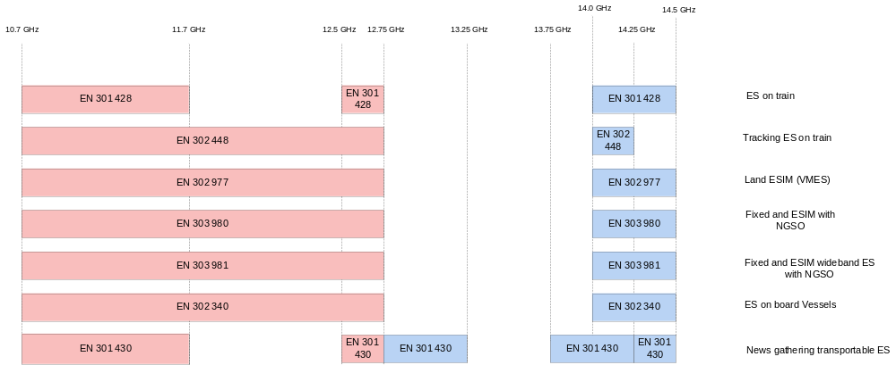

5.3 Regulatory aspects for HAPS
ITU–R began to study HAPS in the 1990s initially for fixed services. The telecommunications ecosystem and technology enablers for HAPS have evolved significantly since then. At WRC-2000, the bands 1885 – 1980 MHz, 2010 – 2025 MHz and 2110 – 2170 MHz were identified for HAPS operating as IMT Base Stations, in accordance with Resolution 221 (Rev.WRC-07) [3]. With increasing interest in HAPS to offer mobile services, the WRC-19 agreed to study certain frequency bands which have been already identified for IMT below 2.7 GHz for HAPS as IMT Base Stations (HIBS). ITU-R Working Party 5D is currently studying co-existence requirements for HIBS in the additional three bands listed in Table 5.4-1 to support spectrum identification decisions in WRC-23 in accordance with Resolution 247 (WRC-19) [3].
NOTE: In the current ITU terminology, the use of HAPS to implement IMT (i.e. offer mobile wireless services) is referred to as “HAPS as IMT Base Stations” or HIBS.
Table 5.4-1: Frequencies for HAPS as IMT Base Stations (HIBS).
Region | Spectrum | Remarks
Region 1 and 3 | 1885 – 1980 MHz  2010 – 2025 MHz  2110 – 2170 MHz | Identified HIBS designations at WRC-2000
Region 2 | 1885 – 1980 MHz³  2110 – 2160 MHz⁴ | Identified HIBS designations at WRC-2000
Global | 694 – 960 MHz  1710 – 1885 MHz¹  2500 – 2690 MHz² | Under study, for decision at WRC-23
NOTE 1: 1710-1815 MHz to be used for uplink only in Region 3.
NOTE 2: 2500-2535 MHz to be used for uplink only in Region 3, except 2655--2690 MHz in Region 3).
NOTE 3: In most of Region 2 1885-1910 is used for Mobile uplink and 1930-1980 is used for Mobile downlink. In the United States, 1910-1915 and 1915-1920 are also used for Mobile uplink.
NOTE 4: In Region 2 2110-2160 is used for Mobile downlink.

6 Co-existence study

6.1 Co-existence simulation scenario
Scenarios for coexistence study are listed in Table 6.1-1.
Table 6.1-1: Scenarios for NTN-NTN/TN co-existence
FR1: 2GHz |  | NTN^{1,4,5}
 |  | Set 1 |  |  | Set 2² |  |  | HAPS
 |  | GEO³ | LEO 600km | LEO 1200km | GEO | LEO 600km | LEO 1200km
NR / NB-IoT | Rural | X | X | X | X | X | X | X
NR / NB-IoT | Urban macro | X | X | X | X | X | X | X
NR / NB-IoT | Dense Urban⁶ | N/A | N/A | N/A | N/A | N/A | N/A | N/A
HAPS |  | N/A | N/A | N/A | N/A | N/A | N/A | X
NOTE 1: Earth Fixed beam has been considered for co-existence studies.
NOTE 2: Use Set 1 satellite antenna has been used as the starting point for co-existence studies.
NOTE 3: GEO and LEO only operate at adjacent channel.
NOTE 4: Use GEO and LEO@600km when TN is victim.
NOTE 5: The satellite-to-satellite coexistence scenarios are not in the scope of this study considering this is already addressed by ITU (ITU RR Article 9 etc.) and regional regulations (e.g. FCC rules).
NOTE 6: Dense Urban is not considered as it is expected NTN UE will connect to terrestrial networks rather than satellite networks in such scenario.

The aggressor and victim combinations are listed in Table 6.1-2.
Table 6.1-2: Aggressor and victim
No. | Combination | Aggressor | Victim | Notes | Study Phase
1 | TN with NTN | TN DL | NTN DL | Applicable for satellite operating in e.g. S-band, for e.g. coexistence with n1 FDD. | Phase 1
2 | TN with NTN | TN UL | NTN UL | Applicable for satellite operating in e.g. S-band, for e.g. coexistence with n1 FDD. | Phase 1
3 | TN with NTN | NTN DL | TN DL | Applicable for satellite operating in e.g. S-band, for e.g. coexistence with n1 FDD. | Phase 1
4 | TN with NTN | NTN UL | TN UL | Applicable for satellite operating in e.g. S-band, for e.g. coexistence with n1 FDD. | Phase 1
5 | TN with NTN | NTN UL | TN DL | Applicable for satellite operating in S-band, for e.g. coexistence with n34 TDD. | Phase 1
6 | TN with NTN | TN DL | NTN UL | Applicable for satellite operating in S-band, for e.g. coexistence with n34 TDD. | Phase 1
7 | NTN with NTN | NTN DL | NTN DL | HAPS-HAPS | Phase 2
7 | NTN with NTN | NTN UL | NTN UL | HAPS-HAPS | Phase 2

For further visualisation, the interference charts with respect to scenarios 1 to 6 are further represented with respect to NTN-TN coexistence scenarios in Figure 6.1-1 (scenarios 1 to 4) and Figure 6.1-2 (scenarios 5 and 6).
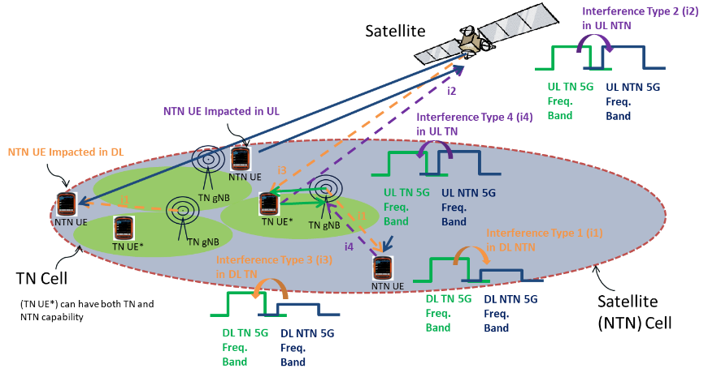
Figure 6.1-1: S-band NTN-TN adjacent band coexistence scenarios with TN in FDD mode
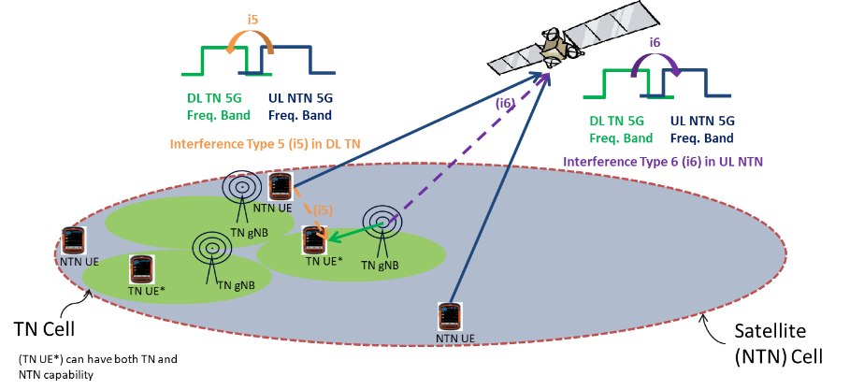
Figure 6.1-2: S-band NTN-TN adjacent band coexistence scenarios with TN in TDD mode (e.g. n34)
The frequency and bandwidth are listed in Table 6.1-3.
Table 6.1-3: Proposed frequency and bandwidth for co-existence study
 | Frequency | Bandwidth | Duplex mode | Frequency reuse factor
TN Rural | 2 GHz | 20MHz | FDD, TDD | 1
TN Urban macro | 2 GHz | 20MHz | FDD, TDD | 1
GEO | 2 GHz | 5/10/15/20 MHz for FR1 | FDD | 1, 3¹
LEO | 2 GHz | 5/10/15/20 MHz for FR1 | FDD | 1, 3¹
HAPS | 2 GHz | TBD | FDD | 1
NOTE: Only FRF=1 has been used in co-existence studies for simplification.

6.2 Co-existence simulation assumption

6.2.1 Network layout model

6.2.1.1 Co-existence between NTN satellite and TN
Cellular cell structure is considered for both NTN satellite and TN network layout.
Referring to TR 38.811[5] Section 6.3 and Annex A, a 3D global coordinate system is considered (Earth-Centred Earth Fixed) for simulating NTN satellite beams direction and location on the earth surface. It means the NTN satellite beam location, TN randomly dropping location are generated with a set of three parameters (x,y,z).
Deployment of NTN satellite and TN cells and UEs for co-existence study is listed in Table 6.2.1.1-1.
NOTE: The NTN UE(s) shall be dropped at the edge of the “central 19 TN cells (cluster)”. For Case 1 (Urban scenario), an Isolation distance of 1500m as 2*ISD is considered to reflect the NTN-TN selection algorithm at the border, assuming TN connection will always be prioritized over NTN.
As defined in Figure 6.2.1.1-1, isolation distance is the distance between the blue-dotted line which represents TN cell boarder and the red line. No UEs deployed in the isolation region is assumed to reduce the calculation complexity.
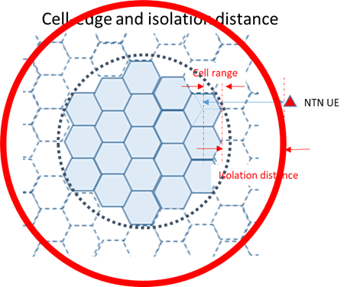
Figure 6.2.1.1-1: Isolation distance for Case 1
Table 6.2.1.1-1: Network and UE deployment
No. | Combination | Aggressor | Victim | Which NTN cell/UE to observe? | Which TN/UE to observe? | Which TN cells in a TN to observe?
1 | TN with NTN satellite | TN DL | NTN DL | NTN cell:  Observe NTN central beam for SINR, 6 adjacent beams for inter-beam interference.  NTN UE:  NTN UEs dropped at the edge of TN clusters | One cluster with 19 TN cells (57 sectors) randomly placed in the central NTN beam | All active TN clusters which has the NTN UE(s) at its edge.
2 | TN with NTN satellite | TN UL | NTN UL | NTN cell:  Observe NTN central beam for SINR, 6 adjacent beams for inter-beam interference.  NTN UE:  NTN UEs dropped at the edge of TN clusters | Consider an active rate of 20% for Rural and Urban of TN. | All active TN cells in central NTN beam
3 | TN with NTN satellite | NTN DL | TN DL | NTN cell:  Nadir point.  NTN UE:  NTN UEs dropped outside or at the edge of TN clusters | TN clusters randomly placed in this NTN beam | All in central NTN beam
 |  |  |  | NTN cell:  NTN cell with satellite at low elevation (45° for GEO and LEO Interested companies can bring analysis and results for other values)  NTN UE:  NTN UEs dropped outside or at the edge of TN clusters | TN clusters randomly placed in this NTN beam | All in central NTN beam
4 | TN with NTN satellite | NTN UL | TN UL | NTN cell:  Nadir point.  NTN UE:  NTN UEs dropped at the edge of TN clusters | TN randomly placed in this NTN beam | Option 1: All active TN clusters which has the NTN UE(s) at its edge.  Option 2: Only the TN sectors which have NTN UE(s) at their edges.  Option 1 is the baseline and it is not precluded companies can follow Option 2 to bring results
5 | TN with NTN satellite | NTN UL | TN DL | NTN cell:  Nadir point  NTN UE:  NTN UEs dropped at the edge of TN clusters | TN clusters randomly placed in this NTN beam | All active TN clusters which has the NTN UE(s) at its edge
 |  |  |  | NTN cell:  NTN cell with satellite at low elevation (45° for GEO and LEO Interested companies can bring analysis and results for other values).  NTN UE:  NTN UEs dropped at the edge of TN clusters | TN clusters randomly placed in this NTN beam | All active TN clusters which has the NTN UE(s) at its edge.
6 | TN with NTN satellite | TN DL | NTN UL | NTN cell:  Observe NTN central beam for SINR, 6 adjacent beams for inter-beam interference.  NTN cell with satellite at low elevation to be further investigated.  NTN UE:  NTN UEs dropped outside or at the edge of TN clusters | Consider the active rate of 20% for Rural and Urban of TN.  The Urban TN deployment for GEO in Case 6 is a mixture of urban and rural TN deployment. A representative percentage of urban TN could be considered for further study. | All active TN cells in central NTN beam

6.2.1.2 Co-existence between HAPS and TN
For simulations of HAPS and TN co-existence, a cluster of TN cells is randomly dropped in the HAPS coverage area as shown in Figure 6.2.1.2-1. The TN cell cluster consists of 19 sites, 57 sectors, with the same assumption described in clause 6.2.2.4. HAPS coverage and cell layout are described in clause 6.2.2.3.
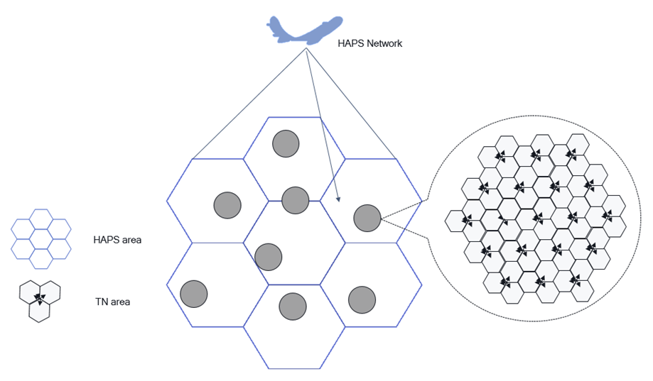
Figure 6.2.1.2-1: Simulation layout between HAPS and TN

6.2.1.3 Co-existence between HAPS and HAPS
HAPS and HAPS co-existence can be characterized by “center-to-center” inter-system distance (i.e., the distance between two coverage centers) as depicted in Figure 6.2.1.3-1. Since HAPS location is at the center of its coverage area, the inter-system distance is the separation of the two HAPS. Different inter-system distances may be simulated to evaluate the interference caused by antenna gain variation in the elevation domain.
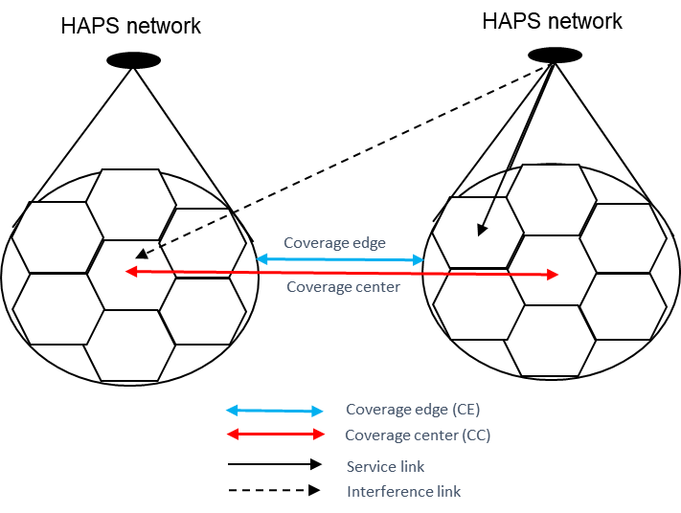
Figure 6.2.1.3-1: Simulation layout between HAPS and HAPS

6.2.2 System parameters

6.2.2.1 Satellite parameters
Two sets of satellite parameters are listed in Table 6.2.2.1-2 and Table 6.2.2.1-3 according to TR 38.821[6].
The satellite max Tx power can be calculated by the equation as below:
$$\max{Tx power\left[dBm\right]=}EIRP density\left[\frac{dBW}{MHz}\right]+30+10 \log_{10}\left(N_{RB}*SCS\left[MHz\right]*12\right)-Max Gain\left[dBi\right]$$
Table 6.2.2.1-1: N_{RB} configuration per BandWidth size and SCS
Configuration FR1 S-band | N_{RB} (5MHz BW) | N_{RB} (10MHz BW) | N_{RB} (15MHz BW) | N_{RB} (20MHz BW)
SCS 15 kHz | 25 | 52 | 79 | 106
SCS 30 kHz | 11 | 24 | 38 | 51

Table 6.2.2.1-2: Set-1 satellite parameters for co-existence study
Satellite orbit |  |  | GEO |  |  |  | LEO-1200 |  |  |  | LEO-600
Satellite altitude |  |  | 35786 km |  |  |  | 1200 km |  |  |  | 600 km
Payload characteristics for DL transmissions
Satellite EIRP density |  | 2GHz | 59 dBW/MHz |  |  |  | 40 dBW/MHz |  |  |  | 34 dBW/MHz
Satellite max TX power in dBm | BW (MHz) | 2GHz | 5 | 10 | 15 | 20 | 5 | 10 | 15 | 20 | 5 | 10 | 15 | 20
Satellite max TX power in dBm | SCS 15kHz | 2GHz | 44.53 | 47.71 | 49.53 | 50.81 | 46.53 | 49.71 | 51.53 | 52.81 | 40.53 | 43.71 | 45.53 | 46.81
Satellite max TX power in dBm | SCS 30kHz | 2GHz | 43.98 | 47.37 | 49.36 | 50.64 | 45.98 | 49.37 | 51.36 | 52.64 | 39.98 | 43.37 | 45.36 | 46.64
Satellite Tx max Gain |  | 2GHz | 51 dBi |  |  |  | 30 dBi |  |  |  | 30 dBi
Channel bandwidth |  | 2GHz | 5/10/15/20MHz |  |  |  | 5/10/15/20MHz |  |  |  | 5/10/15/20MHz
3dB beamwidth or HPBW (Half-Power BandWidth) of main central beam |  | 2GHz | 0.4011 deg |  |  |  | 4.4127 deg |  |  |  | 4.4127 deg
ABS (Adjacent Beam Spacing) of adjacent beams from the central beam |  | 2GHz | 0.3474 deg |  |  |  | 3.8206 deg |  |  |  | 3.8206 deg
Satellite beam diameter |  | 2GHz | 250 km |  |  |  | 90 km |  |  |  | 50 km
Payload characteristics for UL transmissions
G/T |  | 2 GHz | 19 dB K⁻¹ |  |  |  | 1.1 dB K⁻¹ |  |  |  | 1.1 dB K⁻¹
Satellite Rx max Gain |  | 2 GHz | 51 dBi |  |  |  | 30 dBi |  |  |  | 30 dBi

Table 6.2.2.1-3: Set-2 satellite parameters for co-existence study
Satellite orbit |  | GEO | LEO-1200 | LEO-600
Satellite altitude |  | 35786 km | 1200 km | 600 km
Payload characteristics for DL transmissions
Satellite EIRP density | 2GHz | 53.5 dBW/MHz | 34 dBW/MHz | 28 dBW/MHz
Satellite Tx max Gain | 2GHz | 45.5 dBi | 24 dBi | 24
Channel bandwidth | 2GHz | 5/10/15/20MHz | 5/10/15/20MHz | 5/10/15/20MHz
3dB beamwidth | 2GHz | 0.7353 deg | 8.8320 deg | 8.8320 deg
Satellite beam diameter | 2GHz | 450 km | 190 km | 90 km
Payload characteristics for UL transmissions
G/T | 2 GHz | 14 dB K⁻¹ | -4.9 dB K⁻¹ | -4.9 dB K⁻¹
Satellite Rx max Gain | 2 GHz | 45.5 dBi | 24 dBi | 24 dBi

Table 6.2.2.1-4: Other parameters for NTN satellite
Parameters | NTN satellite | Remark
Carrier frequency | 2GHz
The number of active UE (UL) | 9 UEs and 2RBs per UE for GEO and LEO¹ | NOTE
The number of active UE (DL) | 1 | Same with TN
Traffic model | Full buffer
DL power control | NO
UL power control | See Session 6.2.6.2
NTN satellite Noise Figure in dB | See Table 2.3-3-1
Handover margin | 3dB
NOTE: UEs are equally splitted inside the channel bandwidth into ACIR 3 regions. Scheduled PRB position for UE1 per satellite beam should be also fully aligned to simulate the worst case for co-channel interference and this is also aligned with full buffer case.
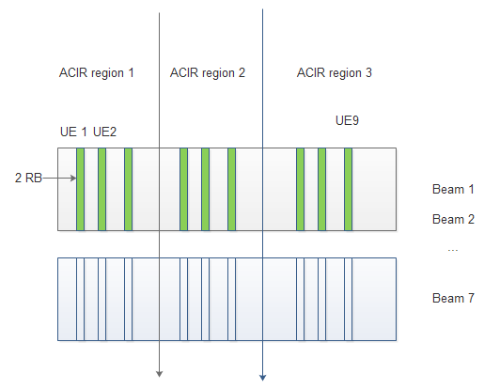

Table 6.2.2.1-5: NTN satellite Noise Figure in dB
Satellite | GEO | LEO 600 | LEO 1200
G/T (dB K⁻¹) | 19 | 1.1 | 1.1
G_Rx (dBi) | 51 | 30 | 30
NF (dB) | 7.4 | 4.3 | 4.3

6.2.2.2 NTN UE parameters
NTN UE parameters are given in Table 6.2.2.2-1
Table 6.2.2.2-1: NTN UE characteristics for system level simulations
Characteristics | Handheld
Frequency band | S band (i.e. 2 GHz)
Antenna type and configuration | (1, 1, 2) with omni-directional antenna element
Polarisation | Linear: +/-45°X-pol
Rx Antenna gain | 0 dBi per element
Antenna temperature | 290 K
Noise figure | 9 dB
Tx transmit power | 200 mW (23 dBm)
Tx antenna gain | 0 dBi per element

6.2.2.3 HAPS parameters
Using the antenna model in Section 6.2.3.3, HAPS deployed at 20 km altitude has a coverage radius of 100 km in a 7-cell layout. Two implementations of the layout are shown in Figure 6.2.2.3-1. The UEs in the HAPS system are assumed to be outdoor and uniformly distributed in the coverage area in the rural environment. The serving cell is selected by the strongest RSRP or least coupling loss. (Note: Calibration data show these two implementations yield similar results). HAPS system parameters for the co-existence study are listed in Table 6.2.2.3-1.
For DL transmission, one UE is scheduled for the full bandwidth. For UL transmission, 9 UEs are scheduled, each using a bandwidth of 6 RBs. The scheduled UEs are evenly distributed in the frequency domain as shown in Figure 6.2.2.3-2. Note that the scheduled resources are aligned among different cells to model co-channel effect. Since the UE uses only part of the channel bandwidth in UL, the ACI impact may differ in the frequency domain of the adjacent channel. The ACIR model described in Section 6.2.4 should be used to model the ACI from aggressor UEs in UL, taking into account the UE’s transmission bandwidth.
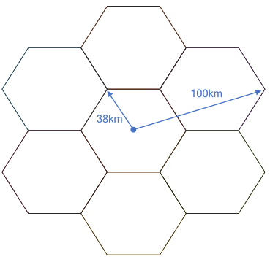  (a) | 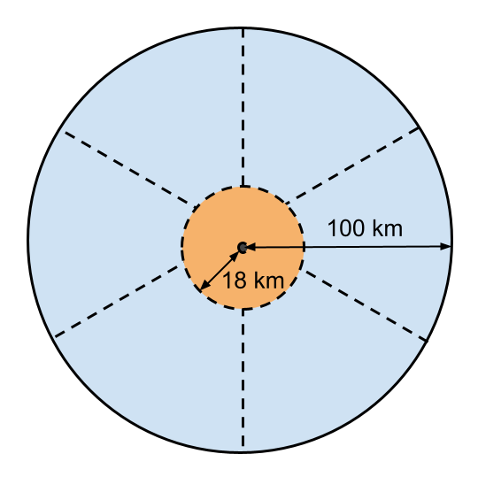  (b)
Figure 6.2.2.3-1: HAPS cell layout
Table 6.2.2.3-1: HAPS system parameters
HAPS altitude | 20 Km
Carrier frequency | 2 GHz
Frequency reuse factor | 1
Duplex scheme | FDD
Channel bandwidth | 20 MHz
Subcarrier spacing (SCS) | 15 KHz
Number of cells | 7
Coverage area (7 cells combined) | A 100 Km radius circular area centered by the serving HAPS
Frequency reuse | 1
Environment¹ | Rural
UE distribution | Uniformly distributed in the coverage area
Indoor UE percentage | 0%
Number of DL scheduled UEs per cell | 1
Number of UL scheduled UEs per cell | 9
DL scheduled bandwidth per UE | 20 MHz
UL scheduled bandwidth per UE | 6 RBs
DL power control | No
UL power control | See section 6.2.6.3
HAPS antenna | See section 6.2.3.3
HAPS noise figure | 5 dB
HAPS-UE pathloss model | See section 6.2.5.4
HAPS UE assumption | Same as TN UE in Table 6.2.2.4-1
NOTE 1: HAPS is assumed to serve UEs in the rural environment, but the co-existed TN may be in the rural or urban macro environment.

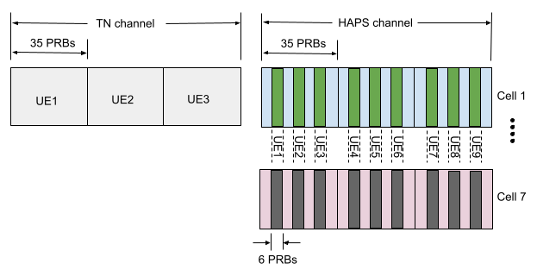
Figure 6.2.2.3-2: UL scheduled UE bandwidth allocation

6.2.2.4 TN parameters
TN parameters for co-existence study are given in Table 6.2.2.4-1, 6.2.2.4-2 and 6.2.2.4-3.
Table 6.2.2.4-1: Simulation assumptions of TN respectively based on NB-IoT and NR
 | NB-IoT  standalone | NR
Carrier frequency in GHz | 2 | 2
Size of each nominal channel BW in MHz | 0.2 | 20
Transmission bandwidth in MHz | 0.18 | N/A
Environment | Urban macro  Rural | Deployment scenario related, see Table 6.2.2.4-2.
Network layout | 19-sites [57 sectors] with wrap-around | 19-sites 57 sectors with wrap-around
Inter-site distance in meter | 500 for 2GHz band for UMA  TBD For Rural | Deployment scenario related, see Table 6.2.2.4-2
System loading and activity | Full buffer 100% | See Table 6.2.1.1-1
Network location | TBD | See Table 6.2.1.1-1
DL subcarrier spacing | 15kHz | 15kHz
UL | See RP-152284[7] | OFDMA
DL power control | No | No
UL power control | TR 36.942[8] section 5.1.1.6 (set 1) by bandwidth scale, target SNR at BS is 15 dB | TR 36.942[8]
Frequency reuse | 1 | 1
Number of scheduled UE per cell (DL) | 1 | 1
Number of scheduled UE per cell (UL) | 3 for multi-tone (60kHz per UE),  12 for 15kHz single-tone,  48 for 3.75kHz single-tone | 3
UE antenna height in meter | 1.5 | 1.5m
UE TX power in dBm | -40 to 23 | -40 to 23
UE antenna gain in dBi | 0 | 0
Building penetration loss | TR 45.820[9] Annex D.1 | In pathloss model, TR 38.901[10]
Cell selection margin in dB | 3 | 3
BS-MS min distance in meters | 35 | 35
BS noise figure in dB | 5 | 5
UE noise figure in dB | 9 | 9
BS-UE path-loss model | TR 36.942[8] macro urban | TR 38.901[10]
Standard deviation of BS-UE log-normal shadow fading in dB | 10 | Deployment scenario related, referring to TR 38.901[10]
Shadowing correlation | Inter-cell 0.5  Intra-cell 1 | Inter-cell 0.5  Intra-cell 1
Link-level performance model |  | See Section 6.2.8  Throughtput-SINR mapping
UE distribution |  | Uniform
Evaluation metrics | SINR vs ACS (as victim) | See Section 6.2.8  Throughtput or SNR loss criteria

Table 6.2.2.4-2: Deployment-related parameters of TN (2 GHz)
 | Urban Macro | Rural Macro | Remarks
ISD in meters | 750 | 7500 | ITU-R Report M.2292[11]
BS Antenna height in meters | 25 | 30 | ITU-R Report M.2292[11]
UE Outdoor/indoor | 100% Outdoor
UE height in meter | 1.5 | 1.5 | RP-200559 [12] 3GPP LS to ITU-R WP5D  and  ITU-R WP5D  [IMT_Parameters] [13]

Table 6.2.2.4-3: ACLR/ACS for TN (2GHz)
 |  | NR | NB-IOT
BS | ACLR | 45 dB | 40 dB
BS | ACS | 46 dB | 46 dB
UE | ACLR | 30dB (ACLR1)  43dB (ACLR2) | 37
UE | ACS | 33 | 28

6.2.3 Antenna and beamforming pattern modelling

6.2.3.1 Satellite and UE Antenna and beam forming pattern modelling
Satellite and UE Antenna and beam forming pattern modelling of satellite could be referred to section 6.4.1 in TR 38.811[5].
The following normalized antenna gain pattern, corresponding to a typical reflector antenna with a circular aperture, is considered.
1 $for θ=0$
${4\left|\frac{J_{1}\left(ka\sin{θ}\right)}{ka\sin{θ}}\right|}^{2}$ $for 0<\left|θ\right|≤90°$
where:
- J₁(x) is the Bessel function of the first kind and first order with argument ‘x’ , where x is $ka\sin{θ}$;
- a, $a$ is the radius of the antenna's circular aperture;
- k = 2πf/c is the wave number;
- f is the frequency of operation;
- c is the speed of light in a vacuum and θ is the angle measured from the bore sight of the antenna's main beam.
Note that ka equals to the number of wavelengths on the circumference of the aperture and is independent of the operating frequency.
The antenna patterns for LEO 600km, 1200km and GEO are shown in Figure 6.2.3.1-1 and 6.2.3.1-2.
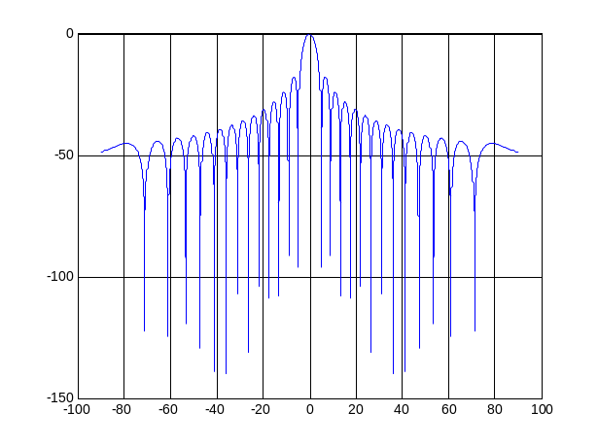
Figure 6.2.3.1-1: Antenna pattern for LEO 600KM and 1200KM (4.4127 deg for 3dB beamwidth)
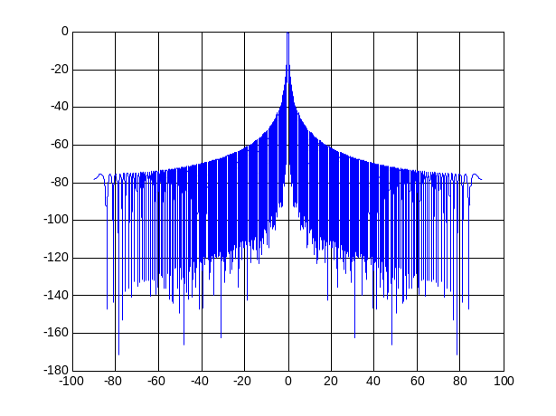
Figure 6.2.3.1-2: Antenna pattern for antenna aperture of GEO (0.4011 deg for 3dB beamwidth)
The beam layout definition for a single satellite simulation in S-Band is defined in Table 6.2.3.1-1.
Table 6.2.3.1-1: Beam layout definition for single satellite simulation
Beam layout definition | Baseline: Hexagonal mapping of the beam bore sight directions on UV plane defined in the satellite reference frame.  Only the 3dB beam width parameters should be used. The beam diameter and beam spacing values can be computed directly from the 3 dB beam width assumptions and should be considered as informative.
Number of beams | Baseline: 7-beam layout (i.e. 6 co-frequency beams surrounding the central beam)
UV plane illustration (extracted from [19]) | 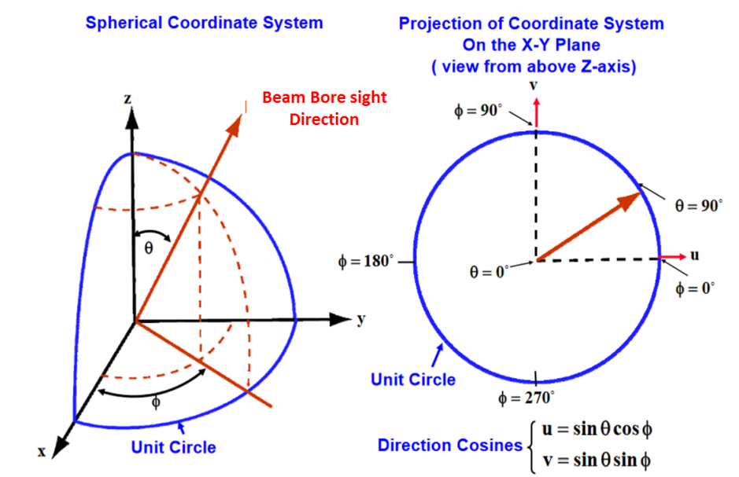
UV plane convention | U axis is defined as the perpendicular line to the satellite-earth line on the orbital plane as illustrated here after:  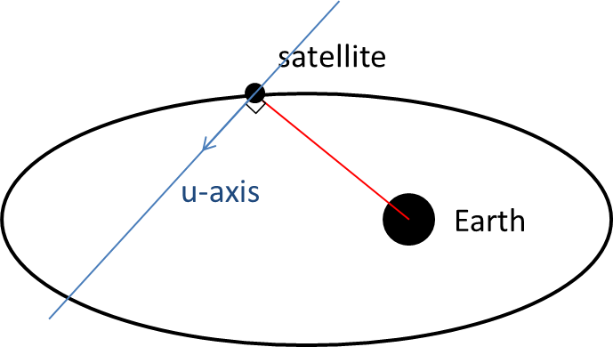  The straight line being orthogonal to UV plane is pointing towards the Earth centre.  UV coordinates of the nadir of the reference satellite is (0,0)
Adjacent beam spacing on UV plane | Baseline: Adjacent beam spacing computation based on 3dB beam width of the satellite antenna pattern:  ABS[rad] = sqrt(3) x sin(HPBW[degrees]/2) or ABS[rad] = sqrt(3) x sinr(HPBW[rad]/2)  with ABS [degree]=180/pi x ABS[rad] and  with HPBW the Half-Power BandWidth of the main lobe from the satellite antenna pattern.
Central beam bore sight direction definition | Baseline:  Case 1: Central beam center is considered at nadir point  Case 2: 45° for GEO and LEO
 | Option 1: FRF=1  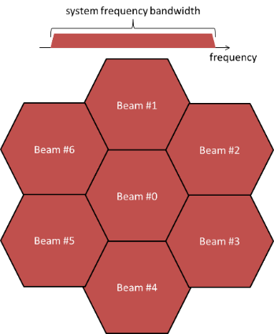 | Option 2: FRF=3  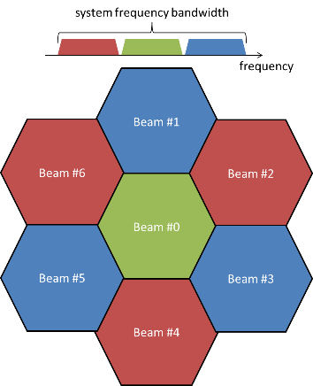 | Option 3: FRF=2  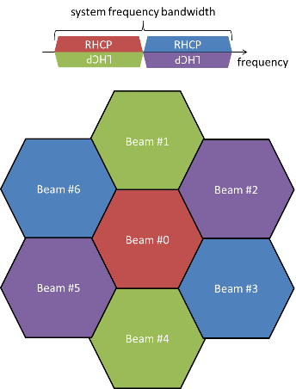
Polarization re-use | Option 1: Disable  Option 2: Enable  Note: Polarization re-use should apply only if circular polarization for terminal antenna is considered
UEs outdoor/indoor distribution | 100% outdoor distribution for UEs
UE distribution | The cell area associated to a given beam is defined as the Voronoi cell associated with the corresponding beam centers.
UE configuration | S-band: Handheld
UE orientation | Handheld: Random
UE attachment | RSRP
NOTE 1: Typical impairment values (additional frequency error, SNR loss) due to the feeder link except for delay can be considered to be negligible. When available, specific values can be considered in the evaluation and should be reported.
NOTE 2: For the calibration purpose, the ionospheric scintillation loss shall be considered equal to zero (i.e., the UEs are located between 20 and 60 degrees of latitude).

6.2.3.2 TN BS and UE antenna and beam forming pattern modelling
For AAS antenna, it refers to the pattern in TR 38.921 [14].
Table 6.2.3.2-1: AAS antenna parameters for 2GHz
 |  | Rural | Macro urban
1 | Base Station Antenna Characteristics
1.1 | Antenna pattern | TR 38.921[14]
1.2 | Element gain (dBi) ^{(Note 2)} | 7.1 | 6.4
1.3 | Horizontal/vertical 3 dB beam width of single element (degree) | 90º for H  54º for V | 90º for H  65º for V
1.4 | Horizontal/vertical front-to-back ratio (dB) | 30 for both H/V | 30 for both H/V
1.5 | Antenna polarization | Linear ±45º | Linear ±45º
1.6 | Antenna array configuration (Row × Column)  ^{(Note 4)} | 8 × 8 elements | 8 × 8 elements
1.7 | Horizontal/Vertical radiating element spacing | 0.5 of wavelength for H, 0.9 of wavelength for V | 0.5 of wavelength for H, 0.7 of wavelength for V
1.8 | Array Ohmic loss (dB) ^{(Note 2)} | 2 | 2
1.9 | Conducted power (before Ohmic loss) per antenna element (dBm) ^{(Note 3)} | 25 | 25
1.10 | Base station maximum coverage angle in the horizontal plane (degrees) | 120 | 120
1.11 | Base station vertical coverage range (degrees) ^{(Note 1)} | 90-100 | 90-120
1.12 | Mechanical downtilt (degrees) | 3 | 10

For non-AAS antenna, the parameters in Table 6.2.3.2-1 are used for 2GHz BS antenna pattern in the NTN system simulation.
Table 6.2.3.2-1: FR1 BS Non-AAS antenna pattern for 2GHz
Parameter for BS | Values
Antenna vertical radiation pattern (dB) | $$A_{E,V}(θ^{″})=-\min\left\{12{\left(\frac{θ^{″}-90°}{θ_{\text{3dB}}}\right)}^{2},SLA_{V}\right\},θ_{\text{3dB}}=10°,SLA_{V}=20\text{dB}$$
Antenna horizontal radiation pattern (dB) | $$A_{E,H}(ϕ^{″})=-\min\left\{12{\left(\frac{ϕ^{″}}{ϕ_{\text{3dB}}}\right)}^{2},A_{m}\right\},ϕ_{\text{3dB}}=65°,A_{m}=20\text{dB}$$
Combining method for 3D antenna pattern (dB) | $$A^{“}（θ^{"},φ^{”}）=-min\left\{-\left[A_{E,V}\left(θ^{"}\right)+A_{E,H}\left(φ^{”}\right)\right], A_{m}\right\}$$
Maximum directional gain of an antenna G_{E,max} | 17 dBi
Conducted power | 46 dBm
Mechanical downtilt in degrees | Rural | 3
Mechanical downtilt in degrees | Urban | 10

Only Non-AAS antenna can be used for NB-IoT.
For UE antennas, an omni-directional radiation pattern with antenna gain 0dBi is assumed.

6.2.3.3 HAPS antenna model
HAPS antenna model is based on the proposal for HIBS (HAPS as IMT base stations) study in ITU WP-5D [24]. The antenna array is composed of seven antenna panels (six side panels and one downward facing panel) as shown in Figure 6.2.3.3-1. Antenna elements on each panel are co-phased to form one beam in two crossed linear polarizations to serve one cell. There are a total of seven cells in two layers, one cell in the 1st layer and six cells in the 2nd layer. The antenna parameters are listed in Table 6.2.3.3-1. Note that a fixed beam in the direction of the panel boresight is formed by each panel to serve one cell. Figure 6.2.3.3-1 shows the antenna gain of the 1st layer cell and a 2nd layer cell projected on the ground.
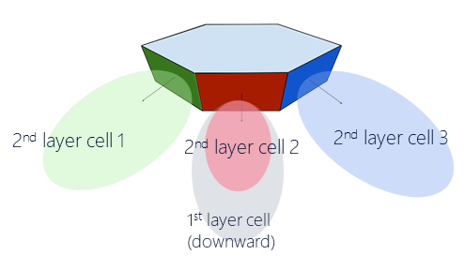
Figure 6.2.3.3-1: HAPS antenna model
Table 6.2.3.3-1: HAPS antenna parameters
Number of cells | 7
Antenna array configuration (row x column) | 2 x 2 for 1st layer cell  4 x 2 for 2nd layer cell
Antenna polarization | Linear $±45°$
Element gain ¹ | 7.8 dBi
Element HPBW horizontal/vertical | 65⁰ for both H/V
Element front-to-back ratio horizontal/vertical | 30 dB for both H/V
Element spacing horizontal/vertical | 0.7 wavelength for both H/V
Antenna panel tilt (from the horizon)² | 90⁰ for 1st layer cell  23⁰for 2nd layer cell
EIPR/cell | 56.8 dBm (1st layer cell),  59.8 dBm (2nd layer cell)
EIRP spectral density/cell | 43.8 dBm/MHz (1st layer cell),  46.8 dBm/MHz (2nd layer cell)
Tx power per antenna panel | 43 dBm
Conducted power (before ohmic loss) per antenna element (dBm) | 34 dBm for 2 x 2 (x 2 polarizations for 1st layer cell)  31 dBm for 4 x 2 (x 2 polarizations for 2nd layer cell)
Antenna weight³ $w_{m,n}$ | $1/2$ for each of 1st layer cell element  $1/{2\sqrt{2}}$ for each of 2nd layer cell element
Polarization gain for SINR | 3 dB
NOTE 1: The element gain includes the Ohmic loss of 2 dB.
NOTE 2: This is mechanical tilt only.
NOTE 3: These antenna weights create a fixed cell beam in the antenna panel’s boresight direction.

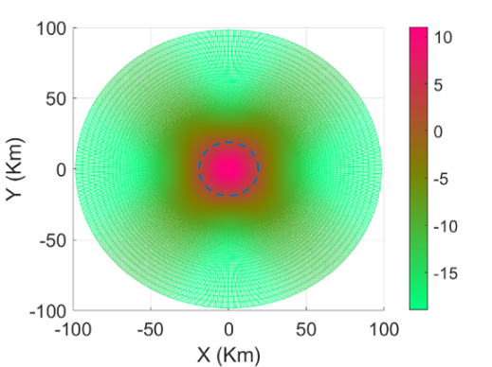  (a) | 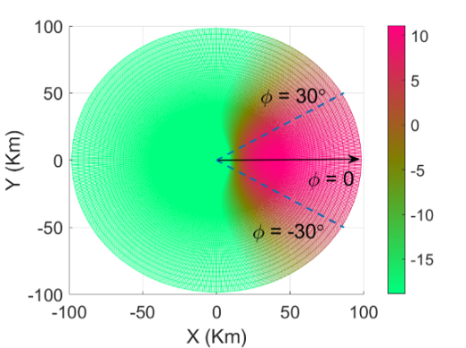  (b)
Figure 6.2.3.3-2: HAPS antenna gain (in dB) in a 100 km radius area on the ground. (a) Antenna gain of the 1st layer cell. (b) Antenna gain of a 2nd layer cell.

6.2.4 ACIR model
ACLR modelling for TN and NTN co-existence study referring to clause 5.1.1.4.1 and 5.1.1.4.2 in TR 36.942[8] is used as baseline. The number of RBs refers to Table 6.2.2.1-4 and Table 6.2.2.4-1 respectively.

6.2.5 Propagation model

6.2.5.1 Propagation model between NTN SAN and UE
Propagation model between NTN SAN and UE should reference to section 6.6 in TR 38.811[5].

6.2.5.2 Propagation model between TN BS and UE
Propagation model between TN BS and UE should reference to section 7.4 in TR 38.901[10].

6.2.5.3 Propagation model between NTN SAN and TN BS
Propagation model between NTN SAN and TN BS should reference to TS 38.811[5] which is used for DL-UL cross link interference for S band.

6.2.5.4 Propagation model for HAPS
Propagation model between HAPS and UE, regardless of whether the UE is connected to HAPS or TN, should reference to section 6.6 in TR 38.811[5].

6.2.6 Transmission power control model

6.2.6.1 TN UL TPC
For uplink scenario, TPC model specified in Section 9.1 TR 36.942[8] is applied for TN with following parameters.
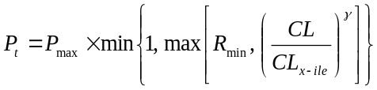
where:
- P_{max} = 23dBm,
- R_{min} = TBD dB,
- CL_{x-ile} and γ are set as following:
- CL_{x-ile} = 88 + 10*log₁₀ (200/X) + 11 – Y, where X is UL transmission BW (MHz) and Y is the BS noise figure
- γ = 1For uplink scenario,

6.2.6.2 NTN UL TPC
For the coexistence study, the same TPC model of TN for NTN UL scenarios is adopted to align with UE UL power control parameters used in TR 38.821[6].

6.2.6.3 NTN DL TPC
For downlink scenario, no power control scheme is applied.

6.2.6.4 HAPS UL TPC
HAPS uplink follows the TPC model in Section 6.2.6.1 with X = 1.08 (scheduled bandwidth 6 RBs) and Y = 5 (HAPS noise figure is 5 dB).

6.2.6.5 HAPS DL TPC
For downlink scenario, no power control scheme is applied.

6.2.7 Received power model
The received power in downlink and uplink scenarios is defined as below:
RX_PWR = TX_PWR – Path loss + G_TX + G_RX
where:
- RX_PWR is the received power
- TX_PWR is the transmitted power
- G_TX is the transmitter antenna gain (directional array gain)
- G_RX is the receiver antenna gain (directional array gain).

6.2.8 Performance metric
For NR, the average throughput loss and 5%-ile throughput loss should be less than 5%.
For NB-IOT, the SNR loss should refer to TR 36.802 [15].
For NTN, the average throughput loss and 5%-ile throughput loss should be less than 5%.

6.2.9 Throughput ~ SNR mapping
Adopt Section 5.2.7 of TR 38.803[20] as the SINR-Throughput performance metrics

6.3 Co-existence simulation methodology

6.3.1 Simulation procedure
Adopt following simulation steps.
- Step 1: Generate aggressor and victim networks.
- NTN central beam is at satellite nadir, surrounded with 6 co-frequency beams. NTN FRFs higher than 1 need to be considered. Assume one NTN aggressor as default.
- Deployment of TN network (19 cells with wraparound) refers to Table 6.2.1.1-1
- Step2: UE associations
- TN UE are generated randomly inside the TN network, make sure enough TN UEs are associated to each TN sectors based on coupling loss.
- Deployment of NTN UE refers to Table 6.2.1.1-1.
- Step 3: Once association is done, round robin scheduling is used. BF weights are adjusted to point to the LOS direction between BS/SAN-UE. This is done for both victim and aggressor networks.
- Step 4: Throughput is computed in the victim systems without considering ACI as below:
${Thput}_{NO ACI}\left[bpshz\right]=f\left({SINR}_{ICI}\right)=f\left(\frac{S}{N+I_{ICI}}\right)$,
where: $I_{ICI}$ is the inter-cell interference.
For TN-NTN SINR calculation, the satellite receiver off angle should be considered in the satellite receiver gain calculation when calculating SINR. Note that such angle is not considered in TR 38.821[6] section 6.1.3 equations. Thus those equations should be used for SINR calculation.
- Step 5: Throughput is computed considering ACI as below:
${Thput}_{ACI}\left[bpshz\right]=f\left({SINR}_{ICI+ACI}\right)=f\left(\frac{S}{N+I_{ICI}+I_{ACI}}\right)$,
where: $I_{ACI}$ is the adjacent channel interference.
- Step 6: RF parameters are determined based on the degradation cause by ACI as below:
$$Loss_{ACI}=1-\frac{{Thput}_{ACI}}{{Thput}_{SINGLE}}$$
To simplify the simulation of interference from TN to NTN UL in Case 2 and 6, following method can be used. Consider the active TN cells from central NTN beam for the ACI evaluation from TN to NTN UL. The scaling factor is to be discussed and determined if any in next meeting. There is a view that simplifying such coexistence simulation work for Case 2 may even not be required.
- Step 1: to drop NTN UE per beamprint randomly;
- Step 2: to drop N clusters consisting of 57 sectors per beamprint randomly:
- Step 3: to calculate the total ACI per beam to NTN UL by following scaling factor:
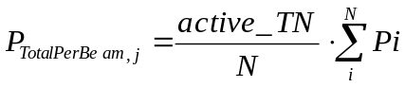
where: active_TN = active_factor*round (the area per beam/the area of 57 sectors)
active_factor = 20% (or lower, particularly for urban scenarios)
- Step 4: to calculate the total ACI from all beams (e.g. M=7 ) for NTN:
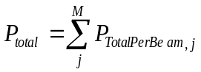

6.3.2 Methods and principle to process co-existence simulation results
In order to process the co-existence simulation results received for all different scenarios and assumptions, the following steps are adopted:
- Step 1: Discuss and agree on the most stringent scenario(s) for each scenario (Scenario 1, 2, 3…,6);
- Step 2: Discuss and determine the required ACIR from results of the most stringent case(s) for each scenario;
- Step 3: Use equation to derive corresponding ACLR or ACS from the agreed ACIR for each scenario
It is noted that the averaged ACIR for the most stringent case in each scenario would be derived by taking the average among the interpolated ACIR results derived from each company’s results for that case.
Moreover, the following considerations are adopted to deal with major disputes for the selected cases’ results in each scenario:
- If the required ACIR results, from the contributor who did not participate or their results is still not well-aligned in calibration table, has a difference larger than 10 dB with most others, this result can be not considered in the discussion.
- If the required ACIR results, from one contributor, has a difference larger than 10 dB with most others, this result can be not considered in the discussion.
The processed results by adopting above principles and methods for scenarios 1 to 7 identified in Table 6.1-2 are captured in section 6.4. It is noted that due to the space limitation, only part of the simulation results for each case are presented, and the whole results for all studied options, as listed in Table 6.1-1 and section 6.2, can be found in Annex C.
Table 6.3.2-1: Selected option for each scenario
Scenario | Aggressor system | Victim system | Environment | Contributing
1 | TN DL | NTN GEO DL | Urban | NTN UE ACS
2 | TN UL | NTN GEO UL | Urban | NTN SAN ACS
3 | NTN LEO-600 DL | TN DL | Rural | NTN SAN LEO ACLR
3 | NTN GEO DL | TN DL | Rural | NTN SAN GEO ACLR
4 | NTN GEO UL | TN UL | Urban | NTN UE ACLR
5 | NTN GEO UL | TN DL | Rural | NTN UE ACLR
6¹ | NR-TN DL | NTN LEO-600 UL | Rural ² | NTN SAN ACS
6¹ | NR-TN DL | NTN GEO UL | Rural ² | NTN SAN ACS
7 | HAPS DL | TN DL | Rural | HAPS ACLR
8 | TN UL | HAPS UL | Rural | HAPS ACS
NOTE 1: Agreed representative case for Scenario 6.
NOTE 2： The initial results suggested that the NR-NTN SAN would suffer more interference in urban deployment scenario. It is agreed that a more relevant environment for case 6 is a mixture of Urban and Rural environment (e.g., urban area with a 50km diameter inside a GEO beam with a 250km diameter). Further studies based on the mixed urban environment could be considered. As compromise, rural only scenario was then selected.

6.4 Co-existence simulation results

6.4.1 Scenario 1: 2GHz TN DL interfering NTN DL
The co-existence results from all concerned options in this scenario were evaluated, and it has been agreed to select the NR DL equipped with both AAS and non-AAS antenna interfering the NR-NTN GEO DL that deployed in urban environment as the most stringent case.
Table 6.4.1-1: Simulation results for average throughput loss - TN BS with AAS antenna
ACIR[dB] | 6 | 8 | 10 | 12 | 14 | 16 | 18 | 20 | 22 | 24
Qualcomm | 32.76 | 26.13 | 19.50 | 15.41 | 11.32 | 8.26 | 6.21 | 4.16 | 3.22 | 2.27
MTK | 7.28 | 5.71 | 4.60 | 3.77 | 3.05 | 2.35 | 1.90 | 1.30 | 1.02 | 0.80
ZTE | 31.76 | 24.81 | 18.95 | 14.18 | 10.47 | 7.63 | 5.50 | 3.92 | 2.79 | 1.99
Ericsson |  |  | 4.2 | 3.0 | 2.1 | 1.5 | 1.1
CATT | 8.7 | 6.5 | 5.3 | 4.3
Xiaomi | 38.11 | 31.51 | 25.56 | 20.35 | 15.94 | 12.29 | 9.36 | 7.06 | 5.29 | 3.95

Figure 6.4.1-1: Simulation results for average throughput loss - TN BS with AAS antenna
Table 6.4.1-2: Simulation results for 5%-tile throughput loss - TN BS with AAS antenna
ACIR[dB] | 14 | 16 | 18 | 20 | 22 | 24 | 26 | 28 | 30 | 32
Qualcomm | 44.68 | 27.01 | 19.33 | 11.66 | 9.31 | 6.96 | 5.20 | 4.03
MTK | 7.38 | 4.80 | 3.09 | 1.97 | 1.26 | 0.80 | 0.50 | 0.32 | 0.20 | 0.13
ZTE | 33.63 | 24.27 | 17.09 | 12.37 | 9.01 | 6.43 | 4.81 | 3.30 | 2.42 | 1.70
Ericsson | 3.0 | 2.8 | 1.8
CATT | 13.4 | 12.7 | 11.8 | 9.33 | 8.76 | 8.18 | 7.65 | 5.83 | 4.91
Xiaomi | 65.22 | 54.94 | 44.26 | 33.58 | 24.20 | 16.78 | 11.29 | 7.43 | 4.51

Figure 6.4.1-2: Simulation results for 5%-tile throughput loss - TN BS with AAS antenna
Table 6.4.1-3: Interpolated ACIR values for Scenario 1 to meet the 5% throughput loss criteria - TN BS with AAS antenna
Source |  | Interpolated ACIR[dB]
Qualcomm | Average | 19.18
Qualcomm | 5%-tile | 26.34
MTK | Average | 9.28
MTK | 5%-tile | 15.85¹
ZTE | Average | 18.63
ZTE | 5%-tile | 25.77
Ericsson | Average
Ericsson | 5%-tile | 12.10¹
CATT | Average | 10.6
CATT | 5%-tile | 29.80
Xiaomi | Average | 22.43
Xiaomi | 5%-tile | 29.40
NOTE 1: According to the principles, these values are not treated for later process.

Table 6.4.1-4: Average ACIR of 5%-tile values in the above worse case for Scenario 1 - TN BS with AAS antenna
 | Scenario 1
ACIR value [dB] | 27.83

Table 6.4.1-5: Simulation results for average throughput loss - TN BS with non-AAS antenna
ACIR[dB] | 6 | 8 | 10 | 12 | 14 | 16 | 18 | 20 | 22 | 24
MTK | 25,91 | 20,30 | 16,17 | 12,92 | 9,97 | 8,19 | 6,76 | 5,54 | 4,32 | 3,34
ZTE | 35,27 | 27,40 | 20,83 | 15,57 | 11,46 | 8,34 | 6,04 | 4,32 | 3,06 | 2,14
THALES | NA | NA | NA | 13,13 | 9,54 | 6,85 | 4,86 | 3,4 | 2,3 | 1,58

Figure 6.4.1-3: Simulation results for average throughput loss - TN BS with non-AAS antenna
Table 6.4.1-6: Simulation results for 5%-tile throughput loss - TN BS with non-AAS antenna
ACIR[dB] | 14 | 16 | 18 | 20 | 22 | 24 | 26 | 28 | 30 | 32
MTK | 69,59 | 59,31 | 48,18 | 37,24 | 26,31 | 18,42 | 12,49 | 8,27 | 5,39 | 3,47
ZTE | 37,88 | 27,97 | 20,08 | 14,18 | 9,80 | 6,65 | 4,46 | 2,78 | 1,82 | 1,24
THALES | 16,36 | 14,55 | 8,64 | 7,27 | 6,36 | 5,91 | 5,45 | 5,45 | 4,55 | 1,82

Figure 6.4.1-4: Simulation results for 5%-tile throughput loss - TN BS with non-AAS antenna
Table 6.4.1-7: Interpolated ACIR values for Scenario 1 to meet the 5% throughput loss criteria - TN BS with non-AAS antenna
Source |  | Interpolated ACIR[dB]
MTK | Average | 20.89
MTK | 5%-tile | 30.41
ZTE | Average | 19.21
ZTE | 5%-tile | 25.51
Thales | Average | 17.86
Thales | 5%-tile | 29.00

Table 6.4.1-8: Average ACIR of 5%-tile values in the above worse case for Scenario 1 - TN BS with non-AAS antenna
 | Scenario 1
ACIR value [dB] | 28.31

6.4.2 Scenario 2: 2GHz TN UL interfering NTN UL
The co-existence results from all concerned options in this scenario were evaluated, and it has been agreed to select the NR UL interfering the NR-NTN GEO UL that deployed in urban environment as the most stringent case.
Table 6.4.2-1: Simulation results for average throughput loss - TN BS with AAS antenna
ACIR[dB] | 18 | 20 | 22 | 24 | 26 | 28 | 30 | 32 | 34 | 36
Qualcomm | 36.46 | 24.81 | 18.43 | 12.06 | 7.70 | 5.34 | 2.98
ZTE | 16.46 | 11.77 | 8.26 | 5.51 | 3.55 | 2.25 | 1.48 | 0.98 | 0.63 | 0.39
MTK | 38.61 | 31.96 | 25.57 | 20.13 | 15.27 | 11.22 | 7.96 | 5.48 | 3.68 | 2.42
Ericsson |  | 15.6 | 10.4 | 7.2 | 4.2 | 2.9 | 1.9
CATT | NA | NA | NA | NA | NA | NA | NA | NA | NA | NA
Xiaomi | 41.11 | 30.58 | 21.75 | 14.92 | 9.96 | 6.53 | 4.22 | 2.70 | 1.72 | 1.09

Figure 6.4.2-1: Simulation results for average throughput loss - TN BS with AAS antenna
Table 6.4.2-2: Simulation results for 5%-tile throughput loss - TN BS with AAS antenna
ACIR[dB] | 22 | 24 | 26 | 28 | 30 | 32 | 34 | 36 | 38 | 40
Qualcomm | NA | NA | NA | NA | NA
ZTE | NA | NA | NA | NA | NA | NA | NA | NA | NA | NA
MTK | 68.80 | 58.62 | 47.26 | 36.43 | 26.97 | 19.13 | 13.06 | 8.68 | 5.67 | 3.67
Ericsson | NA | NA | NA | NA | NA
CATT | NA | NA | NA | NA | NA | NA | NA | NA | NA | NA
Xiaomi | NA | NA | NA | NA | NA | NA | NA | NA | NA

Figure 6.4.2-2: Simulation results for 5%-tile throughput loss - TN BS with AAS antenna
Table 6.4.2-3: Interpolated ACIR values for Scenario 2 to meet the 5% throughput loss criteria - TN BS with AAS antenna
Source |  | Interpolated ACIR[dB]
Qualcomm | Average | 28.29
Qualcomm | 5%-tile
ZTE | Average | 24.52
ZTE | 5%-tile
MTK | Average | 32.53
MTK | 5%-tile | 38.67¹
Ericsson | Average | 25.47
Ericsson | 5%-tile
CATT | Average
CATT | 5%-tile
Xiaomi | Average | 29.32
Xiaomi | 5%-tile
NOTE 1: According to the principles, this value is not treated for later process.

Table 6.4.2-4: Average ACIR values in the above worse case for Scenario 2 - TN BS with AAS antenna
 | Scenario 2
ACIR value [dB] | 28.03

Table 6.4.2-5: Simulation results for average throughput loss - TN BS with non-AAS antenna
ACIR[dB] | 18 | 20 | 22 | 24 | 26 | 28 | 30 | 32 | 34 | 36
Ericsson | NA | NA | NA | NA | NA | 10,4 | 6,8 | 4,2 | 2,9 | NA
THALES | 14,06 | 10,74 | 7,74 | 5,53 | 3,63 | 2,37 | 1,74 | 1,11 | 0,79 | 0,47
MTK | 35,49 | 29,12 | 23,27 | 18,21 | 13,81 | 9,87 | 6,92 | 4,67 | 3,11 | 2,04

Figure 6.4.2-3: Simulation results for average throughput loss - TN BS with non-AAS antenna
Table 6.4.2-6: Simulation results for 5%-tile throughput loss - TN BS with non-AAS antenna
ACIR[dB] | 22 | 24 | 26 | 28 | 30 | 32 | 34 | 36 | 38 | 40
Ericsson | NA | NA | NA | NA | NA | NA | NA | NA | NA | NA
THALES | 0 | 0 | 0 | 0 | 0 | 0 | 0 | 0 | 0 | 0
MTK | 57,18 | 45,86 | 34,92 | 25,60 | 18,05 | 12,29 | 8,15 | 5,31 | 3,42 | 2,19

Figure 6.4.2-4: Simulation results for 5%-tile throughput loss - TN BS with non-AAS antenna
Table 6.4.2-7: Interpolated ACIR values for Scenario 2 to meet the 5% throughput loss criteria - TN BS with non-AAS antenna
Source |  | Interpolated ACIR[dB]
Ericsson | Average | 31.38
Ericsson | 5%-tile | NA
Thales | Average | 24.56
Thales | 5%-tile | NA
MTK | Average | 31.71
MTK | 5%-tile | 36.33

Table 6.4.2-8: Average ACIR values in the above worse case for Scenario 2 TN BS with non-AAS antenna
 | Scenario 2
ACIR value [dB] | 29.22

6.4.3 Scenario 3: 2GHz NTN DL interfering TN DL

6.4.3.1 LEO Class
The co-existence results from all concerned options in this scenario were evaluated, and it has been agreed to select the NR-NTN LEO-600 DL interfering the NR DL equipped with AAS antenna that deployed in rural environment as the most stringent case for LEO class.
Table 6.4.3.1-1: Simulation results for average throughput loss - TN BS with AAS antenna
ACIR[dB] | 10 | 12 | 14 | 16 | 18 | 20 | 22 | 24 | 26 | 28
Qualcomm | 21.02 | 16.68 | 12.34 | 8.94 | 6.48 | 4.03 | 2.98 | 1.93 | 1.21 | 0.84
Samsung | 20.06 | 15.28 | 11.24 | 8.00 | 5.52 | 3.72 | 2.45 | 1.60 | 1.03 | 0.66
MTK | 25.22 | 19.06 | 13.86 | 9.70 | 6.66 | 4.41 | 2.92 | 1.90 | 1.22 | 0.77
ZTE | 16.65 | 12.34 | 8.84 | 6.15 | 4.17 | 2.77 | 1.81 | 1.17 | 0.75 | 0.48
Ericsson |  |  |  |  |  | 3.7 | 2.4 | 1.6 | 1.0
Huawei |  |  |  |  | 5.94 | 3.97 | 2.52 | 1.64 | 1.24
CATT | 17.3 | 12.2 | 10.1 | 8.3 | 6.6 | 4.7
Xiaomi | 30.71 | 23.92 | 17.92 | 12.93 | 9.01 | 6.11 | 4.05 | 2.64 | 1.70 | 1.09

Figure 6.4.3.1-1: Simulation results for average throughput loss - TN BS with AAS antenna
Table 6.4.3.1-2: Simulation results for 5%-tile throughput loss - TN BS with AAS antenna
ACIR[dB] | 14 | 16 | 18 | 20 | 22 | 24 | 26 | 28 | 30 | 32
Qualcomm | 37.78 | 28.51 | 21.12 | 13.72 | 10.16 | 6.60 | 4.18 | 2.89
Samsung | 27.10 | 19.19 | 13.13 | 8.76 | 5.73 | 3.71 | 2.37 | 1.51 | 0.97 | 0.62
MTK | 37.56 | 27.47 | 19.31 | 13.11 | 8.69 | 5.67 | 3.65 | 2.33 | 1.49 | 0.94
ZTE | 16.27 | 10.85 | 7.06 | 4.59 | 2.82 | 1.91 | 1.31 | 0.88 | 0.60 | 0.39
Ericsson |  |  |  | 9.8 | 6.2 | 4.5 | 2.8
Huawei |  |  | 8.61 | 5.01 | 3.12 | 1.94 | 1.32
CATT | 42.07 | 32.30 | 22.43 | 15.88 | 10.74 | 7.90 | 4.40
Xiaomi | 38.87 | 28.90 | 20.59 | 14.15 | 9.47 | 6.22 | 4.03 | 2.59

Figure 6.4.3.1-2: Simulation results for average throughput loss - TN BS with AAS antenna
Table 6.4.3.1-3: Interpolated ACIR values for Scenario 3 to meet the 5% throughput loss criteria - TN BS with AAS antenna
Source |  | Interpolated ACIR[dB]
Qualcomm | Average | 19.21
Qualcomm | 5%-tile | 25.32
Samsung | Average | 18.58
Samsung | 5%-tile | 22.72
MTK | Average | 19.48
MTK | 5%-tile | 24.66
ZTE | Average | 17.16
ZTE | 5%-tile | 19.67
Ericsson | Average
Ericsson | 5%-tile | 23.41
Huawei | Average | 18.95
Huawei | 5%-tile | 20.01
CATT | Average | 19.68
CATT | 5%-tile | 25.66
Xiaomi | Average | 21.01
Xiaomi | 5%-tile | 25.11

Table 6.4.3.1-4: Average ACIR of 5%-tle values in the above worse case for Scenario 3 - TN BS with AAS antenna
 | Scenario 3
ACIR value [dB] | 23.32

Table 6.4.3.1-5: Simulation results for average throughput loss - TN BS with non-AAS antenna
ACIR[dB] | 10 | 12 | 14 | 16 | 18 | 20 | 22 | 24 | 26 | 28
Samsung | 10,42 | 7,20 | 4,86 | 3,21 | 2,09 | 1,35 | 0,86 | 0,55 | 0,35 | 0,22
MTK | 27,33 | 20,75 | 15,22 | 10,59 | 7,32 | 4,81 | 3,29 | 2,16 | 1,45 | 0,93
ZTE | 13,12 | 9,28 | 6,37 | 4,27 | 2,81 | 1,82 | 1,17 | 0,75 | 0,48 | 0,30
THALES | NA | 15,84 | 11,43 | 7,99 | 5,43 | 3,61 | 2,35 | 1,52 | 0,97 | 0,62
Ericsson | NA | NA | NA | NA | NA | 3,0 | 2,0 | 1,3 | 0,8 | 0,5

Figure 6.4.3.1-3: Simulation results for average throughput loss - TN BS with non-AAS antenna
Table 6.4.3.1-6: Simulation results for 5%-tile throughput loss - TN BS with non-AAS antenna
ACIR[dB] | 14 | 16 | 18 | 20 | 22 | 24 | 26 | 28 | 30 | 32
Samsung | 18,31 | 12,33 | 8,12 | 5,28 | 3,40 | 2,17 | 1,38 | 0,87 | 0,55 | 0,35
MTK | 39,11 | 28,66 | 20,18 | 13,63 | 9,06 | 5,92 | 3,81 | 2,44 | 1,55 | 0,98
ZTE | 21,75 | 14,80 | 9,68 | 6,52 | 4,36 | 2,83 | 1,82 | 1,20 | 0,71 | 0,39
THALES | 47,09 | 35,73 | 25,48 | 17,17 | 11,08 | 6,65 | 3,6 | 2,22 | 1,39 | 0,83
Ericsson | NA | NA | NA | 7,2 | 4,5 | 2,9 | 1,8 | 1,2 | NA | NA

Figure 6.4.3.1-4: Simulation results for average throughput loss - TN BS with non-AAS antenna
Table 6.4.3.1-7: Interpolated ACIR values for Scenario 3 LEO Class to meet the 5% throughput loss criteria - TN BS with non-AAS antenna
Source |  | Interpolated ACIR[dB]
Samsung | Average | 13.88
Samsung | 5%-tile | 20.30
MTK | Average | 19.85
MTK | 5%-tile | 24.87
ZTE | Average | 15.3
ZTE | 5%-tile | 21.41
THALES | Average | 18.47
THALES | 5%-tile | 25.08
Ericsson | Average
Ericsson | 5%-tile | 21.63

Table 6.4.3.1-8: Average ACIR of 5%-tile values in the above worse case for Scenario 3 LEO Class - TN BS with non-AAS antenna
 | Scenario 3
ACIR value [dB] | 22.66

6.4.3.2 GEO Class
The co-existence results from all concerned options in this scenario were evaluated, and it has been agreed to select the NR-NTN GEO DL interfering the NR DL equipped with AAS antenna that deployed in rural environment as the most stringent case for GEO class.
Table 6.4.3.2-1: Simulation results for average throughput loss - TN BS with AAS antenna
ACIR[dB] | 2 | 4 | 6 | 8 | 10 | 12 | 14 | 16 | 18 | 20
Qualcomm | 15.65 | 11.48 | 8.25 | 5.96 | 3.67 | 2.70 | 1.74 | 1.09
Samsung | 15.14 | 11.09 | 7.86 | 5.41 | 3.63 | 2.39 | 1.55 | 1.00 | 0.64 | 0.41
MTK | 20.35 | 15.03 | 10.74 | 7.33 | 4.79 | 3.15 | 2.05 | 1.32 | 0.84 | 0.53
ZTE | 11.39 | 8.09 | 5.58 | 3.76 | 2.48 | 1.62 | 1.04 | 0.67 | 0.42 | 0.27
Ericsson |  |  |  |  | 3.9 | 2.5 | 1.6 | 1.0
CATT | 9.73% | 7.94% | 6.42% | 5.15% | 4.08% | 3.20% | 2.48%
Xiaomi | 22.47 | 16.68 | 11.93 | 8.25 | 5.56 | 3.67 | 2.39 | 1.54 | 0.98 | 0.62

Figure 6.4.3.2-1: Simulation results for average throughput loss - TN BS with AAS antenna
Table 6.4.3.2-2: Simulation results for 5%-tile throughput loss - TN BS with AAS antenna
ACIR[dB] | 4 | 6 | 8 | 10 | 12 | 14 | 16 | 18 | 20 | 22
Qualcomm | 35.59 | 26.64 | 19.54 | 12.44 | 9.23 | 6.02 | 3.81
Samsung | 26.43 | 18.68 | 12.77 | 8.49 | 5.55 | 3.58 | 2.30 | 1.46 | 0.93 | 0.59
MTK | 42.08 | 31.47 | 22.53 | 15.53 | 10.41 | 6.83 | 4.43 | 2.84 | 1.81 | 1.15
ZTE | 14.19 | 9.38 | 6.19 | 4.19 | 2.58 | 1.62 | 1.00 | 0.57 | 0.38 | 0.25
Ericsson |  |  |  | 8.3 | 5.6 | 3.5 | 2.2
CATT | 20.86 | 19.31 | 14.49 | 13.09 | 7.33 | 5.23 | 4.17
Xiaomi | 36.44 | 26.85 | 18.99 | 12.97 | 8.65 | 5.67 | 3.66 | 2.35 | 1.50

Figure 6.4.3.2-2: Simulation results for 5%-tile throughput loss - TN BS with AAS antenna
Table 6.4.3.2-3: Interpolated ACIR values for Scenario 3 GEO Class to meet the 5% throughput loss criteria - TN BS with AAS antenna
Source |  | Interpolated ACIR[dB]
Qualcomm | Average | 8.84
Qualcomm | 5%-tile | 14.46
Samsung | Average | 8.46
Samsung | 5%-tile | 12.56
MTK | Average | 9.83
MTK | 5%-tile | 15.53
ZTE | Average | 6.64
ZTE | 5%-tile | 9.2
Ericsson | Average
Ericsson | 5%-tile | 12.57
CATT | Average | 8.28
CATT | 5%-tile | 14.43
Xiaomi | Average | 10.59
Xiaomi | 5%-tile | 14.67

Table 6.4.3.2-4: Average ACIR of 5%-tile values in the above worse case for Scenario 3 GEO Class - TN BS with AAS antenna
 | Scenario 3 GEO Class
ACIR value [dB] | 13.35

Table 6.4.3.2-5: Simulation results for average throughput loss - TN BS with non-AAS antenna
ACIR[dB] | 0 | 2 | 4 | 6 | 8 | 10 | 12 | 14 | 16 | 18
Samsung | 10.22 | 7.04 | 4.73 | 3.12 | 2.03 | 1.31 | 0.83 | 0.53 | 0.34 | 0.21
MTK | 28.38 | 21.62 | 15.91 | 11.36 | 7.76 | 5.17 | 3.37 | 2.24 | 1.34 | 0.85
ZTE | 11.89 | 8.33 | 5.68 | 3.79 | 2.48 | 1.60 | 1.03 | 0.66 | 0.42 | 0.26
THALES |  |  |  |  |  |  | 2.27 | 1.46 | 0.94 | 0.6
Ericsson |  |  |  |  |  | 3.2 | 2.1 | 1.3 | 0.9 | 0.5

Figure 6.4.3.2-3: Simulation results for average throughput loss - TN BS with non-AAS antenna
Table 6.4.3.2-6: Simulation results for 5%-tile throughput loss - TN BS with non-AAS antenna
ACIR[dB] | 6 | 8 | 10 | 12 | 14 | 16 | 18 | 20 | 22 | 24
Samsung | 11,97 | 7,88 | 5,11 | 3,28 | 2,09 | 1,33 | 0,85 | 0,53 | 0,34 | 0,21
MTK | 31,86 | 22,83 | 15,63 | 10,47 | 6,87 | 4,45 | 2,85 | 1,82 | 1,16 | 0,73
ZTE | 13,72 | 9,33 | 6,08 | 3,88 | 2,38 | 1,50 | 1,13 | 0,75 | 0,55 | 0,30
THALES |  |  |  | 9,14 | 5,54 | 3,6 | 2,22 | 1,39 | 0,83 | 0,55
Ericsson |  |  | 9,1 | 5,9 | 4,2 | 2,8 | 1,9

Figure 6.4.3.2-4: Simulation results for 5%-tile throughput loss - TN BS with non-AAS antenna
Table 6.4.3.2-7: Interpolated ACIR values for Scenario 3 GEO Class to meet the 5% throughput loss criteria - TN BS with non-AAS antenna
Source |  | Interpolated ACIR[dB]
Samsung | Average | 3.77
Samsung | 5%-tile | 10.12
MTK | Average | 10.19
MTK | 5%-tile | 15.55
ZTE | Average | 4.72
ZTE | 5%-tile | 10.98
THALES | Average | NA
THALES | 5%-tile | 14.56
Ericsson | Average | NA
Ericsson | 5%-tile | 13.06

Table 6.4.3.2-8: Average ACIR of 5%-tile values in the above worse case for Scenario 3 GEO Class - TN BS with non-AAS antenna
 | Scenario 3
ACIR value [dB] | 12.85

6.4.4 Scenario 4: 2GHz NTN UL interfering TN UL
The co-existence results from all concerned options in this scenario were evaluated, and it has been agreed to select the NR-NTN GEO UL interfering the NR UL equipped with both AAS and non-AAS antenna that deployed in urban environment as the most stringent case.
Table 6.4.4-1: Simulation results for average throughput loss - TN BS with AAS antenna
ACIR[dB] | 10 | 12 | 14 | 16 | 18 | 20 | 22 | 24 | 26 | 28
Qualcomm | 12.60 | 10.78 | 8.96 | 7.42 | 6.18 | 4.93 | 4.11 | 3.29 | 2.63 | 2.12
Samsung | 10.83 | 8.69 | 6.92 | 5.47 | 4.30 | 3.35 | 2.60 | 2.00 | 1.53 | 1.17
MTK | 12.16 | 10.25 | 8.40 | 6.66 | 5.09 | 3.75 | 2.67 | 1.84 | 1.24 | 0.82
ZTE | 9.35 | 7.39 | 5.59 | 4.38 | 3.38 | 2.65 | 2.05 | 1.63 | 1.24 | 0.94
Ericsson¹ |  |  |  |  |  |  |  | 1.5 | 1.2 | 1.0
CATT | 2.72 | 2.26 | 1.88 | 1.58
Xiaomi | 10.31 | 8.30 | 6.66 | 5.34 | 4.27 | 3.42 | 2.74 | 2.19 | 1.76 | 1.41
NOTE 1: This result is derived by observing the NR sector having an NR-NTN transmitting UE at its sector edge.

Figure 6.4.4-1: Simulation results for average throughput loss - TN BS with AAS antenna
Table 6.4.4-2: Simulation results for 5%-tile throughput loss - TN BS with AAS antenna
ACIR[dB] | 20 | 22 | 24 | 26 | 28 | 30 | 32 | 34 | 36 | 38
Qualcomm | 24.62 | 20.07 | 15.53 | 12.02 | 9.55 | 7.08 | 5.83 | 4.58
Samsung | 16.71 | 12.55 | 9.44 | 7.15 | 5.47 | 4.19 | 3.19 | 2.44 | 1.86 | 1.41
MTK | 20.91 | 14.93 | 10.33 | 6.95 | 4.59 | 2.98 | 1.92 | 1.23 | 0.78 | 0.49
ZTE | 11.43 | 8.86 | 7.23 | 6.23 | 4.71 | 3.34 | 2.66 | 1.47 | 0.87 | 0.75
Ericsson¹ |  |  | 7.9 | 7.1 | 4.8 | 4.6 | 0.5 | 0.5
CATT | 8.83 | 7.49 | 5.57 | 4.10 | 3.44 | 2.95
Xiaomi | 16.47 | 11.96 | 8.45 | 5.79 | 3.88 | 2.55 | 1.66 | 1.07
NOTE 1: This result is derived by observing the NR sector having an NR-NTN transmitting UE at its sector edge.

Figure 6.4.4-2: Simulation results for 5%-tile throughput loss - TN BS with AAS antenna
Table 6.4.4-3: Interpolated ACIR values for Scenario 4 to meet the 5% throughput loss criteria - TN BS with AAS antenna
Source |  | Interpolated ACIR[dB]
Qualcomm | Average | 19.89
Qualcomm | 5%-tile | 33.33
Samsung | Average | 16.80
Samsung | 5%-tile | 28.73
MTK | Average | 18.13
MTK | 5%-tile | 27.65
ZTE | Average | 14.98
ZTE | 5%-tile | 27.62
Ericsson(*) | Average
Ericsson(*) | 5%-tile | 27.83
CATT | Average | 3.69
CATT | 5%-tile | 24.78
Xiaomi | Average | 16.64
Xiaomi | 5%-tile | 26.83

Table 6.4.4-4: Average ACIR of 5%-tile values in the above worse case for Scenario 4 - TN BS with AAS antenna
 | Scenario 4
ACIR value [dB] | 28.11

Table 6.4.4-5: Simulation results for average throughput loss - TN BS with non-AAS antenna
ACIR[dB] | 10 | 12 | 14 | 16 | 18 | 20 | 22 | 24 | 26 | 28
Samsung | 10,85 | 8,39 | 6,50 | 5,06 | 3,96 | 3,11 | 2,43 | 1,88 | 1,44 | 1,07
MTK | 11,73 | 9,14 | 7,05 | 5,38 | 4,05 | 2,99 | 2,17 | 1,53 | 1,06 | 0,72
ZTE | 6,12 | 5,01 | 4,16 | 3,32 | 2,85 | 2,27 | 1,83 | 1,17 | 0,80 | 0,50
THALES | NA | 0,04 | 0,03 | 0,01 | 0,01 | 0 | 0 | 0 | 0 | 0
Ericsson¹ | NA | NA | NA | NA | NA | NA | NA | NA | NA | 1,2
NOTE 1: This result is derived by observing the NR sector having an NR-NTN transmitting UE at its sector edge.

Figure 6.4.4-3: Simulation results for average throughput loss - TN BS with non-AAS antenna
Table 6.4.4-6: Simulation results for 5%-tile throughput loss - TN BS with non-AAS antenna
ACIR[dB] | 20 | 22 | 24 | 26 | 28 | 30 | 32 | 34 | 36 | 38
Samsung | NA | NA | NA | NA | NA | NA | NA | NA | NA | NA
MTK | 21,98 | 15,18 | 10,19 | 6,70 | 4,34 | 2,79 | 1,78 | 1,13 | 0,72 | 0,45
ZTE | 1,53 | 1,08 | 0,47 | 0,30 | 0,19 | 0,03 | 0,00 | 0,00 | 0,00 | 0,00
THALES | 0 | 0 | 0 | 0 | 0 | 0 | 0 | 0 | 0 | 0
Ericsson | NA | NA | NA | NA | 12,2 | 9,7 | 8,3 | 7,4 | 6,1 | 4,4
NOTE 1: This result is derived by observing the NR sector having an NR-NTN transmitting UE at its sector edge.

Figure 6.4.4-4: Simulation results for 5%-tile throughput loss - TN BS with non-AAS antenna
Table 6.4.4-7: Interpolated ACIR values for Scenario 4 to meet the 5% throughput loss criteria - TN BS with non-AAS antenna
Source |  | Interpolated ACIR[dB]
Samsung | Average | 16.11
Samsung | 5%-tile | NA
MTK | Average | 16.57
MTK | 5%-tile | 27.44¹
ZTE | Average | 12.02
ZTE | 5%-tile | 15.46
THALES | Average | NA
THALES | 5%-tile | NA
Ericsson | Average | NA
Ericsson | 5%-tile | 37.29¹
NOTE 1: According to the principles, this value is not treated for later process.

Table 6.4.4-8: Average ACIR of 5%-tile values in the above worse case for Scenario 4 - TN BS with non-AAS antenna
 | Scenario 4
ACIR value [dB] | 15.46

6.4.5 Scenario 5: 2GHz NTN UL interfering TN DL
The co-existence results from all concerned options in this scenario were evaluated, and it has been agreed to select the NR-NTN GEO UL interfering the NR DL equipped with both AAS and non-AAS antenna that deployed in rural environment as the most stringent case.
Table 6.4.5-1: Simulation results for average throughput loss - TN BS with AAS antenna
ACIR[dB] | 12 | 14 | 16 | 18 | 20 | 22 | 24 | 26 | 28 | 30
Qualcomm ⁽¹⁾ | 7.32 | 5.28 | 3.78 | 2.81 | 1.84 | 1.42 | 0.99 | 0.68
MTK | NA | NA | NA | NA | NA | NA | NA | NA | NA | NA
Xiaomi | 10.31 | 7.75 | 5.70 | 4.11 | 2.91 | 2.03 | 1.39 | 0.94
Samsung ⁽¹⁾ | 37.13 | 31.30 | 25.62 | 20.30 | 15.53 | 11.43 | 8.07 | 5.43 | 3.43 | 1.98
Samsung ⁽²⁾ | 0.16 | 0.13 | 0.11 | 0.09 | 0.07 | 0.06 | 0.05 | 0.03 | 0.02 | 0.02
Ericsson | 0.00
NOTE 1: These results were derived by adopting free-space path loss model for the links between NR UE and NR-NTN UE.
NOTE 2: These results were derived by adopting path loss model from TR 38.901[10] for the links between NR UE and NR-NTN UE.
NOTE3: In the meeting, views are expressed on which propagation model is more appropriate for the links between NR UE and NR-NTN UE. Due to the limited time and the fact that this scenario is not the worst case to determine the NR-NTN UE ACLR, this is not discussed nor concluded.

Figure 6.4.5-1: Simulation results for average throughput loss - TN BS with AAS antenna
Table 6.4.5-2: Simulation results for 5%-tile throughput loss - TN BS with AAS antenna
ACIR[dB] | 14 | 16 | 18 | 20 | 22 | 24 | 26 | 28 | 30 | 32
Qualcomm ⁽¹⁾ | 23.52 | 17.84 | 13.74 | 9.65 | 7.54 | 5.42 | 3.84
MTK | NA | NA | NA | NA | NA | NA | NA | NA | NA | NA
Xiaomi | 26.06 | 20.19 | 15.30 | 11.29 | 8.09 | 5.64 | 3.81
Samsung ⁽¹⁾ | 72.82 | 63.00 | 52.03 | 40.90 | 30.57 | 21.66 | 14.49 | 9.03 | 5.09 | 2.36
Samsung ⁽²⁾ | 0.99 | 0.82 | 0.66 | 0.53 | 0.41 | 0.30 | 0.21 | 0.14 | 0.08 | 0.04
Ericsson | 0.0
NOTE 1: These results were derived by adopting free-space path loss model for the links between NR UE and NR-NTN UE.
NOTE 2: These results were derived by adopting path loss model from TR 38.901[10] for the links between NR UE and NR-NTN UE.
NOTE 3: In the meeting, views are expressed on which propagation model is more appropriate for the links between NR UE and NR-NTN UE. Due to the limited time and the fact that this scenario is not the worst case to determine the NR-NTN UE ACLR, this is not discussed nor concluded.

Figure 6.4.5-2: Simulation results for 5%-tile throughput loss - TN BS with AAS antenna
Table 6.4.5-3: Interpolated ACIR values for Scenario 5 to meet the 5% throughput loss criteria - TN BS with AAS antenna
Source |  | Interpolated ACIR[dB]
Qualcomm (*) | Average | 14.37
Qualcomm (*) | 5%-tile | 24.53
MTK | Average
MTK | 5%-tile
Xiaomi | Average | 16.88
Xiaomi | 5%-tile | 24.70
Samsung (*) | Average | 26.43
Samsung (*) | 5%-tile | 30.07
Samsung (**) | Average
Samsung (**) | 5%-tile
Ericsson | Average
Ericsson | 5%-tile

Table 6.4.5-4: Average ACIR of 5%-tile values in the above worse case for Scenario 5 - TN BS with AAS antenna
 | Scenario 5
ACIR value [dB] | 26.43

Table 6.4.5-5: Simulation results for average throughput loss - TN BS with non-AAS antenna
ACIR[dB] | 0 | 2 | 4 | 6 | 8 | 10 | 12 | 14 | 16 | 18
MTK | 3,01 | 2,43 | 1,88 | 1,39 | 0,99 | 0,69 | 0,46 | 0,30 | 0,20 | 0,13
Samsung | 0,32 | 0,27 | 0,23 | 0,20 | 0,17 | 0,14 | 0,12 | 0,10 | 0,08 | 0,06
THALES | NA | NA | NA | NA | NA | NA | 0,07 | 0,06 | 0,05 | 0,04
NOTE1: In the meeting, views are expressed on which propagation model is more appropriate for the links between NR UE and NR-NTN UE. Due to the limited time and the fact that this scenario is not the worst case to determine the NR-NTN UE ACLR, this is not discussed nor concluded.

Figure 6.4.5-3: Simulation results for average throughput loss - TN BS with non-AAS antenna
Table 6.4.5-6: Simulation results for 5%-tile throughput loss - TN BS with non-AAS antenna
ACIR[dB] | 6 | 8 | 10 | 12 | 14 | 16 | 18 | 20 | 22 | 24
MTK | 15,03 | 10,72 | 7,39 | 4,96 | 3,27 | 2,12 | 1,36 | 0,87 | 0,55 | 0,35
Samsung | 1,07 | 0,92 | 0,77 | 0,65 | 0,53 | 0,44 | 0,34 | 0,27 | 0,20 | 0,15
THALES |  |  |  | 0 | 0 | 0 | 0 | 0 | 0 | 0
NOTE 1: In the meeting, views are expressed on which propagation model is more appropriate for the links between NR UE and NR-NTN UE. Due to the limited time and the fact that this scenario is not the worst case to determine the NR-NTN UE ACLR, this is not discussed nor concluded.

Figure 6.4.5-4: Simulation results for 5%-tile throughput loss - TN BS with non-AAS antenna
Table 6.4.5-7: Interpolated ACIR values for Scenario 5 to meet the 5% throughput loss criteria - TN BS with non-AAS antenna
Source |  | Interpolated ACIR[dB]
MTK | Average | 0
MTK | 5%-tile | 11.97¹
Samsung | Average | 0
Samsung | 5%-tile | 0
THALES | Average | 0
THALES | 5%-tile | 0
NOTE 1: According to the principles, this value is not treated for later process.

Table 6.4.5-8: Average ACIR of 5%-tile values in the above worse case for Scenario 5 - TN BS with non-AAS antenna
 | Scenario 5
ACIR value [dB] | 0

6.4.6 Scenario 6: 2GHz TN DL interfering NTN UL
The co-existence results from all concerned options in this scenario were evaluated, and the initial results suggested that the NR-NTN SAN would suffer more interference in urban deployment scenario, considering that the central beam of a GEO satellite (with the agreed minimum elevation angle of 45º) will be full of urban TNs. It was further discussed and agreed that simply using 20% active rate and assuming fully deployed NR stations with urban deployment assumptions in the whole NR-NTN beam coverage area would overestimate the density and aggregated interference from NR stations to NR-NTN in this scenario. In the end, the case of NR DL interfering the NR-NTN LEO-600 UL that deployed in a Rural environment has been selected as a representative one that could be used as basis to derive ACIR values. Further study could be considered base on a mixed Urban and Rural environment.
Table 6.4.6-1: Simulation results for average throughput loss - TN BS with non-AAS antenna
ACIR[dB] | 22 | 24 | 26 | 28 | 30 | 32 | 34 | 36 | 38 | 40
THALES | 51.17 | 41.28 | 31.94 | 23.87 | 17.01 | 11.87 | 7.91 | 5.26 | 3.4 | 2.22
MTK | 3.05 | 1.98 | 1.28 | 0.82 | 0.52 | 0.33 | 0.21 | 0.13 | 0.08 | 0.05

Figure 6.4.6-1: Simulation results for average throughput loss - TN BS with non-AAS antenna
Table 6.4.6-2: Simulation results for 5%-tile throughput loss - TN BS with non-AAS antenna
ACIR[dB] | 22 | 24 | 26 | 28 | 30 | 32 | 34 | 36 | 38 | 40
THALES | 53.49 | 43.02 | 33.72 | 25.58 | 17.44 | 12.79 | 8.14 | 5.81 | 3.49 | 2.33
MTK | 8.85 | 5.78 | 3.73 | 2.39 | 1.52 | 0.97 | 0.61 | 0.39 | 0.24 | 0.15

Figure 6.4.6-2: Simulation results for 5%-tile throughput loss - TN BS with non-AAS antenna
Table 6.4.6-3: Interpolated ACIR values for Scenario 5 to meet the 5% throughput loss criteria - TN BS with non-AAS antenna
Source |  | Interpolated ACIR[dB]
THALES | Average | 36.69
THALES | 5%-tile | 36.7
MTK | Average | 19.66
MTK | 5%-tile | 24.67¹
NOTE 1: According to the principles, this value is not treated for later process.

Table 6.4.6-4: Average ACIR of 5%-tile values in the above worse case for Scenario 6 - TN BS with non-AAS antenna
 | Scenario 6
ACIR value [dB] | 36.7

6.4.7 Scenario 7: 2GHz HAPS DL interfering TN DL
The co-existence results contributed have been collected and compared in the following.
Table 6.4.7-1: Simulation results for average throughput loss
ACIR[dB] | 5 | 10 | 15 | 20 | 25 | 30 | 35 | 40
Nokia | 28,80 | 16,80 | 8,10 | 3,30 | 1,10 | 0,30 | 0,10 | 0,10
Qualcomm | 38,41 | 23,95 | 12,26 | 5,14 | 1,86 | 0,62 | 0,20 | 0,06

Figure 6.4.7-1: Simulation results for average throughput loss
Table 6.4.7-2: Simulation results for 5%-tile throughput loss
ACIR[dB] | 5 | 10 | 15 | 20 | 25 | 30 | 35 | 40
Nokia | 77,10 | 53,20 | 26,60 | 9,80 | 1,80 | 0,30 | 0,20 | 0,00
Qualcomm | 100,00 | 68,11 | 39,34 | 17,38 | 6,66 | 2,37 | 0,77 | 0,21

Figure 6.4.7-2: Simulation results for 5%-tile throughput loss
Table 6.4.7-3: Interpolated ACIR values for Scenario 7 to meet the 5% throughput loss criteria
Source |  | Interpolated ACIR[dB]
Nokia | Average | 18.22
Nokia | 5%-tile | 23.00
Qualcomm | Average | 20.10
Qualcomm | 5%-tile | 26.93

Table 6.4.7-4: Average ACIR of 5%-tile values in the above worse case for Scenario 7
 | Scenario 1
ACIR value [dB] | 24.97

6.4.8 Scenario 8: 2GHz TN UL interfering HAPS UL
The co-existence results contributed have been collected and compared in the following.
Table 6.4.8-1: Simulation results for average throughput loss
ACIR[dB] | 5 | 10 | 15 | 20 | 25 | 30 | 35 | 40
Nokia | 14.4% | 7.2% | 3.0% | 1.4% | 0.7% | 0.6% | 0.1% | 0.0%

Figure 6.4.8-1: Simulation results for average throughput loss
Table 6.4.8-2: Simulation results for 5%-tile throughput loss
ACIR[dB] | 5 | 10 | 15 | 20 | 25 | 30 | 35 | 40
Nokia | 35.4% | 22.6% | 12.6% | 11.5% | 7.5% | 5.0% | 4.5% | 1.1%

Figure 6.4.8-2: Simulation results for 5%-tile throughput loss

6.5 Summary of co-existence study

6.5.1 Coexistence at 2GHz
This sub-clause captures the summary of the co-existence studies. The averaged interpolate ACIR values for each scenario are presented in Table 6.5.1-1 below.
Table 6.5.1-1: Average ACIR values for each scenario
Scenario |  | 1 | 2 | 3  LEO | 3  GEO | 4 | 5 | 6
ACIR value [dB] | TN BS with AAS | 27.83 | 28.03 | 23.32 | 13.35 | 28.11 | 26.43 | 36.70
ACIR value [dB] | TN BS with non-AAS | 28.31 | 29.22 | 22.66 | 12.85 | 15.46 | 0 | 36.70

Then, by considering the following ACLR and ACS of TN BS and UE in Table 6.5.1-2, the suggested ACLR and ACS of NTN SAN, HAPS and UE from each scenario are given in Table 6.5.1-3. It should be noted that the values in Table 6.5.1-3 are directly derived from the selected option of each scenario, and it is limited by the nature of assumptions and methodologies adopted in the co-existence studies.
Table 6.5.1-2: ACLR and ACS of TN
TN |  | Values
BS | ACLR | 45 dB
BS | ACS | 46 dB
UE | ACLR | 30 dB
UE | ACS | 33 dB

Table 6.5.1-3: Co-existence results suggested ACLR and ACS of NR-NTN
Scenario | Contributing | ACLR ACS values
1 | NTN UE ACS | 27.91 dB (AAS)
2 | NTN SAN ACS | 37.06 dB (non-AAS)
3 | NTN SAN ACLR | LEO: 23.81 dB  GEO: 13.39 dB
4 | NTN UE ACLR | 28.18 dB (AAS)
5 | NTN UE ACLR | 27.51 dB (AAS)
6 | NTN SAN ACS | 37.4 dB
7 | HAPS ACLR | 24.97 dB
8 | HAPS ACS | 30 dB

Considering the above suggested values, the agreed ACLR and ACS of NR-NTN are given in Table 6.5.1-4.
Table 6.5.1-4: ACLR and ACS of NR-NTN
NR-NTN |  |  | Values
SAN | ACLR | GEO | 14 dB
SAN | ACLR | LEO | 24 dB
SAN | ACS¹ | GEO | 38 dB
SAN | ACS¹ | LEO | 38 dB
HAPS | ACLR |  | 45²
HAPS | ACS |  | 46
UE | ACLR |  | 30 dB
UE | ACS |  | 33 dB
NOTE 1: The ACS values for SAN apply to both Rural and Urban environment.
NOTE 2: This value could be further relaxed based on co-existence studies if it is found more stringent than necessary.

6a Co-existence study for 17/27GHz

6a.1 Co-existence simulation scenario for 17/27GHz
Scenarios for the coexistence study for 17/27GHz are listed in Table 6a.1-1
Table 6a.1-1: Scenarios for NTN-NTN/TN co-existence
FR2: 17/27GHz |  | NTN
 |  | Set 1 |  |  | Set 2²
 |  | GEO³ | LEO 600km | LEO 1200km | GEO | LEO 600km | LEO 1200km
NR | Rural | N/A | N/A | N/A | N/A | N/A | N/A
NR | Urban macro | X | X | X | X | X | X
NR | Dense Urban⁶ | N/A | N/A | N/A | N/A | N/A | N/A

The aggressor and victim combinations for 17/27GHz cases are listed in Table 6a.1-2.
Table 6a.1-2: Aggressor and victim
No. | Combination | Aggressor | Victim | Frequency band | Scope of Coexistence Simulation
1a | TN with NTN | NTN UL | TN UL | 27 GHz | ACLR NTN UE to be varied/defined  ACS TN gNB fixed
2a | TN with NTN | TN UL | NTN UL | 27 GHz | ACLR TN UE fixed  ACS NTN SAN to be varied/defined
3a | TN with NTN | NTN UL | TN DL | 27 GHz | ACLR NTN UE to be varied/defined  ACS TN UE fixed
4a | TN with NTN | TN DL | NTN UL | 27 GHz | ACLR TN gNB fixed  ACS NTN SAN to be varied/defined
5a | TN with NTN | TN DL | NTN DL | 17 GHz | ACLR TN gNB fixed  ACS NTN UE to be varied/defined
6a | TN with NTN | NTN DL | TN DL | 17 GHz | ACLR NTN SAN to be varied/defined  ACS TN UE fixed
7a | TN with NTN | NTN DL | TN UL | 17 GHz | ACLR NTN SAN to be varied/defined  ACS TN gNB fixed
8a | TN with NTN | TN UL | NTN DL | 17 GHz | ACLR TN UE fixed  ACS NTN UE to be varied/defined
NOTE 1: For coexistence between Ka-Band DL and adjacent TN bands, there are no 3GPP defined/specified TN bands.
NOTE 2: To deprioritize scenario 7a and 8a for SAN elevation angle as 90-degree cases. Scenario 7a and 8a should still be studied for SAN elevation angle as 25-degree cases (computed from the center of the central beam).

For further visualisation of coexistence studies for 17/27GHz, the interference charts with respect to scenarios 1a to 8a are further represented with respect to NTN-TN coexistence scenarios in Figure 6a.1-1 (scenarios 1a to 4a) and Figure 6a.1-2 (scenarios 5a to 8a).
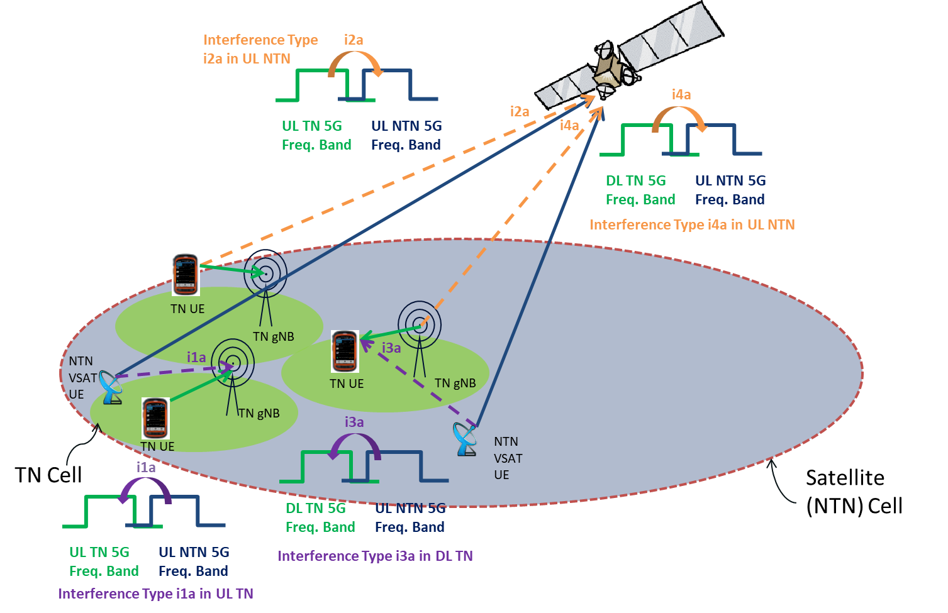
Figure 6a.1-1: NTN-TN adjacent band coexistence scenario 1a to 4a

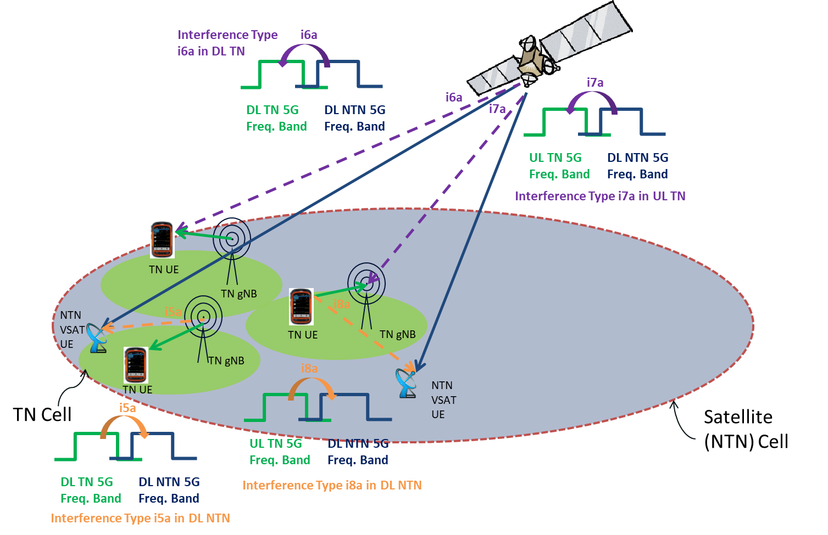
Figure 6a.1-2: NTN-TN adjacent band coexistence scenarios 5a to 8a
The frequency and bandwidth are listed in Table 6a.1-3.
Table 6a.1-3: Proposed frequency and bandwidth for co-existence study
 | Frequency | Bandwidth | Duplex mode | Frequency reuse factor
TN Urban macro | 17/27 GHz | 200/400MHz¹ | TDD | 1
GEO | 17GHz (DL)/27GHz(UL) | 200MHz per beam | FDD | 2²
LEO | 17GHz (DL)/27GHz(UL) | 200MHz per beam | FDD | 2²
NOTE1: Use the same channel BW for TN and NTN. TN 200MHz is the baseline for study and TN 400MHz is with second priority for study.
NOTE2: FRF=1 with single polarization has been adopted for calibration. For co-existence simulation, assume FRF=2 with two polarizations (RHCP, LHCP). The polarization isolation is assumed to be ideal.

6a.2 Co-existence simulation assumption for 17/27GHz

6a.2.1 Network layout model

6a.2.1.1 Co-existence between NTN satellite and TN
Cellular cell structure is considered for both NTN and TN network layout.
Referring to TR 38.811 Section 6.3 and Annex A, a 3D global coordinate system is considered (Earth-Centred Earth Fixed) for simulating NTN beams direction and location on the earth surface. It means the NTN beam location, TN randomly dropping location are generated with a set of three parameters (x,y,z)
Deployment of NTN satellite and TN cells and UEs for co-existence study is listed in Table 6a.2.1.1-1.
Table 6a.2.1.1-1: Network and UE deployment
No. | Combination | Aggressor | Victim | Which NTN cell/UE to observe? | Which TN/UE to observe? | Which TN cells in a TN to observe?
1a | TN with NTN | NTN UL | TN UL | NTN cell:  Nadir point.  NTN UE:  NTN UEs randomly dropped in TN clusters. | TN randomly placed in this NTN beam | Only the active TN clusters which contain NTN UE(s)
2a | TN with NTN | TN UL | NTN UL | NTN cell:  Observe NTN central beam for SINR, 6 adjacent beams for inter-beam interference.  NTN UE:  NTN UEs randomly dropped in TN clusters | Consider an active rate of 20% for TN | Only the active TN cells in central NTN beam
3a | TN with NTN | NTN UL | TN DL | NTN cell:  Nadir point  NTN UE:  NTN UEs randomly dropped in TN clusters. | TN clusters randomly placed in this NTN beam | All active TN clusters which contain NTN UE(s)
 |  |  |  | NTN cell:  NTN cell with satellite at low elevation (to be further discussed for GEO and LEO，interested companies can bring analysis and results for other values).  NTN UE:  NTN UEs randomly dropped in TN clusters. | TN clusters randomly placed in this NTN beam | Only the active TN clusters which contain NTN UE(s)
4a | TN with NTN | TN DL | NTN UL | NTN cell:  Observe NTN central beam for SINR, 6 adjacent beams for inter-beam interference.  NTN UE:  NTN UEs randomly dropped in TN clusters | Consider the active rate of 20% for TN. | All active TN cells in central NTN beam
5a | TN with NTN | TN DL | NTN DL | NTN cell:  Observe NTN central beam for SINR, 6 adjacent beams for inter-beam interference.  NTN UE:  NTN UEs randomly dropped in TN clusters. | One cluster with 19 TN cells (57 sectors) randomly placed in the central NTN beam | Only the active TN clusters which contain the NTN UE(s)
6a | TN with NTN | NTN DL | TN DL | NTN cell:  Nadir point.  NTN UE:  NTN UEs randomly dropped in TN clusters. | TN clusters randomly placed in this NTN beam | All in central NTN beam
 |  |  |  | NTN cell:  NTN cell with satellite at low elevation (to be further discussed for GEO and LEO, interested companies can bring analysis and results for other values)  NTN UE:  NTN UEs randomly dropped in TN clusters | TN clusters randomly placed in this NTN beam | All in central NTN beam
7a | TN with NTN | NTN DL | TN UL | NTN cell:  Nadir point  NTN UE:  NTN UEs randomly dropped in TN clusters. | TN clusters randomly placed in this NTN beam | Only the active TN clusters which contain NTN UE(s)
 |  |  |  | NTN cell:  NTN cell with satellite at low elevation (to be further discussed for GEO and LEO，interested companies can bring analysis and results for other values).  NTN UE:  NTN UEs randomly dropped in TN clusters. | TN clusters randomly placed in this NTN beam | Only the active TN clusters which contain NTN UE(s)
8a | TN with NTN | TN UL | NTN DL | NTN cell:  Observe NTN central beam for SINR, 6 adjacent beams for inter-beam interference.  NTN UE:  NTN UEs randomly dropped in TN clusters | Consider the active rate of 20% for TN | All active TN cells in central NTN beam

6a.2.2 System parameters

6a.2.2.1 Satellite parameters
Set-1 satellite parameters are listed in Table 6a.2.2.1-2 according to TR 38.821[6].
The satellite max Tx power can be calculated by the equation as below:
$\max{Tx power\left[dBm\right]=}EIRP density\left[\frac{dBW}{MHz}\right]+30+10 \log_{10}\left(N_{RB}*SCS\left[MHz\right]*12\right)-Max Gain\left[dBi\right]$
Table 6a.2.2.1-1: N_{RB} configuration per BandWidth size and SCS
Configuration FR2 Ka-band | N_{RB} (200MHz BW)
SCS 120 kHz | 132

Table 6a.2.2.1-2: Set-1 satellite parameters for co-existence study
Satellite orbit |  |  | GEO |  | LEO-1200 |  | LEO-600
Satellite altitude |  |  | 35786 km |  | 1200 km |  | 600 km
Payload characteristics for DL transmissions
Satellite EIRP density |  | 17GHz | 40 dBW/MHz |  | 10 dBW/MHz |  | 4 dBW/MHz
Satellite max TX power in dBm | BW (MHz) |  | 200 | 400 | 200 | 400 | 200 | 400
Satellite max TX power in dBm | SCS |  | 120 | 120 | 120 | 120 | 120 | 120
Satellite max TX power in dBm | N_{RB} |  | 132 | 264 | 132 | 264 | 132 | 264
Equivalent satellite antenna aperture |  |  | 5.9m |  | 0.6m |  | 0.6m
Satellite Tx max Gain |  |  | 58.5 dBi |  | 38.5 dBi |  | 38.5 dBi
3dB beamwidth or HPBW (Half-Power BandWidth) of main central beam |  |  | 0.1765 deg |  | 1.7647 deg |  | 1.7647 deg
ABS (Adjacent Beam Spacing) of adjacent beams from the central beam |  |  | Note 1 |  | Note 1 |  | Note 1
Satellite beam diameter |  |  | 110 km |  | 40 km |  | 20 km
Payload characteristics for UL transmissions
Equivalent satellite antenna aperture |  | 27GHz | 3.66m |  | 0.36m |  | 0.36m
Satellite Rx max Gain |  |  | 58.5 dBi |  | 38.5 dBi |  | 38.5 dBi
NOTE1: ABS[rad] = sqrt(3) x sin(HPBW[degrees]/2) or ABS[rad] = sqrt(3) x sinr(HPBW[rad]/2)
with ABS [degree]=180/pi x ABS[rad] and
with HPBW the Half-Power BandWidth of the main lobe from the satellite antenna pattern.

Table 6a.2.2.1-3: Other parameters for NTN satellite
Parameters | NTN satellite | Remark
Carrier frequency | 27GHz(UL) / 17GHz(DL)
The number of active UE (UL) | 10 UEs and 13RBs per UE for GEO and LEO
The number of active UE (DL) | 1 | Same with TN
Traffic model | Full buffer
DL power control | NO
UL power control | See Session 6a.2.6.2
NTN satellite Noise Figure in dB | See Table 6a.2.2.1-4
Handover margin | 3dB

Table 6a.2.2.1-4: NTN satellite Noise Figure in dB
Satellite | GEO | LEO 600 | LEO 1200
G/T (dB K⁻¹) | 30.4 | 10.4 | 10.4
NF (dB) | 3.5 | 3.5 | 3.5
NOTE: The NF of 5.9dB is used for all satellite types for calibration.

6a.2.2.2 NTN UE parameters
NTN UE parameters are given in Table 6a.2.2.2-1.
Table 6a.2.2.2-1: NTN UE characteristics for system level simulations
Characteristics | Fixed VSAT | L-ESIM
Frequency band | 27GHz UL/17GHz DL | 27GHz UL/17GHz DL
Antenna type and configuration | [TBD] | [TBD]
Polarisation | Circular | Circular
Rx Antenna gain | [TBD] | [TBD]
Antenna temperature | [TBD] | [TBD]
Noise figure¹ | 2.5dB for GEO  [2,5dB and 6dB for LEO] | 2.5dB for GEO  [2,5dB and 6dB for LEO]
Tx transmit power | [TBD] | [TBD]
Tx antenna gain | [TBD] | [TBD]
Antenna elevation angle² | 25˚ and 90˚ | 25˚ and 90˚
NOTE1: The NF of 4dB is used for calibration.
NOTE2: 30 and 90 degree are used for calibration.

The altitudes of NTN UE for different use case are defined in Table 6a.2.2.2-2.
Table 6a.2.2.2-3: NTN UE altitude
Use case | Fixed VSAT (on roof) | M-ESIM | A-ESIM | L-ESIM
Altitude | 22.5m | 22.5m | 3-14km | 1.5m

6a.2.2.3 Void

6a.2.2.4 TN parameters
TN parameters for co-existence study are given in Table 6a.2.2.4-1 and Table 6a.2.2.4-2.
Table 6a.2.2.4-1: Simulation assumptions of TN NR
Carrier frequency in GHz | 27
Size of each nominal channel BW in MHz | 200
Transmission bandwidth in MHz | 190.8
Environment | Urban macro
Network layout | hexagonal grid, 19 macro sites, 3 sectors per site with wrap around
Inter-site distance in meter | 300m
UE number per cell | Same as the number of BS beam
System loading and activity | 20%
Network location | See Table 6a.2.1.1-2
DL subcarrier spacing | 120kHz
UL | OFDMA
DL power control | No
UL power control | See Section 6a.2.6.2
Frequency reuse | 1
Number of scheduled UE per cell (DL) | Same as the number of BS beam
Number of scheduled UE per cell (UL) | Same as the number of BS beam
BS height | 25
UE antenna height in meter | 1.5
UE TX power in dBm | -40 to 23
Building penetration loss | In path loss model, TR 38.901
Cell selection margin in dB | 3
BS-MS min distance in meters | 35
BS noise figure in dB | 10
UE noise figure in dB | 10
BS-UE path-loss model | TR 38.901
Standard deviation of BS-UE log-normal shadow fading in dB | Deployment scenario related, referring to TR 38.901.
Shadowing correlation | Between cells: 1.0  Between sites: 0.5
Link-level performance model | See Section 6a.2.9
UE distribution | Uniform
Evaluation metrics | See Section 6a.2.8

Table 6a.2.2.4-2: ACLR/ACS for TN (27 GHz)
 |  | NR
BS | ACLR | 28 dB
BS | ACS | 24 dB
UE | ACLR | 17 dB
UE | ACS | 23 dB

RAN4 did not have any consensus on the ACLR and ACS values for TN BS and TN UE at 17 GHz and therefore those values were not reported in this TR.

6a.2.3 Antenna and beam forming pattern modelling

6a.2.3.1 Satellite parameters
In Rel-18, antenna pattern in section 6.4.1 of TR38.811 is reused for NTN SAN and NTN UE. Use of phased array antenna model needs further discussion.
The following normalized antenna gain pattern, corresponding to a typical reflector antenna with a circular aperture, is considered.
1 $for θ=0$
${4\left|\frac{J_{1}\left(ka\sin\left(θ\frac{π}{180}\right)\right)}{ka\sin\left(θ\frac{π}{180}\right)}\right|}^{2}$ $for 0<\left|θ\right|≤90°$
For UE, ${4\left|\frac{J_{1}\left(ka\sin\left(\frac{π}{2}\right)\right)}{ka\sin\left(\frac{π}{2}\right)}\right|}^{2}$ $for \left|θ\right|>90°$
where:
- J₁(x) is the Bessel function of the first kind and first order with argument ‘x’;
- ais the radius of the antenna's circular aperture;
- k = 2πf/c is the wave number;
- f is the frequency of operation;
- c is the speed of light in a vacuum and θ is the angle measured from the bore sight of the antenna's main beam.
Note that ka equals to the number of wavelengths on the circumference of the aperture and is independent of the operating frequency. And the sin() function is in radian.
The beam layout definition for a single satellite simulation in Ka-Band is defined in Table 6a.2.3.1-1.
Table 6a.2.3.1-1: Beam layout definition for single satellite simulation
Beam layout definition | Same with Table 6.2.3.1-1
Number of beams | Same with Table 6.2.3.1-1
UV plane illustration (extracted from [19]) | Same with Table 6.2.3.1-1
UV plane convention | Same with Table 6.2.3.1-1
Adjacent beam spacing on UV plane | Same with Table 6.2.3.1-1
Central beam bore sight direction definition | Baseline:  Case 1: Central beam center is considered at nadir point  Case 2: 25° for GEO and LEO
Frequency-reuse factor | FRF=2  Do not consider interference leakage from adjacent beams as starting point for co-ex study. For example for the figure above, do not consider the interference leakage from green, blue and purple beams when study SINR for the red beam.
Polarization re-use | Enable  Note: Polarization re-use should apply only if circular polarization for terminal antenna is considered
UEs outdoor/indoor distribution | Same with Table 6.2.3.1-1
UE distribution | Same with Table 6.2.3.1-1
UE configuration | Fixed and mobile VSAT for GSO  Fixed VSAT for NGSO
UE orientation | Random Ideal Tracking serving beam
UE attachment | RSRP

6a.2.3.2 TN BS and UE antenna and beam forming pattern modelling
The parameters in Table 6a.2.3.2-1 are used for BS antenna pattern in the coexistence study.
Table 6a.2.3.2-1: TN BS antenna modelling for Urban macro scenario
Parameters | Values
Scenario | Urban macro
Antenna pattern | TR 38.803
Element gain GE,max (dBi) | 5.5
Horizontal 3dB /vertical 3dB beam width of single element | 90º for H  90º for V
Horizontal/vertical front-to-back ratio Am (dB) | 30 for both H/V
Side lobe suppression SLAv (dB) | 30
Antenna polarization | Linear ±45º
Antenna array configuration (Row × Column) | 16 × 8 elements
Horizontal/Vertical radiating element spacing | dh = 0.5 λ  dv = 0.5λ
Array Ohmic loss LE (dB) | 2
Conducted power (before Ohmic loss) per antenna element (dBm) | 22
Mechanical downtilt (degrees) | 10
Antenna element vertical radiation pattern (dB) | $$A_{E,V}\left(θ^{"}\right)=-min\left\{12{\left(\frac{θ^{"}-90°}{θ_{3dB}}\right)}^{2}, {SLA}_{V}\right\}, θ_{3dB}=90°， {SLA}_{V}=30dB$$
Antenna element horizontal radiation pattern (dB) | $$A_{E,H}\left(φ^{"}\right)=-min\left\{12{\left(\frac{φ^{"}}{φ_{3dB}}\right)}^{2}, A_{m}\right\}, φ_{3dB}=90°， A_{m}=30dB$$
Combining method for 3D antenna element pattern (dB) | 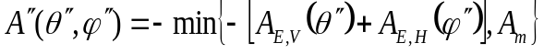
Maximum directional gain of an antenna element G_{E,max} | 5.5 dBi
(M_{g}, N_{g}, M, N, P) ^{note} | For 30GHz: (1, 1, 8, 16, 2)
(d_{v}, d_{h}) | (0.5λ, 0.5λ)
Note: An additional 3dB gain is added to the total beamforming gain to account for the two polarization directions. Boresight direction is horizontal.

For TN UE, the antenna parameters refer to TR 38.803 and are defined in Table 6a.2.3.2-2.
Table 6a.2.3.2-2: TN UE antenna parameters
Parameter | Values
Antenna element vertical radiation pattern (dB) | 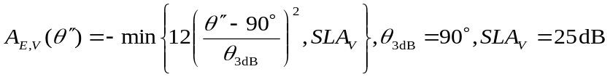
Antenna element horizontal radiation pattern (dB) | 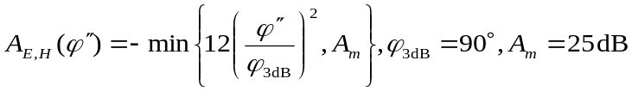
Combining method for 3D antenna element pattern (dB)
Maximum directional gain of an antenna element GE,max | 5 dBi
(Mg, Ng, M, N, P) | (1, 1, 2, 2, 2)
(dv, dh) | (0.5λ, 0.5λ)
UE orientation | Random orientation in the azimuth domain: uniformly distributed between -90 and 90 degrees*  Fixed elevation: 90 degrees
NOTE: This is done to emulate two panels: the configuration is equivalent to 2 panels with 180 shift in horizontal orientation and UE orientation uniformly distributed in the azimuth domain between -180 and 180 degrees.

6a.2.4 ACIR model
ACLR modelling for TN and NTN co-existence study referring to clause 5.1.1.4.1 and 5.1.1.4.2 in TR 36.942[8] is used as baseline. The number of RBs refers to Table 6a.2.2.1-3 and Table 6a.2.2.4-1 respectively.

6a.2.5 Propagation model
Propagation models between NTN and TN components used for the coexistence study are listed in Table 6a.2.5-1.
Table 6a.2.5-1: Propogation models between NTN and TN
Link | Propagation model
TN BS to Fixed VSAT on roof | Free space path loss
TN BS to L-ESIM at 1.5 m | UMa as in 3GPP TR 38.803
TN BS to TN UE | UMa as in 3GPP TR 38.803
TN UE to Fixed VSAT on roof | UMa as in 3GPP TR 38.803 (BS is to be replaced with VSAT)
TN UE to L-ESIM | Umi
Satellite to TN BS/UE | 3GPP TR 38.821
Satellite to VSAT/ESIM | 3GPP TR 38.821
TN BS to Satellite | 3GPP TR 38.821
Note1: For the propagation models which use the 3GPP TR 38.821 [3], to use same assumptions as in [3] and consider the atmospheric losses and the scintillation losses.
Note2: TN BS height is 25m

6a.2.6 Transmission power control model

6a.2.6.1 UL TPC
Following UL power control model for both NTN and TN are used as starting point.
Where,
- P_{max} = maximum UE Tx power, i.e. 23 dBm for TN UE, and 33 dBm for fixed VSAT NTN UE;
- R_{min} = minimum power reduction ratio, i.e. -63 dB for TN UE, and [-63 dB by assuming NTN UE min Tx power as -30dBm as starting point] for NTN UE;
- CL_{x-ile} and γ are set as following:
- γ = 1;
- CL_{x-ile} = –SNR_target + Pmax – Thermal Noise – BS/SAN_NoiseFigure - 10*log10(BW), considering SNR_target is 15dB and BW is actual UL BW.

6a.2.6.2 DL TPC
For downlink scenario, no power control scheme is applied.

6a.2.7 Received power model
See Section 6.2.7.

6a.2.8 Performance metric
See Section 6.2.8.

6a.2.9 Throughput ~ SNR mapping
See Section 6.2.9. [Further discuss the applicability of the mapping for NTN link.]

6a.3 Co-existence simulation methodology for 17/27GHz

6a.3.1 Simulation procedure
See Section 6.3.1, noting the FRF and network deployment for NTN and TN in above 10GHz are specified accordingly.
Following approaches for the deployment of NTN UE and satellite are used:
- The satellite should be generated in the visible area/sky of NTN UE;
- NTN UEs point to the satellite accurately;
- The position of the satellite should guarantee that NTN UE vertical angle towards the satellite;
- For calibration, use 30 degree and 90 degree instead of the range;
- SAN elevation angle value, 25 & 90 degree (computed from the centre of the beam), for co-existence -simulation;
- Horizontal angle of NTN UEs should be calculated based on the satellite position;
- Use 35m as minimum distance assumed between VSAT and TN BS for co-ex study.

6a.3.2 Methods and principle to process co-existence simulation results
See Section 6.3.2.

6a.4 Co-existence simulation results for 17/27GHz

6a.4.1 Scenario 1a: 27GHz NTN UL interfering TN UL
The co-existence results from all concerned options in this scenario were evaluated, and it has been agreed to select the 5% throughput loss of NR-NTN GEO UL and NR-NTN LEO1200 UL interfering the NR UL equipped with AAS antenna 25 degree elevation angle that deployed in urban environment as the most stringent case.
Table 6a.4.1-1 Simulation results for average throughput loss for Scenario 1a - NTN GEO
ACIR(dB) | 0.0 | 2.0 | 4.0 | 5.0 | 6.0 | 8.0 | 10.0 | 12.0 | 14.0 | 15.0 | 16.0 | 18.0 | 20.0
Ericsson | 3.1 |  |  |  |  |  | 0.9 |  |  |  |  |  | 0.2
ZTE | 6.7 | 5.3 | 4.1 |  | 3.3 | 2.4 | 1.8 | 1.3 | 0.9 |  | 0.6 | 0.4 | 0.3
Samsung | 2.3 | 1.8 | 1.3 |  | 1.0 | 0.8 | 0.6 | 0.4 | 0.3 |  | 0.2 | 0.2 | 0.1
Huawei |  |  |  |  | 0.0 | 0.0 | 0.0
CATT | 10.8 | 8.4 | 6.4 |  | 4.8 | 3.5 | 2.5 | 1.8 | 1.3 |  | 0.9 | 0.6 | 0.4
Qualcomm | 7.60 |  |  | 4.6 |  |  | 2.5 |  |  | 1.3

Figure 6a.4.1-1 Simulation results for average throughput loss for Scenario 1a - NTN GEO

Table 6a.4.1-2 Interpolated ACIR values for Scenario 1a to meet the 5% throughput loss criteria - NTN GEO
Company | Interpolated required ACIR
Ericsson | 0.00
ZTE | 2.50
Samsung | 0.00
Huawei | 0.00
CATT | 5.80
Qualcomm | 5.00
NOTE: According to the principles, these values are not treated for later process.

Table 6a.4.1-3 Simulation results for 5%-tile throughput loss for Scenario 1a - NTN GEO
ACIR(dB) | 0.0 | 2.0 | 4.0 | 5.0 | 6.0 | 8.0 | 10.0 | 12.0 | 14.0 | 15.0 | 16.0 | 18.0 | 20.0
Ericsson | 11.9 |  |  |  |  |  | 4.6 |  |  |  |  |  | 1.7
ZTE | 17.1 | 12.3 | 8.6 |  | 5.4 | 3.8 | 2.6 | 2.1 | 1.2 |  | 0.9 | 0.4 | 0.4
Samsung | 4.3 | 3.2 | 2.4 |  | 1.7 | 1.2 | 1.0 | 0.7 | 0.5 |  | 0.3 | 0.2 | 0.2
Huawei |  |  |  |  | 0.0 | 0.0 | 0.0
CATT | 35.5 | 26.8 | 19.8 |  | 13.1 | 8.5 | 5.8 | 4.4 | 2.9 |  | 1.6 | 0.9 | 0.6
Qualcomm | 41.8 |  |  | 24.7 |  |  | 13.9 |  |  | 6.0

Figure 6a.4.1-2 Simulation results for 5%-tile throughput loss for Scenario 1a - NTN GEO

Table 6a.4.1-4 Interpolated ACIR values for Scenario 1a to meet the 5% throughput loss criteria - NTN GEO
Company | Interpolated required ACIR
Ericsson | 9.50
ZTE | 6.50
Samsung | 0.00
Huawei | 0.00
CATT | 11.10
Qualcomm | 15.00

Table 6a.4.1-5 Averaged ACIR of 5%-tile values in the above worse case for Scenario 1a - NTN GEO
Averaged required ACIR
10.5

Table 6a.4.1-6 Simulation results for average throughput loss for Scenario 1a - NTN LEO1200
Company | 0 | 2 | 4 | 5 | 6 | 8 | 10 | 12 | 14 | 15 | 16 | 18 | 20
Ericsson | 6.9 |  |  |  |  |  | 2.3 |  |  |  |  |  | 0.7
ZTE | 3.60 | 2.77 | 2.14 |  | 1.59 | 1.13 | 0.77 | 0.53 | 0.38 |  | 0.26 | 0.16 | 0.11
Samsung | 2.30 | 1.77 | 1.35 |  | 1.02 | 0.77 | 0.57 | 0.42 | 0.31 |  | 0.23 | 0.17 | 0.12
Huawei |  |  |  |  | 0.00 | 0.00 | 0.00
CATT | 9.8 | 7.7 | 5.9 |  | 4.4 | 3.2 | 2.4 | 1.7 | 1.2 |  | 0.8 | 0.6 | 0.4
Qualcomm | 7.10 |  |  | 4.20 |  |  | 2.30 |  |  | 1.20

Figure 6a.4.1-3 Simulation results for average throughput loss for Scenario 1a - NTN LEO1200

Table 6a.4.1-7 Interpolated ACIR values for Scenario 1a to meet the 5% throughput loss criteria - NTN LEO1200
Company | Interpolated required ACIR
Ericsson | 4.10
ZTE | 0.00
Samsung | 0.00
Huawei | 0.00
CATT | 5.20
Qualcomm | 5.00
NOTE: According to the principles, these values are not treated for later process.

Table 6a.4.1-8 Simulation results for 5%-tile throughput loss for Scenario 1a - NTN LEO1200
ACIR[dB] | 0 | 2 | 4 | 5 | 6 | 8 | 10 | 12 | 14 | 15 | 16 | 18 | 20
Ericsson | 35.0 |  |  |  |  |  | 13.0 |  |  |  |  |  | 5.0
ZTE | 7.75 | 5.97 | 4.10 |  | 3.24 | 2.47 | 0.79 | 0.20 | 0.03 |  | 0.03 | 0.02 | 0.02
Samsung | 4.56 | 3.30 | 2.63 |  | 1.80 | 1.32 | 0.89 | 0.60 | 0.46 |  | 0.35 | 0.21 | 0.13
Huawei |  |  |  |  | 0.00 | 0.00 | 0.00
CATT | 35.04 | 25.78 | 18.92 |  | 13.58 | 8.57 | 5.96 | 4.43 | 2.70 |  | 1.27 | 0.63 | 0.51
Qualcomm | 39.60 |  |  | 23.50 |  |  | 12.90 |  |  | 5.30

Figure 6a.4.1-4 Simulation results for 5%-tile throughput loss for Scenario 1a - NTN LEO1200

Table 6a.4.1-9 Interpolated ACIR values for Scenario 1a to meet the 5% throughput loss criteria - NTN LEO1200
Company | Interpolated required ACIR
Ericsson | 20.00
ZTE | 3.10
Samsung | 0.00
Huawei | 0.00
CATT | 11.30
Qualcomm | 15.00
NOTE: According to the principles, some of the values are not treated for later process.

Table 6a.4.1-10 Averaged required ACIR of 5%-tile values in the above worse case for Scenario 1a - NTN LEO1200
Averaged required ACIR
13.15

The following values were also reported by the companies for GEO at 90° elevation angle, with UE NF= 2.5dB and UE height 1.5m (corresponding to L-ESIM).
Table 6a.4.1-11 Simulation results for average throughput loss for Scenario 1a - NTN GEO 90° elevation angle
Required ACIR [dB] |  | Company | 0 | 2 | 4 | 5 | 6 | 8 | 10 | 12 | 14 | 15 | 16 | 18 | 20 | 22 | 24 | 25 | 26 | 28 | 30 | 32 | 34 | 36 | 38 | 40
Throughput Loss | Average | ZTE | 0,93 | 0,77 | 0,60 |  | 0,47 | 0,29 | 0,22 | 0,15 | 0,13 |  | 0,09 | 0,08 | 0,06 | 0,02 | 0,02 |  | 0,02 | 0,01 | 0,01
Throughput Loss | Average | THALES | 2,81 | 2,41 | 2,02 |  | 1,62 | 1,23 | 0,83 | 0,71 | 0,58 |  | 0,45 | 0,33 | 0,20 | 0,17 | 0,14 |  | 0,10 | 0,07 | 0,04 | 0,03 | 0,02 | 0,02 | 0,01 | 0,00
Throughput Loss | Average | Ericsson | 0.5 |  |  |  |  |  | 0.2 |  |  |  |  |  | 0.0
Throughput Loss | Average | Qualcomm | 1,10 |  |  | 0,6 |  |  | 0,30 |  |  | 0,1 |  |  |  |  |  |  |  |  |  |  |  |  |  | 0,0
Throughput Loss | 5%-tile | ZTE | 1,54 | 0,78 | 0,47 |  | 0,23 | 0,05 | 0,04 | 0,00 | 0,00 |  | 0,00 | 0,00 | 0,00 | 0,00 | 0,00 |  | 0,00 | 0,00 | 0,00
Throughput Loss | 5%-tile | THALES | 16,95 | 13,63 | 10,32 |  | 7,00 | 3,68 | 0,36 | 0,29 | 0,22 |  | 0,15 | 0,07 | 0,00 | 0,00 | 0,00 |  | 0,00 | 0,00 | 0,00 | 0,00 | 0,00 | 0,00 | 0,00 | 0,00
Throughput Loss | 5%-tile | Ericsson | 3.0 |  |  |  |  |  | 1.7 |  |  |  |  |  | 0.0
Throughput Loss | 5%-tile | Qualcomm | 6,0 |  |  | 2,4 |  |  | 0,8 |  |  | 0,4 |  |  |  |  |  |  |  |  |  |  |  |  |  | 0,0

The following values were also reported by the companies for GEO at 25° elevation angle, with UE NF= 2.5dB and UE height 1.5m (corresponding to L-ESIM).
Table 6a.4.1-12 Simulation results for average throughput loss for Scenario 1a - NTN GEO 25° elevation angle
Required ACIR [dB] |  | Company | 0 | 2 | 4 | 5 | 6 | 8 | 10 | 12 | 14 | 15 | 16 | 18 | 20 | 22 | 24 | 25 | 26 | 28 | 30 | 32 | 34 | 36 | 38 | 40
Throughput Loss | Average | ZTE | 1,38 | 1,19 | 0,98 |  | 0,78 | 0,67 | 0,52 | 0,40 | 0,31 |  | 0,26 | 0,17 | 0,14 | 0,11 | 0,10 |  | 0,06 | 0,04 | 0,04
Throughput Loss | Average | THALES | 2,81 | 2,41 | 2,02 |  | 1,62 | 1,23 | 0,83 | 0,71 | 0,58 |  | 0,45 | 0,33 | 0,20 | 0,17 | 0,14 |  | 0,10 | 0,07 | 0,04 | 0,03 | 0,02 | 0,02 | 0,01 | 0,00
Throughput Loss | Average | Ericsson | 1.2 |  |  |  |  |  | 0.5 |  |  |  |  |  | 0.2
Throughput Loss | Average | Qualcomm | 8,40 |  |  | 6 |  |  | 4,30 |  |  | 3 |  |  | 2,00 |  |  | 1,3 |  |  | 0,10 |  |  |  |  | 0,0
Throughput Loss | 5%-tile | ZTE | 4,55 | 3,32 | 2,81 |  | 2,29 | 1,79 | 0,93 | 0,88 | 0,81 |  | 0,81 | 0,59 | 0,32 | 0,28 | 0,28 |  | 0,28 | 0,20 | 0,08
Throughput Loss | 5%-tile | THALES | 16,95 | 13,63 | 10,32 |  | 7,00 | 3,68 | 0,36 | 0,29 | 0,22 |  | 0,15 | 0,07 | 0,00 | 0,00 | 0,00 |  | 0,00 | 0,00 | 0,00 | 0,00 | 0,00 | 0,00 | 0,00 | 0,00
Throughput Loss | 5%-tile | Ericsson | 9.1 |  |  |  |  |  | 4.4 |  |  |  |  |  | 1.7
Throughput Loss | 5%-tile | Qualcomm | 64,4 |  |  | 47,3 |  |  | 34,0 |  |  | 23,3 |  |  | 15,5 |  |  | 10,3 |  |  | 6,5 |  |  |  |  | 0,0

The following values were also reported by the companies for LEO1200km at 90° elevation angle, with UE NF= 2.5dB and UE height 1.5m (corresponding to L-ESIM).
Table 6a.4.1-13 Simulation results for average throughput loss for Scenario 1a - NTN LEO@1200km 90° elevation angle
Required ACIR [dB] |  | Company | 0 | 2 | 4 | 5 | 6 | 8 | 10 | 12 | 14 | 15 | 16 | 18 | 20 | 22 | 24 | 25 | 26 | 28 | 30 | 32 | 34 | 36 | 38 | 40
Throughput Loss | Average | Qualcomm | 0,70 |  |  | 0,30 |  |  | 0,17 |  |  | 0,07
Throughput Loss | Average | THALES | 0,63 | 0,53 | 0,43 |  | 0,32 | 0,22 | 0,12 | 0,10 | 0,08 |  | 0,06 | 0,03 | 0,01 | 0,01 | 0,01 |  | 0,01 | 0,00 | 0,00 | 0,00 | 0,00 | 0,00 | 0,00 | 0,00
Throughput Loss | 5%-tile | Qualcomm | 3,20 |  |  | 1,20 |  |  | 0,60 |  |  | 0,30
Throughput Loss | 5%-tile | THALES | 1,29 | 1,03 | 0,77 |  | 0,52 | 0,26 | 0,00 | 0,00 | 0,00 |  | 0,00 | 0,00 | 0,00 | 0,00 | 0,00 |  | 0,00 | 0,00 | 0,00 | 0,00 | 0,00 | 0,00 | 0,0 | 0,00

The following values were also reported by the companies for LEO1200km at 25° elevation angle, with UE NF= 2.5dB and UE height 1.5m (corresponding to L-ESIM).
Table 6a.4.1-14 Simulation results for average throughput loss for Scenario 1a - NTN LEO@1200km 25° elevation angle
Required ACIR [dB] |  | Company | 0 | 2 | 4 | 5 | 6 | 8 | 10 | 12 | 14 | 15 | 16 | 18 | 20 | 22 | 24 | 25 | 26 | 28 | 30 | 32 | 34 | 36 | 38 | 40
Throughput Loss | Average | Qualcomm | 8,00 |  |  | 5,70 |  |  | 4,10 |  |  | 2,80 |  |  | 1,90 |  |  | 1,30 |  |  | 0,80
Throughput Loss | Average | THALES | 2,14 | 1,84 | 1,54 |  | 1,24 | 0,93 | 0,63 | 0,53 | 0,43 |  | 0,33 | 0,23 | 0,13 | 0,11 | 0,08 |  | 0,06 | 0,04 | 0,02 | 0,02 | 0,01 | 0,01 | 0,01 | 0,00
Throughput Loss | 5%-tile | Qualcomm | 61,50 |  |  | 45,00 |  |  | 31,70 |  |  | 21,40 |  |  | 15,00 |  |  | 9,90 |  |  | 6,00
Throughput Loss | 5%-tile | THALES | 15,82 | 13,04 | 10,26 |  | 7,48 | 4,70 | 1,91 | 1,67 | 1,44 |  | 1,20 | 0,96 | 0,72 | 0,57 | 0,43 |  | 0,29 | 0,14 | 0,00 | 0,00 | 0,00 | 0,00 | 0,00 | 0,00

The following values were also reported by the companies for LEO600km at 90° elevation angle, with UE NF= 2.5dB and UE height 1.5m (corresponding to L-ESIM).
Table 6a.4.1-15 Simulation results for average throughput loss for Scenario 1a - NTN LEO@600km 90° elevation angle
Required ACIR [dB] |  | Company | 0 | 2 | 4 | 5 | 6 | 8 | 10 | 12 | 14 | 15 | 16 | 18 | 20 | 22 | 24 | 25 | 26 | 28 | 30 | 32 | 34 | 36 | 38 | 40
Throughput Loss | Average | Qualcomm | 0,30 |  |  | 0,10 |  |  | 0,07 |  |  | 0,02
Throughput Loss | Average | THALES | 0,24 | 0,20 | 0,16 |  | 0,12 | 0,08 | 0,03 | 0,03 | 0,02 |  | 0,02 | 0,01 | 0,00 | 0,00 | 0,00 | 0,00 | 0,00 | 0,00 | 0,00 | 0,00 | 0,00 | 0,00 | 0,00 | 0,00
Throughput Loss | 5%-tile | Qualcomm | 1,30 |  |  | 0,60 |  |  | 0,26 |  |  | 0,13
Throughput Loss | 5%-tile | THALES | 0,47 | 0,38 | 0,28 |  | 0,19 | 0,09 | 0,00 | 0,00 | 0,00 |  | 0,00 | 0,00 | 0,00 | 0,00 | 0,00 | 0,00 | 0,00 | 0,00 | 0,00 | 0,00 | 0,00 | 0,00 | 0,00 | 0,00

The following values were also reported by the companies for LEO600km at 25° elevation angle, with UE NF= 2.5dB and UE height 1.5m (corresponding to L-ESIM).
Table 6a.4.1-16 Simulation results for average throughput loss for Scenario 1a - NTN LEO@600km 25° elevation angle
Required ACIR [dB] |  | Company | 0 | 2 | 4 | 5 | 6 | 8 | 10 | 12 | 14 | 15 | 16 | 18 | 20 | 22 | 24 | 25 | 26 | 28 | 30 | 32 | 34 | 36 | 38 | 40
Throughput Loss | Average | Qualcomm | 7,30 |  |  | 5,20 |  |  | 3,70 |  |  | 2,50 |  |  | 1,70 |  |  | 1,10 |  |  | 0,70
Throughput Loss | Average | THALES | 1,00 | 0,85 | 0,71 |  | 0,56 | 0,42 | 0,28 | 0,23 | 0,19 |  | 0,14 | 0,10 | 0,05 | 0,04 | 0,03 |  | 0,02 | 0,02 | 0,01 | 0,01 | 0,00 | 0,00 | 0,00 | 0,00
Throughput Loss | 5%-tile | Qualcomm | 56,60 |  |  | 41,20 |  |  | 28,90 |  |  | 19,90 |  |  | 13,10 |  |  | 8,20 |  |  | 5,40
Throughput Loss | 5%-tile | THALES | 7,28 | 5,85 | 4,43 |  | 3,01 | 1,58 | 0,16 | 0,13 | 0,09 |  | 0,06 | 0,03 | 0,00 | 0,00 | 0,00 |  | 0,00 | 0,00 | 0,00 | 0,00 | 0,00 | 0,00 | 0,00 | 0,00

6a.4.2 Scenario 2a: 27GHz TN UL interfering NTN UL
The co-existence results from all concerned options in this scenario were evaluated, and it has been agreed to select the 5% throughput loss NR UL interfering the NR-NTN GEO UL and NR-NTN LEO1200 UL that 25 degrees elevation angle and deployed in urban environment as the most stringent case.
Table 6a.4.2-1 Simulation results for average throughput loss for Scenario 2a - NTN GEO
ACIR dB | 0 | 2 | 4 | 5 | 6 | 8 | 10 | 12 | 14 | 15 | 16 | 18 | 20
Ericsson | 1.0 |  |  |  |  |  | 0.1 |  |  |  |  |  | 0.0
ZTE | 1.79 | 1.14 | 0.73 |  | 0.46 | 0.29 | 0.18 | 0.12 | 0.07 |  | 0.05 | 0.03 | 0.02
Samsung | 0.02 | 0.02 | 0.01 |  | 0.01 | 0.00 | 0.00 | 0.00 | 0.00 |  | 0.00 | 0.00 | 0.00
Huawei |  |  |  |  | 0.00 | 0.00 | 0.00
CATT | 46.3 | 37.5 | 29.3 |  | 22.1 | 16.1 | 11.4 | 7.8 | 5.2 |  | 3.4 | 2.2 | 1.4
Qualcomm | 18.30 |  |  | 7.70 |  |  | 2.70 |  |  | 0.90

Figure 6a.4.2-1 Simulation results for average throughput loss for Scenario 2a - NTN GEO

Table 6a.4.2-2 Simulation results for 5%-tile throughput loss for Scenario 2a - NTN GEO
ACIR dB | 0 | 2 | 4 | 5 | 6 | 8 | 10 | 12 | 14 | 15 | 16 | 18 | 20
Ericsson | NA |  |  |  |  |  | NA |  |  |  |  |  | NA
ZTE | 1.93 | 1.24 | 0.79 |  | 0.50 | 0.32 | 0.20 | 0.13 | 0.08 |  | 0.05 | 0.03 | 0.02
Samsung | NaN | NaN | NaN |  | NaN | NaN | NaN | NaN | NaN |  | NaN | NaN | NaN
Huawei |  |  |  |  | 0.00 | 0.00 | 0.00
CATT | 58.87 | 49.68 | 40.51 |  | 31.8 | 24.08 | 17.54 | 12.34 | 8.42 |  | 5.62 | 3.68 | 2.38
Qualcomm | NaN |  |  | NaN |  |  | NaN |  |  | NaN

Figure 6a.4.2-2 Simulation results for 5%-tile throughput loss for Scenario 2a - NTN GEO

Table 6a.4.2-3 Interpolated ACIR values for Scenario 2a to meet the 5% throughput loss criteria - NTN GEO
Company | Interpolated required ACIR
Ericsson | 0.00
ZTE | 0.00
Samsung | 0.00
Huawei | 0.00
CATT | 37.50
Qualcomm | 7.7

Table 6a.4.2-4 Averaged ACIR of 5%-tile values in the above worse case for Scenario 2a - NTN GEO
Averaged required ACIR
1.54

Table 6a.4.2-5 Simulation results for average throughput loss for Scenario 2a - NTN LEO1200
ACIR dB | 0 | 2 | 4 | 5 | 6 | 8 | 10 | 12 | 14 | 15 | 16 | 18
Ericsson | 2.3 |  |  |  |  |  | 0.2
ZTE | 3.98 | 2.58 | 1.66 |  | 1.06 | 0.67 | 0.43 | 0.27 | 0.17 |  | 0.11 | 0.07
Samsung | 0.38 | 0.24 | 0.15 |  | 0.10 | 0.06 | 0.04 | 0.02 | 0.02 |  | 0.01 | 0.01
Huawei |  |  |  |  | 0.00 | 0.00 | 0.00
CATT | 29.5 | 22.3 | 16.3 |  | 11.5 | 7.9 | 5.3 | 3.5 | 2.3 |  | 1.5 | 0.9
Qualcomm | 10.30 |  |  | 3.90 |  |  | 1.30 |  |  | 0.40

Figure 6a.4.2-3 Simulation results for average throughput loss for Scenario 2a - NTN LEO1200

Table 6a.4.2-6 Simulation results for 5%-tile throughput loss for Scenario 2a - NTN LEO1200
ACIR dB | 0 | 2 | 4 | 5 | 6 | 8 | 10 | 12 | 14 | 15 | 16 | 18
Ericsson | NA |  |  |  |  |  | NA
ZTE | 3.98 | 2.58 | 1.66 |  | 1.06 | 0.67 | 0.43 | 0.27 | 0.17 |  | 0.11 | 0.07
Samsung | NaN | NaN | NaN |  | NaN | NaN | NaN | NaN | NaN |  | NaN | NaN
Huawei |  |  |  |  | 0.00 | 0.00 | 0.00
CATT | 41.34 | 32.60 | 24.75 |  | 18.1 | 12.76 | 8.73 | 5.83 | 3.83 |  | 2.48 | 1.59
Qualcomm | NaN |  |  | NaN |  |  | NaN |  |  | NaN

Figure 6a.4.2-4 Simulation results for 5%-tile throughput loss for Scenario 2a - NTN LEO1200

Table 6a.4.2-7 Interpolated ACIR values for Scenario 2a to meet the 5% throughput loss criteria - NTN LEO1200
Company | Interpolated required ACIR
Ericsson | 0.00
ZTE | 0.00
Samsung | 0.00
Huawei | 0.00
CATT | 33.95
Qualcomm | 4.10

Table 6a.4.2-8 Averaged ACIR of 5%-tile values in the above worse case for Scenario 2a - NTN LEO1200
Averaged required ACIR
0.82

The following values were also reported by the companies for GEO at 25° elevation angle, with UE NF= 2.5dB and UE height 1.5m (corresponding to L-ESIM).
Table 6a.4.2-9 Simulation results for average throughput loss for Scenario 2a - NTN GEO 25° elevation angle
Required ACIR [dB] |  | Company | 0 | 2 | 4 | 6 | 8 | 10 | 12 | 14 | 16 | 18 | 20 | 22 | 24 | 26 | 28 | 30 | 32 | 34 | 36 | 38 | 40
Throughput Loss | Average | ZTE | 1,76 | 1,12 | 0,71 | 0,45 | 0,29 | 0,18 | 0,11 | 0,07 | 0,05 | 0,03 | 0,02 | 0,01 | 0,01 | 0,00 | 0,00 | 0,00
Throughput Loss | Average | THALES | 17,96 | 14,85 | 11,75 | 8,64 | 5,54 | 2,43 | 2,00 | 1,56 | 1,13 | 0,69 | 0,25 | 0,21 | 0,16 | 0,12 | 0,07 | 0,03 | 0,02 | 0,02 | 0,01 | 0,01 | 0,00
Throughput Loss | 5%-tile | ZTE | 1,87 | 1,19 | 0,76 | 0,48 | 0,30 | 0,19 | 0,12 | 0,08 | 0,05 | 0,03 | 0,02 | 0,01 | 0,01 | 0,00 | 0,00 | 0,00
Throughput Loss | 5%-tile | THALES | 22,09 | 18,37 | 14,66 | 10,94 | 7,23 | 3,51 | 2,88 | 2,26 | 1,63 | 1,00 | 0,37 | 0,31 | 0,24 | 0,17 | 0,11 | 0,04 | 0,03 | 0,03 | 0,02 | 0,01 | 0,01

The following values were also reported by the companies for LEO1200km at 25° elevation angle, with UE NF= 2.5dB and UE height 1.5m (corresponding to L-ESIM).
Table 6a.4.2-10 Simulation results for average throughput loss for Scenario 2a - NTN LEO@1200km 25° elevation angle
Required ACIR [dB] |  | Company | 0 | 2 | 4 | 6 | 8 | 10 | 12 | 14 | 16 | 18 | 20 | 22 | 24 | 26 | 28 | 30 | 32 | 34 | 36 | 38 | 40
Throughput Loss | Average | THALES | 16,72 | 13,81 | 10,91 | 8,01 | 5,10 | 2,20 | 1,80 | 1,41 | 1,02 | 0,62 | 0,23 | 0,19 | 0,15 | 0,10 | 0,06 | 0,02 | 0,02 | 0,01 | 0,01 | 0,01 | 0,00
Throughput Loss | 5%-tile | THALES | 15,16 | 12,51 | 9,86 | 7,21 | 4,56 | 1,91 | 1,57 | 1,22 | 0,88 | 0,54 | 0,20 | 0,16 | 0,13 | 0,09 | 0,06 | 0,02 | 0,02 | 0,01 | 0,01 | 0,01 | 0,00

The following values were also reported by the companies for LEO600km at 25° elevation angle, with UE NF= 2.5dB and UE height 1.5m (corresponding to L-ESIM).
Table 6a.4.2-11 Simulation results for average throughput loss for Scenario 2a - NTN LEO@600km 25° elevation angle
Required ACIR [dB] |  | Company | 0 | 2 | 4 | 6 | 8 | 10 | 12 | 14 | 16 | 18 | 20 | 22 | 24 | 26 | 28 | 30 | 32 | 34 | 36 | 38 | 40
Throughput Loss | Average | THALES | 17,35 | 14,34 | 11,33 | 8,32 | 5,31 | 2,30 | 1,89 | 1,47 | 1,06 | 0,65 | 0,24 | 0,20 | 0,15 | 0,11 | 0,07 | 0,02 | 0,02 | 0,02 | 0,01 | 0,01 | 0,00
Throughput Loss | 5%-tile | THALES | 17,33 | 14,31 | 11,29 | 8,27 | 5,25 | 2,23 | 1,83 | 1,43 | 1,03 | 0,63 | 0,23 | 0,19 | 0,15 | 0,11 | 0,07 | 0,03 | 0,02 | 0,02 | 0,01 | 0,01 | 0,00

6a.4.3 Scenario 3a: 27GHz NTN UL interfering TN DL
The co-existence results from all concerned options in this scenario were evaluated, and it has been agreed to select the 5% throughput loss NR UL interfering the NR-NTN GEO UL and NR-NTN LEO1200 UL that 25 degrees elevation angle, and deployed in urban environment as the most stringent case.
Table 6a.4.3-1 Simulation results for average and 5%-tile throughput loss for Scenario 3a - NTN GEO
Required ACIR [dB] |  | Company | 0 | 2 | 4 | 6 | 8 | 10 | 12 | 14 | 16 | 18 | 20
Throughput Loss | Average | ZTE | 0.07 | 0.07 | 0.07 | 0.07 | 0.07 | 0.06 | 0.06 | 0.06 | 0.06 | 0.06 | 0.06
Throughput Loss | Average | Samsung | 0.40 | 0.28 | 0.20 | 0.14 | 0.10 | 0.07 | 0.05 | 0.03 | 0.02 | 0.02 | 0.01
Throughput Loss | Average | Huawei |  |  |  | 0.00 | 0.00 | 0.00
Throughput Loss | Average | Qualcomm | 0.00
Throughput Loss | Average | CATT | 0.0 | 0.0 | 0.0 | 0.0 | 0.0 | 0.0 | 0.0 | 0.0 | 0.0 | 0.0 | 0.0
Throughput Loss | 5%-tile | ZTE | 0.49 | 0.49 | 0.49 | 0.49 | 0.49 | 0.33 | 0.33 | 0.33 | 0.33 | 0.27 | 0.27
Throughput Loss | 5%-tile | Samsung | 1.16 | 0.76 | 0.54 | 0.33 | 0.22 | 0.16 | 0.13 | 0.09 | 0.05 | 0.04 | 0.01
Throughput Loss | 5%-tile | CATT | 0.00 | 0.00 | 0.00 | 0.00 | 0.00 | 0.00 | 0.00 | 0.00 | 0.00 | 0.00 | 0.00
Throughput Loss | 5%-tile | Qualcomm | 0.0

Table 6a.4.3-2 Interpolated ACIR values for Scenario 3a to meet the 5% throughput loss criteria - NTN GEO
Company | Interpolated required ACIR
ZTE | 0
Samsung | 0
CATT | 0
Qualcomm | 0

Table 6a.4.3-3 Averaged ACIR of 5%-tile values in the above worse case for Scenario 3a - NTN GEO
Averaged required ACIR
0

Table 6a.4.3-4 Simulation results for average and 5%-tile throughput loss for Scenario 3a - NTN LEO1200
Required ACIR [dB] |  | ACIR | 0 | 2 | 4 | 6 | 8 | 10 | 12 | 14 | 16 | 18 | 20
Throughput Loss | Average | ZTE | 0.03 | 0.03 | 0.03 | 0.03 | 0.03 | 0.03 | 0.03 | 0.02 | 0.02 | 0.02 | 0.02
Throughput Loss | Average | Samsung | 0.41 | 0.29 | 0.21 | 0.15 | 0.11 | 0.08 | 0.06 | 0.04 | 0.03 | 0.02 | 0.02
Throughput Loss | Average | Huawei |  |  |  | 0.00 | 0.00 | 0.00
Throughput Loss | Average | Qualcomm | 0.00
Throughput Loss | Average | CATT | 0.0 | 0.0 | 0.0 | 0.0 | 0.0 | 0.0 | 0.0 | 0.0 | 0.0 | 0.0 | 0.0
Throughput Loss | 5%-tile | ZTE | 0.37 | 0.37 | 0.37 | 0.37 | 0.37 | 0.37 | 0.27 | 0.27 | 0.27 | 0.27 | 0.27
Throughput Loss | 5%-tile | Samsung | 1.35 | 0.98 | 0.75 | 0.59 | 0.40 | 0.27 | 0.17 | 0.14 | 0.10 | 0.09 | 0.08
Throughput Loss | 5%-tile | Huawei |  |  |  | 0.00 | 0.00 | 0.00
Throughput Loss | 5%-tile | Qualcomm | 0.0
Throughput Loss | 5%-tile | CATT | 0.00 | 0.00 | 0.00 | 0.00 | 0.00 | 0.00 | 0.00 | 0.00 | 0.00 | 0.00 | 0.00

Table 6a.4.3-5 Interpolated ACIR values for Scenario 3a to meet the 5% throughput loss criteria - NTN LEO1200
Company | Interpolated required ACIR
ZTE | 0
Samsung | 0
CATT | 0
Qualcomm | 0

Table 6a.4.3-6 Averaged ACIR of 5%-tile values in the above worse case for Scenario 3a - NTN LEO1200
Averaged required ACIR
0

The following values were also reported by the companies for GEO at 25° elevation angle, with UE NF= 2.5dB and UE height 1.5m (corresponding to L-ESIM).
Table 6a.4.3-7 Simulation results for average throughput loss for Scenario 3a - NTN GEO 25° elevation angle
Required ACIR [dB] |  | Company | 0 | 2 | 4 | 6 | 8 | 10 | 12 | 14 | 16 | 18 | 20 | 22 | 24 | 26 | 28 | 30 | 32 | 34 | 36 | 38 | 40
Throughput Loss | Average | ZTE | 0,05 | 0,05 | 0,05 | 0,05 | 0,05 | 0,05 | 0,05 | 0,05 | 0,05 | 0,05 | 0,04 | 0,04 | 0,04 | 0,04 | 0,04 | 0,04
Throughput Loss | Average | THALES | 1,90 | 1,67 | 1,44 | 1,20 | 0,97 | 0,74 | 0,64 | 0,54 | 0,44 | 0,35 | 0,25 | 0,21 | 0,18 | 0,14 | 0,11 | 0,07 | 0,06 | 0,05 | 0,04 | 0,03 | 0,02
Throughput Loss | 5%-tile | ZTE | 0,63 | 0,50 | 0,50 | 0,50 | 0,50 | 0,50 | 0,47 | 0,47 | 0,47 | 0,47 | 0,47 | 0,42 | 0,42 | 0,38 | 0,38 | 0,27
Throughput Loss | 5%-tile | THALES | 10,39 | 8,99 | 7,60 | 6,20 | 4,80 | 3,40 | 2,83 | 2,27 | 1,71 | 1,14 | 0,58 | 0,46 | 0,35 | 0,23 | 0,12 | 0,00 | 0,00 | 0,00 | 0,00 | 0,00 | 0,00

The following values were also reported by the companies for LEO1200km at 25° elevation angle, with UE NF= 2.5dB and UE height 1.5m (corresponding to L-ESIM).
Table 6a.4.3-8 Simulation results for average throughput loss for Scenario 3a - NTN LEO@1200km 25° elevation angle
Required ACIR [dB] |  | Company | 0 | 2 | 4 | 6 | 8 | 10 | 12 | 14 | 16 | 18 | 20 | 22 | 24 | 26 | 28 | 30 | 32 | 34 | 36 | 38 | 40
Throughput Loss | Average | THALES | 1,09 | 0,95 | 0,80 | 0,66 | 0,51 | 0,37 | 0,32 | 0,26 | 0,21 | 0,16 | 0,11 | 0,10 | 0,08 | 0,06 | 0,05 | 0,03 | 0,03 | 0,02 | 0,02 | 0,01 | 0,01
Throughput Loss | 5%-tile | THALES | 3,78 | 3,44 | 3,10 | 2,76 | 2,41 | 2,07 | 1,86 | 1,64 | 1,43 | 1,21 | 1,00 | 0,80 | 0,60 | 0,40 | 0,20 | 0,00 | 0,00 | 0,00 | 0,00 | 0,00 | 0,00

The following values were also reported by the companies for LEO600km at 25° elevation angle, with UE NF= 2.5dB and UE height 1.5m (corresponding to L-ESIM).
Table 6a.4.3-9 Simulation results for average throughput loss for Scenario 3a - NTN LEO@600km 25° elevation angle
Required ACIR [dB] |  | Company | 0 | 2 | 4 | 6 | 8 | 10 | 12 | 14 | 16 | 18 | 20 | 22 | 24 | 26 | 28 | 30 | 32 | 34 | 36 | 38 | 40
Throughput Loss | Average | THALES | 0,82 | 0,71 | 0,61 | 0,50 | 0,40 | 0,30 | 0,25 | 0,21 | 0,16 | 0,12 | 0,07 | 0,06 | 0,05 | 0,04 | 0,02 | 0,01 | 0,01 | 0,01 | 0,00 | 0,00 | 0,00
Throughput Loss | 5%-tile | THALES | 5,63 | 4,84 | 4,05 | 3,26 | 2,47 | 1,68 | 1,41 | 1,14 | 0,86 | 0,59 | 0,32 | 0,32 | 0,31 | 0,31 | 0,31 | 0,31 | 0,25 | 0,18 | 0,12 | 0,06 | 0,00

6a.4.4 Scenario 4a: 27GHz TN DL interfering NTN UL
The co-existence results from all concerned options in this scenario were evaluated, and it has been agreed to select the 5% throughput loss NR UL interfering the NR-NTN GEO UL and NR-NTN LEO1200 UL that 25 degrees elevation angle and deployed in urban environment as the most stringent case.
Table 6a.4.4-1 Simulation results for average and 5%-tile throughput loss for Scenario 4a - NTN GEO
Required ACIR [dB] |  | Company | 0 | 2 | 4 | 5 | 6 | 8 | 10 | 12 | 14 | 15 | 16 | 18 | 20
Throughput Loss | Average | ZTE | 40.55 | 31.82 | 24.02 |  | 17.46 | 12.26 | 8.36 | 5.56 | 3.64 |  | 2.35 | 1.51 | 0.96
Throughput Loss | Average | Samsung | 59.43 | 50.55 | 41.64 |  | 33.11 | 25.40 | 18.82 | 13.46 | 9.34 |  | 6.32 | 4.19 | 2.73
Throughput Loss | Average | CATT | 19.4 | 14.1 | 10.0 |  | 6.8 | 4.6 | 3.0 | 2.0 | 1.3 |  | 0.8 | 0.5 | 0.3
Throughput Loss | Average | Qualcomm | 41.40 |  |  | 23.20 |  |  | 10.70 |  |  | 4.20
Throughput Loss | 5%-tile | ZTE | 45.23 | 35.74 | 27.12 |  | 19.78 | 13.93 | 9.51 | 6.34 | 4.15 |  | 2.68 | 1.72 | 1.10
Throughput Loss | 5%-tile | Samsung | NaN | NaN | NaN |  | NaN | NaN | NaN | NaN | NaN |  | NaN | NaN | NaN
Throughput Loss | 5%-tile | Huawei |  |  |  |  | 3.50 |  | 1.14
Throughput Loss | 5%-tile | Qualcomm | NaN | NaN | NaN |  | NaN | NaN | NaN | NaN | NaN |  | NaN | NaN | NaN
Throughput Loss | 5%-tile | CATT | 30.7 | 23.1 | 16.7 |  | 11.7 | 8.0 | 5.3 | 3.5 | 2.2 |  | 1.4 | 0.9 | 0.6

Figure 6a.4.4-1 Simulation results for average throughput loss for Scenario 4a - NTN GEO

Figure 6a.4.4-2 Simulation results for 5%-tile throughput loss for Scenario 4a - NTN GEO

Table 6a.4.4-2 Interpolated ACIR values for Scenario 4a to meet the 5% throughput loss criteria - NTN GEO
Company | Interpolated required ACIR
ZTE | 13.32
Samsung | 17.20
CATT | 12.22
Qualcomm | 14.38
Huawei | <6 (3.5% @ 6)

Table 6a.4.4-3 Averaged ACIR of 5%-tile values in the above worse case for Scenario 4a - NTN GEO
Averaged required ACIR
14.3

Table 6a.4.4-4 Simulation results for average and 5%-tile throughput loss for Scenario 4a - NTN LEO1200
Required ACIR [dB] |  | ACIR(dB) | 0 | 2 | 4 | 5 | 6 | 8 | 10 | 12 | 14 | 5 | 16 | 18 | 20 | 22 | 24 | 26 | 28 | 30
Throughput Loss | Average | Ericsson | 81.7 |  |  |  |  |  | 36.9 |  |  |  |  |  | 6.5 |  |  |  |  | 0.7
Throughput Loss | Average | ZTE | 59.80 | 50.62 | 41.41 |  | 32.65 | 24.78 | 18.11 | 12.77 | 8.74 |  | 5.84 | 3.83 | 2.48 | 1.59 | 1.01 | 0.64 | 0.41 | 0.26
Throughput Loss | Average | Samsung | 45.76 | 37.89 | 30.40 |  | 23.59 | 17.69 | 12.83 | 9.03 | 6.18 |  | 4.14 | 2.72 | 1.77 | 1.14 | 0.73 | 0.46 | 0.29 | 0.19
Throughput Loss | Average | CATT | 38.6 | 30.6 | 23.5 |  | 17.4 | 12.5 | 8.7 | 5.9 | 3.9 |  | 2.6 | 1.7 | 1.1 | 0.7 | 0.4 | 0.3 | 0.2 | 0.1
Throughput Loss | Average | Qualcomm | 28.10 |  |  | 14 |  |  | 5.8 |  |  | 2.1
Throughput Loss | 5%-tile | ZTE | 59.77 | 50.60 | 41.39 |  | 32.63 | 24.77 | 18.09 | 12.76 | 8.73 |  | 5.83 | 3.83 | 2.48 | 1.59 | 1.01 | 0.64 | 0.41 | 0.26
Throughput Loss | 5%-tile | Samsung | NaN | NaN | NaN |  | NaN | NaN | NaN | NaN | NaN |  | NaN | NaN | NaN | NaN | NaN | NaN | NaN | NaN
Throughput Loss | 5%-tile | Huawei |  |  |  |  | 0.33 |  | 0.11 |  |  |  |  |  | 0.01
Throughput Loss | 5%-tile | CATT | 52.93 | 43.69 | 34.77 |  | 26.65 | 19.65 | 13.98 | 9.64 | 6.47 |  | 4.26 | 2.77 | 1.78 | 1.14 | 0.72 | 0.46 | 0.29 | 0.18
Throughput Loss | 5%-tile | Qualcomm | NaN | NaN | NaN |  | NaN | NaN | NaN | NaN | NaN |  | NaN | NaN | NaN | NaN | NaN | NaN | NaN | NaN

Figure 6a.4.4-3 Simulation results for average throughput loss for Scenario 4a - NTN LEO1200

Figure 6a.4.4-4 Simulation results for 5%-tile throughput loss for Scenario 4a - NTN LEO1200

Table 6a.4.4-5 Interpolated ACIR values for Scenario 4a to meet the 5% throughput loss criteria - NTN LEO1200
Company | Interpolated required ACIR
Ericsson | 22.60
ZTE | 16.83
Samsung | 15.10
CATT | 15.33
Qualcomm | 11.10
Huawei | <6 (0.33@6)

Table 6a.4.4-6 Averaged ACIR of 5%-tile values in the above worse case for Scenario 4a - NTN LEO1200
Averaged required ACIR
16.2

The following values were also reported by the companies for GEO at 90° elevation angle, with UE NF= 2.5dB and UE height 1.5m (corresponding to L-ESIM).
Table 6a.4.4-7 Simulation results for average throughput loss for Scenario 4a - NTN GEO 90° elevation angle
Required ACIR [dB] |  | Company | 0 | 2 | 4 | 6 | 8 | 10 | 12 | 14 | 16 | 18 | 20 | 22 | 24 | 26 | 28 | 30 | 32 | 34 | 36 | 38 | 40
Throughput Loss | Average | ZTE | 20,65 | 14,75 | 10,20 | 6,87 | 4,53 | 2,95 | 1,90 | 1,21 | 0,77 | 0,49 | 0,31 | 0,20 | 0,12 | 0,08 | 0,05 | 0,03 | 0,02 | 0,01 | 0,01 | 0,00 | 0,00
Throughput Loss | Average | THALES | 12,57 | 10,36 | 8,15 | 5,94 | 3,73 | 1,52 | 1,25 | 0,97 | 0,70 | 0,43 | 0,16 | 0,13 | 0,10 | 0,07 | 0,04 | 0,02 | 0,01 | 0,01 | 0,01 | 0,00 | 0,00
Throughput Loss | 5%-tile | ZTE | 23,33 | 16,71 | 11,58 | 7,81 | 5,16 | 3,35 | 2,16 | 1,38 | 0,88 | 0,56 | 0,35 | 0,22 | 0,14 | 0,09 | 0,06 | 0,04 | 0,02 | 0,01 | 0,01 | 0,01 | 0,00
Throughput Loss | 5%-tile | THALES | 14,88 | 12,27 | 9,65 | 7,04 | 4,42 | 1,81 | 1,49 | 1,16 | 0,83 | 0,51 | 0,18 | 0,15 | 0,12 | 0,08 | 0,05 | 0,02 | 0,01 | 0,01 | 0,01 | 0,00 | 0,00

The following values were also reported by the companies for GEO at 25° elevation angle, with UE NF= 2.5dB and UE height 1.5m (corresponding to L-ESIM).
Table 6a.4.4-8 Simulation results for average throughput loss for Scenario 4a - NTN GEO 25° elevation angle
Required ACIR [dB] |  | Company | 0 | 2 | 4 | 6 | 8 | 10 | 12 | 14 | 16 | 18 | 20 | 22 | 24 | 26 | 28 | 30 | 32 | 34 | 36 | 38 | 40
Throughput Loss | Average | ZTE | 41,95 | 33,12 | 25,17 | 18,41 | 13,00 | 8,90 | 5,95 | 3,90 | 2,53 | 1,62 | 1,03 | 0,66 | 0,42 | 0,26 | 0,17 | 0,11 | 0,07 | 0,04 | 0,03 | 0,02 | 0,01
Throughput Loss | Average | THALES | 99,61 | 97,02 | 94,44 | 91,85 | 89,26 | 86,68 | 78,85 | 71,02 | 63,19 | 55,36 | 47,53 | 40,21 | 32,89 | 25,57 | 18,25 | 10,93 | 9,01 | 7,09 | 5,17 | 3,25 | 1,33
Throughput Loss | 5%-tile | ZTE | 45,32 | 35,96 | 27,42 | 20,11 | 14,22 | 9,75 | 6,52 | 4,28 | 2,77 | 1,78 | 1,13 | 0,72 | 0,46 | 0,29 | 0,18 | 0,12 | 0,07 | 0,05 | 0,03 | 0,02 | 0,01
Throughput Loss | 5%-tile | THALES | 100,00 | 98,07 | 96,14 | 94,21 | 92,28 | 90,35 | 82,53 | 74,71 | 66,89 | 59,07 | 51,25 | 43,14 | 35,02 | 26,91 | 18,79 | 10,68 | 8,79 | 6,91 | 5,02 | 3,14 | 1,26

The following values were also reported by the companies for LEO1200km at 90° elevation angle, with UE NF= 2.5dB and UE height 1.5m (corresponding to L-ESIM).
Table 6a.4.4-9 Simulation results for average throughput loss for Scenario 4a - NTN LEO@1200km 90° elevation angle
Required ACIR [dB] |  | Company | 0 | 2 | 4 | 6 | 8 | 10 | 12 | 14 | 16 | 18 | 20 | 22 | 24 | 26 | 28 | 30 | 32 | 34 | 36 | 38 | 40
Throughput Loss | Average | THALES | 10,78 | 8,88 | 6,98 | 5,08 | 3,17 | 1,27 | 1,04 | 0,81 | 0,59 | 0,36 | 0,13 | 0,11 | 0,08 | 0,06 | 0,04 | 0,01 | 0,01 | 0,01 | 0,01 | 0,00 | 0,00
Throughput Loss | 5%-tile | THALES | 10,76 | 8,86 | 6,96 | 5,06 | 3,16 | 1,26 | 1,03 | 0,81 | 0,58 | 0,36 | 0,13 | 0,11 | 0,08 | 0,06 | 0,04 | 0,01 | 0,01 | 0,01 | 0,00 | 0,00 | 0,00

The following values were also reported by the companies for LEO1200km at 25° elevation angle, with UE NF= 2.5dB and UE height 1.5m (corresponding to L-ESIM).
Table 6a.4.4-10 Simulation results for average throughput loss for Scenario 4a - NTN LEO@1200km 25° elevation angle
Required ACIR [dB] |  | Company | 0 | 2 | 4 | 6 | 8 | 10 | 12 | 14 | 16 | 18 | 20 | 22 | 24 | 26 | 28 | 30 | 32 | 34 | 36 | 38 | 40
Throughput Loss | Average | THALES | 99,45 | 96,95 | 94,46 | 91,96 | 89,46 | 86,96 | 79,35 | 71,74 | 64,13 | 56,51 | 48,90 | 41,47 | 34,03 | 26,60 | 19,17 | 11,73 | 9,68 | 7,62 | 5,57 | 3,51 | 1,45
Throughput Loss | 5%-tile | THALES | 99,52 | 97,35 | 95,18 | 93,00 | 90,83 | 88,66 | 81,22 | 73,77 | 66,33 | 58,89 | 51,45 | 42,82 | 34,19 | 25,56 | 16,93 | 8,30 | 6,83 | 5,36 | 3,89 | 2,42 | 0,95

The following values were also reported by the companies for LEO600km at 90° elevation angle, with UE NF= 2.5dB and UE height 1.5m (corresponding to L-ESIM).
Table 6a.4.4-11 Simulation results for average throughput loss for Scenario 4a - NTN LEO@600km 90° elevation angle
Required ACIR [dB] |  | Company | 0 | 2 | 4 | 6 | 8 | 10 | 12 | 14 | 16 | 18 | 20 | 22 | 24 | 26 | 28 | 30 | 32 | 34 | 36 | 38 | 40
Throughput Loss | Average | THALES | 10,87 | 8,96 | 7,04 | 5,12 | 3,20 | 1,28 | 1,05 | 0,82 | 0,59 | 0,36 | 0,13 | 0,11 | 0,08 | 0,06 | 0,04 | 0,01 | 0,01 | 0,01 | 0,01 | 0,00 | 0,00
Throughput Loss | 5%-tile | THALES | 10,67 | 8,79 | 6,90 | 5,01 | 3,13 | 1,24 | 1,02 | 0,79 | 0,57 | 0,35 | 0,13 | 0,10 | 0,08 | 0,06 | 0,04 | 0,01 | 0,01 | 0,01 | 0,00 | 0,00 | 0,00

The following values were also reported by the companies for LEO600km at 25° elevation angle, with UE NF= 2.5dB and UE height 1.5m (corresponding to L-ESIM).
Table 6a.4.4-12 Simulation results for average throughput loss for Scenario 4a - NTN LEO@600km 25° elevation angle
Required ACIR [dB] |  | Company | 0 | 2 | 4 | 6 | 8 | 10 | 12 | 14 | 16 | 18 | 20 | 22 | 24 | 26 | 28 | 30 | 32 | 34 | 36 | 38 | 40
Throughput Loss | Average | THALES | 99,49 | 96,95 | 94,42 | 91,88 | 89,35 | 86,82 | 79,14 | 71,46 | 63,78 | 56,10 | 48,42 | 41,01 | 33,60 | 26,20 | 18,79 | 11,38 | 9,39 | 7,39 | 5,39 | 3,39 | 1,40
Throughput Loss | 5%-tile | THALES | 100,00 | 97,66 | 95,33 | 92,99 | 90,66 | 88,32 | 80,99 | 73,67 | 66,34 | 59,01 | 51,69 | 43,34 | 34,98 | 26,63 | 18,28 | 9,93 | 8,17 | 6,42 | 4,66 | 2,90 | 1,15

6a.4.5 Scenario 5a: 17GHz TN DL interfering NTN DL
The co-existence results from all concerned options in this scenario were evaluated, and it has been agreed to select the 5% throughput loss NR UL interfering the NR-NTN GEO UL and NR-NTN LEO1200 UL that 25 degrees elevation angle, 2.5dB noise figure and deployed in urban environment as the most stringent case.
Table 6a.4.5-1 Simulation results for average and 5%-tile throughput loss for Scenario 5a - NTN GEO
Required ACIR [dB] |  | Company | 18 | 20 | 22 | 24 | 25 | 26 | 28 | 30 | 32 | 34 | 35 | 36 | 38 | 40 | 42 | 44 | 45 | 46
Throughput Loss | Average | Ericsson |  |  |  |  |  |  |  |  |  |  |  |  |  | 10.60 | 6.70 | 4.80 |  | 3.50
Throughput Loss | Average | ZTE | 37.95 | 31.05 | 24.79 | 19.32 |  | 14.68 | 10.89 | 7.88 | 5.57 | 3.86 |  | 2.62 | 1.74 | 1.15
Throughput Loss | Average | Samsung | 9.10 | 6.84 | 5.07 | 3.72 |  | 2.70 | 1.95 | 1.40 | 1.01 | 0.73 |  | 0.52 | 0.38 | 0.28
Throughput Loss | Average | CATT | 34.9 | 28.8 | 23.3 | 18.5 |  | 14.3 | 10.9 | 8.1 | 5.9 | 4.2 |  | 3.0 | 2.1 | 1.4 | 0.9 | 0.6 |  | 0.4
Throughput Loss | Average | Qualcomm |  | 75.60 |  |  | 61.40 |  |  | 45.50 |  |  | 30.90 |  |  | 19.30 |  |  | 11.2
Throughput Loss | 5%-tile | Ericsson |  |  |  |  |  |  |  |  |  |  |  |  |  | NA | NA | NA |  | NA
Throughput Loss | 5%-tile | ZTE | 75.46 | 66.03 | 57.64 | 46.11 |  | 39.06 | 28.22 | 19.15 | 12.53 | 10.13 |  | 4.57 | 2.31 | 1.91
Throughput Loss | 5%-tile | Samsung | NaN | NaN | NaN | NaN |  | NaN | NaN | NaN | NaN | NaN |  | NaN | NaN | NaN
Throughput Loss | 5%-tile | Huawei |  | 100.0
Throughput Loss | 5%-tile | CATT | 57.2 | 50.5 | 43.9 | 37.3 |  | 31.0 | 25.0 | 19.6 | 14.8 | 10.8 |  | 7.6 | 5.2 | 3.5 | 2.29 | 1.49 |  | 0.95
Throughput Loss | 5%-tile | Qualcomm | NaN | NaN

Figure 6a.4.5-1 Simulation results for average throughput loss for Scenario 5a - NTN GEO

Figure 6a.4.5-2 Simulation results for 5%-tile throughput loss for Scenario 5a - NTN GEO

Table 6a.4.5-2 Interpolated ACIR values for Scenario 5a to meet the 5% throughput loss criteria - NTN GEO
Company | Interpolated required ACIR
Ericsson | 43.8
ZTE | 35.8
Samsung | 22.1
CATT | 38.2
Qualcomm | 51.2
Huawei | >20 (100@20)

Table 6a.4.5-3 Averaged ACIR of 5%-tile values in the above worse case for Scenario 5a - NTN GEO
Averaged required ACIR
39.2

Table 6a.4.5-4 Simulation results for average and 5%-tile throughput loss for Scenario 5a - NTN LEO1200
Required ACIR [dB] |  | Company | 18 | 20 | 22 | 24 | 25 | 26 | 28 | 30 | 32 | 34 | 35 | 36 | 38 | 40 | 42 | 44 | 45 | 46
Throughput Loss | Average | Ericsson |  | 89.2 |  |  |  |  |  | 55.0 |  |  |  |  |  | 21.9
Throughput Loss | Average | ZTE | 61.19 | 53.45 | 45.65 | 38.06 |  | 30.97 | 24.63 | 19.15 | 14.54 | 10.80 |  | 7.84 | 5.57 | 3.88
Throughput Loss | Average | Samsung | 13.72 | 10.66 | 8.20 | 6.21 |  | 4.66 | 3.45 | 2.53 | 1.84 | 1.32 |  | 0.94 | 0.66 | 0.47
Throughput Loss | Average | CATT | 41.7 | 34.7 | 28.3 | 22.6 |  | 17.7 | 13.5 | 10.1 | 7.4 | 5.3 |  | 3.8 | 2.6 | 1.8 | 1.2 | 0.8 |  | 0.5
Throughput Loss | Average | Qualcomm |  | 81.50 |  |  | 68.4 |  |  | 52.90 |  |  | 36.9 |  |  | 23.5 |  |  | 13.7
Throughput Loss | 5%-tile | Ericsson |  | NA |  |  |  |  |  | NA |  |  |  |  |  | NA
Throughput Loss | 5%-tile | ZTE | 100.00 | 100.00 | 85.54 | 78.45 |  | 68.55 | 54.72 | 43.78 | 40.13 | 30.75 |  | 20.65 | 17.19 | 11.77
Throughput Loss | 5%-tile | Samsung | NaN | NaN | NaN | NaN |  | NaN | NaN | NaN | NaN | NaN |  | NaN | NaN | NaN
Throughput Loss | 5%-tile | Huawei |  | 100.0
Throughput Loss | 5%-tile | CATT | 60.1 | 53.1 | 45.9 | 38.9 |  | 32.1 | 25.7 | 19.9 | 14.9 | 10.8 |  | 7.5 | 5.1 | 3.4 | 2.2 | 1.4 |  | 0.9
Throughput Loss | 5%-tile | Qualcomm | NaN | NaN

Figure 6a.4.5-3 Simulation results for average throughput loss for Scenario 5a - NTN LEO1200

Figure 6a.4.5-4 Simulation results for 5%-tile throughput loss for Scenario 5a - NTN LEO1200

Table 6a.4.5-5 Interpolated ACIR values for Scenario 5a to meet the 5% throughput loss criteria - NTN LEO1200
Company | Interpolated required ACIR
Ericsson | >40 (118.2@40)
ZTE | 38.8
SAMSUNG | 25.8
CATT | 41.5
Qualcomm | 52.0
Huawei | >20 (100@20)

Table 6a.4.5-6 Averaged ACIR of 5%-tile values in the above worse case for Scenario 5a - NTN LEO1200
Averaged required ACIR
42.9

The following values were also reported by the companies for GEO at 90° elevation angle, with UE NF= 2.5dB and UE height 1.5m (corresponding to L-ESIM).
Table 6a.4.5-7 Simulation results for average throughput loss for Scenario 5a - NTN GEO 90° elevation angle
Required ACIR [dB] |  | Company | 0 | 2 | 4 | 5 | 6 | 8 | 10 | 12 | 14 | 15 | 16 | 18 | 20 | 22 | 24 | 25 | 26 | 28 | 30 | 32 | 34 | 35 | 36 | 38 | 40
Throughput Loss | Average | Ericsson |  |  |  |  |  |  |  |  |  |  |  |  |  |  |  |  |  |  |  |  |  |  |  | 2.9 | 2.2
Throughput Loss | Average | ZTE | 36,99 | 31,78 | 26,96 |  | 22,55 | 18,63 | 15,24 | 12,34 | 9,90 |  | 7,89 | 6,23 | 4,88 | 3,77 | 2,88 |  | 2,16 | 1,60 | 1,16 | 0,83 | 0,58 |  | 0,40 | 0,27 | 0,18
Throughput Loss | Average | THALES | 30,27 | 26,83 | 23,38 |  | 19,94 | 16,50 | 13,06 | 11,43 | 9,79 |  | 8,15 | 6,52 | 4,88 | 4,18 | 3,47 |  | 2,76 | 2,05 | 1,34 | 1,12 | 0,89 |  | 0,67 | 0,44 | 0,22
Throughput Loss | Average | Qualcomm | 78,70 |  |  | 66,7 |  |  | 52,90 |  |  | 38,9 |  |  | 26,50 |  |  | 16,5 |  |  | 9,40 |  |  | 4,9 |  |  | 2,30
Throughput Loss | 5%-tile | Ericsson |  |  |  |  |  |  |  |  |  |  |  |  |  |  |  |  |  |  |  |  |  |  |  | 9.2 | 7.2
Throughput Loss | 5%-tile | ZTE | 100,00 | 91,93 | 87,77 |  | 81,85 | 73,82 | 63,51 | 53,88 | 47,05 |  | 41,40 | 31,30 | 20,27 | 18,52 | 13,32 |  | 9,23 | 4,40 | 3,15 | 2,53 | 0,01 |  | 0,00 | 0,00 | 0,00
Throughput Loss | 5%-tile | THALES | 89,17 | 81,08 | 72,99 |  | 64,90 | 56,82 | 48,73 | 41,14 | 33,56 |  | 25,97 | 18,39 | 10,81 | 10,19 | 9,57 |  | 8,95 | 8,33 | 7,71 | 6,43 | 5,15 |  | 3,88 | 2,60 | 1,32
Throughput Loss | 5%-tile | Qualcomm | 100,0 |  |  | 100,0 |  |  | 100,0 |  |  | 100,0 |  |  | 100,0 |  |  | 73,5 |  |  | 47,7 |  |  | 17,6 |  |  | 8,7

The following values were also reported by the companies for GEO at 25° elevation angle, with UE NF= 2.5dB and UE height 1.5m (corresponding to L-ESIM).
Table 6a.4.5-8 Simulation results for average throughput loss for Scenario 5a - NTN GEO 25° elevation angle
Required ACIR [dB] |  | Company | 0 | 2 | 4 | 5 | 6 | 8 | 10 | 12 | 14 | 15 | 16 | 18 | 20 | 22 | 24 | 25 | 26 | 28 | 30 | 32 | 34 | 35 | 36 | 38 | 40
Throughput Loss | Average | Ericsson |  |  |  |  |  |  |  |  |  |  |  |  |  |  |  |  |  |  |  |  |  |  |  | 8.8 | 6.5
Throughput Loss | Average | ZTE | 48,21 | 43,10 | 38,20 |  | 33,57 | 29,23 | 25,28 | 21,65 | 18,37 |  | 15,42 | 12,79 | 10,49 | 8,48 | 6,77 |  | 5,33 | 4,15 | 3,19 | 2,43 | 1,83 |  | 1,36 | 1,00 | 0,73
Throughput Loss | Average | THALES | 33,16 | 29,10 | 25,03 |  | 20,96 | 16,90 | 12,83 | 10,99 | 9,16 |  | 7,32 | 5,49 | 3,65 | 3,08 | 2,52 |  | 1,95 | 1,39 | 0,82 | 0,68 | 0,54 |  | 0,40 | 0,26 | 0,11
Throughput Loss | Average | Qualcomm | 96,5 |  |  | 92,6 |  |  | 86,4 |  |  | 77,8 |  |  | 67,1 |  |  | 55,2 |  |  | 43,1 |  |  | 31,9 |  |  | 22,4
Throughput Loss | 5%-tile | Ericsson |  |  |  |  |  |  |  |  |  |  |  |  |  |  |  |  |  |  |  |  |  |  |  | NA | NA
Throughput Loss | 5%-tile | ZTE | 100,00 | 100,00 | 100,00 |  | 100,00 | 92,51 | 88,59 | 82,94 | 75,12 |  | 64,86 | 52,18 | 39,82 | 29,55 | 20,99 |  | 13,31 | 8,72 | 6,97 | 4,43 | 3,32 |  | 3,32 | 1,87 | 1,83
Throughput Loss | 5%-tile | THALES | 80,08 | 72,16 | 64,24 |  | 56,32 | 48,41 | 40,49 | 38,89 | 37,30 |  | 35,70 | 34,10 | 32,51 | 26,32 | 20,12 |  | 13,93 | 7,74 | 1,55 | 1,25 | 0,94 |  | 0,64 | 0,33 | 0,02
Throughput Loss | 5%-tile | Qualcomm | NaN | NaN | NaN | NaN | NaN | NaN | NaN | NaN | NaN | NaN | NaN | NaN | NaN | NaN | NaN | NaN | NaN | NaN | NaN | NaN | NaN | NaN | NaN | NaN

The following values were also reported by the companies for LEO1200km at 90° elevation angle, with UE NF= 2.5dB and UE height 1.5m (corresponding to L-ESIM).
Table 6a.4.5-9 Simulation results for average throughput loss for Scenario 5a - NTN LEO@1200km 90° elevation angle
Required ACIR [dB] |  | Company | 0 | 2 | 4 | 5 | 6 | 8 | 10 | 12 | 14 | 15 | 16 | 18 | 20 | 22 | 24 | 25 | 26 | 28 | 30 | 32 | 34 | 35 | 36 | 38 | 40
Throughput Los | Average | Qualcomm | 80,80 |  |  | 69,10 |  |  | 55,30 |  |  | 41,00 |  |  | 28,00 |  |  | 17,50 |  |  | 10,00 |  |  | 5,20 |  |  | 2,50
Throughput Los | Average | THALES | 29,20 | 25,84 | 22,48 |  | 19,12 | 15,76 | 12,41 | 10,81 | 9,21 |  | 7,61 | 6,01 | 4,41 | 3,78 | 3,16 |  | 2,53 | 1,90 | 1,28 | 1,06 | 0,85 |  | 0,63 | 0,42 | 0,20
Throughput Los | 5%-tile | Qualcomm | 100,00 |  |  | 100,00 |  |  | 100,00 |  |  | 100,00 |  |  | 100,00 |  |  | 74,10 |  |  | 43,20 |  |  | 21,60 |  |  | 8,10
Throughput Los | 5%-tile | THALES | 87,48 | 78,49 | 69,50 |  | 60,51 | 51,52 | 42,53 | 37,93 | 33,33 |  | 28,73 | 24,13 | 19,53 | 16,31 | 13,09 |  | 9,87 | 6,66 | 3,44 | 2,75 | 2,07 |  | 1,38 | 0,69 | 0,01

The following values were also reported by the companies for LEO1200km at 25° elevation angle, with UE NF= 2.5dB and UE height 1.5m (corresponding to L-ESIM).
Table 6a.4.5-10 Simulation results for average throughput loss for Scenario 5a - NTN LEO@1200km 25° elevation angle
Required ACIR [dB] |  | Company | 0 | 2 | 4 | 5 | 6 | 8 | 10 | 12 | 14 | 15 | 16 | 18 | 20 | 22 | 24 | 25 | 26 | 28 | 30 | 32 | 34 | 35 | 36 | 38 | 40
Throughput Loss | Average | Qualcomm | 97,70 |  |  | 94,60 |  |  | 89,10 |  |  | 80,90 |  |  | 70,60 |  |  | 58,80 |  |  | 46,60 |  |  | 34,90 |  |  | 25,10
Throughput Loss | Average | THALES | 45,29 | 40,21 | 35,14 |  | 30,07 | 24,99 | 19,92 | 17,29 | 14,66 |  | 12,03 | 9,40 | 6,77 | 5,73 | 4,69 |  | 3,66 | 2,62 | 1,58 | 1,31 | 1,03 |  | 0,76 | 0,48 | 0,21
Throughput Loss | 5%-tile | Qualcomm | NaN | NaN | NaN | NaN | NaN | NaN | NaN | NaN | NaN | NaN | NaN | NaN | NaN | NaN | NaN | NaN | NaN | NaN | NaN | NaN | NaN | NaN | NaN | NaN | NaN
Throughput Loss | 5%-tile | THALES | 83,59 | 69,48 | 55,38 |  | 41,28 | 27,18 | 13,07 | 10,47 | 7,88 |  | 5,28 | 2,68 | 0,08 | 0,06 | 0,05 |  | 0,04 | 0,03 | 0,01 | 0,01 | 0,01 |  | 0,01 | 0,00 | 0,00

The following values were also reported by the companies for LEO600km at 90° elevation angle, with UE NF= 2.5dB and UE height 1.5m (corresponding to L-ESIM).
Table 6a.4.5-11 Simulation results for average throughput loss for Scenario 5a - NTN LEO@600km 90° elevation angle
Required ACIR [dB] |  | Company | 0 | 2 | 4 | 5 | 6 | 8 | 10 | 12 | 14 | 15 | 16 | 18 | 20 | 22 | 24 | 25 | 26 | 28 | 30 | 32 | 34 | 35 | 36 | 38 | 40
Throughput Loss | Average | Qualcomm | 80,90 |  |  | 69,10 |  |  | 55,40 |  |  | 41,00 |  |  | 28,00 |  |  | 17,50 |  |  | 10,00 |  |  | 5,20 |  |  | 2,50
Throughput Loss | Average | THALES | 29,19 | 25,84 | 22,48 |  | 19,13 | 15,77 | 12,42 | 10,82 | 9,22 |  | 7,62 | 6,01 | 4,41 | 3,79 | 3,16 |  | 2,53 | 1,91 | 1,28 | 1,06 | 0,85 |  | 0,63 | 0,42 | 0,20
Throughput Loss | 5%-tile | Qualcomm | 100,00 |  |  | 100,00 |  |  | 100,00 |  |  | 100,00 |  |  | 100,00 |  |  | 74,40 |  |  | 42,80 |  |  | 21,20 |  |  | 8,90
Throughput Loss | 5%-tile | THALES | 87,44 | 78,46 | 69,47 |  | 60,49 | 51,51 | 42,53 | 37,92 | 33,32 |  | 28,72 | 24,11 | 19,51 | 16,30 | 13,09 |  | 9,88 | 6,67 | 3,46 | 2,77 | 2,08 |  | 1,39 | 0,70 | 0,01

The following values were also reported by the companies for LEO600km at 25° elevation angle, with UE NF= 2.5dB and UE height 1.5m (corresponding to L-ESIM).
Table 6a.4.5-12 Simulation results for average throughput loss for Scenario 5a - NTN LEO@600km 25° elevation angle
Required ACIR [dB] |  | Company | 0 | 2 | 4 | 5 | 6 | 8 | 10 | 12 | 14 | 15 | 16 | 18 | 20 | 22 | 24 | 25 | 26 | 28 | 30 | 32 | 34 | 35 | 36 | 38 | 40
Throughput Loss | Average | Qualcomm | 97,80 |  |  | 94,80 |  |  | 89,50 |  |  | 81,40 |  |  | 71,20 |  |  | 59,20 |  |  | 47,20 |  |  | 35,50 |  |  | 25,30
Throughput Loss | Average | THALES | 39,92 | 35,61 | 31,31 |  | 27,00 | 22,70 | 18,40 | 16,07 | 13,75 |  | 11,42 | 9,09 | 6,77 | 5,68 | 4,59 |  | 3,50 | 2,41 | 1,33 | 1,09 | 0,86 |  | 0,62 | 0,39 | 0,15
Throughput Loss | 5%-tile | Qualcomm | NAN | NAN | NAN | NAN | NAN | NAN | NAN | NAN | NAN | NAN | NAN | NAN | NAN | NAN | NAN | NAN | NAN | NAN | NAN | NAN | NAN | NAN | NAN | NAN | NAN
Throughput Loss | 5%-tile | THALES | 100,00 | 88,28 | 76,57 |  | 64,85 | 53,13 | 41,42 | 34,36 | 27,30 |  | 20,24 | 13,18 | 6,12 | 4,90 | 3,69 |  | 2,47 | 1,26 | 0,04 | 0,04 | 0,03 |  | 0,02 | 0,01 | 0,00

6a.4.6 Scenario 6a: 17GHz NTN DL interfering TN DL
The co-existence results from all concerned options in this scenario were evaluated, and it has been agreed to select the 5% throughput loss NR UL interfering the NR-NTN GEO UL and NR-NTN LEO1200 UL that 25 degrees elevation angle and deployed in urban environment as the most stringent case.
Table 6a.4.6-1 Simulation results for average and 5%-tile throughput loss for Scenario 6a - NTN GEO
Required ACIR [dB] |  | Company | 0 | 2 | 4 | 6 | 8 | 10 | 12 | 14 | 16 | 18 | 20
Throughput Loss | Average | Ericsson | 0.00 |  |  |  |  | 0.00
Throughput Loss | Average | ZTE | 0.00 | 0.00 | 0.00 | 0.00 | 0.00 | 0.00 | 0.00 | 0.00 | 0.00 | 0.00 | 0.00
Throughput Loss | Average | Samsung | 0.00 | 0.00 | 0.00 | 0.00 | 0.00 | 0.00 | 0.00 | 0.00 | 0.00 | 0.00 | 0.00
Throughput Loss | Average | CATT | 0.00 | 0.00 | 0.00 | 0.00 | 0.00 | 0.00 | 0.00 | 0.00 | 0.00 | 0.00 | 0.00
Throughput Loss | Average | Qualcomm | 0.00
Throughput Loss | 5%-tile | Ericsson | 0.00 |  |  |  |  | 0.00
Throughput Loss | 5%-tile | ZTE | 0.00 | 0.00 | 0.00 | 0.00 | 0.00 | 0.00 | 0.00 | 0.00 | 0.00 | 0.00 | 0.00
Throughput Loss | 5%-tile | Samsung | 0.04 | 0.03 | 0.03 | 0.02 | 0.02 | 0.01 | 0.00 | 0.00 | 0.00 | 0.00 | 0.00
Throughput Loss | 5%-tile | Huawei |  |  |  | 0.0 | 0.0 | 0.0
Throughput Loss | 5%-tile | CATT | 0.00 | 0.00 | 0.00 | 0.00 | 0.00 | 0.00 | 0.00 | 0.00 | 0.00 | 0.00 | 0.00
Throughput Loss | 5%-tile | Qualcomm | 0.00

Table 6a.4.6-2 Interpolated ACIR values for Scenario 6a to meet the 5% throughput loss criteria - NTN GEO
Company | Interpolated required ACIR
Ericsson | 0
ZTE | 0
Samsung | 0
Huawei | 0
CATT | 0

Table 6a.4.6-3 Averaged ACIR of 5%-tile values in the above worse case for Scenario 6a - NTN GEO
Averaged required ACIR
0

Table 6a.4.6-4 Simulation results for average and 5%-tile throughput loss for Scenario 6a - NTN LEO1200
Required ACIR [dB] |  | Company | 0 | 2 | 4 | 6 | 8 | 10 | 12 | 14 | 16 | 18 | 20
Throughput Loss | Average | Ericsson | 0.00 |  |  |  |  | 0.00 |  |  |  |  | 0.00
Throughput Loss | Average | ZTE | 0.00 | 0.00 | 0.00 | 0.00 | 0.00 | 0.00 | 0.00 | 0.00 | 0.00 | 0.00 | 0.00
Throughput Loss | Average | Samsung | 0.00 | 0.00 | 0.00 | 0.00 | 0.00 | 0.00 | 0.00 | 0.00 | 0.00 | 0.00 | 0.00
Throughput Loss | Average | CATT | 0.0 | 0.0 | 0.0 | 0.0 | 0.0 | 0.0 | 0.0 | 0.0 | 0.0 | 0.0 | 0.0
Throughput Loss | Average | Qualcomm | 0.00
Throughput Loss | 5%-tile | Ericsson | 0.00 |  |  |  |  | 0.00 |  |  |  |  | 0.00
Throughput Loss | 5%-tile | ZTE | 0.00 | 0.00 | 0.00 | 0.00 | 0.00 | 0.00 | 0.00 | 0.00 | 0.00 | 0.00 | 0.00
Throughput Loss | 5%-tile | Samsung | 0.00 | 0.00 | 0.00 | 0.00 | 0.00 | 0.00 | 0.00 | 0.00 | 0.00 | 0.00 | 0.00
Throughput Loss | 5%-tile | Huawei |  |  |  | 0.0 | 0.0 | 0.0
Throughput Loss | 5%-tile | CATT | 0.00 | 0.00 | 0.00 | 0.00 | 0.00 | 0.00 | 0.00 | 0.00 | 0.00 | 0.00 | 0.00
Throughput Loss | 5%-tile | Qualcomm | 0.00

Table 6a.4.6-5 Interpolated ACIR values for Scenario 6a to meet the 5% throughput loss criteria - NTN LEO1200
Company | Interpolated required ACIR
Ericsson | 0
ZTE | 0
SAMSUNG | 0
Huawei | 0
CATT | 0

Table 6a.4.6-6 Averaged ACIR of 5%-tile values in the above worse case for Scenario 6a - NTN LEO1200
Averaged required ACIR
0

The following values were also reported by the companies for GEO at 25° elevation angle, with UE NF= 2.5dB and UE height 1.5m (corresponding to L-ESIM).
Table 6a.4.6-7 Simulation results for average throughput loss for Scenario 6a - NTN GEO 25° elevation angle
Required ACIR [dB] |  | Company | 0 | 2 | 4 | 6 | 8 | 10 | 12 | 14 | 16 | 18 | 20 | 22 | 24 | 26 | 28 | 30 | 32 | 34 | 36 | 38 | 40
Throughput Loss | Average | THALES | 0,00 | 0,00 | 0,00 | 0,00 | 0,00 | 0,00 | 0,00 | 0,00 | 0,00 | 0,00 | 0,00 | 0,00 | 0,00 | 0,00 | 0,00 | 0,00 | 0,00 | 0,00 | 0,00 | 0,00 | 0,00
Throughput Loss | 5%-tile | THALES | 0,00 | 0,00 | 0,00 | 0,00 | 0,00 | 0,00 | 0,00 | 0,00 | 0,00 | 0,00 | 0,00 | 0,00 | 0,00 | 0,00 | 0,00 | 0,00 | 0,00 | 0,00 | 0,00 | 0,00 | 0,00

The following values were also reported by the companies for LEO1200km at 25° elevation angle, with UE NF= 2.5dB and UE height 1.5m (corresponding to L-ESIM).
Table 6a.4.6-8 Simulation results for average throughput loss for Scenario 6a - NTN LEO@1200km 25° elevation angle
Required ACIR [dB] |  | Company | 0 | 2 | 4 | 6 | 8 | 10 | 12 | 14 | 16 | 18 | 20 | 22 | 24 | 26 | 28 | 30 | 32 | 34 | 36 | 38 | 40
Throughput Loss | Average | THALES | 0,00 | 0,00 | 0,00 | 0,00 | 0,00 | 0,00 | 0,00 | 0,00 | 0,00 | 0,00 | 0,00 | 0,00 | 0,00 | 0,00 | 0,00 | 0,00 | 0,00 | 0,00 | 0,00 | 0,00 | 0,00
Throughput Loss | 5%-tile | THALES | 0,00 | 0,00 | 0,00 | 0,00 | 0,00 | 0,00 | 0,00 | 0,00 | 0,00 | 0,00 | 0,00 | 0,00 | 0,00 | 0,00 | 0,00 | 0,00 | 0,00 | 0,00 | 0,00 | 0,00 | 0,00

The following values were also reported by the companies for LEO600km at 25° elevation angle, with UE NF= 2.5dB and UE height 1.5m (corresponding to L-ESIM).
Table 6a.4.6-9 Simulation results for average throughput loss for Scenario 6a - NTN LEO@600km 25° elevation angle
Required ACIR [dB] |  | Company | 0 | 2 | 4 | 6 | 8 | 10 | 12 | 14 | 16 | 18 | 20 | 22 | 24 | 26 | 28 | 30 | 32 | 34 | 36 | 38 | 40
Throughput Loss | Average | THALES | 0,00 | 0,00 | 0,00 | 0,00 | 0,00 | 0,00 | 0,00 | 0,00 | 0,00 | 0,00 | 0,00 | 0,00 | 0,00 | 0,00 | 0,00 | 0,00 | 0,00 | 0,00 | 0,00 | 0,00 | 0,00
Throughput Loss | 5%-tile | THALES | 0,00 | 0,00 | 0,00 | 0,00 | 0,00 | 0,00 | 0,00 | 0,00 | 0,00 | 0,00 | 0,00 | 0,00 | 0,00 | 0,00 | 0,00 | 0,00 | 0,00 | 0,00 | 0,00 | 0,00 | 0,00

6a.4.7 Scenario 7a: 17GHz NTN DL interfering TN UL
The co-existence results from all concerned options in this scenario were evaluated, and it has been agreed to select the 5% throughput loss NR UL interfering the NR-NTN GEO UL and NR-NTN LEO1200 UL that 25 degrees elevation angle and deployed in urban environment as the most stringent case.
Table 6a.4.7-1 Simulation results for average and 5%-tile throughput loss for Scenario 7a - NTN GEO
Required ACIR [dB] |  | Company | 0 | 2 | 4 | 6 | 8 | 10 | 12 | 14 | 16 | 18 | 20
Throughput Loss | Average | Ericsson | 0.00 |  |  |  |  | 0.00
Throughput Loss | Average | ZTE | 0.00 | 0.00 | 0.00 | 0.00 | 0.00 | 0.00 | 0.00 | 0.00 | 0.00 | 0.00 | 0.00
Throughput Loss | Average | Samsung | 0.00 | 0.00 | 0.00 | 0.00 | 0.00 | 0.00 | 0.00 | 0.00 | 0.00 | 0.00 | 0.00
Throughput Loss | Average | CATT | 0.0 | 0.0 | 0.0 | 0.0 | 0.0 | 0.0 | 0.0 | 0.0 | 0.0 | 0.0 | 0.0
Throughput Loss | 5%-tile | Ericsson | 2.0 |  |  |  |  | 0.00
Throughput Loss | 5%-tile | ZTE | 0.00 | 0.00 | 0.00 | 0.00 | 0.00 | 0.00 | 0.00 | 0.00 | 0.00 | 0.00 | 0.00
Throughput Loss | 5%-tile | Samsung | 0.00 | 0.00 | 0.00 | 0.00 | 0.00 | 0.00 | 0.00 | 0.00 | 0.00 | 0.00 | 0.00
Throughput Loss | 5%-tile | Huawei |  |  |  | 0.00 | 0.00 | 0.00
Throughput Loss | 5%-tile | CATT | 0.0 | 0.0 | 0.0 | 0.0 | 0.0 | 0.0 | 0.0 | 0.0 | 0.0 | 0.0 | 0.0

Table 6a.4.7-2 Interpolated ACIR values for Scenario 7a to meet the 5% throughput loss criteria - NTN GEO
Company | Interpolated required ACIR
Ericsson | 0
ZTE | 0
Samsung | 0
Huawei | 0
CATT | 0

Table 6a.4.7-3 Averaged ACIR of 5%-tile values in the above worse case for Scenario 7a - NTN GEO
Averaged required ACIR
0

Table 6a.4.7-4 Simulation results for average and 5%-tile throughput loss for Scenario 7a - NTN LEO1200
Required ACIR [dB] |  | Company | 0 | 2 | 4 | 6 | 8 | 10 | 12 | 14 | 16 | 18 | 20
Throughput Loss | Average | ZTE | 0.00 | 0.00 | 0.00 | 0.00 | 0.00 | 0.00 | 0.00 | 0.00 | 0.00 | 0.00 | 0.00
Throughput Loss | Average | Samsung | 0.00 | 0.00 | 0.00 | 0.00 | 0.00 | 0.00 | 0.00 | 0.00 | 0.00 | 0.00 | 0.00
Throughput Loss | Average | CATT | 0.0 | 0.0 | 0.0 | 0.0 | 0.0 | 0.0 | 0.0 | 0.0 | 0.0 | 0.0 | 0.0
Throughput Loss | 5%-tile | ZTE | 0.00 | 0.00 | 0.00 | 0.00 | 0.00 | 0.00 | 0.00 | 0.00 | 0.00 | 0.00 | 0.00
Throughput Loss | 5%-tile | Samsung | 0.00 | 0.00 | 0.00 | 0.00 | 0.00 | 0.00 | 0.00 | 0.00 | 0.00 | 0.00 | 0.00
Throughput Loss | 5%-tile | Huawei |  |  |  | 0.00 | 0.00 | 0.00
Throughput Loss | 5%-tile | CATT | 0.00 | 0.00 | 0.00 | 0.00 | 0.00 | 0.00 | 0.00 | 0.00 | 0.00 | 0.00 | 0.00

Table 6a.4.7-5 Interpolated ACIR values for Scenario 7a to meet the 5% throughput loss criteria - NTN LEO1200
Company | Interpolated required ACIR
Ericsson | 0
ZTE | 0
Samsung | 0
Huawei | 0
CATT | 0

Table 6a.4.7-6 Averaged ACIR of 5%-tile values in the above worse case for Scenario 7a - NTN LEO1200
Averaged required ACIR
0

The following values were also reported by the companies for GEO at 25° elevation angle, with UE NF= 2.5dB and UE height 1.5m (corresponding to L-ESIM).
Table 6a.4.7-7 Simulation results for average throughput loss for Scenario 7a - NTN GEO 25° elevation angle
Required ACIR [dB] |  | Company | 0 | 2 | 4 | 6 | 8 | 10 | 12 | 14 | 16 | 18 | 20 | 22 | 24 | 26 | 28 | 30 | 32 | 34 | 36 | 38 | 40
Throughput Loss | Average | THALES | 0,42 | 0,35 | 0,27 | 0,20 | 0,13 | 0,05 | 0,04 | 0,03 | 0,02 | 0,01 | 0,01 | 0,00 | 0,00 | 0,00 | 0,00 | 0,00 | 0,00 | 0,00 | 0,00 | 0,00 | 0,00
Throughput Loss | 5%-tile | THALES | 0,68 | 0,54 | 0,41 | 0,28 | 0,14 | 0,01 | 0,01 | 0,00 | 0,00 | 0,00 | 0,00 | 0,00 | 0,00 | 0,00 | 0,00 | 0,00 | 0,00 | 0,00 | 0,00 | 0,00 | 0,00

The following values were also reported by the companies for LEO1200km at 25° elevation angle, with UE NF= 2.5dB and UE height 1.5m (corresponding to L-ESIM).
Table 6a.4.7-8 Simulation results for average throughput loss for Scenario 7a - NTN LEO@1200km 25° elevation angle
Required ACIR [dB] |  | Company | 0 | 2 | 4 | 6 | 8 | 10 | 12 | 14 | 16 | 18 | 20 | 22 | 24 | 26 | 28 | 30 | 32 | 34 | 36 | 38 | 40
Throughput Loss | Average | THALES | 0,02 | 0,02 | 0,01 | 0,01 | 0,01 | 0,00 | 0,00 | 0,00 | 0,00 | 0,00 | 0,00 | 0,00 | 0,00 | 0,00 | 0,00 | 0,00 | 0,00 | 0,00 | 0,00 | 0,00 | 0,00
Throughput Loss | 5%-tile | THALES | 0,11 | 0,10 | 0,08 | 0,06 | 0,04 | 0,02 | 0,02 | 0,01 | 0,01 | 0,00 | 0,00 | 0,00 | 0,00 | 0,00 | 0,00 | 0,00 | 0,00 | 0,00 | 0,00 | 0,00 | 0,00

The following values were also reported by the companies for LEO600km at 25° elevation angle, with UE NF= 2.5dB and UE height 1.5m (corresponding to L-ESIM).
Table 6a.4.7-9 Simulation results for average throughput loss for Scenario 7a - NTN LEO@600km 25° elevation angle
Required ACIR [dB] |  | Company | 0 | 2 | 4 | 6 | 8 | 10 | 12 | 14 | 16 | 18 | 20 | 22 | 24 | 26 | 28 | 30 | 32 | 34 | 36 | 38 | 40
Throughput Loss | Average | THALES | 0,12 | 0,10 | 0,08 | 0,05 | 0,03 | 0,01 | 0,01 | 0,01 | 0,01 | 0,00 | 0,00 | 0,00 | 0,00 | 0,00 | 0,00 | 0,00 | 0,00 | 0,00 | 0,00 | 0,00 | 0,00
Throughput Loss | 5%-tile | THALES | 0,04 | 0,04 | 0,03 | 0,02 | 0,01 | 0,01 | 0,01 | 0,00 | 0,00 | 0,00 | 0,00 | 0,00 | 0,00 | 0,00 | 0,00 | 0,00 | 0,00 | 0,00 | 0,00 | 0,00 | 0,00

6a.4.8 Scenario 8a: 17GHz TN UL interfering NTN DL
The co-existence results from all concerned options in this scenario were evaluated, and it has been agreed to select the 5% throughput loss NR UL interfering the NR-NTN GEO UL and NR-NTN LEO1200 UL that 25 degrees elevation angle, 2.5dB noise figure and deployed in urban environment as the most stringent case.
Table 6a.4.8-1: Simulation results for average throughput loss for Scenario 8a - NTN GEO
Required ACIR [dB] | 0 | 2 | 4 | 6 | 8 | 10 | 12 | 14 | 16
Ericsson | 8.20 |  |  |  |  | 2.60
ZTE | 0.01 | 0.00 | 0.00 | 0.00 | 0.00 | 0.00 | 0.00 | 0.00 | 0.00
Samsung | 4.98 | 3.61 | 2.57 | 1.81 | 1.25 | 0.86 | 0.58 | 0.39 | 0.26
CATT | 7.5 | 5.7 | 4.3 | 3.2 | 2.3 | 1.6 | 1.1 | 0.8 | 0.5

Figure 6a.4.8-1: Simulation results for average throughput loss for Scenario 8a - NTN GEO

Table 6a.4.8-2: Interpolated ACIR values for Scenario 8a to meet the 5% throughput loss criteria - NTN GEO
Company | Interpolated required ACIR
Ericsson | 5.70
ZTE | 0.00
Samsung | 0.00
CATT | 3.00

Table 6a.4.8-3: Averaged ACIR of 5%-tile values in the above worse case for Scenario 8a - NTN GEO
Averaged required ACIR
2.2

Table 6a.4.8-4: Simulation results for average throughput loss for Scenario 8a - NTN LEO1200
Required ACIR [dB] | 0 | 2 | 4 | 6 | 8 | 10 | 12 | 14 | 16
ZTE | 0.06 | 0.04 | 0.02 | 0.01 | 0.01 | 0.01 | 0.00 | 0.00 | 0.00
Samsung | 7.69 | 5.80 | 4.30 | 3.13 | 2.23 | 1.56 | 1.07 | 0.72 | 0.48
CATT | 9.3 | 7.1 | 5.3 | 3.9 | 2.8 | 2.0 | 1.4 | 0.9 | 0.6

Figure 6a.4.8-2: Simulation results for average throughput loss for Scenario 8a - NTN LEO1200

Table 6a.4.8-5: Interpolated ACIR values for Scenario 8a to meet the 5% throughput loss criteria - NTN LEO1200
Company | Interpolated required ACIR
ZTE | 0.00
Samsung | 3.10
CATT | 4.40

Table 6a.4.8-6: Averaged ACIR of 5%-tile values in the above worse case for Scenario 8a - NTN LEO1200
Averaged required ACIR
2.5

The following values were also reported by the companies for GEO at 90° elevation angle, with UE NF= 2.5dB and UE height 1.5m (corresponding to L-ESIM).
Table 6a.4.8-7 Simulation results for average throughput loss for Scenario 8a - NTN GEO 90° elevation angle
Required ACIR [dB] |  | Company | 0 | 2 | 4 | 6 | 8 | 10 | 12 | 14 | 16 | 18 | 20 | 22 | 24 | 26 | 28 | 30 | 32 | 34 | 36 | 38 | 40
Throughput Loss | Average | ZTE | 0,00 | 0,00 | 0,00 | 0,00 | 0,00 | 0,00 | 0,00 | 0,00 | 0,00 | 0,00 | 0,00 | 0,00 | 0,00 | 0,00 | 0,00 | 0,00 | 0,00 | 0,00 | 0,00 | 0,00 | 0,00
Throughput Loss | Average | THALES | 19,38 | 17,14 | 14,90 | 12,67 | 10,43 | 8,19 | 7,00 | 5,80 | 4,61 | 3,41 | 2,22 | 1,86 | 1,50 | 1,14 | 0,78 | 0,42 | 0,34 | 0,27 | 0,20 | 0,12 | 0,05
Throughput Loss | 5%-tile | ZTE | 0,00 | 0,00 | 0,00 | 0,00 | 0,00 | 0,00 | 0,00 | 0,00 | 0,00 | 0,00 | 0,00 | 0,00 | 0,00 | 0,00 | 0,00 | 0,00 | 0,00 | 0,00 | 0,00 | 0,00 | 0,00

The following values were also reported by the companies for GEO at 25° elevation angle, with UE NF= 2.5dB and UE height 1.5m (corresponding to L-ESIM).
Table 6a.4.8-8 Simulation results for average throughput loss for Scenario 8a - NTN GEO 25° elevation angle
Required ACIR [dB] |  | Company | 0 | 2 | 4 | 6 | 8 | 10 | 12 | 14 | 16 | 18 | 20 | 22 | 24 | 26 | 28 | 30 | 32 | 34 | 36 | 38 | 40
Throughput Loss | Average | ZTE | 0,02 | 0,01 | 0,01 | 0,00 | 0,00 | 0,00 | 0,00 | 0,00 | 0,00 | 0,00 | 0,00 | 0,00 | 0,00 | 0,00 | 0,00 | 0,00 | 0,00 | 0,00 | 0,00 | 0,00 | 0,00
Throughput Loss | Average | THALES | 31,59 | 27,80 | 24,02 | 20,23 | 16,44 | 12,66 | 11,02 | 9,38 | 7,75 | 6,11 | 4,48 | 3,92 | 3,36 | 2,80 | 2,24 | 1,69 | 1,48 | 1,27 | 1,07 | 0,86 | 0,65
Throughput Loss | 5%-tile | ZTE | 0,00 | 0,00 | 0,00 | 0,00 | 0,00 | 0,00 | 0,00 | 0,00 | 0,00 | 0,00 | 0,00 | 0,00 | 0,00 | 0,00 | 0,00 | 0,00 | 0,00 | 0,00 | 0,00 | 0,00 | 0,00
Throughput Loss | 5%-tile | THALES | 81,99 | 72,85 | 63,71 | 54,57 | 45,43 | 36,29 | 31,22 | 26,16 | 21,09 | 16,03 | 10,96 | 9,37 | 7,78 | 6,20 | 4,61 | 3,02 | 2,81 | 2,61 | 2,40 | 2,20 | 1,99

The following values were also reported by the companies for LEO1200km at 90° elevation angle, with UE NF= 2.5dB and UE height 1.5m (corresponding to L-ESIM).
Table 6a.4.8-9 Simulation results for average throughput loss for Scenario 8a - NTN LEO@1200km 90° elevation angle
Required ACIR [dB] |  | Company | 0 | 2 | 4 | 6 | 8 | 10 | 12 | 14 | 16 | 18 | 20 | 22 | 24 | 26 | 28 | 30 | 32 | 34 | 36 | 38 | 40
Throughput Loss | Average | THALES | 27,68 | 24,49 | 21,30 | 18,11 | 14,92 | 11,74 | 10,28 | 8,82 | 7,37 | 5,91 | 4,45 | 3,76 | 3,07 | 2,38 | 1,69 | 1,00 | 0,83 | 0,65 | 0,48 | 0,30 | 0,12
Throughput Loss | 5%-tile | THALES | 73,86 | 65,94 | 58,02 | 50,10 | 42,17 | 34,25 | 30,10 | 25,95 | 21,80 | 17,66 | 13,51 | 10,83 | 8,15 | 5,47 | 2,79 | 0,12 | 0,10 | 0,07 | 0,05 | 0,03 | 0,01

The following values were also reported by the companies for LEO1200km at 25° elevation angle, with UE NF= 2.5dB and UE height 1.5m (corresponding to L-ESIM).
Table 6a.4.8-10 Simulation results for average throughput loss for Scenario 8a - NTN LEO@1200km 25° elevation angle
Required ACIR [dB] |  | Company | 0 | 2 | 4 | 6 | 8 | 10 | 12 | 14 | 16 | 18 | 20 | 22 | 24 | 26 | 28 | 30 | 32 | 34 | 36 | 38 | 40
Throughput Loss | Average | THALES | 44,33 | 39,58 | 34,83 | 30,07 | 25,32 | 20,57 | 18,02 | 15,47 | 12,92 | 10,36 | 7,81 | 6,80 | 5,79 | 4,78 | 3,77 | 2,76 | 2,33 | 1,90 | 1,47 | 1,03 | 0,60
Throughput Loss | 5%-tile | THALES | 81,14 | 75,58 | 70,01 | 64,44 | 58,87 | 53,30 | 50,35 | 47,41 | 44,47 | 41,53 | 38,58 | 30,89 | 23,19 | 15,50 | 7,80 | 0,11 | 0,09 | 0,07 | 0,05 | 0,03 | 0,01

The following values were also reported by the companies for LEO600km at 90° elevation angle, with UE NF= 2.5dB and UE height 1.5m (corresponding to L-ESIM).
Table 6a.4.8-11 Simulation results for average throughput loss for Scenario 8a - NTN LEO@600km 90° elevation angle
Required ACIR [dB] |  | Company | 0 | 2 | 4 | 6 | 8 | 10 | 12 | 14 | 16 | 18 | 20 | 22 | 24 | 26 | 28 | 30 | 32 | 34 | 36 | 38 | 40
Throughput Loss | Average | THALES | 26,79 | 23,83 | 20,86 | 17,90 | 14,94 | 11,97 | 10,41 | 8,84 | 7,27 | 5,71 | 4,14 | 3,49 | 2,83 | 2,18 | 1,52 | 0,87 | 0,72 | 0,56 | 0,41 | 0,26 | 0,11
Throughput Loss | 5%-tile | THALES | 60,98 | 53,53 | 46,08 | 38,63 | 31,18 | 23,74 | 20,44 | 17,15 | 13,86 | 10,57 | 7,28 | 5,82 | 4,37 | 2,92 | 1,46 | 0,01 | 0,01 | 0,00 | 0,00 | 0,00 | 0,00

The following values were also reported by the companies for LEO600km at 25° elevation angle, with UE NF= 2.5dB and UE height 1.5m (corresponding to L-ESIM).
Table 6a.4.8-12 Simulation results for average throughput loss for Scenario 8a - NTN LEO@600km 25° elevation angle
Required ACIR [dB] |  | Company | 0 | 2 | 4 | 6 | 8 | 10 | 12 | 14 | 16 | 18 | 20 | 22 | 24 | 26 | 28 | 30 | 32 | 34 | 36 | 38 | 40
Throughput Loss | Average | THALES | 42,22 | 37,63 | 33,04 | 28,45 | 23,86 | 19,27 | 16,98 | 14,69 | 12,40 | 10,11 | 7,82 | 6,78 | 5,75 | 4,71 | 3,67 | 2,63 | 2,21 | 1,79 | 1,36 | 0,94 | 0,52
Throughput Loss | 5%-tile | THALES | 92,54 | 83,52 | 74,50 | 65,48 | 56,45 | 47,43 | 40,29 | 33,15 | 26,01 | 18,87 | 11,73 | 11,59 | 11,45 | 11,31 | 11,17 | 11,04 | 8,84 | 6,64 | 4,44 | 2,24 | 0,04

6a.5 Summary of co-existence study

6a.5.1 Coexistence at 17/27GHz
This sub-clause captures the summary of the co-existence studies. The averaged interpolate ACIR values for each scenario are presented in Table 6a.5.1-1 below.
Table 6a.5.1-1 Average ACIR values for each scenario at 17/27GHz
Scenario |  | 1a | 2a | 3a | 4a | 5a | 6a | 7a | 8a
ACIR value [dB] | GEO | 10.5 | 1.54 | 0 | 14.3 | - | 0 | 0 | 2.2
ACIR value [dB] | LEO1200 | 13.15 | 0.82 | 0 | 16.2 | - | 0 | 0 | 2.5

Then, by considering the following ACLR and ACS of TN BS and UE in Table 6a.5.1-2 and Clause 6a.2.2.4, the suggested ACLR and ACS of NTN SAN and VSAT from each scenario are given in Table 6a.5.1-3. It should be noted that the values in Table 6a.5.1-3 are directly derived from the selected option of each scenario, and it is limited by the nature of assumptions and methodologies adopted in the co-existence studies.
Table 6a.5.1-2: ACLR and ACS of FR2 TN (27 GHz)
TN |  | Values
BS | ACLR | 28 dB
BS | ACS | 24 dB
UE | ACLR | 17 dB
UE | ACS | 23 dB

Table 6a.5.1-3: Co-existence results suggested ACIR of NR-NTN at 17/27GHz
Scenario | Contributing | ACIR values
1a | NTN VSAT ACLR | GEO:11 dBc  LEO: 14 dBc
2a | SAN ACS | GEO: 2 dBc  LEO: 1 dBc
3a | NTN VSAT ACLR | 0 dBc
4a | SAN ACS | GEO: 14 dBc  LEO: 16 dBc
5a | NTN VSAT ACS | 25 dBc
6a | SAN ACLR | 0 dBc
7a | SAN ACLR | 0 dBc
8a | NTN VSAT ACS | GEO: 2 dBc  LEO: 3 dBc

With the above suggested values, recognizing the characteristics of SAN and VSAT to the state of art and their future developments, the agreed ACLR and ACS of NR-NTN at 17/27GHz are given in Table 6a.5.1-4.
Table 6a.5.1-4: ACLR and ACS of NR-NTN at 17/27GHz
 | SAN |  | VSAT
 | GEO | LEO | Fixed | Mobile
ACLR (dBc) | 12 | 12 | 14 | 14
ACS (dBc) | 18 | 24 | 25^{1, 2, 3} | 25^{1, 2, 3}
NOTE 1: At the time of this 3GPP co-existence study, there is no TN band defined or planned near 17 GHz. The parameters are derived based on 3GPP coexistence scenarios in which a TN system is simulated to be operating in the band directly adjacent to the proposed NTN system as well as technical assumptions that may or may not be applicable in practice. The results of the study are not intended to address coexistence issues from a regulatory standpoint.
NOTE 2: There are existing non-3GPP VSAT UEs operating in Ka-band and these will likely continue operating in the future, with a less stringent ACS value as per the ETSI EN 303 978 specification.
NOTE 3: Additional solutions could be further considered to address coexistence issues if and when TN is deployed in 17 GHz.

With respect to NOTE 3 at least several techniques have been identified as potential to alleviate interference from TN BS to VSAT at 17 GHz such as increasing NTN SAN transmission power, increasing TN gNB antenna gain (e.g. by increasing the number of TN gNB antenna elements while at the same time decreasing TN gNB transmission power for a constant EIRP), using a frequency guard band for a better protection from the TN gNB, increasing the antenna gain of the NTN VSAT UE.

6b Co-existence study for NTN HPUE in FR1

6b.1 Co-existence simulation scenario for NTN HPUE in FR1
Scenarios for coexistence study are listed in Table 6b.1-1.
Table 6b.1-1: Scenarios for NTN HPUE co-existence
FR1: 2GHz |  | NTN^{1,4,5}
 |  | GEO³ | LEO 600km | LEO 1200km
NR/ NB-IoT | Rural | X | X | X
NR/ NB-IoT | Urban macro | X | X | X
NR/ NB-IoT | Dense Urban⁶ | N/A | N/A | N/A
NOTE 1: Earth Fixed beam has been considered for co-existence studies.
NOTE 2: Void
NOTE 3: GEO and LEO only operate at adjacent channel.
NOTE 4: Use GEO and LEO@600km when TN is victim.
NOTE 5: The satellite-to-satellite coexistence scenarios are not in the scope of this study considering this is already addressed by ITU (ITU RR Article 9 etc.) and regional regulations (e.g. FCC rules).
NOTE 6: Dense Urban is not considered as it is expected NTN UE will connect to terrestrial networks rather than satellite networks in such scenario.

The aggressor and victim combinations are listed in Table 6b.1-2.
Table 6b.1-2: Aggressor and victim
No. | Combination | Aggressor | Victim | Notes
4b | TN with NTN | NTN UL | TN UL | ACLR of NTN HPUE to be defined.

For further visualisation of coexistence studies for NTN HPUE in FR1, the interference charts with respect to scenario 4b are further represented with respect to NTN-TN coexistence scenarios in Figure 6b.1-1.
Figure 6b.1-1: NTN-TN adjacent band coexistence scenario 4b

The frequency and bandwidth are listed in Table 6b.1-3.
Table 6b.1-3: Proposed frequency and bandwidth for co-existence study
 | Frequency | Bandwidth |  | Duplex mode | Frequency reuse factor
 | Frequency | NR-NTN | IoT-NTN | Duplex mode | Frequency reuse factor
TN Rural | 2 GHz | 20MHz |  | FDD, TDD | 1
TN Urban macro | 2 GHz | 20MHz |  | FDD, TDD | 1
GEO | 2 GHz | 20 MHz for FR1 | 0.18MHz | FDD | 1, 3¹
LEO | 2 GHz | 20 MHz for FR1 | 0.18MHz | FDD | 1, 3¹
NOTE: Only FRF=1 has been used in co-existence studies for simplification.

6b.2 Co-existence simulation assumption for NTN HPUE in FR1

6b.2.1 Network layout model

6b.2.1.1 Co-existence between NTN satellite and TN
Cellular cell structure is considered for both NTN satellite and TN network layout.
Referring to TR 38.811[5] Section 2.3 and Annex A, a 3D global coordinate system is considered (Earth-Centred Earth Fixed) for simulating NTN satellite beams direction and location on the earth surface. It means the NTN satellite beam location, TN randomly dropping location are generated with a set of three parameters (x,y,z).
Deployment of NTN satellite and TN cells and UEs for co-existence study is listed in Table 6b.2.1.1-1.
As defined in Figure 6b.2.1.1-1, isolation distance is the distance between the blue-dotted line which represents TN cell boarder and the red line. No UEs deployed in the isolation region is assumed to reduce the calculation complexity. The baseline is to use 2 x ISD (ISD = 750 meters) as the isolation distance
Figure 6b.2.1.1-1: Isolation distance

Table 6b.2.1.1-1: Network and UE deployment
No. | Combination | Aggressor | Victim | Which NTN cell/UE to observe? | Which TN/UE to observe? | Which TN cells in a TN to observe?
4b | TN with NTN satellite | NTN UL | TN UL | NTN cell:  Nadir point.  NTN UE:  NTN UEs dropped at the edge of TN clusters | TN randomly placed in this NTN beam | Option 1: All active TN clusters which has the NTN UE(s) at its edge.  Option 2: Only the TN sectors which have NTN UE(s) at their edges.

6b.2.2 System parameters

6b.2.2.1 Satellite parameters
Set-1 satellite parameters are listed in Table 6b.2.2.1-2 and Table 6b.2.2.1-3 according to TR 38.821[6].
The satellite max Tx power can be calculated by the equation as below:
$$\max{Tx power\left[dBm\right]=}EIRP density\left[\frac{dBW}{MHz}\right]+30+10 \log_{10}\left(N_{RB}*SCS\left[MHz\right]*12\right)-Max Gain\left[dBi\right]$$
Table 6b.2.2.1-1: N_{RB} configuration per BandWidth size and SCS
Configuration FR1 S-band | For IoT-NTN | For NR-NTN
Configuration FR1 S-band | N_{RB} (Subcarriers) | N_{RB} (5MHz BW) | N_{RB} (10MHz BW) | N_{RB} (15MHz BW) | N_{RB} (20MHz BW)
For IoT-NTN :  SCS 3.75kHz | 1 (12) | - | - | - | -
For NR-NTN and IoT-NTN :  SCS 15 kHz | 1 (48) | 25 | 52 | 79 | 106
For NR-NTN :  SCS 30 kHz | - | 11 | 24 | 38 | 51

Table 6b.2.2.1-2a: Satellite parameters for co-existence study
(Note: For NR-NTN)
Satellite orbit |  |  | GEO |  |  |  | LEO-1200 |  |  |  | LEO-600
Satellite altitude |  |  | 35786 km |  |  |  | 1200 km |  |  |  | 600 km
Payload characteristics for DL transmissions
Satellite EIRP density |  | 2GHz | 59 dBW/MHz |  |  |  | 40 dBW/MHz |  |  |  | 34 dBW/MHz
Satellite max TX power in dBm | BW (MHz) | 2GHz | 5 | 10 | 15 | 20 | 5 | 10 | 15 | 20 | 5 | 10 | 15 | 20
Satellite max TX power in dBm | SCS 15kHz | 2GHz | 44.53 | 47.71 | 49.53 | 50.81 | 46.53 | 49.71 | 51.53 | 52.81 | 40.53 | 43.71 | 45.53 | 46.81
Satellite max TX power in dBm | SCS 30kHz | 2GHz | 43.98 | 47.37 | 49.36 | 50.64 | 45.98 | 49.37 | 51.36 | 52.64 | 39.98 | 43.37 | 45.36 | 46.64
Satellite Tx max Gain |  | 2GHz | 51 dBi |  |  |  | 30 dBi |  |  |  | 30 dBi
Channel bandwidth |  | 2GHz | 5/10/15/20MHz |  |  |  | 5/10/15/20MHz |  |  |  | 5/10/15/20MHz
3dB beamwidth or HPBW (Half-Power BandWidth) of main central beam |  | 2GHz | 0.4011 deg |  |  |  | 4.4127 deg |  |  |  | 4.4127 deg
ABS (Adjacent Beam Spacing) of adjacent beams from the central beam |  | 2GHz | 0.3474 deg |  |  |  | 3.8206 deg |  |  |  | 3.8206 deg
Satellite beam diameter |  | 2GHz | 250 km |  |  |  | 90 km |  |  |  | 50 km
Payload characteristics for UL transmissions
G/T |  | 2 GHz | 19 dB K⁻¹ |  |  |  | 1.1 dB K⁻¹ |  |  |  | 1.1 dB K⁻¹
Satellite Rx max Gain |  | 2 GHz | 51 dBi |  |  |  | 30 dBi |  |  |  | 30 dBi

Table 6b.2.2.1-2b Satellite parameters for co-existence study
(Note: For IoT-NTN)
Satellite orbit |  |  | GEO | LEO-1200 | LEO-600
Satellite altitude |  |  | 35786 km | 1200km | 600 km
 |  |  | Payload characteristics for DL transmissions
Satellite EIRP density |  | 2GHz | 59 dBW/MHz | 40 dBW/MHz | 34 dBW/MHz
Satellite max TX power in dBm | BW (MHz) | 2GHz | 0.18 (NB-IoT) | 0.18 (NB-IoT) | 0.18 (NB-IoT)
Satellite max TX power in dBm | SCS 15kHz | 2GHz | 30.55 | 32.55 | 26.55
Satellite max TX power in dBm | SCS 3.75kHz | 2GHz | 30.55 | 32.55 | 26.55
Satellite Tx max Gain |  | 2GHz | 51 dBi | 30 dBi | 30 dBi
3dB beamwidth or HPBW (Half-Power BandWidth) of main central beam |  | 2GHz | 0.4011 deg | 4.4127 deg | 4.4127 deg
ABS (Adjacent Beam Spacing) of adjacent beams from the central beam |  | 2GHz | 0.3474 deg | 3.8206 deg | 3.8206 deg
Satellite beam diameter |  | 2GHz | 250 km | 90 km | 50 km
 |  |  | Payload characteristics for UL transmissions
G/T |  | 2 GHz | 19 dB K⁻¹ | 1.1 dB K⁻¹ | 1.1 dB K⁻¹
Satellite Rx max Gain |  | 2 GHz | 51 dBi | 30 dBi | 30 dBi

Table 6b.2.2.1-3: Other parameters for NTN satellite
Parameters | NR-NTN | IoT NTN
Carrier frequency | 2GHz | 2GHz
The number of active UE (UL) | 9 UEs and 2RBs per UE for GEO and LEO¹  NOTE 2 | 9 for 15kHz SCS  18 and 36 for 3.75kHz SCS  (1 subcarrier per UE)
The number of active UE (DL) | 1 | 1
Traffic model | Full buffer | Full buffer
DL power control | NO | NO
UL power control | See Session 2.2.6.2  NOTE 2 | 36.942 section 5.1.1.6 (set 1) by bandwidth scale, target SNR at BS is 15 dB
UE Tx power in dBm (PC3) | -40 to 23 | -40 to 23
UE Tx power in dBm (PC2) | -40 to 26 | -40 to 26
UE Tx power in dBm (PC1.5) | -40 to 29 | -
UE Tx power in dBm (PC1) | -40 to 31 | -40 to 31
NTN satellite Noise Figure in dB | See Table 2.3-3-1 | See Table 2.3-3-1
Handover margin | 3dB | 3dB
NOTE 1: UEs are equally splitted inside the channel bandwidth into ACIR 3 regions. Scheduled PRB position for UE1 per satellite beam should be also fully aligned to simulate the worst case for co-channel interference and this is also aligned with full buffer case.
NOTE 2: For NR-NTN HPUE: Option 1: 3 dB SNR target and 5MHz UL BW (One company proposed for LEO only); Option 2: 15 dB SNR target and 2RB UL BW as baseline assumption
NOTE 3: Assuming all NR-NTN/IoT-NTN UEs are HPUE, i.e. 100% HPUE ratio as baseline.

Table 6b.2.2.1-5: NTN satellite Noise Figure in dB
Satellite | GEO | LEO 600 | LEO 1200
G/T (dB K⁻¹) | 19 | 1.1 | 1.1
G_Rx (dBi) | 51 | 30 | 30
NF (dB) | 7.4 | 4.3 | 4.3

6b.2.2.2 NTN UE parameters
NTN UE parameters are given in Table 6b.2.2.2-1
Table 6b.2.2.2-1: NTN UE characteristics for system level simulations
Characteristics | For NR-NTN and IoT-NTN
Frequency band | S band (i.e. 2 GHz)
Antenna type and configuration | (1, 1, 2) with omni-directional antenna element
Polarisation | Linear: +/-45°X-pol
Rx Antenna gain | 0 dBi per element
Antenna temperature | 290 K
Noise figure | 9 dB
Tx antenna gain | 0 dBi per element

6b.2.2.3 TN parameters
TN parameters for co-existence study are given in Table 6b.2.2.3-1, 6b.2.2.3-2 and 6b.2.2.3-3.
Table 6b.2.2.3-1: Simulation assumptions of TN respectively based on NR
 | NR
Carrier frequency in GHz | 2
Size of each nominal channel BW in MHz | 20
Transmission bandwidth in MHz | N/A
Environment | Deployment scenario related, see Table 6b.2.2.3-2.
Network layout | 19-sites 57 sectors with wrap-around
Inter-site distance in meter | Deployment scenario related, see Table 6b.2.2.3-2
System loading and activity | See Table 6b.2.1.1-1
Network location | See Table 6b.2.1.1-1
DL subcarrier spacing | 15kHz
UL | OFDMA
DL power control | No
UL power control | TR 36.942[8]
Frequency reuse | 1
Number of scheduled UE per cell (DL) | 1
Number of scheduled UE per cell (UL) | 3
UE antenna height in meter | 1.5m
UE TX power in dBm | -40 to 23
UE antenna gain in dBi | 0
Building penetration loss | In pathloss model, TR 38.901[10]
Cell selection margin in dB | 3
BS-MS min distance in meters | 35
BS noise figure in dB | 5
UE noise figure in dB | 9
BS-UE path-loss model | TR 38.901[10]
Standard deviation of BS-UE log-normal shadow fading in dB | Deployment scenario related, referring to TR 38.901[10]
Shadowing correlation | Inter-cell 0.5  Intra-cell 1
Link-level performance model | See Section 6b.2.8  Throughtput-SINR mapping
UE distribution | Uniform
Evaluation metrics | See Section 6b.2.8  Throughtput or SNR loss criteria

Table 6b.2.2.3-2: Deployment-related parameters of TN (2 GHz)
 | Urban Macro | Rural Macro | Remarks
ISD in meters | 750 | 7500 | ITU-R Report M.2292[11]
BS Antenna height in meters | 25 | 30 | ITU-R Report M.2292[11]
UE Outdoor/indoor | 100% Outdoor
UE height in meter | 1.5 | 1.5 | RP-200559 [12] 3GPP LS to ITU-R WP5D and ITU-R WP5D [IMT_Parameters] [13]

Table 6b.2.2.3-3: ACLR/ACS for TN (2GHz)
 |  | NR
BS | ACLR | 45 dB
BS | ACS | 46 dB
UE | ACLR | 30dB (ACLR1)  43dB (ACLR2)
UE | ACS | 33

6b.2.3 Antenna and beam forming pattern modelling

6b.2.3.1 NTN SAN and NTN UE
Satellite and UE Antenna and beam forming pattern modelling of satellite could be referred to section 6.4.1 in TR 38.811[5].
The following normalized antenna gain pattern, corresponding to a typical reflector antenna with a circular aperture, is considered.
1 $for θ=0$
${4\left|\frac{J_{1}\left(ka\sin{θ}\right)}{ka\sin{θ}}\right|}^{2}$ $for 0<\left|θ\right|≤90°$
where:
- J₁(x) is the Bessel function of the first kind and first order with argument ‘x’ , where x is $ka\sin{θ}$;
- a, $a$ is the radius of the antenna's circular aperture;
- k = 2πf/c is the wave number;
- f is the frequency of operation;
- c is the speed of light in a vacuum and θ is the angle measured from the bore sight of the antenna's main beam.
Note that ka equals to the number of wavelengths on the circumference of the aperture and is independent of the operating frequency.
The antenna patterns for LEO 600km, 1200km and GEO are shown in Figure 6b.2.3.1-1 and 6b.2.3.1-2.
Figure 6b.2.3.1-1: Antenna pattern for LEO 600KM and 1200KM (4.4127 deg for 3dB beamwidth)
Figure 6b.2.3.1-2: Antenna pattern for antenna aperture of GEO (0.4011 deg for 3dB beamwidth)
The beam layout definition for a single satellite simulation in S-Band is defined in Table 6b.2.3.1-1.
Table 6b.2.3.1-1: Beam layout definition for single satellite simulation
Beam layout definition | Baseline: Hexagonal mapping of the beam bore sight directions on UV plane defined in the satellite reference frame.  Only the 3dB beam width parameters should be used. The beam diameter and beam spacing values can be computed directly from the 3 dB beam width assumptions and should be considered as informative.
Number of beams | Baseline: 7-beam layout (i.e. 6 co-frequency beams surrounding the central beam)
UV plane illustration (extracted from [19])
UV plane convention | U axis is defined as the perpendicular line to the satellite-earth line on the orbital plane as illustrated here after:  The straight line being orthogonal to UV plane is pointing towards the Earth centre.  UV coordinates of the nadir of the reference satellite is (0,0)
Adjacent beam spacing on UV plane | Baseline: Adjacent beam spacing computation based on 3dB beam width of the satellite antenna pattern:  ABS[rad] = sqrt(3) x sin(HPBW[degrees]/2) or ABS[rad] = sqrt(3) x sinr(HPBW[rad]/2)  with ABS [degree]=180/pi x ABS[rad] and  with HPBW the Half-Power BandWidth of the main lobe from the satellite antenna pattern.
Central beam bore sight direction definition | Baseline:  Case 1: Central beam center is considered at nadir point  Case 2: 45° for GEO and LEO
 | Option 1: FRF=1
Polarization re-use | Option 1: Disable  Option 2: Enable  Note: Polarization re-use should apply only if circular polarization for terminal antenna is considered
UEs outdoor/indoor distribution | 100% outdoor distribution for UEs
UE distribution | The cell area associated to a given beam is defined as the Voronoi cell associated with the corresponding beam centers.
UE orientation | Omnidirectional
UE attachment | RSRP
NOTE 1: Typical impairment values (additional frequency error, SNR loss) due to the feeder link except for delay can be considered to be negligible. When available, specific values can be considered in the evaluation and should be reported.
NOTE 2: For the calibration purpose, the ionospheric scintillation loss shall be considered equal to zero (i.e., the UEs are located between 20 and 60 degrees of latitude).

6b.2.3.2 TN BS and TN UE
For AAS antenna, it refers to the pattern in TR 38.921 [14].
Table 6b.2.3.2-1: AAS antenna parameters for 2GHz
 |  | Rural | Macro urban
1 | Base Station Antenna Characteristics
1.1 | Antenna pattern | TR 38.921[14]
1.2 | Element gain (dBi) ^{(Note 2)} | 7.1 | 6.4
1.3 | Horizontal/vertical 3 dB beam width of single element (degree) | 90º for H  54º for V | 90º for H  65º for V
1.4 | Horizontal/vertical front-to-back ratio (dB) | 30 for both H/V | 30 for both H/V
1.5 | Antenna polarization | Linear ±45º | Linear ±45º
1.6 | Antenna array configuration (Row × Column)  ^{(Note 4)} | 8 × 8 elements | 8 × 8 elements
1.7 | Horizontal/Vertical radiating element spacing | 0.5 of wavelength for H, 0.9 of wavelength for V | 0.5 of wavelength for H, 0.7 of wavelength for V
1.8 | Array Ohmic loss (dB) ^{(Note 2)} | 2 | 2
1.9 | Conducted power (before Ohmic loss) per antenna element (dBm) ^{(Note 3)} | 25 | 25
1.10 | Base station maximum coverage angle in the horizontal plane (degrees) | 120 | 120
1.11 | Base station vertical coverage range (degrees) ^{(Note 1)} | 90-100 | 90-120
1.12 | Mechanical downtilt (degrees) | 3 | 10

For non-AAS antenna, the parameters in Table 6b.2.3.2-1 are used for 2GHz BS antenna pattern in the NTN system simulation.
Table 6b.2.3.2-1: FR1 BS Non-AAS antenna pattern for 2GHz
Parameter for BS | Values
Antenna vertical radiation pattern (dB) | $$A_{E,V}(θ^{″})=-\min\left\{12{\left(\frac{θ^{″}-90°}{θ_{\text{3dB}}}\right)}^{2},SLA_{V}\right\},θ_{\text{3dB}}=10°,SLA_{V}=20\text{dB}$$
Antenna horizontal radiation pattern (dB) | $$A_{E,H}(ϕ^{″})=-\min\left\{12{\left(\frac{ϕ^{″}}{ϕ_{\text{3dB}}}\right)}^{2},A_{m}\right\},ϕ_{\text{3dB}}=65°,A_{m}=20\text{dB}$$
Combining method for 3D antenna pattern (dB) | $$A^{“}（θ^{"},φ^{”}）=-min\left\{-\left[A_{E,V}\left(θ^{"}\right)+A_{E,H}\left(φ^{”}\right)\right], A_{m}\right\}$$
Maximum directional gain of an antenna G_{E,max} | 17 dBi
Conducted power | 46 dBm
Mechanical downtilt in degrees | Rural | 3
Mechanical downtilt in degrees | Urban | 10

For UE antennas, an omni-directional radiation pattern with antenna gain 0dBi is assumed.

6b.2.4 ACIR model

6b.2.4.1 NR-NTN
ACLR modelling for TN and NTN co-existence study referring to clause 5.1.1.4.1 and 5.1.1.4.2 in TR 36.942[8] is used as baseline. The number of RBs refers to Table 6b.2.2.1-4 and Table 6b.2.2.3-1 respectively.

6b.2.4.2 IoT-NTN
For scenario 4b, symmetric bandwidth IoT-NTN ACLR model is assumed according to TR 36.942 section 5.1.1.4.2 with flat NTN ACLR model and FACLR = 0 dB, assuming flat ACS.

6b.2.5 Propagation model

6b.2.5.1 Propagation model between NTN SAN and UE
Propagation model between NTN SAN and UE should reference to section 6.6 in TR 38.811[5].

6b.2.5.2 Propagation model between TN BS and UE
Propagation model between TN BS and UE should reference to section 7.4 in TR 38.901[10].

6b.2.5.3 Propagation model between NTN SAN and TB BS
Propagation model between NTN SAN and TN BS should reference to TS 38.811[5] which is used for DL-UL cross link interference for S band.

6b.2.6 Transmission power control model

6b.2.6.1 TN uplink transmission power control
For uplink scenario, transmission power control model specified in Section 9.1 TR 36.942[8] is applied for TN with following parameters.
where:
- P_{max} = 23dBm,
- R_{min} = -63 dB,
- CL_{x-ile} and γ are set as following:
- CL_{x-ile} = 88 + 10*log₁₀ (200/X) + 11 – Y, where X is UL transmission BW (MHz) and Y is the BS noise figure
- γ = 1For uplink scenario,

6b.2.6.2 NTN uplink transmission power control
For NTN HPUE uplink trnasmission power control model, the following parameters are assumed:
where:
- P_{max} = 26dBm for PC2, 29 dBm for PC1.5, 31 dBm for PC1.
- R_{min} = -66 dB for PC2, -69 dB for PC1.5, -71 dB, assuming -40dBm minimum output power,
- CL_{x-ile} and γ are set as following:
- CL_{x-ile} = 10*log10(Pmax) – (SNR_{target} + 10*log10(kTB) + NF ),
  - Where:
  - SNR_{target} and BW
For NR-NTN HPUE:
    - Option 1: 3 dB SNR target and 5MHz UL BW (One company proposed for LEO only)
    - Option 2: 15 dB SNR target and 2RB UL BW as baseline assumption
  - NF is the SAN noise figure, i.e. 4.3dB.
  - 10log10(kT) = -174dBm/Hz.
  - γ = 1 For uplink scenario.

6b.2.6.3 Downlink transmission power control
For downlink scenario, no power control scheme is applied to both NTN and TN scenarios.

6b.2.7 Received power model
See Section 6.2.7.

6b.2.8 Performance metric
See Section 6.2.8.

6b.2.9 Throughput ~ SNR mapping
See Section 6.2.9.

6b.3 Co-existence simulation methodology for NTN HPUE in FR1

6b.3.1 Simulation procedure
See section 6.3.1.

6b.3.2 Methods and principle to process co-existence simulation results
See section 6.3.2, noting that the following scenario is selected, in principle, to draw conclusion for NTN HPUE co-existence study.
Table 6b.3.2-1: Selected option for each scenario
Scenario | Aggressor system | Victim system | Environment | Contributing
4b | NTN UL | TN UL | Urban | NTN UE ACLR

6b.4 Co-existence simulation results for NTN HPUE in FR1

6b.4.1 NR-NTN Power Class 2: Scenario 4b
The co-existence results from all concerned options for NR-NTN power class 2 in this scenario were evaluated, and the detailed results can be found in Annex F to this TR. The numbers in below table have taken into account all the submitted results from these contributing companies for both average throughput loss and cell edge loss, and picked from the worst results from each source.
Table 6b.4.1-1 Interpolated required ACLR values for Scenario 4b with isolation distance 1.5km assumed
Company | Interpolated required ACLR
Samsung | <20
Vivo | <20
Ericsson | <20
ZTE | 30.6
Mediatek | <20
Thales | <20
Xiaomi | <20
Qualcomm | <20
Average | <20
Note: Some company’s results meet performance metrics at certain starting ACIR/ACLR level they used, e.g. 20dBc. These results are listed as smaller than those starting level.

Table 6b.4.1-2 Interpolated required ACLR values for Scenario 4b without isolation distance assumed
Company | Interpolated required ACLR
Samsung | 25.9
Vivo | 27.1
Ericsson | 30.1
Mediatek | 33
Huawei | 23.7
Xiaomi | 24.7
Qualcomm | 20
Average | 26.4

6b.4.2 NR-NTN Power Class 1.5: Scenario 4b
The co-existence results from all concerned options for NR-NTN power class 1.5 in this scenario were evaluated, and the detailed results can be found in Annex F to this TR. The numbers in below table have taken into account all the submitted results from these contributing companies for both average throughput loss and cell edge loss, and picked from the worst results from each source.
Table 6b.4.2-1 Interpolated required ACLR values for Scenario 4b with isolation distance 1.5km assumed
Company | Interpolated required ACLR
Samsung | <20
Vivo | <20
Ericsson | 14.4
ZTE | 31.4
Mediatek | 22.6
Thales | 13
Xiaomi | 23.2
Qualcomm | <20
Average | <20.6
Note: Some company’s results meet performance metrics at certain starting ACIR/ACLR level they used, e.g. 20dBc. These results are listed as smaller than those starting level.

Table 6b.4.2-2 Interpolated required ACLR values for Scenario 4b without isolation distance assumed
Company | Interpolated required ACLR
Samsung | 29.3
Vivo | 31.2
Ericsson | 37.9
Mediatek | 37.4
Huawei | 26.2
Xiaomi | 43.9
Qualcomm | 20
Average | 32.3

6b.4.3 NR-NTN Power Class 1: Scenario 4b
The co-existence results from all concerned options for NR-NTN power class 1 in this scenario were evaluated, and the detailed results can be found in Annex F to this TR. The numbers in below table have taken into account all the submitted results from these contributing companies for both average throughput loss and cell edge loss, and picked from the worst results from each source.
Table 6b.4.3-1 Interpolated required ACLR values for Scenario 4b with isolation distance 1.5km assumed
Company | Interpolated required ACLR
Samsung | <20
Vivo | 20.5
Ericsson | 14.4
ZTE | 33.7
Mediatek | 24.6
Thales | <13
Xiaomi | 25.1
Average | <21.6
Note: Some company’s results meet performance metrics at certain starting ACIR/ACLR level they used, e.g. 20dBc. These results are listed as smaller than those starting level.

Table 6b.4.3-2 Interpolated required ACLR values for Scenario 4b without isolation distance assumed
Company | Interpolated required ACLR
Samsung | 30.9
Vivo | 34.5
Ericsson | 40.3
Mediatek | 39.4
Huawei | 27.3
Xiaomi | 38.6
Qualcomm | 20
Average | 35.2

6b.4.4 IoT-NTN Power Class 2: Scenario 4b
The co-existence results from all concerned options for IoT-NTN power class 2 in this scenario were evaluated, and the detailed results can be found in Annex F to this TR. The numbers in below table have taken into account all the submitted results from these contributing companies for both average throughput loss and cell edge loss, and picked from the worst results from each source.
Table 6b.4.4-1 Interpolated required ACLR values for Scenario 4b with isolation distance 1.5km assumed
Company | Interpolated required ACLR
Samsung | <20
Vivo | <20
ZTE | 39.2
Mediatek | 9.2
Xiaomi | 34.3
Qualcomm | <20
Ericsson | 13.4
Average | <22.8
Note: Some company’s results meet performance metrics at certain starting ACIR/ACLR level they used, e.g. 20dBc. These results are listed as smaller than those starting level.

Table 6b.4.4-2 Interpolated required ACLR values for Scenario 4b without isolation distance assumed
Company | Interpolated required ACLR
Samsung | 35.3
Vivo | <20
Mediatek | 33.6
Qualcomm | <20
Average | <27.2
Note: Some company’s results meet performance metrics at certain starting ACIR/ACLR level they used, e.g. 20dBc. These results are listed as smaller than those starting level.

6b.4.5 IoT-NTN Power Class 1: Scenario 4b
The co-existence results from all concerned options for IoT-NTN power class 1 in this scenario were evaluated, and the detailed results can be found in Annex F to this TR. The numbers in below table have taken into account all the submitted results from these contributing companies for both average throughput loss and cell edge loss, and picked from the worst results from each source.
Table 6b.4.5-1 Interpolated required ACLR values for Scenario 4b with isolation distance 1.5km assumed
Company | Interpolated required ACLR
Samsung | <20
Vivo | <20
ZTE | 41.8
Mediatek | 9.2
Xiaomi | 42.4
Qualcomm | <20
Ericsson | 19.0
Average | <24.7
Note: Some company’s results meet performance metrics at certain starting ACIR/ACLR level they used, e.g. 20dBc. These results are listed as smaller than those starting level.

Table 6b.4.5-2 Interpolated required ACLR values for Scenario 4b without isolation distance assumed
Company | Interpolated required ACLR
Samsung | 39.8
Vivo | <20
Mediatek | 33.6
Qualcomm | 32
Average | <31.4
Note: Some company’s results meet performance metrics at certain starting ACIR/ACLR level they used, e.g. 20dBc. These results are listed as smaller than those starting level.

6b.5 Summary of co-existence study for NTN HPUE in FR1
The averaged interpolate ACLR values for each power class of NR-NTN and IoT-NTN in Scenario 4b are presented in Table 6b.5-1 below. It should be noted that only co-ex study results assuming 1.5km isolation distance are taken into account in this summary.
Table 6b.5-1: Average ACLR values for NTN HPUE in FR1
Power classes |  | PC 2 | PC 1.5 | PC 1
ACLR values  (dBc) | NR-NTN | <20 | <20.6 | <21.6
ACLR values  (dBc) | IoT-NTN | <22.8 | Note 2 | <24.7
Note 1: Some company’s results meet performance metrics at certain starting ACIR/ACLR level they used, e.g. 20dBc. These results are listed as smaller than those starting level.
Note 2: The power class 1.5 for IoT-NTN is not studied in this version.

With the above averaged values from co-existence study and recognizing the characteristics of NTN HPUE in FR1 to the state of art and their future developments; and the protection to the operators in adjacent channel, the agreed ACLR of NR-NTN and IoT NTN HPUE are given in Table 6b.5.1-2.
Table 6b.5.1-2: ACLR and ACS of NTN HPUE in FR1
Power classes |  | PC 2 | PC 1.5 | PC 1
ACLR (dBc) | NR-NTN | 31 | 31 | 34³
ACLR (dBc) | NB-IoT based IoT-NTN | 37¹ | Note 2 | 37¹
ACLR (dBc) | eMTC based IoT-NTN | 31 | Note 2 | [34]³
Note 1: NB-IoT based IoT-NTN PC2 and PC1 ACLR reused from NB-IoT based IoT-NTN PC3 UTRA_ACLR.
Note 2: The power class 1.5 for IoT-NTN is not studied in this version.
Note 3: It is observed in some company co-existence results that the 5%-ile throughput degradation is slightly higher than 5% with zero km isolation distance assumption. It was however agreed to progress with this ACLR as it faciliates UE RF implementation.

6c Co-existence study for 11/14GHz

6c.1 Co-existence simulation scenario for 11/14GHz
Scenarios for the coexistence study for 11/14GHz are listed in Table 6c.1-1
Table 6c.1-1: Scenarios for NTN-NTN/TN co-existence
11/14GHz |  | NTN
 |  | GEO | LEO 600km | LEO 1200km
NR | Rural | N/A | N/A | N/A
NR | Urban macro | X | X | N/A
NR | Dense Urban | N/A | N/A | N/A
Note: It was agreed to focus on Urban Macro for GEO and LEO600 as they represent the worst-case.

The aggressor and victim combinations for 11/14GHz cases are listed in Table 6c.1-2.
Table 6c.1-2: Aggressor and victim
No | Combination | Aggressor | Victim | Frequency Band | Notes on the Ku Band | Scope of Coexistence Simulation
1 | TN with NTN | VSAT UL | UE UL | 14 GHz | Ku Band VSAT uplink interfering with gNodeB receiver. | The ACLR of the VSAT to be varied/defined.  The ACS of the gNodeB is fixed.
2 | TN with NTN | UE UL | VSAT UL | 14 GHz | UE uplink interfering with Ku Band Satellite receiver. | The ACLR of the UE is fixed.  The ACS of the satellite to be varied/defined.
3 | TN with NTN | VSAT UL | gNodeB DL | 14 GHz | Ku Band VSAT uplink interfering with UE receiver. | The ACLR of the VSAT to be varied/defined.  The ACS of the UE is fixed.
4 | TN with NTN | gNodeB DL | VSAT UL | 14 GHz | gNodeB downlink interfering with Ku Band Satellite receiver. | The ACLR of the gNodeB is fixed.  The ACS of the Satellite to be varied/defined.
5 | TN with NTN | gNodeB DL | Satellite DL | 11 GHz | gNodeB downlink interfering with Ku Band VSAT receiver. | The ACLR of the gNodeB is fixed.  The ACS of the VSAT to be varied/defined.
6 | TN with NTN | Satellite DL | gNodeB DL | 11 GHz | Ku Band Satellite downlink interfering with UE receiver. | The ACLR of the Satellite to be varied/defined.  The ACS of the UE is fixed.
7 | TN with NTN | Satellite DL | UE UL | 11 GHz | Ku Band Satellite downlink interfering with gNodeB receiver. | The ACLR of the Satellite to be varied/defined.  The ACS of the gNodeB is fixed.
8 | TN with NTN | UE UL | Satellite DL | 11 GHz | UE uplink interfering with Ku Band VSAT receiver. | The ACLR of the UE is fixed.  The ACS of the VSAT to be varied/defined.

The frequency and bandwidth are listed in Table 6c.1-3.
Table 6c.1-3: Proposed frequency and bandwidth for co-existence study
 | Frequency | Bandwidth | Duplex mode | Frequency reuse factor
TN Urban macro | 11/14 GHz | 100MHz | TDD | 1
GEO | 11GHz (DL)/14GHz(UL) | 100MHz per beam | FDD | 2
LEO | 11GHz (DL)/14GHz(UL) | 100MHz per beam | FDD | 2
Note: FRF=1 with single polarization has been adopted for calibration. For co-existence simulation, assume FRF=2 with two polarizations (RHCP, LHCP).

6c.2 Co-existence simulation assumption for 11/14GHz

6c.2.1 Network layout model

6c.2.1.1 Co-existence between NTN satellite and TN
Cellular cell structure is considered for both NTN and TN network layout.
Referring to TR 38.811 Section 6.3 and Annex A, a 3D global coordinate system is considered (Earth-Centred Earth Fixed) for simulating NTN beams direction and location on the earth surface. It means the NTN beam location, TN randomly dropping location are generated with a set of three parameters (x,y,z).
Deployment of NTN satellite and TN cells and UEs for co-existence study is listed in Table 6c.2.1.1-1.
Table 6c.2.1.1-1: Network and UE deployment
No. | Combination | Aggressor | Victim | Which NTN cell/UE to observe? | Which TN/UE to observe? | Which TN cells in a TN to observe?
1x | TN with NTN | NTN UL | TN UL | NTN cell:  Nadir point.  NTN UE:  NTN UEs randomly dropped in TN clusters. | TN randomly placed in this NTN beam | Only the active TN clusters which contain NTN UE(s)
2x | TN with NTN | TN UL | NTN UL | NTN cell:  Observe NTN central beam for SINR, 6 adjacent beams for inter-beam interference.  NTN UE:  NTN UEs randomly dropped in TN clusters | Consider an active rate of 20% for TN | Only the active TN cells in central NTN beam
3x | TN with NTN | NTN UL | TN DL | NTN cell:  Nadir point  NTN UE:  NTN UEs randomly dropped in TN clusters. | TN clusters randomly placed in this NTN beam | All active TN clusters which contain NTN UE(s)
 |  |  |  | NTN cell:  NTN cell with satellite at low elevation (to be further discussed for GEO and LEO，interested companies can bring analysis and results for other values).  NTN UE:  NTN UEs randomly dropped in TN clusters. | TN clusters randomly placed in this NTN beam | Only the active TN clusters which contain NTN UE(s)
4x | TN with NTN | TN DL | NTN UL | NTN cell:  Observe NTN central beam for SINR, 6 adjacent beams for inter-beam interference.  NTN UE:  NTN UEs randomly dropped in TN clusters | Consider the active rate of 20% for TN. | All active TN cells in central NTN beam
5x | TN with NTN | TN DL | NTN DL | NTN cell:  Observe NTN central beam for SINR, 6 adjacent beams for inter-beam interference.  NTN UE:  NTN UEs randomly dropped in TN clusters. | One cluster with 19 TN cells (57 sectors) randomly placed in the central NTN beam | Only the active TN clusters which contain the NTN UE(s)
6c | TN with NTN | NTN DL | TN DL | NTN cell:  Nadir point.  NTN UE:  NTN UEs randomly dropped in TN clusters. | TN clusters randomly placed in this NTN beam | All in central NTN beam
 |  |  |  | NTN cell:  NTN cell with satellite at low elevation (to be further discussed for GEO and LEO, interested companies can bring analysis and results for other values)  NTN UE:  NTN UEs randomly dropped in TN clusters | TN clusters randomly placed in this NTN beam | All in central NTN beam
7x | TN with NTN | NTN DL | TN UL | NTN cell:  Nadir point  NTN UE:  NTN UEs randomly dropped in TN clusters. | TN clusters randomly placed in this NTN beam | Only the active TN clusters which contain NTN UE(s)
 |  |  |  | NTN cell:  NTN cell with satellite at low elevation (to be further discussed for GEO and LEO，interested companies can bring analysis and results for other values).  NTN UE:  NTN UEs randomly dropped in TN clusters. | TN clusters randomly placed in this NTN beam | Only the active TN clusters which contain NTN UE(s)
8x | TN with NTN | TN UL | NTN DL | NTN cell:  Observe NTN central beam for SINR, 6 adjacent beams for inter-beam interference.  NTN UE:  NTN UEs randomly dropped in TN clusters | Consider the active rate of 20% for TN | All active TN cells in central NTN beam

6c.2.2 System parameters

6c.2.2.1 Satellite parameters
Set-1 satellite parameters are listed in Table 6c.2.2.1-2 according to TR 38.821 [6].
The satellite max Tx power can be calculated by the equation as below:
$\max{Tx power\left[dBm\right]=}EIRP density\left[\frac{dBW}{MHz}\right]+30+10 \log_{10}\left(N_{RB}*SCS\left[MHz\right]*12\right)-Max Gain\left[dBi\right]$
Table 6c.2.2.1-1: N_{RB} configuration per BandWidth size and SCS
Configuration Ku-band | N_{RB} (100MHz BW)
SCS 30 kHz | 273

Table 6c.2.2.1-2: Satellite parameters for co-existence study
Satellite orbit |  | GEO | LEO-600
Satellite altitude |  | 35786 km | 600 km
Satellite antenna pattern |  | Section 6.4.1 in [2] | Section 6.4.1 in [2]
Payload characteristics for DL transmissions
Equivalent satellite antenna aperture | Ku-band  (i.e. 11 GHz for DL) | 4 m | 0.91 m
Satellite EIRP density |  | 43 dBW/MHz | 7 dBW/MHz
Satellite Tx max Gain |  | 43 dBi | 38.5 dBi
3dB beamwidth |  | 0.400 deg | 1.768 deg
Satellite beam diameter |  | 250 km | 19 km
Payload characteristics for UL transmissions
Equivalent satellite antenna aperture | Ku-band  (i.e. 14 GHz for UL) | 4 m | 0.714 m
G/T | Ku-band  (i.e. 14 GHz for UL) | 16.5 dB K⁻¹ | 10.9 dB K⁻¹
Satellite RX max Gain | Ku-band  (i.e. 14 GHz for UL) | 44 dBi | 38.5 dBi

Table 6c.2.2.1-3: Other parameters for NTN satellite
Parameters | NTN satellite | Remark
Carrier frequency | 14GHz(UL) / 11GHz(DL)
The number of active UE (UL) | 10 UEs and 27RBs per UE for GEO and LEO
The number of active UE (DL) | 1
Traffic model | Full buffer
DL power control | NO
UL power control | See Session 6c.2.6.2
NTN satellite Noise Figure in dB | See Table 6c.2.2.1-4
Handover margin | 3dB

Table 6c.2.2.1-4: NTN satellite Noise Figure in dB
Satellite | GEO | LEO 600
G/T (dB K⁻¹) | 16.5 | 10.9
NF (dB) | 3 | 3

6c.2.2.2 NTN UE parameters
The NTN UE antenna characteristics are given in Table 6c.2.2.2-1
Table 6c.2.2.2-1: NTN UE antenna characteristics for system level simulations
 | VSAT Antenna Characteristics
1 |  | VSAT phased array – 45x45 | VSAT phased array – 78x78 | VSAT Parabolic
1.1 | Antenna pattern | TR 38.922 | TR 38.922 | Circular Aperture  TR 38.863 Clause 6.2.3.1
1.2 | Element gain (dBi) ^{(Note 1)} | 3.5 | 3.5 | N/A
1.3 | Y axis / Z axis element 3 dB beam width of single element (degree) | 90° for Y axis  90° for Z axis | 90° for Y axis  90° for Z axis | N/A
1.4 | Y axis / Z axis element front-to-back ratio (dB) | 30 dB | 30 dB | N/A
1.5 | Antenna polarization (Note 5) | Circular (RHCP or LHCP) | Circular (RHCP or LHCP) | Circular (RHCP or LHCP)
1.6 | Antenna array configuration (Y axis × Z axis)^{(Note 3)} | 45x45 elements | 78x78 elements | 60 cm diameter aperture with Rx antenna gain 34.3 dBi for 11GHz (DL) and Tx antenna gain 36.6 dBi for 14GHz (UL)
1.7 | Number of supported polarizations, P | 1 | 1 | 1
1.8 | Y axis / Z axis radiating element spacing | 0.5 lambda | 0.5 lambda | N/A
1.9 | Array Ohmic loss (dB) ^{(Note 1)} | 2 | 2 | N/A
1.10 | Conducted power (before Ohmic loss) per antenna element (dBm) ^{(Note 2)} | 6.9 | 9.1 | N/A
1.11 | Tx Transmit power | 10 Watts (Both GEO and LEO) | 50 Watts (Only GEO) | 10 Watts (Both GEO and LEO)
1.12 | Maximum coverage angle in the horizontal plane (degrees) | 0~360 degrees | 0~360 degrees | 0~360 degrees
1.13 | Vertical coverage range (degrees) between beam direction and normal direction | 0~60 degrees | 0~60 degrees | 0~60 degrees
1.14 | Normal direction | Toward X+ axis | Toward X+ axis | Toward X+ axis
1.15 | Max EIRP Value | 76.6 dBm | 88.2 dBm | 76.6 dBm
1.16 | Noise Figure | 6 dB | 6.0 dB | 2.5 dB
Note 1: The element gain in row 1.2 includes the loss given in row 1.9.
Note 2: The conducted power per element assumes Y axis × Z axis ×Number of supported polarizations elements (i.e. power per Y axis / Z axis polarized element).
Note 3: All of the Y axis × Z axis elements are assumed as the horizontal radiating elements in the horizontal plane.
Note 4: Antenna model for NTN VSAT uses circular polarization, but since many GEO satellites use linear polarization evaluations are conducted by converting to linear polarization

The altitudes of NTN UE for different use case are defined in Table 6c.2.2.2-2.
Table 6c.2.2.2-2: NTN UE altitude
Use case | M-ESIM | A-ESIM | L-ESIM
Altitude | 22.5m | 3-14km | 1.5m
Note 1: Co-existence evaluation is only limited to L-ESIM.

6c.2.2.3 TN parameters
TN parameters for co-existence study are given in Table 6c.2.2.3-1.
Table 6c.2.2.3-1: Simulation assumptions of TN NR
Carrier frequency in GHz | 11 and 14
Size of each nominal channel BW in MHz | 100
Transmission bandwidth in MHz | 98.28
Environment | Urban macro
Network layout | hexagonal grid, 19 macro sites, 3 sectors per site with wrap around
Inter-site distance in meter | 450m
UE number per cell | 3
System loading and activity | 20%
Network location | See Table 6c.2.1.1-2
DL subcarrier spacing | 30kHz
UL | OFDMA
DL power control | No
UL power control | See Section 6c.2.6.2
Frequency reuse | 1
Number of scheduled UE per cell (DL) | Same as the number of BS beam
Number of scheduled UE per cell (UL) | Same as the number of BS beam
BS height | 25
UE antenna height in meter | 1.5
UE TX power in dBm | -40 to 23
Building penetration loss | 3GPP TR 38.803
Cell selection margin in dB | 3
BS-MS min distance in meters | 35
BS noise figure in dB | 10
UE noise figure in dB | 10
BS-UE path-loss model | TR 38.901
Standard deviation of BS-UE log-normal shadow fading in dB | Deployment scenario related, referring to TR 38.901.
Shadowing correlation | Between cells: 1.0  Between sites: 0.5
Link-level performance model | See Section 6c.2.9
UE distribution | Uniform
Evaluation metrics | See Section 6c.2.8

6c.2.3 Antenna and beam forming pattern modelling

6c.2.3.1 Satellite parameters
In Rel-18, antenna pattern in section 6.4.1 of TR 38.811 is reused for NTN SAN and NTN UE.
The following normalized antenna gain pattern, corresponding to a typical reflector antenna with a circular aperture, is considered.
1 $for θ=0$
${4\left|\frac{J_{1}\left(ka\sin\left(θ\frac{π}{180}\right)\right)}{ka\sin\left(θ\frac{π}{180}\right)}\right|}^{2}$ $for 0<\left|θ\right|≤90°$
For UE, ${4\left|\frac{J_{1}\left(ka\sin\left(\frac{π}{2}\right)\right)}{ka\sin\left(\frac{π}{2}\right)}\right|}^{2}$ $for \left|θ\right|>90°$
where:
- J₁(x) is the Bessel function of the first kind and first order with argument ‘x’;
- ais the radius of the antenna's circular aperture;
- k = 2πf/c is the wave number;
- f is the frequency of operation;
- c is the speed of light in a vacuum and θ is the angle measured from the bore sight of the antenna's main beam.
Note that ka equals to the number of wavelengths on the circumference of the aperture and is independent of the operating frequency. And the sin() function is in radian.
The beam layout definition for a single satellite simulation in Ku-Band is defined in Table 6c.2.3.1-1.
Table 6c.2.3.1-1: Beam layout definition for single satellite simulation
Beam layout definition | Same with Table 6.2.3.1-1
Number of beams | Same with Table 6.2.3.1-1
UV plane illustration (extracted from [19]) | Same with Table 6.2.3.1-1
UV plane convention | Same with Table 6.2.3.1-1
Adjacent beam spacing on UV plane | Same with Table 6.2.3.1-1
Central beam bore sight direction definition | Baseline:  Case 1: Central beam center is considered at nadir point  Case 2: 35° for GEO and LEO
Frequency-reuse factor | FRF=2  Do not consider interference leakage from adjacent beams for co-ex study. For example for the figure above, do not consider the interference leakage from green, blue and purple beams when study SINR for the red beam.
Polarization re-use | Enable  Note: Polarization re-use should apply only if circular polarization for terminal antenna is considered
UEs outdoor/indoor distribution | 100% outdoor
UE distribution | Same with Table 6.2.3.1-1
UE configuration | Mobile VSAT for GSO and NGSO
UE orientation | Random Ideal Tracking serving beam
UE attachment | RSRP

6c.2.3.2 TN BS antenna and beam forming pattern modelling
The parameters in Table 6c.2.3.2-1, Table 6c.2.3.2-2, Table 6c.2.3.2-3 and Table 6c.2.3.2-4 are used for BS antenna pattern in the coexistence study.
Table 6c.2.3.2-1: TN BS antenna modelling for Urban macro scenario for 11 GHz
Parameters | Values for 11 GHz
Scenario | Urban macro
Antenna pattern | AAS model see below (from TR 38.922)
Element gain GE,max (dBi) | 6.4
Horizontal 3dB /vertical 3dB beam width of single element | 90º for H  65º for V
Horizontal/vertical front-to-back ratio (dB) | 30 for both H/V
Antenna polarization | Linear ±45º
Antenna array configuration (Row × Column)  ^{(Note 4)} | 8x16
Horizontal/Vertical radiating sub-array or element spacing ^{(Note 5)} | 0.5 of wavelength for H, 2.1 of wavelength for V
Number of element rows in sub-array | 3
Vertical element separation in sub-array ($d_{v,sub}$) | 0.7 of wavelength for V
Pre-set sub-array down-tilt (degrees) ^{(Note 6)} | 3
Array Ohmic loss LE (dB) | 2
Conducted power (before Ohmic loss) per antenna element (dBm) | 22
Mechanical downtilt (degrees) | 6

Table 6c.2.3.2-2: Array antenna model details
Description | Equation | Unit
Peak normalized element radiation pattern | $$A\left(θ,φ\right)=-min\left[-\left(-min\left[12{\left(\frac{φ}{φ_{3dB}}\right)}^{2},A_{m}\right]-min\left[12{\left(\frac{θ-90}{θ_{3dB}}\right)}^{2},{SLA}_{v}\right] \right),A_{m}\right]$$ | dB
Peak gain normalized element radiation pattern | $$A_{E}\left(θ,φ\right)=G_{E,max}+A\left(θ,φ\right)$$ | dBi
Composite array radiation pattern | $$A_{A}\left(θ,φ\right)=A_{E}\left(θ,φ\right)+10\log_{10}\left({\left|\sum_{m=1}^{M}{\sum_{n=1}^{N}{w_{m,n}v_{m,n}}}\right|}^{2}\right)$$  , where  $$v_{m,n}=exp\left(j2π\left(\left(m-1\right)\frac{d_{v}}{λ}cos\left(θ\right)+\left(n-1\right)\frac{d_{h}}{λ}sin\left(θ\right)sin\left(φ\right)\right)\right)$$  $$w_{m,n}=\frac{1}{\sqrt{MN}}exp\left(j2π\left(\left(m-1\right)\frac{d_{v}}{λ}sin\left(θ_{etilt}\right)-\left(n-1\right)\frac{d_{h}}{λ}cos\left(θ_{etilt}\right)sin\left(φ_{escan}\right)\right)\right)$$ | dBi

Table 6c.2.3.2-3: TN BS antenna modelling for Urban macro scenario for 14 GHz
Parameters | Values for 14GHz
Scenario | Urban macro
Antenna pattern | Extended AAS model see below (from TR 38.922)
Element gain GE,max (dBi) | 6.4
Horizontal 3dB /vertical 3dB beam width of single element | 90º for H  65º for V
Horizontal/vertical front-to-back ratio Am (dB) | 30 for both H/V
Side lobe suppression SLAv (dB) | 30
Antenna polarization | Linear ±45º
Antenna array configuration (Row × Column) | 16 × 24 elements
Horizontal/Vertical radiating element spacing | H = 0.5 λ  V = 2.8λ
Number of element rows in sub-array | 4
Vertical element separation in sub-array ($d_{v,sub}$) | 0.7 of wavelength of V
Pre-set sub-array down-tilt (degrees) | 3
Array Ohmic loss LE (dB) | 2
Conducted power (before Ohmic loss) per antenna element (dBm) | 17.14
Base station horizontal coverage range (degrees) | +/-60
Base station vertical coverage range (degrees) ^{(Note 1)} | 90-100
Mechanical down-tilt (degrees) | 6

Table 6c.2.3.2-4: Extended AAS model
Description | Equation
Peak normalized element radiation pattern | $$A\left(θ,φ\right)=-min\left[-\left(-min\left[12{\left(\frac{φ}{φ_{3dB}}\right)}^{2},A_{m}\right]-min\left[12{\left(\frac{θ-90}{θ_{3dB}}\right)}^{2},{SLA}_{v}\right] \right),A_{m}\right]$$
Peak gain normalized element radiation pattern | $$A_{E}\left(θ,φ\right)=G_{E,max}+A\left(θ,φ\right)$$
Sub-array excitation | $$w_{m}=\frac{1}{\sqrt{M_{sub}}}exp\left(j2π\left(m-1\right)\frac{d_{v,sub}}{λ}sin\left(θ_{subtilt}\right)\right)$$
Sub-array radiation pattern | $$A_{sub}\left(θ,φ\right)=A_{E}\left(θ,φ\right)+10\log_{10}\left({\left|\sum_{m=1}^{M_{sub}}{w_{m}v_{m}}\right|}^{2}\right)$$  , where  $$v_{m}=exp\left(j2π\left(m-1\right)\frac{d_{v,sub}}{λ}cos\left(θ\right)\right)$$
Array excitation | $$w_{m,n}=\frac{1}{\sqrt{MN}}exp\left(j2π\left(\left(m-1\right)\frac{d_{v}}{λ}sin\left(θ_{etilt}\right)-\left(n-1\right)\frac{d_{h}}{λ}cos\left(θ_{etilt}\right)sin\left(φ_{escan}\right)\right)\right)$$
Composite array radiation pattern | $$A_{A}\left(θ,φ\right)=A_{sub}\left(θ,φ\right)+10\log_{10}\left({\left|\sum_{m=1}^{M}{\sum_{n=1}^{N}{w_{m,n}v_{m,n}}}\right|}^{2}\right)$$  , where  $$v_{m,n}=exp\left(j2π\left(\left(m-1\right)\frac{d_{v}}{λ}cos\left(θ\right)+\left(n-1\right)\frac{d_{h}}{λ}sin\left(θ\right)sin\left(φ\right)\right)\right)$$

6c.2.3.3 TN UE antenna model
The UE is expected to have a conducted interface assuming an isotropic radiation pattern antenna and without beamforming.

6c.2.4 ACIR model
ACLR modelling for TN and NTN co-existence study referring to clause 5.1.1.4.1 and 5.1.1.4.2 in TR 36.942 [8] is used as baseline. The number of RBs refers to Table 6c.2.2.1-3 and Table 6c.2.2.4-1 respectively.

6c.2.5 Propagation model
Propagation models between NTN and TN components used for the coexistence study are listed in Table 6c.2.5-1.
Table 6a.2.5-1: Propagation models between NTN and TN
Link | Propagation model
TN BS to Mobile VSAT on roof | Free space path loss
TN BS to L-ESIM at 1.5 m | UMa as in 3GPP TR 38.803
TN BS to TN UE | UMa as in 3GPP TR 38.803
TN UE to Mobile VSAT on roof | UMa as in 3GPP TR 38.803 (BS is to be replaced with VSAT)
TN UE to L-ESIM | Umi
Satellite to TN BS/UE | 3GPP TR 38.821, Refer to Table 6.6.2-2 TR 38.811 for NLOS Clutter Loss assumptions
Satellite to VSAT/ESIM | 3GPP TR 38.821, Refer to Table 6.6.2-2 TR 38.811 for NLOS Clutter Loss assumptions
TN BS to Satellite | 3GPP TR 38.821, Refer to Table 6.6.2-2 TR 38.811 for NLOS Clutter Loss assumptions
Note1: For the propagation models which use the 3GPP TR 38.821 [3], to use same assumptions as in [3] and consider the atmospheric losses and the scintillation losses.
Note2: TN BS height is 25m

6c.2.6 Transmission power control model

6c.2.6.1 UL TPC
Following UL power control model for both NTN and TN are used as starting point
Where,
- P_{max} = maximum UE Tx power, i.e. 23 dBm for TN UE;
- R_{min} = minimum power reduction ratio, i.e. -63 dB for TN UE, and [-63 dB by assuming NTN UE min Tx power as -30dBm as starting point] for NTN UE;
- CL_{x-ile} and γ are set as following:
- γ = 1;
- CL_{x-ile} = –SNR_target + Pmax – Thermal Noise – BS/SAN_NoiseFigure - 10*log10(BW), considering SNR_target is 15dB and BW is actual UL BW.

6c.2.6.2 DL TPC
For downlink scenario, no power control scheme is applied.

6c.2.7 Received power model
The received power in downlink and uplink scenarios is defined as below:
RX_PWR = TX_PWR – Path loss + G_TX + G_RX
where:
- RX_PWR is the received power
- TX_PWR is the transmitted power
- G_TX is the transmitter antenna gain (directional array gain)
- G_RX is the receiver antenna gain (directional array gain).

6c.2.8 Performance metric
For NR, the average throughput loss and 5%-ile throughput loss should be less than 5%.
For NTN, the average throughput loss and 5%-ile throughput loss should be less than 5%.

6c.2.9 Throughput ~ SNR mapping
Adopt Section 5.2.7 of TR 38.803 [20] as the SINR-Throughput performance metrics

6c.3 Co-existence simulation methodology for 11/14GHz

6c.3.1 Simulation procedure
See Section 6.3.1 of TR 38.863, noting the FRF and network deployment for NTN and TN in above 10GHz are specified accordingly.
Following approaches for the deployment of NTN UE and satellite are used:
- The satellite should be generated in the visible area/sky of NTN UE;
- NTN UEs point to the satellite accurately;
- The position of the satellite should guarantee that NTN UE vertical angle towards the satellite;
- For calibration, use 35 degree instead of the range;
- SAN elevation angle value, 35, & 90 degrees (computed from the centre of the beam), for co-existence -simulation.
- Horizontal angle of NTN UEs should be calculated based on the satellite position;
- Use 35m as minimum distance assumed between VSAT and TN BS for co-ex study.

6c.3.2 Methods and principle to process co-existence simulation results
In order to process the co-existence simulation results received for all different scenarios and assumptions, the following steps are adopted:
- Step 1: Discuss and agree on the most stringent scenario(s) for each scenario (Scenario 1, 2, 3…,8);
- Step 2: Discuss and determine the required ACIR from results of the most stringent case(s) for each scenario;
- Step 3: Use equation to derive corresponding ACLR or ACS from the agreed ACIR for each scenario
It is noted that the averaged ACIR for the most stringent case in each scenario would be derived by taking the average among the interpolated ACIR results derived from each company’s results for that case.
Moreover, the following considerations are adopted to deal with major disputes for the selected cases’ results in each scenario:
- If the required ACIR results, from the contributor who did not participate or their results is still not well-aligned in calibration table, has a difference larger than 10 dB with most others, this result can be not considered in the discussion.
- If the required ACIR results, from one contributor, has a difference larger than 10 dB with most others, this result can be not considered in the discussion.

6c.4 Co-existence simulation results for 11/14GHz
It was agreed to simulate only Scenarios 1x, 4x, 5x, and 6c among the possible combinations, as these adequately cover the relevant ACLR/ACS conditions for both SAN and VSAT.

6c.4.1 Scenario 1x: 14GHz NTN UL interfering TN UL
The co-existence results from all concerned options in this scenario were evaluated, and it has been agreed to select worst case between 35 and 90 degrees elevation angle of GEO and LEO-600. The antenna assumptions for VSAT UE include Parabolic, Phase array 45x45 and Phase array 78x78 (only applicable for GEO). The required ACIR for throughput loss of 5% is selected as the most stringent case. In cases where 5th percentile cannot be achieved, 50th percentile is considered to determine the worst case.
Table 6c.4.1-1 Simulation results for Scenario 1x - GEO
VSAT | Xiaomi | Ericsson | Qualcomm | Mediatek | CATT | ZTE
Parabolic | 21.2 | 3 | 20 | 21.53 | 18.67 | 34.03
Phased array - 45x45 | 17.3 | 16 | 25 | 21.16 | 31.55 | 22.57
Phased array - 78x78 | 18.1 |  | 30 | 21.45 |  | 20.71

Table 6c.4.1-2 Simulation results for Scenario 1x – LEO600
ACIR (dB) | Xiaomi | Ericsson | Qualcomm | Mediatek | CATT | ZTE
Parabolic | 13.7 | 0 | 20 | 0 | 14.52 | 30.15
Phased array - 45x45 | 12.7 | 6 | 25 | 0 | 27.77 | 18.91

The average ACIR values from above simulation is calculated based on the methods and principle to process co-existence simulation results defined in clause 6.3x.2.
Table 6c.4.1-3 Averaged ACIR for Scenario 1x - GEO
 | Average required ACIR (dB)
Phase array 45x45 | 20.06
Phase array 78x78 | 21.18
Parabolic | 21.08

Table 6c.4.1-4 Averaged ACIR for Scenario 1x – LEO600
 | Average required ACIR (dB)
Parabolic | 17.26
Phased array - 45x45 | 12.45

6c.4.2 Scenario 4x: 14GHz TN DL interfering NTN UL
The co-existence results from all concerned options in this scenario were evaluated, and it has been agreed to select worst case between 35 and 90 degrees elevation angle of GEO and LEO-600. The antenna assumptions for VSAT UE include Parabolic, Phase array 45x45 and Phase array 78x78 (only applicable for GEO). The required ACIR for throughput loss of 5% is selected as the most stringent case. In cases where 5th percentile cannot be achieved, 50th percentile is considered to determine the worst case.
Table 6c.4.2-1 Simulation results for Scenario 4x - GEO
VSAT | Ericsson | Qualcomm | Mediatek | CATT | ZTE
Parabolic | 10 | 20 | 0 | 38.43 | 33.36
Phased array - 45x45 | 14 | 20 | 0 | 37.77 | 33.04
Phased array - 78x78 |  | 15 | 0 |  | 34.25

Table 6c.4.2-2 Simulation results for Scenario 4x – LEO600
ACIR (dB) | Ericsson | Qualcomm | Mediatek | CATT | ZTE
Parabolic | 13 | 30 | 14.51 | 40 | 30
Phased array - 45x45 | 12 | 25 | 14.51 | 40 | 26

The average ACIR values from above simulation is calculated based on the methods and principle to process co-existence simulation results defined in clause 6.3x.2.
Table 6c.4.2-3 Averaged ACIR for Scenario 4x - GEO
 | Average required ACIR (dB)
Phase array 45x45 | 15
Phase array 78x78 | 17
Parabolic | 15

Table 6c.4.2-4 Averaged ACIR for Scenario 4x – LEO600
 | Average required ACIR (dB)
Parabolic | 30
Phased array - 45x45 | 21.83

6c.4.3 Scenario 5x: 11GHz TN DL interfering NTN DL
The co-existence results from all concerned options in this scenario were evaluated, and it has been agreed to select worst case between 35 and 90 degrees elevation angle of GEO and LEO-600. The antenna assumptions for VSAT UE include Parabolic, Phase array 45x45 and Phase array 78x78 (only applicable for GEO). The required ACIR for throughput loss of 5% is selected as the most stringent case. In cases where 5th percentile cannot be achieved, 50th percentile is considered to determine the worst case.
Table 6c.4.2-1 Simulation results for Scenario 5x - GEO
VSAT | Xiaomi | Ericsson | Qualcomm | Mediatek | CATT | ZTE
Parabolic | 41.47 | 32 | 40 | 35.53 | 33.58 | 35.8
Phased array - 45x45 | 40.09 | 42 | 45 | 35.92 | 40 | 30.04
Phased array - 78x78 | 35.23 |  | 45 | 31.01 |  | 20.57

Table 6c.4.2-2 Simulation results for Scenario 5x – LEO600
ACIR (dB) | Xiaomi | Ericsson | Qualcomm | Mediatek | CATT | ZTE
Parabolic | 39.84 | 29 | 40 | 35.88 | 38.41 | 46.37
Phased array - 45x45 | 40.34 | 38 | 45 | 36.26 | 40 | 16.77

The average ACIR values from above simulation is calculated based on the methods and principle to process co-existence simulation results defined in clause 6.3b.2.
Table 6c.4.2-3 Averaged ACIR for Scenario 5x - GEO
 | Average required ACIR (dB)
Phase array 45x45 | 36.39
Phase array 78x78 | 38.84
Parabolic | 33.12

Table 6c.4.2-4 Averaged ACIR for Scenario 5b – LEO600
 | Average required ACIR (dB)
Parabolic | 38.25
Phased array - 45x45 | 39.92

6c.4.4 Scenario 6c: 11GHz NTN DL interfering TN DL
The co-existence results from all concerned options in this scenario were evaluated, and it has been agreed to select worst case between 35 and 90 degrees elevation angle of GEO and LEO-600. The antenna assumptions for VSAT UE include Parabolic, Phase array 45x45 and Phase array 78x78 (only applicable for GEO). The required ACIR for throughput loss of 5% is selected as the most stringent case. In cases where 5th percentile cannot be achieved, 50th percentile is considered to determine the worst case.
Table 6c.4.2-1 Simulation results for Scenario 6c - GEO
VSAT | Xiaomi | Ericsson | Qualcomm | Mediatek | CATT | ZTE
Parabolic | 0 | 0 | 0 | 0 | 0 | 0
Phased array - 45x45 | 0 | 0 | 0 | 0 | 0 | 0
Phased array - 78x78 | 0 |  | 0 | 0 |  | 0

Table 6c.4.2-2 Simulation results for Scenario 6c – LEO600
ACIR (dB) | Xiaomi | Ericsson | Qualcomm | Mediatek | CATT | ZTE
Parabolic | 0 | 0 | 0 | 0 | 0 | 0
Phased array - 45x45 | 0 | 0 | 0 | 0 | 0 | 0

The average ACIR values from above simulation is calculated based on the methods and principle to process co-existence simulation results defined in clause 6.3b.2.
Table 6c.4.2-3 Averaged ACIR for Scenario 6c - GEO
 | Average required ACIR (dB)
Phase array 45x45 | 0
Phase array 78x78 | 0
Parabolic | 0

Table 6c.4.2-4 Averaged ACIR for Scenario 6c – LEO600
 | Average required ACIR (dB)
Parabolic | 0
Phased array - 45x45 | 0

6c.5 Summary of co-existence study

6c.5.1 Coexistence at 11/14GHz
This sub-clause captures the summary of the co-existence studies. The averaged ACIR values for each scenario are presented in Table 6c.5.1-1 below.
Table 6c.5.1-1 Average ACIR values for each scenario at 17/27GHz
Co-existence results suggested ACIR values
 |  |  | ACIR values
Scenario | Contributing | NTN | Parabolic | Phased array - 45x45 | Phased array - 78x78
1x | VSAT ACLR | GEO | 20,06 | 21,18 | 21,08
1x | VSAT ACLR | LEO600 | 17,26 | 12,45
4x | SAN ACS | GEO | 15 | 17 | 15
4x | SAN ACS | LEO600 | 30 | 21,83
5x | VSAT ACS | GEO | 36,39 | 38,84 | 33,12
5x | VSAT ACS | LEO600 | 38,25 | 39,92
6c | SAN ACLR | GEO | 0 | 0 | 0
6c | SAN ACLR | LEO600 | 0 | 0

By considering the ACLR and ACS of TN BS and UE in Table 6c.5.1-2, and the average ACIR values for each scenario at 11/14GHz in Table 6c.5.1-1, the suggested ACLR and ACS of NTN SAN and VSAT from each scenario are given in Table 6c.5.1-3. It should be noted that the values in Table 6c.5.1-3 are directly derived from the selected option of each scenario, and it is limited by the nature of assumptions and methodologies adopted in the co-existence studies.
Table 6c.5.1-2: ACLR and ACS of TN for 11/14GHz
 | TN |  | Values
11 GHz (IMT studies for 10 GHz from TR 38.921) | BS | ACLR | 37 dB
11 GHz (IMT studies for 10 GHz from TR 38.921) | BS | ACS | 40 dB
11 GHz (IMT studies for 10 GHz from TR 38.921) | UE | ACLR | 24 dB
11 GHz (IMT studies for 10 GHz from TR 38.921) | UE | ACS | 31 dB
14 GHz (IMT studies for 15 GHz from TR 38.922) | BS | ACLR | 30 dB
14 GHz (IMT studies for 15 GHz from TR 38.922) | BS | ACS | 30 dB
14 GHz (IMT studies for 15 GHz from TR 38.922) | UE | ACLR | 24 dB
14 GHz (IMT studies for 15 GHz from TR 38.922) | UE | ACS | 24 dB

Table 6c.5.1-3: Co-existence results suggested ACIR of NR-NTN at 11/14GHz
 | SAN |  | VSAT
 | GEO | LEO 600 | Parabolic | Phased array 45x45 | Phased array 78x78
ACLR (dBc) | Note 1 | Note 1 | GEO: 20.52  LEO 17.49 | GEO: 21.79  LEO: 12.52 | GEO: 21.67
ACS (dBc) | 17.22 | 22.54 | GEO: 45.21  LEO: Note 2 | Note 2 | GEO: 35.4
Note 1: NTN/TN coexistence simulations indicate that there is no interference condition under current assumptions.
Note 2: The current simulation assumptions do not allow the required ACIR obtained from simulation.

With the above suggested values, recognizing the characteristics of SAN and VSAT to the state of art and their future developments, the agreed ACLR and ACS of NR-NTN at 11/14 GHz are given in Table 6c.5.1-4.
Table 6c.5.1-4: ACLR and ACS of NR-NTN at 11/14GHz
 | SAN |  | VSAT
 | GEO | LEO 600 | VSAT
ACLR (dBc) | 16 | 16 | 18.5¹
ACS (dBc) | 20 | 26 | 26²
Note 1: Co-existence results suggested stricter ACLR values. However, a relaxed requirement was selected to balance feasibility and implementation practicality
Note 2: The VSAT ACS is derived from co-existence results and taking several factors into considerations including the likelihood of encountering similar geometrical conditions (i.e., a very weak NTN link and a very strong adjacent TN link) in realistic VSAT operations.

7 RF requirements

7.1 SAN Reference points for RF requirements

7.1.1 General
This section describes the SAN reference points for RF requirements with respect to different SAN types.

7.1.2 SAN type 1-C
This requirement is not applicable in Release 17.

7.1.3 SAN type 1-H
For SAN type 1-H, the requirements are defined for two points of reference, signified by radiated requirements and conducted requirements.
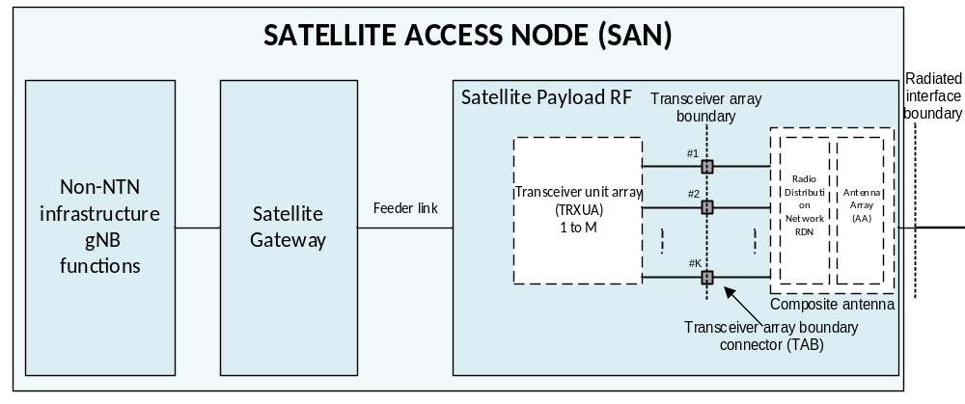
Figure 7.1.3-1: Radiated and conducted reference points for SAN type 1-H
Radiated characteristics are defined over the air (OTA), where the operating band specific radiated interface is referred to as the Radiated Interface Boundary (RIB). Radiated requirements are also referred to as OTA requirements. The (spatial) characteristics in which the OTA requirements apply are detailed for each requirement.
Conducted characteristics are defined at individual or groups of TAB connectors at the transceiver array boundary, which is the conducted interface between the transceiver unit array and the composite antenna.
The transceiver unit array is part of the composite transceiver functionality receiving and transmitting modulated signals to ensure radio links with ground base stations and users.
The Non-NTN infrastructure gNB functions implement the modulation and demodulation functionalities of the NTN gNB.
The Satellite NTN Gateway is part of the NTN ground infrastructure and is responsible for up- and down-converting, as well as transmitting and receiving modulated signals between the Non-NTN infrastructure gNB functions and the Satellite payload via the Feeder link.
The satellite payload is composed by a transceiver unit array and a composite antenna array. The transceiver unit array contains an implementation of specific number of transmitter units and an implementation of specific number of receiver units.
The composite antenna contains a radio distribution network (RDN) and an antenna array. The RDN is a linear passive network which distributes the RF power generated by the transceiver unit array to the transmit antenna array.
How a conducted requirement is applied to the transceiver array boundary is detailed in the respective requirement clause.

7.1.4 SAN type 1-O
For SAN type 1-O the radiated characteristics are defined over the air (OTA), where the operating band specific radiated interface is referred to as the Radiated Interface Boundary (RIB). Radiated requirements are also referred to as OTA requirements. The (spatial) characteristics in which the OTA requirements apply are detailed for each requirement.
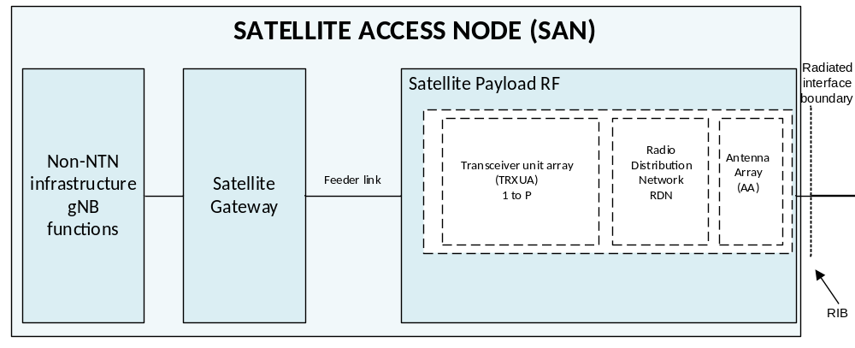
Figure 7.1.4-1: Radiated reference points for SAN type 1-O
The SAN type 1-O payload includes an active antenna with performances characterized in radiated mode (OTA).

7.2 Common issues for satellite access node and NTN UE

7.2.1 General
This section aims to present the agreed definitions for the newly introduced NTN operating bands. The possible configurations in terms of channel bandwidth, SCS, channel and synchronization raster for NTN operations are introduced as well.

7.2.2 Operating bands
The following bands in Table 7.2.2-1 are agreed NTN satellite bands. Regarding the band numbering for NTN satellite bands, it is agreed to start from the largest band number in FR1 range for NTN satellite bands which fully within FR1 frequency ranges to better differentiate NTN satellite band and TN bands and ensure contiguous band number allocation for NTN satellite bands, the number can be taken in a decreased order with first come, first service.
Table 7.2.2-1: NTN satellite bands in FR1
NTN satellite band # | Uplink (UL) operating band  Satellite Access Node receive / UE transmit  F_{UL,low} – F_{UL,high} | Downlink (DL) operating band  Satellite Access Node transmit / UE receive  F_{DL,low} – F_{DL,high} | Duplex mode
n256 | 1980MHz – 2010 MHz | 2170 MHz – 2200 MHz | FDD
n255 | 1626.5 MHz – 1660.5 MHz | 1525 MHz – 1559 MHz | FDD
n253 | 1668 MHz – 1675 MHz | 1518 MHz – 1525 MHz | FDD
n252 | 2000 MHz – 2020 MHz | 2180 MHz – 2200 MHz | FDD
n251 | 1626.5 MHz – 1660.5 MHz | 1518 MHz – 1559 MHz | FDD
n250 | 1668 MHz – 1675 MHz | 1518 MHz – 1559 MHz | FDD
NOTE: NTN bands are numbered in descending order from n256.

7.2.3 Channel bandwidth, SCS and spectral utilization
The common definition for channel bandwidth, transmission bandwidth configuration, minimum guard band, and RB alignment in TS 38.104[16] and TS 38.101-1[17] can be reused for NTN satellite system.
The supported channel bandwidths per operating band should be defined based on NTN operator input. The details are given in Table 7.2.3-1.
Table 7.2.3-1: Channel bandwidths and SCS per NTN satellite operating band in FR1
NTN satellite band # |  | SCS  kHz | 3MHz | 5 MHz | 10 MHz | 15 MHz | 20 MHz | 25 MHz¹ | 30 MHz¹ | 35 MHz¹ | 40 MHz¹
 |  | 15 | Yes | Yes | Yes | Yes | Yes
n256 |  | 30 |  |  | Yes | Yes | Yes
 |  | 60 |  |  | Yes | Yes | Yes
 |  | 15 | Yes | Yes | Yes | Yes | Yes
n255 |  | 30 |  |  | Yes | Yes | Yes
 |  | 60 |  |  | Yes | Yes | Yes
n253 |  | 15 |  | Yes
 |  | 30
 |  | 60
 |  | 15 |  | Yes | Yes | Yes | Yes
n252 |  | 30 |  |  | Yes | Yes | Yes
 |  | 60 |  |  | Yes | Yes | Yes
n251 |  | 15 |  | Yes | Yes | Yes | Yes | [Yes] | [Yes] | [Yes²] | [Yes²]
 |  | 30 |  |  | Yes | Yes | Yes | [Yes] | [Yes] | [Yes²] | [Yes²]
 |  | 60 |  |  | Yes | Yes | Yes | [Yes²] | [Yes] | [Yes²] | [Yes²]
n250 |  | 15 |  | Yes | Yes² | Yes² | Yes² | [Yes²] | [Yes²] | [Yes²] | [Yes²]
 |  | 30 |  |  | Yes² | Yes² | Yes² | [Yes²] | [Yes²] | [Yes²] | [Yes²]
 |  | 60 |  |  | Yes² | Yes² | Yes² | [Yes²] | [Yes²] | [Yes²] | [Yes²]
NOTE 1: Deployment of 30, 35 and 40 MHz channel bandwidths for NTN needs to be preceded by introduction of all applicable Tx RF, Rx RF, and demodulation requirements.
NOTE 2: This channel bandwidth is applicable only to downlink.

7.2.3.1 Asymmetric channel bandwidth
The UE channel bandwidth can be asymmetric in downlink and uplink. In asymmetric channel bandwidth operation, the narrower carrier shall be confined within the frequency range of the wider channel bandwidth.
In FDD, the confinement is defined as a maximum deviation to the Tx-Rx carrier center frequency separation (defined in table 7.4.1.1-1) as following:
ΔF_{TX-RX} = | (BW_{DL} – BW_{UL})/2 |
The operating bands and supported asymmetric channel bandwidth combinations are defined in table 7.2.3-1.
Table 7.2.3-1: FDD asymmetric UL and DL channel bandwidth combinations
 | NR Band | Channel bandwidths for UL (MHz) | Channel bandwidths for DL (MHz) | Asymmetric channel bandwidth combination set
 |  | 5 | 10,15, 20
 | n252 | 10 | 15, 20 | 0
 |  | 15 | 20
 | n251 | 5 | 10,15, 20 | 0
 | n251 | 10 | 15, 20 | 0
 | n251 | 15 | 20 | 0
 | n250 | 5 | 10, 15, 20 | 0
NOTE 1: The assignment of the paired UL and DL channels are subject to a TX-RX separation as specified in clause 5.4.4.
NOTE 2: As indicated in TS38.306 [11], it is mandatory for UEs to support asymmetric channel BCS0 if there is an asymmetric BCS0 defined for the band.

7.2.4 Channel raster and sync raster

7.2.4.1 Channel raster
In order to be compatible with current design of sync raster below 3 GHz, the ARFCN parameters below 3000 MHz will be reused and 100 kHz was chosen as the channel raster for NR NTN satellite bands below 3 GHz.
The applicable ARFCNs per operating and for satellite access node are defined in table 7.2.4.1-1.
Table 7.2.4.1-1: ARFCNs per operating band satellite access node
NTN satellite band # | ΔF_{Raster}  (kHz) | Uplink  range of N_{REF}  (First – <Step size> – Last) | Downlink  range of N_{REF}  (First – <Step size> – Last)
n256 | 100 | 396000 – <20> – 402000 | 434000 – <20> – 440000
n255 | 100 | 325300 – <20> – 332100 | 305000 – <20> – 311800
n253 | 100 | 333600 – <20> – 335000 | 303600 – <20> – 305000
n252 | 100 | 400000 – <20> – 404000 | 436000 – <20> – 440000
n251 | 100 | 325300 – <20> – 332100 | 303600 – <20> – 311800
n250 | 100 | 333600 – <20> – 335000 | 303600 – <20> – 311800

In addition to the 100 kHz channel raster, Enhanced channel raster is defined with ΔF_{Raster} = 2 × ΔF_{Global}. In this case every 2th NR-ARFCN within the operating band are applicable for the channel raster within the operating band and the step size for the channel raster in Table 7.2.4.1-2 is given as <2>.
Table 7.2.4.1-2: ARFCNs per operating band satellite access node
NTN satellite band # | ΔF_{Raster}  (kHz) | Uplink  Range of N_{REF}  (First – <Step size> – Last) | Downlink  Range of N_{REF}  (First – <Step size> – Last)
n256 | 10 | 396000 – <2> – 402000 | 434000 – <2> – 440000
n255 | 10 | 325300 – <2> – 332100 | 305000 – <2> – 311800
n253 | 10 | 333600 – <2> – 335000 | 303600 – <2> – 305000
n252 | 10 | 400000 – <2> – 404000 | 436000 – <2> – 440000
n251 | 10 | 325300 – <2> – 332100 | 303600 – <2> – 311800
n250 | 10 | 333600 – <2> – 335000 | 303600 – <2> – 311800

7.2.4.2 Sync raster
The applicable SS raster entries per operating band are defined in Table 7.2.4.2-1 and 7.2.4.2-2.
Table 7.2.4.2-1: Applicable SS raster entries per operating band (for above 3MHz channel)
NTN satellite band # | SS Block SCS | SS Block pattern | Range of GSCN  (First – <Step size> – Last)
n256 | 15 kHz | Case A | 5429 – <1> – 5494
n255 | 15 kHz | Case A | 3818 – <1> – 3892
n255 | 30 kHz | Case B | 3824 – <1> – 3886
n253 | 15 kHz | Case A | 3800 – <1> – 3807
n252 | 15 kHz | Case A | 5456 – <1> – 5494
n251 | 15 kHz | Case A | 3800 – <1> – 3892
n251 | 30 kHz | Case B | 3806 – <1> – 3886
n250 | 15 kHz | Case A | 3800 – <1> – 3892
n250 | 30 kHz | Case B | 3806 – <1> – 3886

Table 7.2.4.2-2: Applicable SS raster entries per operating band (for the 3MHz channel)
NTN satellite band # | SS Block SCS | SS Block pattern | Range of GSCN  (First – <Step size> – Last)
n256 | 15 kHz | Case A | 37492 – <1> – 37629
n255 | 15 kHz | Case A | 34267 – <1> – 34424

7.3 Satellite Access Node requirements

7.3.1 General
This section aims to provide some recommendations for the Satellite Access Node RF requirements definition in TS 38.181 [25] and TS 38.108 [26]. The technical justifications which support the requirements definition are also presented in the following sub-clauses.
NTN products are assumed to use AAS BS architecture, with both 1-H and 1-O being included in Release 17 WI. Therefore, both conducted, as well as radiated requirements are required to be considered.

7.3.1.1 SAN class
The requirements in TS 38.108 [26] apply to Satellite Access Node otherwise stated. The associated deployment scenarios are exactly the same for SAN with and without connectors.
For SAN type 1-O and SAN type 1-H, two SAN classes (LEO and GEO) are currently defined in Table 7.3.1.1-1.
Table 7.3.1.1-1: SAN classes
SAN Class | Satellite Constellation
GEO class | GEO satellite
LEO class | LEO 600 km satellite  LEO 1200 km satellite

The classification is based on the requirements associated with SAN classes in case-by-case manner including [IoT level/ICS, NF, ACLR/ACS, Emission] requirements. The satellite altitude or orbit type were not identified as part of the class differentiation, and for this reason LEO at 600 km and LEO at 1200 km were grouped together in the same class. At least NF, ACLR and ACS values are the same for LEO 600 km and LEO 1200 km and therefore are not requiring class differentiation. On the other hand, as resulted from the coexistence studies, ACLR requirement values are different between GEO and LEO constellations, requiring a class differentiation. Differences exist as well in terms of emission requirements (e.g. Out-of-band emissions and spurious emissions) between GEO and LEO. At the same time, ACS requirement values from the coexistence studies are the same between GEO and LEO constellations.

7.3.2 Transmission characteristics

7.3.2.1 General
Radiated characteristics are defined over the air (OTA), where the radiated interface is referred to as the Radiated Interface Boundary (RIB) as shown in Figure 7.3.2.1-1.
Conducted characteristics are defined at individual or groups of TAB connectors at the transceiver array boundary, which is the conducted interface between the transceiver unit array and the composite antenna. The TAB connector is shown in Figure 7.3.2.1-1.

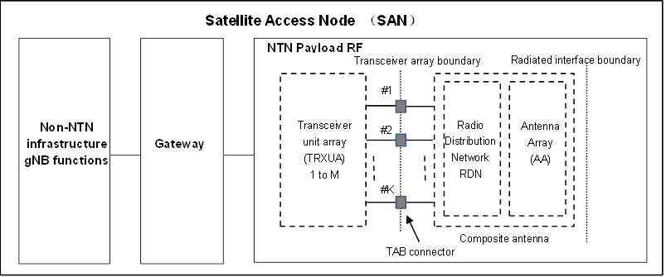
Figure 7.3.2.1-1: Reference point for SAN type 1-H

7.3.2.2 Conducted transmitter requirements

7.3.2.2.1 SAN output power
The SAN conducted output power requirement applies at TAB connector for SAN type 1-H.
The rated carrier output power of the SAN type 1-H shall be as specified in Table 7.3.2.2.1-1.
Table 7.3.2.2.1-1: SAN type 1-H rated output power limits for SAN classes
SAN class | P_{rated,c,sys} | P_{rated,c,TABC}
SAN GEO class | (NOTE) | (NOTE)
SAN LEO class | (NOTE) | (NOTE)
NOTE: P_{rated,c,sys} or P_{rated,c,TABC} of SAN shall be based on manufacture declaration and comply with regulation requirement.

In normal conditions, P_{max,c,TABC} shall remain within +2 dB and -2 dB of the rated carrier output power P_{rated,c,TABC} for each TAB connector as declared by the manufacturer.
In extreme conditions, P_{max,c,TABC} shall remain within +2.5 dB and -2.5 dB of the rated carrier output power P_{rated,c,TABC} for each TAB connector as declared by the manufacturer.

7.3.2.2.2 Output power dynamics
7.3.2.2.2.1 RE power dynamic range
The RE power control dynamic range is the difference between the power of an RE and the average RE power for a SAN at maximum output power for a specified reference condition.
RE power control dynamic range requirement is define in Table 7.3.2.2.2.1-1.
Table 7.3.2.2.2.1-1: RE power control dynamic range
Modulation scheme used | RE power control dynamic range (dB)
on the RE | (down) | (up)
QPSK (PDCCH) | -6 | +4
QPSK (PDSCH) | -6 | +3
16QAM (PDSCH) | -3 | +3
NOTE: The output power per carrier shall always be less or equal to the maximum output power of the satellite access node.

7.3.2.2.2.2 Total power dynamic range
Total power dynamic range for SAN will reuse the requirement from TN BS for the same channel bandwidth.
The downlink (DL) total power dynamic range for each carrier shall be larger than or equal to the level in table 7.3.2.2.2.2-1.
Table 7.3.2.2.2.2-1: Total power dynamic range
SAN channel | Total power dynamic range (dB)
bandwidth (MHz) | 15 kHz SCS | 30 kHz SCS | 60 kHz SCS
5 | 13.9 | 10.4 | N/A
10 | 17.1 | 13.8 | 10.4
15 | 18.9 | 15.7 | 12.5
20 | 20.2 | 17 | 13.8

7.3.2.2.3 Transmitted signal quality
7.3.2.2.3.1 Frequency error
For SAN type 1-H, the modulated carrier frequency of each carrier configured by the satellite access node shall be accurate to within 0.05ppm observed over 1 ms.
7.3.2.2.3.2 Modulation quality (EVM)
It is agreed to support QPSK and 16QAM for SAN. 64QAM will be optionally supported based on manufacture declaration.
For SAN type 1-H, the EVM levels of each carrier for different modulation schemes on PDSCH outlined in table 7.3.2.2.3.2-1 shall be met.
Table 7.3.2.2.3.2-1: EVM requirements for satellite access node type 1-H
Modulation scheme for PDSCH | Required EVM
QPSK | 17.5 %
16QAM | 12.5 %
64QAM¹ | 8 %
NOTE: Support of 64QAM is based on manufacture declaration

7.3.2.2.4 Unwanted emissions
7.3.2.2.4.1 ACLR
Adjacent Channel Leakage power Ratio (ACLR) is the ratio of the filtered mean power centred on the assigned channel frequency to the filtered mean power centred on an adjacent channel frequency.
From Section 6.5 Summary of co-existence study (see TR 38.863 related section), it can be observed in Table 6.5.1-3 Co-existence results suggested ACLR and ACS of NR-NTN the resulted study value of NTN SAN ACLR:
Table 7.3.2.2.4.1-1: NTN SAN ACLR
NTN LEO class ACLR | 23.81 dB
NTN GEO class ACLR | 13.39 dB

Therefore, the value of 24 dB is the ACLR LEO class limit for the conducted transmitter requirements of SAN as shown in Table 7.3.2.2.4.1-2 and the value 14 dB is the ACLR GEO class limit for the conducted transmitter requirements of SAN as shown in Table 7.3.2.2.4.1-3:
Table 7.3.2.2.4.1-2: Satellite Access Node LEO class ACLR limit
SAN channel bandwidth of lowest/highest carrier transmitted BW_{Channel} (MHz) | SAN adjacent channel centre frequency offset below the lowest or above the highest carrier centre frequency transmitted | Assumed adjacent channel carrier (informative) | Filter on the adjacent channel frequency and corresponding filter bandwidth | ACLR limit
5, 10, 15, 20 | BW_{Channel} | NR of same BW² | Square (BW_{Config})¹ | 24 dB
 | 2 x BW_{Channel} | NR of same BW² | Square (BW_{Config})¹ | 24 dB
NOTE 1: BW_{Channel} and BW_{Config} are the SAN channel bandwidth and transmission bandwidth configuration of the lowest/highest carrier transmitted on the assigned channel frequency.
NOTE 2: With SCS that provides largest transmission bandwidth configuration (BW_{Config}).

Table 7.3.2.2.4.1-3: Satellite Access Node GEO class ACLR limit
SAN channel bandwidth of lowest/highest carrier transmitted BW_{Channel} (MHz) | SAN adjacent channel centre frequency offset below the lowest or above the highest carrier centre frequency transmitted | Assumed adjacent channel carrier (informative) | Filter on the adjacent channel frequency and corresponding filter bandwidth | ACLR limit
5, 10, 15, 20 | BW_{Channel} | NR of same BW² | Square (BW_{Config}) ¹ | 14 dB
 | 2 x BW_{Channel} | NR of same BW² | Square (BW_{Config}) ¹ | 14 dB
NOTE 1: BW_{Channel} and BW_{Config} are the SAN channel bandwidth and transmission bandwidth configuration of the lowest/highest carrier transmitted on the assigned channel frequency.
NOTE 2: With SCS that provides largest transmission bandwidth configuration (BW_{Config}).

7.3.2.2.4.2 Out-of-band emissions
The SAN out-of-band emissions requirements for GEO and LEO classes are therefore defined as described in Table 7.3.2.2.4.2-1.

Table 7.3.2.2.4.2-1: SAN out-of-band emissions basic limits
Frequency offset of measurement filter -3dB point, Δf | Frequency offset of measurement filter centre frequency, f_offset | Basic limits  dBm | Measurement bandwidth
0 MHz ≤ Δf < 2* BW_{Channel} | 0.002 MHz ≤ f_offset < 2× BW_{Channel} + 0.002 MHz | $$max\left(SE limit, { PSD}_{channel} -Δ_{Sat_Type}\left[dB\right]- 40×log10\left(\frac{{ f}_{_offset}-0.002}{{BW}_{Channel}}*2+1\right)\right)dBm$$ | 4kHz
NOTE 1: PSD_{channel} = P_{rated,c,sys} – 10log10(BW_{Channel}) – 24, unit dBm/4kHz.
NOTE 2: SE limit is spurious emission limit specified in spurious emission clause.
NOTE 3: PSD attenuation as in Recommendation ITU-R SM.1541-6[29], Annex 5 OoB domain emission limits for space services.
NOTE 4: $Δ_{Sat_Type}$=0 dB for GEO class and $Δ_{Sat_Type}$=3 dB for LEO class.

Recommendation ITU-R SM.1541-6 [29] specifies the OoB mask requirements. The OoB domain emission as attached Annex 5 should be attenuated below the maximum psd by the following and the attenuation can’t be greater than the spurious emission limit.
The OoB domain emissions of a station operating in the bands allocated to the FSS and MSS should be attenuated below the maximum psd, in a reference bandwidth of 4 kHz (for systems operating above 15 GHz a reference bandwidth of 1 MHz may be used in place of 4 kHz) within the necessary bandwidth, by the following:
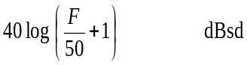
where F is the frequency offset from the edge of the total assigned band, expressed as a percentage of necessary bandwidth. It is noted that the OoB emission domain starts at the edges of the total assigned band.
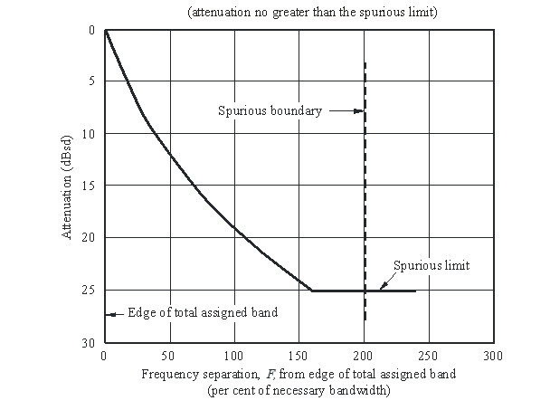
Figure 7.3.2.2.4.2-1: Example of OoB mask assuming the spurious limit is equivalent to 25 dBsd
The “F” = Frequency offset / channel bandwidth × 100 can be get as above. Thus, the OoB mask requirements can be specified as below based on the ITU regulation when we use f_offset and BW_{channel} to replace “F”.

7.3.2.2.5 Transmitter spurious emission
Transmitter basic limits for spurious emissions are presented in Table 7.3.2.2.5-1.
Table 7.3.2.2.5-1: SAN transmitter spurious emission limits
Spurious frequency range | Basic limit GEO class (dBm) | Basic limit LEO class (dBm) | Measurement bandwidth | Notes
30 MHz – 5th harmonic  (NOTE 2, 4, 5) | When P_{rated,c,sys} ≤ 47dBm :  -13  When P_{rated,c,sys} > 47dBm :  P_{rated,c,sys}-60  (NOTE 3) |  | 4 kHz  (NOTE 1) | See NOTES 1, 2, 3, 4 ,5
NOTE 1: Measurement bandwidths as in Recommendation ITU-R SM.329 [30], s4.1.
NOTE 2: Lower and Upper frequency as in Recommendation ITU-R SM.329 [30], s2.5, Table 1. Applies only for the fundamental frequency range 600 MHz - 5.2 GHz (e.g. for n255 and n256 frequency bands).
NOTE 3: Values as in Recommendation ITU-R SM.329 [30], Table 10.
NOTE 4: Lower frequency limit is replaced by 0.7 times the waveguide cut-off frequency, according to ITU-R SM.329-12[30], for systems having an integral antenna incorporating a waveguide section, or with an antenna connection in such form, and of unperturbed length equal to at least twice the cut-off
NOTE 5: This spurious frequency range applies only to SAN type 1-H.

Recommendation ITU-R SM.329 [30] defines Unwanted emissions in the spurious domain. Measurement bandwidth is listed in section 4.1, lower and upper frequencies are specified in the Table 1 of section 2.5 and the values are taken from the table 10.

7.3.2.3 Radiated transmitter requirements

7.3.2.3.1 Reserved

7.3.2.3.2 Reserved

7.3.2.3.3 Reserved

7.3.2.3.4 Reserved

7.3.2.3.5 Reserved

7.3.2.3.6 Reserved

7.3.2.3.7 Reserved
7.3.2.3.7.1 Reserved
7.3.2.3.7.2 Reserved
7.3.2.3.7.3 OTA Adjacent Channel Leakage Power Ratio (ACLR)
7.3.2.3.7.3.1 General
OTA Adjacent Channel Leakage power Ratio (ACLR) is the ratio of the filtered mean power centred on the assigned channel frequency to the filtered mean power centred on an adjacent channel frequency. The measured power is TRP.
7.3.2.3.7.3.2 Minimum requirement for SAN type 1-O
The OTA ACLR limit requirement for SAN type 1-O is the same as the ACLR limit defined in Section 7.3.2.2.4.1 ACLR of TR 38.863. For the OTA SAN ACLR limit refer to Table 7.3.2.2.4.1-2: Satellite Access Node ACLR limit.
The OTA SAN ACLR absolute basic limit from Table 7.3.2.2.4.1-3: SAN ACLR absolute basic limit does not apply to SAN type 1-O.
7.3.2.3.7.3.3 Minimum requirement for SAN type 2-O
This requirement is not applicable in Release 17.

7.3.3 Receiver characteristics

7.3.3.1 General
For Rx requirements, the TAB connector is located in the satellite payload, while the throughput measurement is done in the “non-NTN infrastructure gNB”, as shown in the Figure 7.3.3.1-1 for reference sensitivity requirement.[18][19]
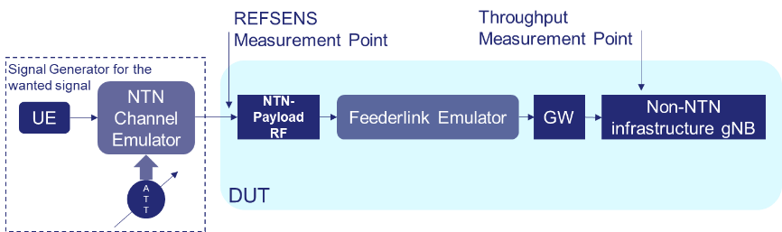
Figure 7.3.3.1-1: Reference points for mmeasurement of Rx requirements
The FRCs specified in TS 38.104[16] shall be re-used to specify the satellite access node Rx requirements. Further revisit is not precluded if the spectrum utilization (SU) would be different.
For derivation of the Rx requirements, the following assumptions were made:
- The FRCs specified in TS 38.104 [16] for NR BS were re-used to specify the NTN SAN Rx requirements.
- The Implementation Margin (IM) value was assumed to be 2 dB for NTN SAN.
- The following Noise Figure (NF) values were used for the derivation of Rx requirements for NTN SAN:
Table 7.3.3.1-1: NF values for NTN SAN requirements derivation
 | GEO | LEO 600 | LEO 1200
G/T (dB K⁻¹) | 19 | 1.1 | 1.1
G_Rx (dBi) | 51 | 30 | 30
NF (dB) | 7.4 | 4.3 | 4.3

7.3.3.2 Conducted receiver characteristics

7.3.3.2.1 Reference sensitivity level
The following equation was used to derive the reference sensitivity for NTN SAN requirement development, reusing the same methodology for the reference sensitivity derivation as done for the NR BS, as captured in TR 38.817-02 [31]:
P_{REFSENS} = -174 dBm/Hz + 10 * log10 BW + NF + IM + SNR [dBm]
Where:
- BW is the maximum transmission bandwidth,
- NF is noise figure of NTN SAN receiver in dB,
- IM is implementation margin reserved for NTN SAN manufacturer in dB;
- SNR is the value to satisfy the 95% throughput of the FRC channel.

7.3.3.2.2 Dynamic range
The Rx dynamic range is specified as a measure of the capability of the receiver to receive a wanted signal in the presence of an interfering signal at the TAB connector for SAN type 1-H inside the received SAN channel bandwidth. In this condition, a throughput requirement shall be met for a specified reference measurement channel. As the Rx dynamic range requirement measures the effects of NTN SAN receiver’s impairments, the uncertainty due to the receiver’s own thermal noise floor should be minimized. Therefore, the interference level should be increased by a certain amount of margin to mask the receiver’s own noise floor, represented by Interference over Thermal (IoT).
In order to define the dynamic range requirement, both wanted and interfering signal power levels need to be defined. The mean power levels of interfering and the wanted signals were defined in the following method:
P_{Intf} = -174 dBm/Hz + 10 * log10(N_{RB} * SCS * 12) + NF + IoT
P_{wanted} = -174 dBm/Hz + 10 * log₁₀(N_{RB} * SCS * 12) + NF + IoT + SNR + IM
Where:
- N_{RB} is the transmission bandwidth configuration of the lowest SCS defined for SAN for each BS channel bandwidth;
- SCS is the lowest sub-carrier spacing defined for SAN for each BS channel bandwidth;
- NF is noise figure of SAN receiver in dB as defined in table 6.2.2.1-5,
- IoT: during the discussion various values of the IoT were considered for the definition of the dynamic range requirement. In case of LEO600, IoT values in range of 15-18 dB were collected based on the simulation results. In case of LEO1200, IoT values in range of 10-15 dB were collected based on the simulation results, as captured in annex D.
- SNR is the value to satisfy the 95% throughput of measurement channel. As the derivation methodology and the FRC’s from the NR BS was reused, more details on the SNR simulation results can be found in TR 38.817-02 [31];
- IM is implementation margin reserved for SAN manufacturer in dB. The IM values was reused from the NR BS as 2 dB;
For SAN it was agreed to define a single dynamic range requirement for LEO SAN (both 600 and 1200) based on the IoT value of 15 dB. Based on the collected simulation results for NTN scenarios, it was decided not to define dynamic rage requirement for SAN GEO class.
The interfering signal for the dynamic range requirement was defined as AWGN signal, same as for NR BS requirements.

7.3.3.2.3 In-band selectivity and blocking
7.3.3.2.3.1 Adjacent Channel Selectivity (ACS)
7.3.3.2.3.1.1 General
Adjacent channel selectivity (ACS) is a measure of the receiver’s ability to receive a wanted signal at its assigned channel frequency at the antenna connector for NTN Satellite Access Node (SAN) in the presence of an adjacent channel signal with a specified centre frequency offset of the interfering signal to the band edge of a victim system.
The ACS value is coming from coexistence analysis. A worst case value of 38 dB ACS is found in GEO case and the interfering signal mean power (dBm) is computed given a NF 7.4 dB for a 5 MHz band.
It is worth noting that OFDM is considered as interfering waveform (rather than DFT-s-OFDM) corresponding to a coexistence scenario 6 for the MSS S-band where TN BS DL is interfering with SAN UL.
7.3.3.2.3.1.2 Minimum requirements for Satellite Access Node
The throughput shall be ≥ 95% of the maximum throughput of the reference measurement channel.
For SAN, the wanted and the interfering signal coupled to the antenna connector are specified in table 7.3.3.2.3.1.2-1 and table 7.3.3.2.3.1.2-2 and the frequency offset between the wanted and interfering signal in table 7.3.3.2.3.1.2-3 for ACS.
The ACS requirement is applicable outside the SAN RF Bandwidth or Radio Bandwidth. The interfering signal offset is defined relative to the SAN RF Bandwidth edges or Radio Bandwidth edges.
Minimum conducted requirement is defined at the antenna connector.
Table 7.3.3.2.3.1.2-1: SAN GEO class ACS requirement
SAN channel bandwidth of the lowest/highest carrier received (MHz) | Wanted signal mean power (dBm) | Interfering signal mean power (dBm)
5, 10, 15, 20 (NOTE 1) | P_{REFSENS} + 6 dB | -57
NOTE 1: The SCS for the lowest/highest carrier received is the lowest SCS supported by the SAN for that bandwidth.
NOTE 2: For SAN, P_{REFSENS} depends on the SAN channel bandwidth.

Table 7.3.3.2.3.1.2-2: SAN LEO class ACS requirement
SAN channel bandwidth of the lowest/highest carrier received (MHz) | Wanted signal mean power (dBm) | Interfering signal mean power (dBm)
5, 10, 15, 20 (NOTE 1) | P_{REFSENS} + 6 dB | -60
NOTE 1: The SCS for the lowest/highest carrier received is the lowest SCS supported by the SAN for that bandwidth.
NOTE 2: For SAN, P_{REFSENS} depends on the SAN channel bandwidth.

The wanted signal and interfering signal power level are calculated in the following way in FR1:
Wanted signal power level = REFSENS + 6 dB
Interfering signal power level = SAN noise floor + ACS + 4.7dB = -174 dBm/Hz+10*log₁₀(BW) + NF + ACS + 4.7 dB
Where:
- BW is wanted signal bandwidth in Hz, e.g. 25 PRB for 5 MHz SCS 15 kHz;
- NF is noise figure which is agreed as 7.4 dB for GEO, 4.3 dB for LEO@600, 4.3 dB for LEO@1200;
- SAN ACS is agreed as 38 dBc (more precisely according to coexistence Scenario 6, it has been noticed from the coexistence simulations that the required SAN ACS is in the order of 38 dBc ACS);
- 4.7 dB is calculated from 10log₁₀(10^(6/10)-1).
If the equation considers the worst case of 38 dB ACS, with NF of 7.4 dB for GEO class and NF of 4.3 dB for LEO class, for 5 MHz signal bandwidth (as for TS 38.104[16]), the interfering signal mean power level is:
-174+10*log10(5*10^6)+7.4+38+4.7=-57dBm for GEO class, according to the interfering signal mean power value from Table 7.4.1.2-1.
-174+10*log10(5*10^6)+4.3+38+4.7=-60dBm for LEO class, according to the interfering signal mean power value from Table 7.4.1.2-2.
Table 7.3.3.2.3.1.2-3: SAN ACS interferer frequency offset values
SAN channel bandwidth of the lowest/highest carrier received (MHz) | Interfering signal centre frequency offset from the lower/upper SAN RF Bandwidth edge or sub-block edge inside a sub-block gap (MHz) | Type of interfering signal
5 | ±2.5025
10 | ±2.5075 | 5 MHz OFDM NR signal
15 | ±2.5125 | 15 kHz SCS, 25 RBs
20 | ±2.5025

7.3.3.2.3.2 In-band blocking
No In-band blocker is considered for SAN.

7.3.3.2.4 Out-of-band blocking
7.3.3.2.4.1 General
The out-of-band blocking characteristics is a measure of the receiver ability to receive a wanted signal at its assigned channel at the TAB connector for SAN type 1-H in the presence of an unwanted interferer out of the operating band, which is a CW signal for out-of-band blocking.
Uplink Satellite IMT
3G/Mobile
MSS Reg2
MSS North-Am
MSS North-Am
MSS Reg2
Downlink Satellite IMT
Terrestrial IMT
downlink
Space Ops (TC)
Space Ops (TM)
Terrestrial IMT
uplink
1920
1980
2000
2010
2020
2025
2110
2160
2170
2180
2200
Figure 7.3.3.2.4.1-1: Band of concern to determine OOB blocking
The identified worst case is for the band n256 with the SpaceOps TC (TeleCommand) band between 2025 and 2110 MHz. This band is used to send commands to the satellite platform, taking into account the fact that a very robust radio link is established. To do so, the maximum EIRP of SpaceOps (Space Operations) TC (TeleCommand) stations is 80 dBW.
For a LEO satellite at 600 km (LEO@600km), in a worst case scenario (i.e. SpaceOps TC station at satellite Nadir), the free space losses are 154 dB.
Therefore, the signal level at satellite level is -44 dBm.
7.3.3.2.4.2 Minimum requirements for Satellite Access Node
The throughput shall be ≥ 95% of the maximum throughput of the reference measurement channel, with a wanted and an interfering signal coupled to SAN type 1-H TAB connector using the parameters in table 7.3.3.2.4.2-1.
The out-of-band blocking requirement apply from 1 MHz to F_{UL,low} – Δf_{OOB} and from F_{UL,high} + Δf_{OOB} up to 12750 MHz, including the downlink frequency range of the FDD operating band.
Minimum conducted requirement is defined at the antenna connector at the TAB connector for SAN type 1-H.
Table 7.3.3.2.4.2-1: Out-of-band blocking performance requirement for NR
Wanted Signal mean power (dBm) | Interfering Signal mean power (dBm) | Type of Interfering Signal
P_{REFSENS} +6 dB  (NOTE) | -44 | CW carrier
NOTE: P_{REFSENS} depends on the RAT. For NR, P_{REFSENS} depends also on the SAN channel bandwidth.

7.3.3.2.5 Receiver spurious emissions
The requirement is not applicable in this version of the specification.

7.3.3.2.6 Receiver intermodulation
The requirement is not applicable in this version of the specification.

7.3.3.2.7 In-channel selectivity
The requirement framework from terrestrial network (TN) NR specification is agreed to be reused.

7.3.3.3 Radiated receiver characteristics

7.3.3.3.1 OTA sensitivity
On the same principle as for the NR TN BS Specification TS 38.104[16], the SAN OTA sensitivity testing procedure should be based on SAN manufacturer declarations of sensitivity direction and EIS level.

7.3.3.3.2 OTA reference sensitivity level
OTA reference sensitivity level is a directional requirement specified as an EIS level. On the same principle as for the NR TN BS specification TS38.104[16], the SAN OTA reference sensitivity EIS_{REFSENS} requirements should be derived from:
- the conducted reference sensitivity P_{REFSENS} which can be calculated based on the formula presented in Section 7.3.3.2.1;
- a hypothetical antenna gain of a passive satellite antenna;
- some implementation margin reserved for the NTN SAN manufacturer.
The last two contributions are both taken into account under Δ_{OTAREFSENS} parameter.
As OTA reference sensitivity is used as a reference for many of the interference requirements where it is important that the interferer is polarization matched to the receiver antenna it is also important that the wanted signal is polarization matched. Hence OTA reference sensitivity is specifically declared per polarization and the EIS values are under the assumption of polarization match.
For SAN type 1-O, OTA reference sensitivity is intended to provide equivalent protection and performance as the conducted reference sensitivity level. The OTA reference sensitivity level is calculated based on the conducted reference sensitivity level for SAN type 1-H and antenna gain of a passive antenna which would be used with a non-AAS SAN in the same deployment scenario.

7.3.3.3.3 OTA dynamic range
The requirement assumes that the wanted signal and interfering signal come from the same direction. And since both wanted signal and AWGN will be transmitted from the test equipment in the same direction, the same combining gain will be achieved for both wanted signal and the AWGN. Hence, the OTA dynamic range for FR1 can be defined based on conductive requirements plus an offset, i.e., Δ_{OTAREFSENS.}

7.3.3.3.4 OTA in-band selectivity and blocking
7.3.3.3.4.1 OTA adjacent channel selectivity
OTA Adjacent channel selectivity (ACS) is a measure of the receiver’s ability to receive an OTA wanted signal at its assigned channel frequency in the presence of an OTA adjacent channel signal with a specified centre frequency offset of the interfering signal to the band edge of a victim system. For SAN type 1-O, interfering signal mean power should be offset by the value Δ_{minSENS}, other parameters could be reused from SAN type 1-H and respective ACS clause.

7.3.3.3.5 OTA out-of-band blocking
7.3.3.3.5.1 General
The OTA out-of-band blocking characteristics are a measure of the receiver unit ability to receive a wanted signal at the RIB at its assigned channel in the presence of an unwanted interferer.
7.3.3.3.5.2 Minimum requirement for SAN type 1-O
7.3.3.3.5.2.1 General minimum requirement
The requirement shall apply at the RIB when the AoA of the incident wave of the received signal and the interfering signal are from the same direction and are within the minSENS RoAoA.
The wanted signal applies to each supported polarization, under the assumption of polarization match. The interferer shall be polarization matched in-band and the polarization maintained for out-of-band frequencies.
The values for the minimum requirements have been obtained with the hypothesis from section 7.3.3.2.4 Out-of-band blocking, considering the maximum EIRP of SpaceOps (Space Operations) TC (TeleCommand) stations of 80 dBW, and the interfering signal mean power of -44 dBm, for a LEO satellite at 600 km of altitude (LEO@600km).
For OTA wanted and OTA interfering signals provided at the RIB using the parameters in table 7.3.5.6.2.1-1, the following requirements shall be met:
- The throughput shall be ≥ 95% of the maximum throughput of the reference measurement channel.
For SAN type 1-O the OTA out-of-band blocking requirement apply from 30 MHz to F_{UL,low} – Δf_{OOB} and from F_{UL,high} + Δf_{OOB} up to 12750 MHz, including the downlink frequency range of the FDD operating band.
Table 7.3.3.3.5.2.1-1: OTA out-of-band blocking performance requirement
Wanted signal mean power (dBm) | Interfering signal RMS field-strength (V/m) | Type of interfering Signal
EIS_{minSENS} + 6 dB  (NOTE 1) | 0.091 | CW carrier
NOTE 1: EIS_{minSENS} depends on the channel bandwidth.
NOTE 2: The RMS field-strength level in V/m is related to the interferer EIRP level at a distance described as 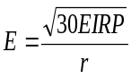, where EIRP is in W and r is in m.

7.3.3.3.5.2.2 Co-location minimum requirement
This requirement is not applicable in Release 17.

7.3.3.3.6 OTA receiver spurious emissions
The requirement is not applicable in this version of the specification.

7.3.3.3.7 OTA receiver intermodulation
This requirement is not applicable in Release 17.

7.3.3.3.8 OTA in-channel selectivity
For SAN type 1-O, power level of wanted signal and interfering signal should be offset by the value Δ_{minSENS}. Other parameters could be reused from SAN type 1-H and respective in-channel selectivity (ICS) clause.

7.3.4 Others

7.3.4.1 SAN RF requirements for 3MHz channel bandwidth

7.3.4.1.1 Conducted Tx/Rx requirements
The agreed changes to SAN RF conducted Tx/Rx requirements for 3MHz channel bandwidth are provided in Table 7.3.4.1.1-1.
Table 7.3.4.1.1-1: Conducted Tx/Rx requirements for 3MHz channel bandwidth
NR SAN RF conducted Tx/Rx requirement in TS 38.108 [26] | Proposal for 3MHz channel bandwidth in FR1-NTN bands
6.2 Satellite Access Node output power | No specification impact.
6.3.2 RE power control dynamic range | No specification impact.
6.3.3 Total power dynamic range | Minimum requirement calculated according to transmission bandwidth configuration in Table 6.3.3.2-1.
6.4 Transmit ON/OFF power | No specification impact.
6.5 Transmitted signal quality | No specification impact.
6.6.2 Occupied bandwidth | No specification impact.
6.6.3 Adjacent Channel Leakage Power Ratio | Requirement limits as other channel bandwidth, but assume different adjacent channel carriers in Table 6.6.3.2-1 and Table 6.6.3.2-2.
6.6.4 Out-of-band emissions | No specification impact.
6.6.5 Transmitter spurious emissions | No specification impact
6.7 Transmitter intermodulation | No specification impact.
7.2 Reference sensitivity level | Add minimum requirements for 3 MHz in Table 7.2.2-1 and Table 7.2.2-2. Scaling from 5 MHz can be used. Use FRC G-FR1-A1-7, same as in TN.
7.3 Dynamic range | Add minimum requirements for 3 MHz in Table 7.3.2-1. Scaling from 5 MHz can be used. Reuse TN FRC G-FR1-A2-15 (to be introduced to A.2).
7.4.1 Adjacent Channel Selectivity (ACS) | Define ACS requirement similar to TN for 3MHz in Table 7.4.1.2-1, and assume same interferer frequency offset values as TN 3 MHz in Table 7.4.1.2-2.
7.4.2 In-band blocking | No specification impact.
7.5 Out-of-band blocking | No specification impact.
7.6 Receiver spurious emissions | No specification impact.
7.7 Receiver intermodulation | No specification impact.
7.8 In-channel selectivity | Add minimum requirements for 3 MHz in Table 7.8.2-1 and Table 7.8.2-2. Reuse TN FRC G-FR1-A1-20 (to be introduced to A.1).
A.1 Fixed Reference Channels for RF Rx requirements (QPSK, R=1/3) | FRC for 3MHz in-channel selectivity need to be added in Table A.1-1. Reuse TN FRC G-FR1-A1-20. Rename the FRC to indicate “NTN” can be discussed as Rel-18 maintenance.
A.2 Fixed Reference Channels for dynamic range (16QAM, R=2/3) | FRC for 3MHz needs to be added in Table A.2-1. Reuse TN FRC G-FR1-A2-15. Rename the FRC to indicate “NTN” can be discussed as Rel-18 maintenance.

7.3.4.1.2 Radiated Tx/Rx requirements
The agreed changes to SAN RF radiated Tx/Rx requirements for 3MHz channel bandwidth are provided in Table 7.3. 4.x.2-1.
Table 7.3.4.1.2-1: Radiated Tx/Rx requirements for 3MHz channel bandwidth
NR SAN RF conformance requirement in TS 38.181 [25] | Expected updates for 3MHz channel bandwidth in FR1-NTN bands
4.1.2 Acceptable uncertainty of Test System | Add maximum test system uncertainty for 3 MHz in Table 4.1.2.2-1 and Table 4.1.2.2-2.
4.7.2 Test signal used to build Test Configurations | Add a note in Table 4.7.2-1 to use 3 MHz channel bandwidth if supported.
6.2 Satellite Access Node output power | No specification impact.
6.3.2 RE power control dynamic range | No specification impact.
6.3.3 Total power dynamic range | Add minimum requirements for 3 MHz in Table 6.3.3.5-1.
6.4 Transmit ON/OFF power | No specification impact.
6.5 Transmitted signal quality | Add minimum requirements for 3 MHz in Table 6.5.3.5-2.
6.6.2 Occupied bandwidth | Add minimum requirements for 3 MHz in Table 6.6.2.4.2-1.
6.6.3 Adjacent Channel Leakage Power Ratio | Requirement limits as other channel bandwidth, but assume different adjacent channel carriers in Table 6.6.3.5.2-1 and Table 6.6.3.5.2-2.
6.6.4 Out-of-band emissions | No specification impact.
6.6.5 Transmitter spurious emissions | No specification impact
6.7 Transmitter intermodulation | No specification impact.
7.2 Reference sensitivity level | Add minimum requirements for 3 MHz in Table 7.2.5-1 and Table 7.2.5-2. Scaling from 5 MHz can be used. Use FRC G-FR1-A1-7, same as in TN.
7.3 Dynamic range | Add minimum requirements for 3 MHz in Table 7.3.5-1. Scaling from 5 MHz can be used. Reuse TN FRC G-FR1-A2-15 (to be introduced to A.2).
7.4.1 Adjacent Channel Selectivity (ACS) | Define ACS requirement similar to TN for 3MHz in Table 7.4.1.5-1, and assume same interferer frequency offset values as TN 3 MHz in Table 7.4.1.5-2.
7.4.2 In-band blocking | No specification impact.
7.5 Out-of-band blocking | No specification impact.
7.6 Receiver spurious emissions | No specification impact.
7.7 Receiver intermodulation | No specification impact.
7.8 In-channel selectivity | Add minimum requirements for 3 MHz in Table 7.8.5-1 and Table 7.8.5-2. Reuse TN FRC G-FR1-A1-20 (to be introduced to A.1).
9.2 Radiated transmit power | No specification impact.
9.3 OTA SAN Output power dynamics | No specification impact.
9.4 OTA output power dynamic range | Similar update as conductive requirements to add 3MHz channel bandwidth.
9.5 OTA transmit ON/OFF Power | No specification impact.
9.6 OTA transmitted signal quality | Similar update as conductive requirements to add 3MHz channel bandwidth.
9.7 OTA unwanted emissions | Similar update as conductive requirements to add 3MHz channel bandwidth.
9.8 OTA Transmitter intermodulation | No specification impact.
10.2 OTA sensitivity | Similar update as conductive requirements to add 3MHz channel bandwidth.
10.3 OTA reference sensitivity level | Similar update as conductive requirements to add 3MHz channel bandwidth.
10.4 OTA dynamic range | Similar update as conductive requirements to add 3MHz channel bandwidth.
10.5 OTA In-band selectivity and blocking | Similar update as conductive requirements to add 3MHz channel bandwidth.
10.6 OTA Out-of-band blocking | No specification impact.
10.7 OTA receiver spurious emissions | No specification impact.
10.8 OTA receiver intermodulation | No specification impact.
10.9 OTA In-channel selectivity | Similar update as conductive requirements to add 3MHz channel bandwidth.
A.1 Fixed Reference Channels for RF Rx requirements (QPSK, R=1/3) | FRC for 3MHz in-channel selectivity need to be added in Table A.1-1. Reuse TN FRC G-FR1-A1-20. Rename the FRC to indicate “NTN” can be discussed as Rel-18 maintenance.
A.2 Fixed Reference Channels for dynamic range (16QAM, R=2/3) | FRC for 3MHz needs to be added in Table A.2-1. Reuse TN FRC G-FR1-A2-15. Rename the FRC to indicate “NTN” can be discussed as Rel-18 maintenance.

7.4 NTN UE requirements

7.4.1 General
In general, NTN UE products are assumed to meet TN UE requirements as specified in TS 38.101-1[17]. The structure and content of the NTN UE specification TS 38.101-5 should be based on TS 38.101-1[17]. The development of TS 38.101-5 should follow the set of conditions that were agreed at the RAN#94e meeting in RP-213618[27].

7.4.1.1 TX-RX frequency separation
The default TX channel (carrier centre frequency) to RX channel (carrier centre frequency) separation for operating bands is specified in Table 7.4.1.1-1 for FR1-NTN.
Table 7.4.1.1-1: UE TX-RX frequency separation (FR1-NTN)
NTN Satellite Operating Band | TX – RX  carrier centre frequency  separation
n253 | -150 MHz¹  -148 to -152 MHz²
n252 | 180 MHz¹  165 – 195 MHz²
n251 | -108.5 MHz¹  -72.5 to -137.5 MHz²
n250 | -150 MHz¹  -114 to -152 MHz²
NOTE 1: Default Tx-Rx separation
NOTE 2: The verification of flexible Tx-Rx frequency separation within this range is limited to reference sensitivity.

7.4.2 UE Transmission characteristics for satellite access

7.4.2.1 General
Unless otherwise stated, the transmitter characteristics are specified at the antenna connector of the UE with a single or multiple transmit antenna(s). For UE with integral antenna only, a reference antenna with a gain of 0dBi is assumed.

7.4.2.2 Conducted transmitter characteristics

7.4.2.2.1 Maximum output power
The following UE Power Classes define the maximum output power for any transmission bandwidth within the channel bandwidth of NR carrier unless otherwise stated. The period of measurement shall be at least one sub frame (1ms).
Table 7.4.2.2.1-1: UE Power Class
NTN satellite band # | Class 1 (dBm) | Tolerance (dB) | Class 2 (dBm) | Tolerance (dB) | Class 3 (dBm) | Tolerance (dB)
n256 | 31 | +2/-3 | 26 | +2/-3 | 23 | ±2
n255 | 31 | +2/-3 | 26 | +2/-3 | 23 | ±2
n253 |  |  |  |  | 23 | ±2
n252 |  |  |  |  | 23 | +2
n251 |  |  |  |  | 23 | ±2
n250 |  |  |  |  | 23 | ±2
NOTE 1: P_{PowerClass} is the maximum UE power specified without taking into account the tolerance
NOTE 2: Power class 3 is default power class unless otherwise stated
NOTE 3: Generally, PC1 UE are not targeted for smartphone form factor in this version of the specification.

7.4.2.2.2 MPR/AMPR
7.4.2.2.2.1 MPR
UE is allowed to reduce the maximum output power (MPR) due to higher order modulations and transmit bandwidth configurations to meet the general transmission requirements which includes in-band emission, ACLR, out-of-band emission and general spurious emission. As it was agreed those general transmission requirements for PC3 NTN UE can be reused from TN, the same requirements specified in Table 6.2.2-1 in TS 38.101-1 [17] can be reused for NTN satellite access UEs.
For PC2 UE with 1Tx and 2Tx, the allowed maximum power reduction (MPR) is defined as Table 6.2.2-2 in 3GPP TS 38.101-1[17] clause 6.2.2 and Table 6.2D.2-1 in 3GPP TS 38.101-1[17] clause 6.2D.2 respectively, except for 256QAM. For UE power class 1 with 1Tx, the allowed maximum power reduction (MPR) is defined in Table 7.4.2.2.2.1-1. And for UE power class 1 with 4Tx, the allowed maximum power reduction (MPR) is defined as Table 7.4.2.2.2.1-1a.
Table 7.4.2.2.2.1-1 Maximum power reduction (MPR) for power class 1 with 1Tx
Modulation |  | MPR (dB)
 |  | Edge RB allocations | Outer RB allocations | Inner RB allocations
DFT-s-OFDM | Pi/2 BPSK | ≤ 10.0 | ≤ 0.5 | ≤ 0
 | QPSK | ≤ 10.5 | ≤ 1.0 | ≤ 0
 | 16 QAM | ≤ 10.5 | ≤ 2.0 | ≤ 1.0
 | 64 QAM | ≤ 10.5 | ≤ 2.5
CP-OFDM | QPSK | ≤ 11.0 | ≤ 3 | ≤ 1.5
 | 16 QAM | ≤ 11.0 | ≤ 3 | ≤ 2.0
 | 64 QAM | ≤ 11.0 | ≤3.5

Table 7.4.2.2.2.1-1a Maximum power reduction (MPR) for power class 1 with 4Tx
Modulation |  | MPR (dB)
 |  | Edge RB allocations | Outer RB allocations | Inner RB allocations
DFT-s-OFDM | Pi/2 BPSK | ≤ 10.0 | ≤ 2.0 | ≤ 0.5
 | QPSK | ≤ 10.5 | ≤ 2.5 | ≤ 0.5
 | 16 QAM | ≤ 10.5 | ≤ 3.5 | ≤ 1.5
 | 64 QAM | ≤ 10.5 | ≤ 4.0 | ≤ 3.5
CP-OFDM | QPSK | ≤ 11.0 | ≤ 4.5 | ≤ 2.0
 | 16 QAM | ≤ 11.0 | ≤ 4.5 | ≤ 2.5
 | 64 QAM | ≤ 11.0 | ≤ 5.0 | ≤ 5.0
NOTE 1: This table is targeted to devices with 15 dB or above antenna isolation.

The definitions for Edge, Outer and Inner RB allocations defined in clause 6.2.2 of 3GPP TS 38.101-1 [17] shall apply to NTN UE, except for PC1 NTN UE.
For PC1 NTN UE, RB allocation is an Edge RB allocation if
$L_{CRB}≤L_{CRB,edge}$ AND ( ${RB}_{start}≤{RB}_{start,edge}$ OR ${RB}_{start}≥{N_{RB}-RB}_{start,edge}-L_{CRB}$ ),
where
$L_{CRB,edge}=8 and RB_{start,edge}=0$.
7.4.2.2.2.2 A-MPR
A-MPR is band specific requirement which is used to meet the additional requirements indicated by network signalling (NS) value.
For n256, based on the regulation conclusion in section 5.2, the A-MPR requirements for n65 could be as starting point. From TS 38.101-1, since the maximum carrier centre frequency of NS_05 and NS_05U is lower than 1960 MHz and the maximum carrier centre frequency of NS_51 is lower than 1980 MHz, it is proposed NS_05, NS_05U and NS_51 don’t need to be considered for n256. The requirements of NS_01, NS_24 and NS_100 specified in Table 6.2.3.1-1 in TS 38.101-1 [17] for band n65 can be reused for n256. For the band n256 3MHz channel bandwidth, additional power back-off simulation results are provided in Annex X, based on which the corresponding A-MPR values are adopted.
For PC2 and PC1 NTN UE for band n256, the A-MPR analysis have been performed as documented in Annex F, and the concluded A-MPR requirements can be found in sub-clause 7.4.2.2.2.2.6.
For n255, based on regulatory requirements, a new NS is required. The following observations were made from the measurement results using an LTE modem and transceiver supporting 1626.5 – 1656.5 MHz:
- For 5 MHz channel, PA emissions for DFT-s-OFDM are below the spurious emission limits between 1559 and 1606 MHz.
- For 10 MHz channel, PA emissions for DFT-s-OFDM are exceeding the spurious emission limits for 1 MHz MBW by 5 dB between 1604 and 1606 MHz.
- For 15 MHz channel, PA emissions for DFT-s-OFDM are exceeding the spurious emission limits for 1 MHz MBW by 9 dB between 1599 and 1606 MHz.
- For 20 MHz channel, PA emissions for DFT-s-OFDM are exceeding the spurious emission limits by 9 dB between 1584 and 1606 MHz.
- For 700 Hz MBW, PA emissions for all channel bandwidths are below the spurious emission limits between 1559 and 1606 MHz.
A n255 duplexer with rejection of more than 10 dB will be a sufficient to satisfy the spurious emission limits specified in Table 7.4.2.2.8-1.
Based on this measurement observations, the expected filter attenuation of more than 10 dB below 1610 MHz is going to be adequate to meet the additional emissions requirements between 1559 – 1610 MHz, and therefore, no A-MPR needs to be specified for n255.
In view of the above, the additional requirements with their associated network signalling values and the allowed A-MPR and applicable operating band(s) for each NS value shall be specified in Table 7.4.2.2.2.2-1 and the mapping of NR satellite band numbers and values of the additionalSpectrumEmission to network signalling labels is specified in Table 7.4.2.2.2.2-1A.
For PC2 and PC1 NTN UE for band n255, the A-MPR analysis have been performed as documented in Annex G, and the concluded A-MPR requirements can be found in sub-clause 7.4.2.2.2.2.7. These PC2 and PC1 A-MPR values for NS_02N are specified with duplexer filter achieving at least 10 dB attenuation at frequencies 1610 MHz and below. Previous evaluation of duplexer data in R4-2016896 during the development of specifications of b24/n24 band showed that it is possible to achieve a higher attenuation than 10 dB which will likely to reduce the A-MPR being needed to meet the additional out of band emissions requirements related to NS_02N.
For n252, the following three NSs are defined:
- NS_06N: for protection of aeronautical radionavigation-satellite service. This requirement is based on FCC rule 47 C.F.R § 25.216 (e)
- NS_07N and NS_08N: for protection of n2/n25. This requirement applies based on coordination between operators and subject to regional/national regulation. See section 7.4.2.2.8 for detail on UE-to-UE coexistence additional spurious requirements. From UE perspective, UE applies this requirement based on the received NS value. For implementation flexibility, the requirement for aeronautical radionavigation-satellite service is also included in these NSs.
NS_09N and NS_10N are defined to capture additional spectrum emission requirements based on ETSI 301 681, while NS_13N and NS_14N are defined to capture additional spectrum emission requirements based on the new initial draft ETSI requirements for “Harmonised Standard for NTN capable UE” under discussion in ETSI TC SES SCN as referenced by the ETSI LS received at RAN4#116 (R4-2509023_SES(25)000071).
Table 7.4.2.2.2.2-1: Additional maximum power reduction (A-MPR)
Network signalling label | Requirements (clause) | NR satellite Band | Channel bandwidth (MHz) | Resources blocks (N_{RB}) | A-MPR (dB)
NS_01 |  | Table 5.2.1-1 | 3, 5, 10, 15, 20 | Table 5.3.2-1 in TS 38.101-1 | N/A
NS_02N | 6.5.3.3.1 in TS 38.101-5 | n255 | 3, 5, 10, 15, 20 |  | Clause 7.4.2.2.2.2.7
NS_24N | 6.5.3.3.5 in TS 38.101-5 | n256 | 3, 5, 10, 15, 20 |  | Clause 6.2.3.5 in TS 38.101-5²  Clause 7.4.2.2.2.2.6
NS_100 | 6.5.2.4.2 in TS 38.101-1 | n256¹ |  |  | Table  6.2.3.1-2 in TS 38.101-1
NS_06N | 7.4.2.2.8 | n252 | 5, 10, 15, 20 |  | N/A
NS_07N | 7.4.2.2.8 | n252 | 5, 10, 15, 20 |  | Clause 7.4.2.2.2.2.1
NS_08N | 7.4.2.2.8 | n252 | 5, 10, 15, 20 |  | Clause 7.4.2.2.2.2.2
NS_09N | 6.5.2.3.3 in TS 38.101-5  6.5.3.3.8 in TS 38.101-5 | n250, n253 | 5 |  | Clause 7.4.2.2.2.2.3
NS_10N | 6.5.2.3.3 in TS 38.101-5  6.5.3.3.9 in TS 38.101-5 | n251 | 5, 10, 15, 20 |  | Clause 7.4.2.2.2.2.4
NS_13N⁵ | 6.5.3.3.10 in TS 38.101-5 |  | 5 |  | Clause 7.4.2.2.2.2.3
NS_14N⁵ | 6.5.3.3.10 in TS 38.101-5 |  | 5, 10, 15, 20 |  | Clause 7.4.2.2.2.2.4
NOTE 1: This NS can be signalled for NTN satellite bands that have UTRA services deployed.
NOTE 2: A-MPR for the upper 5 MHz is not specified, and therefore shall be used as a guard band.
NOTE 3: The NS_07N and NS_08N is signalled based on coordination between operators and subject to regional/national regulation
NOTE 5: NS_09N (n253, n250), NS_10N (n251) are currently in force. NS_13N (n253, n250), NS_14N (n251) may supersede NS_09N, NS_10N when the new ETSI requirements get ratified.

Table 7.4.2.2.2.2-1A: Mapping of network signalling label
NTN satellite band | Value of additionalSpectrumEmission
 | 0 | 1 | 2 | 3 | 4 | 5 | 6 | 7
n256 | NS_01 | NS_24N | NS_100
n255 | NS_01 | NS_02N
n253 | NS_01 | NS_02N | NS_09N
n252 | NS_01 | NS_06N | NS_07N | NS_08N
n251 | NS_01 | NS_02N | NS_10N
n250 | NS_01 | NS_02N | NS_09N
NOTE: additionalSpectrumEmission corresponds to an information element of the same name defined in clause 6.3.2 of TS 38.331.

For n256, FFS for how to protect n2, n25, n70 and whether A-MPR required.
7.4.2.2.2.2.1 AMPR for NS_07N (UE-to-UE coexistence requirement of -40dBm/MHz)
Table 7.4.2.2.2.2.1-1: A-MPR regions for NS_07N
Channel BW | Carrier Frequency, Fc, MHz | RB_{Start}*12*SCS (MHz) | L_{CRB}*12*SCS (MHz) | A-MPR
5MHz | < 2007.5 | ≥ 0 | ≥ 2.16 | A1
10MHz | < 2010 | ≤ 1.44 | ≥ 0 | A2
 | < 2010 | > 1.44 | ≥ 3.6 | A1
 | < 2010 | > 7.74 | ≤ 0.72 | A1
 | 2010 ≤ Fc ≤ 2015 | ≥ 0 | ≥ 4.5 | A1
15MHz | < 2012.5 | ≤ 3.24 | ≥ 0 | A3
15MHz | < 2012.5 | > 3.24 | ≥ 4.5, ≤ 7.2 | A1
15MHz | < 2012.5 | > 3.24 | > 7.2 | A2
15MHz | < 2012.5 | > 10.8 | ≤ 0.72 | A1
15MHz | 2012.5 | ≤ 1.44 | ≥ 0 | A2
15MHz | 2012.5 | > 1.44 | ≥ 6.48 | A1
15MHz | 2012.5 | > 12.6 | ≤ 0.72 | A1
20 MHz | 2010 | ≤ 4.68 | ≥ 0 | A3
20 MHz | 2010 | > 4.68 | ≥ 4.5, ≤ 7.2 | A1
20 MHz | 2010 | > 4.68 | > 7.2 | A2
20 MHz | 2010 | > 12.6 | ≤ 0.72 | A1

Table 7.4.2.2.2.2.1-2: A-MPR for NS_07N
Modulation/Waveform | A1 | A2 | A3
 | Outer/Inner | Outer/Inner | Outer/Inner
DFT-s-OFDM PI/2 BPSK | ≤ 6 | ≤ 9 | ≤ 11
DFT-s-OFDM QPSK | ≤ 6.5 | ≤ 9.5 | ≤ 11.5
DFT-s-OFDM 16 QAM | ≤ 7 | ≤ 10 | ≤ 12
DFT-s-OFDM 64 QAM | ≤ 7.5 | ≤ 10.5 | ≤ 12.5
CP-OFDM QPSK | ≤ 9 | ≤ 11 | ≤ 13
CP-OFDM 16 QAM | ≤ 9 | ≤ 11 | ≤ 13
CP-OFDM 64 QAM | ≤ 9 | ≤ 11 | ≤ 13

7.4.2.2.2.2.2 AMPR for NS_08N (UE-to-UE coexistence requirement of -30dBm/MHz)
Table 7.4.2.2.2.2.2-1: A-MPR regions for NS_08N
Channel BW | Carrier Frequency, Fc, MHz | RB_{Start}*12*SCS (MHz) | L_{CRB}*12*SCS (MHz) | A-MPR
5 MHz | - | - | - | -
10MHz | < 2010 | ≤ 1.44 | ≤ 2.7 | A1
10MHz | < 2010 | ≤ 1.44 | > 2.7, < 4.5 | A2
10MHz | < 2010 | ≤ 1.44 | ≥ 4.5 | A1
10MHz | < 2010 | > 1.44 | ≥ 5.4 | A2
15MHz | < 2012.5 | ≤ 3.24 | ≤ 2.7 | A1
15MHz | < 2012.5 | ≤ 3.24 | > 2.7, < 4.5 | A2
15MHz | < 2012.5 | ≤ 3.24 | ≥ 4.5 | A1
15MHz | < 2012.5 | > 3.24 | ≥ 5.4 | A2
15MHz | 2012.5 | ≤ 1.44 | ≤ 2.7 | A1
15MHz | 2012.5 | ≤ 1.44 | > 2.7, < 5.4 | A2
15MHz | 2012.5 | ≤ 1.44 | ≥ 5.4 | A1
15MHz | 2012.5 | > 1.44 | ≥ 7.2 | A2
20 MHz | 2010 | ≤ 4.68 | ≤ 3.6 | A1
20 MHz | 2010 | ≤ 4.68 | > 3.6, ≤ 5.4 | A2
20 MHz | 2010 | ≤ 4.68 | > 5.4 | A1
20 MHz | 2010 | > 4.68 | ≥ 7.2 | A2

Table 7.4.2.2.2.2.2-2: A-MPR for NS_08N
Modulation/Waveform | A1 | A2
 | Outer/Inner | Outer/Inner
DFT-s-OFDM PI/2 BPSK | ≤ 4 | ≤ 2.5
DFT-s-OFDM QPSK | ≤ 4.5 | ≤ 3
DFT-s-OFDM 16 QAM | ≤ 5 | ≤ 3.5
DFT-s-OFDM 64 QAM | ≤ 5.5 | ≤ 4
CP-OFDM QPSK | ≤ 7 | ≤ 4.5
CP-OFDM 16 QAM | ≤ 7 | ≤ 4.5
CP-OFDM 64 QAM | ≤ 7 | ≤ 4.5

7.4.2.2.2.2.3 A-MPR for NS_09N and NS_13N
Table 7.4.2.2.2.2.3-1: A-MPR regions for NS_09N
Channel Bandwidth  (MHz) | Carrier Centre Frequency, Fc  (MHz) | Region
Channel Bandwidth  (MHz) | Carrier Centre Frequency, Fc  (MHz) | RBstart*12*SCS | LCRB*12*SCS | A-MPR
5MHz | 1670.5 <= Fc <= 1672.5 | >= 3.6 |  | A1

Table 7.4.2.2.2.2.3-2: A-MPR values for NS_09N
 | Modulation | A1
DFT-s-OFDM | Pi/2 BPSK | 1
DFT-s-OFDM | QPSK | 1.5
DFT-s-OFDM | 16QAM | 1.5
DFT-s-OFDM | 64QAM | 2
CP-OFDM | QPSK | 3.0
CP-OFDM | 16QAM | 3
CP-OFDM | 64QAM | 3

7.4.2.2.2.2.4 A-MPR for NS_10N and NS_14N
Table 7.4.2.2.2.2.4-1: A-MPR regions for NS_10N
Channel Bandwidth  (MHz) | Carrier Centre Frequency, Fc  (MHz) | Region
Channel Bandwidth  (MHz) | Carrier Centre Frequency, Fc  (MHz) | RBstart*12*SCS | LCRB*12*SCS | A-MPR
5MHz | 1629 <= Fc < 1632.5 | <= 0.9 |  | A1
5MHz | 1654< Fc <= 1658 | >= 3.24 |  | A1
5MHz | 1654< Fc <= 1658 |  | >= 3.24 | A1
10MHz | 1631.5 <= Fc < 1636 | <= 2.7 | < 7.2 | A1
10MHz | 1631.5 <= Fc < 1636 |  | >= 7.2 | A2
10MHz | 1650 < Fc <= 1655.5 | >= 6.84 |  | A3
10MHz | 1650 < Fc <= 1655.5 | < 6.84 | >= 3.6 | A2
15MHz | 1634 <= Fc < 1641 | <= 4.32 |  | A2
15MHz | 1634 <= Fc < 1641 | <= 6.12 | >= 7.2 | A2
15MHz | 1641 <= Fc <= 1646 | <= 1.8, >= 12.02 | <= 1.08 | A3
15MHz | 1646 < Fc <= 1653 | >= 10.08 |  | A4
15MHz | 1646 < Fc <= 1653 | < 10.8 | >= 3.6 | A3
20MHz | 1636.5 <= Fc < 1644 | <= 3.6 | <= 3.6 | A5
20MHz | 1636.5 <= Fc < 1644 | >3.6, <=5.4 | <= 0.72 | A1
20MHz | 1636.5 <= Fc < 1644 | <= 3.6 | > 3.6 | A4
20MHz | 1636.5 <= Fc < 1644 | >= 18.0 |  | A1
20MHz | 1644 < Fc <= 1650.5 | < 13.32 | >= 3.6 | A3
20MHz | 1644 < Fc <= 1650.5 | >= 13.32 |  | A4
20MHz | 1644 < Fc <= 1650.5 | <= 1.08 |  | A1

Table 7.4.2.2.2.2.4-2: A-MPR values for NS_10N
 | Modulation | A1 | A2 | A3 | A4 | A5
DFT-s-OFDM | Pi/2 BPSK | 1.5 | 2 | 2 | 3 | 3.5
DFT-s-OFDM | QPSK | 2 | 2.5 | 2.5 | 3.5 | 4.5
DFT-s-OFDM | 16QAM | 2 | 2.5 | 3 | 4 | 5
DFT-s-OFDM | 64QAM | 2.5 | 3 | 3 | 4 | 5
CP-OFDM | QPSK | 3.5 | 4 | 4.0 | 5.5 | 6
CP-OFDM | 16QAM | 3.5 | 4 | 4 | 5.5 | 6
CP-OFDM | 64QAM | 3.5 | 4 | 4 | 5.5 | 6

Table 7.4.2.2.2.2.4-3: A-MPR regions for NS_14N
Channel Bandwidth  (MHz) | Carrier Centre Frequency, Fc  (MHz) | Region
Channel Bandwidth  (MHz) | Carrier Centre Frequency, Fc  (MHz) | RBstart*12*SCS | LCRB*12*SCS | A-MPR
5MHz | 1629 <= Fc <= 1632.5 | <= 0.9 |  | A1
10MHz | 1631.5 <= Fc <= 1636 | <= 2.7 | < 5.4 | A1
10MHz | 1631.5 <= Fc <= 1636 |  | >= 5.4 | A1
15MHz | 1634 <= Fc < 1641 | <= 4.32 |  | A2
20MHz | 1636.5 <= Fc < 1644 | <= 3.6 | <= 3.6 | A5
20MHz | 1636.5 <= Fc < 1644 | > 3.6, <= 5.4 | <= 0.72 | A1
20MHz | 1636.5 <= Fc < 1644 | <= 3.6 | > 3.6 | A4
20MHz | 1636.5 <= Fc < 1644 | >= 18 |  | A1

Table 7.4.2.2.2.2.4-4: A-MPR values for NS_14N
 | Modulation | A1 | A2 | A3 | A4 | A5
DFT-s-OFDM | Pi/2 BPSK | 1.5 | 2 | 2 | 3 | 3.5
DFT-s-OFDM | QPSK | 2 | 2.5 | 2.5 | 3.5 | 4.5
DFT-s-OFDM | 16QAM | 2 | 2.5 | 3 | 4 | 5
DFT-s-OFDM | 64QAM | 2.5 | 3 | 3 | 4 | 5
CP-OFDM | QPSK | 3.5 | 4 | 4.0 | 5.5 | 6
CP-OFDM | 16QAM | 3.5 | 4 | 4 | 5.5 | 6
CP-OFDM | 64QAM | 3.5 | 4 | 4 | 5.5 | 6

7.4.2.2.2.2.5 void

7.4.2.2.2.2.6 A-MPR for NS_24N
Table 7.4.2.2.2.2.6-0a: A-MPR regions for NS_24N 3MHz channel bandwidth (Power class 3)
Channel Bandwidth  (MHz) | Carrier Centre Frequency, Fc  (MHz) | Region
Channel Bandwidth  (MHz) | Carrier Centre Frequency, Fc  (MHz) | RBend*12*SCS | RBend*12*SCS | RBend*12*SCS
3MHz | 2000.5 < fc <= 2003.5 |  | > 1.08 | A8
3MHz | 2000.5 < fc <= 2003.5 |  | < 1.08 | A9
3MHz | 1997.5 < fc <= 2000.5 |  | >= 1.8 | A11
3MHz | 1997.5 < fc <= 2000.5 |  | < 1.8 | A10

Table 7.4.2.2.2.2.6-0b: A-MPR for NS_24N 3MHz channel bandwidth (Power class 3)
 | Modulation | A8 | A9 | A10 | A11
DFT-s-OFDM | Pi/2 BPSK | 6.0 | 3 | 2 | 2.0
DFT-s-OFDM | QPSK | 7.0 | 3 | 2 | 3.5
DFT-s-OFDM | 16QAM | 8.0 | 3.5 | 2.5 | 3.5
DFT-s-OFDM | 64QAM | 8.5 | 3.5 | 2.5 | 3.5
CP-OFDM | QPSK | 9.0 | 3.5 | 2.5 | 5.0
CP-OFDM | 16QAM | 9.0 | 3.5 | 2.5 | 5.0
CP-OFDM | 64QAM | 9.0 | 3.5 | 2.5 | 5.0

Table 7.4.2.2.2.2.6-1: A-MPR regions for NS_24N (Power Class 2)
Channel Bandwidth, MHz | Carrier Centre Frequency, Fc, MHz | Region A |  |  | Region B |  |  | Region C |  |  | Region D
 |  | RBend*12*SCS  MHz | LCRB*12*SCS  MHz | A-MPR | RBend*12*SCS  MHz | LCRB*12*SCS  MHz | A-MPR | RBend*12*SCS  MHz | LCRB*12*SCS  MHz | A-MPR | RBend*12*SCS  MHz | LCRB*12*SCS  MHz | A-MPR
5MHz | 1987.5 < Fc ≤ 1992.5 |  | >3.24 | A7
5MHz | 1992.5 < Fc ≤ 1997.5 |  | >3.24 | A4 |  | ≤ 3.24 | A8
5MHz | 1997.5 < Fc ≤ 2002.5 |  | >1.98 | A1 | >3.6 | >1.08 ≤1.98 | A2 | ≤ 3.6 | ≤1.98 | A3
 |  |  |  |  |  | ≤1.08 | A6
10MHz | Fc = 1985 | >5.4 |  | A4 | ≤ 5.4  ≥ 4.5 |  | A8
10MHz | 1985 < Fc ≤ 1995 |  | >4.32 | A1 | ≥7.2 | >1.08 ≤4.32 | A2 | <7.2 | ≤4.32 | A3
 |  |  |  |  |  | ≤1.08 | A6
10MHz | 1995 < Fc ≤ 2000 | ≥5.76 |  | A5 | <3.06 |  | A5 | ≥3.06  <5.76 | >1.44 | A6 | ≥3.06  <5.76 | ≤1.44 | A8
15MHz | Fc = 1987.5 |  | >6.84 | A1 | ≥10.8 | >1.08 ≤6.84 | A2 | <10.8 | ≤6.84 | A3
 |  |  |  |  |  | ≤1.08 | A6
15MHz | 1987.5 < Fc ≤ 1997.5 | ≥8.64 |  | A5 | <4.04 |  | A5 | ≥4.04  <8.64 | >1.44 | A6 | ≥4.04  <8.64 | ≤1.44 | A8
20MHz | Fc = 1990 | ≥12.96 |  | A5 | <4.68 |  | A5 | ≥4.68  <12.96 | >2.16 | A6 | ≥ 4.68  < 12.96 | ≤2.16 | A8
20MHz | 1990 < Fc ≤ 1995 | ≥11.52 |  | A5 | <5.58 |  | A5 | ≥5.58  <11.52 | >1.44 | A6 | ≥ 5.58  < 11.52 | ≤1.44 | A8

Table 7.4.2.2.2.2.6-2: A-MPR for NS_24N (Power Class 2)
Modulation/Waveform |  | A1 | A2 | A3 | A4 | A5 | A6 | A7 | A8
 |  | Outer/Inner | Outer/Inner | Outer/Inner | Outer/Inner | Outer/Inner | Outer/Inner | Outer/Inner | Outer/Inner
DFT-s-OFDM | Pi/2 BPSK | ≤ 14 | ≤ 8 | ≤ 6.5 | ≤ 8.5 | ≤ 21 | ≤ 13 | ≤ 5.0 | ≤ 3
DFT-s-OFDM | QPSK | ≤ 14 | ≤ 8 | ≤ 6.5 | ≤ 8.5 | ≤ 21 | ≤ 13 | ≤ 5.0 | ≤ 3
DFT-s-OFDM | 16 QAM | ≤ 14 | ≤ 8 | ≤ 6.5 | ≤ 8.5 | ≤ 21 | ≤ 13 | ≤ 5.0 | ≤ 4
DFT-s-OFDM | 64 QAM | ≤ 14 | ≤ 8 | ≤ 7 | ≤ 8.5 | ≤ 22 | ≤ 13 | ≤ 5.0 | ≤ 4.5
CP-OFDM | QPSK | ≤ 15 | ≤ 9 | ≤ 7 | ≤ 8.5 | ≤ 22 | ≤ 15 | ≤ 6.5 | ≤ 4.5
CP-OFDM | 16 QAM | ≤ 15 | ≤ 9 | ≤ 7 | ≤ 8.5 | ≤ 22 | ≤ 15 | ≤ 6.5 | ≤ 5
CP-OFDM | 64 QAM | ≤ 15 | ≤ 9 | ≤ 7 | ≤ 8.5 | ≤ 22 | ≤ 15 | ≤ 6.5 | ≤ 5

Table 7.4.2.2.2.2.6-3: A-MPR regions for NS_24N (Power Class 1)
Channel Bandwidth, MHz | Carrier Centre Frequency, Fc, MHz | Region A |  |  | Region B |  |  | Region C |  |  | Region D
 |  | RBend*12*SCS  MHz | LCRB*12*SCS  MHz | A-MPR | RBend*12*SCS  MHz | LCRB*12*SCS  MHz | A-MPR | RBend*12*SCS  MHz | LCRB*12*SCS  MHz | A-MPR | RBend*12*SCS  MHz | LCRB*12*SCS  MHz | A-MPR
5MHz | 1982.5 < Fc ≤ 1992.5 |  | >3.24 | A7 |  | ≤ 3.24 | A9
5MHz | 1992.5 < Fc ≤ 1997.5 |  | >3.24 | A4 |  | ≤ 3.24 | A8
5MHz | 1997.5 < Fc ≤ 2002.5 |  | >1.98 | A1 | >3.6 | >1.08 ≤1.98 | A2 | ≤3.6 | ≤1.98 | A3
 |  |  |  |  |  | ≤1.08 | A6
10MHz | Fc = 1985 | >5.4 |  | A4 | ≤ 5.4  ≥ 4.5 |  | A8 | < 4.5 |  | A9
10MHz | 1985 < Fc ≤ 1995 |  | >4.32 | A1 | ≥7.2 | >1.08 ≤4.32 | A2 | <7.2 | ≤4.32 | A3
 |  |  |  |  |  | ≤1.08 | A6
10MHz | 1995 < Fc ≤ 2000 | ≥5.76 |  | A5 | <3.06 |  | A5 | ≥3.06  <5.76 | >1.44 | A6 | ≥3.06  <5.76 | ≤1.44 | A8
15MHz | Fc = 1987.5 |  | >6.84 | A1 | ≥10.8 | >1.08 ≤6.84 | A2 | <10.8 | ≤6.84 | A3
 |  |  |  |  |  | ≤1.08 | A6
15MHz | 1987.5 < Fc ≤ 1997.5 | ≥8.64 |  | A5 | <4.04 |  | A5 | ≥4.04  <8.64 | >1.44 | A6 | ≥4.04  <8.64 | ≤1.44 | A8
20MHz | Fc = 1990 | ≥12.96 |  | A5 | <4.68 |  | A5 | ≥4.68  <12.96 | >2.16 | A6 | ≥ 4.68  < 12.96 | ≤2.16 | A8
20MHz | 1990 < Fc ≤ 1995 | ≥11.52 |  | A5 | <5.58 |  | A5 | ≥5.58  <11.52 | >1.44 | A6 | ≥ 5.58  < 11.52 | ≤1.44 | A8

Table 7.4.2.2.2.2.6-2: A-MPR for NS_24N (Power Class 1)
Modulation/Waveform |  | A1 | A2 | A3 | A4 | A5 | A6 | A7 | A8 | A9
 |  | Outer/Inner | Outer/Inner | Outer/Inner | Outer/Inner | Outer/Inner | Outer/Inner | Outer/Inner | Outer/Inner | Outer/Inner
DFT-s-OFDM | Pi/2 BPSK | ≤ 19 | ≤ 13 | ≤ 10.5 | ≤ 11.5 | ≤ 26 | ≤ 18 | ≤ 7 | ≤ 8 | ≤ 4.5
DFT-s-OFDM | QPSK | ≤ 19 | ≤ 13 | ≤ 10.5 | ≤ 11.5 | ≤ 26 | ≤ 18 | ≤ 7 | ≤ 8 | ≤ 4.5
DFT-s-OFDM | 16 QAM | ≤ 19 | ≤ 13 | ≤ 10.5 | ≤ 11.5 | ≤ 26 | ≤ 18 | ≤ 7 | ≤ 9 | ≤ 4.5
DFT-s-OFDM | 64 QAM | ≤ 19 | ≤ 13 | ≤ 11 | ≤ 11.5 | ≤ 27 | ≤ 18 | ≤ 7 | ≤ 9.5 | ≤ 5
CP-OFDM | QPSK | ≤ 20 | ≤ 14 | ≤ 11 | ≤ 11.5 | ≤ 27 | ≤ 20 | ≤ 8 | ≤ 9.5 | ≤ 5.5
CP-OFDM | 16 QAM | ≤ 20 | ≤ 14 | ≤ 11 | ≤ 11.5 | ≤ 27 | ≤ 20 | ≤ 8 | ≤ 10 | ≤ 5.5
CP-OFDM | 64 QAM | ≤ 20 | ≤ 14 | ≤ 11 | ≤ 11.5 | ≤ 27 | ≤ 20 | ≤ 8 | ≤ 10 | ≤ 5.5

7.4.2.2.2.2.7 A-MPR for NS_02N
Table 7.4.2.2.2.2.7-1: A-MPR regions for NS_02N (Power Class 2)
Channel BW | Carrier Frequency, Fc, MHz | RB_{Start}*12*SCS (MHz) | L_{CRB}*12*SCS (MHz) | A-MPR
15MHz | 1634 < Fc ≤ 1645 |  | > 10.8 | A2
20MHz | 1636.5 ≤ Fc ≤ 1650.5 | ≤ 0.54 | < 1.8 | A1
20MHz | 1636.5 ≤ Fc ≤ 1650.5 |  | > 10.8 | A1

Table 7.4.2.2.2.2.7-2: A-MPR for NS_02N (Power Class 2)
Modulation/Waveform |  | A1 (dB) | A2 (dB)
 |  | Outer/Inner | Outer/Inner
DFT-s-OFDM | Pi/2 BPSK | ≤ 2.5 | ≤ 1.0
DFT-s-OFDM | QPSK | ≤ 3.0 | ≤ 2.0
DFT-s-OFDM | 16 QAM | ≤ 3.5 | ≤ 2.5
DFT-s-OFDM | 64 QAM | ≤ 4.0 | ≤ 3.0
CP-OFDM | QPSK | ≤ 4.5 | ≤ 3.5
CP-OFDM | 16 QAM | ≤ 4.5 | ≤ 3.5
CP-OFDM | 64 QAM | ≤ 4.5 | ≤ 4

Table 7.4.2.2.2.2.7-3: A-MPR regions for NS_02N (Power Class 1 with 1Tx or 4Tx)
Channel BW | Carrier Frequency, Fc, MHz | RB_{Start}*12*SCS (MHz) | L_{CRB}*12*SCS (MHz) | A-MPR
15MHz | 1634 < Fc ≤ 1645 |  | > 10.8 | A2
20MHz | 1636.5 ≤ Fc ≤ 1650.5 | ≤ 0.54 | < 1.8 | A1
20MHz | 1636.5 ≤ Fc ≤ 1650.5 |  | > 14.4 | A1
20MHz | 1636.5 ≤ Fc ≤ 1650.5 |  | >10.8, ≤ 14.4 | A2

Table 7.4.2.2.2.2.7-4: A-MPR for NS_02N (Power Class 1 with 1Tx)
Modulation/Waveform |  | A1 (dB) | A2 (dB)
 |  | Outer/Inner | Outer/Inner
DFT-s-OFDM | Pi/2 BPSK | ≤ 5.0 | ≤ 3.0
DFT-s-OFDM | QPSK | ≤ 5.0 | ≤ 3.0
DFT-s-OFDM | 16 QAM | ≤ 5.0 | ≤ 3.5
DFT-s-OFDM | 64 QAM | ≤ 5.5 | ≤ 4.0
CP-OFDM | QPSK | ≤ 6.0 | ≤ 4.0
CP-OFDM | 16 QAM | ≤ 6.0 | ≤ 4.0
CP-OFDM | 64 QAM | ≤ 6.0 | ≤ 4.0

Table 7.4.2.2.2.2.7-4a: A-MPR for NS_02N (Power Class 1 with 4Tx)
Modulation/Waveform |  | A1 (dB) | A2 (dB)
 |  | Outer/Inner | Outer/Inner
DFT-s-OFDM | Pi/2 BPSK | ≤ 6.0 | ≤ 4.0
DFT-s-OFDM | QPSK | ≤ 6.0 | ≤ 4.0
DFT-s-OFDM | 16 QAM | ≤ 6.0 | ≤ 4.5
DFT-s-OFDM | 64 QAM | ≤ 6.5 | ≤ 5.0
CP-OFDM | QPSK | ≤ 7.0 | ≤ 5.0
CP-OFDM | 16 QAM | ≤ 7.0 | ≤ 5.0
CP-OFDM | 64 QAM | ≤ 7.0 | ≤ 5.0

7.4.2.2.3 Output power dynamics
For Transmit OFF power and Power control, the framework and requirements for existing TN UE can be reused for satellite UE. The transmit OFF power is -50 dBm for 20MHz.
Since handheld UE always transmits the maximum output power for satellite access scenario based on the NR NTN calibration summary in R4-2115628, FFS whether relaxed value needed or not based on existing TN UE requirements

7.4.2.2.4 Frequency error
The UE basic measurement interval of modulated carrier frequency is 1 UL slot. The mean value of basic measurements of UE modulated carrier frequency shall be accurate to within ± 0.1 PPM observed over a period of 1 ms of cumulated measurement intervals compared to the carrier frequency received from the Satellite Access Node.
NOTE: The requirements is applicable only when PVT ephemeris updated at least once [10] seconds.

7.4.2.2.5 Transmit modulation quality
For the EVM (Error Vector Magnitude), the same requirements specified in TS 38.101-1 [17] sub-clause 6.4.2.1 for QPSK, 16QAM, and 64QAM can be reused for NTN satellite access UEs. NTN satellite access UEs support UL/DL 64QAM for NTN operation as optional with per band.
For the carrier leakage, the same requirements specified in TS 3.101-1 [17] sub-clause 6.4.2.2 can be reused for NTN satellite access UEs.
For the in-band emission, the same requirements specified in TS 3.101-1 [17] sub-clause 6.4.2.3 can be reused for NTN satellite access UEs.

7.4.2.2.6 Spectrum emission mask
For SEM of NTN satellite access UEs, the same requirements of TN UE specified in TS 38.101-1 [17] sub-clause 6.5.2.2 can be reused.

7.4.2.2.7 ACLR
For ACLR, for PC3 and PC2 the same ACLR for TN NR UE which is specified in TS 38.101-1 [17] sub-clause 6.5.2.4.1 can be applied for NTN satellite access UEs. For PC1, a relaxed ACLR requirement of 34dB compared to that in TN NR has been specified as a trade-off between the required protection of adjacent bands, as determined by coexistence studies, and the challenges of UE implementation.
The requirement of ALCR is specified in Table 7.4.2.2.7-1.
Table 7.4.2.2.7-1: NTN satellite access UE ACLR requirement
 | Power class 1 | Power class 2 | Power class 3
NTN UE ALCR | 34 dB | 31 dB | 30 dB

7.4.2.2.8 Spurious emissions
The spurious emissions limits specified in TS 38.101-1[17] sub-clause 6.5.3 would also be applicable to NTN satellite access UEs referring to the ERC Recommendation 74-01[28] Annex 3 item 3.1.4 for Mobile Earth Stations (MES) (see Note 1bis) transmitting in the Mobile Satellite Service between 1 GHz and 3 GHz.
Considering FCC rule 47 C.F.R § 25.216 (h) [23], TN UE’s general spurious emission requirements will be inadequate for L-band NTN satellite UE operation in the US. A new NS value and a subclause with Table 7.4.2.2.8-1 needs to be specified for n255 for NTN satellite operations in the US.
Table 7.4.2.2.8-1: Additional requirements for NS_02N
Frequency band  (MHz) | Channel bandwidth / Spectrum emission limit¹ (dBW) | Measurement bandwidth | NOTE
Frequency band  (MHz) | 3 MHz, 5 MHz, 10 MHz, 15 MHz, 20 MHz | Measurement bandwidth | NOTE
1559≤ f ≤ 1605 | -80 | 700 Hz | Averaged over any 2 millisecond active transmission interval
1605≤ f ≤ 1610 | -80 + 24/5 (f-1605) | 700Hz
1559 ≤ f ≤ 1605 | -70 | 1MHz | Averaged over any 2 millisecond active transmission interval
1605≤ f ≤ 1610 | -70 + 24/5 (f-1605) | 1MHz
NOTE 1: The EIRP requirement in regulation is converted to conducted requirement using a 0 dBi antenna.

For n252, to protect n2 and n25, the following two additional spurious emission requirements are defined, each is associated to an NS value, and a corresponding A-MPR (See section 7.4.2.2.2).
- -40 dBm/MHz (NS_07N)
- -30 dBm/MHz (NS_08N)
The above requirements apply based on coordination between operators and subject to regional/national regulation. From UE perspective, UE applies this requirement based on the received NS value.
For n252, as described in section 5.2.4, FCC rule 47 C.F.R § 25.216 (e) shall be applied to protect aeronautical radionavigation-satellite service. This requirement is included in all three NSs (NS_06N, NS_07N, NS_08N) for n252 for implementation flexibility purpose.

Table 7.4.2.2.8-2: Additional out-of-band requirements for "NS_06N"
Frequency range  (MHz) | Channel bandwidth / Spectrum emission limit (dBm) | Measurement bandwidth | NOTE
Frequency range  (MHz) | 5 MHz, 10 MHz, 15 MHz, 20MHz | Measurement bandwidth | NOTE
1559 ≤ f < 1610 | -50 | 700 Hz | Averaged over any 2 millisecond active transmission interval
1559 ≤ f < 1610 | -40 | 1MHz | Averaged over any 2 millisecond active transmission interval

Table 7.4.2.2.8-3: Additional out-of-band requirements for "NS_07N"
Frequency range  (MHz) | Channel bandwidth / Spectrum emission limit (dBm) | Measurement bandwidth | NOTE
Frequency range  (MHz) | 5 MHz, 10 MHz, 15 MHz, 20MHz | Measurement bandwidth | NOTE
1559 ≤ f < 1610 | -50 | 700 Hz | Averaged over any 2 millisecond active transmission interval
1559 ≤ f < 1610 | -40 | 1MHz | Averaged over any 2 millisecond active transmission interval
1930 ≤ f ≤1995 | -40 | 1MHz

Table 7.4.2.2.8-4: Additional out-of-band requirements for "NS_08N"
Frequency range  (MHz) | Channel bandwidth / Spectrum emission limit (dBm) | Measurement bandwidth | NOTE
Frequency range  (MHz) | 5 MHz, 10 MHz, 15 MHz, 20MHz | Measurement bandwidth | NOTE
1559 ≤ f < 1610 | -50 | 700 Hz | Averaged over any 2 millisecond active transmission interval
1559 ≤ f < 1610 | -40 | 1MHz | Averaged over any 2 millisecond active transmission interval
1930 ≤ f ≤1995 | -30 | 1MHz

7.4.2.2.9 Transmit intermodulation
The transmit intermodulation limits specified in TS 38.101-1[17] sub-clause 6.5.4 (Table 7.4.2.2.9-1) would also be applicable to NTN satellite access UEs.
The requirement of transmit intermodulation is specified in Table 7.4.2.2.9-1.
Table 7.4.2.2.9-1: Transmit Intermodulation
Wanted signal  channel bandwidth | BW_{Channel}
Interference signal  frequency offset from channel center | BW_{Channel} | 2*BW_{Channel}
Interference CW signal level | -40 dBc
Intermodulation product | < -29 dBc | < -35 dBc
Measurement bandwidth | The maximum transmission bandwidth configuration among the different SCS's for the channel BW as defined in Table 6.5.2.4.1-1 from TS 38.101-1[17]
Measurement offset from channel center | BW_{Channel} and 2*BW_{Channel} | 2*BW_{Channel} and 4*BW_{Channel}

7.4.2.2.10 UE to UE coexistence issues between NTN and TN
7.4.2.2.10.1 UE-to-UE coexistence for n256
In recent RAN4#102 and RAN4#103 meetings, the spurious emissions requirements (-50dBm/MHz) for protected bands UE co-existence (especially for band n256 UL: 1980~2010MHz DL: 2170~2200MHz) were widely discussed. The adjacent/overlapping TN bands to NTN band n256 are shown in Figure 5.2.1-1.
1) Coexistence protection for band n34 DL
The NS_24 including associated A-MPR value as specified in TS 38.101-1[17] is reused to solve this issue in Release 17. However, other companies pointed out the n256 UL frequency range can’t be leveraged due to 5MHz guard band at the upper of n256 UL frequency range to protect band n34.If NS_24 is used, n256 will be reduced due to the 5 MHz guard band that has been considered with NS_24, frequency range 2005-2010 MHz can not be used anymore. Besides, when NS_24 is indicated to protect the DL frequency range of band n34, satellite UE has to reduce the out power in band n256. It will lead to UL throughput loss and even UL radio link failure for some UL RB configurations.
2) Coexistence protection for band n39 DL
-50dBm/MHz co-existence requirement can be met considering 20MHz channel bandwidth for band n256 without A-MPR requirement, even if a band n65 duplexer is reused for band n256.
Based on extrapolating the SEM mask to the ACLR4 region which overlaps n39 for the lowest n256 20MHz channel it is feasible to specify -50dBm/MHz protection level for n39 by n256 even when using n65 duplexer (no filter help assumed). This assumes the maximum n256 bandwidth is 20MHz.

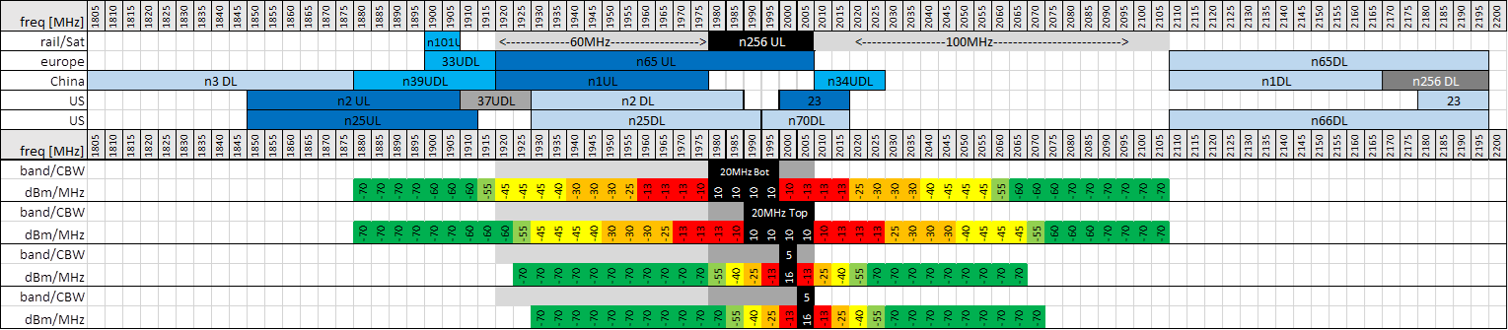
Figure 7.4.2.2.10.1-1: Coexistence analysis based on SEM mask extension for band n256
3) Coexistence protection for band n2, n25, n70 DL
From RAN4 perspective, UE co-existence requirements can’t be fulfilled (-50dBm/MHz) for the TN bands (i.e., n2, n25 and n70) which are overlapping n256. In Release 17, it is RAN4 understanding that the co-existence issue between n256 and those TN bands shall rely on regional or national regulation.
Other proposals:
Other proposals were submitted to solve the UE to UE coexistence issues between NTN and TN especially for the protected DL frequency range which is overlapping with UL frequency range of band n256 or next to the edge of band n256 UL filter.
For example:
- Isolation regions could be defined between NTN and TN coverage. And a corresponding signaling could be designed by RAN2.
- Before transmitting UL band n256 signals, satellite UE should determine (or be informed) whether the IMT services exist for the protected DL frequency range in the vicinity.
- Other potential mechanisms/solutions are not precluded.
Considering these proposals will have impacts on RAN1/RAN2 specifications, these proposals were not further discussed in Release 17.

7.4.2.2.10.2 UE-to-UE coexistence for n252
The adjacent/overlapping TN bands to NTN band n252 are shown in Figure 5.2.4-1. Band n252 UL has 5MHz frequency separation from TN band n25, and 10 MHz separation from TN band n2. Furthermore, band n252 UL is overlapped with TN band n70 DL, and band 252 DL is overlapped with TN band n66 DL. The following are RAN4 agreements regarding UE-to-UE coexistence between band n252 and the adjacent/overlapping TN bands.
1. Coexistence protection for band n2, n25 DL
It is very challenging to meet the traditional -50 dBm/MHz UE-to-UE coexistence spurious emission requirement for n2, n25 without significant amount of power reduction (A-MPR) to n252. RAN4 agrees to define a more relaxed UE-to-UE coexistence spurious emission requirement compared to -50 dBm/MHz, that allows the NTN service to work effectively, across the full n252 bands, whilst still provide protection to n2/n25 DL UE from n252 UL UE.
The following two (2) different additional spurious emission requirements, each with the associated NS value and A-MPR, are agreed.
- -30 dBm/MHz
- -40 dBm/MHz
The above requirement applies based on coordination between operators and subject to regional/national regulation
To allow operation flexibility, RAN4 also agreed to define asymmetric channel bandwidth with 5, 10 and 15 MHz UL channel bandwidth for band n252, with BCS0 including all permutation based on UL channel bandwidth. See Table 7.2.3-1 for asymmetric channel bandwidth definition.
2. Coexistence protection for band n70 DL
From RAN4 perspective, there is no 3GPP solution to address coexistence between overlapping bands. Coexistence between n252 and band n70 is subject to regional/national regulation.
3. Coexistence protection for band n66 DL
UE-to-UE coexistence requirements of -50dBm/MHz between n252 UL and TN band n66 DL can be met without additional power reduction (A-MPR).

7.4.2.3 Radiated transmitter characteristics for Ka band VSAT

7.4.2.3.1 VSAT maximum output power
There are many kinds of implementations for VSAT in Ka band. Based on the ITU regulation, VSAT could be fixed or mobile. The antenna beam steering types could be mechanical or electronic. Thus, the following VSAT types are considered.
Table 7.4.2.3.1-1: Assumptions of UE Types
UE class | UE type | Type description
Fixed VSAT | 1 | Fixed VSAT communicating with GSO and LEO with mechanical steering antenna.
 | 2 | Fixed VSAT communicating with GSO and LEO with electronic steering antenna.
 | 3 | Fixed VSAT communicating with LEO only with electronic steering antenna.
Mobile VSAT | 4 | Mobile VSAT communicating with GSO with mechanical steering antenna.
 | 5 | Mobile VSAT communicating with GSO with electronic steering antenna.
Note 1: The UE types are assuming UE has only one antenna beam towards one satellite at a given time in this release.
Note 2: The Mobile VSAT communicating with non-GSO is not considered in this release.

As the 76.2dBm maximum peak EIRP is assumed for the adjacent coexistence studies, the 76.2dBm maximum peak EIRP was specified in Rel-18.
For type 3 in LEO600 scenario, at least 61dBm EIRP is assumed with the following UL budget.
Table 7.4.2.3.1-2: The calculation of UL budget for LEO600 scenario
 | LEO600
NTN VSAT EIRP (dBm) | 61
Elevation angle (degree) | 45
Slant range (km) | 814.83
center frequency (GHz) | 27
freePathloss | 179.29
SAN UL Received SINR (dB) | > 0.7

The 61dBm minimum peak EIRP can guarantee the uplink budget without failure.
For other types in GSO scenario, at least 70dBm EIRP is assumed with the following UL budget.
Table 7.4.2.3.1-3: The calculation of UL budget for GSO scenario
 | GSO
NTN VSAT EIRP (dBm) | 70
Elevation angle (degree) | 30
Slant range (km) | 38611
center frequency (GHz) | 27
freePathloss | 212.80
SAN UL Received SINR (dB) | > -1

The 70dBm minimum peak EIRP can guarantee the uplink budget without failure.

7.4.3 UE Receiver characteristics for satellite access

7.4.3.1 General
Unless otherwise stated the receiver characteristics are specified at the antenna connector(s) of the UE. For UE(s) with an integral antenna only, a reference antenna(s) with a gain of 0 dBi is assumed for each antenna port(s). UE with an integral antenna(s) may be taken into account by converting these power levels into field strength requirements, assuming a 0 dBi gain antenna. For UEs with more than one receiver antenna connector, identical interfering signals shall be applied to each receiver antenna port if more than one of these is used (diversity).

7.4.3.2 Conducted receiver characteristics

7.4.3.2.1 General and diversity characteristics
Unless otherwise stated the receiver characteristics are specified at the antenna connector(s) of the UE for satellite access.
The handheld UE for satellite access is required to be equipped with a minimum of two Rx antenna ports in all NTN satellite operating bands in FR1.

7.4.3.2.2 Reference sensitivity
The reference sensitivity power level REFSENS is the minimum mean power applied to each one of the UE antenna ports for all UE categories, at which the throughput shall meet or exceed the requirements for the specified reference measurement channel. For below 6GHz, the REFSENS level can be calculated by the equation below in TR 38.817-01[32]:
Sensitivity = -174dBm(kT) + 10*log(RX BW) + NF + SNR +IM – diversity gain
It is noted that the Rx BW is identical to the transmission bandwidth configuration, which is determined by the spectrum utilization. The RB values in the analysis of this contribution are based on the agreed SU for NR.
SNR in Nagoya meeting was agreed as -1dB for NR.
The REFSENS for E-UTRA assumes that the receiver is equipped with two Rx port as a baseline. If 2Rx is considered, the diversity gain is 3dB and the Implementation Margin (IM) uses 2.5dB. In the following calculation, same assumptions are used for NR NTN satellite bands.
For band n255, 9dB noise figure is assumed which is aligned with band n24.
Both dedicate 30MHz duplexer and n65 duplexer are allowed to be used for band n256. Finally, 9dB noise figure is assumed for band n256 as well.
For n252, RAN4 agreed that as a starting point the UE REFSENS value for n252 is aligned with the values for n256.
The throughput shall be ≥ 95 % of the maximum throughput of the reference measurement channels as specified in Annexes A.2.2.2 and A.3.2 from TS 38.101-1 [17] (with one sided dynamic OCNG Pattern OP.1 FDD for the DL-signal as described in Annex A.5.1.1 from TS 38.101-1 [17]) with parameters specified in Table 7.4.3.2.2-1 and Table 7.4.3.2.2-2.
Table 7.4.3.2.2-1: Two antenna port reference sensitivity QPSK REFSENS
Operating band / SCS / Channel bandwidth / Duplex-mode
NTN satellite band # | SCS kHz | 3 MHz (dBm) | 5  MHz  (dBm) | 10  MHz  (dBm) | 15  MHz  (dBm) | 20  MHz  (dBm) | Duplex Mode
 | 15 | -101.7 | -100.0 | -96.8 | -95.0 | -93.8
n255 | 30 |  |  | -97.1 | -95.1 | -94.0 | FDD
 | 60 |  |  | -97.5 | -95.4 | -94.2
 | 15 | -101.7 | -99.5 | -96.3 | -94.5 | -93.3
n256 | 30 |  |  | -96.6 | -94.6 | -93.5 | FDD
 | 60 |  |  | -97 | -94.9 | -93.7
n253 | 15 | -100.0 |  |  |  | 15 | FDD
 | 30 |  |  |  |  | 30
 | 60 |  |  |  |  | 60
 | 15 |  | -99.5 | -96.3 | -94.5 | -93.3
n252 | 30 |  |  | -96.6 | -94.6 | -93.5 | FDD
 | 60 |  |  | -97.0 | -94.9 | -93.7
n251 | 15 | -100.0 | -96.8 | -95.0 | -93.8 | 15 | FDD
 | 30 |  | -97.1 | -95.1 | -94.0 | 30
 | 60 |  | -97.5 | -95.4 | -94.2 | 60
n250 | 15 | -100.0 | -96.8 | -95.0 | -93.8 | 15 | FDD
 | 30 |  | -97.1 | -95.1 | -94.0 | 30
 | 60 |  | -97.5 | -95.4 | -94.2 | 60

For power class 2 and power class 1 UEs, certain degradation of the reference sensitivity in Table 7.4.3.2.2-1 is allowed. For a power class 2 UE the maximum amount of degradation is specified in Table 7.4.3.2.2-1a, and in Table 7.4.3.2.2-1b for a UE that indicates txDiversity-r16 or txDiversity2Tx-r18. For a power class 1 UE the maximum amount of degradation is specified in Table 7.4.3.2.2-1c, and in Table 7.4.3.2.2-1d for a UE that indicates txDiversity-4Tx-r18.
Table 7.3.2-1a Reference Sensitivity Degradation from PC3 to PC2 for FDD bands for UE with 1Tx
Operating Band | 5  MHz  (dB) | 10  MHz  (dB) | 15  MHz  (dB) | 20  MHz  (dB) | 25  MHz  (dB) | 30 MHz (dB) | 35 MHz (dB) | 40  MHz  (dB) | 45 MHz (dB) | 50  MHz  (dB)
n256 | 0 | 0 | 0 | 0
n255 | 0.8 | 0.8 | 0.9 | 0.9
NOTE 1: The transmitter shall be set to P_{UMAX} as defined in clause 6.2.4 of 3GPP TS 38.101-1 [5].

Table 7.3.2-1b Reference Sensitivity Degradation from PC3 to PC2 for
FDD bands for UE with 2Tx
Operating Band | 5  MHz  (dB) | 10  MHz  (dB) | 15  MHz  (dB) | 20  MHz  (dB) | 25  MHz  (dB) | 30 MHz (dB) | 35 MHz (dB) | 40  MHz  (dB) | 45 MHz (dB) | 50  MHz  (dB)
n256 | 0 | 0 | 0 | 0
n255 | 1.6 | 1.6 | 1.7 | 1.7
NOTE 1: The transmitter shall be set to P_{UMAX} as defined in clause 6.2.4 of 3GPP TS 38.101-1 [5].

Table 7.3.2-1c Reference Sensitivity Degradation from PC3 to PC1 for
FDD bands for UE with 1Tx
Operating Band | 5  MHz  (dB) | 10  MHz  (dB) | 15  MHz  (dB) | 20  MHz  (dB) | 25  MHz  (dB) | 30 MHz (dB) | 35 MHz (dB) | 40  MHz  (dB) | 45 MHz (dB) | 50  MHz  (dB)
n256 | 1.5 | 1.5 | 1.5 | 1.5
n255 | 2 | 2 | 2 | 2
NOTE 1: The transmitter shall be set to P_{UMAX} as defined in clause 6.2.4 of 3GPP TS 38.101-1 [5].

Table 7.3.2-1d Reference Sensitivity Degradation from PC3 to PC1 for
FDD bands for UE with 4Tx
Operating Band | 5  MHz  (dB) | 10  MHz  (dB) | 15  MHz  (dB) | 20  MHz  (dB) | 25  MHz  (dB) | 30 MHz (dB) | 35 MHz (dB) | 40  MHz  (dB) | 45 MHz (dB) | 50  MHz  (dB)
n256 | 2.1 | 2.1 | 2.1 | 2.1
n255 | 3.3 | 3.3 | 3.3 | 3.3
NOTE 1: The transmitter shall be set to P_{UMAX} as defined in clause 6.2.4 of 3GPP TS 38.101-1 [5].

Table 7.4.3.2.2-2: Uplink configuration for reference sensitivity
 | Operating band / SCS / Channel bandwidth / Duplex-mode
NTN satellite band # |  | SCS kHz | 3 MHz (dBm) | 5  MHz  (dBm) | 10  MHz  (dBm) | 15  MHz  (dBm) | 20  MHz  (dBm) | Duplex Mode
 |  | 15 | 15 | 25 | 50 | 75 | 100
n255 |  | 30 |  |  | 24 | 36 | 50 | FDD
 |  | 60 |  |  | 10 | 18 | 24
 |  | 15 | 15 | 25 | 50 | 75 | 100
n256 |  | 30 |  |  | 24 | 36 | 50 | FDD
 |  | 60 |  |  | 10 | 18 | 24
n253 |  | 15 |  | 25 |  |  |  | FDD
 |  | 30 |  |  |  |  |  | FDD
 |  | 60 |  |  |  |  |  | FDD
 |  | 15 |  | 25 | 50 | 75 | 100
n252 |  | 30 |  |  | 24 | 36 | 50 | FDD
 |  | 60 |  |  | 10 | 18 | 24
n251 |  | 15 |  | 25 | 50 | 75 | 75²  50³ | FDD
 |  | 30 |  |  | 24 | 36 | 36²  24³ | FDD
 |  | 60 |  |  | 10 | 18 | 18²  10³ | FDD
n250 |  | 15 |  | 25 |  |  | 75²  50³ | FDD

Table 7.4.3.2.2-3: TX – RX carrier centre frequency separation for REFSENS verification
Operating Band | Channel bandwidth | TX – RX carrier centre frequency separation for REFSENS verification
n253 | 5 MHz | -148MHz, -152MHz
n251 | 5 MHz | -72.5 MHz, -137.5 MHz
n251 | 20 MHz | -87.5 MHz, -122.5MHz
n250 | 5 MHz | -114 MHz, -152 MHz
n250 | 20 MHz | -129 MHz, -137 MHz

7.4.3.2.3 Maximum input level
Maximum input level is defined as the maximum mean power received at the UE antenna port, at which the specified relative throughput shall meet or exceed the minimum requirements for the specified reference measurement channel. In defining requirements for maximum input level, there are two effects should be considered. One is the dynamic range for Rx link since the maximum input level would determine the high limit of dynamic range. The other is the maximum received input power at UE in real deployment. If the maximum received input signal level is increased, then pre-LNA attenuation is required, which adds complexity to UE RX chain. Similar as the method in TN system, in order to evaluate the level of maximum received power, the Min distance for consideration is given in Table 7.4.3.2.3-1.
Table 7.4.3.2.3-1: Min distance for conderation
 |  | Satellite Type
 | Parameters
 |  | GEO | LEO 1200 | LEO 600
 | Carrier frequency [GHz] | 2 | 2 | 2
 | Min Distance from Satellite D_Min [Km] | 35786 | 1200 | 600
 | The free space path loss (FSPL) (dB) | 189.5 | 160.1 | 154.0
SET 1 | Satellite EIRP density (dBW/MHz) | 59 | 40 | 34
SET 1 | Bandwidth (15kHz SCS) (MHz) | 20
SET 1 | Rx signal at min Distance (dBm) | -87.7 | -77.2 | -77.2
SET 2 | Satellite EIRP density (dBW/MHz) | 53.3 | 34 | 28
SET 2 | Bandwidth (15kHz SCS) (MHz) | 20
SET 2 | Rx signal at min Distance (dBm) | -93.4 | -83.2 | -83.2

From above table, the maximum received power is -77.2 dBm for 20 MHz which is very lower than -25dBm in TN. It is therefore the maximum input level can be relaxed by 15 dB compared with TN requirement.

7.4.3.2.4 Adjacent channel selectivity
For ACS, the coexistence studies outcome shows that the same ACS values as for NR TN UE are appropriate, and therefore reused.
ACS test parameters in case 1 is applied. ACS requirements in case 2 can be specified based on the maximum input level of -40dBm.

7.4.3.2.5 Blocking characteristics
For blocking characteristics, it is agreed, the same requirements as for NR TN UEs are applicable, and therefore reused. For NR satellite band n255, OOBB requirements of n24 are reused. For n256, it is assumed to keep UE implementation freedom with different options (e.g., reusing n65 duplexer or dedicated 30MHz duplexer).
For n252, the agreed Out-of-band blocking requirement does not preclude any implementation of UE duplexer architecture.
Table 7.4.3.2.5-1 describes the agreed out-of-band blocking requirement for n252.
Table 7.4.3.2.5-1: Out-of-band blocking for n252
Operating Band | Parameter | Unit | Range 1 | Range 2 | Range 3
 | P_{interferer} | dBm | -44 | -30 | -15
n252 | F_{interferer} (CW) | MHz | -110 < f – F_{DL_low} < -15  or  15 < f – F_{DL_high} < 60 | -155 < f – F_{DL_low} ≤ -110  or  60 ≤ f – F_{DL_high} < 85 | 1 ≤ f ≤ F_{DL_low} – 155  or  F_{DL_high} + 85 ≤ f  ≤ 12750

7.4.3.2.6 Spurious response
Spurious response is a measure of the ability of the receiver to receive a wanted signal on its assigned channel frequency without exceeding a given degradation due to the presence of an unwanted CW interfering signal at any other frequency for which a response is obtained, i.e. for which the out-of-band blocking limit is not met. To assume the same interfering signals for guaranteeing TN and NTN UE performance, TN spurious response requirements in section 7.7 of TS 38.101-1[17] could be applicable to NTN satellite access UEs.

7.4.3.2.7 Intermodulation characteristics
Intermodulation response rejection is a measure of the capability of the receiver to receive a wanted signal on its assigned channel frequency in the presence of two or more interfering signals which have a specific frequency relationship to the wanted signal. To assume the same interfering signals for guaranteeing TN and NTN UE performance, TN wide-band intermodulation parameters in Table 7.8.2-1 of TS 38.101-1[17] could be applicable to NTN satellite access UEs.

7.4.3.2.8 Rx Spurious emissions
The spurious emissions limits specified in TS 38.101-1[17] sub-clause 7.9 would also be applicable to NTN satellite access UEs referring to the ERC Recommendation 74-01[28] Annex 3 item 3.1.5 for Mobile Earth Stations (MES) (see Note 1bis) operating below 3 GHz: receivers, receive only MES and transmitters in the carrier-off state.

7.4.3.2.9 Void

7.4.3.3 Radiated receiver characteristics for Ka band VSAT

7.4.3.3.1 Polarization characteristics
Due to the faraday rotation effect in the atomosphere, the circular polarization is usually used for satellite communication. The minimum requirements on the receiver characteristics apply under RHCP (right hand circular polarization) or LHCP (left hand circular polarization).

7.4.3.3.2 OTA reference sensitivity level
If 62dBm EIRP can be assumed for LEO600 SAN with 30 degree elevation angle scenario, the DL budget calculation is shown below to get the DL received signal at OTA (effective isotropic received signal).
Table 7.4.3.3.2-1: The calculation of DL budget for LEO600 scenario
 | LEO600
NTN SAN EIRP (dBm) | 62
Elevation angle (degree) | 30
Slant range (km) | 1075
center frequency (GHz) | 17
freePathloss | 177.68
VSAT DL Received signal level at OTA (dBm) | -115.68

If -5dB G/T can be assumed to calculate the EIS requirements, the following calculation can be used to derived it.
EIS=10*log10(k)+30+10*log10(BW)+SNR+IM-G/T
BW is channel bandwidth. (candidate value: 50MHz)
IM is implementation margin. 2dB can be assumed.
SNR is the required SNR for demodulation. -1dB can be assumed.
G/T: -5dB.
K: is Boltzmann constant, 1.38*10-23 J/K
Based on the calculation, the 50MHz minimum EIS for fixed VSAT communicating with LEO only with electronical steering antenna is -115.6dBm, which is valid for DL link budget.
If 82dBm EIRP can be assumed for GSO SAN with 30 degree elevation angle scenario, the DL budget calculation is shown below to get the DL received signal at OTA (effective isotropic received signal).
Table 7.4.3.3.2-1: The calculation of DL budget for GSO scenario
 | GSO
NTN SAN EIRP (dBm) | 87
Elevation angle (degree) | 30
Slant range (km) | 38611
center frequency (GHz) | 17
freePathloss | 208.78
VSAT DL Received signal level at OTA (dBm) | -121.78

If 6dB G/T can be assumed to calculate the EIS requirements, the following calculation can be used to derived it.
EIS=10*log10(k)+30+10*log10(BW)+SNR+IM-G/T
BW is channel bandwidth. (candidate value: 50MHz)
IM is implementation margin. 2dB can be assumed.
SNR is the required SNR for demodulation. -1dB can be assumed.
G/T: 6 dB.
K: is Boltzmann constant, 1.38*10-23 J/K
Based on the calculation, the 50MHz minimum EIS for other types is -122 dBm, which is valid for DL link budget.

7.4.4 UE antenna characteristics for satellite access

7.4.4.1 Handheld UE antenna characteristics for satellite access
In Release 17, a reference antenna with a gain of 0dBi is assumed for handheld UE. However, the actual antenna gain can’t meet 0dBi in each direction considering the antenna efficiency which is not 100%. Since all the Tx and Rx requirements are specified at conduct connector for handheld UE, the actual antenna characteristic will have no impact on the RF specification for Release 17 handheld UE.

8 Conclusion
It is recommended to take due consideration of contents in Chapter 6 and Chapter 7 when developing Technical Specifications of RF requirements for SAN, HAPS and UE using NR to support non-terrestrial networks (NTN).

Annex A:
Calibration results of NTN components

A.1 Calibration assumptions at 2GHz
Assumptions in Section 6.2 are adopted as the baseline for calibration. It should be noted there are different parts which are listed in Table A.1-1.
Table A.1-1: NTN Assumptions for calibration
Propagation model 38.811[5] considerations | Basic path loss | Yes
Propagation model 38.811[5] considerations | Atmospheric loss | 0
Propagation model 38.811[5] considerations | Ionospheric or scintillation loss | 0
Propagation model 38.811[5] considerations | O2I / building-entry loss | N/A
NTN SINR | SINR statistics target | Central beam (UL/DL)
NTN SINR | Interference | Co-channel interference from 6 adjacent beams
NTN SINR | BW / #UE | 20MHz / 1 DL, 3UL
NTN SINR | Polarization gain with 3dB | not considered
NTN SINR | Elevation angle | 90 degrees for GEO and LEO
HAPS SINR | SINR statistics target | 7 cells for DL and UL, HAPS UE is uniformly distributed in 7 cells
HAPS SINR | Interference | Co- channel interference from other 6 cells
HAPS SINR | BW / #UE | 20MHz/1DL, 3UL and each UE BW is 0.36MHz
HAPS SINR | Polarization gain with 3dB | considered
Propagation model 38.811[5] considerations for HAPS | Basic path loss | yes
Propagation model 38.811[5] considerations for HAPS | Atmospheric loss | 0
Propagation model 38.811[5] considerations for HAPS | Ionospheric or scintillation loss | 0
Propagation model 38.811[5] considerations for HAPS | O2I / building-entry loss | 0
HAPS | power control parameter | gamma =1, CL-ile = 121.45
HAPS | rural vs. urban difference | only reflect on the propagation model. Other assumptions are the same.

A.1a Calibration assumptions at 11/14GHz
Assumptions in Section 6c.2 are adopted as the baseline for calibration. It should be noted there are different parts which are listed in Table A.1a-1.
Table A.1a-1: NTN Assumptions for calibration
Propagation model 38.811[5] considerations | Basic path loss | Yes (including Clutter Loss from Table 6.6.2-1 TR 38.811)
Propagation model 38.811[5] considerations | Atmospheric loss | 0
Propagation model 38.811[5] considerations | Ionospheric or scintillation loss | 0
Propagation model 38.811[5] considerations | O2I / building-entry loss | N/A
NTN SINR | SINR statistics target | Central beam (UL/DL)
NTN SINR | Interference | Co-channel interference from 6 adjacent beams
NTN SINR | BW / #UE | 100MHz / 1 DL, 10UL
NTN SINR | Polarization gain with 3dB | not considered
NTN SINR | Elevation angle | 35 degrees for GEO and LEO
NTN SINR | Scenario | Urban
VSAT phased array | Antenna characteristics | 45x45 antenna elements - Refer to Table 6a.2.2.2-1
VSAT phased array | VSAT NF | 6 dB

A.2 Calibration results at 2GHz
The calibration results include SINR and coupling loss distributions in DL, and SINR, coupling loss and transmit power distributions in UL. Both rural and urban propagation models defined in TR 38.811[5] are considered. For NTN simulation, HAPS, LEO-600, LEO-1200 and GEO are calibrated and results are summarized in Table A.2-1, 2-2, 2-3 and 2-4.
NOTE: The “-” means the data was not provided by its corresponding contributor.
Table A.2-1: Calibration summary for NTN DL Rural cases
Calibration metrics |  | DL Coupling Loss |  |  | DL Geometry SINR
CDF percentile |  | @5% | @50% | @95% | @5% | @50% | @95%
LEO-600 | Samsung | 123.60 | 125.25 | 126.98 | -2.49 | -0.41 | 2.23
LEO-600 | Qualcomm | 123.69 | 125.38 | 127.13 | -2.72 | -0.72 | 2.16
LEO-600 | CATT | 123.59 | 125.21 | 127.10 | -3.07 | -0.84 | 2.22
LEO-600 | THALES | 123.75 | 125.84 | 127.90 | -3.86 | -1.40 | 2.17
LEO-600 | Huawei | 123.54 | 125.63 | 129.16 | 7.44 | 10.91 | 12.97
LEO-600 | Xiaomi | 123.61 | 125.15 | 126.93 | -3.01 | -0.59 | 2.02
LEO-600 | ZTE | 123.66 | 125.57 | 127.64 | -3.05 | -0.22 | 3.65
LEO-600 | Nokia | 123.68 | 125.33 | 127.05 | -3.10 | -1.16 | 0.94
LEO-600 | Ericsson | - | - | - | -2.58 | 6.97 | 9.95
LEO-600 | FhG | 123.61 | 125.37 | 127.07 | -3.48 | -1.19 | 1.36
LEO-600 | Variance | 0.00 | 0.04 | 0.46 | 10.03 | 16.13 | 14.92
LEO-600 | Mean | 123.64 | 125.41 | 127.44 | -1.99 | 1.14 | 3.97
LEO-1200 | Samsung | 129.61 | 131.27 | 132.99 | -2.47 | -0.40 | 2.23
LEO-1200 | Qualcomm | 129.60 | 131.21 | 132.91 | -2.35 | -0.42 | 2.13
LEO-1200 | CATT | 129.56 | 131.20 | 132.86 | -2.21 | -0.54 | 2.08
LEO-1200 | THALES | 129.68 | 131.51 | 133.28 | -2.91 | -0.79 | 2.27
LEO-1200 | Huawei | 129.48 | 131.28 | 133.83 | 1.47 | 7.62 | 12.76
LEO-1200 | Xiaomi | 129.68 | 131.21 | 132.94 | -2.55 | -0.70 | 1.65
LEO-1200 | ZTE | 129.71 | 131.53 | 133.31 | -2.42 | -0.18 | 3.66
LEO-1200 | Nokia | 129.70 | 131.36 | 133.10 | -3.09 | -1.20 | 0.94
LEO-1200 | Ericsson | - | - | - | -3.04 | 6.14 | 10.22
LEO-1200 | FhG | 129.75 | 131.30 | 132.97 | -3.36 | -1.11 | 1.20
LEO-1200 | Variance | 0.01 | 0.01 | 0.08 | 1.70 | 9.31 | 15.16
LEO-1200 | Mean | 129.64 | 131.32 | 133.13 | -2.29 | 0.84 | 3.91
GEO | Samsung | 138.15 | 139.85 | 141.61 | -3.77 | -1.79 | 0.50
GEO | Qualcomm | 138.11 | 139.76 | 141.49 | -3.75 | -1.97 | 0.29
GEO | CATT | 137.97 | 139.80 | 141.51 | -3.74 | -2.08 | 0.36
GEO | THALES | 138.23 | 140.07 | 141.90 | -3.86 | -1.85 | 1.05
GEO | Huawei | 139.45 | 140.61 | 142.00 | -1.04 | 0.26 | 1.27
GEO | Xiaomi | 138.54 | 140.07 | 141.77 | -3.76 | -1.94 | 0.23
GEO | ZTE | 137.81 | 140.36 | 142.92 | -3.81 | -2.24 | -0.02
GEO | Nokia | 137.95 | 140.21 | 142.49 | -3.91 | -2.06 | -0.08
GEO | Ericsson | - | - | - | -6.62 | -0.18 | 3.60
GEO | FhG | 138.43 | 139.99 | 141.80 | -5.18 | -2.75 | -0.59
GEO | Variance | 0.21 | 0.07 | 0.20 | 1.72 | 0.79 | 1.22
GEO | Mean | 138.29 | 140.08 | 141.94 | -3.94 | -1.66 | 0.66
HAPS | Nokia | 112.15 | 118.78 | 142.92 | -7.82 | 10.20 | 17.05
HAPS | Qualcomm | 114.14 | 118.70 | 141.92 | -12.54 | 10.19 | 18.46
HAPS | Variance | 0.99 | 0.00 | 0.25 | 5.58 | 0.00 | 0.50
HAPS | Mean | 113.14 | 118.74 | 142.42 | -10.18 | 10.20 | 17.75

Table A.2-2: Calibration summary for NTN DL Urban cases
Calibration metrics |  | DL Coupling Loss |  |  | DL Geometry SINR
CDF percentile |  | @5% | @50% | @95% | @5% | @50% | @95%
LEO-600 | Samsung | 118.57 | 125.31 | 132.31 | -2.67 | -0.50 | 2.17
LEO-600 | Qualcomm | 118.56 | 125.21 | 132.93 | -2.94 | -0.84 | 2.12
LEO-600 | CATT | 118.94 | 125.50 | 132.25 | -2.51 | -0.35 | 2.25
LEO-600 | THALES | 119.00 | 125.67 | 132.50 | -3.93 | -1.50 | 2.13
LEO-600 | Huawei | 120.16 | 125.74 | 131.63 | 1.80 | 9.01 | 15.14
LEO-600 | Xiaomi | 119.19 | 125.45 | 132.56 | -2.69 | -0.79 | 1.57
LEO-600 | ZTE | 118.90 | 125.58 | 132.40 | -3.05 | -0.61 | 3.37
LEO-600 | Ericsson | - | - | - | -3.66 | 4.92 | 13.77
LEO-600 | Nokia | 118.71 | 125.16 | 131.68 | -3.53 | -1.15 | 2.42
LEO-600 | FhG | 119.50 | 125.89 | 133.01 | -11.24 | -3.00 | 3.96
LEO-600 | Variance | 0.23 | 0.05 | 0.20 | 9.11 | 11.73 | 23.37
LEO-600 | Mean | 119.06 | 125.50 | 132.36 | -3.44 | 0.52 | 4.89
LEO-1200 | Samsung | 124.61 | 131.33 | 138.34 | -2.64 | -0.50 | 2.17
LEO-1200 | Qualcomm | 124.35 | 131.34 | 138.33 | -2.49 | -0.50 | 2.12
LEO-1200 | CATT | 125.02 | 131.78 | 137.85 | -2.63 | -0.37 | 2.23
LEO-1200 | THALES | 124.60 | 131.40 | 138.00 | -3.00 | -0.88 | 2.23
LEO-1200 | Huawei | 123.64 | 131.62 | 139.59 | -4.73 | 6.35 | 14.64
LEO-1200 | Xiaomi | 125.02 | 131.28 | 138.73 | -2.62 | -0.77 | 1.57
LEO-1200 | ZTE | 124.71 | 131.52 | 138.22 | -2.40 | -0.32 | 3.45
LEO-1200 | Ericsson | - | - | - | -3.67 | 4.81 | 14.30
LEO-1200 | Nokia | 123.97 | 130.42 | 136.92 | -3.58 | -1.27 | 2.28
LEO-1200 | FhG | 125.31 | 131.45 | 138.08 | -10.40 | -2.51 | 4.21
LEO-1200 | Variance | 0.25 | 0.13 | 0.45 | 5.29 | 7.18 | 23.32
LEO-1200 | Mean | 124.58 | 131.35 | 138.23 | -3.82 | 0.40 | 4.92
GEO | Samsung | 133.18 | 139.90 | 146.93 | -5.72 | -2.09 | 1.10
GEO | Qualcomm | 132.93 | 139.89 | 146.94 | -5.83 | -2.21 | 0.92
GEO | CATT | 132.50 | 139.69 | 146.40 | -5.39 | -2.16 | 1.03
GEO | THALES | 133.30 | 139.97 | 146.60 | -4.97 | -2.16 | 1.34
GEO | Huawei | 132.43 | 138.44 | 145.29 | -5.93 | -0.54 | 6.53
GEO | Xiaomi | 133.23 | 139.68 | 146.97 | -5.24 | -2.63 | -0.56
GEO | ZTE | 133.72 | 140.50 | 146.99 | -5.23 | -2.51 | -0.11
GEO | Ericsson | - | - | - | -7.49 | -0.59 | 7.41
GEO | FhG | 132.74 | 139.69 | 146.97 | -11.58 | -3.57 | 4.35
GEO | Variance | 0.17 | 0.30 | 0.30 | 3.86 | 0.81 | 7.54
GEO | Mean | 133.00 | 139.72 | 146.64 | -6.38 | -2.05 | 2.45
HAPS | Nokia | 111.39 | 145.66 | 164.30 | -29.10 | -10.47 | 16.29
HAPS | Qualcomm | 112.00 | 143.12 | 159.76 | -30.86 | -10.70 | 20.84
HAPS | Variance | 0.09 | 1.61 | 5.14 | 0.77 | 0.01 | 5.17
HAPS | Mean | 111.69 | 144.39 | 162.03 | -29.98 | -10.58 | 18.57

Table A.2-3: Calibration summary for NTN UL Rural cases
Calibration metrics |  | UL Coupling Loss |  |  | UL Geometry SINR |  |  | UL UE Tx Power
CDF percentile |  | @5% | @50% | @95% | @5% | @50% | @95% | @5% | @50% | @95%
LEO-600 | Samsung | 123.60 | 125.25 | 126.98 | -5.51 | -3.07 | -0.70 | 23.00 | 23.00 | 23.00
LEO-600 | Qualcomm | 123.64 | 125.37 | 127.14 | -5.43 | -2.92 | -0.42 | 23.00 | 23.00 | 23.00
LEO-600 | CATT | 123.68 | 125.47 | 127.29 | -7.22 | -1.78 | 0.42 | - | - | -
LEO-600 | THALES | 123.75 | 125.84 | 127.90 | -6.16 | -3.76 | -1.31 | 23.00 | 23.00 | 23.00
LEO-600 | Huawei | 123.54 | 125.63 | 129.16 | -5.12 | -1.31 | 0.60 | 23.00 | 23.00 | 23.00
LEO-600 | Xiaomi | 123.66 | 125.22 | 126.92 | -5.14 | -2.60 | 0.18 | 23.00 | 23.00 | 23.00
LEO-600 | ZTE | 123.83 | 125.65 | 127.46 | -5.45 | -3.04 | -0.55 | 23.00 | 23.00 | 23.00
LEO-600 | Ericsson | - | - | - | -14.64 | -8.63 | -3.87 | - | - | -
LEO-600 | FhG | 123.85 | 125.27 | 127.12 | -5.98 | -3.47 | -1.38 | 23.00 | 23.00 | 23.00
LEO-600 | Variance | 0.01 | 0.04 | 0.48 | 8.19 | 3.96 | 1.63 | 0.00 | 0.00 | 0.00
LEO-600 | Mean | 123.69 | 125.46 | 127.50 | -6.74 | -3.40 | -0.78 | 23.00 | 23.00 | 23.00
LEO-1200 | Samsung | 129.62 | 131.27 | 132.99 | -9.44 | -7.60 | -5.83 | 23.00 | 23.00 | 23.00
LEO-1200 | Qualcomm | 129.56 | 131.18 | 132.89 | -9.40 | -7.61 | -5.78 | 23.00 | 23.00 | 23.00
LEO-1200 | CATT | 129.72 | 131.31 | 132.85 | -8.84 | -6.97 | -5.28 | - | - | -
LEO-1200 | THALES | 129.68 | 131.51 | 133.28 | -9.46 | -7.68 | -5.75 | 23.00 | 23.00 | 23.00
LEO-1200 | Huawei | 129.48 | 131.28 | 133.83 | -9.48 | -6.85 | -5.18 | 23.00 | 23.00 | 23.00
LEO-1200 | Xiaomi | 129.61 | 131.23 | 132.93 | -7.97 | -6.09 | -4.20 | 23.00 | 23.00 | 23.00
LEO-1200 | ZTE | 129.60 | 131.38 | 133.25 | -9.27 | -7.32 | -5.63 | 23.00 | 23.00 | 23.00
LEO-1200 | Ericsson | - | - | - | -19.05 | -13.42 | -9.84 | - | - | -
LEO-1200 | FhG | 129.68 | 131.28 | 133.06 | -9.51 | -7.69 | -5.98 | 23.00 | 23.00 | 23.00
LEO-1200 | Variance | 0.01 | 0.01 | 0.09 | 9.87 | 4.03 | 2.16 | 0.00 | 0.00 | 0.00
LEO-1200 | Mean | 129.62 | 131.31 | 133.14 | -10.27 | -7.91 | -5.94 | 23.00 | 23.00 | 23.00
GEO | Samsung | 138.15 | 139.85 | 141.59 | -20.31 | -18.54 | -16.85 | 23.00 | 23.00 | 23.00
GEO | Qualcomm | 138.06 | 139.73 | 141.47 | -20.21 | -18.47 | -16.78 | 23.00 | 23.00 | 23.00
GEO | CATT | 138.07 | 139.61 | 141.26 | -19.86 | -18.24 | -16.70 | - | - | -
GEO | THALES | 138.23 | 140.07 | 141.90 | -20.37 | -18.55 | -16.68 | 23.00 | 23.00 | 23.00
GEO | Huawei | 139.45 | 140.61 | 142.00 | -17.89 | -16.73 | -15.61 | 23.00 | 23.00 | 23.00
GEO | Xiaomi | 138.10 | 139.59 | 141.16 | -18.98 | -17.45 | -15.92 | 23.00 | 23.00 | 23.00
GEO | ZTE | 137.76 | 140.33 | 142.91 | -18.35 | -15.72 | -13.37 | 23.00 | 23.00 | 23.00
GEO | Ericsson | - | - | - | -30.59 | -25.37 | -21.63 | - | - | -
GEO | FhG | 138.33 | 139.76 | 141.56 | -20.26 | -18.49 | -17.06 | 23.00 | 23.00 | 23.00
GEO | Variance | 0.22 | 0.12 | 0.27 | 12.84 | 6.56 | 4.15 | 0.00 | 0.00 | 0.00
GEO | Mean | 138.27 | 139.94 | 141.73 | -20.76 | -18.62 | -16.73 | 23.00 | 23.00 | 23.00
HAPS | Nokia | 112.20 | 118.96 | 143.51 | -11.47 | 10.01 | 14.49 | 13.75 | 20.51 | 23.00
HAPS | Qualcomm | 114.14 | 118.70 | 141.92 | -9.93 | 10.59 | 14.85 | 15.69 | 20.25 | 23.00
HAPS | Variance | 0.94 | 0.02 | 0.64 | 0.60 | 0.09 | 0.03 | 0.93 | 0.02 | 0.00
HAPS | Mean | 113.17 | 118.83 | 142.72 | -10.70 | 10.30 | 14.67 | 14.72 | 20.38 | 23.00

Table A.2-4: Calibration summary for NTN UL Urban cases
Calibration metrics |  | UL Coupling Loss |  |  | UL Geometry SINR |  |  | UL UE Tx Power
CDF percentile |  | @5% | @50% | @95% | @5% | @50% | @95% | @5% | @50% | @95%
LEO-600 | Samsung | 118.58 | 125.30 | 132.31 | -11.38 | -3.64 | 3.57 | 23.00 | 23.00 | 23.00
LEO-600 | Qualcomm | 118.71 | 125.16 | 132.66 | -11.83 | -3.91 | 2.64 | 23.00 | 23.00 | 23.00
LEO-600 | CATT | 118.41 | 125.45 | 132.54 | -11.13 | -3.89 | 2.97 | - | - | -
LEO-600 | THALES | 119.00 | 125.67 | 132.50 | -11.15 | -3.92 | 2.70 | 23.00 | 23.00 | 23.00
LEO-600 | Huawei | 120.16 | 125.74 | 131.63 | -11.52 | -4.25 | 1.70 | 23.00 | 23.00 | 23.00
LEO-600 | Xiaomi | 118.63 | 125.29 | 132.62 | -11.20 | -3.19 | 4.57 | 23.00 | 23.00 | 23.00
LEO-600 | ZTE | 118.92 | 125.71 | 132.43 | -11.19 | -3.75 | 3.56 | 23.00 | 23.00 | 23.00
LEO-600 | Ericsson | - | - | - | -17.17 | -8.77 | 0.15 | - | - | -
LEO-600 | FhG | 117.88 | 125.14 | 132.15 | -11.34 | -4.04 | 3.87 | 23.00 | 23.00 | 23.00
LEO-600 | Variance | 0.37 | 0.05 | 0.10 | 3.40 | 2.49 | 1.52 | 0.00 | 0.00 | 0.00
LEO-600 | Mean | 118.79 | 125.43 | 132.35 | -11.99 | -4.37 | 2.86 | 23.00 | 23.00 | 23.00
LEO-1200 | Samsung | 124.60 | 131.32 | 138.32 | -15.10 | -7.94 | -1.13 | 23.00 | 23.00 | 23.00
LEO-1200 | Qualcomm | 124.40 | 131.30 | 138.36 | -15.23 | -8.01 | -0.95 | 23.00 | 23.00 | 23.00
LEO-1200 | CATT | 123.95 | 131.27 | 137.95 | -13.61 | -6.83 | -0.26 | - | - | -
LEO-1200 | THALES | 124.60 | 131.40 | 138.00 | -14.36 | -7.79 | -1.27 | 23.00 | 23.00 | 23.00
LEO-1200 | Huawei | 123.64 | 131.62 | 139.59 | -16.30 | -7.25 | -0.41 | 23.00 | 23.00 | 23.00
LEO-1200 | Xiaomi | 124.84 | 131.32 | 138.61 | -13.72 | -6.53 | 0.40 | 23.00 | 23.00 | 23.00
LEO-1200 | ZTE | 124.73 | 131.47 | 138.22 | -14.30 | -7.40 | -0.51 | 23.00 | 23.00 | 23.00
LEO-1200 | Ericsson | - | - | - | -21.09 | -13.52 | -5.47 | - | - | -
LEO-1200 | FhG | 124.30 | 130.66 | 137.02 | -14.02 | -7.35 | -0.89 | 23.00 | 23.00 | 23.00
LEO-1200 | Variance | 0.15 | 0.07 | 0.45 | 4.83 | 3.93 | 2.55 | 0.00 | 0.00 | 0.00
LEO-1200 | Mean | 124.38 | 131.30 | 138.26 | -15.30 | -8.07 | -1.17 | 23.00 | 23.00 | 23.00
GEO | Samsung | 133.17 | 139.89 | 146.92 | -25.64 | -18.62 | -11.90 | 23.00 | 23.00 | 23.00
GEO | Qualcomm | 132.96 | 139.86 | 146.90 | -25.69 | -18.61 | -11.73 | 23.00 | 23.00 | 23.00
GEO | CATT | 133.28 | 139.84 | 147.04 | -24.99 | -18.36 | -11.24 | - | - | -
GEO | THALES | 133.30 | 139.97 | 146.60 | -25.25 | -18.47 | -11.80 | 23.00 | 23.00 | 23.00
GEO | Huawei | 132.43 | 138.44 | 145.29 | -24.06 | -17.38 | -11.26 | 23.00 | 23.00 | 23.00
GEO | Xiaomi | 133.03 | 139.55 | 146.75 | -24.19 | -17.39 | -10.63 | 23.00 | 23.00 | 23.00
GEO | ZTE | 133.58 | 140.24 | 146.91 | -22.79 | -15.32 | -8.86 | 23.00 | 23.00 | 23.00
GEO | Ericsson | - | - | - | -32.17 | -25.29 | -17.44 | - | - | -
GEO | FhG | 133.46 | 140.15 | 147.08 | -25.79 | -18.93 | -12.26 | 23.00 | 23.00 | 23.00
GEO | Variance | 0.11 | 0.28 | 0.30 | 6.22 | 6.50 | 4.73 | 0.00 | 0.00 | 0.00
GEO | Mean | 133.15 | 139.74 | 146.69 | -25.62 | -18.71 | -11.90 | 23.00 | 23.00 | 23.00
HAPS | Nokia | 111.39 | 145.66 | 164.30 | -28.44 | -10.17 | 14.88 | 12.94 | 23.00 | 23.00
HAPS | Qualcomm | 111.89 | 143.11 | 158.93 | -26.02 | -8.42 | 14.90 | 13.44 | 23.00 | 23.00
HAPS | Variance | 0.06 | 1.62 | 7.21 | 1.46 | 0.76 | 0.00 | 0.06 | 0.00 | 0.00
HAPS | Mean | 111.64 | 144.38 | 161.61 | -27.23 | -9.29 | 14.89 | 13.19 | 23.00 | 23.00

Annex B:
Calibration results of TN components

B.1 Calibration assumptions at 2GHz
Assumptions in Section 6.2 are adopted as the baseline for calibration. It should be noted there are different parts which are listed in Table B.1-1.
Table B.1-1: TN Assumptions for calibration
Calibration assumptions
TN AAS | Rural | Element gain: 7.1 dBi
TN AAS | Rural | 3dB: H 90 / V 54
TN AAS | Rural | Front-back: 30 H/V
TN AAS | Rural | Array: 8x8
TN AAS | Rural | Element spacing: H 0.5/V 0.9
TN AAS | Rural | Conducted Tx: 25 dBm
TN AAS | Rural | Ohmic loss: 2 dB
TN AAS | Rural | Mechanical downtilt: 3 deg
TN AAS | Rural | Polarization gain 3 dB
TN AAS | Rural | #UE: 1 DL/ 3 UL
TN AAS | Rural | 100% Outdoor
TN AAS | Rural | ISD 7.5 KM
TN AAS | Urban | Element gain: 6.4 dBi
TN AAS | Urban | 3dB: H 90 / V 65
TN AAS | Urban | Front-back: 30 H/V
TN AAS | Urban | Array: 8x8
TN AAS | Urban | Element spacing: H 0.5/V 0.7
TN AAS | Urban | Conducted Tx: 25 dBm
TN AAS | Urban | Ohmic loss: 2 dB
TN AAS | Urban | Mechanical downtilt: 10 deg
TN AAS | Urban | Polarization gain 3 dB
TN AAS | Urban | #UE: 1 DL/ 3 UL
TN AAS | Urban | 100% Outdoor
TN AAS | Urban | ISD 0.75 KM
TN non-AAS | Antenna gain | 17 dBi
TN non-AAS | Conducted Tx | 46 dBm
TN non-AAS | 3dB | R4-2108645 Section 2.4.2
TN non-AAS | Front-back | R4-2108645 Section 2.4.2
TN non-AAS | Mechanical downtilt | Rural 3 / Urban 10

B.1a Calibration assumptions at 11/14GHz
Assumptions in Section 6c.2 are adopted as the baseline for calibration. It should be noted there are different parts which are listed in Table B.1a-1.
Table B.1a-1: TN Assumptions for calibration
Calibration assumptions
TN AAS BS | Antenna characteristics | Refer to Table 6a.2.3.2-1 and Table 6a.2.3.2-2 for 11 GHz  Refer to Table 6a.2.3.2-3 and Table 6a.2.3.2-4 for 14 GHz
TN AAS BS | Scenario | Urban
TN AAS BS | Scenario | #UE: 1 DL/ 3 UL
TN AAS BS | Scenario | 100% Outdoor
TN AAS BS | Scenario | ISD 0.45 KM
TN UE | Antenna characteristics | Omni-directional radiation pattern with 0 dBi gain

B.2 Calibration results at 2GHz
The calibration results include SINR and coupling loss distributions in DL, and SINR, coupling loss and transmit power distributions in UL. Both rural macro and urban macro propagation models defined in TR 38.901[10] are considered. NR BS with AAS and non-AAS antennas are calibrated separately and results are summarized in Table B.2-1, 2-2 and 2-3. NB-IoT scenarios are not calibrated.
NOTE: The “-” means the data was not provided by its corresponding contributor.
Table B.2-1: Calibration summary for TN NR AAS DL cases
Calibration metrics |  | DL Coupling Loss |  |  | DL Geometry SINR
CDF percentile |  | @5% | @50% | @95% | @5% | @50% | @95%
Urban Macro | Samsung | 60.05 | 88.58 | 98.98 | 8.47 | 24.01 | 45.77
Urban Macro | Huawei | 52.84 | 85.79 | 103.53 | 5.75 | 22.23 | 43.40
Urban Macro | Qualcomm | 57.89 | 87.11 | 100.61 | 5.08 | 19.51 | 43.65
Urban Macro | Nokia | 59.04 | 87.59 | 99.32 | 12.42 | 20.15 | 36.50
Urban Macro | Ericsson | - | - | - | 6.66 | 19.58 | 39.57
Urban Macro | ZTE | 58.76 | 86.90 | 99.74 | 5.63 | 20.56 | 45.14
Urban Macro | Variance | 6.42 | 0.83 | 2.69 | 6.35 | 2.62 | 10.70
Urban Macro | Mean | 57.72 | 87.19 | 100.44 | 7.33 | 21.01 | 42.34
Rural Macro | Samsung | 78.09 | 116.25 | 127.96 | 4.52 | 16.53 | 37.71
Rural Macro | Huawei | 77.53 | 114.99 | 128.13 | 3.02 | 15.15 | 31.35
Rural Macro | Qualcomm | 78.27 | 116.81 | 131.58 | 0.17 | 12.60 | 35.83
Rural Macro | Nokia | 78.55 | 116.18 | 127.72 | 5.60 | 14.93 | 28.23
Rural Macro | Ericsson | - | - | - | 10.03 | 20.17 | 37.72
Rural Macro | Variance | 0.14 | 0.44 | 2.51 | 10.51 | 6.21 | 14.21
Rural Macro | Mean | 78.11 | 116.06 | 128.85 | 4.67 | 15.87 | 34.17

Table B.2-2: Calibration summary for TN NR non-AAS DL cases
Calibration metrics |  | DL Coupling Loss |  |  | DL Geometry SINR
CDF percentile |  | @5% | @50% | @95% | @5% | @50% | @95%
Urban Macro | Samsung | 73.23 | 99.36 | 110.33 | -1.76 | 6.99 | 14.85
Urban Macro | Huawei | 70.73 | 99.50 | 113.81 | -5.02 | 5.47 | 14.44
Urban Macro | Qualcomm | 71.85 | 99.44 | 113.47 | -4.03 | 4.52 | 14.81
Urban Macro | ZTE | 71.00 | 99.00 | 112.09 | -2.89 | 5.24 | 14.99
Urban Macro | THALES | 71.84 | 100.22 | 112.26 | -3.03 | 4.25 | 14.40
Urban Macro | Variance | 0.95 | 0.04 | 1.88 | 1.50 | 0.81 | 0.04
Urban Macro | Mean | 71.73 | 99.50 | 112.39 | -3.35 | 5.29 | 14.70
Rural Macro | Samsung | 87.82 | 125.94 | 138.22 | -4.25 | 5.77 | 15.42
Rural Macro | Huawei | 93.87 | 126.75 | 141.60 | -8.93 | 1.10 | 15.33
Rural Macro | Qualcomm | 89.63 | 127.43 | 142.65 | -7.37 | 2.54 | 15.47
Rural Macro | THALES | 88.83 | 127.81 | 139.57 | -5.31 | 2.57 | 15.24
Rural Macro | Variance | 6.43 | 0.37 | 3.58 | 3.78 | 3.81 | 0.00
Rural Macro | Mean | 90.04 | 126.98 | 140.51 | -6.47 | 3.00 | 15.37

Table B.2-3: Calibration summary for TN NR AAS UL cases
Calibration metrics |  | UL Coupling Loss |  |  | UL Geometry SINR |  |  | UL UE Tx Power
CDF percentile |  | @5% | @50% | @95% | @5% | @50% | @95% | @5% | @50% | @95%
Urban Macro | Samsung | 60.00 | 88.58 | 99.02 | 3.42 | 14.01 | 14.96 | -25.77 | 2.81 | 13.25
Urban Macro | Huawei | 52.84 | 85.79 | 103.53 | 7.53 | 13.89 | 14.89 | -31.46 | 4.14 | 16.51
Urban Macro | Qualcomm | 62.00 | 91.09 | 104.80 | 1.33 | 10.10 | 13.87 | -23.77 | 5.32 | 19.03
Urban Macro | Nokia | 59.04 | 87.59 | 99.32 | 10.98 | 14.55 | 15.10 | -27.23 | 1.32 | 13.05
Urban Macro | Ericsson | - | - | - | 6.83 | 12.94 | 15.08 | -28.52 | -1.70 | 13.98
Urban Macro | ZTE | 58.43 | 87.22 | 98.46 | 5.47 | 13.42 | 14.81 | -27.59 | 1.20 | 12.44
Urban Macro | Variance | 9.37 | 3.11 | 6.81 | 9.41 | 2.11 | 0.18 | 5.61 | 5.14 | 5.41
Urban Macro | Mean | 58.46 | 88.05 | 101.03 | 5.93 | 13.15 | 14.78 | -27.39 | 2.18 | 14.71
Rural Macro | Samsung | 78.00 | 116.25 | 127.95 | -4.86 | 7.03 | 14.96 | -7.77 | 23.00 | 23.00
Rural Macro | Huawei | 77.53 | 114.99 | 128.13 | -10.84 | 4.42 | 14.86 | -3.46 | 23.00 | 23.00
Rural Macro | Qualcomm | 82.05 | 120.47 | 135.46 | -13.41 | 2.07 | 14.69 | -3.72 | 23.00 | 23.00
Rural Macro | Nokia | 78.42 | 116.20 | 127.85 | -4.15 | 7.69 | 15.17 | -7.85 | 22.99 | 22.99
Rural Macro | Ericsson | - | - | - | 3.30 | 13.55 | 15.14 | -8.00 | 21.55 | 23.00
Rural Macro | Variance | 3.20 | 4.32 | 10.50 | 33.91 | 14.88 | 0.03 | 4.41 | 0.34 | 0.00
Rural Macro | Mean | 79.00 | 116.98 | 129.85 | -5.99 | 6.95 | 14.96 | -6.16 | 22.71 | 23.00

Table B.2-4: Calibration summary for TN NR non-AAS UL cases
Calibration metrics |  | UL Coupling Loss |  |  | UL Geometry SINR |  |  | UL UE Tx Power
CDF percentile |  | @5% | @50% | @95% | @5% | @50% | @95% | @5% | @50% | @95%
Urban Macro | Samsung | 73.18 | 99.31 | 110.33 | -10.99 | 4.31 | 9.49 | -12.59 | 13.54 | 23.00
Urban Macro | Huawei | 70.73 | 99.50 | 113.81 | -6.46 | 3.08 | 8.88 | -10.26 | 18.51 | 23.00
Urban Macro | Qualcomm | 71.53 | 99.51 | 113.45 | -3.52 | 3.36 | 8.00 | -14.24 | 13.74 | 23.00
Urban Macro | ZTE | 70.11 | 98.57 | 111.77 | -1.39 | 3.87 | 8.01 | -16.23 | 12.57 | 23.00
Urban Macro | THALES | 71.84 | 100.22 | 112.26 | -0.01 | 4.13 | 6.80 | -14.05 | 14.90 | 22.76
Urban Macro | Variance | 1.32 | 0.15 | 1.94 | 12.98 | 0.22 | 0.39 | 4.79 | 5.32 | 0.00
Urban Macro | Mean | 71.48 | 99.42 | 112.32 | -4.48 | 3.75 | 8.24 | -13.47 | 14.65 | 22.95
Rural Macro | Samsung | 87.78 | 125.93 | 138.22 | -17.23 | -3.82 | 14.65 | 2.01 | 23.00 | 23.00
Rural Macro | Huawei | 93.87 | 126.75 | 141.60 | -24.83 | -9.72 | 14.75 | 12.88 | 23.00 | 23.00
Rural Macro | Qualcomm | 89.53 | 127.64 | 142.62 | -21.39 | -5.65 | 14.33 | 3.76 | 23.00 | 23.00
Rural Macro | THALES | 88.83 | 127.81 | 139.57 | -17.29 | -5.16 | 14.26 | 3.55 | 22.42 | 22.94
Rural Macro | Variance | 6.55 | 0.49 | 3.54 | 9.66 | 6.07 | 0.03 | 22.71 | 0.00 | 0.00
Rural Macro | Mean | 90.00 | 127.03 | 140.50 | -20.18 | -6.09 | 14.50 | 5.55 | 22.86 | 22.99

Annex C:
Summary of NR-NTN co-existence study
All NR-NTN co-existence study results have been captured in the list. Please see attachment Summary of NR-NTN co-existence study.
[Editor note: see attachment Summary of NR-NTN coexistence study_r1]

C1: Summary of n252 UE-to-UE co-existence study/simulations

C.1.1 UE-to-UE separation distance and UE-to-UE protection limit (R4-2416459)
The origins of the -50 dBm/MHz limit can be tracked back to 2008 [R4-080710]. The analysis back then was largely based on approximately 1m separation between UEs and assumptions on human body and antenna losses. For terrestrial networks, this scenario can realize e.g. in indoor environments or in a bus where multiple people are using data intensive applications simultaneously. Given the penetration loss of walls, it is also possible that indoors UEs both would need to use high transmit power to reach the gNB outdoors, as well as operate near sensitivity.
For NTN, outdoor environment is the typical condition. One could also expect outdoor rural conditions to be more appropriate, as one would expect urban environments to have TN coverage always available. As rural environment is very different from indoor environment, we did evaluations on how different UE-to-UE distances and what would need to be the emission level at UE antenna to provide same protection as -50 dBm/MHz requirement does for 1m separation. We looked at different distances and two different propagation (path loss) models, i.e. free space and urban micro. Urban micro was included as TR 38.863 has documented it to be used for UE-to-UE interference in Ka-band studies.
The summary of the results is provided in Table C.1.1.1-1.
Table C.1.1.1-1: impact of UE-to-UE separation distance to required UE-to-UE protection limit
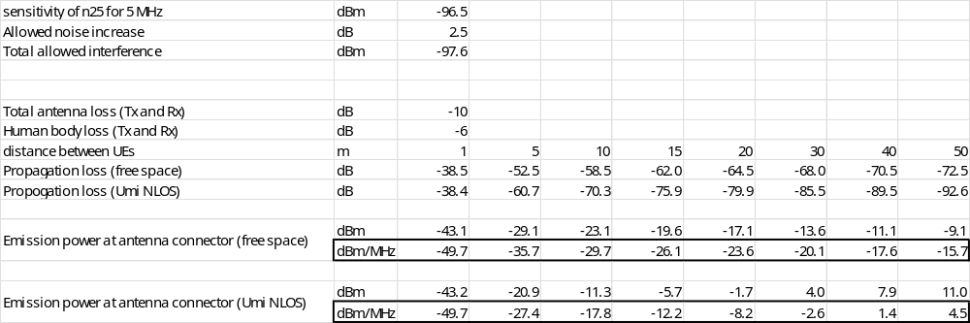

2GHz center frequency was used in the path loss calculation. It can be seen that with the assumed parameters 1m separation distance sets the emission power to -49.7 dBm/MHz. At 10 m distance there is 20 dB more power allowed assuming free space propagation. Then every doubling of the distance allows 6 dB more emissions. For example, if 20 m would be used in deriving the coex-limit, -24 dBm/MHz could be used as the limit.

C.1.2: AMPR study for n252

C.1.2.1 Power back-off simulation from company A (R4-2503176)

C.1.2.1.1 Assumption for power-back off simulation
The following are common assumptions for the power back-off simulation results for the NTN band n252:
- Tx power: PC3 (+23dBm)
- LO placement: always in the centre of the carrier
- Additional requirements: -40dBm/MHz and -30dBm/MHz protection criterion for band n25

C.1.2.1.2 Power back-off simulations for -40dBm/MHz
Figure C.1.2.1.2-1 and Figure C.1.2.1.2-2 below present simulation results for the 5MHz channel, which is placed in the following locations within the band: left edge of the band (Fc=2002.5MHz) and when the center frequency shifted further away from the left edge (Fc=2007.5MHz). For the sake of brevity, we present only DFT-s-OFDM and CP-OFDM results (DFT-s-OFDM PI/2 BPSK results are usually close to DFT-s-OFDM QPSK and sometimes even outperform the latter). So, referring to Figure C.1.2.1.2-1 and Figure C.1.2.1.2-2 the following general observations could be made for the 5MHz channel:
- If the 5MHz channel is right at the left edge of the band, then large UL allocations may need large power back-off of up to 5dB even for DFT-s-OFDM. On the other hand, if we consider small UL allocations, which are likely to be the case for the NTN channels, then no power back-off is needed. In fact, even medium size UL allocations of up to 10RBs are not likely to have any power back-off.
- If the 5MHz channel is shifted farther away from the band lower edge, then required power back-off reduces dramatically. Only large UL allocations may need power back-off.

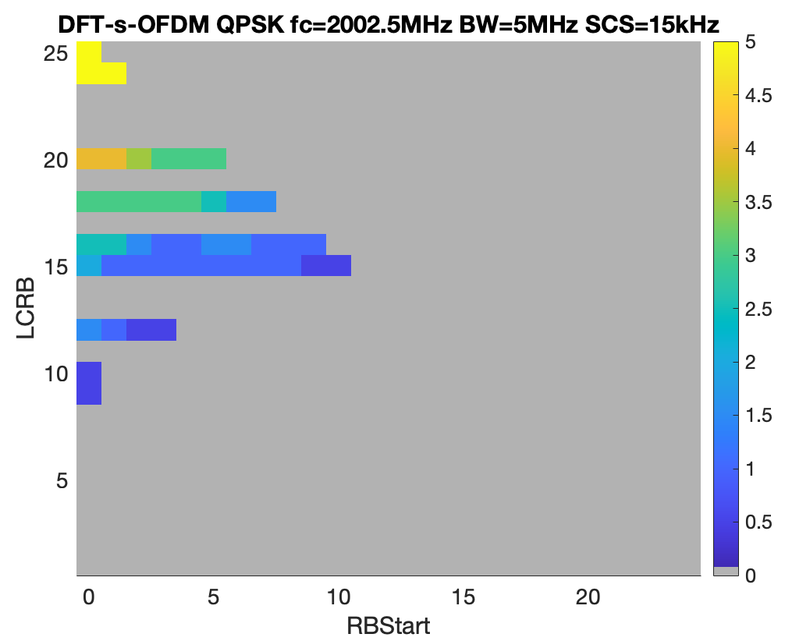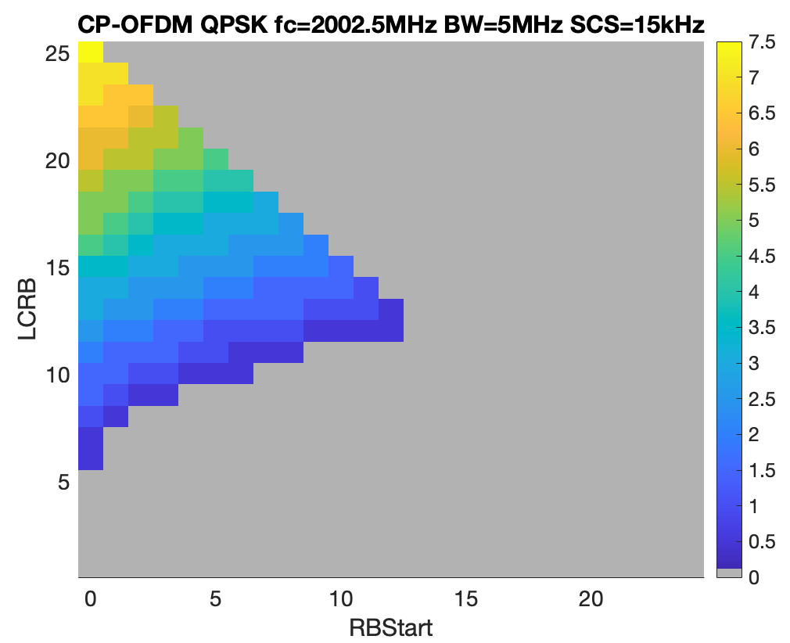
Figure C.1.2.1.2-1: Power back-off values for the 5MHz channel (Fc=2002.5MHz)

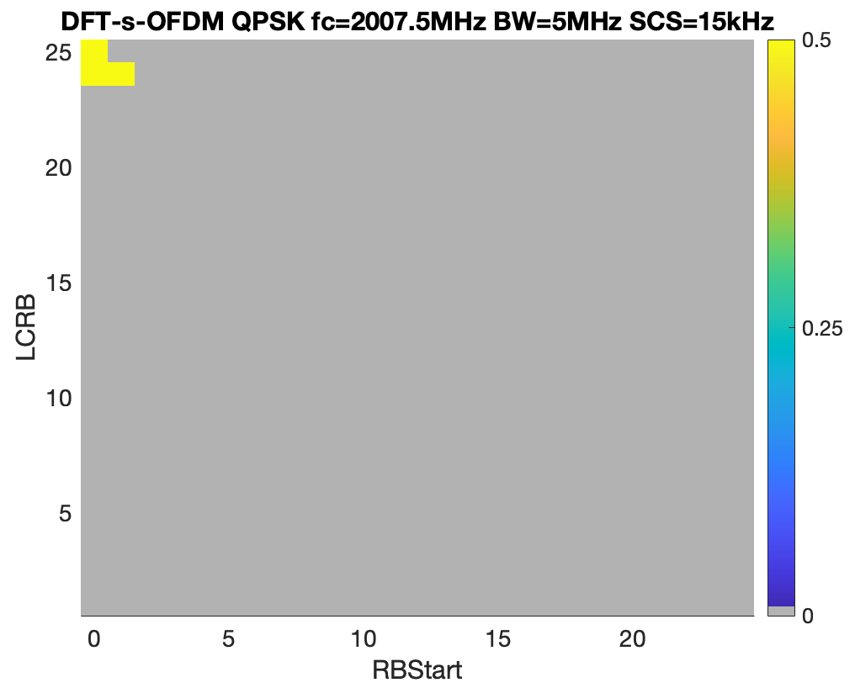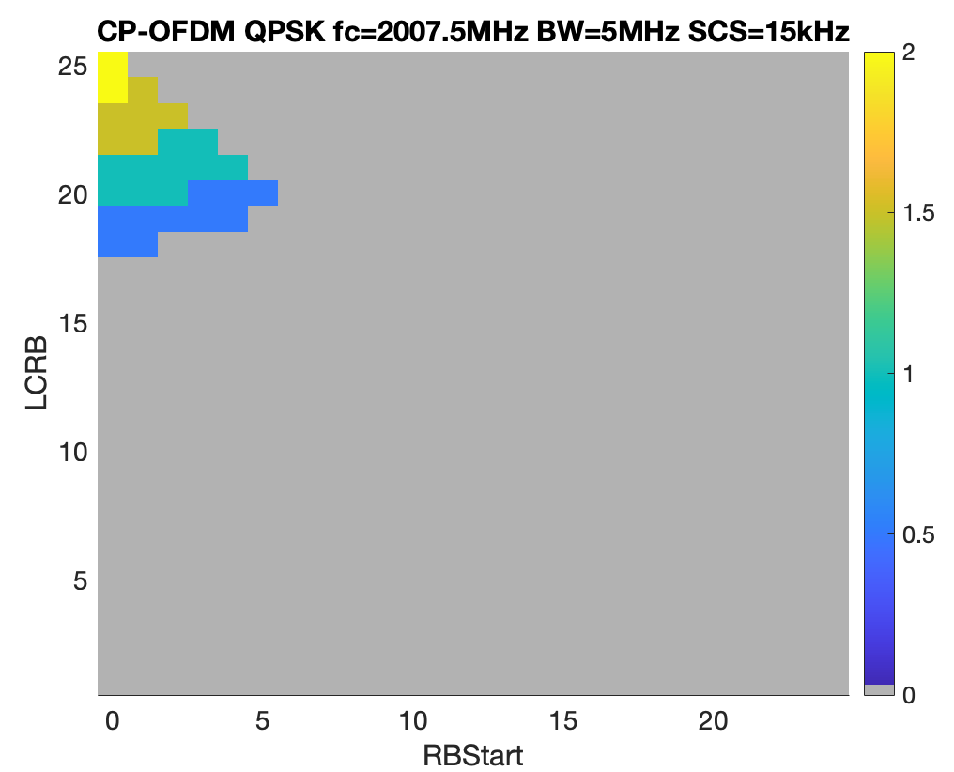
Figure C.1.2.1.2-2: Power back-off values for the 5MHz channel (Fc=2007.5MHz)

Figure C.1.2.1.2-3 and Figure C.1.2.1.2-4 present power back-off values for the 10MHz channel considering the following locations of the channel: right at the left edge of the band (Fc=2005) and shifted to the right so that the offset from the band edge is 5MHz (Fc=2010). The following general observations can be made:
- For the first case, i.e. when the 10MHz channel resides at the left edge of the band, large power back-off is needed even for small UL allocations.
- If the 10MHz channel is offset by at least the 5MHz gap from the left edge, then small UL allocations will require no power back-off backoff.

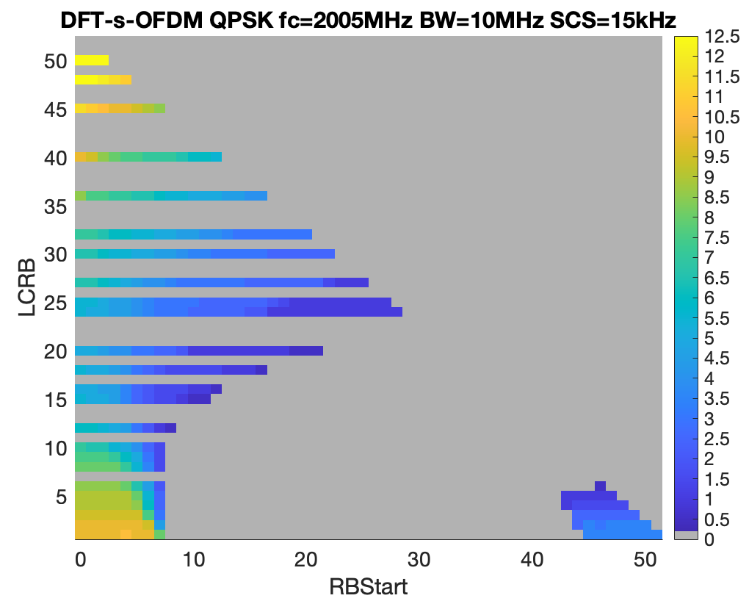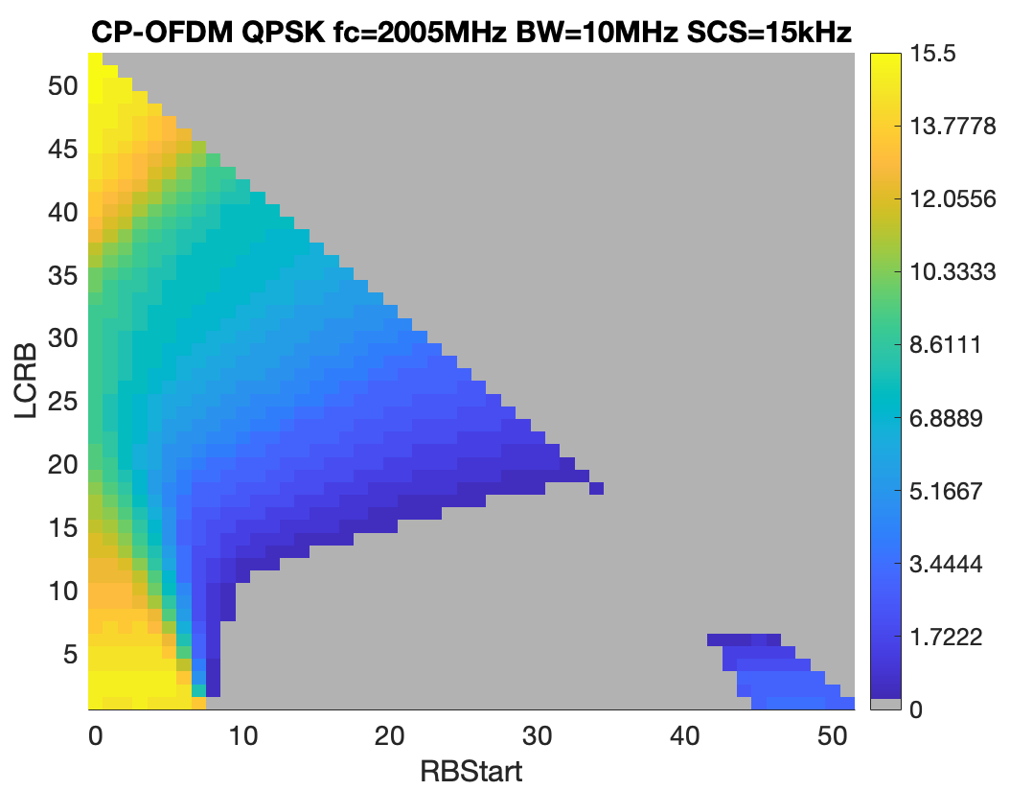
Figure C.1.2.1.2-3: Power back-off values for the 10MHz channel (Fc=2005MHz)

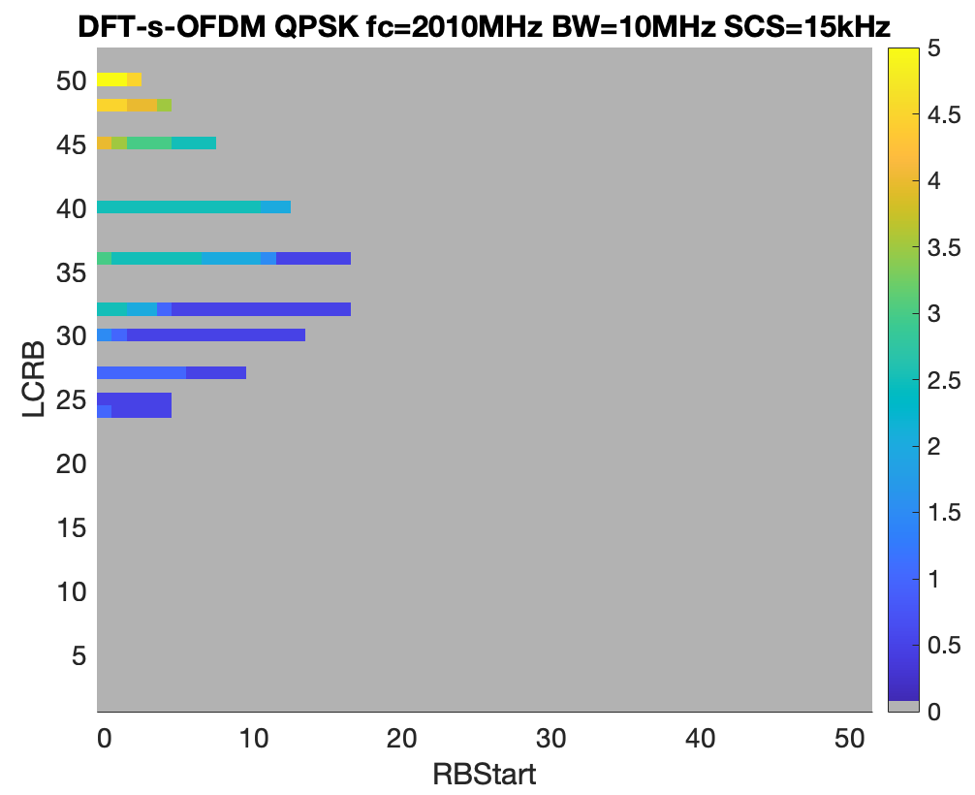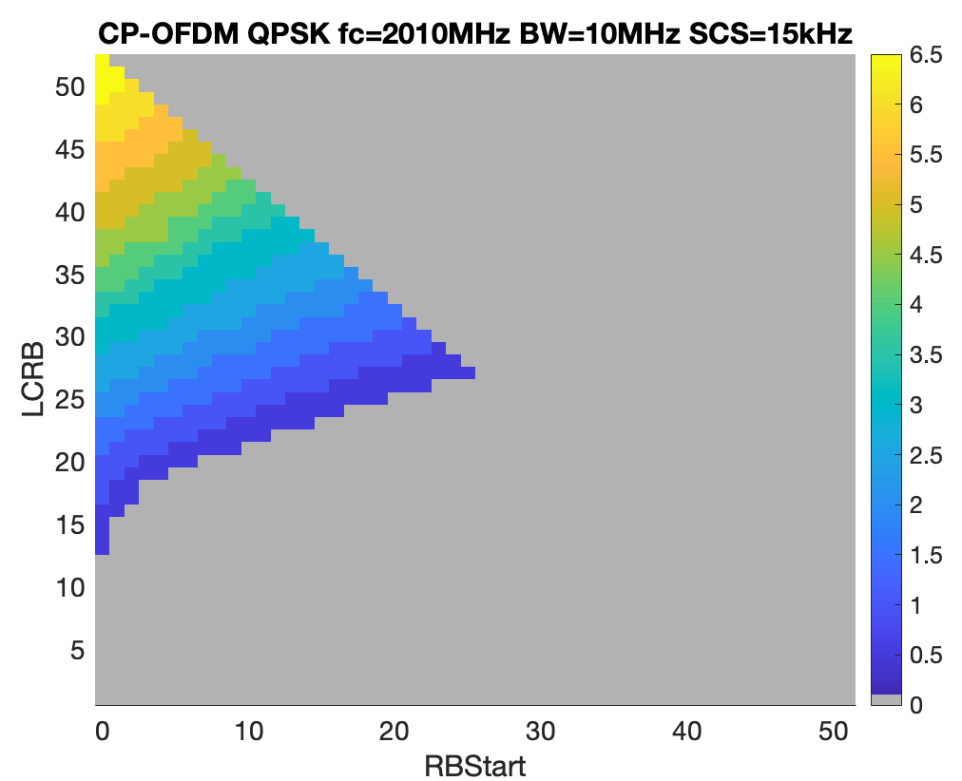
Figure C.1.2.1.2-4: Power back-off values for the 10MHz channel (Fc=2010MHz)

Next, Figure C.1.2.1.2-5 and C.1.2.1.2-6 present power back-off values for the 15MHz channel at the following locations: right at the left edge of the band (Fc=2007.5) and shifted to the right so that the offset from the band edge is 5MHz (Fc=2012.5). As can be seen from the figures, irrespective of the15MHz channel location, edge allocations, even small ones, will require large power back-off.
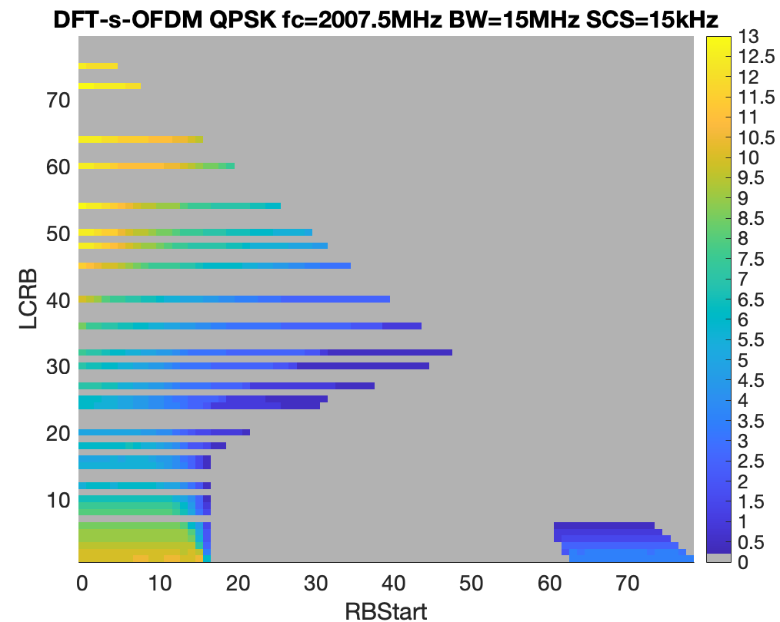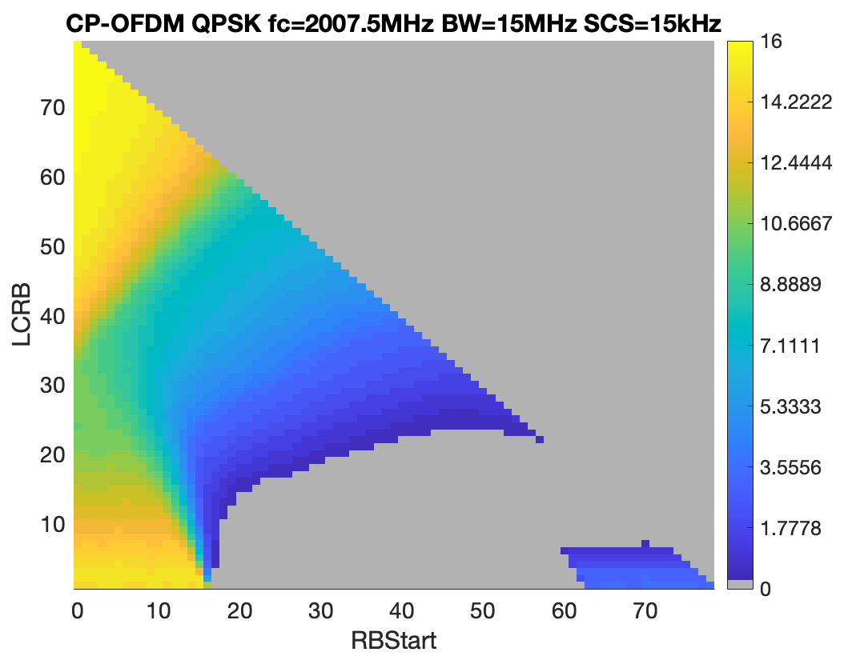
Figure C.1.2.1.2-5: Power back-off values for the 15MHz channel (Fc=2007.5MHz)
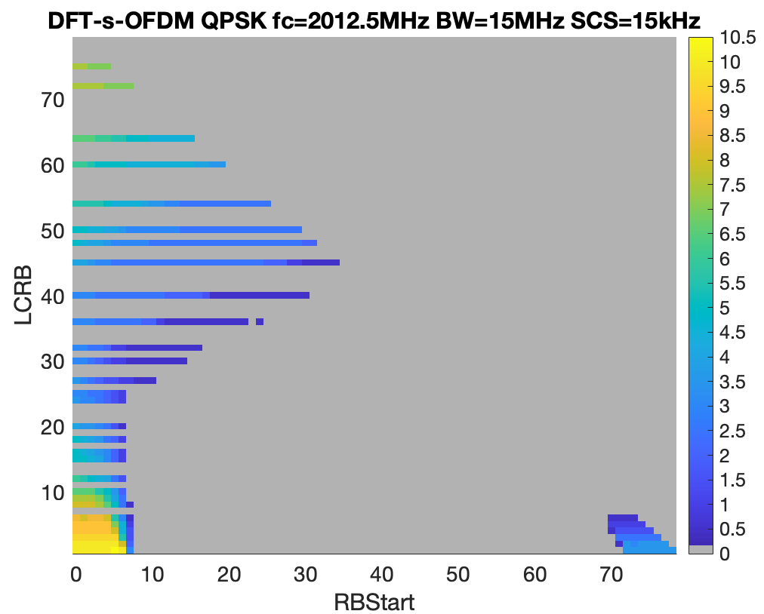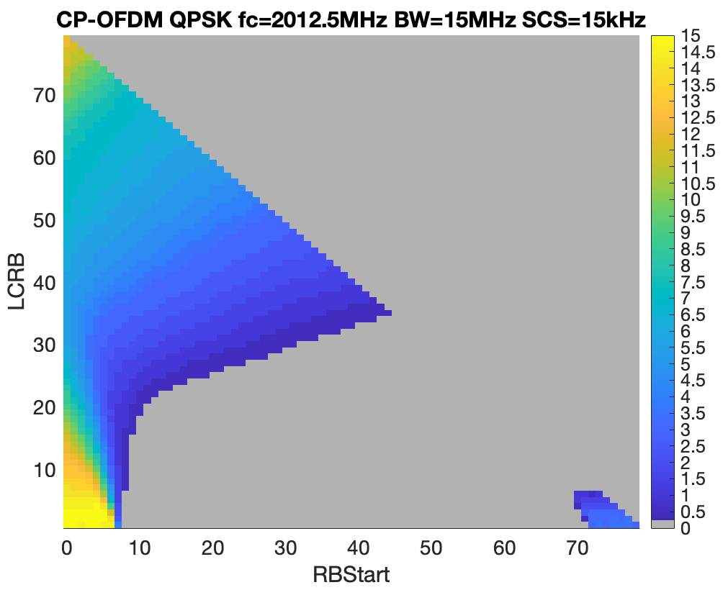
Figure C.1.2.1.2-6: Power back-off values for the 15MHz channel (Fc=2012.5MHz)

Figure C.1.2.1.2-7 presents power back-off results for the 20MHz channel, which as can be seen has even large back-off values comparing to the 15MHz channel bandwidth.
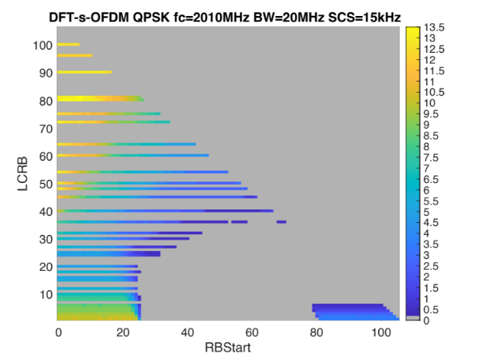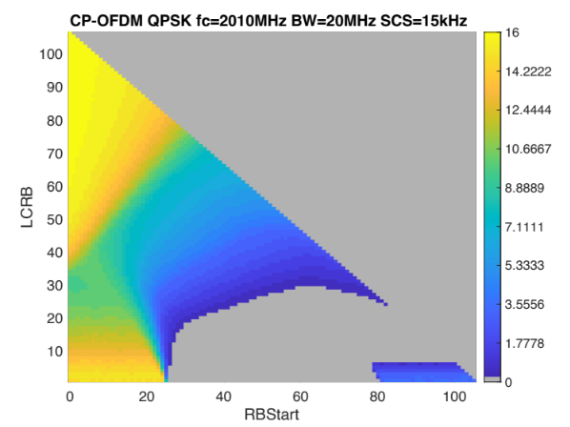
Figure C.1.2.1.2-7: Power back-off values for the 20MHz channel (Fc=2010MHz)

C.1.2.1.3 Power back-off simulations for -30dBm/MHz
In this section we present UE power back-off values for the same channel sizes and center frequencies as in the previous sub-section, but a more relaxed -30dBm/MHz protection criterion is used.
Figure C.1.2.1.3-1 below presents power back-off values for the 5MHz channel, which is right at the left edge of the band. As can be seen, only large allocations might need power back-off, which should be even within the existing MPR margins.
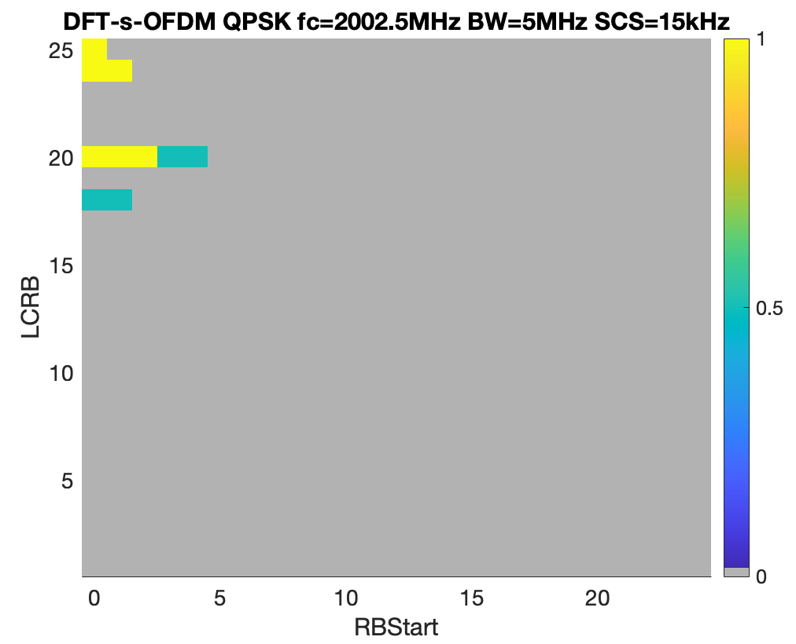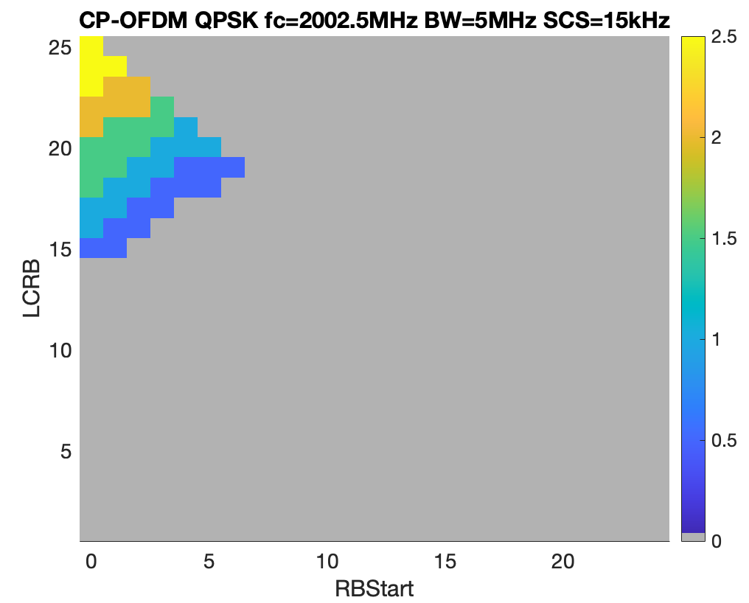
Figure C.1.2.1.3-1: Power back-off values for the 5MHz channel (Fc=2002.5MHz)
Figure C.1.2.1.3-2 and Figure C.1.2.1.3-3 present power back-off values for the 10MHz channel. General observations are the same as for the -40dBm/MHz protection limit, with the only noticeable difference that for the edge 10MHz channel bandwidth only the leftmost edge allocations will need high power back-off values.
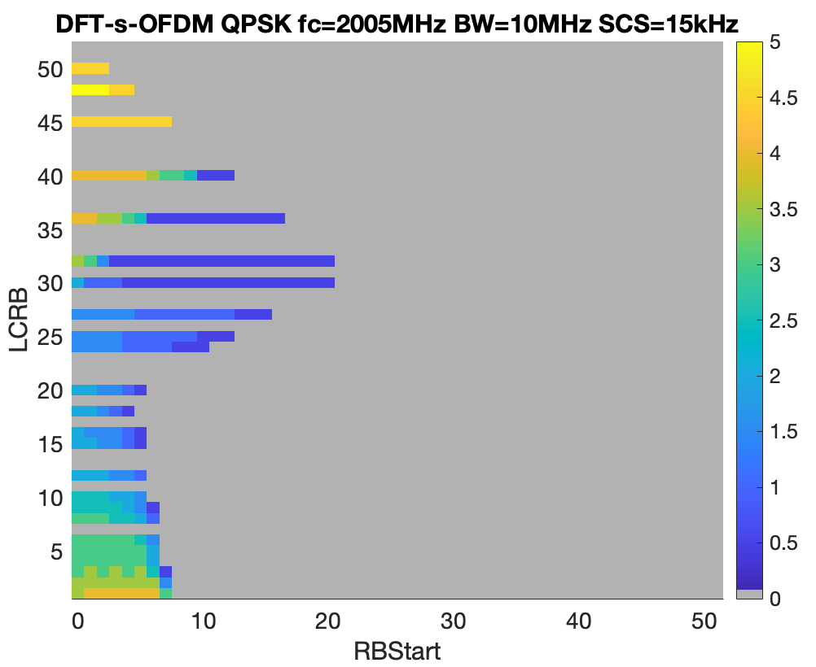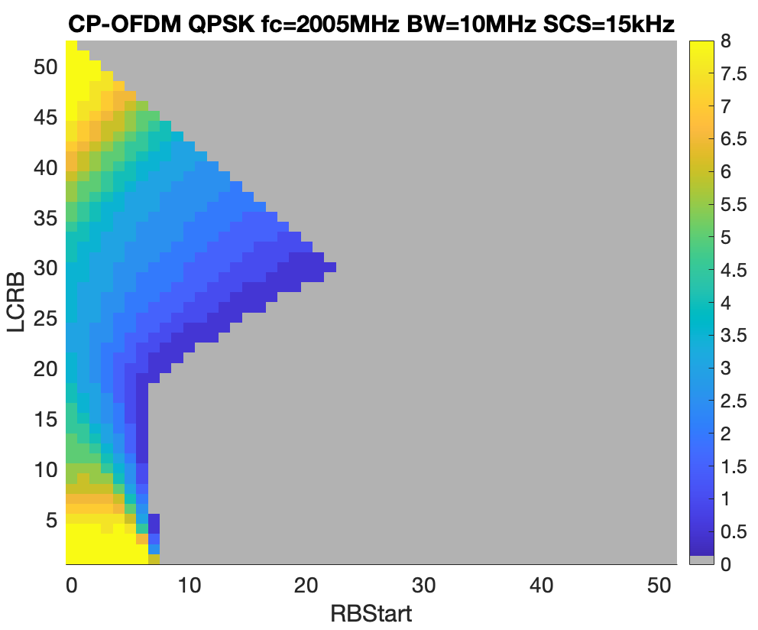
Figure C.1.2.1.3-2: Power back-off values for the 10MHz channel (Fc=2005MHz)

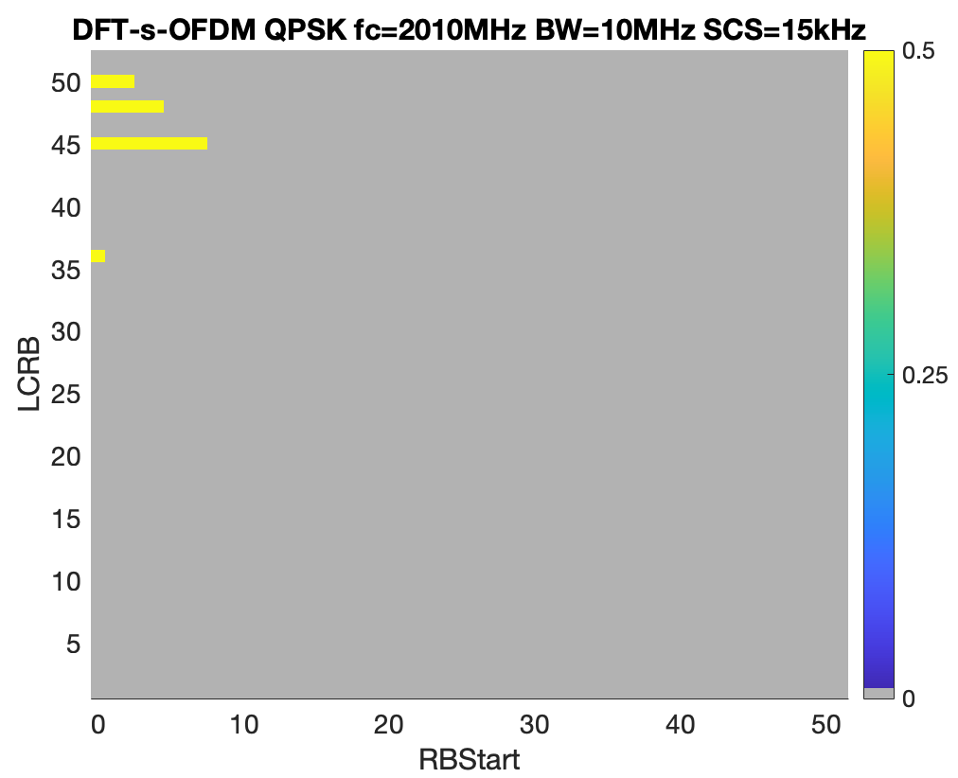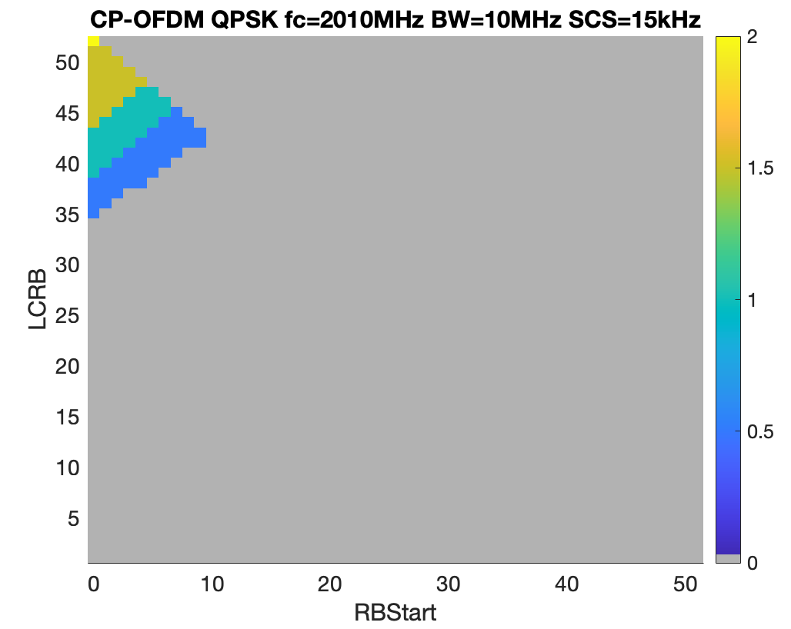
Figure C.1.2.1.3-3: Power back-off values for the 10MHz channel (Fc=2010MHz)
Figure C.1.2.1.3-4 and Figure C.1.2.1.3-5 present power back-off values for the 15MHz channel. Like in the previous simulation case of the -40dBm/MHz protection limit, the edge 15MHz channel will require large back-off values for a wide range of UL allocations. Once shifted to the right, large power back-off values are mostly constrained to the leftmost edge RBs.
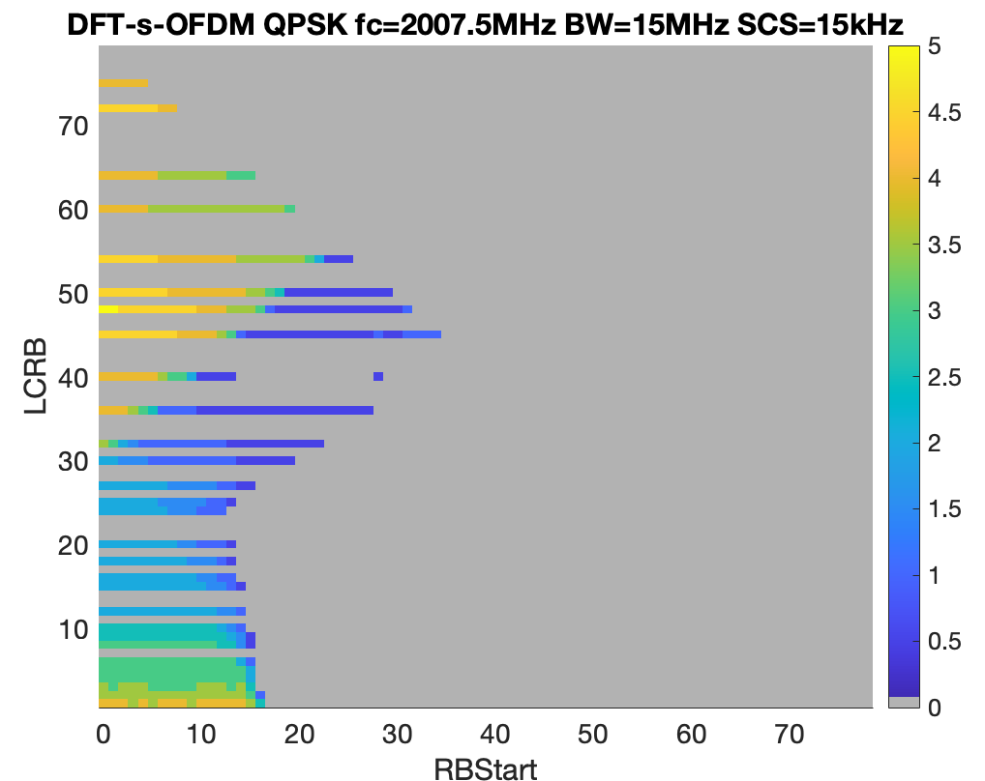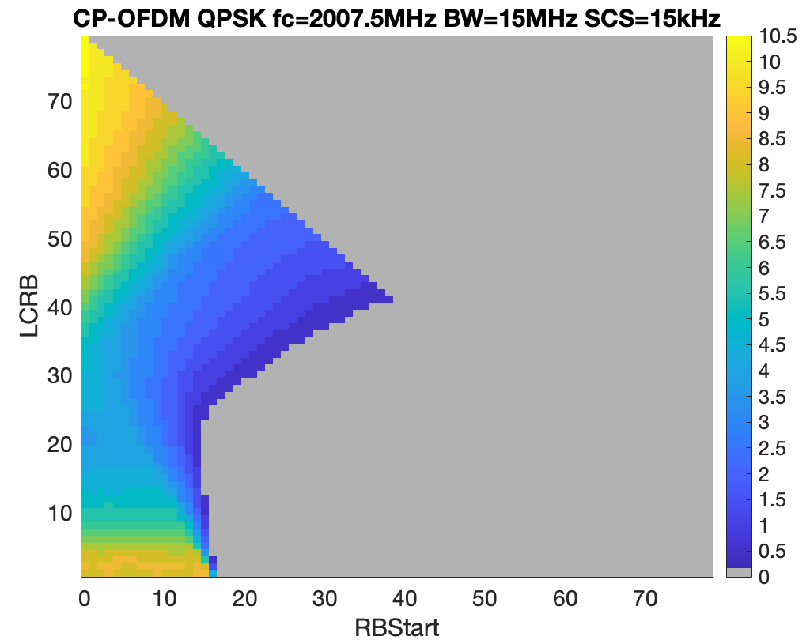
Figure C.1.2.1.3-4: Power back-off values for the 15MHz channel (Fc=2007.5MHz)

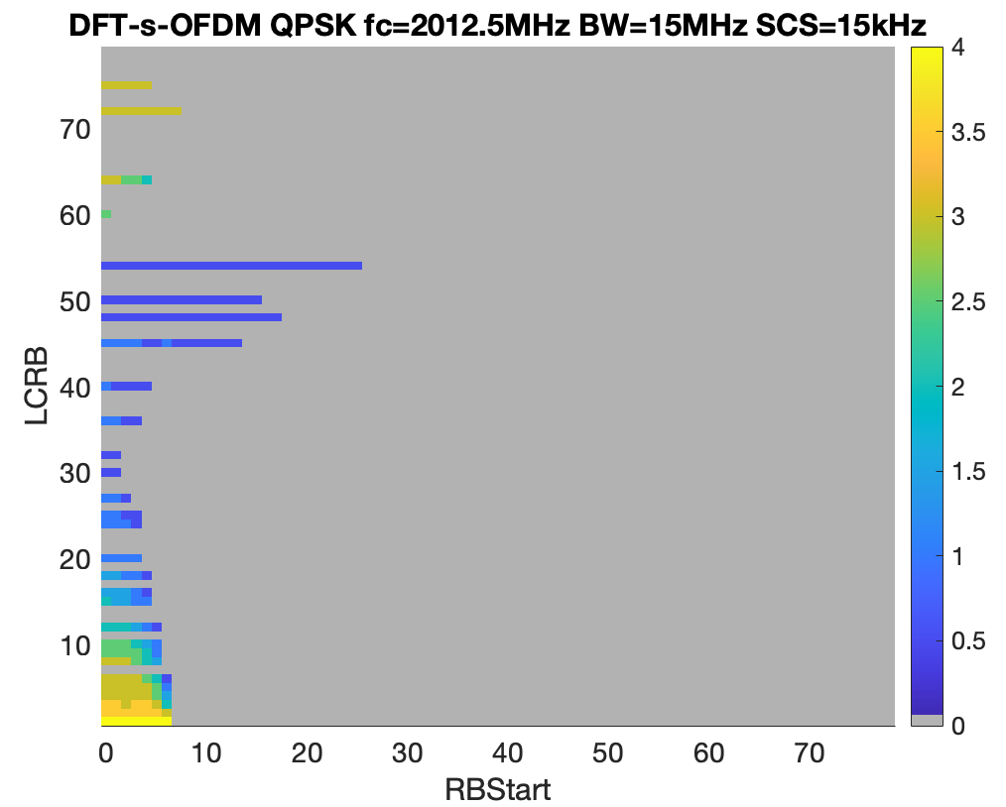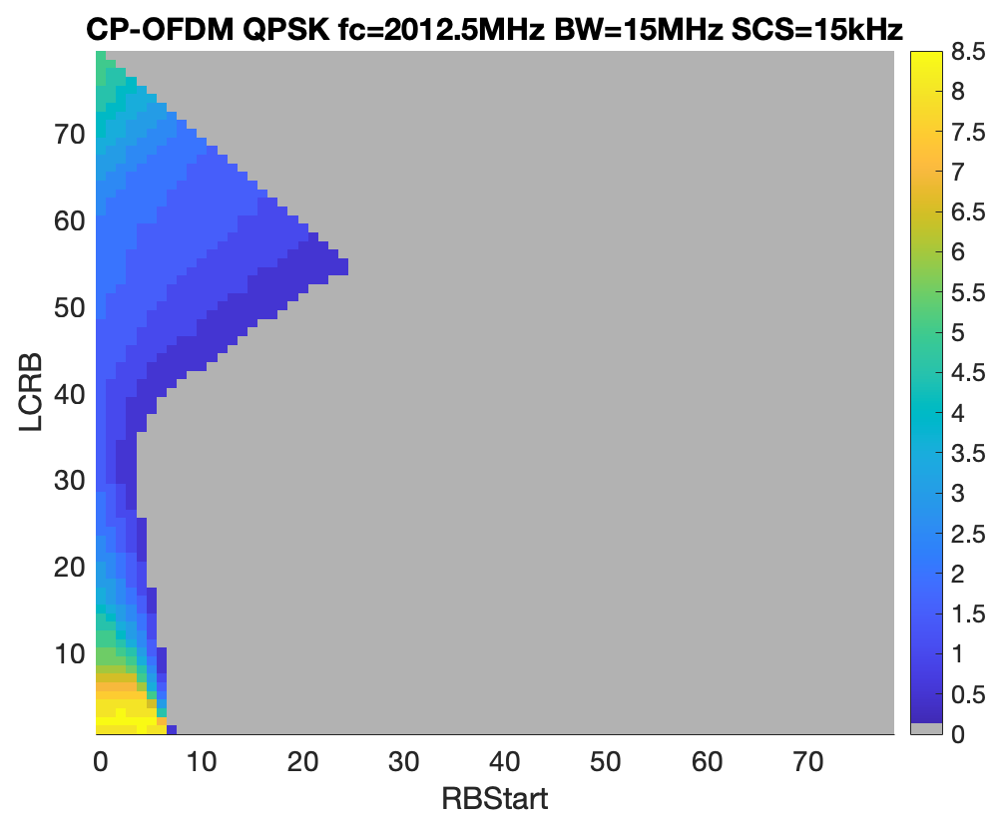
Figure C.1.2.1.3-5: Power back-off values for the 15MHz channel (Fc=2012.5MHz)

Figure C.1.2.1.3-6 presents power back-off results for the 20MHz channel, which follows the trend of large channels resulting in higher power back-off values for large allocations and allocations residing at the left edge of the channel.

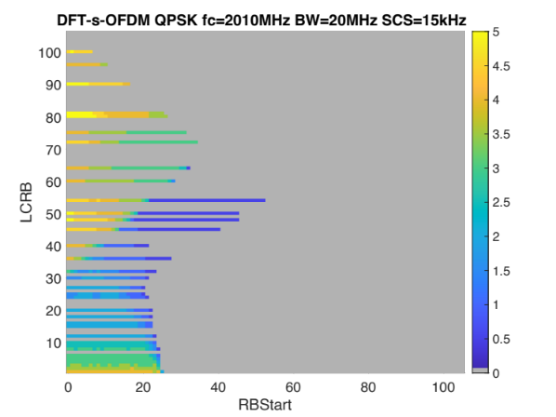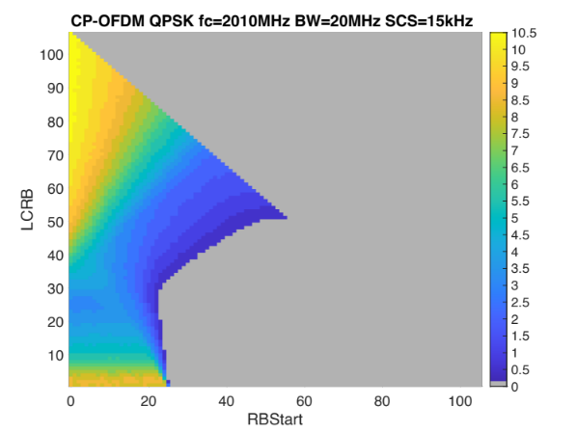
Figure C.1.2.1.3-6: Power back-off values for the 20MHz channel (Fc=2010MHz)

C.1.2.2 Power back-off simulation from company B (R4-2504544)
The need for A-MPR was studied using the following assumptions:
- PA calibrated to 30 dB ACLR with 100 RB DFT-s-OFDM QPSK waveform with 22 dBm at antenna connector
- -28 dBc IQ-image and DC-leakage
- -60 dBc CIM3
The proposed A-MPR is summarized in Tables C.1.2.2-1 to C.1.2.2-4.
Table C.1.2.2-1: A-MPR regions for -40 dBm/MHz
Channel BW | Carrier Frequency, Fc, MHz | RB_{Start}*12*SCS (MHz) | L_{CRB}*12*SCS (MHz) | A-MPR
5MHz | < 2007.5 | ≥ 0 | ≥ 2.7 | A1
10MHz | < 2010 | ≤ 1.44 | ≥ 0 | A2
 | < 2010 | > 1.44 | ≥ 3.6 | A1
 | < 2010 | > 7.74 | ≤ 0.72 | A1
 | 2010 ≤ Fc ≤ 2015 | ≥ 0 | ≥ 4.5 | A1
15MHz | < 2012.5 | ≤ 3.06 | ≥ 0 | A3
15MHz | < 2012.5 | > 3.06 | 4.5 ≤ L_{CRB}*12*SCS ≤ 9 | A1
15MHz | < 2012.5 | > 3.06 | > 9 | A2
15MHz | < 2012.5 | > 10.98 | ≤ 0.72 | A1
15MHz | 2012.5 | ≤ 1.44 | ≥ 0 | A2
15MHz | 2012.5 | > 1.44 | ≥ 6.48 | A1
15MHz | 2012.5 | > 12.6 | ≤ 0.72 | A1
20 MHz | 2010 | ≤ 4.68 | ≥ 0 | A3
20 MHz | 2010 | > 4.68 | 4.5 ≤ L_{CRB}*12*SCS ≤ 9 | A1
20 MHz | 2010 | > 4.68 | > 9 | A2
20 MHz | 2010 | > 12.6 | ≤ 0.72 | A1

Table C.1.2.2-2: A-MPR for -40 dBm/MHz
Modulation/Waveform | A1 | A2 | A3
 | Outer/Inner | Outer/Inner | Outer/Inner
DFT-s-OFDM PI/2 BPSK | ≤ 4 | ≤ 6 | ≤ 7
DFT-s-OFDM QPSK | ≤ 4.5 | ≤ 6.5 | ≤ 7.5
DFT-s-OFDM 16 QAM | ≤ 5 | ≤ 6.5 | ≤ 7.5
DFT-s-OFDM 64 QAM | ≤ 5.5 | ≤ 7 | ≤ 8
CP-OFDM QPSK | ≤ 6 | ≤ 8.5 | ≤ 9
CP-OFDM 16 QAM | ≤ 6 | ≤ 8.5 | ≤ 9
CP-OFDM 64 QAM | ≤ 6 | ≤ 8.5 | ≤ 9

Table C.1.2.2-3: A-MPR regions for -30 dBm/MHz
Channel BW | Carrier Frequency, Fc, MHz | RB_{Start}*12*SCS (MHz) | L_{CRB}*12*SCS (MHz) | A-MPR
5 MHz | - | - | - | -
10MHz | < 2010 | ≤ 1.44 | ≤ 2.7 | A1
10MHz | < 2010 | ≤ 1.44 | 2.7 < L_{CRB}*12*SCS < 4.5 | A2
10MHz | < 2010 | ≤ 1.44 | ≥ 4.5 | A1
10MHz | < 2010 | ≥ 1.44 | ≥ 5.4 | A2
15MHz | < 2012.5 | ≤ 3.06 | ≤ 2.7 | A1
15MHz | < 2012.5 | ≤ 3.06 | 2.7 < L_{CRB}*12*SCS < 4.5 | A2
15MHz | < 2012.5 | ≤ 3.06 | ≥ 4.5 | A1
15MHz | < 2012.5 | ≥ 3.06 | ≥ 5.4 | A2
15MHz | 2012.5 | ≤ 1.44 | ≤ 2.7 | A1
15MHz | 2012.5 | ≤ 1.44 | 2.7 < L_{CRB}*12*SCS < 5.4 | A2
15MHz | 2012.5 | ≤ 1.44 | ≥ 5.4 | A1
15MHz | 2012.5 | ≥ 1.44 | ≥ 7.2 | A2
20 MHz | 2010 | ≤ 4.68 | ≤ 2.7 | A1
20 MHz | 2010 | ≤ 4.68 | 2.7 ≤ L_{CRB}*12*SCS ≤ 5.4 | A2
20 MHz | 2010 | ≤ 4.68 | > 5.4 | A1
20 MHz | 2010 | > 4.68 | ≥ 7.2 | A2

Table C.1.2.2-4: A-MPR for -30 dBm/MHz
Modulation/Waveform | A1 | A2
 | Outer/Inner | Outer/Inner
DFT-s-OFDM PI/2 BPSK | ≤ 4 | ≤ 2.5
DFT-s-OFDM QPSK | ≤ 4.5 | ≤ 3
DFT-s-OFDM 16 QAM | ≤ 5 | ≤ 3.5
DFT-s-OFDM 64 QAM | ≤ 5.5 | ≤ 4
CP-OFDM QPSK | ≤ 6 | ≤ 4.5
CP-OFDM 16 QAM | ≤ 6 | ≤ 4.5
CP-OFDM 64 QAM | ≤ 6 | ≤ 4.5

C.1.2.3 Power back-off simulation from company C (R4-2506521)

C.1.2.3.1 Simulation parameters
The following are the parameters used for this simulation:
- Operating band n252 (UL 2000 MHz – 2020 MHz)
- 10 MHz, 15 MHz, and 20 MHz CBWs
- Power class PC3
- WOLA processing
- I/Q image -28 dBc
- Carrier leakage -28 dBc
- CIM3 -60 dBc
- Only additional spurious emission mask from NS_07N is simulated. Other gating factors (ACLR, SEM, etc.) are excluded because they are handled by MPR.

C.1.2.3.2 NS_07N mask
Table C.1.2.3.2-1: Additional out-of-band requirements for "NS_07N"
Frequency range  (MHz) | Channel bandwidth / Spectrum emission limit (dBm) | Measurement bandwidth | NOTE
Frequency range  (MHz) | 5 MHz, 10 MHz, 15 MHz, 20MHz | Measurement bandwidth | NOTE
1559 ≤ f < 1605 | -50 | 700 Hz | Averaged over any 2 millisecond active transmission interval
1559 ≤ f < 1605 | -40 | 1MHz | Averaged over any 2 millisecond active transmission interval
1930 ≤ f ≤1995 | -40 | 1MHz

Table C.1.2.3.2-1 shows the NS_07N mask. This table is aligned with the agreed emission mask as described in the Table 7.4.2.2.8-3. Only the 1930 MHz ≤ f ≤ 1995 MHz segment is considered because the other segments are very far from the channel.

C.1.2.3.3 Simulation result
Figure. C.1.2.3.3-1 and C.1.2.3.3-2 present the examples of the A-MPR triangles for 10 MHz and 20 MHz CBWs, respectively. The maximum A-MPR at 20 MHz CBW is close to the average between the two results in C.1.2.1 and C.1.2.2. Details results of the A-MPR triangles can be seen from the appendix of R4-2506521.
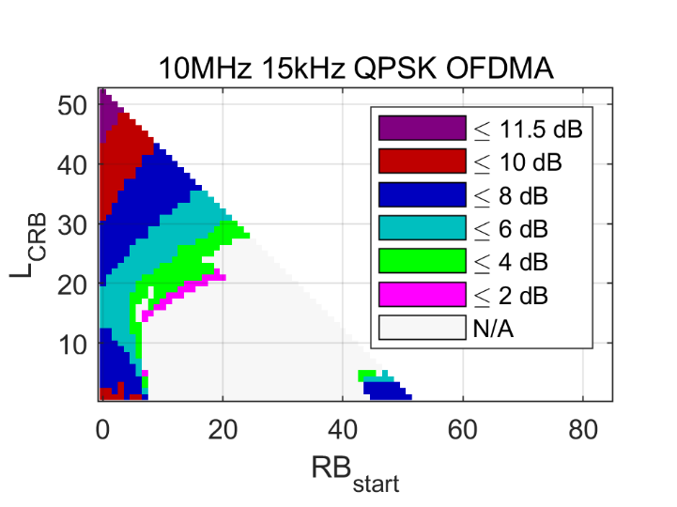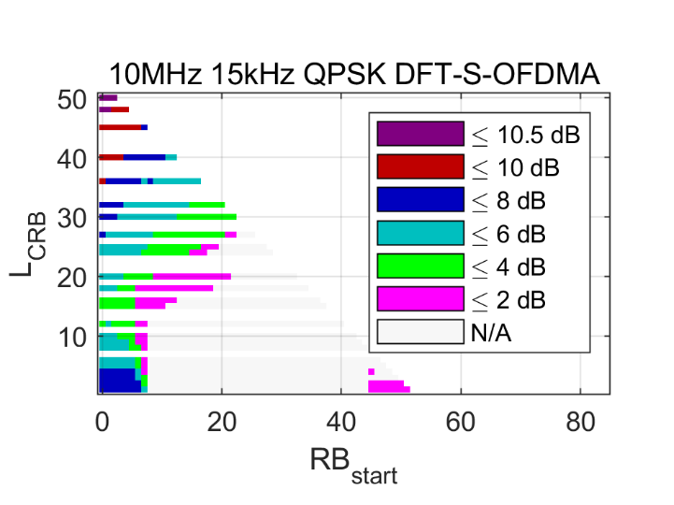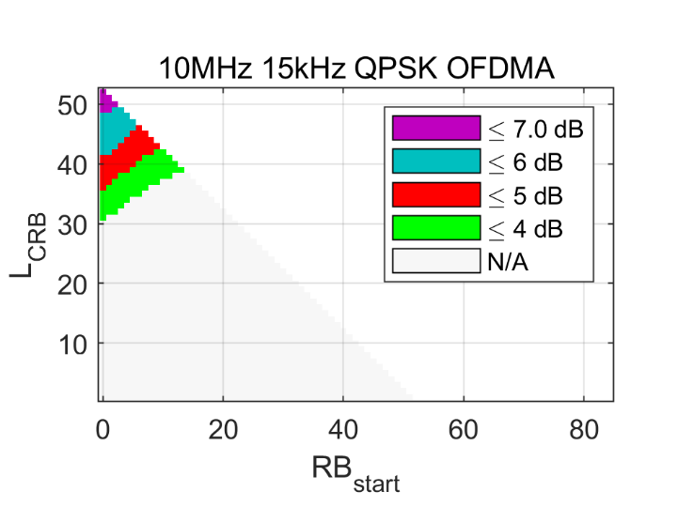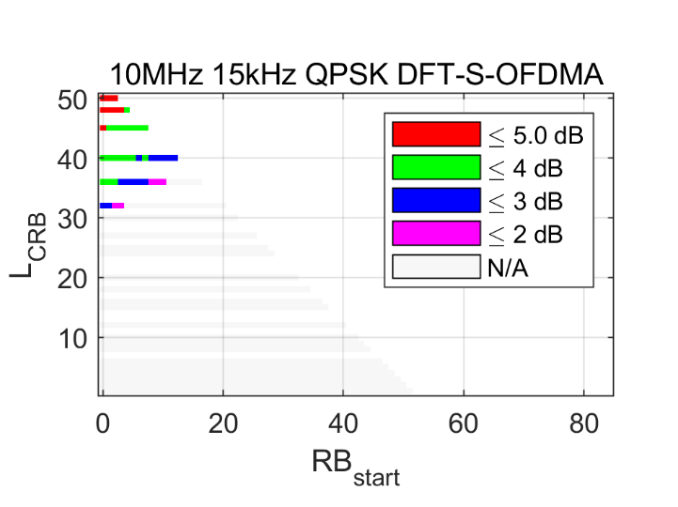
Fc = 2010 MHz
Fc = 2005 MHz
Figure C.1.2.3.3-1: Examples of the simulated A-MPR to satisfy the -40dBm/MHz additional spurious emission limit for 10 MHz channel at Fc = 2005 MHz (upper row) and Fc = 2010 MHz (bottom row).

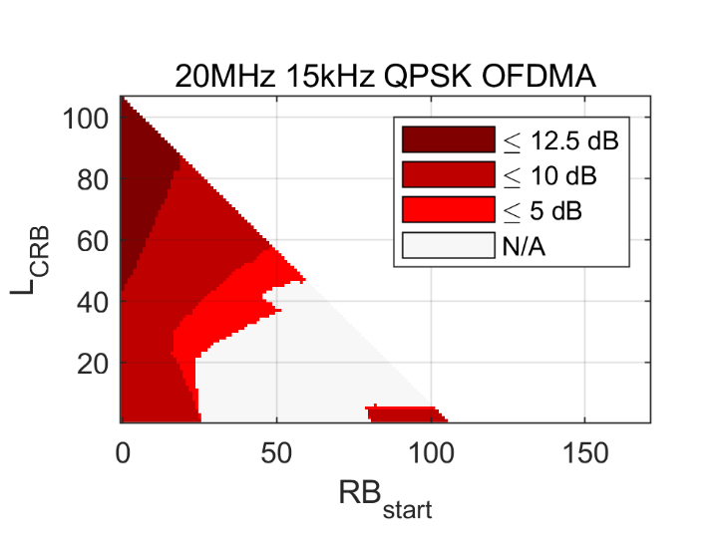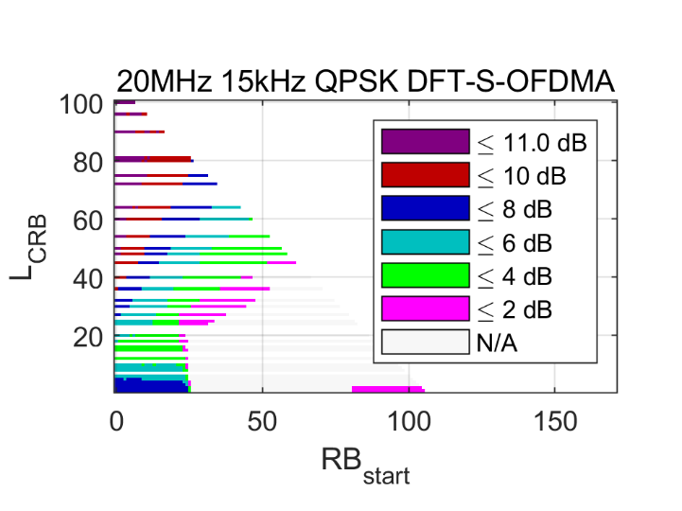
Figure C.1.2.3.3-2: Examples of the simulated A-MPR to satisfy the -40dBm/MHz additional spurious emission limit for 20 MHz channel at Fc = 2010 MHz.

C.1.2.3.4 A-MPR proposal
Using with the result in C.1.2.1 and C.1.2.2 as a comparison, the result that differ to either of the two proposals are highlighted with yellow color. In this simulations the maximum A-MPR values at 10 MHz do not differ much from the corresponding ones at higher CBWs, therefore the A2 region at 10 MHz is changed to A3 to better optimize the remaining A2 values. If the region at 10 MHz CBW is kept as A2, then the A2 values need to be increased.
Table C.1.2.3.4-1: A-MPR regions for -40 dBm/MHz
Channel BW | Carrier Frequency, Fc, MHz | RB_{Start}*12*SCS (MHz) | L_{CRB}*12*SCS (MHz) | A-MPR
10MHz | < 2010 | ≤ 1.44 | ≥ 0 | A3
 | < 2010 | > 1.44 | ≥ 3.6 | A1
 | < 2010 | > 7.74 | ≤ 0.72 | A1
 | 2010 ≤ Fc ≤ 2015 | ≥ 0 | ≥ 4.5 | A1
15MHz | < 2012.5 | ≤ 3.06 | ≥ 0 | A3
15MHz | < 2012.5 | > 3.06 | ≥ 4.5, ≤ 7.2 | A1
15MHz | < 2012.5 | > 3.06 | > 7.2 | A2
15MHz | < 2012.5 | > 10.98 | ≤ 0.72 | A1
15MHz | 2012.5 | ≤ 1.44 | ≥ 0 | A2
15MHz | 2012.5 | > 1.44 | ≥ 6.48 | A1
15MHz | 2012.5 | > 12.6 | ≤ 0.72 | A1
20 MHz | 2010 | ≤ 4.68 | ≥ 0 | A3
20 MHz | 2010 | > 4.68 | ≥ 4.5, ≤ 9 | A1
20 MHz | 2010 | > 4.68 | > 9 | A2
20 MHz | 2010 | > 12.6 | ≤ 0.72 | A1

Table C.1.2.3.4-2: A-MPR for -40 dBm/MHz
Modulation/Waveform | A1 | A2 | A3
 | Outer/Inner | Outer/Inner | Outer/Inner
DFT-s-OFDM PI/2 BPSK | ≤ 4 | ≤ 8 | ≤ 10.5
DFT-s-OFDM QPSK | ≤ 4.5 | ≤ 8 | ≤ 11
DFT-s-OFDM 16 QAM | ≤ 5 | ≤ 8 | ≤ 11.5
DFT-s-OFDM 64 QAM | ≤ 5.5 | ≤ 8 | ≤ 11.5
DFT-s-OFDM 256 QAM | ≤ 5.5 | ≤ 8 | ≤ 11.5
CP-OFDM QPSK | ≤ 7 | ≤ 8.5 | ≤ 12.5
CP-OFDM 16 QAM | ≤ 7 | ≤ 8.5 | ≤ 12.5
CP-OFDM 64 QAM | ≤ 7 | ≤ 8.5 | ≤ 12.5
CP-OFDM 256 QAM | ≤ 7 | ≤ 8.5 | ≤ 12.5

C.1.2.4 Measurement results from company D

C.1.2.4.1 Measurement parameters
The following parameters are used for measurements:
- power class PC3 23dBm
- band n1 PA
- post PA insertion loss 4dB
- image rejection -28dBc
- LO leakage -28dBc
- CIM3 -60dBc and CIM5 -70dBc
- the PA is calibrated with two supply voltages Vcc1 and Vcc2 using DFT-s-OFDM the 20MHz channel bandwidth QPSK 100RB0 SCS 15 kHz waveform:
- Vcc1 to meet -30dBc ACLR at MPR1
- Vcc2 to meet -30dBc ACLR at MPR6
- additional spurious emission limit of -40dBm/MHz for NS_07N
- additional spurious emission limit of -30dBm/MHz for NS_07N

C.1.2.4.2 Measurement result
The measurement results for different waveforms results are captured in tabes below using the following the same naming convention "DFT_4_xMHZ_yRB_z_15" where:
- x denotes the channel bandwidth in MHz;
- y denotes the configuration number RBs;
- z denotes the RB start position.
Measurement results for NS_07N are presented in Table C.1.2.4.2-1. These results indicate that some configurations, such as full 5MHz and 10MHz channel, require high power back-off. Similarly, single RB allocations right at the lower edge of the channel also require high power back-off.
Table C.1.2.4.2-1: PC3 measurement results for NS_07N
Test  case # | Waveform | UL Fc  (MHz) | Measured power back-off (dB)
1 | DFT_4_5MHZ_25RB_0_15 | 2002.5 | 6.5
2 | DFT_4_10MHZ_50RB_0_15 | 2005 | 9.5
3 | DFT_4_10MHZ_50RB_0_15 | 2010 | 4.1
4 | DFT_4_15MHZ_75RB_0_15 | 2007.5 | 9.1
5 | DFT_4_15MHZ_75RB_0_15 | 2012.5 | 7.0
6 | DFT_4_20MHZ_100RB_0_15 | 2010 | 9.3
7 | DFT_4_5MHZ_1RB_0_15 | 2002.5 | 0
8 | DFT_4_10MHZ_1RB_0_15 | 2005 | 9.5
9 | DFT_4_10MHZ_1RB_0_15 | 2010 | 0
10 | DFT_4_15MHZ_1RB_0_15 | 2007.5 | 9.5
11 | DFT_4_15MHZ_1RB_0_15 | 2012.5 | 6.5
12 | DFT_4_20MHZ_1RB_0_15 | 2010 | 9.5

Measurement results for NS_08N are presented in Table C.1.2.4.2-2. These results are somewhat similar to NS_07N indicating that the full channel and single RB allocations right at the lower edge of the channel still require power back-off exceeding baseline MPR values.
Table C.1.2.4.2-2: PC3 measurement results for NS_08N
Test  case # | Waveform | UL Fc  (MHz) | Measured power back-off (dB)
1 | DFT_4_5MHZ_25RB_0_15 | 2002.5 | 1
2 | DFT_4_10MHZ_50RB_0_15 | 2005 | 3.9
3 | DFT_4_15MHZ_75RB_0_15 | 2007.5 | 3.0
4 | DFT_4_15MHZ_75RB_0_15 | 2012.5 | 2.5
5 | DFT_4_20MHZ_100RB_0_15 | 2010 | 3.5
6 | DFT_4_5MHZ_1RB_0_15 | 2002.5 | 0
7 | DFT_4_10MHZ_1RB_0_15 | 2005 | 3.7
8 | DFT_4_15MHZ_1RB_0_15 | 2007.5 | 3.4
9 | DFT_4_15MHZ_1RB_0_15 | 2012.5 | 3.4
10 | DFT_4_20MHZ_1RB_0_15 | 2010 | 3.7

Annex D:
Summary of simulation results for the IoT derivation
In this annex, simulations results used to derive the IoT value were collected.
[To be updated]

Annex E:
Examples of Delay and Doppler shift variation as a function of time for different satellite orbit types
The purpose of Annex E is only informative and is related to the distance variation between NTN UE and Satellite as captured in Section 5.3 of TR 38.811 [5] which presents methodology to characterise Doppler and propagation Delay.
Therefore, the information in current section shall not be interpreted as testing configuration. The purpose is only to provide a more realistic representation of Doppler and Delay with respect to a few constellations given as examples.
As described below, Delay and Doppler shift variation with time are presented as examples for different defined NGSO (LEO@600km, LEO@1200km) and GSO satellite representative orbits. The NTN UE location is assumed static for all graphs as follows:
- Latitude: 25.08439333 deg;
- Longitude: 121.56076999 deg;
- Altitude: 0 m.
Three representative cases are further defined in following sub-sections E.1, E.2 and E.3 respectively:
- Low Earth Orbit (LEO) at 600 km altitude case;
- Low Earth Orbit (LEO) at 1200 km altitude case;
- GSO orbit case with a satellite inclination of 7 degrees relative to the Equator.

E.1 LEO 600 km case
For this example, a satellite orbit inclination with respect of the Equator plane of 88° is considered.
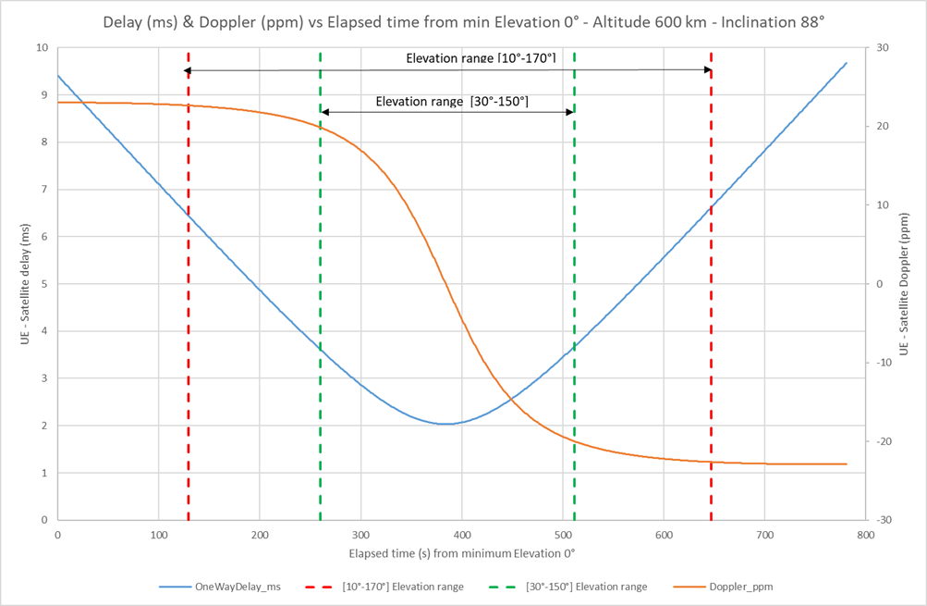
Figure E.1-1: LEO600km with 88° orbit inclination

E.2 LEO 1200 km case
For this example, a satellite orbit inclination with respect of the Equator plane of 88° is considered.
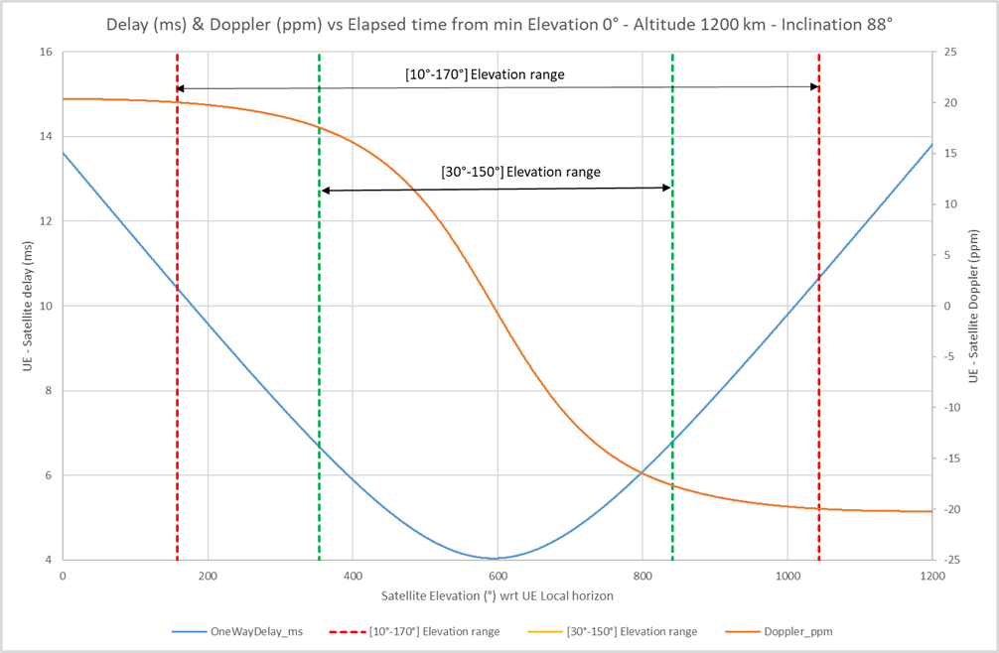
Figure E.2-1: LEO1200km with 88° orbit inclination

E.3 GSO orbit case
For this example, a satellite orbit inclination with respect of the Equator plane of 7° is considered.
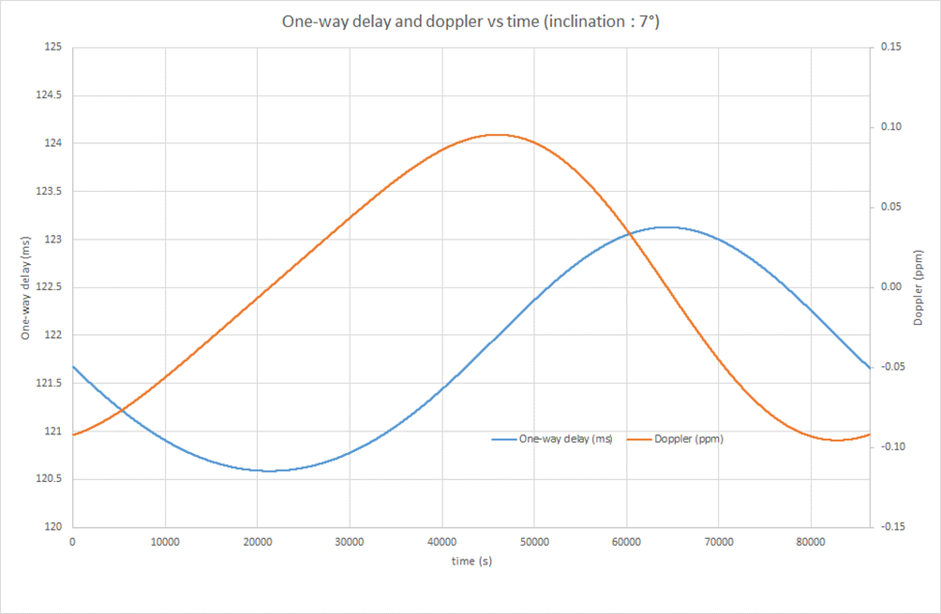
Figure E.3-1: GSO with 7° orbit inclination

E.4 Examples of Doppler and Delay for different elevation angles and for different satellite orbit types
One can represent the following few “selected” example scenarios computed for a min elevation angle target of 30°:
Table E.4-1: Example scenarios with values computed for 30° min elevation angle target
Frequency | Constellation | Elevation | Doppler shift (kHz) | OneWayDelay_ms
2,00 GHz | LEO@600 km | 30,0 | 39,734 | 3,6
2,00 GHz | LEO@600 km | 149,9 | -39,899 | 3,7
2,00 GHz | LEO@600 km | 89,6 | 0,026 | 2,0
2,00 GHz | LEO@1200 km | 29,9 | 35,127 | 6,7
2,00 GHz | LEO@1200 km | 149,9 | -35,273 | 6,8
2,00 GHz | LEO@1200 km | 89,5 | 0,007 | 4,0
30,00 GHz | LEO@600 km | 30,0 | 596,011 | 3,6
30,00 GHz | LEO@600 km | 149,9 | -598,486 | 3,7
30,00 GHz | LEO@600 km | 89,6 | 0,384 | 2,0
30,00 GHz | LEO@1200 km | 29,9 | 526,908 | 6,7
30,00 GHz | LEO@1200 km | 149,9 | -529,095 | 6,8
30,00 GHz | LEO@1200 km | 89,5 | 0,110 | 4,0
2,00 GHz | GEO | 90,14 | 0,000 | 119,37
2,00 GHz | GSO | 58,85 | 0,19 | 121,99
2,00 GHz | GSO | 58,85 | -0,19 | 121,99
2,00 GHz | GSO | 68,87 | 0,000 | 120,59
30,00 GHz | GEO | 90,14 | 0,000 | 119,37
30,00 GHz | GSO | 58,85 | 2,87 | 121,99
30,00 GHz | GSO | 58,85 | -2,87 | 121,99
30,00 GHz | GSO | 68,87 | 0,000 | 120,59

Similarly, one can represent the following few “selected” example scenarios computed for a min elevation angle target of 10°:
Table E.4-2: Example scenarios with values computed for 10° min elevation angle target
Frequency | Constellation | Elevation | Doppler shift (kHz) | OneWayDelay_ms
2,00 GHz | LEO@600 km | 9,9 | 45,304 | 6,5
2,00 GHz | LEO@600 km | 170,0 | -45,239 | 6,6
2,00 GHz | LEO@600 km | 89,6 | 0,026 | 2,0
2,00 GHz | LEO@1200 km | 10,0 | 40,062 | 10,4
2,00 GHz | LEO@1200 km | 170,0 | -39,918 | 10,7
2,00 GHz | LEO@1200 km | 89,5 | 0,007 | 4,0
30,00 GHz | LEO@600 km | 9,9 | 679,567 | 6,458
30,00 GHz | LEO@600 km | 170,0 | -678,582 | 6,605
30,00 GHz | LEO@600 km | 89,6 | 0,384 | 2,031
30,00 GHz | LEO@1200 km | 10,0 | 600,927 | 10,441
30,00 GHz | LEO@1200 km | 170,0 | -598,774 | 10,656
30,00 GHz | LEO@1200 km | 89,5 | 0,110 | 4,039
2,00 GHz | GEO | 90,14 | 0,000 | 119,37
2,00 GHz | GSO | 58,85 | 0,19 | 121,99
2,00 GHz | GSO | 58,85 | -0,19 | 121,99
2,00 GHz | GSO | 68,87 | 0,000 | 120,59
30,00 GHz | GEO | 90,14 | 0,000 | 119,37
30,00 GHz | GSO | 58,85 | 2,87 | 121,99
30,00 GHz | GSO | 58,85 | -2,87 | 121,99
30,00 GHz | GSO | 68,87 | 0,000 | 120,59

Note: UE position was considered as stationary and configured with Latitude: 25.08439333, Longitude: 121.56076999, Altitude: 0.

Annex F:
Power back-off simulation results for the S-band

F.1 PC3 power class

F.1.1 General aspects
NOTE: The purpose of the section is to capture general aspects, such as considered UE RF architectures, assumptions, considered regulations, etc.

F.1.1.1 NS_24N

F.1.1.1.1 Company A

F.1.1.1.1.1 Simulation assumptions
The power back-off simulations are performed for the PC3 power class and the 3MHz channel with the following common assumptions:
- Tx power: PC3 (+23dBm)
- Calibration: 1dB MPR with 30dBc ACLR and DFT-s-OFDM QPSK 20MHz 100RB0
- Carrier leakage: -28dBc
- Image: -28dBc
- CIM3: -60dBc
- CIM5: -70dBc
- LO placement: always in the centre of the carrier
- Additional requirements: -50dBm/MHz to protect the 2010 ≤ f ≤ 2025MHz frequency range
The power back-off simulations were conducted for the following center frequencies:
- the right-most channel with the 5MHz offset, as "guard" band, from the upper edge of the band (Fc=2003.5MHz)
- the upper channel with the 6.5MHz offset from the upper edge (Fc=2002MHz)
- the upper channel with the 8MHz offset from the upper edge (Fc=2000.5MHz)
- the upper channel with the 9.5MHz offset from the upper edge (Fc=1999MHz)

F.2.1.1.1.2 Simulation results
Figures below present the power back-off simulation results for the 3MHz channel at three different locations as mentioned in the previous sub-clause. As anticipated, the upper most channel has the highest power back-off values. For instance, the full channel allocation of 15RB might require 6dB power back-off. And as the channel shifts to the left from the upper edge of the band, the power back-off decreases as well.
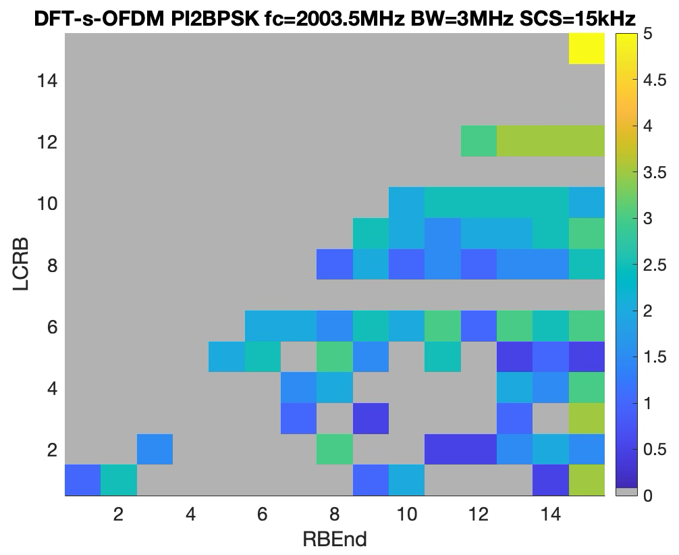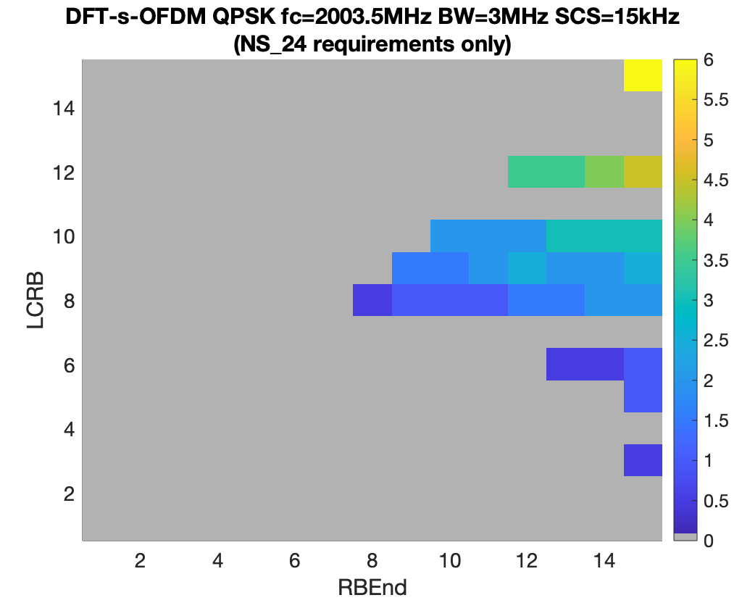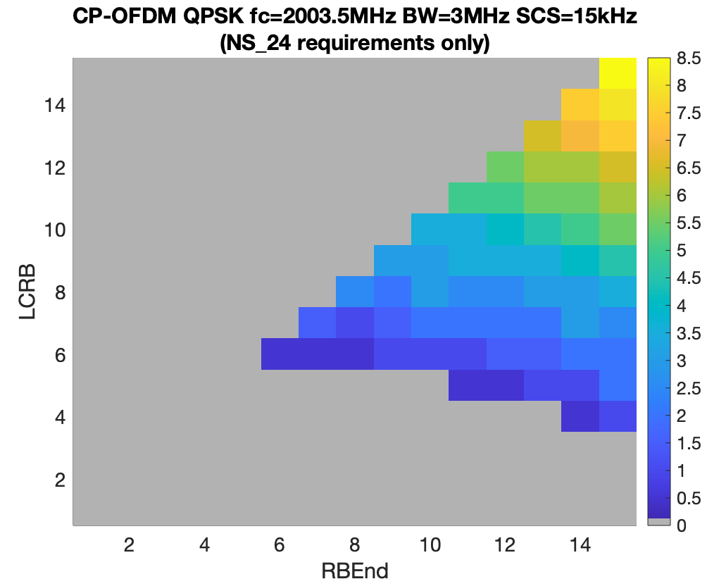
Figure F.2.1.1.1.2-1: Power back-off results at Fc=2003.5MHz.

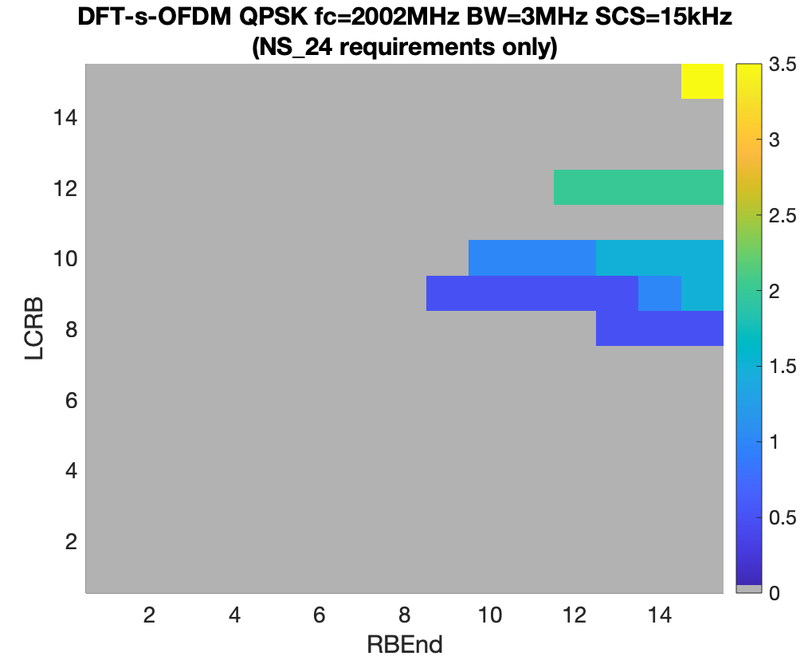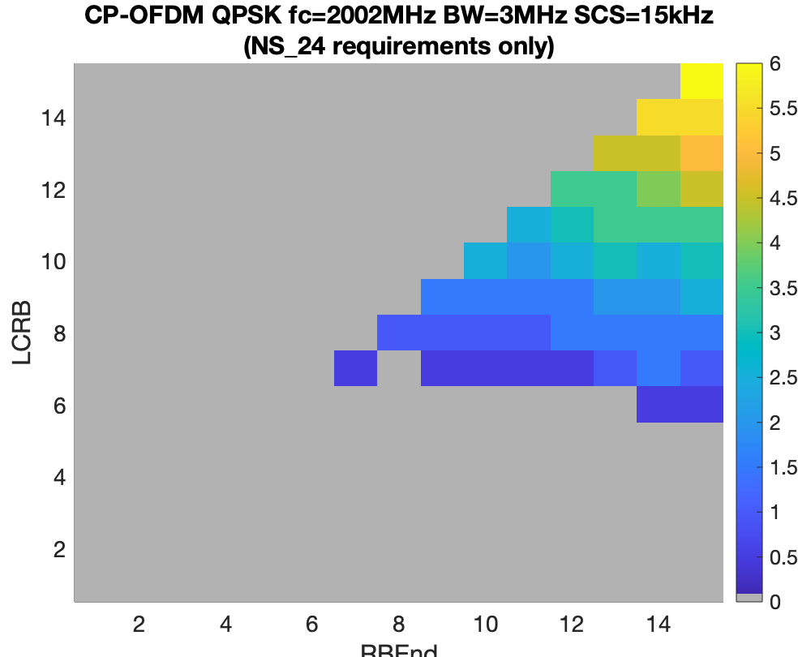
Figure F.2.1.1.1.2-2: Power back-off results at Fc=2002MHz.

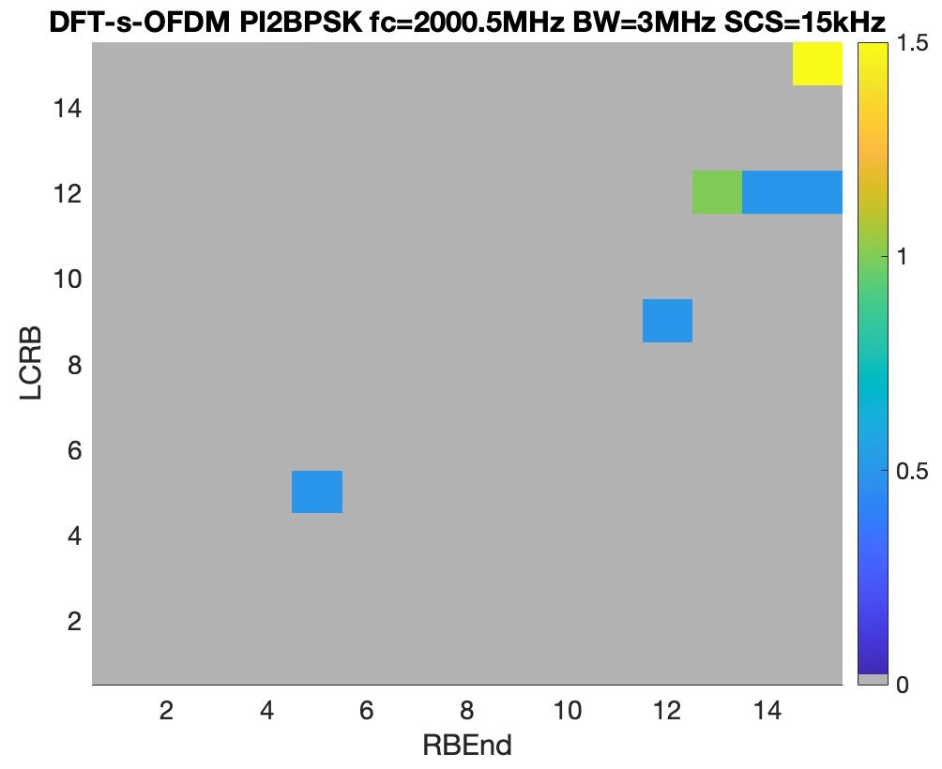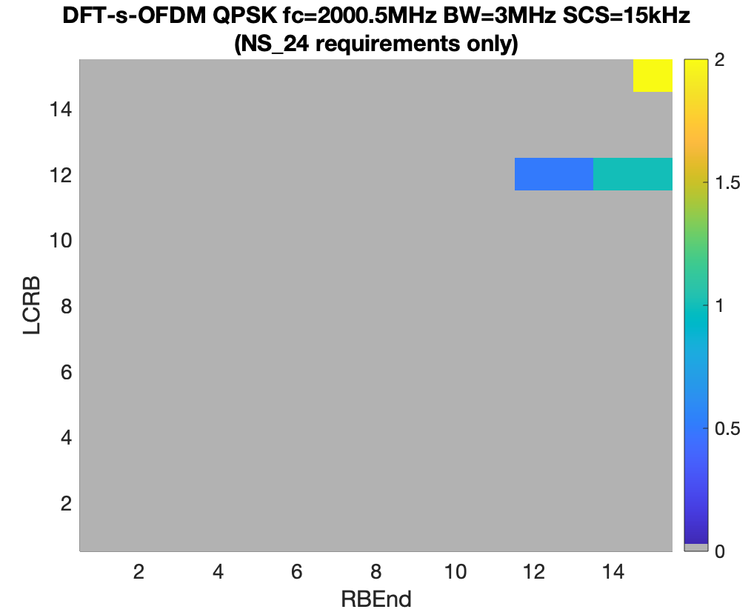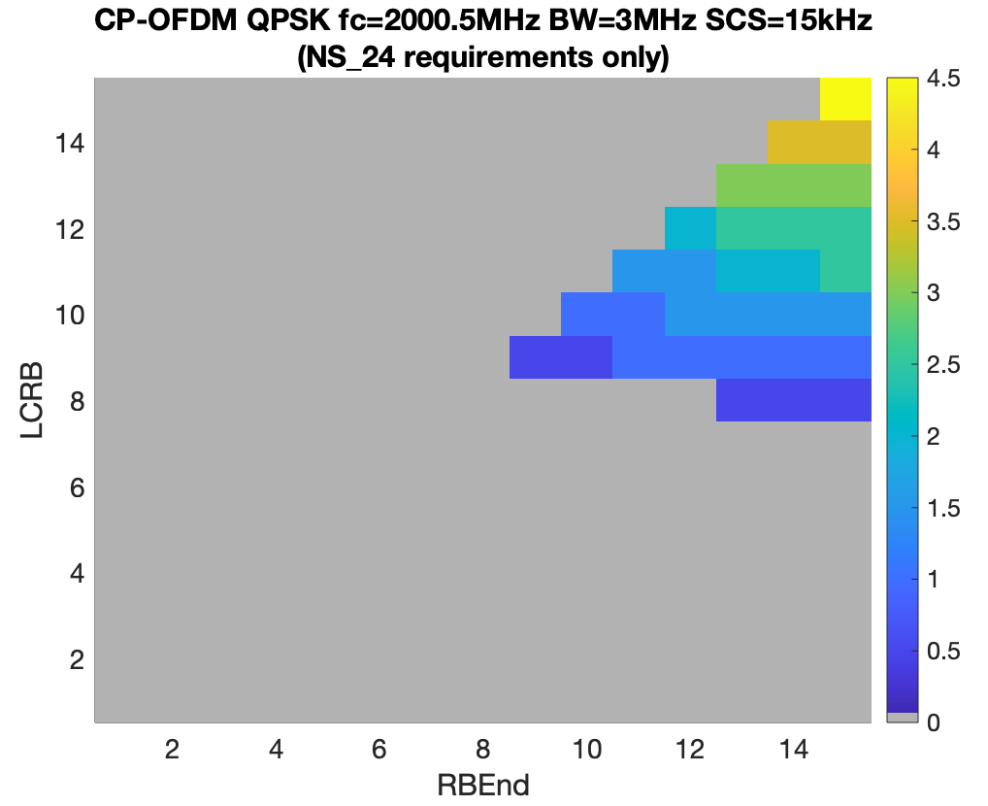
Figure F.2.1.1.1.2-3: Power back-off results at Fc=2000.5MHz.

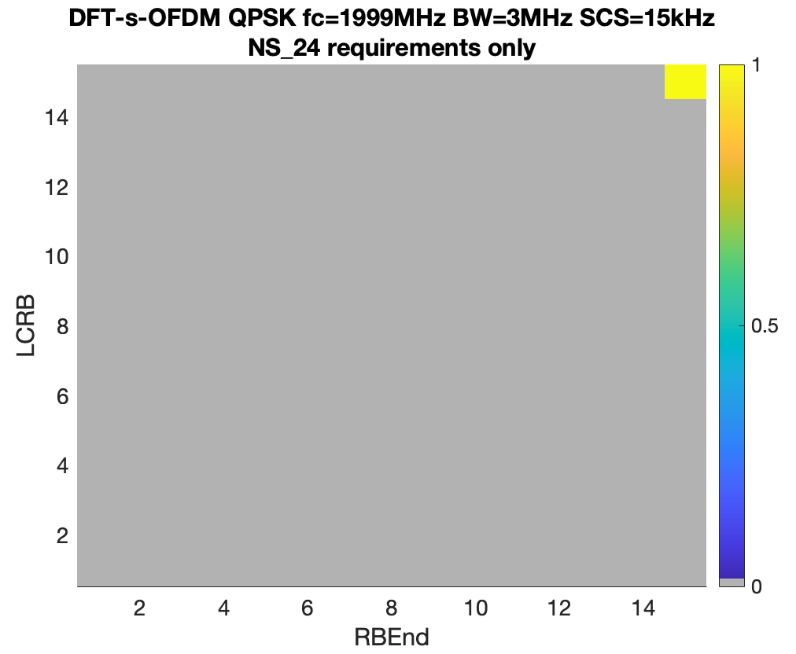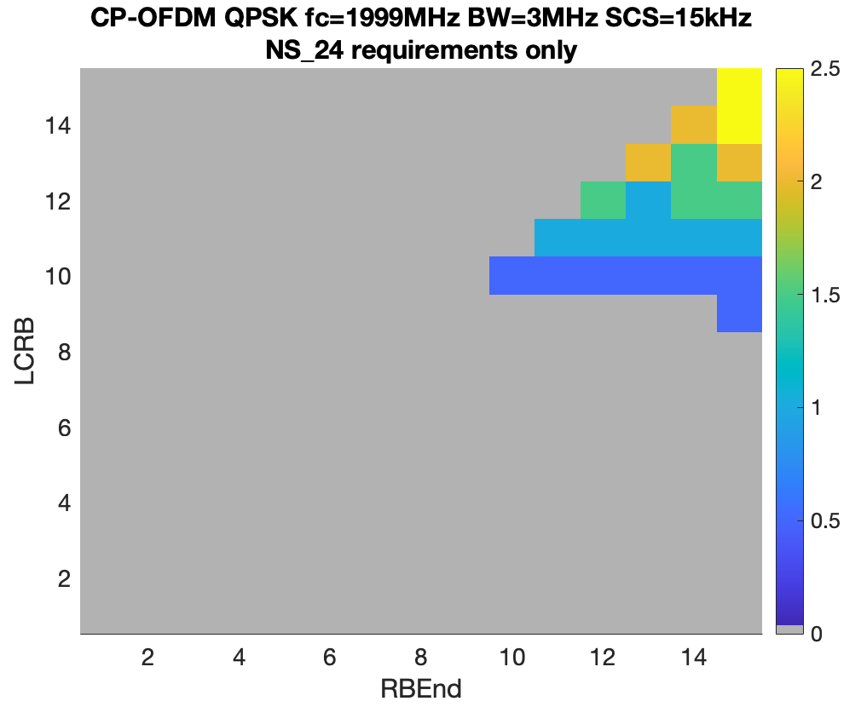
Figure F.2.1.1.1.2-4: Power back-off results at Fc=1999MHz.

F.1.1.1.2 Company B

F.1.1.1.2.1 Simulation assumptions
For the power back-off simulations the PA was calibrated with the following assumptions:
- PC3 23dBm
- 1dB MPR: DFT-s-OFDM QPSK 20MHz, 100RB
- Carrier leakage of 28dBc, image of 28dBc, CIM3 of 60dBc, and CIM5 of 70dBc
- ASE and A-SEM, SEM and ACLR are considered as gating factors (EVM was excluded)

F.1.1.1.2.2 Simulation results
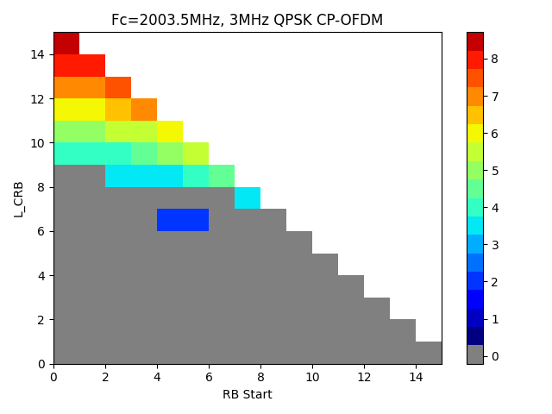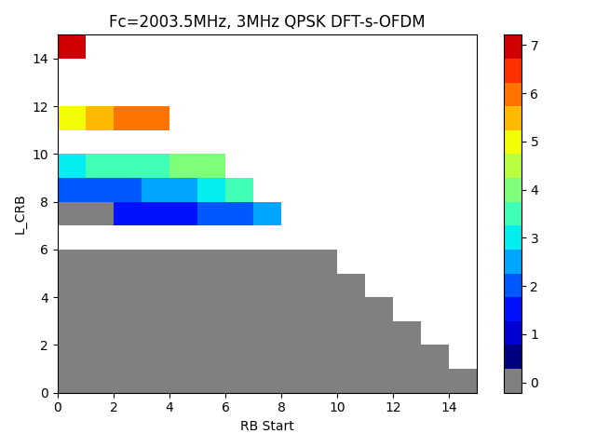
Figure F.2.1.1.2.2-1: A-MPR evaluations of the 3MHz channel at Fc=2003.5 MHz

F.1.1.1.3 Company C

F.1.1.1.3.1 Simulation assumptions
The following assumptions are used for the power back-off simulations:
- Power class PC3
- WOLA processing
- I/Q image -28 dBc
- Carrier leakage -28 dBc
- CIM3 -60 dBc, CIM5 -70 dBc
- Additional requirements are -50dBm/MHz to protect the 2010 ≤ f ≤ 2025MHz frequency range
Only additional spurious emission mask from NS_24 is simulated. Other gating factors (ACLR, SEM, etc.) are excluded because they are covered by the existing MPR requirements.

F.1.1.1.3.2 Simulation results
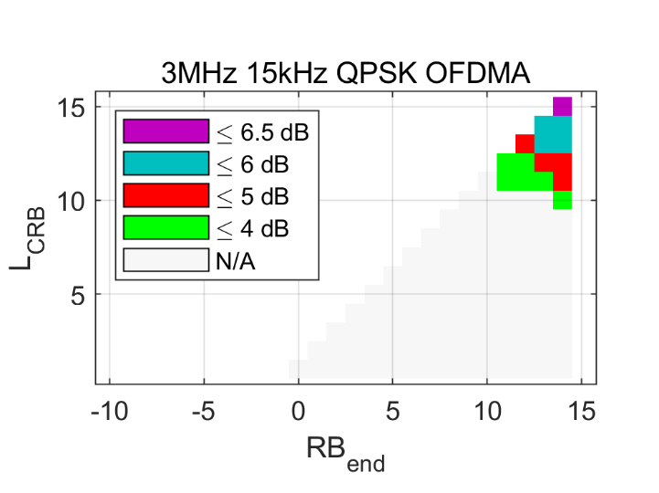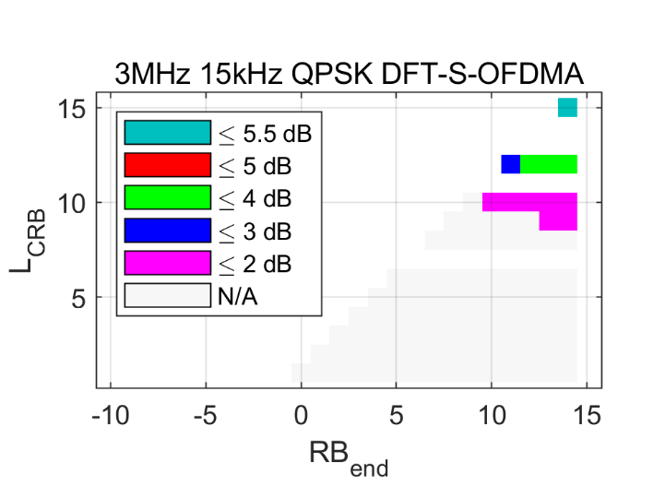
Figure F.1.1.1.3.2-1: Simulated power back-off for the 3MHz channel at Fc=2003.5 MHz.

F.2 PC2 power class

F.2.1 General aspects
NOTE: The purpose of the section is to capture general aspects, such as considered UE RF architectures, assumptions, considered regulations, etc.

F.2.1.1 NS_24N

F.2.1.1.1 Company A (MediaTek/R4-2509854)

F.2.1.1.1.1 Simulation assumptions F.2.1.1.1.2 Simulation results
Table below summarises proposed A-MPR values for the existing A-MPR regions, i.e., same regions that already exist for the PC3 power class.
Table F.2.1.1.1.2-1: Proposed A-MPR regions and values
Modulation/Waveform | A1 | A2 | A3 | A4 | A5 | A6 | A7
 | Outer/  Inner | Outer/  Inner | Outer/  Inner | Outer | Outer/  Inner | Outer/  Inner | Outer
DFT-s-OFDM PI/2 BPSK | ≤ 12.5 | ≤ 7 | ≤ 4.5 | ≤ 8.5 | ≤ 19.6 | ≤ 11.7 | ≤ 3.5
DFT-s-OFDM QPSK | ≤ 12.5 | ≤ 7 | ≤ 4.5 | ≤ 8.5 | ≤ 19.6 | ≤ 11.7 | ≤ 3.5
DFT-s-OFDM 16 QAM | ≤ 13.3 | ≤ 7.1 | ≤ 5.2 | ≤ 8.5 | ≤ 21 | ≤ 13.0 | ≤ 3.5
DFT-s-OFDM 64 QAM | ≤ 13.3 | ≤ 7.1 | ≤ 5.2 | ≤ 8.5 | ≤ 21 | ≤ 13.5 | ≤ 3.5
DFT-s-OFDM 256 QAM | ≤ 13.3 | ≤ 7.1 |  | ≤ 8.5 | ≤ 21 | ≤ 13.5
CP-OFDM QPSK | ≤ 13.9 | ≤ 7.3 | ≤ 5.6 | ≤ 8.5 | ≤ 22.1 | ≤ 15.5 | ≤ 5.5
CP-OFDM 16 QAM | ≤ 13.9 | ≤ 7.3 | ≤ 5.6 | ≤ 8.5 | ≤ 22.6 | ≤ 15.9 | ≤ 5.5
CP-OFDM 64 QAM | ≤ 13.9 | ≤ 7.3 | ≤ 5.6 | ≤ 8.5 | ≤ 22.6 | ≤ 15.9 | ≤ 5.5
CP-OFDM 256 QAM | ≤ 13.9 | ≤ 7.3 |  | ≤ 8.5 | ≤ 22.6 | ≤ 16.1

F.2.1.1.2 Company B (Qualcomm/R4-2511400)

F.2.1.1.2.1 Simulation assumptions
The following simulation assumptions are used:
- Tx power: PC3 (23dBm)
- PA calibrated to 1dB MPR with 30dBc ACLR with DFT-s-OFDM QPSK 100 RB waveform
- -28 dBc IQ-image
- -28 dBc LO-leakage
- -60 dBc CIM3 and -70 dBc CIM5

F.2.1.1.2.2 Simulation results
In the table below, A-MPR regions A to C are the existing regions from the PC3 power, and region D is a new A-MPR reion.
Table F.2.1.1.2.2-1: Proposed A-MPR regions and values
Channel Bandwidth, MHz | Carrier Centre Frequency, Fc, MHz | Region A |  |  | Region B |  |  | Region C |  |  | Region D
 |  | RB_{end}*12*SCS  MHz | LCRB*12*SCS  MHz | A-MPR | RB_{end}*12*SCS  MHz | LCRB*12*SCS  MHz | A-MPR | RB_{end}*12*SCS  MHz | LCRB*12*SCS  MHz | A-MPR | RB_{end}*12*SCS  MHz | LCRB*12*SCS  MHz | A-MPR
5MHz | 1987.5 < Fc ≤ 1992.5 |  | >3.24 | A7
5MHz | 1992.5 < Fc ≤ 1997.5 |  | >3.24 | A4 |  | ≤ 3.24 | A8
5MHz | 1997.5 < Fc ≤ 2002.5 |  | >1.98 | A1 | >3.6 | >1.08 ≤1.98 | A2 | ≤3.6 | ≤1.98 | A3
 |  |  |  |  |  | ≤1.08 | A6
10MHz | Fc = 1985 | >5.4 |  | A4 |  | ≥ 4.5 | A8
10MHz | 1985 ≤ Fc ≤ 1995 |  | >4.32 | A1 | ≥7.2 | >1.08 ≤4.32 | A2 | <7.2 | ≤4.32 | A3
 |  |  |  |  |  | ≤1.08 | A6
10MHz | 1995 < Fc ≤ 2000 | ≥5.76 |  | A5 | <3.06 |  | A5 | ≥3.06  <5.76 | >1.44 | A6 | ≥3.06  <5.76 | ≤1.44 | A8
15MHz | Fc = 1987.5 |  | >6.84 | A1 | ≥10.8 | >1.08 ≤6.84 | A2 | <10.8 | ≤6.84 | A3
 |  |  |  |  |  | ≤1.08 | A6
15MHz | 1987.5 < Fc ≤ 1997.5 | ≥8.64 |  | A5 | <4.04 |  | A5 | ≥4.04  <8.64 | >1.44 | A6 | ≥4.04  <8.64 | ≤1.44 | A8
20MHz | Fc = 1990 | ≥12.96 |  | A5 | <4.68 |  | A5 | ≥4.68  <12.96 | >2.16 | A6 | ≥ 4.68  < 12.96 | ≤2.16 | A8
20MHz | 1990 < Fc ≤ 1995 | ≥11.52 |  | A5 | <5.58 |  | A5 | ≥5.58  <11.52 | >1.44 | A6 | ≥ 5.58  < 11.52 | ≤1.44 | A8

Modulation/Waveform | A1 | A2 | A3 | A4 | A5 | A6 | A7 | A8
 | Outer/Inner | Outer/Inner | Outer/Inner | Outer/Inner | Outer/Inner | Outer/Inner | Outer/Inner | Outer/Inner
DFT-s-OFDM PI/2 BPSK | ≤ 14 | ≤ 8 | ≤ 5.5 | ≤ 8.5 | ≤ 21 | ≤ 13 | ≤ 4.5 | ≤ 3
DFT-s-OFDM QPSK | ≤ 14 | ≤ 8 | ≤ 5.5 | ≤ 8.5 | ≤ 21 | ≤ 13 | ≤ 4.5 | ≤ 3
DFT-s-OFDM 16 QAM | ≤ 14 | ≤ 8 | ≤ 5.5 | ≤ 8.5 | ≤ 21 | ≤ 13 | ≤ 4.5 | ≤ 4
DFT-s-OFDM 64 QAM | ≤ 14 | ≤ 8 | ≤ 6 | ≤ 8.5 | ≤ 22 | ≤ 13 | ≤ 4.5 | ≤ 4.5
CP-OFDM QPSK | ≤ 15 | ≤ 9 | ≤ 6.5 | ≤ 8.5 | ≤ 22 | ≤ 15 | ≤ 5.5 | ≤ 4.5
CP-OFDM 16 QAM | ≤ 15 | ≤ 9 | ≤ 6.5 | ≤ 8.5 | ≤ 22 | ≤ 15 | ≤ 5.5 | ≤ 5
CP-OFDM 64 QAM | ≤ 15 | ≤ 9 | ≤ 6.5 | ≤ 8.5 | ≤ 22 | ≤ 15 | ≤ 5.5 | ≤ 5

F.2.1.1.3 Company C (R4-2510521/OPPO)

F.2.1.1.3.1 Simulation assumptions
The simulation assumptions are as follows:
- PC2 power class with 1Tx
- 5,10, 15 and 20MHz channels residing at the higher edge of the uplink operating band n256 and keeping 5MHz protecting guard gap between the higher edge of the channel bandwidth and the highest edge of the uplink operating band.
- CP-OFDM and DFT-s-OFDM

F.2.1.1.3.2 Simulation results
To assess PC2 power back-off values and potential A-MPR regions, PC2 CP-OFDM QPSK power back-off values are compared to the corresponding results obtained for the PC3 power class under the existing A-MPR regions. Based on that the following observations are made:
- The PC3 power back-off simulations results have more margins compared the current region frame and related AMPR values in existing specification.
- Some regions for PC2 are extended compared with PC3 due to higher output power, i.e., A5 region for 10MHz, 15MHz and 20 MHz, A1 region for 5MHz and 10MHz, A4 region for 5MHI.
- The power back-off value of A6 region in F.2.1.1.3.2-1 is 5dB smaller than the value of A6 region in F.2.1.1.3.2-2.

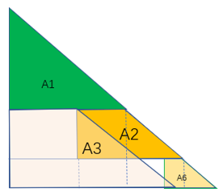
Figure F.2.1.1.3.2-1: A-MPR regions for the for 5MHz channel at 1997.5 < Fc ≤ 2002.5 and 10MHz channel at 1985 < Fc ≤ 1995

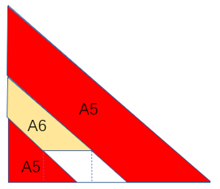
Figure F.2.1.1.3.2-2: A-MPR regions for the for 10MHz at 1995 < Fc ≤ 2000, 15MHz and 20MHI.

According to the simulation results, A-MPR regions for NS_24N can reuse same regions as the existing PC3 regions. However, some region ranges should be extended compared to PC3, i.e., A5 region for 10MHz, 15MHz and 20 MHz, A1 region for 5MHz and 10MHz, A4 region for 5MHI. It is also necessary to a new region name for the A6 region in Figure F.2.1.1.3.2-2 for 10MHz, 15MHz, and 20MHz to distinguish with the A6 region in F.2.1.1.3.2-1 for 5MHz and 10MHz, i.e., A8 replace A6.
In the figures below further results are presented for NS_24N with PC2 10MHz at Fc=2000MHz under different modulations with CP-OFDM and DFT-s-OFDM waveforms, whereupon the simulation results are based on fixed bias PA.
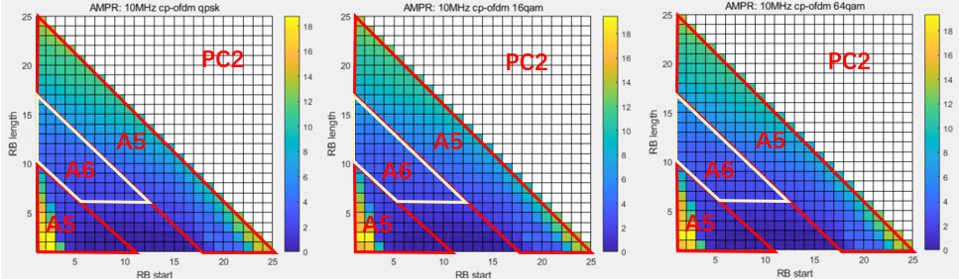
Figure F.2.1.1.3.2-3: AMPR for PC2 10MHz CP-OFDM under different modulations.

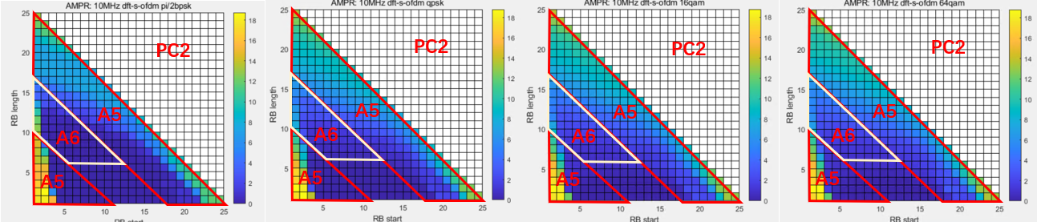
Figure F.2.1.1.3.2-4: AMPR for PC2 10MHz DFT-s-OFDM under different modulations.

Table F.2.1.1.3.2-1 proposes A-MPR regions and power back-off values, which are based on the existing PC3 regions.
Table F.2.1.1.3.2-1: Proposed A-MPR values and regions based on existing PC3 A-MPR regions
Channel Bandwidth, MHz | Carrier Centre Frequency, Fc, MHz | Region A |  |  | Region B |  |  | Region C
 |  | RB_{end}*12*SCS  MHz | LCRB*12*SCS  MHz | A-MPR | RB_{end}*12*SCS  MHz | LCRB*12*SCS  MHz | A-MPR | RB_{end}*12*SCS  MHz | LCRB*12*SCS  MHz | A-MPR
5MHz | 1987.5 < Fc ≤ 1992.5 |  | >3.24 | A7
5MHz | 1992.5 < Fc ≤ 1997.5 |  | >3.24 | A4
5MHz | 1997.5 < Fc ≤ 2002.5 |  | >1.98 | A1 | >3.6 | >1.08 ≤1.98 | A2 | ≤3.6 | ≤1.98 | A3
 |  |  |  |  |  | ≤1.08 | A6
10MHz | 1985 < Fc ≤ 1995 |  | >4.32 | A1 | ≥7.2 | >1.08 ≤4.32 | A2 | <7.2 | ≤4.32 | A3
 |  |  |  |  |  | ≤1.08 | A6
10MHz | 1995 < Fc ≤ 2000 | ≥5.76 |  | A5 | <3.06 |  | A5 | ≥3.06  <5.76 | >1.44 | A6
15MHz | 1987.5 < Fc ≤ 1997.5 | ≥8.64 |  | A5 | <3.78 |  | A5 | ≥3.78  <8.64 | >1.44 | A6
20MHz | 1990 < Fc ≤ 1995 | ≥11.52 |  | A5 | <5.58 |  | A5 | ≥5.58  <11.52 | >1.44 | A6

Modulation/ Waveform | A1 | A2 | A3 | A4 | A5 | A6 | A7
 | Outer/Inner | Outer/Inner | Outer/Inner | Outer | Outer/Inner | Outer/Inner | Outer
CP-OFDM QPSK | 16 | 12 | 11 | 9.5 | 26 | 21 | 8.5
CP-OFDM 16QAM | 16 | 12 | 11 | 9.5 | 26 | 21 | 8.5
CP-OFDM 64QAM | 16 | 12 | 11 | 9.5 | 26 | 21 | 8.5
DFT-s-OFDM pi/2 BPSK | 15 | 11 | 10 | 8.5 | 26 | 20 | 7.5
DFT-s-OFDM QPSK | 15 | 11 | 10 | 8.5 | 26 | 20 | 7.5
DFT-s-OFDM 16QAM | 15 | 11 | 10 | 8.5 | 26 | 20 | 7.5
DFT-s-OFDM 64QAM | 15 | 11 | 10 | 8.5 | 26 | 20 | 7.5

If we use the modified regions as shown in Table F.2.1.1.3.2-2 for PC2 AMPR, we can see that the regions of A1, A4 and A5 are extended, but regions A2, A3 and A8 are reduced.
Table F.2.1.1.3.2-2: Proposed values based on modified AMPR regions
Channel Bandwidth, MHz | Carrier Centre Frequency, Fc, MHz | Region A |  |  | Region B |  |  | Region C
 |  | RB_{end}*12*SCS  MHz | LCRB*12*SCS  MHz | A-MPR | RB_{end}*12*SCS  MHz | LCRB*12*SCS  MHz | A-MPR | RB_{end}*12*SCS  MHz | LCRB*12*SCS  MHz | A-MPR
5MHz | 1987.5 < Fc ≤ 1992.5 |  | >3.24 | A7
5MHz | 1992.5 < Fc ≤ 1997.5 |  | > 2.16 | A4
5MHz | 1997.5 < Fc ≤ 2002.5 |  | > 1.44 | A1 | > 2.7 | >1.08 ≤ 1.44 | A2 | ≤2.7 | ≤  1.44 | A3
 |  |  |  |  |  | ≤1.08 | A6
10MHz | 1985 < Fc ≤ 1995 |  | > 3.24 | A1 | ≥ 5.4 | > 2.16 ≤ 3.24 | A2 | < 5.4 | ≤ 3.24 | A3
 |  |  |  |  |  | ≤ 2.16 | A6
10MHz | 1995 < Fc ≤ 2000 | ≥ 5.4 |  | A5 | < 3.42 |  | A5 | ≥ 3.42  <5.4 | >1.08 | A8
15MHz | 1987.5 < Fc ≤ 1997.5 | ≥8.64 |  | A5 | < 5.94 |  | A5 | ≥ 5.94  <8.64 | >1.44 | A8
20MHz | 1990 < Fc ≤ 1995 | ≥11.52 |  | A5 | <7.74 |  | A5 | ≥7.74  <11.52 | >1.44 | A8

Modulation/ Waveform | A1 | A2 | A3 | A4 | A5 | A6 | A8 | A7
 | Outer/Inner | Outer/Inner | Outer/Inner | Outer | Outer/Inner | Outer/Inner |  | Outer
CP-OFDM QPSK /16QAM/64QAM | ≤ 16 | ≤ 10 | ≤ 10 | ≤ 9.5 | ≤ 26 | ≤ 12 | ≤ 17 | ≤ 8.5
DFT-s-OFDM pi/2 BPSK /QPSK/16QAM/64QAM | ≤ 15 | ≤ 9 | ≤ 9 | ≤ 8.5 | ≤ 26 | ≤ 11 | ≤ 16 | ≤ 7.5

F.2.1.1.4 Company D (R4-2511269/Nokia)

F.2.1.1.4.1 Simulation assumptions
The following simulation assumptions are made:
- Operating band n256 (UL 1980 MHz – 2010 MHz)
- 5MHz, 10 MHz, 15 MHz, and 20 MHz channel bandwidth
- Power class PC2
- WOLA processing
- I/Q image -28 dBc (default according to 38.101-1, Table 6.4.2.3-1) for other modulations than 256QAM
- For 256QAM the I/Q image is -33.7 dBc as in MPR simulations.
- Carrier leakage -28 dBc (default according to 38.101-1, Table 6.4.2.3-1)
- CIM3 -60 dBc
- CIM5 -70 dBc
- Channel noise 38.5 dBc
- PA noise -75 dBm/MHz
- Only additional spurious emission mask from NS_24 is simulated. Other gating factors (ACLR, SEM, etc.) are excluded because they are handled by MPR.
- Phase noise and channel noise are only added for QAM256, following LTE 256-QAM MPR simulations.

F.2.1.1.4.2 Simulation results
The following figures provide simulation results for different channel sizes and different locations for PI/2 BPSK, DFT-s-OFDM QPSK and CP-OFDM QPSK.
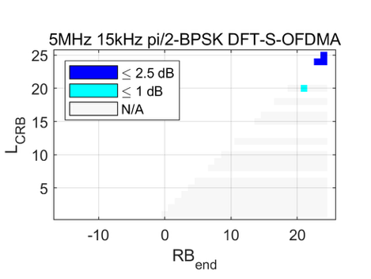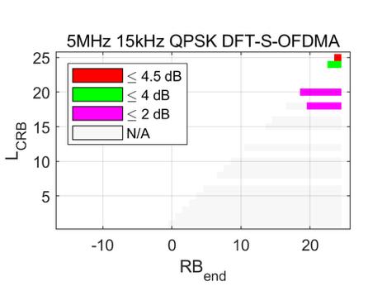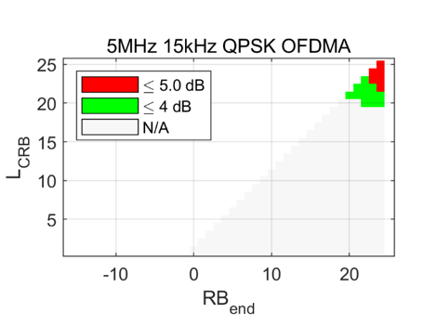
Figure F.2.1.1.4.2-1: 5MHz results at Fc=1997.5MHz

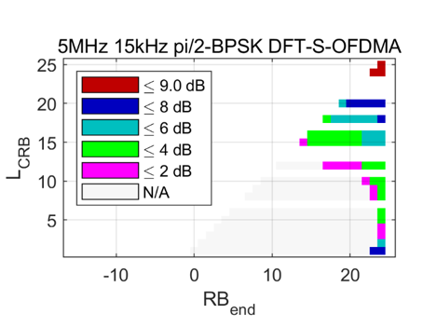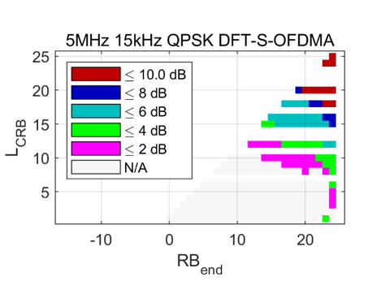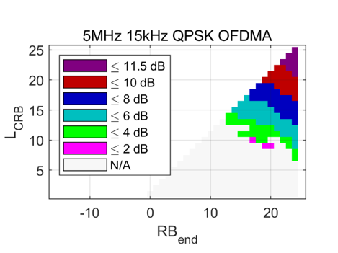
Figure F.2.1.1.4.2-2: 5MHz results at Fc=2002.5MHz

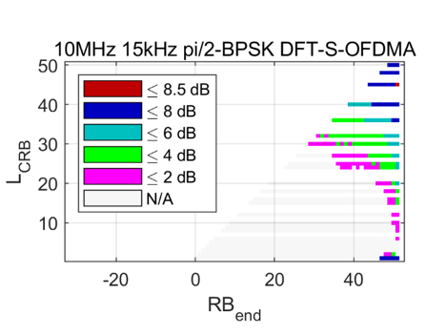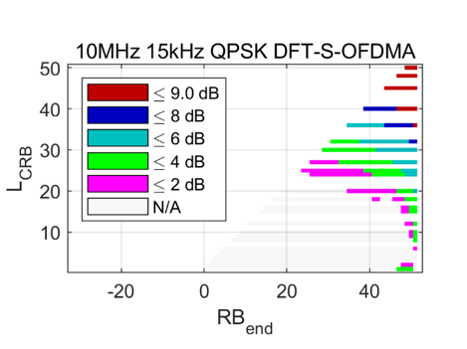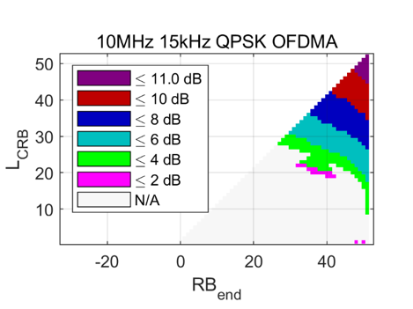
Figure F.2.1.1.4.2-3: 10MHz results at Fc=1995MHz

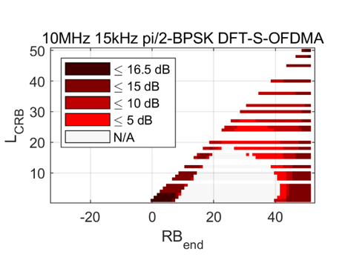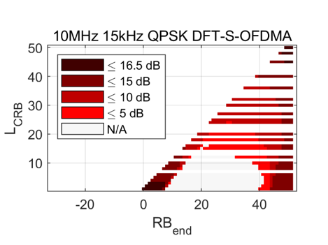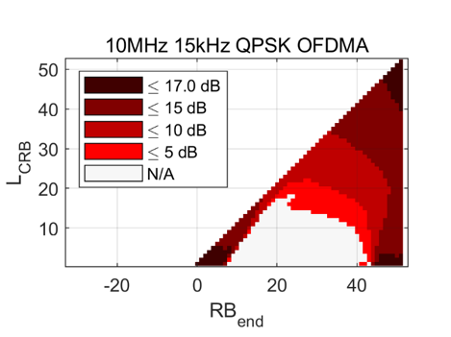
Figure F.2.1.1.4.2-4: 10MHz results at Fc=2000MHz

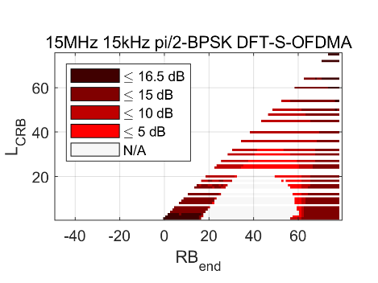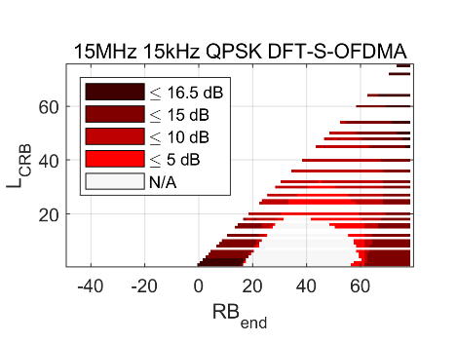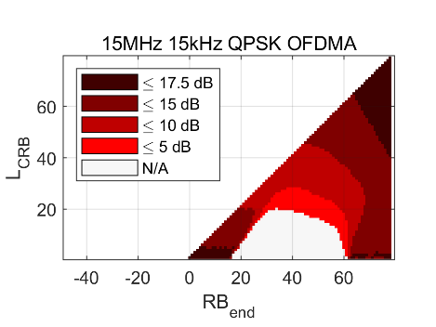
Figure F.2.1.1.4.2-5: 15MHz results at Fc=2000MHz

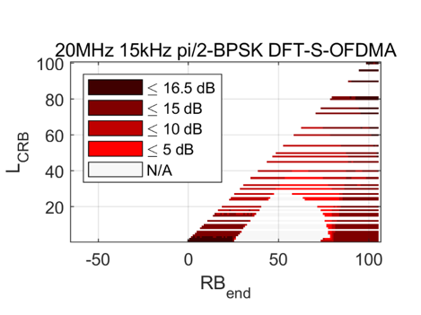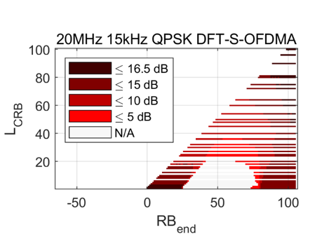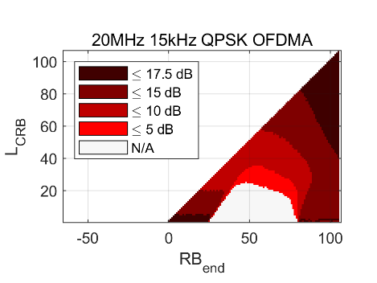
Figure F.2.1.1.4.2-6: 20MHz results at Fc=1995MHz

Based on conducted simulations the follow A-MPR values and regions can be defined. The simulation results based on the A-MPR table of PC3, but some regions are different from PC3. Empty cells indicate that MPR is already enough according to our results. In some cases, region B needs to be slightly extended to cover all the allocations that need A-MPR, which also affects region C. This extension is likely needed due to the tail of the CIM3 peak. An alternative way to cover the A-MPR allocations is to decrease the upper LCRB limit of region C or create a new region. We also found that in case of PC2 the region A at 5MHz needs to be extended a bit due to regrowth of the allocation. and regions B and C need to be modified for 15MH. The reason we think why 5MHz regions for PC1 can be the same as PC3’s is because the linearity of the PC1 PAs is better due to the difference of form factors from PC2 and PC2 PAs.

Table F.2.1.1.4.2-1: Proposed A-MPR regions and values for PC2
Channel Bandwidth, MHz | Carrier Centre Frequency, Fc, MHz | Region A |  |  | Region B |  |  | Region C
 |  | RB_{end}*12*SCS  MHz | LCRB*12*SCS  MHz | A-MPR | RB_{end}*12*SCS  MHz | LCRB*12*SCS  MHz | A-MPR | RB_{end}*12*SCS  MHz | LCRB*12*SCS  MHz | A-MPR
5MHz | 1987.5 < Fc ≤ 1992.5 |  | >3.24 | A7
5MHz | 1992.5 < Fc ≤ 1997.5 |  | >3.06 | A4
5MHz | 1997.5 < Fc ≤ 2002.5 |  | >1.98 | A1 | >3.6 | >1.08 ≤1.98 | A2 | ≤3.6 | ≤1.98 | A3
 |  |  |  |  |  | ≤1.08 | A6
10MHz | 1975 < Fc ≤ 1985 | >5.4 |  | A4
10MHz | 1985 < Fc ≤ 1995 |  | >4.32 | A1 | ≥7.2 | >1.08 ≤4.32 | A2 | <7.2 | ≤4.32 | A3
 |  |  |  |  |  | ≤1.08 | A6
10MHz | 1995 < Fc ≤ 2000 | ≥5.76 |  | A5 | <3.06 |  | A5 | ≥3.06  <5.76 | >1.44 | A6
15MHz | 1972.5 < Fc ≤ 1987.5 |  | >6.84 | A1 | ≥10.8 | >1.08 ≤6.84 | A2 | <10.8 | ≤6.84 | A3
 |  |  |  |  |  | ≤1.08 | A6
15MHz | 1987.5 < Fc ≤ 1997.5 | ≥8.64 |  | A5 | <4.14 |  | A5 | ≥4.14  <8.64 | >1.44 | A6
20MHz | 1970 < Fc ≤ 1990 | ≥12.96 |  | A5 | <4.68 |  | A5 | ≥4.68  <12.96 | >2.16 | A6
20MHz | 1990 < Fc ≤ 1995 | ≥11.52 |  | A5 | <5.58 |  | A5 | ≥5.58  <11.52 | >1.44 | A6

Modulation/Waveform | A1 | A2 | A3 | A4 | A5 | A6 | A7
 | Outer/Inner | Outer/Inner | Outer/Inner | Outer | Outer/Inner | Outer/Inner | Outer
DFT-s-OFDM PI/2 BPSK | 9 | 5 | 0.5 | 2.5 | 16.5 | 11.5
DFT-s-OFDM QPSK | 10 | 5 | 2 | 4.5 | 16.5 | 11.5
DFT-s-OFDM 16 QAM | 11 | 5 | 2.5 | 4.5 | 16.5 | 11.5
DFT-s-OFDM 64 QAM | 11 | 5 |  | 4.5 | 17 | 11.5
DFT-s-OFDM 256 QAM | 11 | 5 |  |  | 17 | 11.5
CP-OFDM QPSK | 11.5 | 5.5 | 3.5 | 5 | 17.5 | 12.5
CP-OFDM 16 QAM | 11.5 | 5.5 | 3.5 | 5.5 | 17.5 | 12.5
CP-OFDM 64 QAM | 11.5 | 5.5 |  | 5.5 | 17.5 | 12.5
CP-OFDM 256 QAM | 11.5 |  |  |  | 17.5 | 12.5

F.2.1.1.5 Company E (R4-2509537/Apple)

F.2.1.1.5.1 Simulation assumptions
PC2 power class simulations are conducted with the common assumptions as presented below:
- Tx power: PC2 (+26dBm)
- Calibration: 1dB MPR with 31dBc ACLR and DFT-s-OFDM QPSK 20MHz 100RB0
- Carrier leakage: -28dBc
- Image: -28dBc
- CIM3: -60dBc
- CIM5: -70dBc
- LO placement: always in the centre of the carrier
- Regulations: Requirements from NS_24
For the sake of completeness, the channel bandwidts and the corresponding center frequencies are summarised below:
- 5MHz: Fc=2002.5MHz, Fc=1997.5MHz, Fc=1992.5MHz
- 10MHz: Fc=2000MHz, Fc=1995MHz, Fc=1985MHz
- 15MHz: Fc=1997.5MHz, Fc=1987.5MHz
- 20MHz: Fc=1995MHz, Fc=1990MHz

F.2.1.1.5.2 Simulation results
Figure F.2.1.1.5.2-1, Figure F.2.1.1.5.2-2 and Figure F.2.1.1.5.2-3 present results for the 5MHz channel with the PC2 power class. The results are in line with the existing 5MHz channel A-MPR values for PC3 as defined by NS_24. For instance, while the large allocation with CP-OFDM and PC3 would need up to 13dB A-MPR, in case of PC2 the maximum power baack-off increases up to 15dB. Nevertheless, it is worth noting that large power back-off is needed only for the full channel allocations, which are not likely to be used with the NTN deployments. Once the 5MHz channel is shifted father away from the upper band edge, one can notice an improvement in the required power back-off values. For instance, for the 5MHz channel residing at 1992.5MHz A-MPR would be need only for the large allocations, whereas small allocations do not even need MPR.

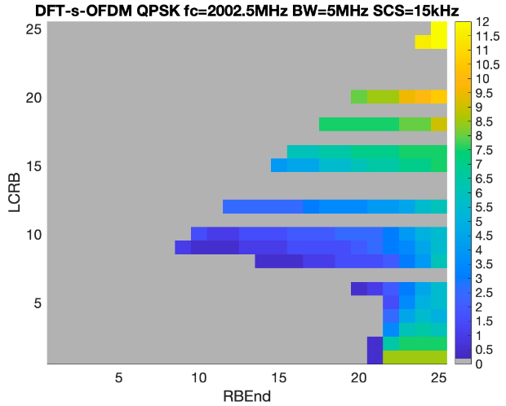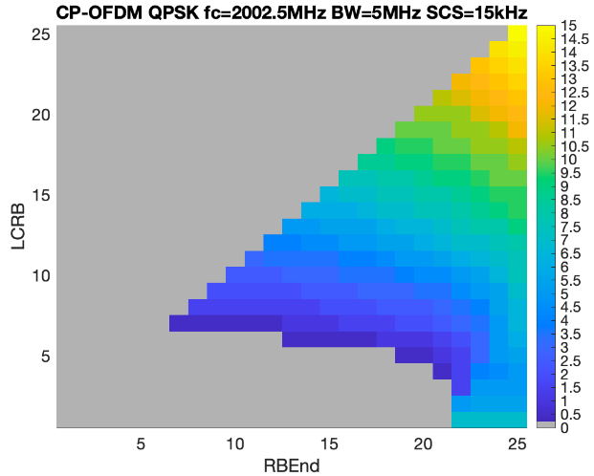
Figure F.2.1.1.5.2-1: Power back-off results for 5MHz at Fc=2002.5MHI.

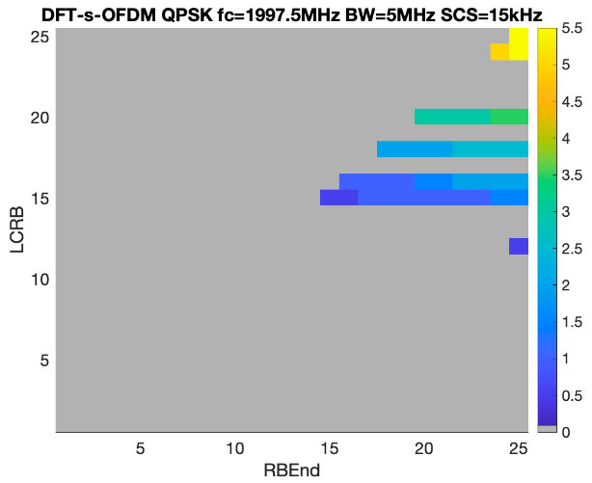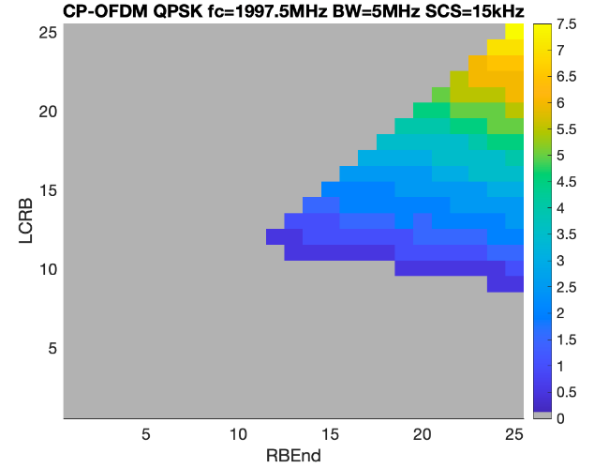
Figure F.2.1.1.5.2-2: Power back-off results for 5MHz at Fc=1997.5MHI.

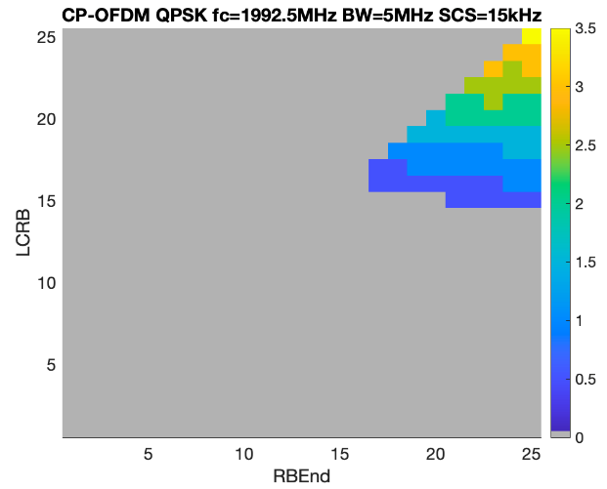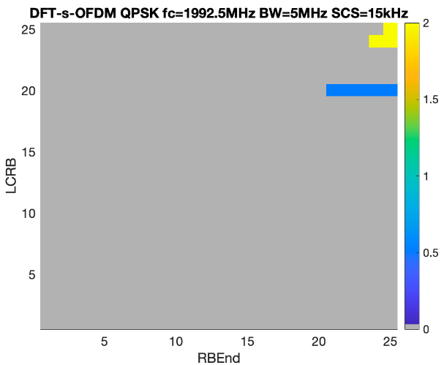
Figure F.2.1.1.5.2-3: Power back-off results for 5MHz at Fc=1992.5MHI.

Next, Figure F.2.1.1.5.2-4 to F.2.1.1.5.2-6 present the 10MHz simulation results, from which as anticipated we can see even higher power back-off required for the full channel and upper band edge allocations. In fact, the same trend can be observed further for the 15MHz and 20MHz channel bandwidths presented at figures below.

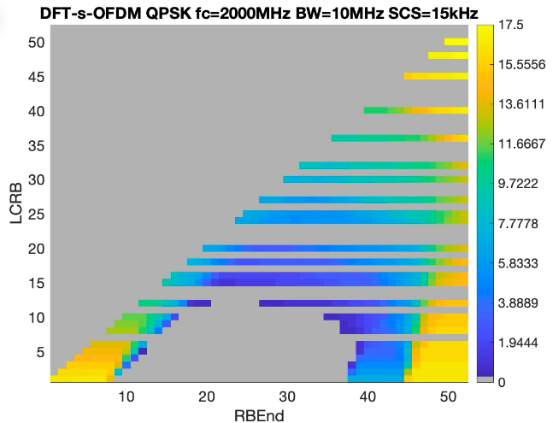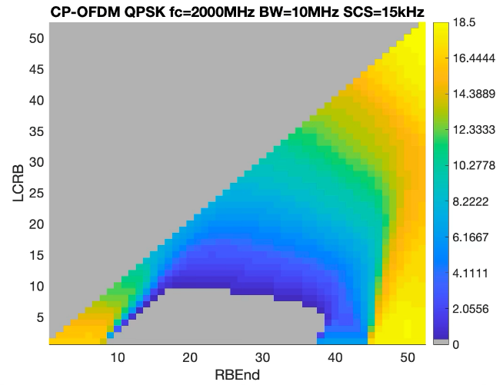
Figure F.2.1.1.5.2-4: Power back-off results for 10MHz at Fc=2000MHz

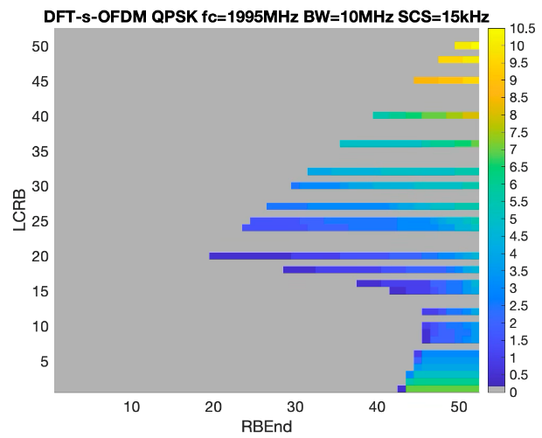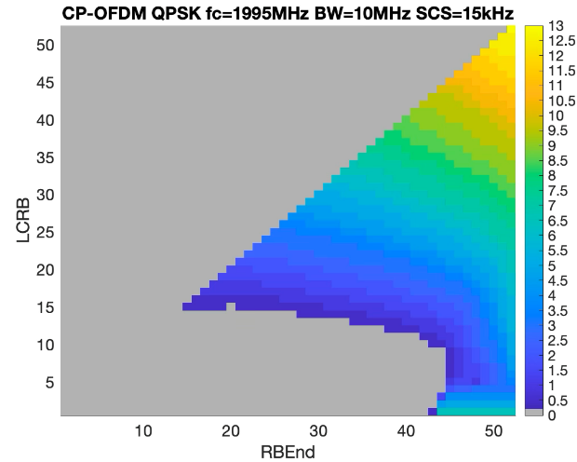
Figure F.2.1.1.5.2-4: Power back-off results for 10MHz at Fc=1995MHz

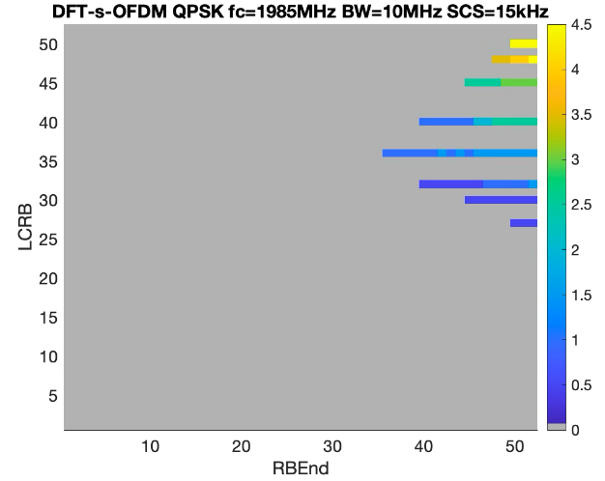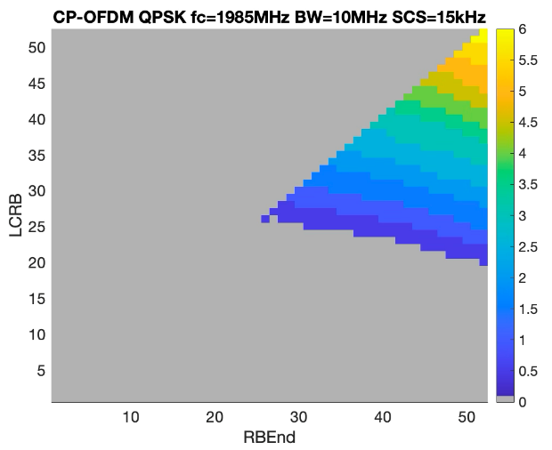
Figure F.2.1.1.5.2-5: Power back-off results for 10MHz at Fc=1985MHz

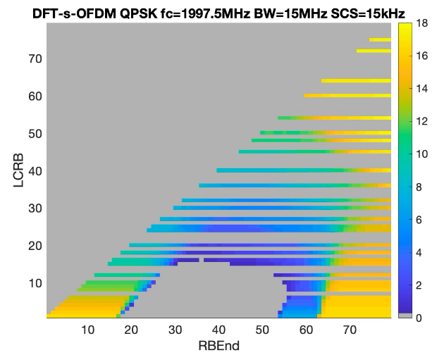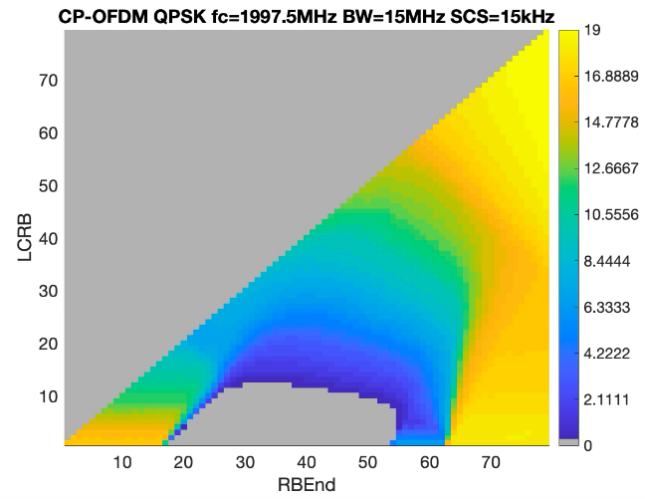
Figure F.2.1.1.5.2-6: Power back-off results for 15MHz at Fc=1997.5MHz

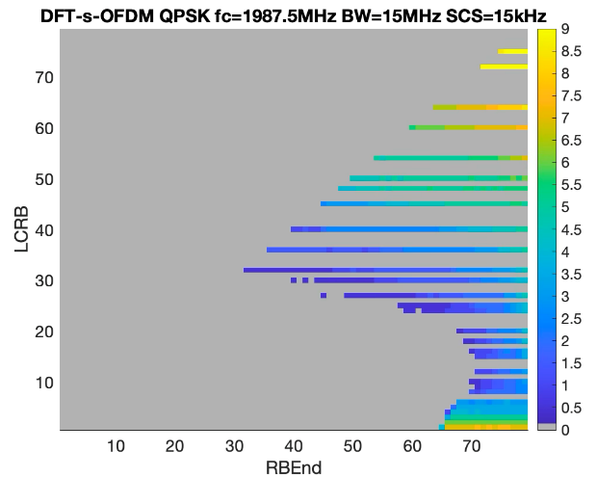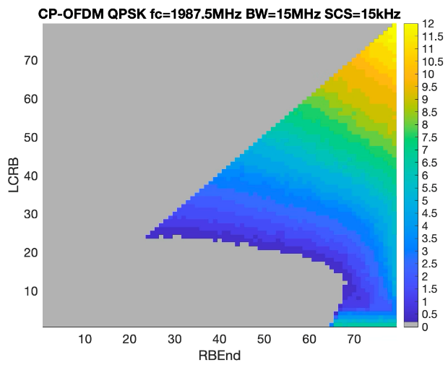
Figure F.2.1.1.5.2-7: Power back-off results for 15MHz at Fc=1987.5MHz

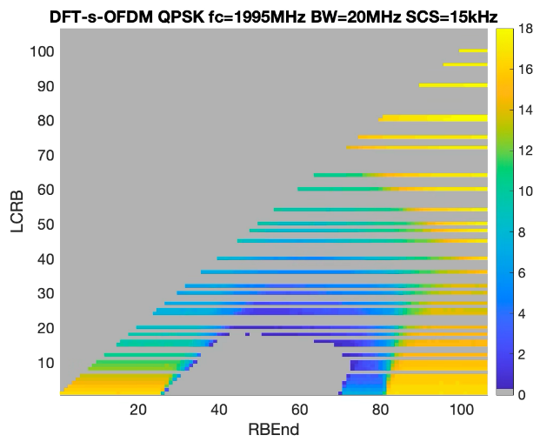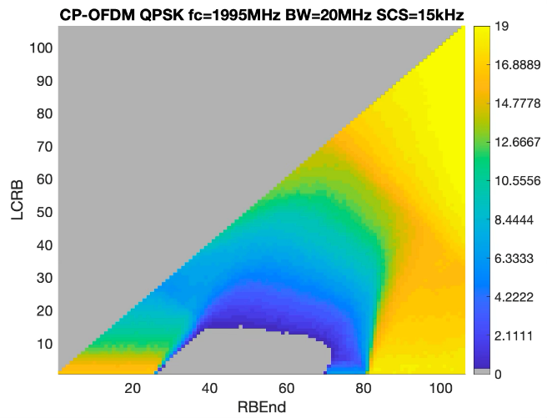
Figure F.2.1.1.5.2-8: Power back-off results for 20MHz at Fc=1995MHz

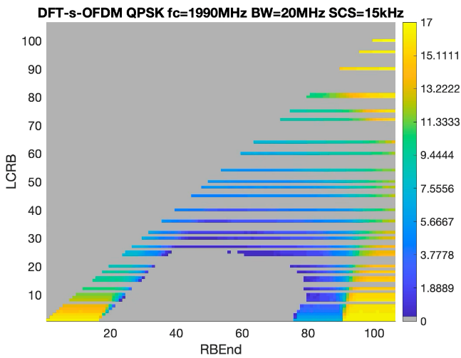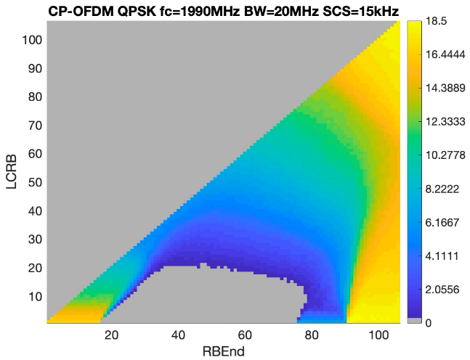
Figure F.2.1.1.5.2-9: Power back-off results for 20MHz at Fc=1990MHz

F.3 PC1.5 power class

F.3.1 General aspects
NOTE: The purpose of the section is to capture general aspects, such as considered UE RF architectures, assumptions, considered regulations, etc.

F.4 PC1 power class

F.4.1 General aspects
NOTE: The purpose of the section is to capture general aspects, such as considered UE RF architectures, assumptions, considered regulations, etc.

F.4.1.1 NS_24N

F.4.1.1.1 Company A (R4-2511269/Nokia)

F.4.1.1.1.1 Simulation assumptions
The following simulation assumptions are made:
- Operating band n256 (UL 1980 MHz – 2010 MHz)
- 5MHz, 10 MHz, 15 MHz, and 20 MHz channel bandwidth
- Power class PC1
- WOLA processing
- I/Q image -28 dBc (default according to 38.101-1, Table 6.4.2.3-1) for other modulations than 256QAM
- For 256QAM the I/Q image is -33.7 dBc as in MPR simulations.
- Carrier leakage -28 dBc (default according to 38.101-1, Table 6.4.2.3-1)
- CIM3 -60 dBc
- CIM5 -70 dBc
- Channel noise 38.5 dBc
- PA noise -75 dBm/MHz
- Only additional spurious emission mask from NS_24 is simulated. Other gating factors (ACLR, SEM, etc.) are excluded because they are handled by MPR.
- Phase noise and channel noise are only added for QAM256, following LTE 256-QAM MPR simulations.

F.4.1.1.1.2 Simulation results
The following figures provide simulation results for different channel sizes and different locations for PI/2 BPSK, DFT-s-OFDM QPSK and CP-OFDM QPSK. It should be noted that power back-off is presented only for those cases when the corresponding value exceeds existing MPR margins.

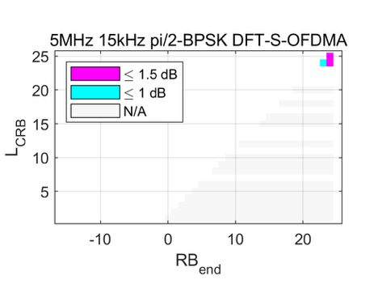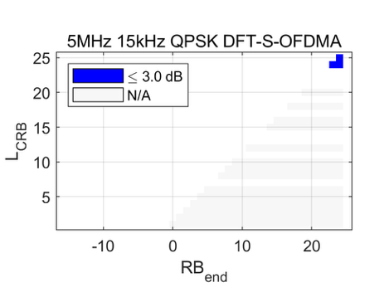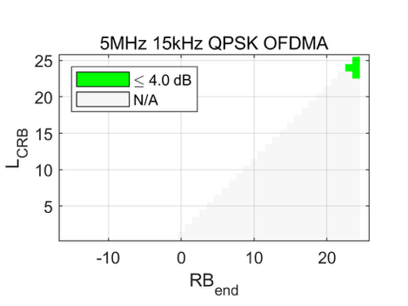
Figure F.4.1.1.1.2-1: 5MHz results at Fc=1997.5MHz

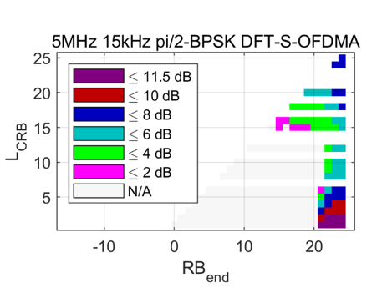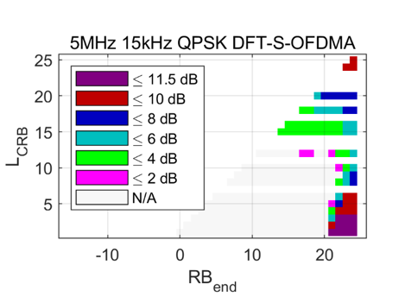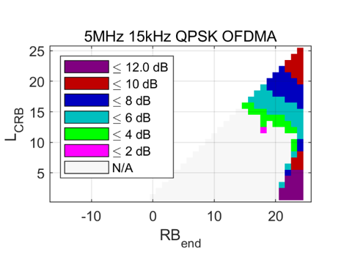
Figure F.4.1.1.1.2-2: 5MHz results at Fc=2002.5MHz

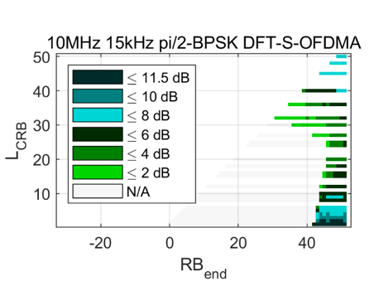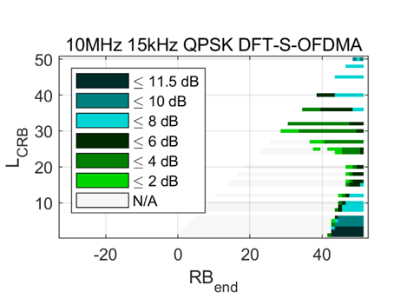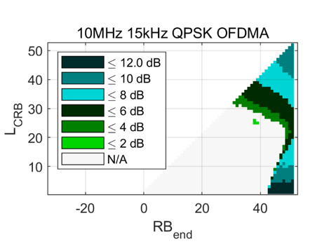
Figure F.4.1.1.1.2-3: 10MHz results at Fc=1995MHz

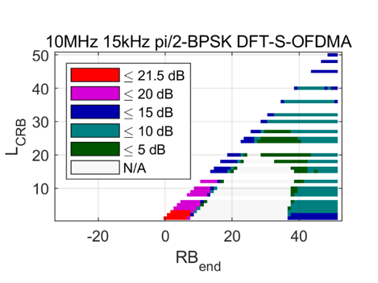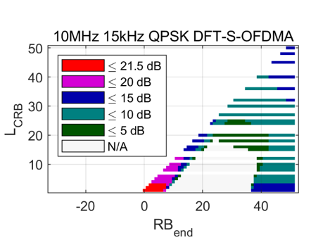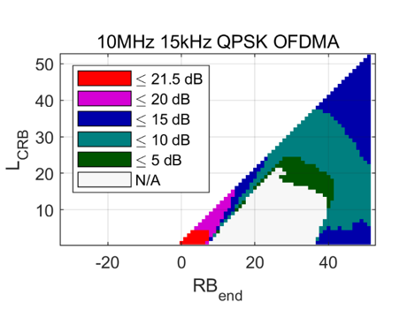
Figure F.4.1.1.1.2-4: 10MHz results at Fc=2000MHz

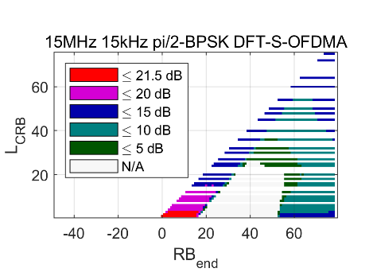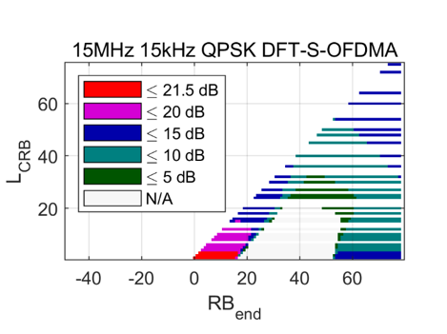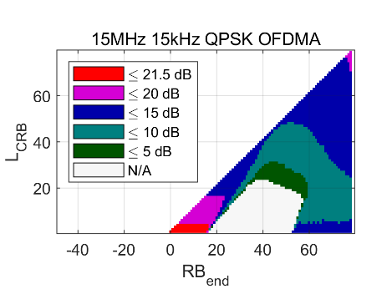
Figure F.4.1.1.1.2-5: 15MHz results at Fc=2000MHz

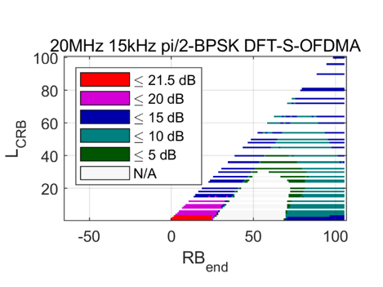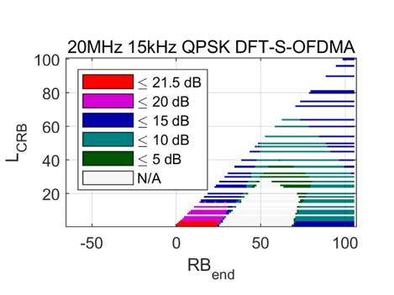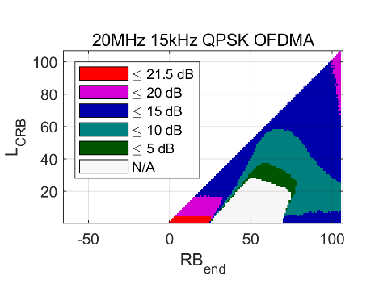
Figure F.4.1.1.1.2-6: 20MHz results at Fc=1995MHz

Based on the presented results PC1 A-MPR regions and the corresponding A-MPR values can be as summarised below in Table F.4.1.1.1.2-1.
Table F.4.1.1.1.2-1: Proposed A-MPR regions and values for PC1
Channel Bandwidth, MHz | Carrier Centre Frequency, Fc, MHz | Region A |  |  | Region B |  |  | Region C
 |  | RB_{end}*12*SCS  MHz | LCRB*12*SCS  MHz | A-MPR | RB_{end}*12*SCS  MHz | LCRB*12*SCS  MHz | A-MPR | RB_{end}*12*SCS  MHz | LCRB*12*SCS  MHz | A-MPR
5MHz | 1987.5 < Fc ≤ 1992.5 |  | >3.24 | A7
5MHz | 1992.5 < Fc ≤ 1997.5 |  | >3.24 | A4
5MHz | 1997.5 < Fc ≤ 2002.5 |  | >1.98 | A1 | >3.6 | >1.08 ≤1.98 | A2 | ≤3.6 | ≤1.98 | A3
 |  |  |  |  |  | ≤1.08 | A6
10MHz | 1975 < Fc ≤ 1985 | >5.4 |  | A4
10MHz | 1985 < Fc ≤ 1995 |  | >4.32 | A1 | ≥7.2 | >1.08 ≤4.32 | A2 | <7.2 | ≤4.32 | A3
 |  |  |  |  |  | ≤1.08 | A6
10MHz | 1995 < Fc ≤ 2000 | ≥5.76 |  | A5 | <3.06 |  | A5 | ≥3.06  <5.76 | >1.44 | A6
15MHz | 1972.5 < Fc ≤ 1987.5 |  | >6.84 | A1 | ≥10.8 | >1.08 ≤6.84 | A2 | <10.8 | ≤6.84 | A3
 |  |  |  |  |  | ≤1.08 | A6
15MHz | 1987.5 < Fc ≤ 1997.5 | ≥8.64 |  | A5 | <4.14 |  | A5 | ≥4.14  <8.64 | >1.44 | A6
20MHz | 1970 < Fc ≤ 1990 | ≥12.96 |  | A5 | <4.86 |  | A5 | ≥4.86  <12.96 | >2.16 | A6
20MHz | 1990 < Fc ≤ 1995 | ≥11.52 |  | A5 | <5.76 |  | A5 | ≥5.76  <11.52 | >1.44 | A6

Modulation/Waveform | A1 | A2 | A3 | A4 | A5 | A6 | A7
 | Outer/Inner | Outer/Inner | Outer/Inner | Outer | Outer/Inner | Outer/Inner | Outer
DFT-s-OFDM PI/2 BPSK | 8 | 6.5 |  | 1.5 | 21.5 | 16.5
DFT-s-OFDM QPSK | 9 | 8 |  | 3 | 21.5 | 16
DFT-s-OFDM 16 QAM | 9.5 | 8 |  | 3.5 | 21.5 | 16
DFT-s-OFDM 64 QAM | 9.5 | 8.5 |  | 3.5 | 21.5 | 16
DFT-s-OFDM 256 QAM | 9.5 | 8.5 |  |  | 21.5 | 16
CP-OFDM QPSK | 10 | 10 |  | 4 | 21.5 | 16.5
CP-OFDM 16 QAM | 10 | 10 |  | 4 | 21.5 | 16.5
CP-OFDM 64 QAM | 10 | 10 |  | 4 | 21.5 | 16.5
CP-OFDM 256 QAM | 10 | 10 |  |  | 21.5 | 16.5

F.4.1.1.2 Company B (R4-2510521/OPPO)

F.4.1.1.2.1 Simulation assumptions
Simulation assumptions are as follows:
- PC1 power class with 4Tx
- 5,10, 15 and 20MHz channels residing at the higher edge of the uplink operating band n256 and keeping 5MHz protecting guard gap between the higher edge of the channel bandwidth and the highest edge of the uplink operating band.
- CP-OFDM and DFT-s-OFDM

F.4.1.1.2.2 Simulation results
Figure F.4.1.1.2.2-1 and Figure F.4.1.1.2.2-2 present a comparison of the NS_24 power back-off results for 5MHz (Fc=2002.5) and 10MHz (Fc=2000MHz) under PC2 1Tx, PC1.5 2Tx and PC1 4Tx with CP-OFDM QPSK. The simulation results are based on fixed bias PA.
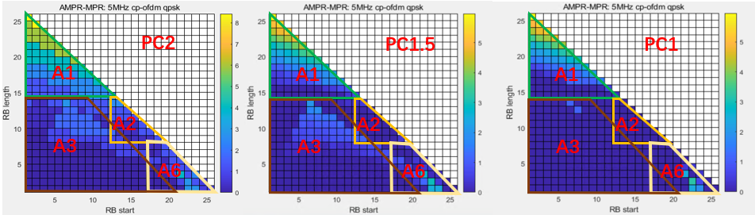
Figure F.4.1.1.2.2-1 AMPR for 5MHz CP-OFDM QPSK under different power classes
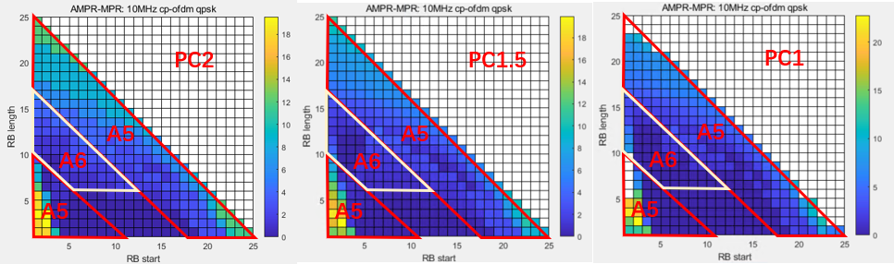
Figure F.4.1.1.2.2-2 AMPR for 10MHz CP-OFDM QPSK under different power classes
In the AMPR simulation for PC2 1Tx, PC1.5 2Tx and PC1 4Tx, the same PC2 PA with fixed bias is assumed for these three power classes. From Figure F.4.1.1.2.2-1 and Figure F.4.1.1.2.2-2 it can be seen that:
- The PC2 and PC1.5 have the similar AMPR region frame and values due to the maximum output power of each PA for PC2 and PC1.5 is 26dBm;
- The AMPR region frame for PC1 has more margin than PC2 and PC1, since the maximum output power of each PA for PC1 is 25dBm.
Therefore, PC1 can use same AMPR regions as PC2. Table F.4.1.1.2.2-1 proposes power back-off values, which are based on the existing PC3 regions.
Table F.4.1.1.2.2-1: Proposed PC1 4Tx AMPR values based on PC3 A-MPR regions
Modulation/ Waveform | A1 | A2 | A3 | A4 | A5 | A6 | A7
 | Outer/Inner | Outer/Inner | Outer/Inner | Outer | Outer/Inner | Outer/Inner | Outer
CP-OFDM QPSK | ≤ 20.5 | ≤ 16 | ≤ 16 | ≤ 15 | ≤ 31 | ≤ 23 | ≤ 10
CP-OFDM 16QAM | ≤ 20.5 | ≤ 16 | ≤ 16 | ≤ 15 | ≤ 31 | ≤ 23 | ≤ 10
CP-OFDM 64QAM | ≤ 20.5 | ≤ 16 | ≤ 16 | ≤ 15 | ≤ 31 | ≤ 23 | ≤ 10
DFT-s-OFDM pi/2 BPSK | ≤ 18.5 | ≤ 15 | ≤ 15 | ≤ 13.5 | ≤ 31 | ≤ 22 | ≤ 9
DFT-s-OFDM QPSK | ≤ 18.5 | ≤ 15 | ≤ 15 | ≤ 13.5 | ≤ 31 | ≤ 22 | ≤ 9
DFT-s-OFDM 16QAM | ≤ 18.5 | ≤ 15 | ≤ 15 | ≤ 13.5 | ≤ 31 | ≤ 22 | ≤ 9
DFT-s-OFDM 64QAM | ≤ 18.5 | ≤ 15 | ≤ 15 | ≤ 13.5 | ≤ 31 | ≤ 22 | ≤ 9

If the modified regions are used as shown in Table F.2.1.1.3.2-2, regions A1, A4 and A5 are extended, but regions A2, A3 and A8 are reduced as shown in Table F.4.1.1.2.2-2 below
Table F.4.1.1.2.2-2: PC1 4Tx AMPR values based on modified A-MPR regions as PC2
Modulation/ Waveform | A1 | A2 | A3 | A4 | A5 | A6 | A8 | A7
 | Outer/Inner | Outer/Inner | Outer/Inner | Outer | Outer/Inner | Outer/Inner |  | Outer
CP-OFDM QPSK | ≤ 20.5 | ≤ 15 | ≤ 15 | ≤ 10 | ≤ 31 | ≤ 15.5 | ≤ 23 | ≤ 10
CP-OFDM 16QAM | ≤ 20.5 | ≤ 15 | ≤ 15 | ≤ 10 | ≤ 31 | ≤ 15.5 | ≤ 23 | ≤ 10
CP-OFDM 64QAM | ≤ 20.5 | ≤ 15 | ≤ 15 | ≤ 10 | ≤ 31 | ≤ 15.5 | ≤ 23 | ≤ 10
DFT-s-OFDM pi/2 BPSK | ≤ 18.5 | ≤ 14 | ≤ 14 | ≤ 9 | ≤ 31 | ≤ 14 | ≤ 22 | ≤ 9
DFT-s-OFDM QPSK | ≤ 18.5 | ≤ 14 | ≤ 14 | ≤ 9 | ≤ 31 | ≤ 14 | ≤ 22 | ≤ 9
DFT-s-OFDM 16QAM | ≤ 18.5 | ≤ 14 | ≤ 14 | ≤ 9 | ≤ 31 | ≤ 14 | ≤ 22 | ≤ 9
DFT-s-OFDM 64QAM | ≤ 18.5 | ≤ 14 | ≤ 14 | ≤ 9 | ≤ 31 | ≤ 14 | ≤ 22 | ≤ 9

Annex G:
Power back-off simulation results for the L-band

G.1 PC3 power class

G.1.1 General aspects
NOTE: The purpose of the section is to capture general aspects, such as considered UE RF architectures, assumptions, considered regulations, etc.

G.1.1.1 NS_02N

G.1.1.1.1 Company A (OPPO/R4-2510521)

G.1.1.1.1.1 Simulation assumptions
Since filter rejection at the frequencies 1559-1610MHz is not a constant 10dB attenuation, but rather has a slope, it is hard to add the filter rejection without the slope factor. Thus, to evaluate the rejection effect of the filter, required power back-off is simulated under the following assumptions:
- no filter rejection is assumed;
- PC3 CP-OFDM QPSK using fixed bias PA and APT PA;
- 5, 10, 15 and 20MHz channels residing at the lowest edge of the uplink operating band n255

G.1.1.1.1.2 Simulation results
For PC3 CP-OFDM QPSK using fixed bias PA:
- Power back-off 0dB is needed for 5MHz, 10MHz and 15MHz without additional filter rejection.
- Power back-off 3dB is needed for 20MHz without additional filter rejection.
For PC3 CP-OFDM QPSK using APT PA:
- Power back-off 0dB is needed for 5MHz and 10MHz without additional filter rejection.
- Power back-off 2dB for 15MHz and 10.5dB for 20MHz without additional filter rejection.
Based on the simulation results, no matter which PA model is used, the filter attenuation is needed for NS_02N for PC3 to be able to operate within existing MPR margins.

G.1.1.2 NS_09N

G.1.1.2.1 Company A

G.1.1.2.1.1 Simulation assumptions
The following simulation assumptions are used:
- Considered Tx frequency: 1668 – 1675MHz
- Tx power: PC3 (23dBm)
- Calibration: 1dB MPR with DFT-s-OFDM QPSK 20MHz, 100RB0
- Carrier Leakage: 28dBc
- Image: 28dBc
- CIM3: 60dBc
- CIM5: 70dBc
- Additional requirements: out-of-band unwanted emission limits according to ETSI EN 301681

G.1.1.2.1.2 Simulation results
Figure G.1.1.2.1.2-1 presents power back-off values for the 5MHz channel at the lower edge of the band. As can be seen most allocations do not need A-MPR, except the case(s) with a single RB allocated at the right edge of the 5MHz channel. The reason for that is the upper edge out-of-band emission requirement limits, which would require some A-MPR. As presented in Figure G.1.1.2.1.2-2 below, CP-OFDM slightly exceeds the limit of -30dBm/30kHz and DFT-s-OFDM is also hitting that limit.
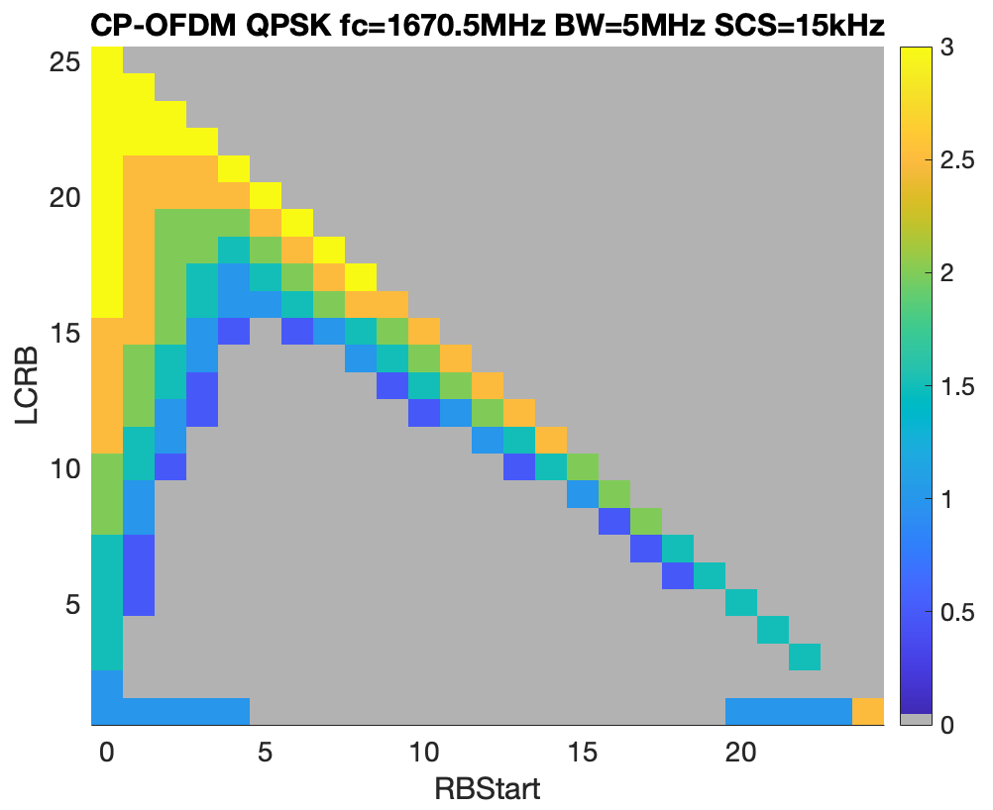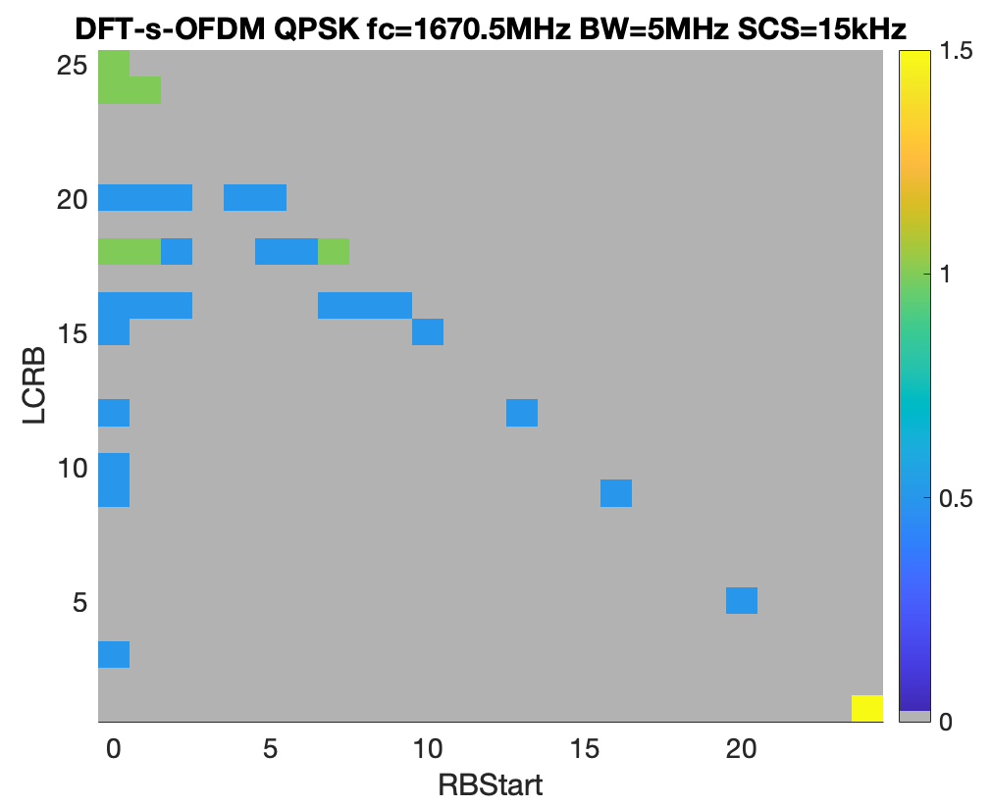
Figure G.1.1.2.1.2-1: Power back-off for CP-OFDM and DFT-s-OFDM (Fc=1670.5MHz).

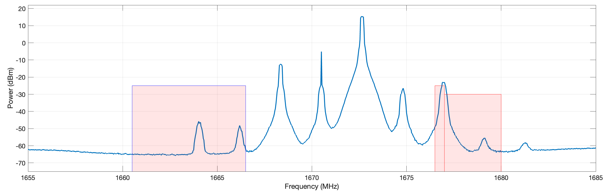
Figure G.1.1.2.1.2-2: Spectrum plot for the 5MHz channel and 1RB allocation (Fc=1670.5MHz).
Once the 5MHz channel is shifted farther towards the upper edge of the band, even higher A-MPR might be needed, which is however mostly concerns single RB allocations at the upper edge of the configured channel.
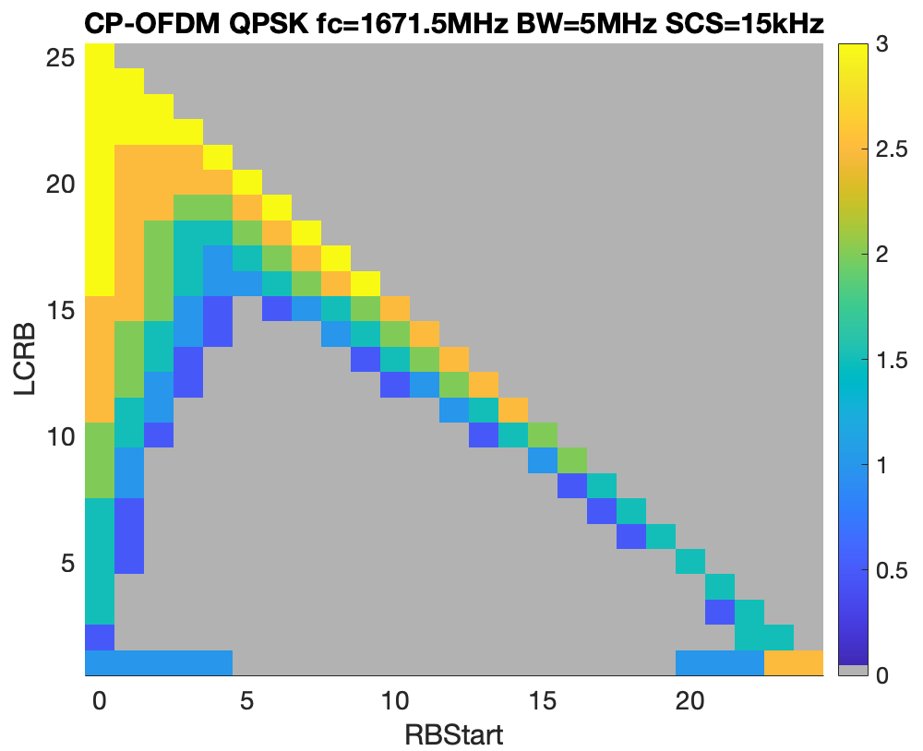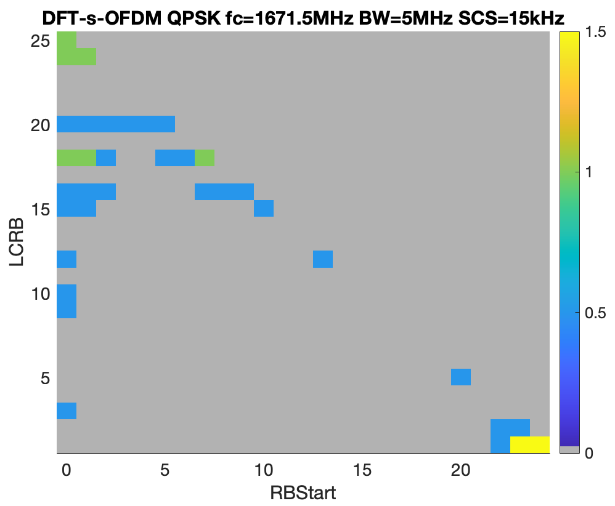
Figure G.1.1.2.1.2-3: Power back-off for CP-OFDM and DFT-s-OFDM (Fc=1671.5MHz).

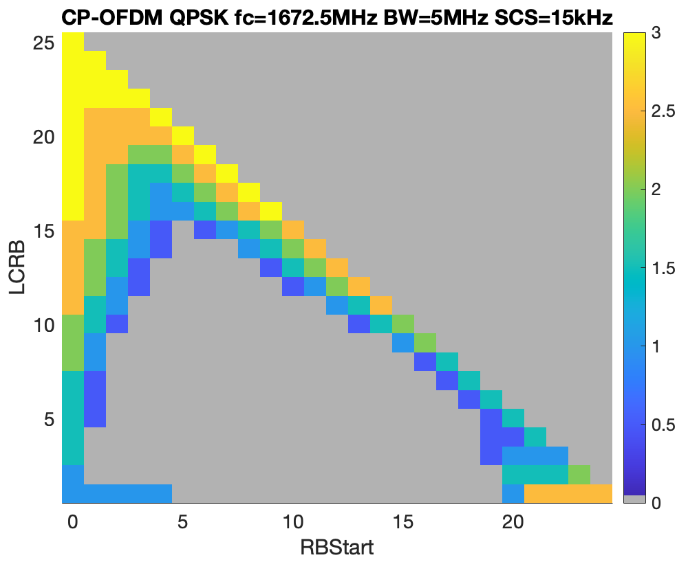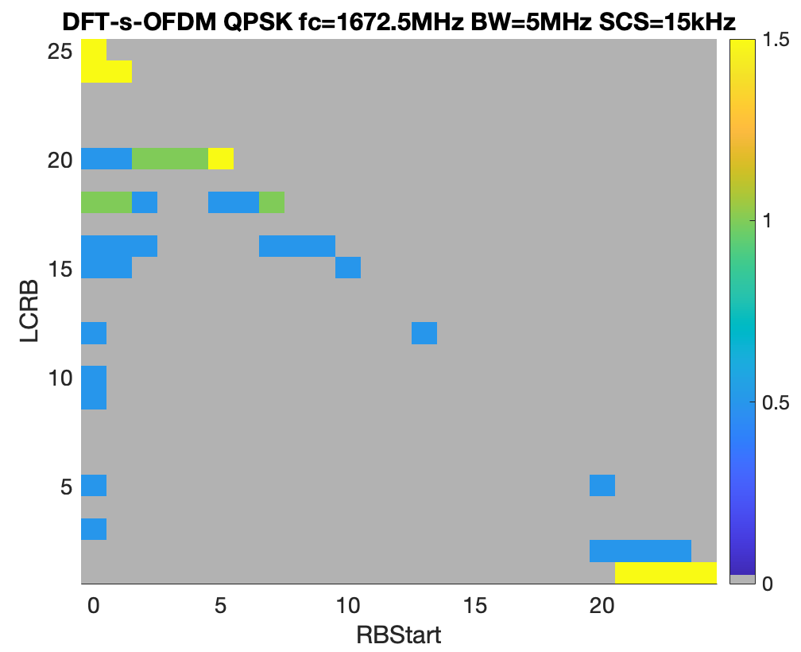
Figure G.1.1.2.1.2-4: Power back-off for CP-OFDM and DFT-s-OFDM (Fc=1672.5MHz).

G.1.1.3 NS_10N

G.1.1.3.1 Company A

G.1.1.3.1.1 Simulation assumptions
The following simulation assumptions are used:
- Considered Tx frequency: 1626.5 – 1660.5MHz
- Tx power: PC3 (23dBm)
- Calibration: 1dB MPR with DFT-s-OFDM QPSK 20MHz, 100RB0
- Carrier Leakage: 28dBc
- Image: 28dBc
- CIM3: 60dBc
- CIM5: 70dBc
- Addition requirements: out-of-band unwanted emission limits according to ETSI EN 301681

G.1.1.3.1.2 Simulation results
As can be seen from the Figure G.1.1.3.1.2-1 below, when the 5MHz NR channel is in the middle of the band, no additional AMPR is anticipated: the out-of-band emission requirements are not relevant because of the size of the band and the in-band ETSI emission mask does not create any additional restrictions either.
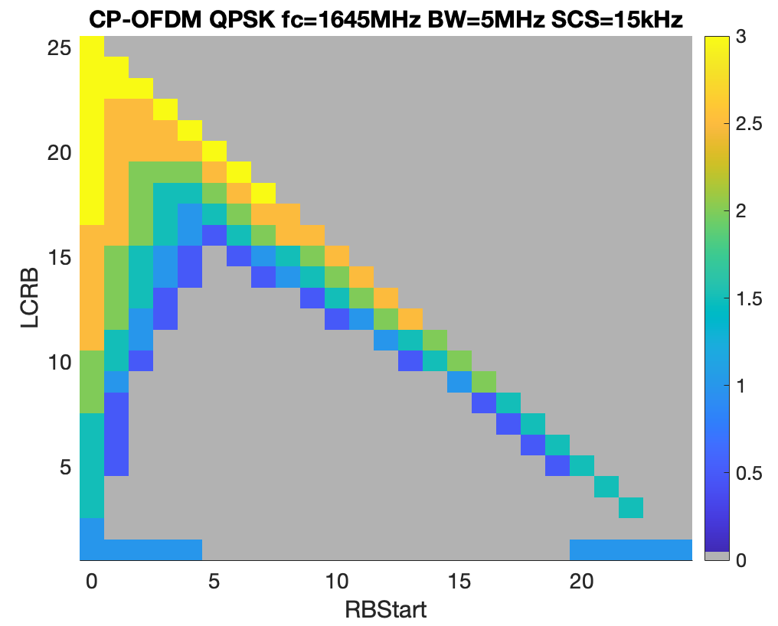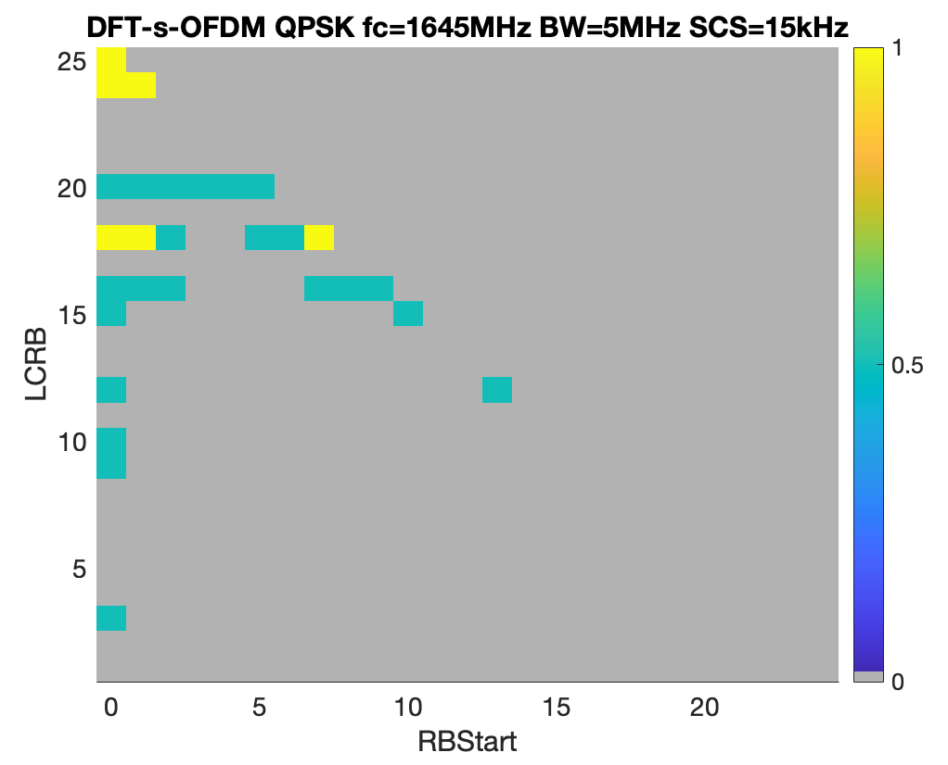
Figure G.1.1.3.1.2-1: Power back-off for CP-OFDM and DFT-s-OFDM (5MHz at Fc=1645MHz).
As for the channels either at the lower or the upper edge of the band, extra A-MPR is needed for larger allocations with DFT-s-OFDM and the right-most channel edge allocations as presented in Figure G.1.1.3.1.2-2 below. And the same observations can be done for the 5MHz channel at the upper edge of the band: left-most channel allocations will need extra A-MPR to comply with the out-of-band emission requirements.
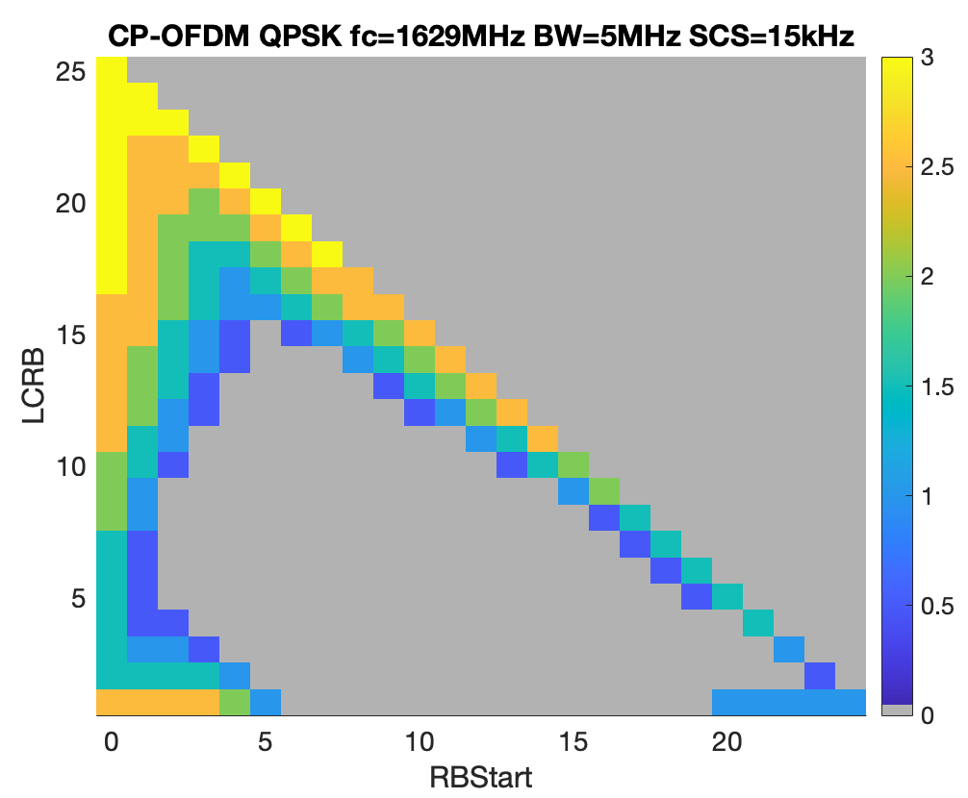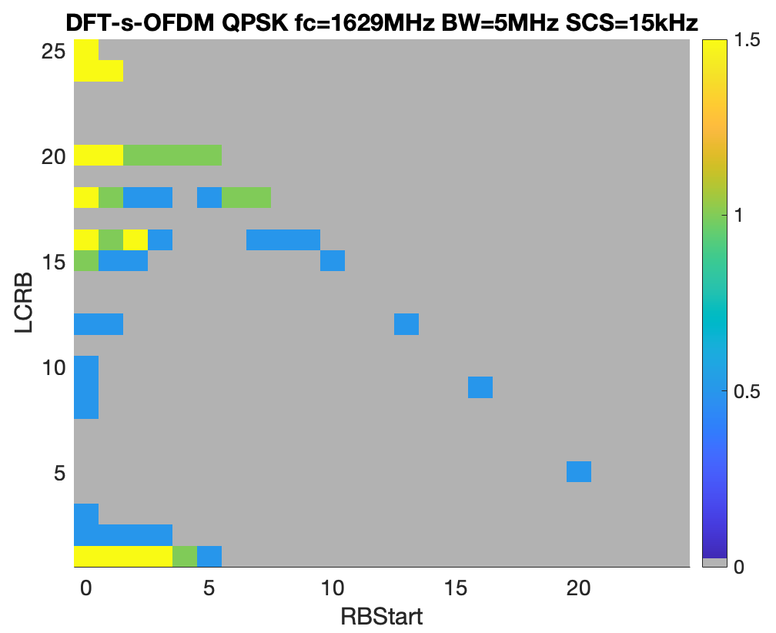
Figure G.1.1.3.1.2-2: Power back-off for CP-OFDM and DFT-s-OFDM (5MHz at Fc=1629MHz).
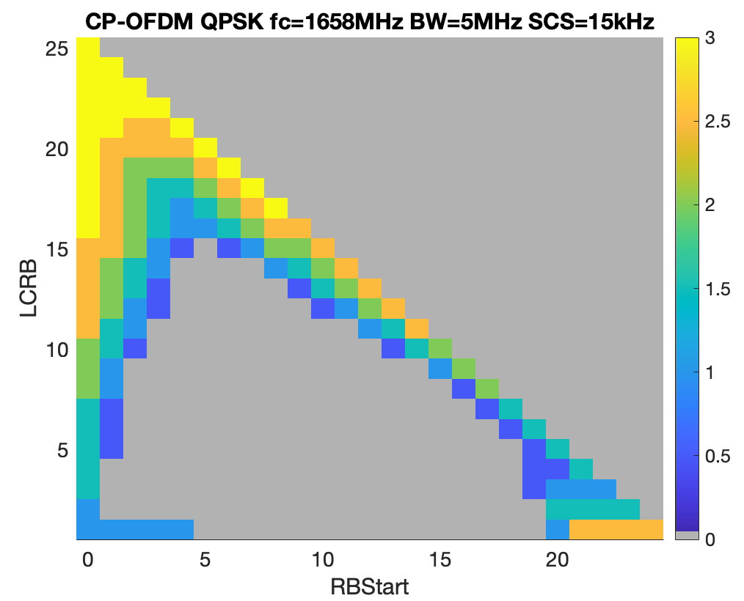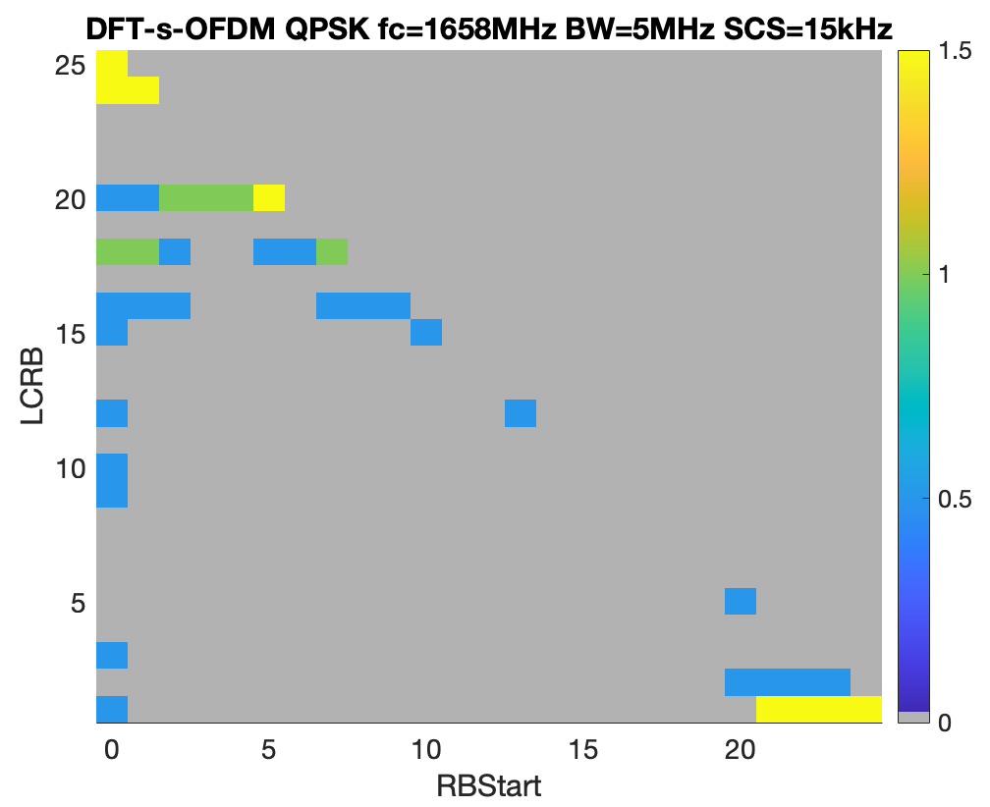
Figure G.1.1.3.1.2-3: Power back-off for CP-OFDM and DFT-s-OFDM (5MHz at Fc=1658MHz).
One of the reasons why the left- and right-most channel power back-off look identical despite the fact that out-of-band emission requirements are not the same is the fact that the limiting factor is -30dBm/30kHz. Two figures below present the spectrum plot for the 5MHz channels at the left and right edges of the band, from which one can see that the most limiting factor is the -30dBm/30kHz emission limit at the offset of 2MHz from the band edge.

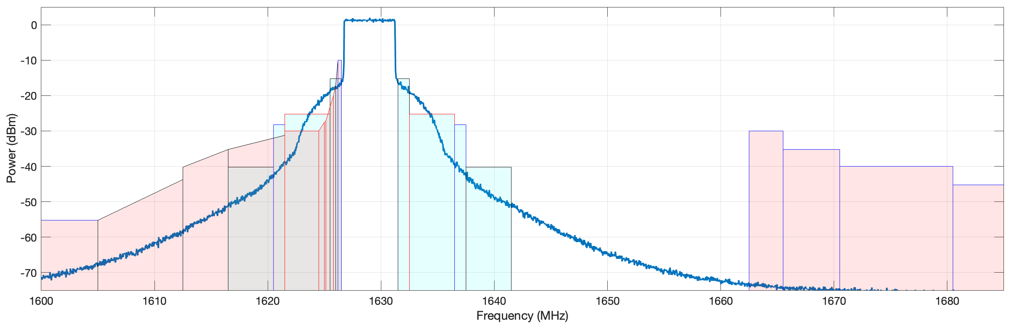
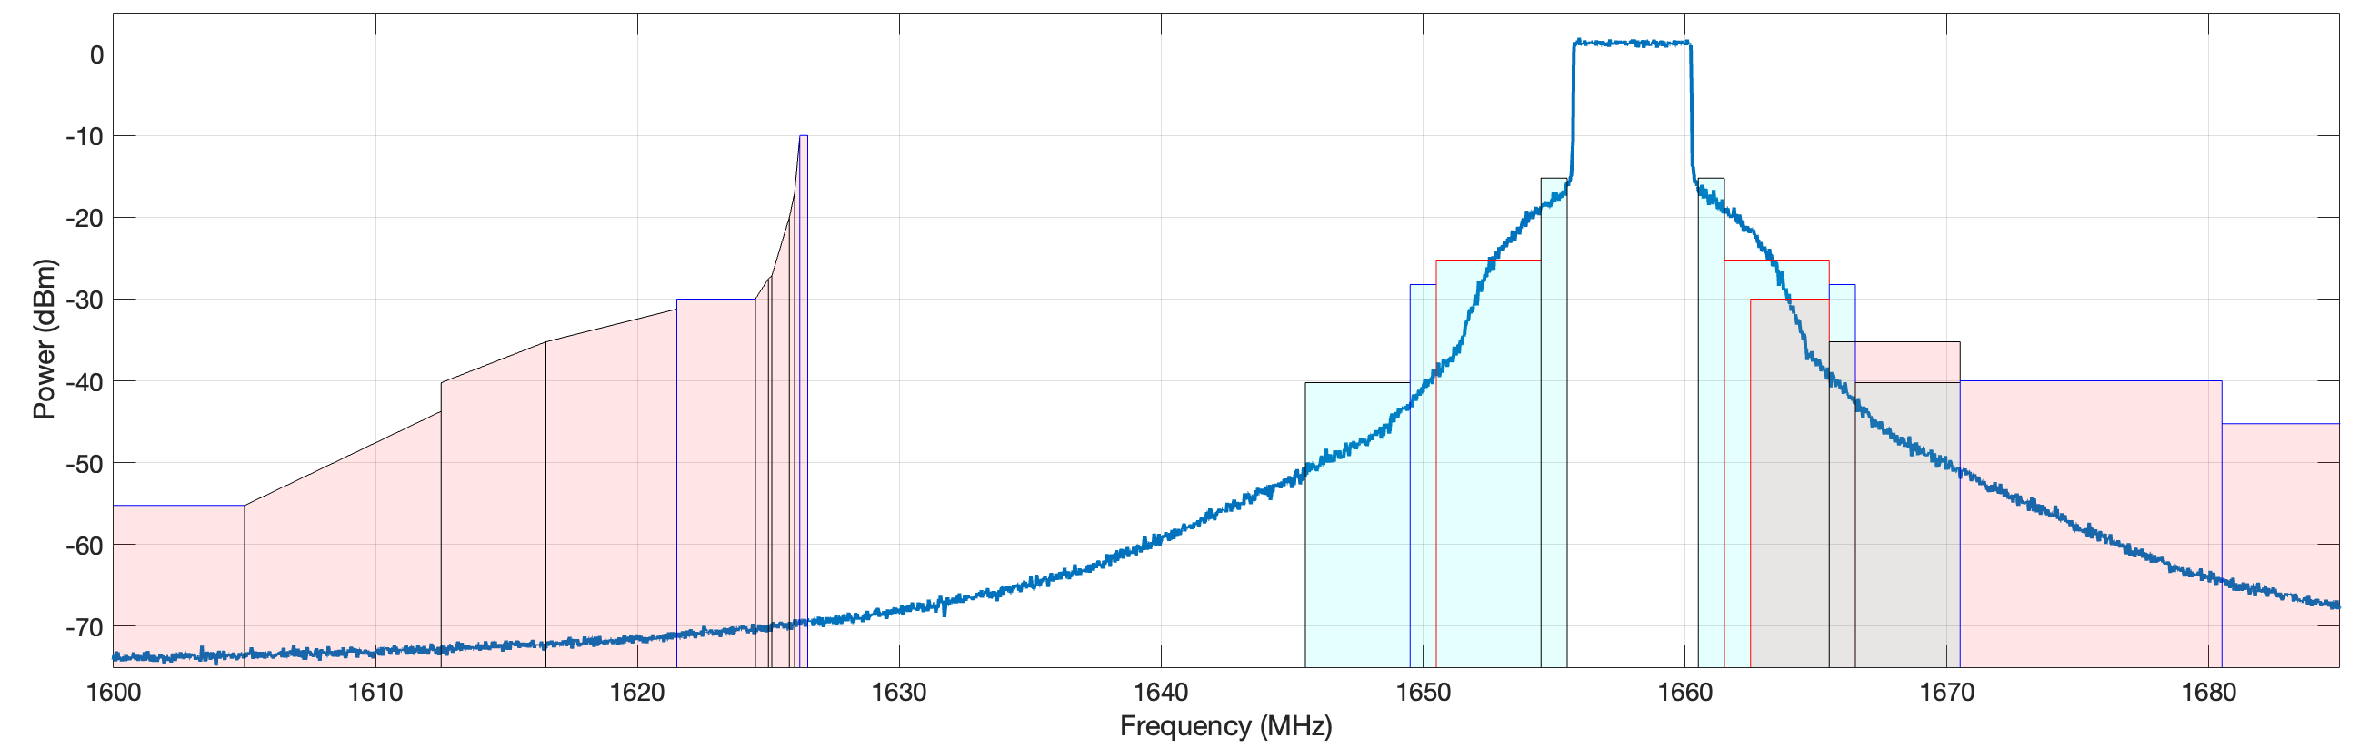
Figure G.1.1.3.1.2-4: Spectrum plot for the 5MHz channel at the left edge (top figure) and right edge (bottom figure) of the band.

For the 10MHz channel, G.1.1.3.1.2-4 presents results for a case when the 10MHz channel resides in the middle of the band; and as can be seen from the figure, no extra A-MPR is needed, i.e. power back-off values are within the MPR margin.
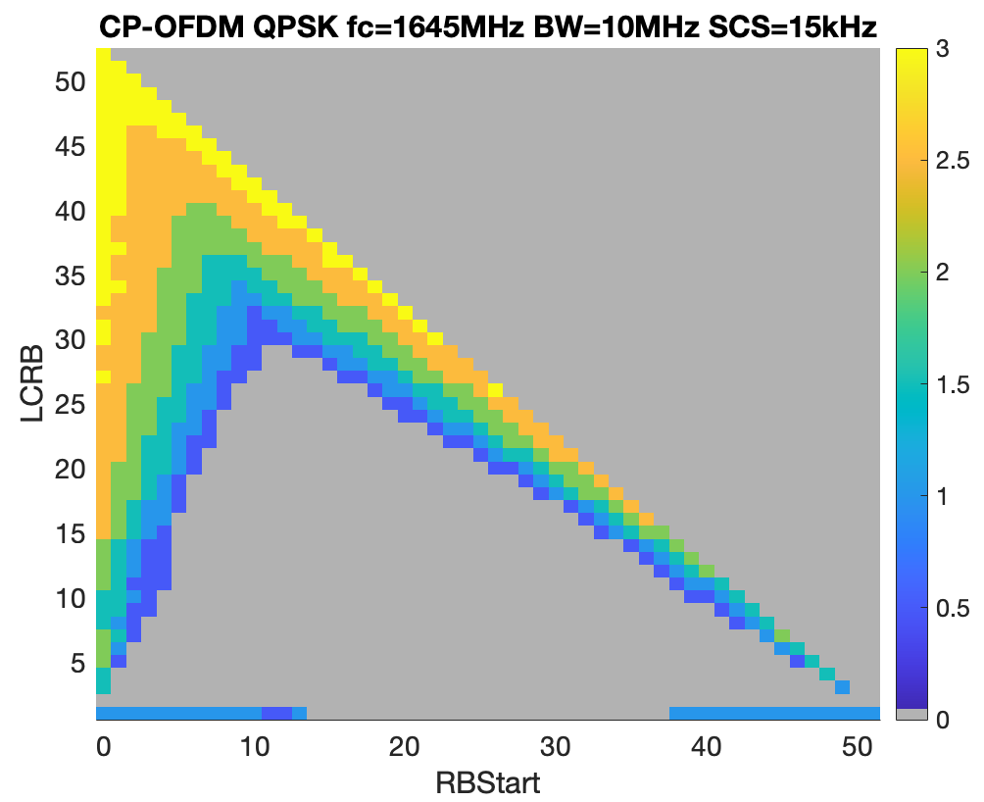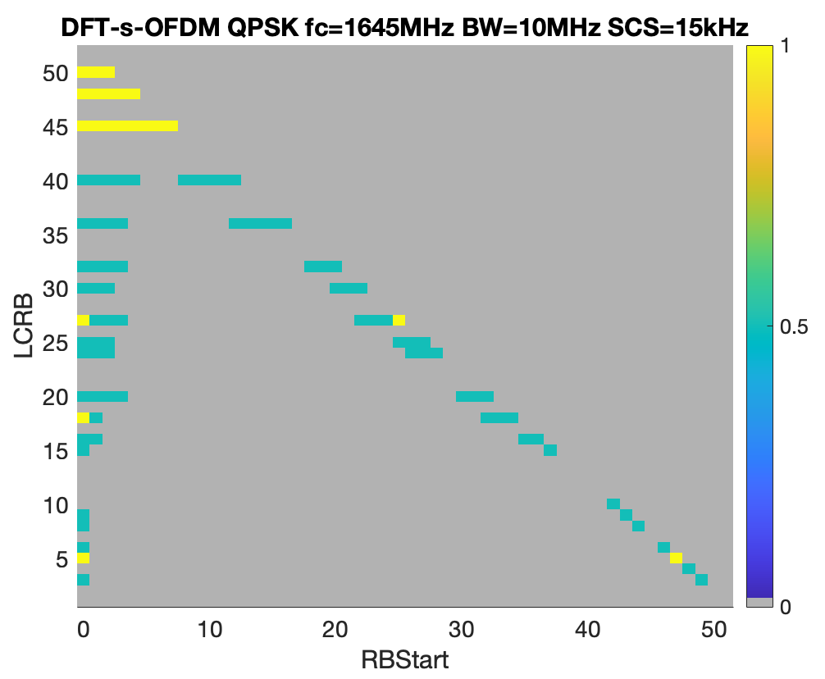
Figure G.1.1.3.1.2-4: Power back-off for CP-OFDM and DFT-s-OFDM (10MHz at Fc=1645MHz)
Figure G.1.1.3.1.2-5 and G.1.1.3.1.2-6 present results for channels residing at the left and the right edges of the band. General observations are similar to the 5MHz channel, the only noticeable difference is that the 10MHz channel at the upper edge of the band requires slightly higher power back-off due to more stringent out-of-band emission requirements.
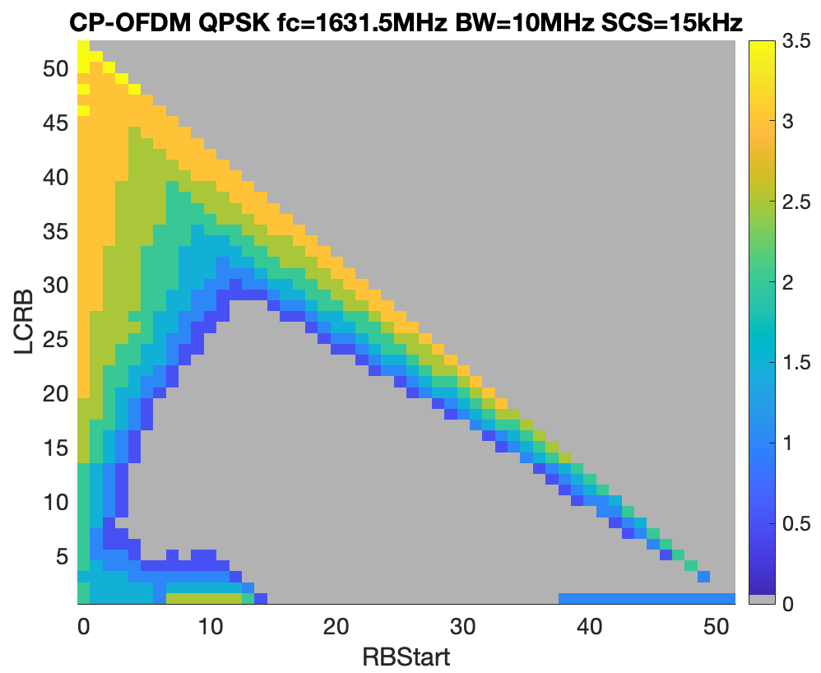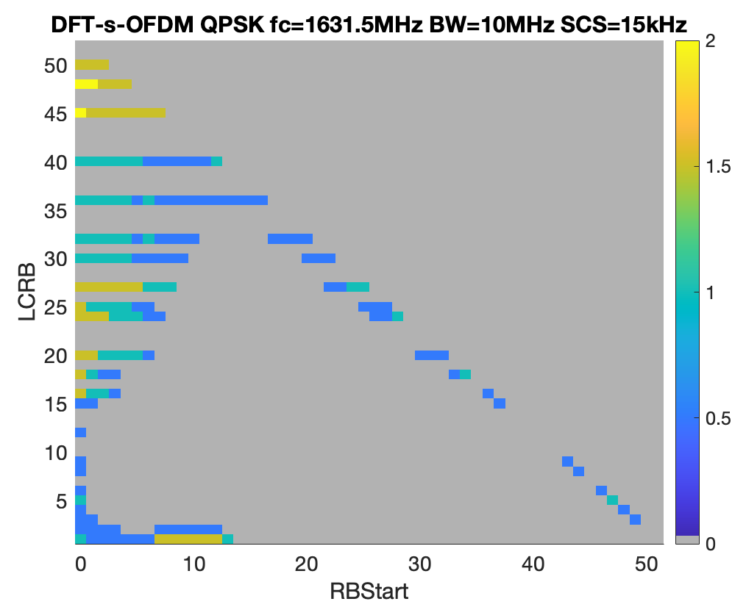
Figure G.1.1.3.1.2-5: Power back-off for CP-OFDM and DFT-s-OFDM (10MHz at Fc=1631.5MHz).

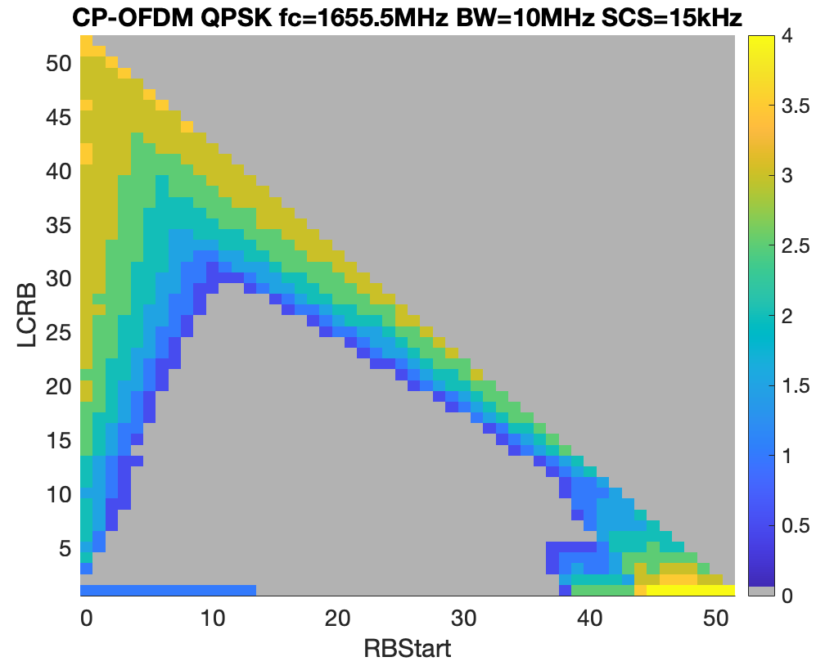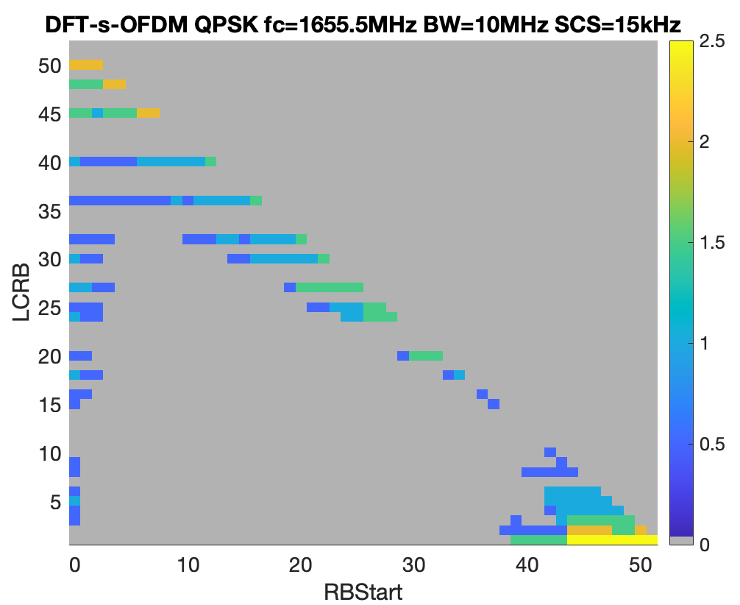
Figure G.1.1.3.1.2-6: Power back-off for CP-OFDM and DFT-s-OFDM (10MHz at Fc=1655.5MHz).

Figure 2.3.1.3-1 presents results for the 15MHz channel located in the middle of the band. Unlike previous cases for the 5 and 10MHz channels, this time extra A-MPR is need because the power back-off values exceed the MPR margin for edge RB allocations.
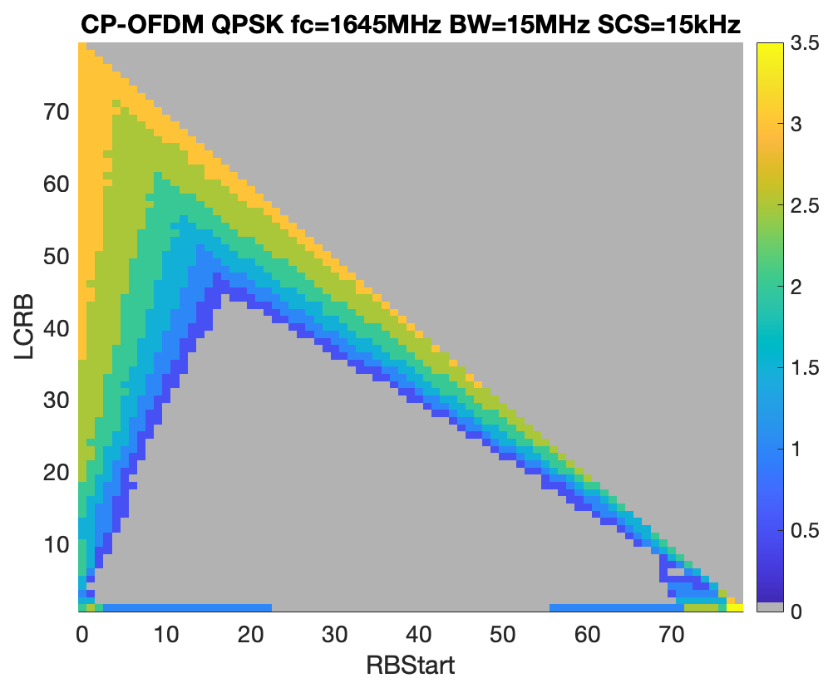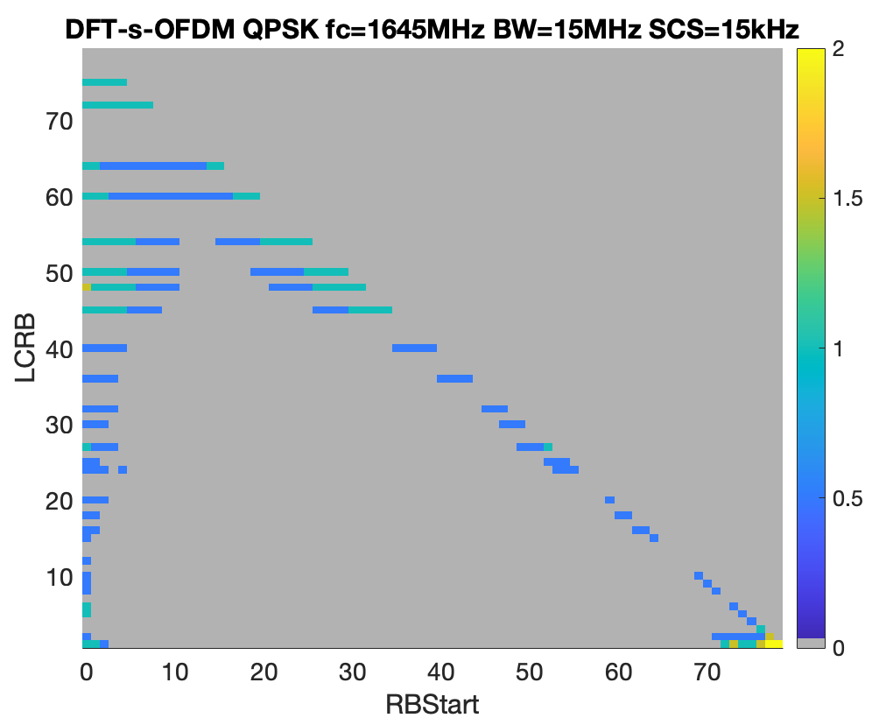
Figure G.1.1.3.1.2-7: Power back-off for CP-OFDM and DFT-s-OFDM (15MHz at Fc=1645MHz).

Power back-off simulation results for the 15MHz channels residing at the band edges are logically identical to the 10MHz results presented above. The 15MHz channel at the upper edge of the band requires even higher power back-off for large allocations and the for the right-most allocations within the band.
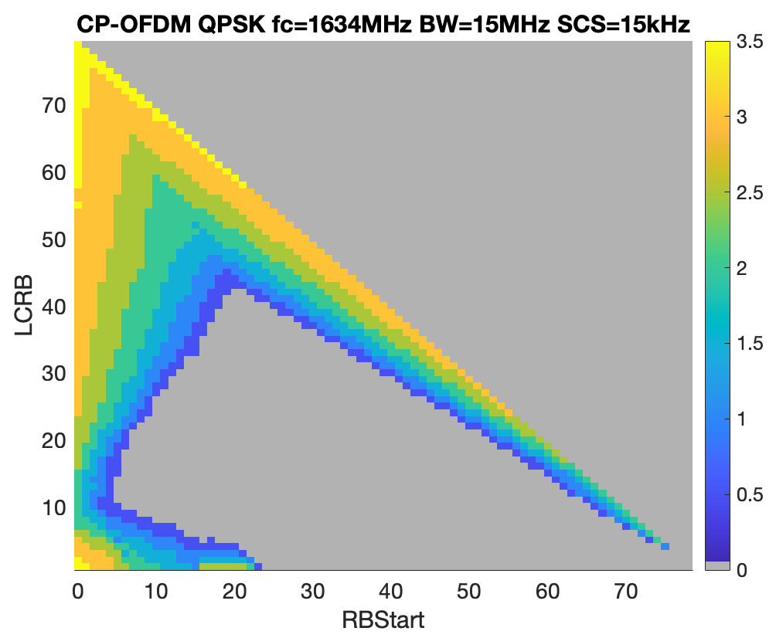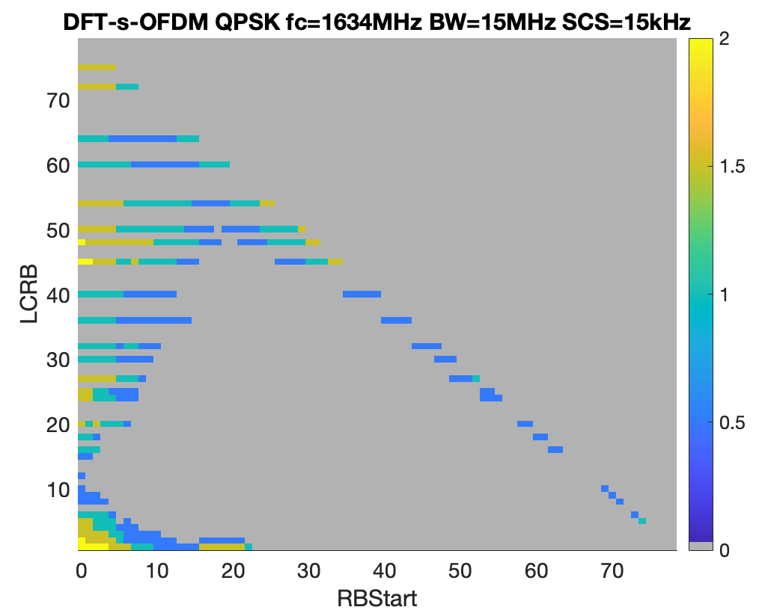
Figure G.1.1.3.1.2-8: Power back-off for CP-OFDM and DFT-s-OFDM (15MHz at Fc=1634MHz).
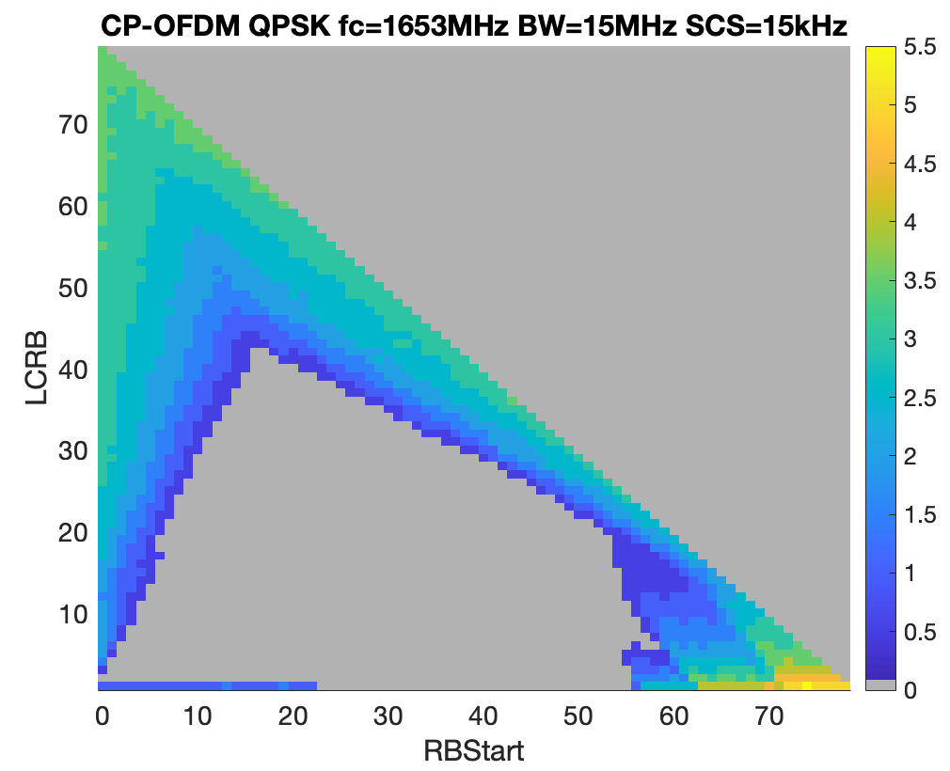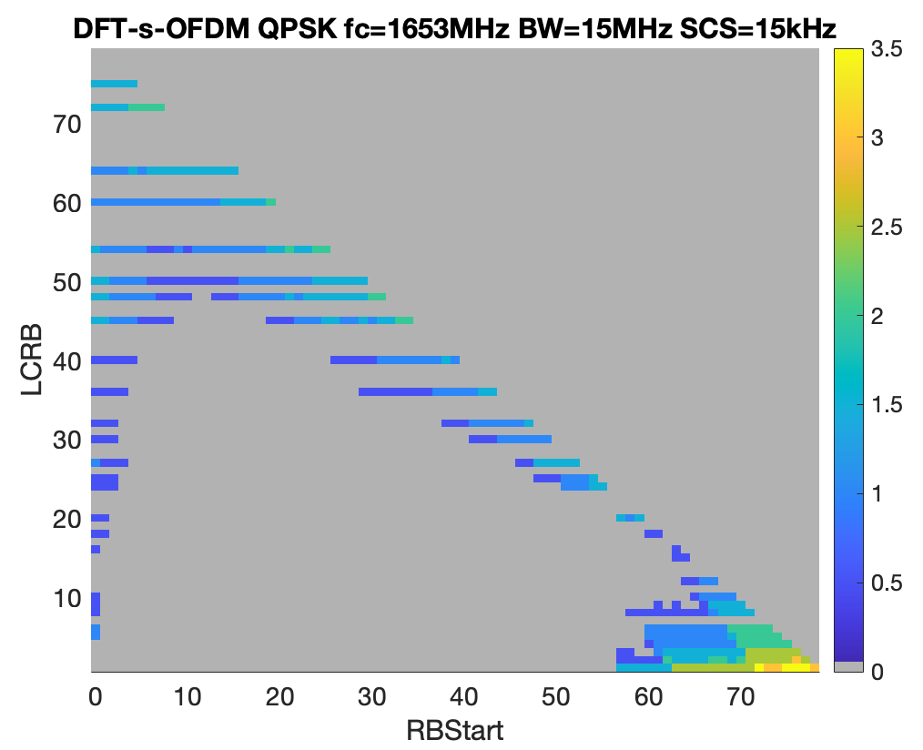
Figure G.1.1.3.1.2-9: Power back-off for CP-OFDM and DFT-s-OFDM (15MHz at Fc=1653MHz).

The 20MHz channel will require even higher power back-off. As can be seen from Figure G.1.1.3.1.2-10, when the 20MHz channel is in the middle of the band, only edge RB allocations need extra A-MPR.
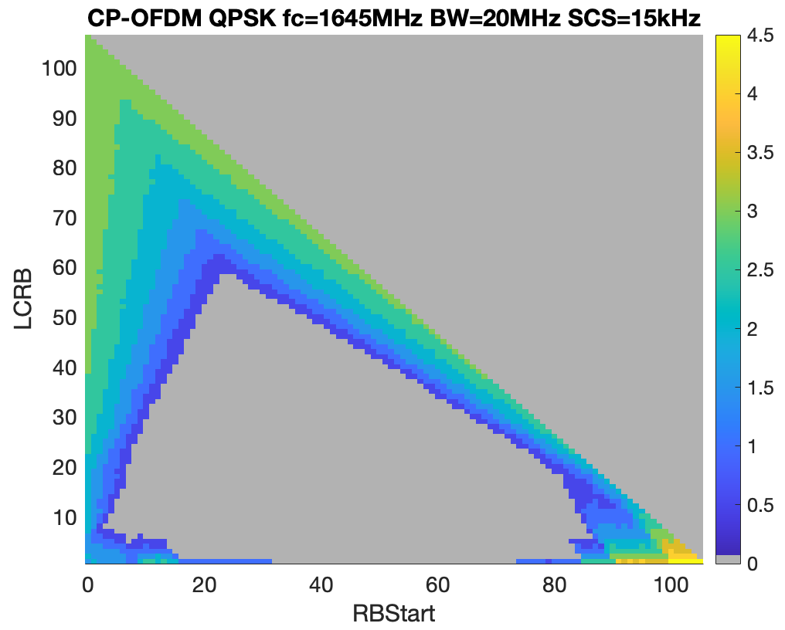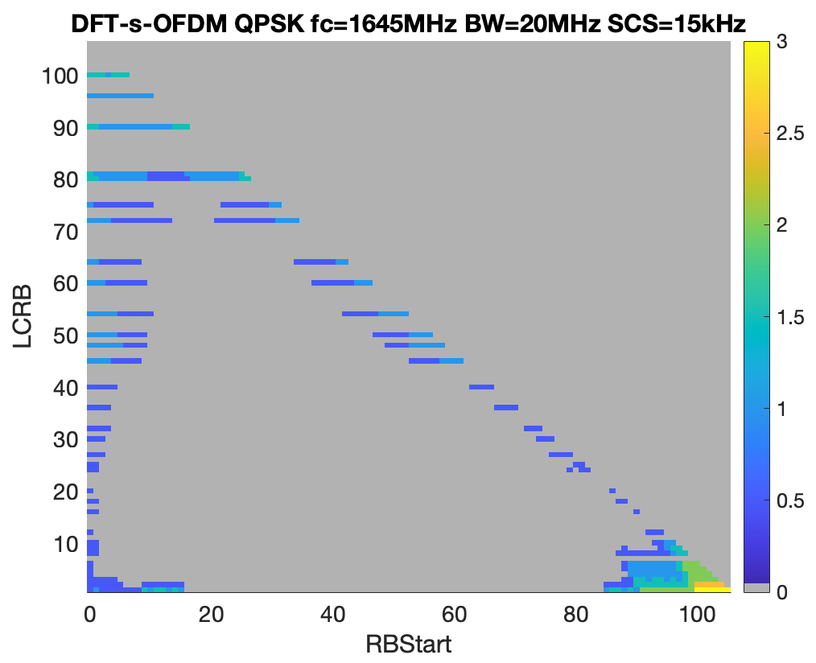
Figure G.1.1.3.1.2-10: Power back-off for CP-OFDM and DFT-s-OFDM (20MHz at Fc=1645MHz).

For the channel at the lower edge of the band, the left-most allocations will need the highest power back-off reaching 5-6.5dB. And similarly, the right-most allocations within the channel at the upper edge of the band will require power back-off in the order of 5.5dB.
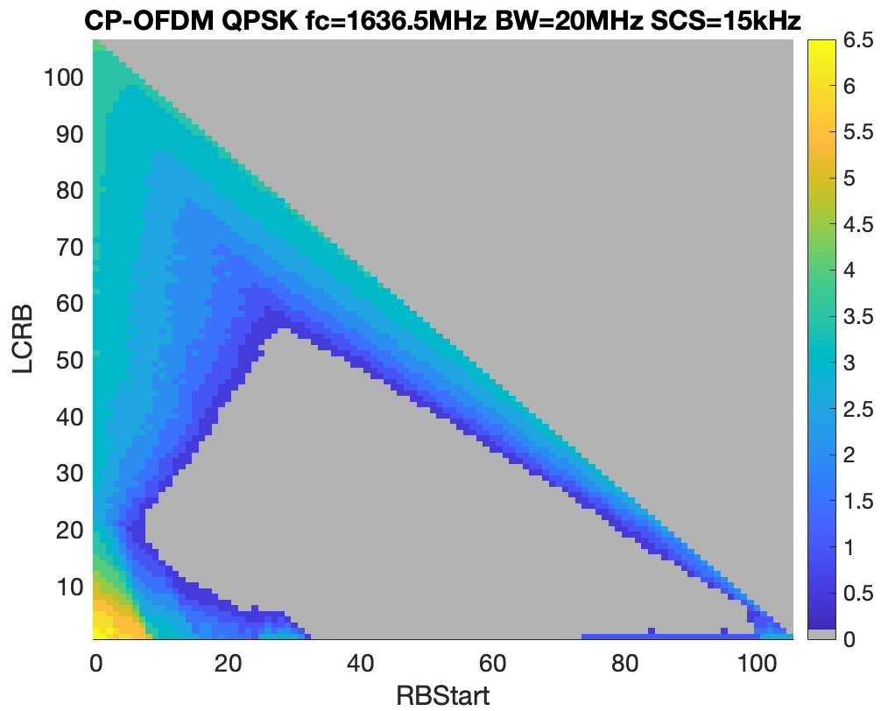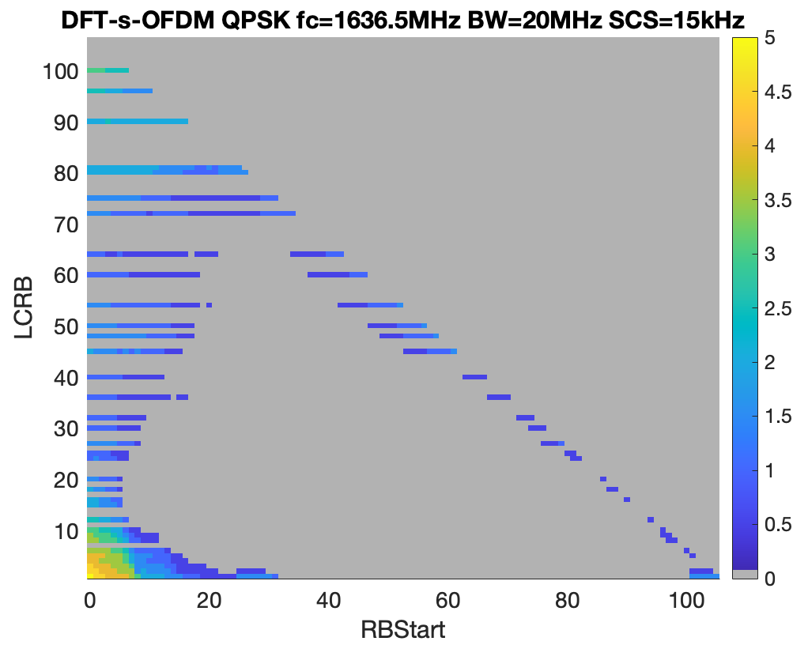
Figure G.1.1.3.1.2-11: Power back-off for CP-OFDM and DFT-s-OFDM (20MHz at Fc=1636.5MHz).

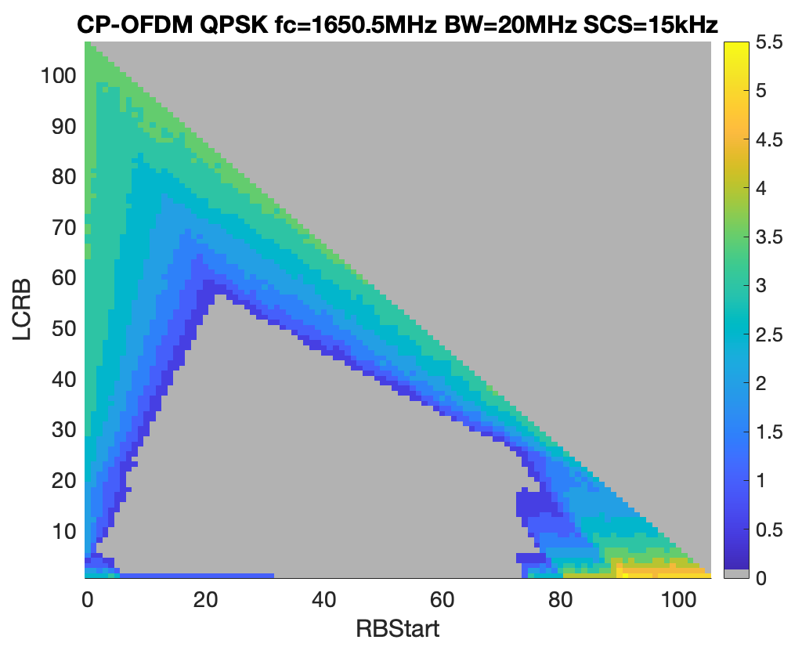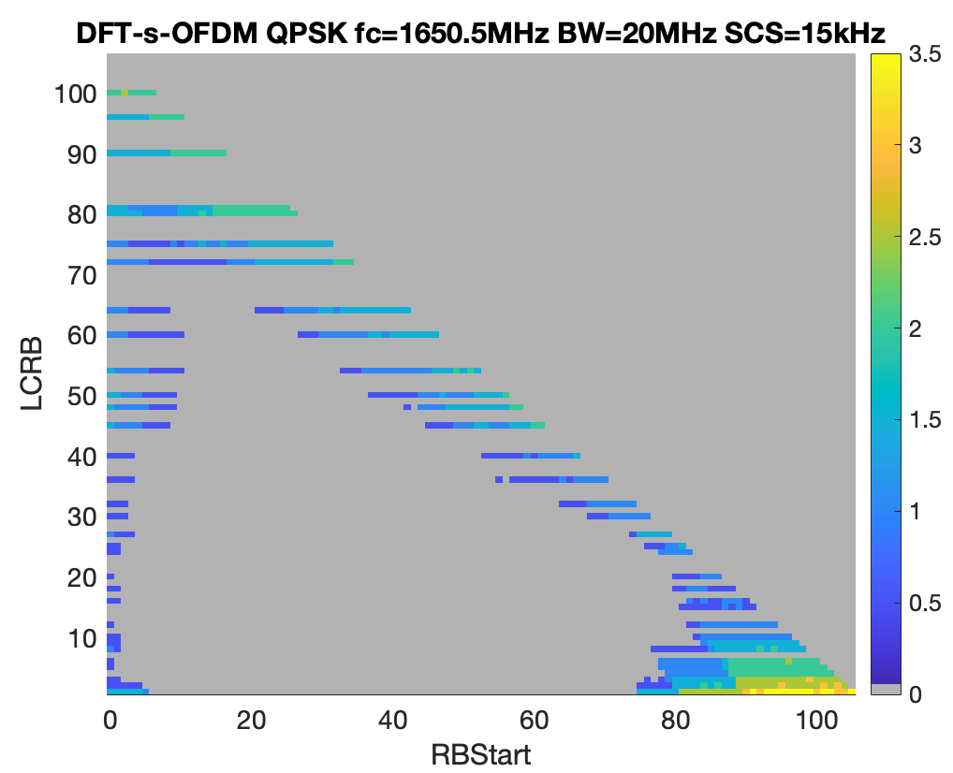
Figure G.1.1.3.1.2-12: Power back-off for CP-OFDM and DFT-s-OFDM (20MHz at Fc=1650.5MHz).

G.1.1.4 NS_14N

G.1.1.4.1 Company A

G.1.1.4.1.1 Simulation assumptions
The following simulation assumptions are used:
- PA calibrated to 1 dB MPR with 30 dBc ACLR with DFT-s-OFDM QPSK 100 RB waveform
- -28 dBc IQ-image
- -28 dBc LO-leakage
- -60 dBc CIM3 and -70 dBc CIM5
Additional emission limits considered in Table G.1.1.4.1.1-1. Only backoff due to additional emissions limits is shown in figures in clause G.1.1.4.1.2.
Table G.1.1.4.1.1-1: Additional emission requirements
Frequency range  (MHz) | Spectrum emission limit¹ (dBm) | Measurement bandwidth | NOTE  (measurement method)
1559 to 1605 | -40 | 1 MHz | Average
1605 to 1612.5 | -40 to -28.5 | 1 MHz | Average
1612.5 to 1616.5 | -25 to -20 | 1 MHz | Average
1616.5 to 1621.5 | -20 to -16 | 1 MHz | Average
1621.5 to 1624.5 | -30 to -27.5 | 30 kHz | Average
1624.5 to 1625.125 | -27.5 to -27.2 | 30 kHz | Average
1625.125 to 1625.8 | -27.2 to -20 | 30 kHz | Average
1625.8 to 1626 | -20 to -17 | 30 kHz | Average
1626 to 1626.2 | -17 to -10 | 30 kHz | Average
1626.2 to 1626.5 | -10 | 30 kHz | Average
NOTE 1: Spectrum emissions are linearly interpolated versus frequency offset.

G.1.1.4.1.2 Simulation results
Only backoff due to additional emissions limits is shown.
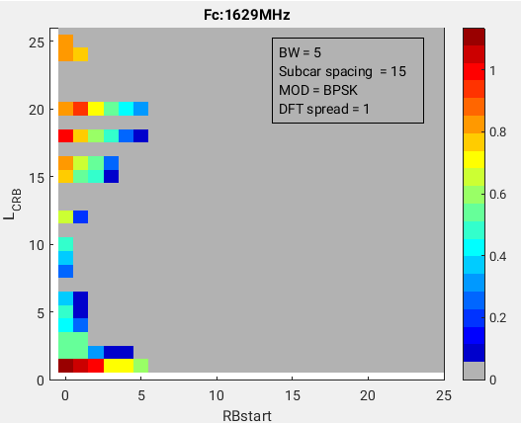 | 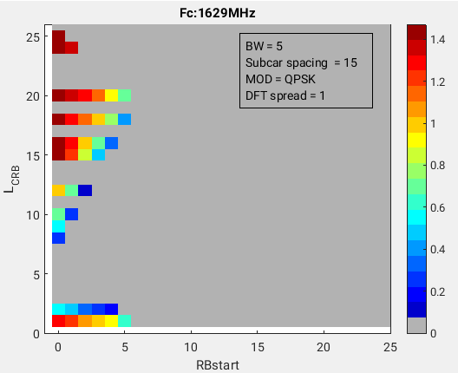
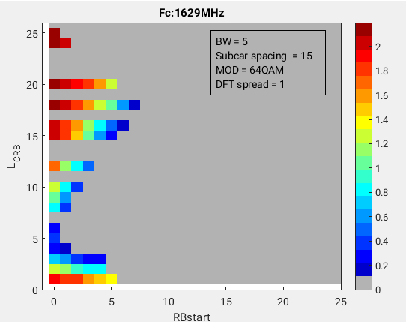 | 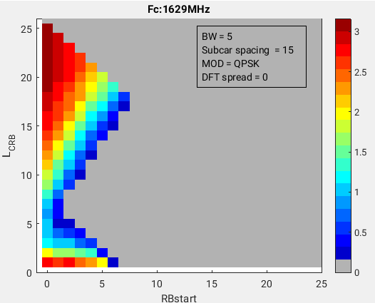

Figure G.1.1.4.1.2-1: 5MHz at Fc=1629MHz.
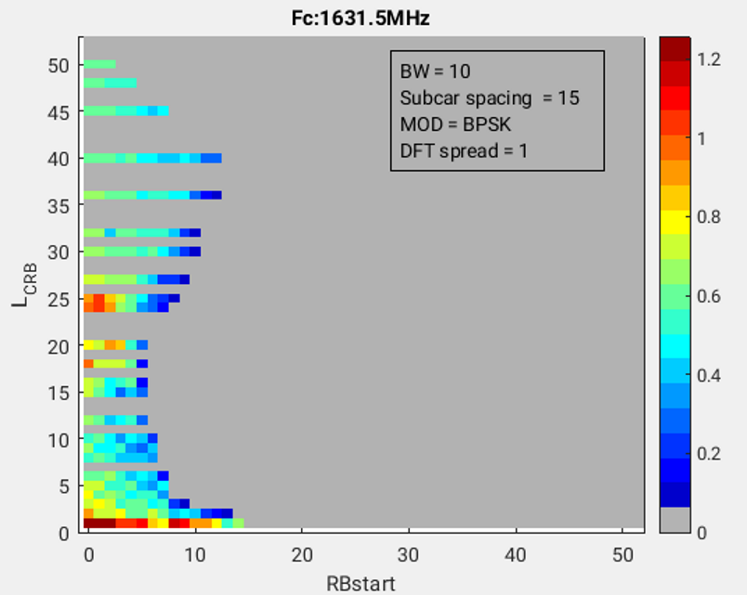 | 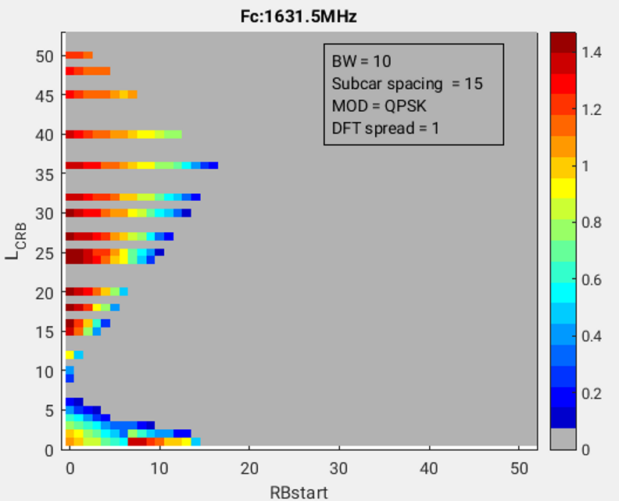
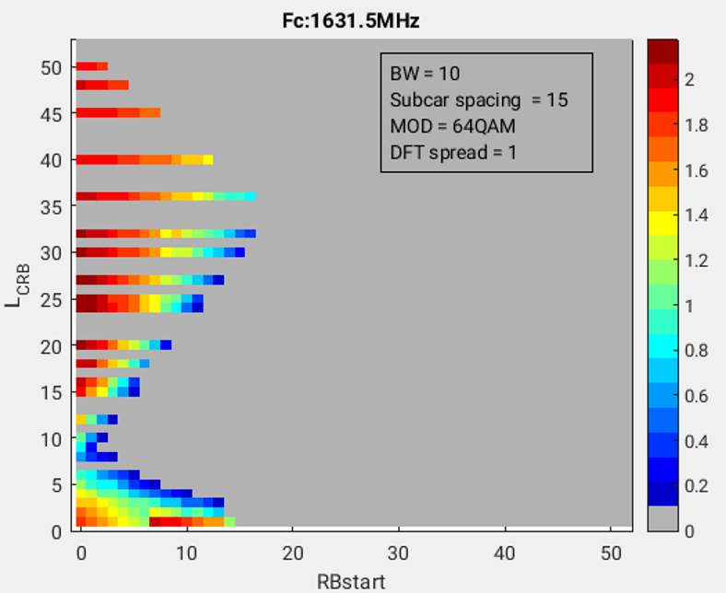 | 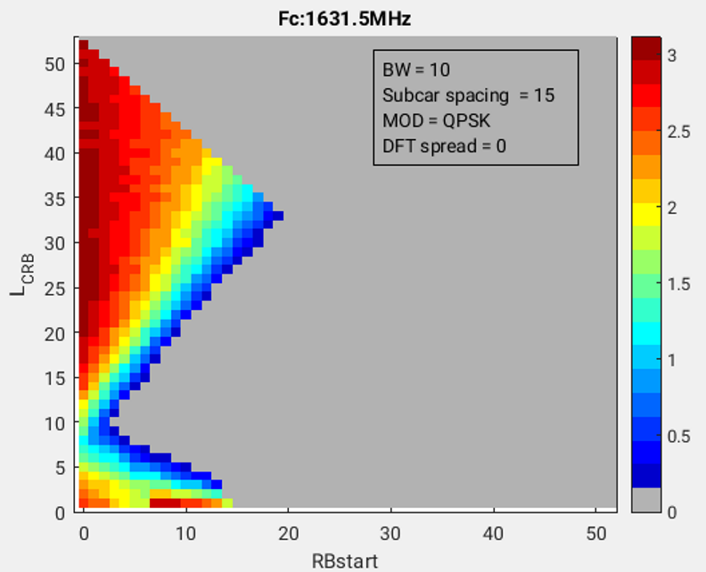

Figure G.1.1.4.1.2-2: 10MHz at Fc=1631.5MHz.

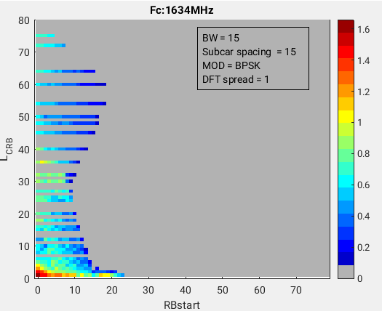 | 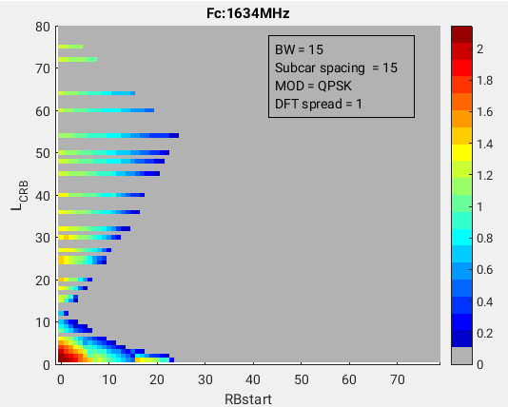
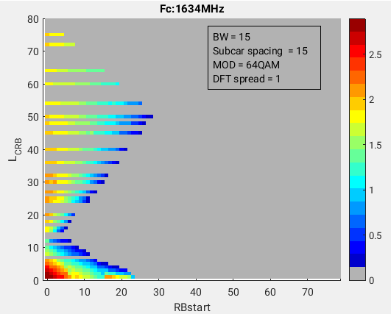 | 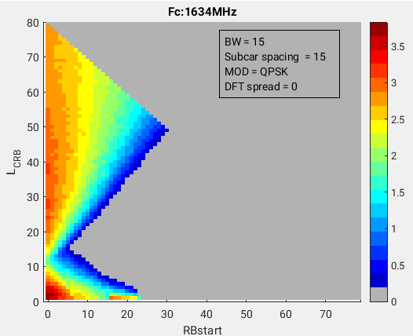

Figure G.1.1.4.1.2-3: 15MHz at Fc=1634MHz.

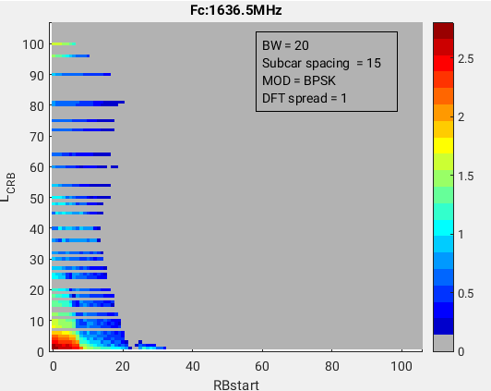 | 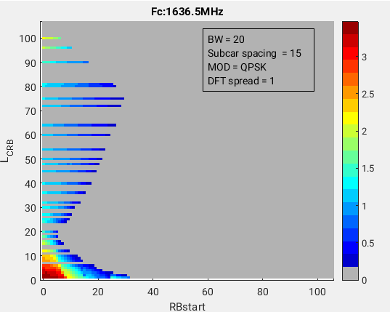
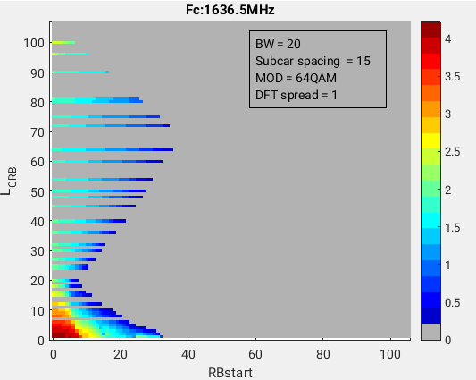 | 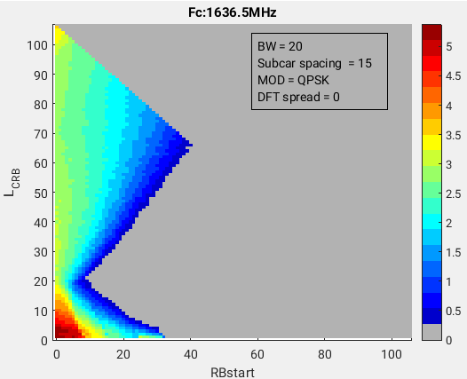

Figure G.1.1.4.1.2-4: 20MHz at Fc=1636.5MHz.

G.2 PC2 power class

G.2.1 General aspects
NOTE: The purpose of the section is to capture general aspects, such as considered UE RF architectures, assumptions, considered regulations, etc.

G.2.1.1 NS_02N

G.2.1.1.1 Company A (Qualcomm/R4-2511400)

G.2.1.1.1.1 Simulation assumptions
The following simulation assumptions are used:
- Tx power: PC2 (26dBm)
- PA calibrated to 1dB MPR with 31dBc ACLR with DFT-s-OFDM QPSK 100 RB waveform
- -28 dBc IQ-image
- -28 dBc LO-leakage
- -60 dBc CIM3 and -70 dBc CIM5

G.2.1.1.1.2 Simulation results
If the 10dB filter rejection is assumed for the frequency range 1559-1610MHz, then a small A-MPR is needed to meet emission requirements. As presented in Table below A-MPR is needed only for the 20MHz channel.
Table G.2.1.1.1.2-1: Proposed A-MPR regions and values.
Channel Bandwidth, MHz | Carrier Centre Frequency, Fc, MHz | RB_{start}*12*SCS  MHz | LCRB*12*SCS  MHz | A-MPR
20MHz | 1636.5 ≤ Fc ≤ 1650.5 | ≤ 0.54 | < 1.08 | A1
20MHz | 1636.5 ≤ Fc ≤ 1650.5 |  | > 14.4 | A1

Modulation/Waveform | A1
 | Outer/Inner
DFT-s-OFDM PI/2 BPSK | ≤ 2.5
DFT-s-OFDM QPSK | ≤ 2.5
DFT-s-OFDM 16 QAM | ≤ 3
DFT-s-OFDM 64 QAM | ≤ 3.5
CP-OFDM QPSK | ≤ 4
CP-OFDM 16 QAM | ≤ 4
CP-OFDM 64 QAM | ≤ 4

G.2.1.1.2 Company B (OPPO/R4-2510521)

G.2.1.1.2.1 Simulation assumptions
Simulation assumptions are as follows:
- PC2 power class
- 10, 15 and 20MHz channels residing at the lowest edge of the uplink operating band n255
- CP-OFDM and DFT-s-OFDM
- both cases, with and without 10dB filter attenuation are considered

G.2.1.1.2.2 Simulation results
To check the effect of filter rejection, power back-off results are presented for the 10, 15 and 20MHz channels with PC2 CP-OFDM QPSK using APT PA w/o filter rejection and with a constant 10 dBfilter attenuation at the frequencies 1559-1610 MHI. In the following figures, A-MPR and "A-MPR – MPR" simulation results are provided separately, i.e. "A-MPR – MPR" figres show the difference between required power back-off and existing MPR margings.
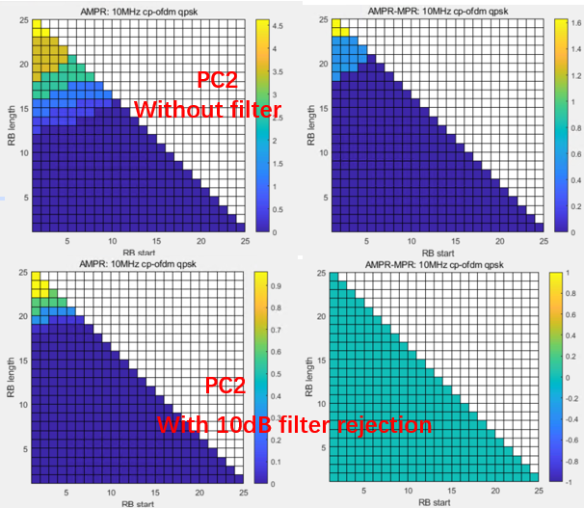
Figure G.2.1.1.2.2-1: Power back-off change for 10MHz based on a constant 10dB filter rejection using APT PA
From Figure G.2.1.1.2.2-1 for the 10MHz channel it can be seen that:
- For PC2 without filter isolation, the AMPR region starts at LCRB>16RB and the largest AMPR value is around 4.5dB and even larger.
- For PC2 with 10dB filter isolation, we can see that required power back-off is smaller than the existing MPR margin, i.e. there is no need to define A-MPR for 10MHz channel bandwidth.

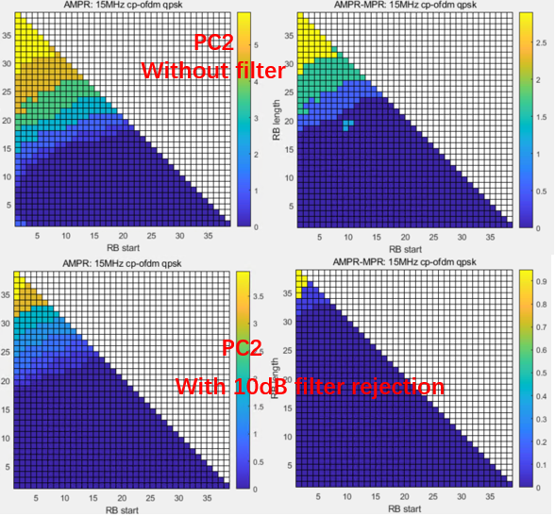
Figure G.2.1.1.2.2-2: Power back-off change for 15MHz based on a constant 10dB filter rejection using APT PA
From Figure G.2.1.1.2.2-2 for the 15MHz channel it can be seen that:
- The A-MPR regions with the 10dB filter isolation becomes smaller than the A-MPR regions without filter isolation, but the overall required power back-off is still larger than MPR.
- For PC2 with the 10dB filter isolation, the AMPR region starts building at LCRB>30RB, whereupon the largest power back-off is larger than 3.5 dB.

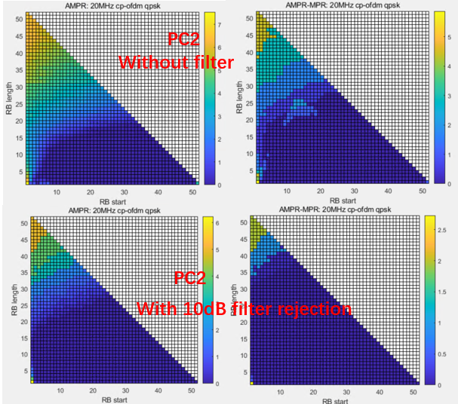
Figure G.2.1.1.2.2-3: Power back-off change for 20MHz based on a constant 10dB filter rejection using APT PA
From Figure G.2.1.1.2.2-3 for the 20MHz channel it can be seen that:
- The A-MPR region with the 10dB filter isolation becomes smaller than the AMPR region without filter isolation, but the required power back-off is larger than MPR.
- For PC2 with the 10dB filter isolation, the AMPR region starts at LCRB>34RB, and the required power back-off is larger than 6dB.

In addition to the above results, Figure G.2.1.1.2.2-4 and G.2.1.1.2.2-5 below presents additional results for the CP-OFDM and DFT-s-OFDM for the 15MHz channel with different modulations.
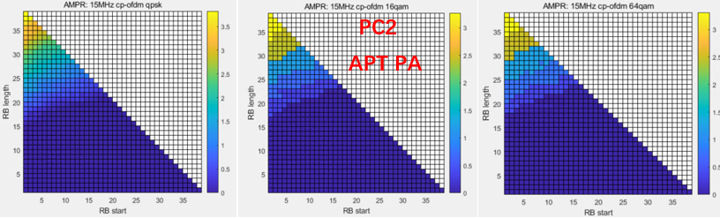
Figure G.2.1.1.2.2-4: Power back-off for 15MHz CP-OFDM QPSK, 16QAM and 64QAM.
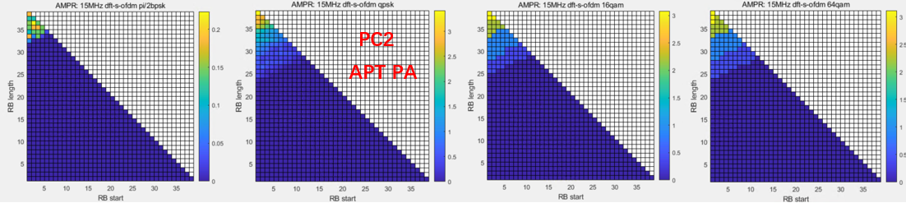
Figure G.2.1.1.2.2-5: Power back-off for 15MHz DFT-s-OFDM PI/2 BPSK, QPSK, 16QAM and 64QAM.
From Figure G.2.1.1.2.2-4 and Figure G.2.1.1.2.2-5 it can be seen that:
- The A-MPR regions and the A-MPR values are almost the same for different modulations for both of CP-OFDM and DFT-s-OFDM.
Considering presented results and the 10dB filter rejection, PC2 A-MPR may look as presented in the table below.
Table G.2.1.1.2.2-1: Proposed A-MPR regions and values
Channel Bandwidth, MHz | Carrier Centre Frequency, Fc, MHz | RBstart*12*SCS  MHz | LCRB*12*SCS  MHz | A-MPR
15MHz | 1634 < Fc ≤ 1649 |  | >10.8 | A1
20MHz | 1636.5 < Fc ≤ 1650.5 |  | >10.8 | A2
20MHz | 1636.5 < Fc ≤ 1650.5 | <0.54 | <1.8 | A2

Modulation |  | A1 | A2
DFT-s-OFDM | Pi/2 BPSK | ≤ 0.5 | ≤ 3
DFT-s-OFDM | QPSK/16QAM/64QAM | ≤ 3.5 | ≤ 6
CP-OFDM | QPSK/16QAM/64QAM | ≤ 4 | ≤ 6.5

G.2.1.1.3 Company C (LGE/R4-2510776)

G.2.1.1.3.1 Simulation assumptions
Simulation assumptions are as follows:
- PC2 power class
- 5, 10, 15 and 20MHz channels in the frequency range of 1629-1654MHz
- DFT-s-OFDM QPSK
- both cases, with and without 10dB filter attenuation are considered

G.2.1.1.3.2 Simulation results
Table below presents required power back-off values for two cases with and without 10dB filter rejection. According to the simulation results, there is only one case without the 10dB filter at 20 MHz bandwidth and center frequency of 1636.5MHz (RBstart: 0, LCRB: 51) requires A-MPR driven by the NS_02N limit. In all other cases, power back-off is determined by factors other than NS_02N, such as ACLR or SEM. Furthermore, when the 10 dB filtering is applied, none of the scenarios require A-MPR driven by NS_02N.

Table G.2.1.1.3.2-1: Summary of A-MPR simulations for DFT-s-OFDM QPSK.
Channel bandwidth | Frequency range | (RB_start, LCRB)
5MHz | 1629 < Fc ≤ 1654 | (0,11) | (0,1)
PC2 W/O 10dB |  | 0 | 1.47
PC2 W 10dB |  | 0 | 1.47
10MHz | 1631.5 < Fc ≤ 1641.5 | (0,24) | (0,1)
PC2 W/O 10dB |  | 0 | 2.09
PC2 W 10dB |  | 0 | 2.09
10MHz | 1641.5 < Fc ≤ 1655.5 | (0,24) | (0,1)
PC2 W/O 10dB |  | 0 | 2.03
PC2 W 10dB |  | 0 | 2.03
15MHz | 1634 < Fc ≤ 1649 | (0,38) | (0,1)
PC2 W/O 10dB |  | 0.31 | 4.03
PC2 W 10dB |  | 0.31 | 4.03
15MHz | 1649 < Fc ≤ 1653 | (0,38) | (0,1)
PC2 W/O 10dB |  | 0.34 | 4.16
PC2 W 10dB |  | 0.34 | 4.16
20MHz | 1636.5 < Fc ≤ 1640.5 | (0,19) | (0,51) | (0,1) | (50,1)
PC2 W/O 10dB |  | 0 | 1.19 | 3.69 | 3.28
PC2 W 10dB |  | 0 | 0.38 | 3.69 | 3.28
20MHz | 1640.5 < Fc ≤ 1650.5 | (0,38) | (0,1) | (0,1) | (50,1)
PC2 W/O 10dB |  | 0 | 0.38 | 3.72 | 3.09
PC2 W 10dB |  | 0 | 0.38 | 3.72 | 3.09

Additionally, further simulations are conducted as shown below to determine the required A-MPR region for the 20MHz channel bandwidth. Accordin to these results A-MPR would be needed for scenarios from (0,51) to (0,45).
Table G.2.1.1.3.2-2: Further results for the 20MHz channel at 1636.5 < Fc ≤ 1640.5.
Channel | (RB start, LCRB)
20MHz | (0,51) | (0,49) | (0,47) | (0,45) | (0,43) | (0,41) | (0,39) | (0,37)
DFT-s-OFDM QPSK | 1.19 | 0.97 | 0.72 | 0.41 | 0.34 | 0.38 | 0.41 | 0.41

Based on the presented results potential A-MPR definitions may look as follows.
Table G.2.1.1.3.2-3: Proposed A-MPR regions and values
Channel Bandwidth, MHz | Carrier Centre Frequency, Fc, MHz | Region A
 |  | RBend*12*SCS  MHz | LCRB*12*SCS  MHz | A-MPR
20MHz | 1636.5 < Fc ≤ 1640.5 |  | >16.2 | A1

Modulation/Waveform | A1
 | Outer/Inner
DFT-s-OFDM PI/2 BPSK | 1.19
DFT-s-OFDM QPSK | 1.19
DFT-s-OFDM 16 QAM | 1.41
DFT-s-OFDM 64 QAM | 1.44
CP-OFDM QPSK | 1.91
CP-OFDM 16 QAM | 1.94
CP-OFDM 64 QAM | 1.91

G.2.1.1.4 Company D (Apple/R4-2509536)

G.2.1.1.4.1 Simulation assumptions
Simulation assumptions are as follows:
- Tx power: PC2 (+26dBm)
- Calibration: 1dB MPR with 31dBc ACLR and DFT-s-OFDM QPSK 20MHz 100RB0
- Carrier leakage: -28dBc
- Image: -28dBc
- CIM3: -60dBc
- CIM5: -70dBc
- LO placement: always in the centre of the carrier
- Regulations: Requirements from NS_02N
- 10dB filter rejection is assumed
For the sake of brevity, simulations are considered for the 5, 10, 15 and 20MHz channel bandwidths, whereupon the corresponding channel is always located at the lower edge of the n255 band:
- 5MHz: Fc=1629MHz
- 10MHz: Fc=1631.5MHz
- 15MHz: Fc=1634MHz
- 20MHz: Fc=1636.5MHz

G.2.1.1.4.2 Simulation results
According to the preliminary simulation results, no additional power back-off is needed for the 5 and 10MHz channel bandwidths. Thus, the corresponding figures for these channel bandwidths will not be presented.
As for the 15 and 20MHz channels, some power back-off is needed as can be seen from figures below. Nevertheless, the 15MHz channel power back-off is quite marginal and is within the existing MPR margins. As for the 20MHz channel, it naturally experiences higher power back-off, which in some cases reaches existing MPR margins, especially for the full channel and single RB edge allocations.

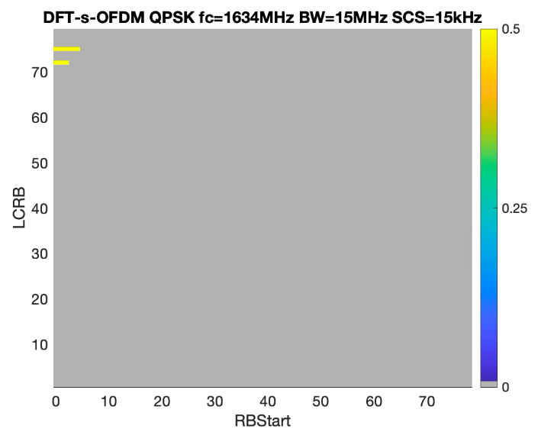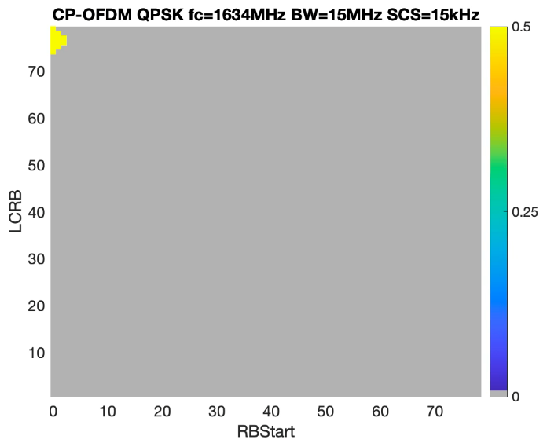
Figure G.2.1.1.4.2-1: Power back-off results for 15MHz at Fc=1634MHI.

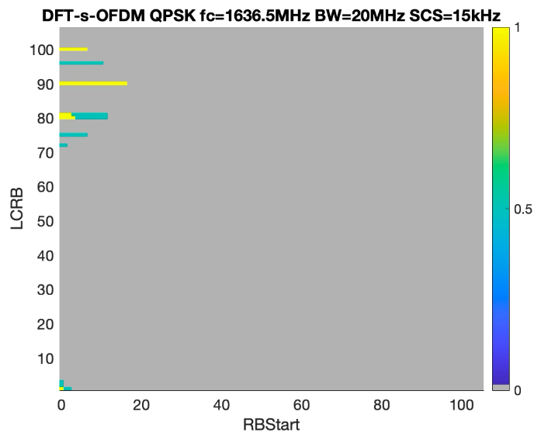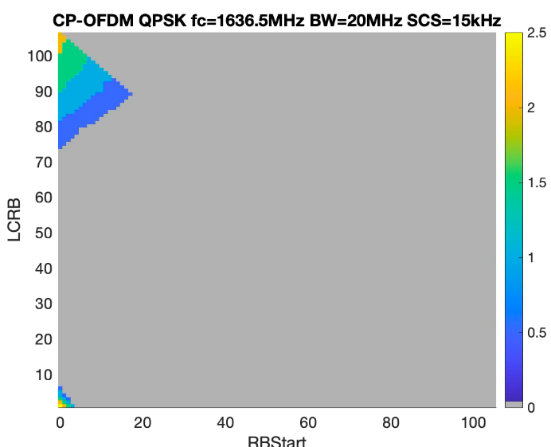
Figure G.2.1.1.4.2-2: Power back-off results for 20MHz at Fc=1636.5MHI.
Based on the presented results it is not likely that 15MHz channel needs A-MPR. As for the 20MHz channel, small A-MPR can be considered for large allocations.

G.3 PC1.5 power class

G.3.1: General aspects
NOTE: The purpose of the section is to capture general aspects, such as considered UE RF architectures, assumptions, considered regulations, etc.

G.3.1.1 NS_02N

G.3.1.1.1 Company B (OPPO/ R4-2510521)

G.3.1.1.1.1 Simulation assumptions
The following simulation assumptions are used:
- PC1.5 power class with 2Tx
- 10, 15 and 20MHz channels residing at the lowest edge of the uplink operating band n255
- CP-OFDM and DFT-s-OFDM
- without 10dB filter attenuation

G.3.1.1.1.2 Simulation results
Figure G.3.1.1.1.2-1 and Figure G.3.1.1.1.2-2 show the AMPR and AMPR-MPR simulation results for CP-OFDM and DFT-s-OFDM with QPSK for 15MHz and 20MHz sepatatelH.
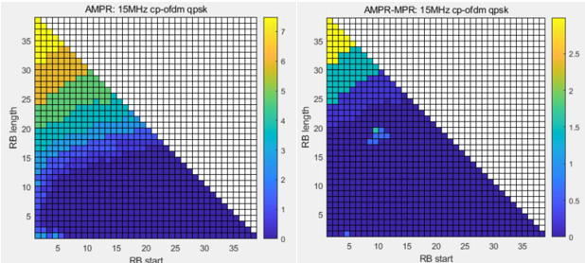
Figure G.3.1.1.1.2-1: Power back-off change for 15MHz without filter rejection using APT PA

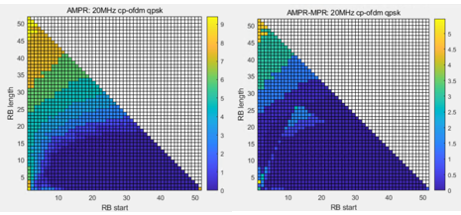
Figure G.3.1.1.1.2-2: Power back-off change for 20MHz without filter rejection using APT PA
From Figure G.3.1.1.1.2-1 for the 15MHz channel it can be seen that:
- For PC1.5 without filter isolation, the AMPR region is at LCRB>15RB, and the largest AMPR is almost 7.5 dB.
From Figure G.3.1.1.1.2-2 for the 20MHz channel we can find that:
- For PC1.5 without filter isolation, the largest AMPR is almost 9.5 dB for the AMPR region at LCRB>15RBs. And the AMPR region of LCRB<15RBs and RBstart<3RBs.
In additional, due to time limitation, we didn’t do the simulation with 10dB filter isolation totally, we just simulated the AMPR for the point of (RBstart=0, LCRB=52) with 10dB filter isolation, the AMPR with 10dB filter isolation is smaller 1.5dB than the AMPR value without filter isolation.
If the 10dB filter rejection is assumed for the frequency range 1559-1610MHz, PC1.5 A-MPR presents in the table below:
Table G.3.1.1.1.2-1: Proposed A-MPR regions and values.
Channel Bandwidth, MHz | Carrier Centre Frequency, Fc, MHz | RBstart*12*SCS  MHz | LCRB*12*SCS  MHz | A-MPR
20MHz | 1636.5 ≤ Fc ≤ 1650.5 | ≤ 0.54 | < 1.08 | A1
20MHz | 1636.5 ≤ Fc ≤ 1650.5 |  | > 14.4 | A1
20MHz | 1636.5 ≤ Fc ≤ 1650.5 |  | > 10.8, ≤ 14.4 | A2
15MHz | 1634 ≤ Fc ≤ 1645 |  | > 10.8 | A2

Modulation/Waveform | A1 | A2
 | Outer/Inner | Outer/Inner
DFT-s-OFDM PI/2 BPSK | ≤ 8 | ≤ 4
DFT-s-OFDM QPSK | ≤ 8 | ≤ 4
DFT-s-OFDM 16 QAM | ≤ 8 | ≤ 4
DFT-s-OFDM 64 QAM | ≤ 8 | ≤ 4
CP-OFDM QPSK | ≤ 8 | ≤ 6
CP-OFDM 16 QAM | ≤ 8 | ≤ 6
CP-OFDM 64 QAM | ≤ 8 | ≤ 6

G.4 PC1 power class

G.4.1 General aspects
NOTE: The purpose of the section is to capture general aspects, such as considered UE RF architectures, assumptions, considered regulations, etc.

G.4.1.1 NS_02N

G.4.1.1.1 Company A (Qualcomm/R4-2511400)

G.4.1.1.1.1 Simulation assumptions
The following simulation assumptions are used:
- Tx power: PC1 (31dBm) with 4TX
- PA calibrated to 1dB MPR with 34dBc ACLR with DFT-s-OFDM QPSK 100 RB waveform
- -28 dBc IQ-image
- -28 dBc LO-leakage
- -60 dBc CIM3 and -70 dBc CIM5

G.4.1.1.1.2 Simulation results
If the 10dB filter rejection is assumed for the frequency range 1559-1610MHz, then a small A-MPR is needed to meet emission requirements. As presented in Table below A-MPR is needed only for the 20MHz channel.
Table G.4.1.1.1.2-1: Proposed A-MPR regions and values.
Channel Bandwidth, MHz | Carrier Centre Frequency, Fc, MHz | RBstart*12*SCS  MHz | LCRB*12*SCS  MHz | A-MPR
20MHz | 1636.5 ≤ Fc ≤ 1650.5 | ≤ 0.54 | < 1.08 | A1
20MHz | 1636.5 ≤ Fc ≤ 1650.5 |  | > 14.4 | A1
20MHz | 1636.5 ≤ Fc ≤ 1650.5 |  | > 10.8, ≤ 14.4 | A2
15MHz | 1634 ≤ Fc ≤ 1645 |  | > 10.8 | A2

Modulation/Waveform | A1 | A2
 | Outer/Inner | Outer/Inner
DFT-s-OFDM PI/2 BPSK | ≤ 5 | ≤ 3
DFT-s-OFDM QPSK | ≤ 5 | ≤ 3
DFT-s-OFDM 16 QAM | ≤ 5 | ≤ 3.5
DFT-s-OFDM 64 QAM | ≤ 5.5 | ≤ 4
CP-OFDM QPSK | ≤ 6 | ≤ 4
CP-OFDM 16 QAM | ≤ 6 | ≤ 4
CP-OFDM 64 QAM | ≤ 6 | ≤ 4

Annex H:
Summary of NTN HPUE simulation results
All NTN HPUE co-existence study results have been captured in the list. Please see attachment Summary of NTN HPUE simulation results.

Annex I (informative):
Change history
Change history
Date | Meeting | TDoc | CR | Rev | Cat | Subject/Comment | New version
2021-11 | RAN4# 101-e | R4-2120776 |  |  |  | Added approved TPs in RAN4#101-e including:  R4-2120759, draft TP to TR 38.863: Operating bands and channel arrangements  R4-2120760, TP for 38.863 on system parameters on satellite bands  R4-2120761,TP to TR 38.863 – Regulatory aspects  R4-2120762, TP to TR 38.863: node class, RF RX (6.2)  R4-2120763, TP for 38.863 on NTN UE transmission characteristics  R4-2120772, Draft text proposal to update TR 38.863 NTN related RF and co-existence aspects | 0.1.0
2022-01 | RAN4#101-bis-e |  |  |  |  | Added approved TPs in RAN4#101-bis-e including:  R4-2201257, TP for 38.863 on system parameters to clarify “NTN satellite bands”  R4-2201838, Draft proposal to update TR 38.863 NTN related RF and co-existence aspects  R4-2202988, Draft Text Proposal for TR 38.863  R4-2203037, TP for 38.863 on UE transmission characteristics for satellite access  R4-2203038, TP for 38.863 on maximum input level for NTN UE  R4-2203039, TP for 38.863 on UE Receiver characteristics for satellite access  R4-2203040, TP to TR 38.863 on transmitter characteristics for satellite access node  R4-2203081, Draft text proposal to update TR 38.863 Chapter 3  R4-2203082, TP to TR 38.863 on channel raster and sync raster  R4-2203084, TP to TR 38.863 Regulatory aspects for HAPS  R4-2203085, TP to TR 38.863 on general aspects  R4-2203129, TP to TR 38.863 – Regulatory aspects | 0.2.0
2022-03 | RAN4#102-e |  |  |  |  | Added approved TPs in RAN4#102--e including:  R4-2205557,  R4-2207330, TP TR 38.863 7.4.1 NTN UE Requirement (General)  R4-2207333, TP to TR 38.863 on Section 5.2 NTN Satellite band  R4-2207338, TP for TR 38.863: Regulatory aspects for NTN satellite access nodes and Ues operating in UL1626.5-1660.5 MHz and DL 1525-1559 MHz frequencies ranges  R4-2207339, TP to TR 38.863 Regulatory aspects for HAPS  R4-2207345, Draft text proposal for Clauses 7, 7.1, 7.2, 7.3 in TR 38.863  R4-2207351, Draft text proposal to update TR 38.863 Chapter 6  R4-2207353, Draft text proposal for Clauses 6.4 and 6.5 in TR 38.863 to include simulation results based on Non-AAS antenna assumption  R4-2207360, Draft text proposal for Clause 7.3.4.7.3 OTA ACLR in TR 38.863  R4-2207367, Draft text proposal for Clause 7.3.5.6 OTA Out-of-band blocking in TR 38.863  R4-2207379, Draft text proposal for Clause 7.3.3.2.4 Out-of-band blocking in TR 38.863  R4-2207381, Draft text proposal for Clauses 7.3.3.2.3.1 Adjacent Channel Selectivity (ACS) and 7.3.3.2.3.2 In-band blocking in TR 38.863  R4-2207397, TP on TR 38.863 for NTN UE Tx requirements  R4-2207398, Draft TP to update TR 38.863 clause 7.4.3.2 on NTN UE ACS  R4-2207399, Draft TP to update TR 38.863 clause 7.4.3.2 on Blocking characteristics  R4-2207401, TP for TR38.863 on Intermodulation characteristics for NTN UE  R4-2207402, TP for 38.863 on spurious response for NTN UE  R4-2207403, TP for TR 38.863: Unwanted emissions for NTN satellite Ues transmitting in 1626.5 to 1660.5 MHz  R4-2207406, TP for TR 38.863: Updates to UE Maximum Output Power for n255  R4-2207414, TP for 38.863 on UE Receiver characteristics for satellite access  R4-2207460, Draft text proposal for Clause 7.3.2.2.4.1 ACLR in TR 38.863 | 0.3.0
2022-05 | RAN4#103-e |  |  |  |  | Added approved TPs in RAN4#103e including:  R4-2209089, TP for 38.863 on general part for NTN UE conducted receiver characteristics  R4-2209364, TP for 38.863 on UE Rx spurious emission requirements for satellite access  R4-2209365, TP for 38.863 on UE antenna characteristics for satellite access  R4-2210228, Draft text proposal for Clauses 6.4 and 6.5 Corrections Typos - TR 38.863  R4-2210636, TP to TR 38.863: coexistence issues between NTN and TN from Rel-17 RAN4 study.  R4-2210847, TP to TR 38.863 - Updates  R4-2210848, Draft text proposal for Clause 6.1 Coexistence Figures - TR 38.863  R4-2210853, TP for 38.863: clause 7.3.2 Conducted transmission characteristics  R4-2210858, TP to TR 38.863: Conducted reference sensitivity  R4-2210859, TP to TR 38.863: Conducted Rx dynamic range  R4-2210860, Draft text proposal for Clause 7.3.2.2.5 Transmitter spurious emissions - TR38.863  R4-2210865, Tentative draft pCR for Clause 7.3.2.2.4.2 Operating band unwanted emissions - TR 38.863  R4-2210866, Draft text proposal for Clause 7.3.2.2.1 SAN output power - TR 38.863  R4-2210867, Draft text proposal for Clause 7.3.3.3.1 OTA sensitivity - TR 38.863  R4-2210868, Draft text proposal for Clause 7.3.3.3.2 OTA reference sensitivity - TR 38.863  R4-2210869, Draft text proposal for Clause 7.3.3.3.3 OTA dynamic range - TR 38.863  R4-2210870, Draft text proposal for Clause 7.3.3.3.7 OTA receiver intermodulation - TR 38.863  R4-2210871, Draft text proposal for Clause 7.3.3.3.8 OTA in-channel selectivity - TR 38.863  R4-2210872, Draft text proposal for Clause 7.3.3.3.4 OTA in-band selectivity and blocking - TR 38.863  R4-2210875, TP for TR 38.863: Updates to n255 A-MPR Clause  R4-2211133, Draft Text Proposal to Update TR 38.863 Chapter 3,6 and 8  R4-2211134, Draft Text Proposal to Update TR 38.863 structure  R4-2211146, Draft text proposal for Clause 7.3.3.3.2 OTA reference sensitivity - TR 38.863 | 0.4.0

Change history
Date | Meeting | TDoc | CR | Rev | Cat | Subject/Comment | New version
2022-06 | RAN#96 |  |  |  |  | Approved by plenary – Rel-17 spec under change control | 17.0.0
2022-09 | RAN#97 | RP-222035 | 0001 |  | F | CR for 38.863 to maintain UE RF parts | 17.1.0
2022-09 | RAN#97 | RP-222035 | 0002 | 1 | F | Correction to TR 38.863 on Regulatory aspects for HAPS | 17.1.0
2023-03 | RAN#99 | RP-230516 | 0005 |  | F | CR for TR 38.863 to maintain SAN parts | 17.2.0
2023-12 | RAN#102 | RP-233349 | 0009 | 1 | F | CR for TR 38.863, Correction on Satellite and UE Antenna and beam forming pattern modelling | 17.3.0

Change history
Date | Meeting | TDoc | CR | Rev | Cat | Subject/Comment | New version
2023-12 | RAN#102 | RP-233362 | 0010 |  | B | NTN enhancement: CR to TR 38.863 NTN Ka-band Regulatory aspects | 18.0.0
2024-03 | RAN#103 | RP-240589 | 0012 |  | B | CR on TR38.863 Addition of simulation assumptions in above 10GHz | 18.1.0
2024-03 | RAN#103 | RP-240589 | 0013 |  | B | CR proposal to add Doppler and Delay variation examples as a function of time for NGSO and GSO in a new Annex | 18.1.0
2024-06 | RAN#104 | RP-241429 | 0015 |  | B | CR on TR 38.863 Addition of simulation results in above 10GHz | 18.2.0
2024-06 | RAN#104 | RP-241429 | 0016 | 1 | B | CR on TR38.863 Summary of coeixstence results in above 10GHz | 18.2.0
2024-06 | RAN#104 | RP-241429 | 0017 |  | F | CR for TR 38.863 to introduce some technical background for R18 NTN VSAT UE Tx requirements | 18.2.0
2024-06 | RAN#104 | RP-241429 | 0018 |  | F | CR for TR 38.863 to introduce some technical background for R18 NTN VSAT UE Rx requirements | 18.2.0
2024-09 | RAN#105 | RP-242178 | 0020 | 1 | F | Maintenance CR for Ka-band coexistence results to TR 38.863 | 18.3.0
2024-12 | RAN#106 | RP-243056 | 0021 |  | F | (NR_NTN_enh-Core) CR for TR 38.863, On NTN system parameters for Ka-band co-existence | 18.4.0
2025-03 | RAN#107 | RP-250593 | 0023 | 1 | F | (NR_NTN_solutions-Core) Corrections to TR 38.863 to align with TS 38.101-5 | 18.5.0
2025-06 | RAN#108 | RP-250920 | 0025 |  | A | CR for TR 38.863, Correction on tolerance for UE Transmission characteristics for satellite access | 18.6.0

Change history
Date | Meeting | TDoc | CR | Rev | Cat | Subject/Comment | New version
2025-06 | RAN#108 | RP-250949 | 0028 | 1 | B | CR to TR 38.863: Introduction of NR-NTN band n252 | 19.0.0
2025-06 | RAN#108 |  |  |  |  | Minor editorial update | 19.0.1
2025-09 | RAN#109 | RP-252422 | 0029 |  | B | CR to TR 38.863 on SAN RF requirements for less than 5MHz | 19.1.0
2025-09 | RAN#109 | RP-252386 | 0032 |  | A | (NR_NTN_solutions-Core) Correction of the NR NTN band n256 REFSENS values | 19.1.0
2025-09 | RAN#109 | RP-252386 | 0035 |  | A | (NR_NTN_solutions-Core) Clarification of the NR NTN band n256 out-of-band blocking requirements | 19.1.0
2025-09 | RAN#109 | RP-252422 | 0037 |  | B | Formal BigCR to TR 38.863 for NTN HPUE | 19.1.0
2025-09 | RAN#109 | RP-252428 | 0039 | 1 | B | CR to TR 38.863: Introduction of combined L-bands n253, n251, n250 | 19.1.0
2025-09 | RAN#109 | RP-252422 | 0036 | 1 | B | Addition of the 3MHz channel to TR 38.863 | 19.1.0
2025-09 | RAN#109 | RP-252897 | 0042 |  | B | Big CR for TR 38.863 Introduction of Ku Bands | 19.1.0
2025-12 | RAN#110 | RP-253630 | 0043 |  | F | Addition of power back-off simulation results for the NTN L-bands | 19.2.0
2025-12 | RAN#110 | RP-253631 | 0045 |  | F | (NR_NTN_Ku_bands-Core) CR to TR 38.863 - Regulatory context for the NTN Ku-bands | 19.2.0
2025-12 | RAN#110 | RP-253664 | 0044 | 1 | F | Clarification for the simulation assumptions for NTN L-band and S-band power back-off results | 19.2.0
2026-03 | RAN#111 | RP-260442 | 0050 |  | F | Corrections for the NTN NR L-band NS flag references | 19.3.0
2026-03 | RAN#111 | RP-260442 | 0051 |  | F | Corrections for the NS_02N and NS_24N flag references | 19.3.0
2026-03 | RAN#111 | RP-260442 | 0049 | 1 | F | Corrections for the NTN NR L-band NS flag references | 19.3.0
2026-06 | RAN#112 | RP-261394 | 0053 |  | F | Corrections for the NTN band n255 NS_02N flag references | 19.4.0
2026-06 | RAN#112 | RP-261394 | 0054 | 1 | F | Corrections of the NTN band n256 NS_24N A-MPR values | 19.4.0
2026-06 | RAN#112 | RP-261390 | 0055 |  | F | Corrections of the NTN band n252 A-MPR values | 19.4.0

